Report

**Course Name:** Programming Fundamentals

**Course Instructor:** Dr. Syed Sohaib Ali

**Project Name:** Snake Game

**Group Members**: Batool Ali Akbar, Laiba Zehra, Abeeha Zehra

**Objective:**

Our game consists of a snake which moves around to collect the food, and as it eats the food its length as well as the score increases by 10. As the snake starts collecting the food, its speed increases by 10x. But if the snake either collides with the boundaries of the frame or the head of the snake collides with the tail of the snake, the game ends. After the game is over, the user is provided with his score and is given the chance to either start to the game again or to quit the game.

**Background:**

To make this game we took inspiration from the snake game which we played in our nokia mobile. Now that we don’t have those tiny nokia phones around us, we wanted to make the same game using Python so that we can play it on PC.

**Libraries:**

In our code we used two different libraries:

1. Pygame

2. Random

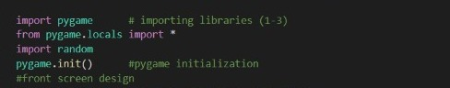

**Data Types**:

We used:

1. Variables

2. Functions

3. Conditions

4. Loops

**Design:**

Our game had 3 different windows.

1. The first window had the option to either continue or exit the game. To make this happen we used the pygame function such as display.set mode (), update (), blit(), image.load(), SysFont, and font.render.

The code written to display the screen is:

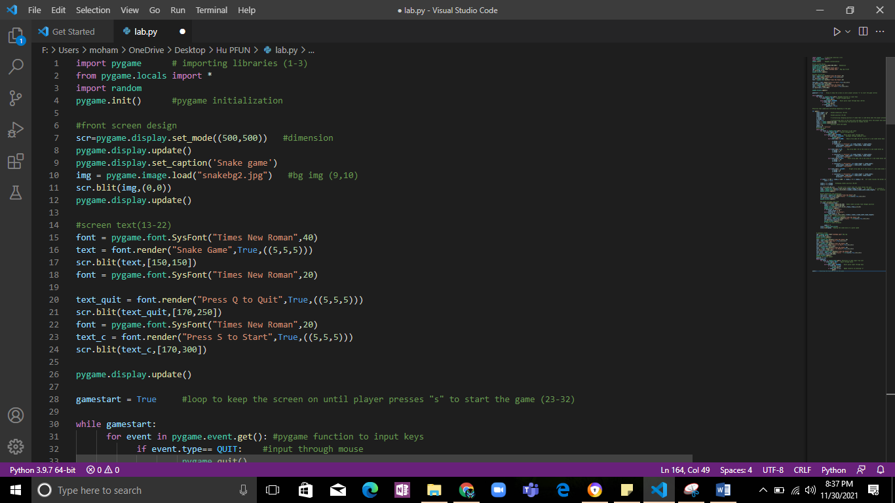

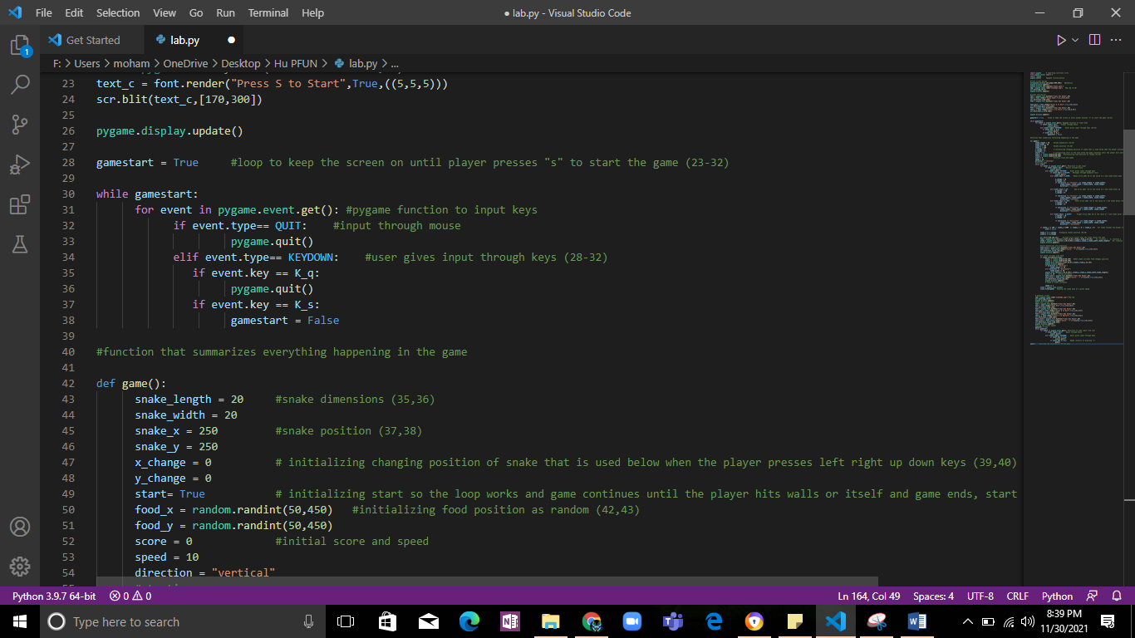

The output after running the above code is:

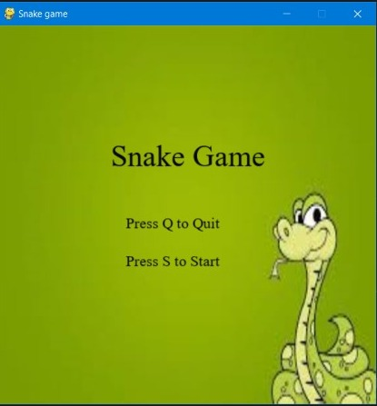

2. To create the second window we made a function called “game ()” where all the main work was done. To create this screen we firstly chose the screen color through the RGB values of color picker, and inserted the dimensions in the fill () function. Since this screen consisted of snake and the food, so we made 2 different variables namely “snake” and “food” in which we defined the color, location, and the shape of these by using the draw() function of the pygame library. The initial position of the snake was defined, but for food we used the random function to generate its position. The movement of the snake was to be controlled by the user, so made a while loop and used the function event.get() to get the input from the user. To move the snake according to the user input we made some if- else conditions. Since the main objective of the snake in this game was to collect the food, so we made a condition using the collidedirect() function of the pygame, that if the snake collides with the food, then the food should be placed at a new position and the length of the snake and the score should be increased by 10 points. Since this game was set inside a frame, so we made a condition that if the snake collides with the boundary, the user should be directed to the third screen.

The code written to fulfill the above mentioned conditions is:

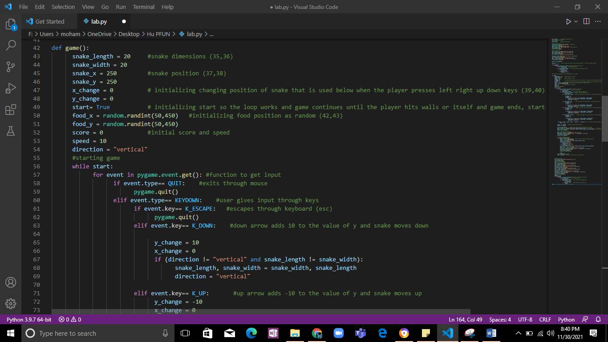

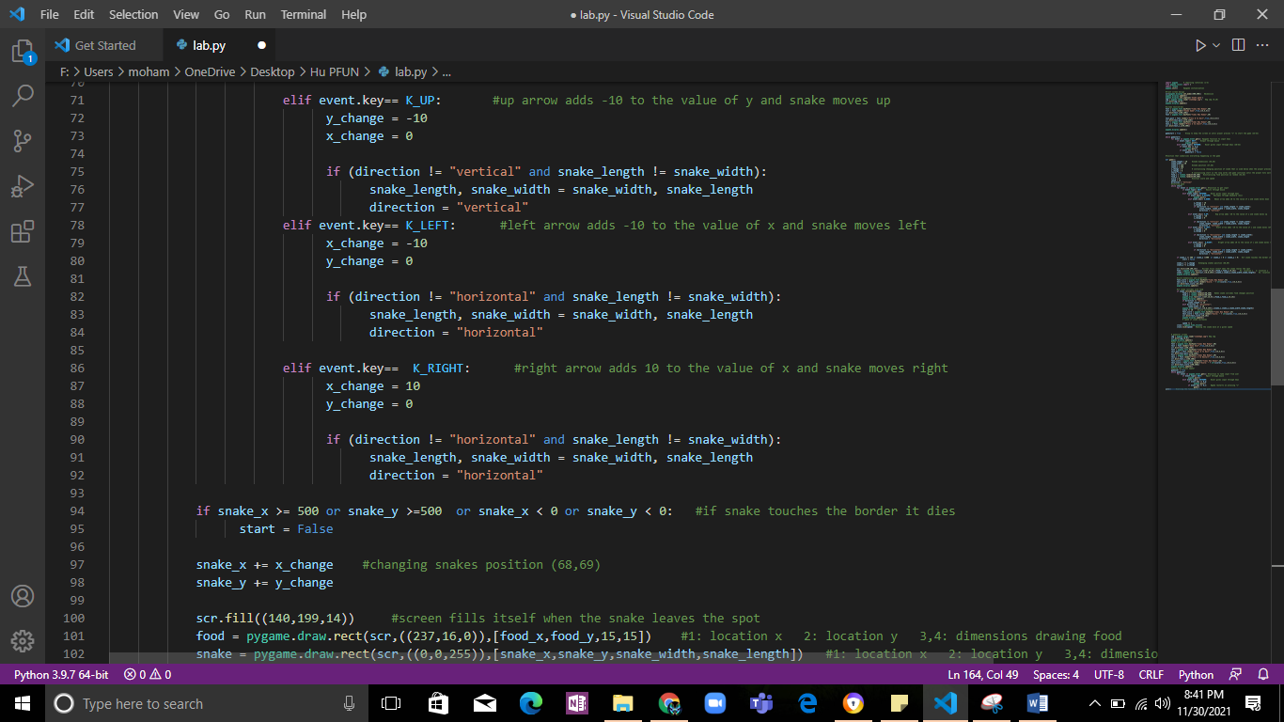

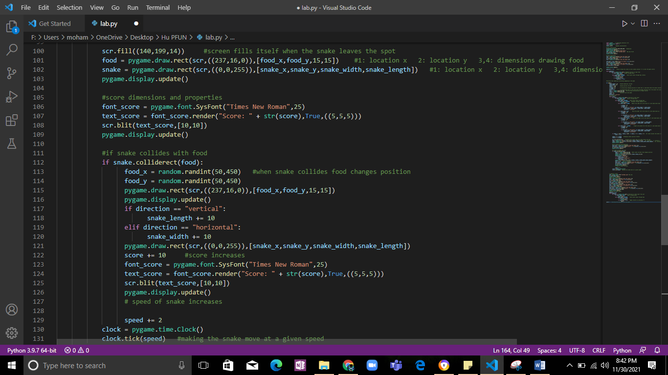

The output after running the above mentioned code is:

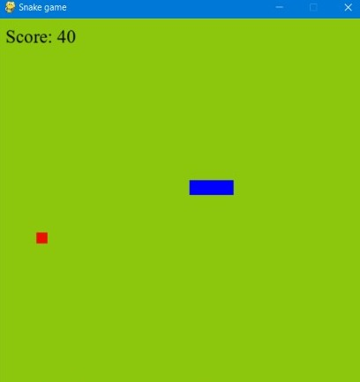

3. The last and the final screen used almost the same functions as the first screen but with a slight difference. The last screen displayed the score of the user, and the chance to either play the game again or to quit the game.

The code to display the last screen is:

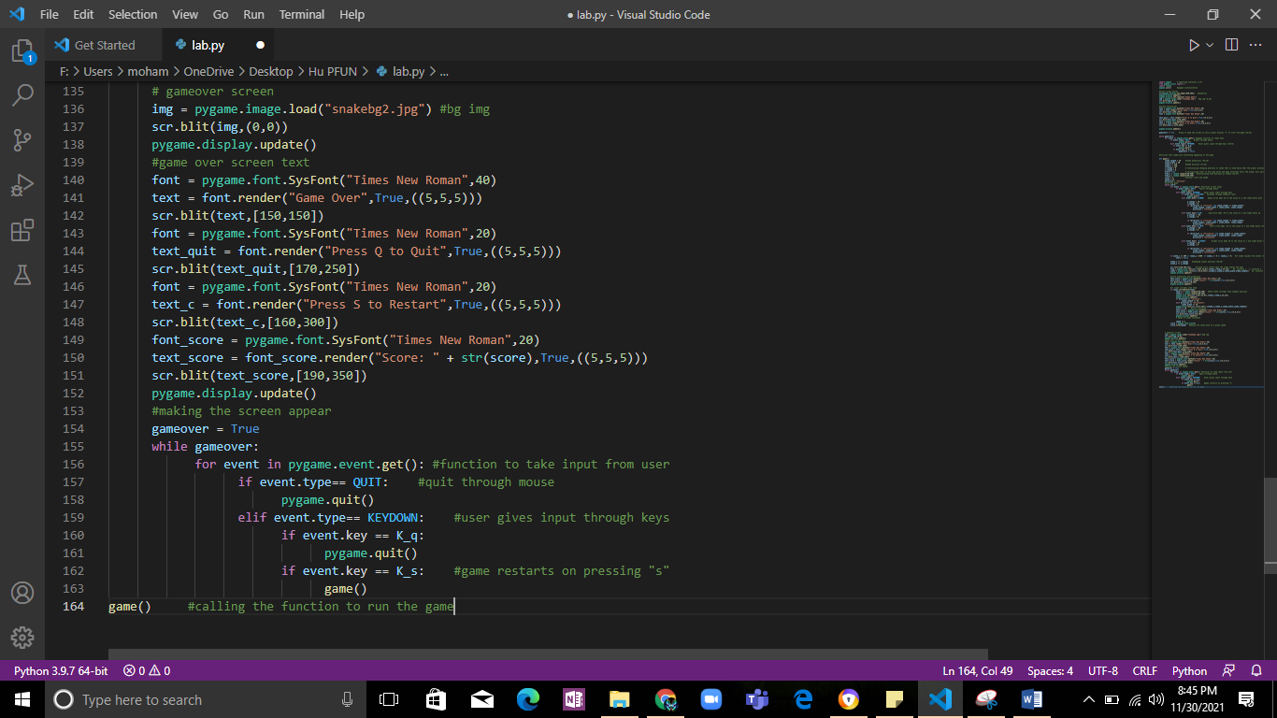

The output after running the above code is:

