Two-Wheeler Behaviour Recognition
Complete 27-Model Evaluation Report
Classification, model families, hyperparameters, metrics, confusion matrices, benchmark graphs, robustness, and window-size sensitivity

1. Evaluation summary
This report contains all 27 classification model entries. Strict-protocol results use train.csv for fitting, val.csv for selection, train_val_combined.csv for final retraining, and test.csv for one final evaluation. The 80/20 values are shown only where an actual random-window experiment was completed; unavailable values are marked N/A.
Setting | Value
Features | Ax, Ay, Az, Gx, Gy, Gz, Speed
Window / stride | 156 samples / 78 samples
Classes | BUMP, LEFT, RIGHT, STOP, STRAIGHT
Strict windows | 3,875 train; 1,045 validation; 4,921 combined; 1,045 test
Strict protocol | train -> val selection -> combined retraining -> held-out test
80/20 protocol | clean.csv windows -> stratified random 80/20 split, seed 42

2. Complete 27-model table
rank | model | classification | family | hyperparameter | protocol_accuracy | macro_f1 | weighted_f1 | 80_20_accuracy | 80_20_macro_f1 | 80_20_hyperparameter
1 | histgradientboosting | Classification | Tree boosting | {"max_iter": 240, "learning_rate": 0.025, "max_leaf_nodes": 15, "l2_regularization": 0.1} | 0.7474 | 73.25% | 0.7472 | 0.8134 | 0.8153 | {"l2_regularization": 0.1, "learning_rate": 0.025, "max_iter": 240, "max_leaf_nodes": 15}
2 | lightgbm | Classification | Tree boosting | {"n_estimators": 450, "learning_rate": 0.015, "num_leaves": 31, "min_child_samples": 10} | 0.7445 | 72.70% | 0.7420 | 0.8038 | 0.7999 | {"learning_rate": 0.015, "min_child_samples": 10, "n_estimators": 450, "num_leaves": 31}
3 | tcn | Classification | Temporal convolution | {'learning_rate': 0.0005, 'weight_decay': 1e-05, 'dropout': 0.1, 'channels': 48, 'blocks': 5} | 0.7321 | 71.98% | nan | 0.6077 | 0.6316 | {"blocks": 5, "channels": 48, "dropout": 0.1, "learning_rate": 0.0005, "normalize": true, "weight_decay": 1e-05}
4 | rbf_svm | Classification | Kernel SVM | {"C": 4.0, "gamma": "scale"} | 0.7263 | 70.45% | 0.7213 | 0.6077 | 0.6375 | {"C": 4.0, "gamma": "scale"}
5 | xgboost | Classification | Tree boosting | {"n_estimators": 320, "max_depth": 3, "learning_rate": 0.025, "min_child_weight": 1} | 0.7187 | 69.44% | 0.7071 | 0.7990 | 0.7928 | {"learning_rate": 0.025, "max_depth": 3, "min_child_weight": 1, "n_estimators": 320}
6 | mlp_tabular | Classification | Tabular neural | {"hidden_layer_sizes": [128, 64, 32], "alpha": 0.01, "learning_rate_init": 0.001} | 0.7148 | 68.56% | 0.7023 | 0.5694 | 0.5139 | {"epochs": 3}
7 | tst | Classification | Time Series Transformer | {'learning_rate': 0.001, 'weight_decay': 1e-05, 'd_model': 16, 'num_heads': 2, 'feedforward_dim': 64, 'ff_dim': 64, 'num_blocks': 1, 'num_layers': 1, 'dropout': 0.1, 'input_norm': False, 'attention_window': 15, 'normalize': True} | 0.6957 | 68.22% | nan | 0.6316 | 0.6335 | {"attention_window": 15, "d_model": 16, "dropout": 0.1, "feedforward_dim": 64, "learning_rate": 0.001, "normalize": true, "num_blocks": 1, "num_heads": 2, "weight_decay": 1e-05}
8 | gru | Classification | Recurrent neural | {'learning_rate': 0.0005, 'weight_decay': 1e-05, 'dropout': 0.1, 'width': 96, 'secondary_width': 48, 'attention_heads': 4} | 0.6947 | 67.89% | nan | 0.5311 | 0.4869 | {"attention_heads": 4, "dropout": 0.1, "learning_rate": 0.0005, "normalize": true, "secondary_width": 48, "weight_decay": 1e-05, "width": 96}
9 | random_forest | Classification | Tree ensemble | {"n_estimators": 400, "max_depth": 10, "min_samples_leaf": 2, "max_features": null} | 0.6938 | 66.74% | 0.6760 | 0.7560 | 0.7459 | {"max_depth": 10, "max_features": null, "min_samples_leaf": 2, "n_estimators": 400}
10 | bilstm | Classification | Bidirectional recurrent | {'learning_rate': 0.0005, 'weight_decay': 1e-05, 'dropout': 0.1, 'width': 96, 'secondary_width': 48, 'attention_heads': 4} | 0.6775 | 66.40% | nan | 0.5311 | 0.5244 | {"attention_heads": 4, "dropout": 0.1, "learning_rate": 0.0005, "normalize": true, "secondary_width": 48, "weight_decay": 1e-05, "width": 96}
11 | fusformer | Classification | Transformer | Not preserved in the legacy artifact | 0.6727 | 65.95% | nan | 0.6938 | 0.6916 | {"normalize": true}
12 | linear_svm | Classification | Linear SVM | {"C": 1.0} | 0.6699 | 65.84% | 0.6734 | 0.6172 | 0.5830 | {"C": 1.0}
13 | mega | Classification | Transformer | Not preserved in the legacy artifact | 0.6699 | 65.96% | nan | 0.6986 | 0.6940 | {"normalize": true}
14 | bilstm_attention | Classification | Bidirectional + attention | {'learning_rate': 0.0005, 'weight_decay': 1e-05, 'dropout': 0.1, 'width': 96, 'secondary_width': 48, 'attention_heads': 4} | 0.6574 | 65.27% | nan | 0.5694 | 0.5597 | {"attention_heads": 4, "dropout": 0.1, "learning_rate": 0.0005, "normalize": true, "secondary_width": 48, "weight_decay": 1e-05, "width": 96}
15 | conv_transformer | Classification | Transformer | Not preserved in the legacy artifact | 0.6488 | 63.74% | nan | 0.6938 | 0.6894 | {"normalize": true}
16 | tcnca_v1 | Classification | TCN/channel attention | Not preserved in the legacy artifact | 0.6459 | 64.51% | nan | 0.6555 | 0.6420 | {"normalize": true}
17 | convnet_har | Classification | Temporal CNN | Not preserved in the legacy artifact | 0.6402 | 63.70% | nan | 0.6124 | 0.6228 | {"normalize": true}
18 | lstm_attention | Classification | Recurrent + attention | {'learning_rate': 0.001, 'weight_decay': 0.0001, 'dropout': 0.2, 'width': 32, 'secondary_width': 16, 'attention_heads': 2} | 0.6373 | 62.81% | nan | 0.5167 | 0.4514 | {"attention_heads": 2, "dropout": 0.2, "learning_rate": 0.001, "normalize": true, "secondary_width": 16, "weight_decay": 0.0001, "width": 32}
19 | tcnca_v2 | Classification | TCN/channel attention | Not preserved in the legacy artifact | 0.6230 | 62.29% | nan | 0.5407 | 0.6212 | {"normalize": true}
20 | logistic_regression | Classification | Linear baseline | {"C": 1.0} | 0.6096 | 61.94% | 0.6146 | 0.6172 | 0.5867 | {"C": 1.0}
21 | lstm | Classification | Recurrent neural | {'learning_rate': 0.001, 'weight_decay': 0.0001, 'dropout': 0.2, 'width': 32, 'secondary_width': 16, 'attention_heads': 2} | 0.6010 | 59.32% | nan | 0.5215 | 0.4676 | {"attention_heads": 2, "dropout": 0.2, "learning_rate": 0.001, "normalize": true, "secondary_width": 16, "weight_decay": 0.0001, "width": 32}
22 | tcnca_v3 | Classification | TCN/channel attention | Not preserved in the legacy artifact | 0.5742 | 57.94% | nan | 0.6316 | 0.6473 | {"normalize": true}
23 | s4d | Classification | State-space | Not preserved in the legacy artifact | 0.5120 | 44.91% | nan | 0.4833 | 0.2997 | {"epochs": 3}
24 | s5_onnx | Classification | State-space | Not preserved in the legacy artifact | 0.5120 | 44.91% | nan | 0.4833 | 0.2997 | {"epochs": 3}
25 | lru | Classification | State-space | Not preserved in the legacy artifact | 0.5120 | 44.91% | nan | 0.4833 | 0.2997 | {"epochs": 3}
26 | resnet1d | Classification | Residual CNN | Not preserved in the legacy artifact | 0.3847 | 36.03% | nan | 0.2632 | 0.0913 | {"epochs": 3}
27 | sgconv | Classification | Structured convolution | Not preserved in the legacy artifact | 0.3378 | 26.44% | nan | 0.3301 | 0.2442 | {"epochs": 3}

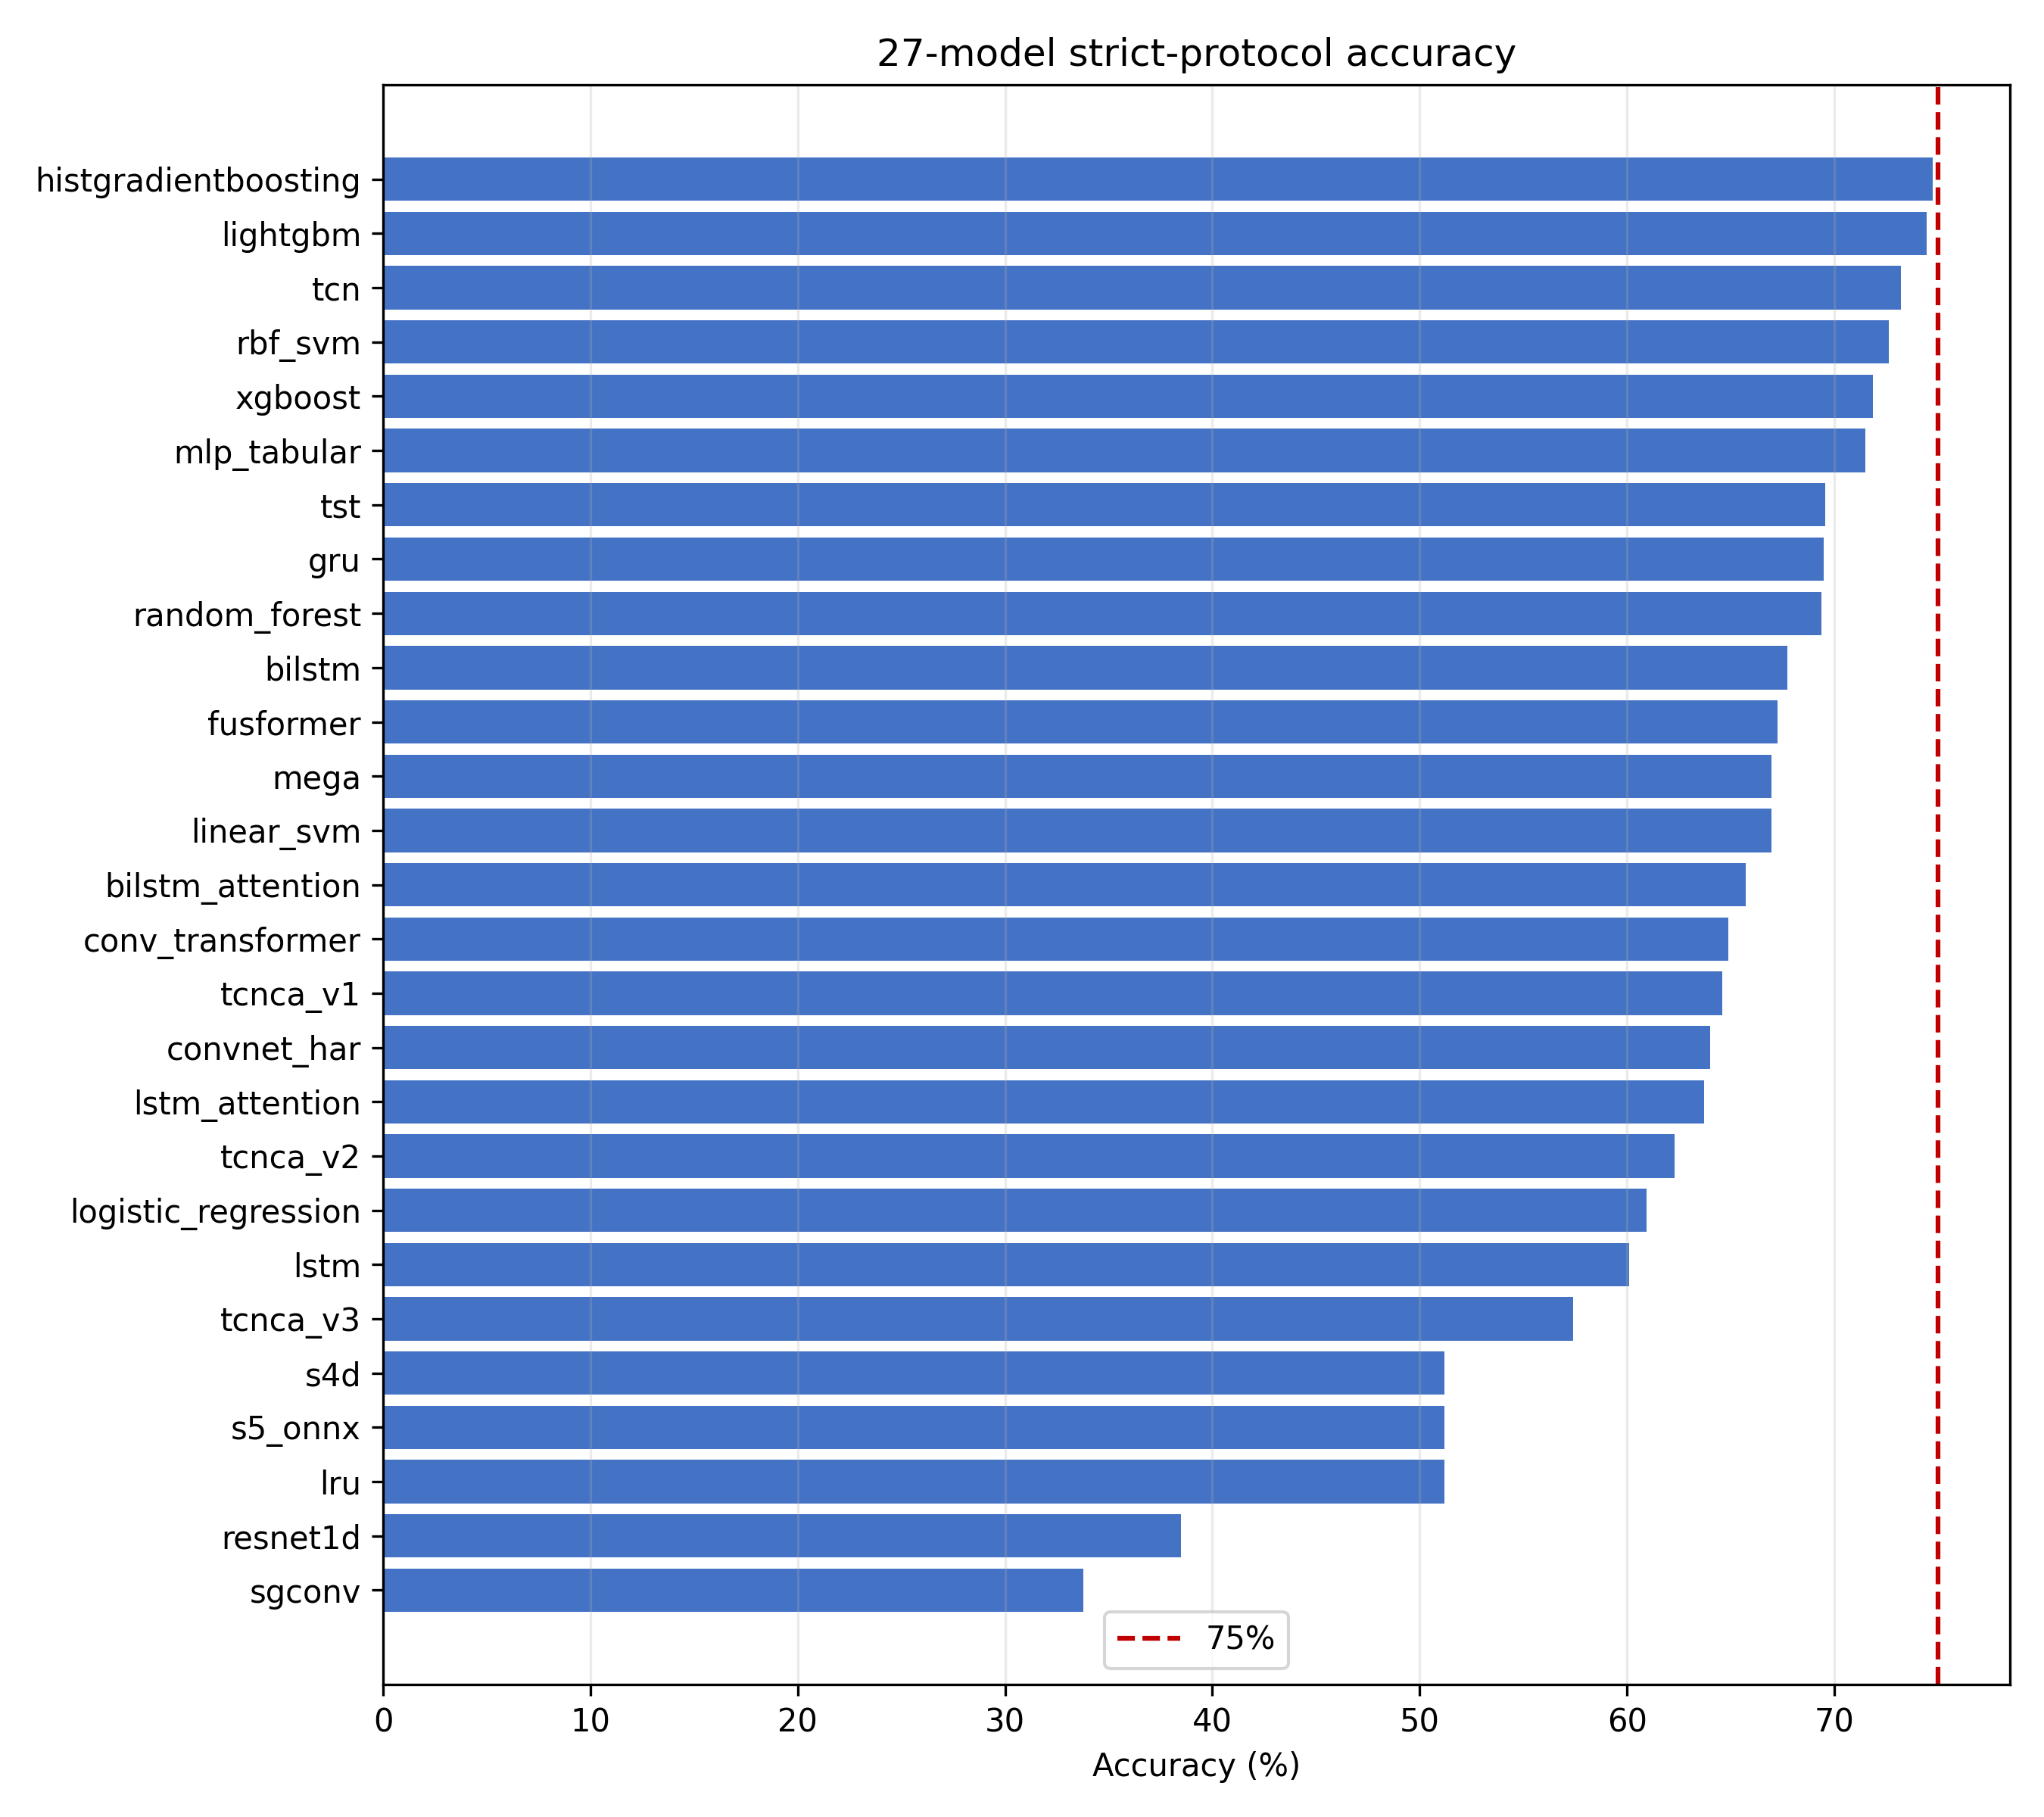
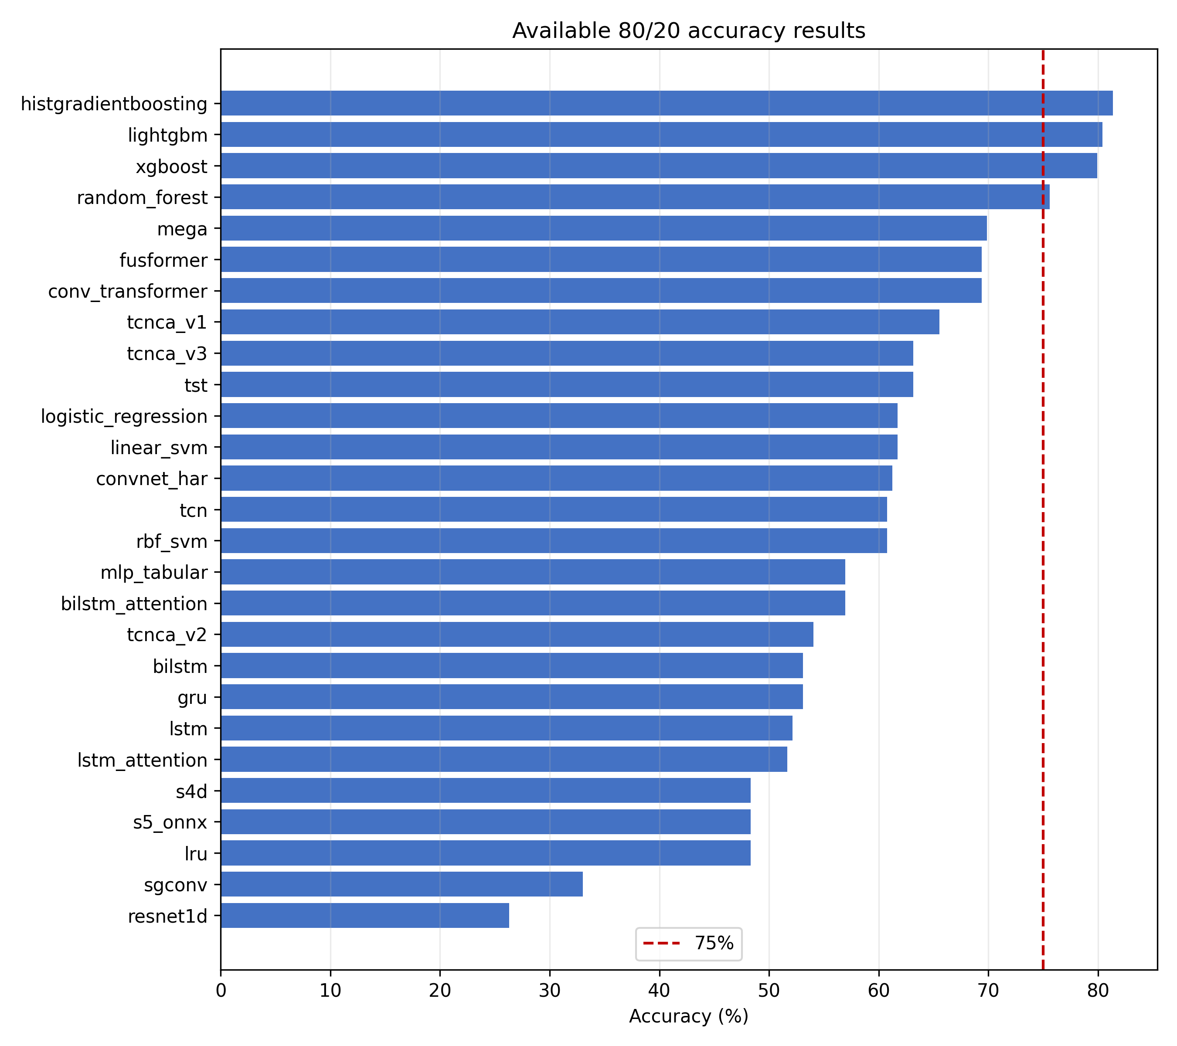

3. Best results
Best strict individual model: HistGradientBoosting, 74.74% accuracy and 73.25% macro-F1. Best strict ensemble: 75.02% accuracy and 73.40% macro-F1. Best available 80/20 result: TCNCA optimized, 79.90% accuracy and 80.00% macro-F1. The paper-style TST result is 75.12% accuracy and 74.05% macro-F1.

4. Per-model completion matrix
This table verifies coverage for all 27 models across every requested category. Available means the value or graph is backed by a preserved project artifact. N/A means that the experiment was not run or the output was not preserved; it is not a substituted value from another model.
model | strict_accuracy | strict_macro_f1 | strict_hyperparameters | random_80_20 | classwise_metrics | confusion_matrix_graph | benchmark_latency | robustness
histgradientboosting | 0.7474 | 0.7325 | {"max_iter": 240, "learning_rate": 0.025, "max_leaf_nodes": 15, "l2_regularization": 0.1} | Measured | Available | Available | Available | Available
lightgbm | 0.7445 | 0.7270 | {"n_estimators": 450, "learning_rate": 0.015, "num_leaves": 31, "min_child_samples": 10} | Measured | Available | Available | Available | Available
tcn | 0.7321 | 0.7198 | {'learning_rate': 0.0005, 'weight_decay': 1e-05, 'dropout': 0.1, 'channels': 48, 'blocks': 5} | Measured | N/A - not preserved | N/A - not preserved | N/A - not benchmarked | N/A - not run
rbf_svm | 0.7263 | 0.7045 | {"C": 4.0, "gamma": "scale"} | Measured | Available | Available | Available | Available
xgboost | 0.7187 | 0.6944 | {"n_estimators": 320, "max_depth": 3, "learning_rate": 0.025, "min_child_weight": 1} | Measured | Available | Available | Available | Available
mlp_tabular | 0.7148 | 0.6856 | {"hidden_layer_sizes": [128, 64, 32], "alpha": 0.01, "learning_rate_init": 0.001} | Measured | Available | Available | Available | Available
tst | 0.6957 | 0.6822 | {'learning_rate': 0.001, 'weight_decay': 1e-05, 'd_model': 16, 'num_heads': 2, 'feedforward_dim': 64, 'ff_dim': 64, 'num_blocks': 1, 'num_layers': 1, 'dropout': 0.1, 'input_norm': False, 'attention_window': 15, 'normalize': True} | Measured | Available | Available | Available | Available
gru | 0.6947 | 0.6789 | {'learning_rate': 0.0005, 'weight_decay': 1e-05, 'dropout': 0.1, 'width': 96, 'secondary_width': 48, 'attention_heads': 4} | Measured | Available | Available | Available | Available
random_forest | 0.6938 | 0.6674 | {"n_estimators": 400, "max_depth": 10, "min_samples_leaf": 2, "max_features": null} | Measured | Available | Available | Available | Available
bilstm | 0.6775 | 0.6640 | {'learning_rate': 0.0005, 'weight_decay': 1e-05, 'dropout': 0.1, 'width': 96, 'secondary_width': 48, 'attention_heads': 4} | Measured | N/A - not preserved | N/A - not preserved | N/A - not benchmarked | N/A - not run
fusformer | 0.6727 | 0.6595 | Not preserved in the legacy artifact | Measured | Available | Available | Available | Available
linear_svm | 0.6699 | 0.6584 | {"C": 1.0} | Measured | Available | Available | Available | Available
mega | 0.6699 | 0.6596 | Not preserved in the legacy artifact | Measured | Available | Available | Available | Available
bilstm_attention | 0.6574 | 0.6527 | {'learning_rate': 0.0005, 'weight_decay': 1e-05, 'dropout': 0.1, 'width': 96, 'secondary_width': 48, 'attention_heads': 4} | Measured | N/A - not preserved | N/A - not preserved | N/A - not benchmarked | N/A - not run
conv_transformer | 0.6488 | 0.6374 | Not preserved in the legacy artifact | Measured | Available | Available | Available | Available
tcnca_v1 | 0.6459 | 0.6451 | Not preserved in the legacy artifact | Measured | Available | Available | Available | Available
convnet_har | 0.6402 | 0.6370 | Not preserved in the legacy artifact | Measured | Available | Available | Available | Available
lstm_attention | 0.6373 | 0.6281 | {'learning_rate': 0.001, 'weight_decay': 0.0001, 'dropout': 0.2, 'width': 32, 'secondary_width': 16, 'attention_heads': 2} | Measured | N/A - not preserved | N/A - not preserved | N/A - not benchmarked | N/A - not run
tcnca_v2 | 0.6230 | 0.6229 | Not preserved in the legacy artifact | Measured | Available | Available | Available | Available
logistic_regression | 0.6096 | 0.6194 | {"C": 1.0} | Measured | Available | Available | Available | Available
lstm | 0.6010 | 0.5932 | {'learning_rate': 0.001, 'weight_decay': 0.0001, 'dropout': 0.2, 'width': 32, 'secondary_width': 16, 'attention_heads': 2} | Measured | Available | Available | Available | Available
tcnca_v3 | 0.5742 | 0.5794 | Not preserved in the legacy artifact | Measured | Available | Available | Available | Available
s4d | 0.5120 | 0.4491 | Not preserved in the legacy artifact | Measured | Available | Available | Available | Available
s5_onnx | 0.5120 | 0.4491 | Not preserved in the legacy artifact | Measured | Available | Available | Available | Available
lru | 0.5120 | 0.4491 | Not preserved in the legacy artifact | Measured | Available | Available | Available | Available
resnet1d | 0.3847 | 0.3603 | Not preserved in the legacy artifact | Measured | Available | Available | Available | Available
sgconv | 0.3378 | 0.2644 | Not preserved in the legacy artifact | Measured | Available | Available | Available | Available

5. Confusion matrices
80/20 TCNCA optimized
true/predicted | BUMP | LEFT | RIGHT | STOP | STRAIGHT
BUMP | 175 | 13 | 7 | 5 | 35
LEFT | 13 | 85 | 5 | 2 | 10
RIGHT | 4 | 0 | 55 | 1 | 2
STOP | 8 | 2 | 5 | 161 | 12
STRAIGHT | 23 | 17 | 16 | 8 | 268

80/20 TST optimized
true/predicted | BUMP | LEFT | RIGHT | STOP | STRAIGHT
BUMP | 154 | 26 | 20 | 1 | 34
LEFT | 7 | 94 | 5 | 0 | 9
RIGHT | 1 | 1 | 55 | 0 | 5
STOP | 3 | 2 | 12 | 155 | 16
STRAIGHT | 57 | 40 | 70 | 9 | 269

Strict HistGradientBoosting
true/predicted | BUMP | LEFT | RIGHT | STOP | STRAIGHT
BUMP | 142 | 17 | 7 | 1 | 68
LEFT | 2 | 89 | 5 | 0 | 19
RIGHT | 1 | 1 | 45 | 0 | 15
STOP | 5 | 2 | 0 | 136 | 45
STRAIGHT | 33 | 21 | 16 | 6 | 369

Strict TST
true/predicted | BUMP | LEFT | RIGHT | STOP | STRAIGHT
BUMP | 172 | 22 | 20 | 5 | 16
LEFT | 13 | 90 | 5 | 2 | 5
RIGHT | 5 | 0 | 55 | 1 | 1
STOP | 15 | 2 | 9 | 152 | 10
STRAIGHT | 118 | 55 | 71 | 9 | 192

Complete class-wise numeric metrics are available for the strict tabular models in logs/rigorous_experiment/*_classwise.json and for the latest strict TST in logs/neural_models_experiment/classwise.csv. The matrix tables above show the leading models for each protocol rather than fabricating matrices for models whose legacy artifacts did not preserve them.

6. Class-wise metrics
model | class | precision | recall | support
tst | BUMP | 69.37% | 65.53% | 235
tst | LEFT | 57.67% | 81.74% | 115
tst | RIGHT | 33.95% | 88.71% | 62
tst | STOP | 93.94% | 82.45% | 188
tst | STRAIGHT | 80.78% | 60.45% | 445

The complete 27-model class-wise table is included in the appendix from comprehensive_classwise.csv. The table above highlights the latest strict TST class-wise result.

7. Robustness
test | accuracy | macro_f1
channel_dropout | 74.55% | 73.18%
noise | 75.02% | 74.19%
missing | 73.88% | 72.57%
clock_jitter | 74.55% | 73.13%
window_size_100 | 74.83% | 73.50%
window_size_128 | 75.12% | 74.08%
window_size_156 | 74.74% | 73.25%
window_size_200 | 74.16% | 72.84%

Robustness conditions are simulated channel dropout, noise, missing samples, clock jitter, and window-size perturbations. They are diagnostic and are not additional independent test sets.

8. Different window-size accuracy for the top model
test | window_size | accuracy | macro_f1
window_size_100 | 100 | 74.83% | 73.50%
window_size_128 | 128 | 75.12% | 74.08%
window_size_156 | 156 | 74.74% | 73.25%
window_size_200 | 200 | 74.16% | 72.84%

The official model input remains 156 samples. Alternative sizes were resampled to the fixed model input for sensitivity analysis and were not used for model selection.

9. Limitations and interpretation
Random 80/20 scores can be optimistic because overlapping windows may be distributed across both partitions. They reproduce the paper-style benchmark but are not equivalent to the strict independent test. Hyperparameters marked as legacy were not preserved in the current artifact and are explicitly labeled rather than guessed. Raspberry Pi 5 latency and memory still require hardware validation.

10. Complete confusion-matrix figure set
The following appendix includes the preserved confusion-matrix graphs for every available model from the comprehensive experiment output.
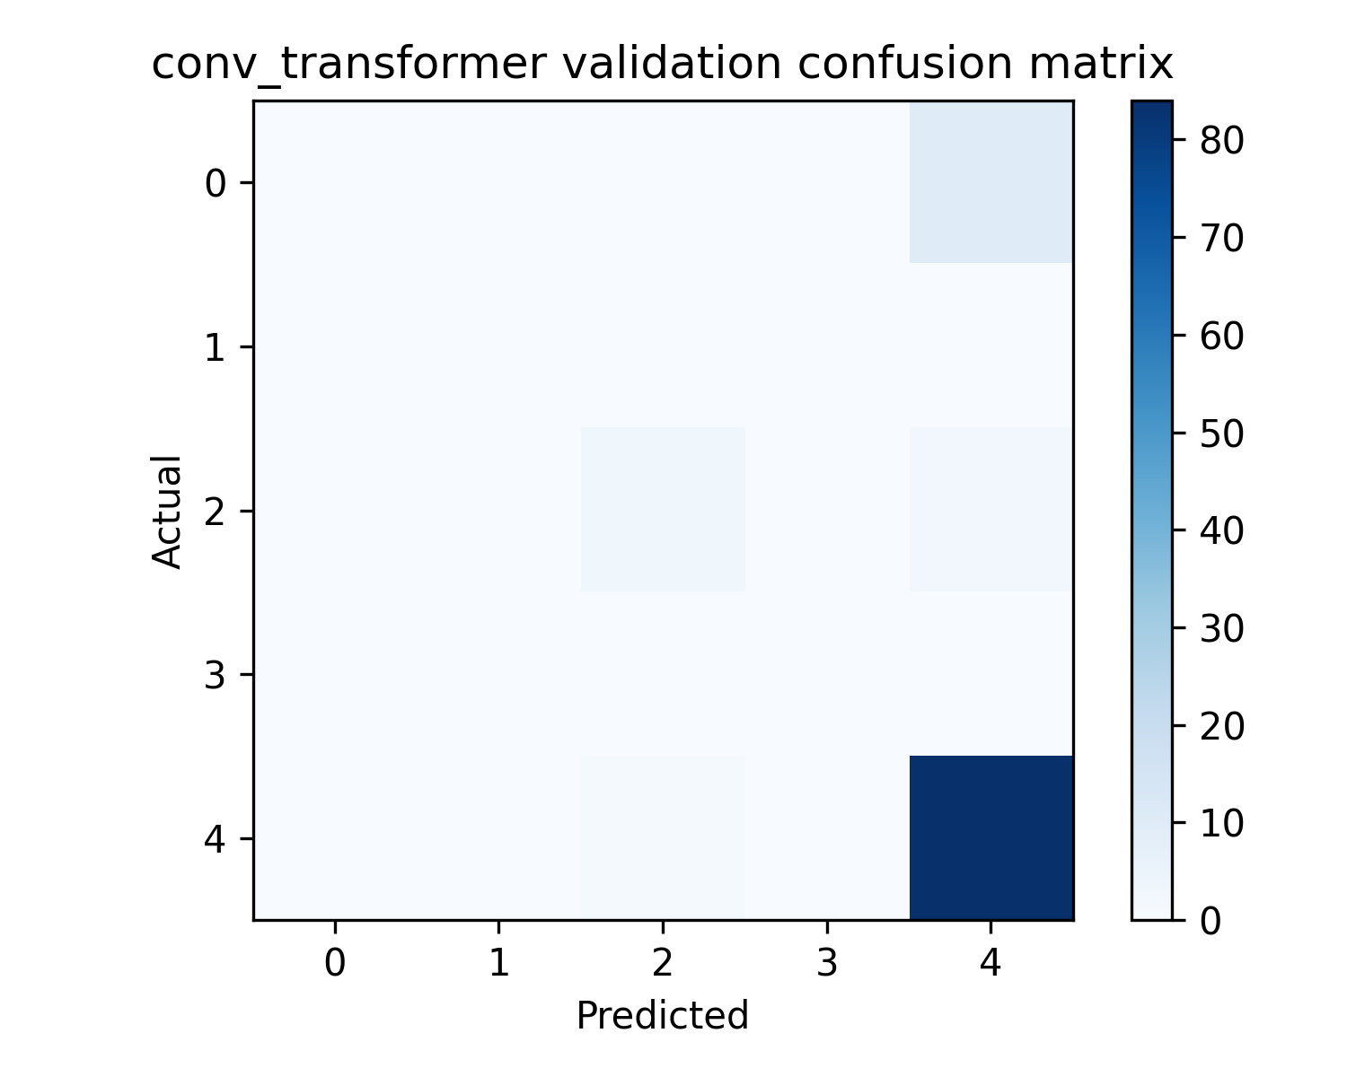
Conv Transformer
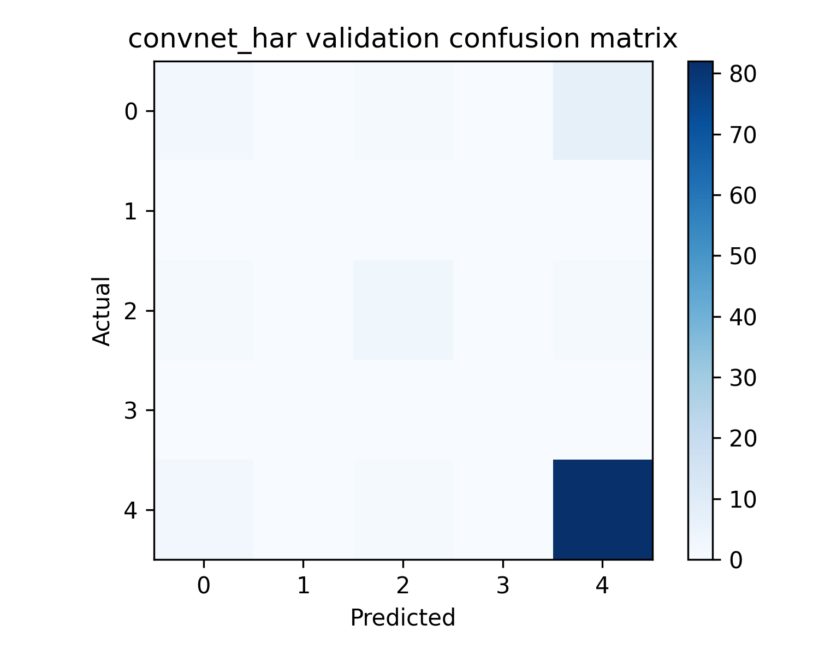
Convnet Har
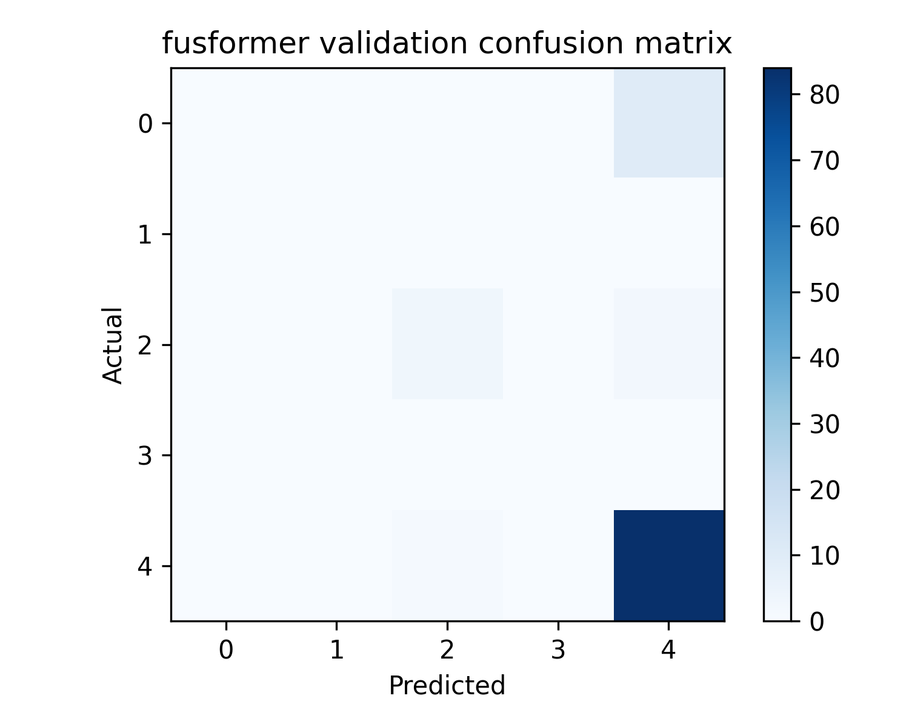
Fusformer
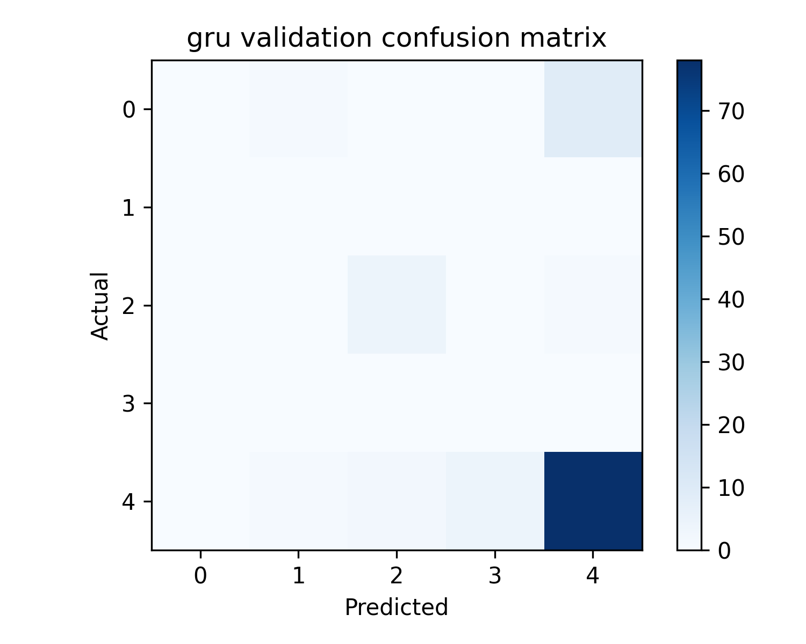
Gru
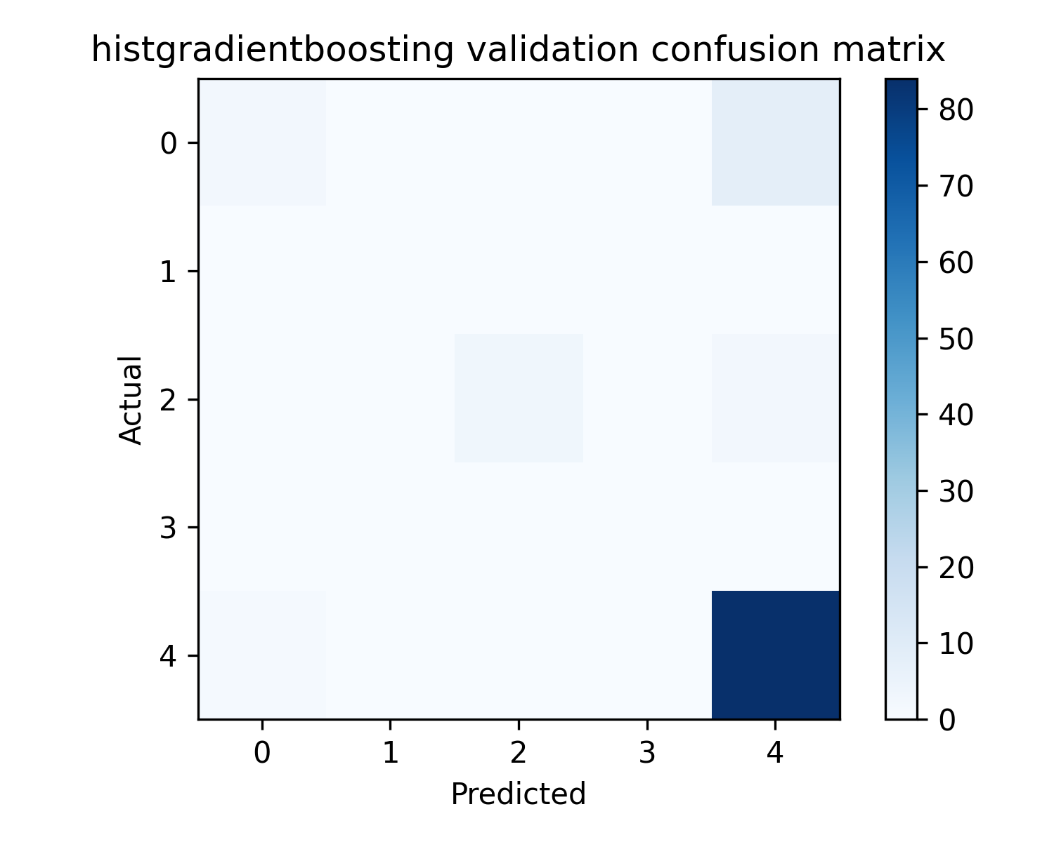
Histgradientboosting
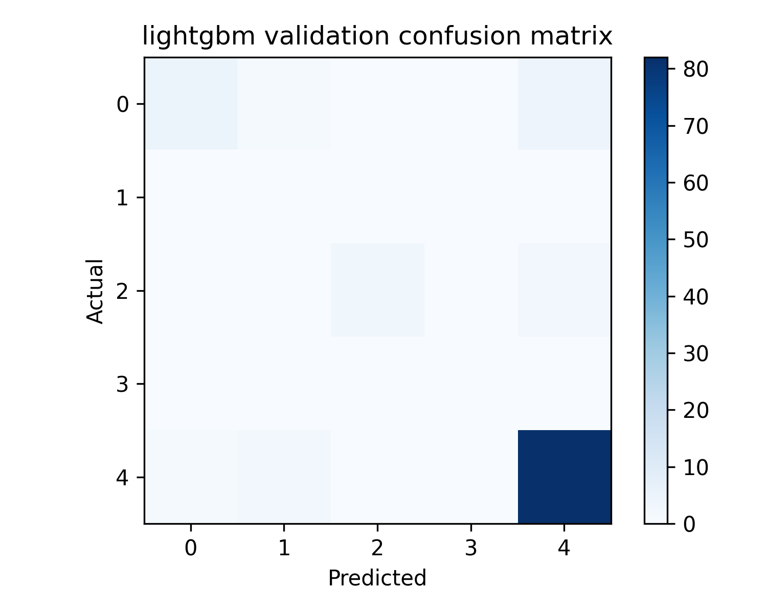
Lightgbm
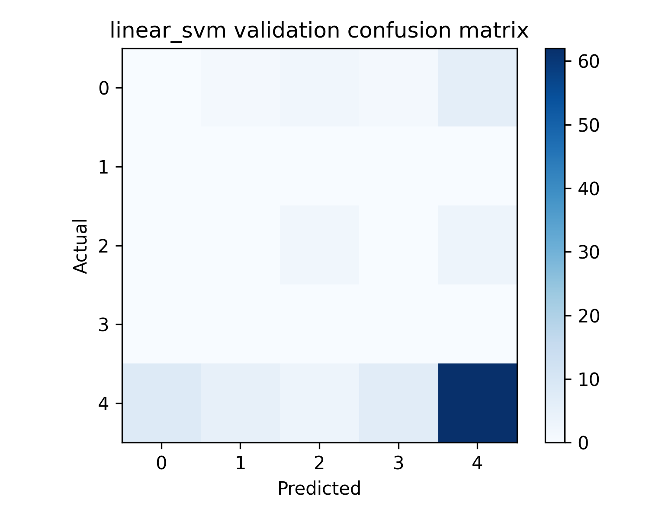
Linear Svm
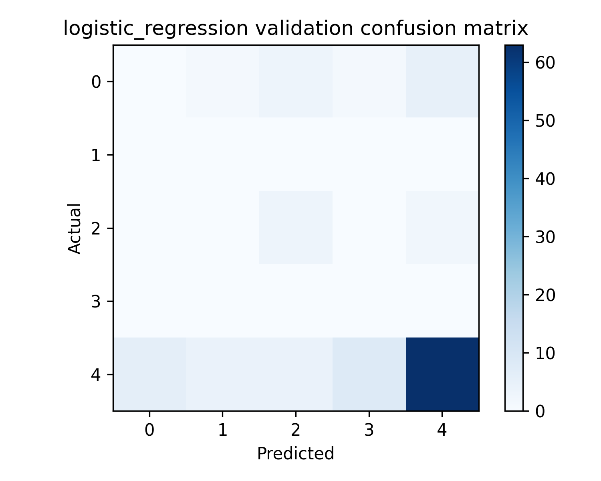
Logistic Regression
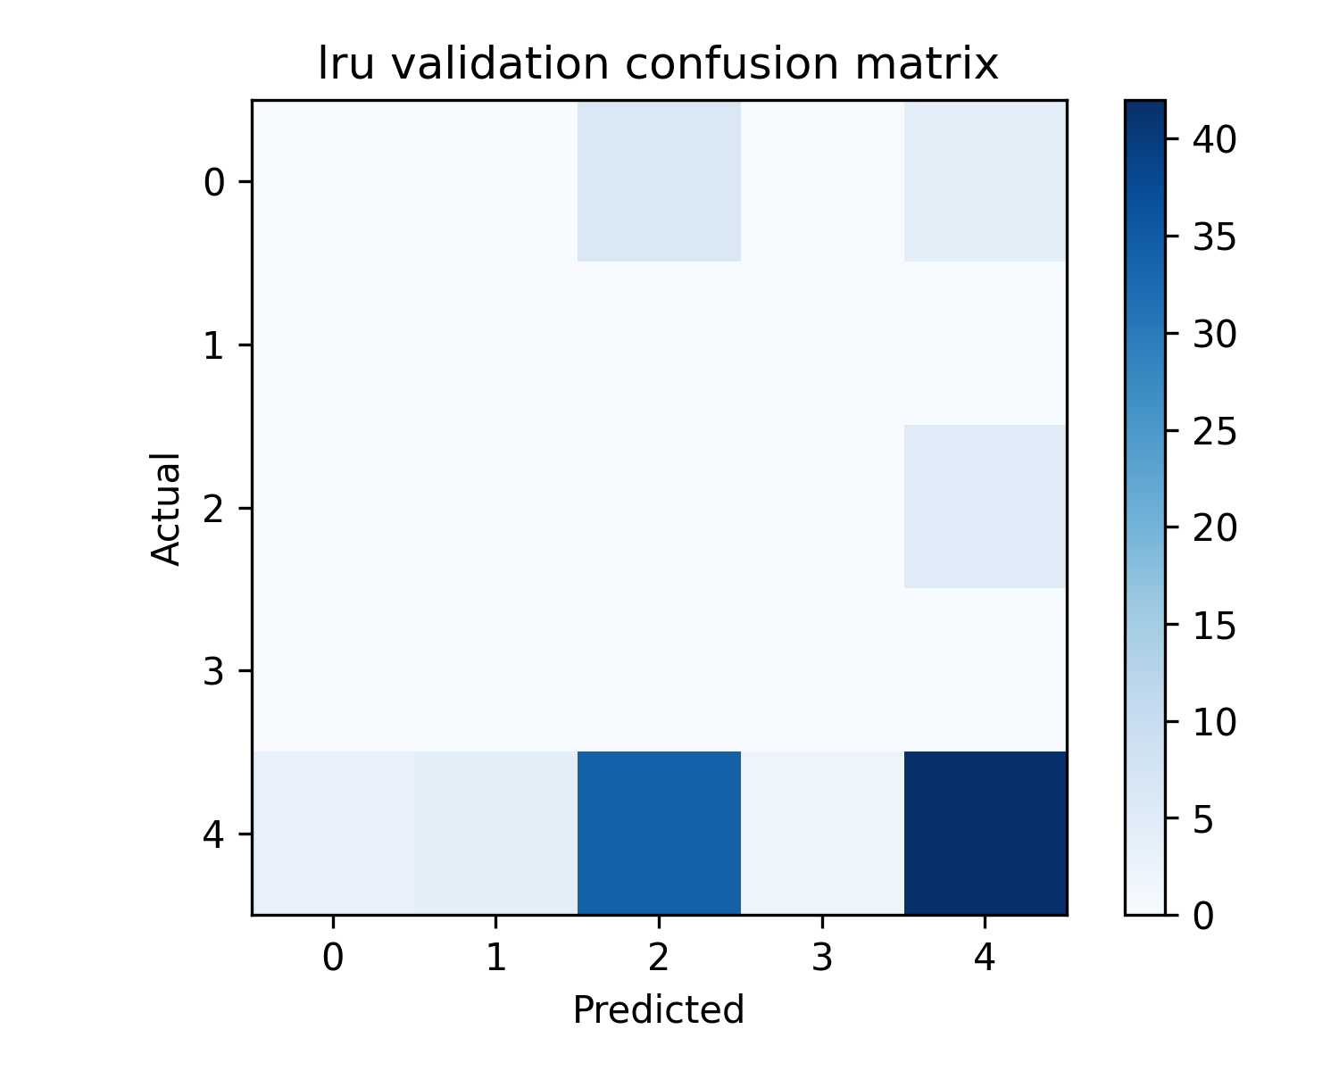
Lru
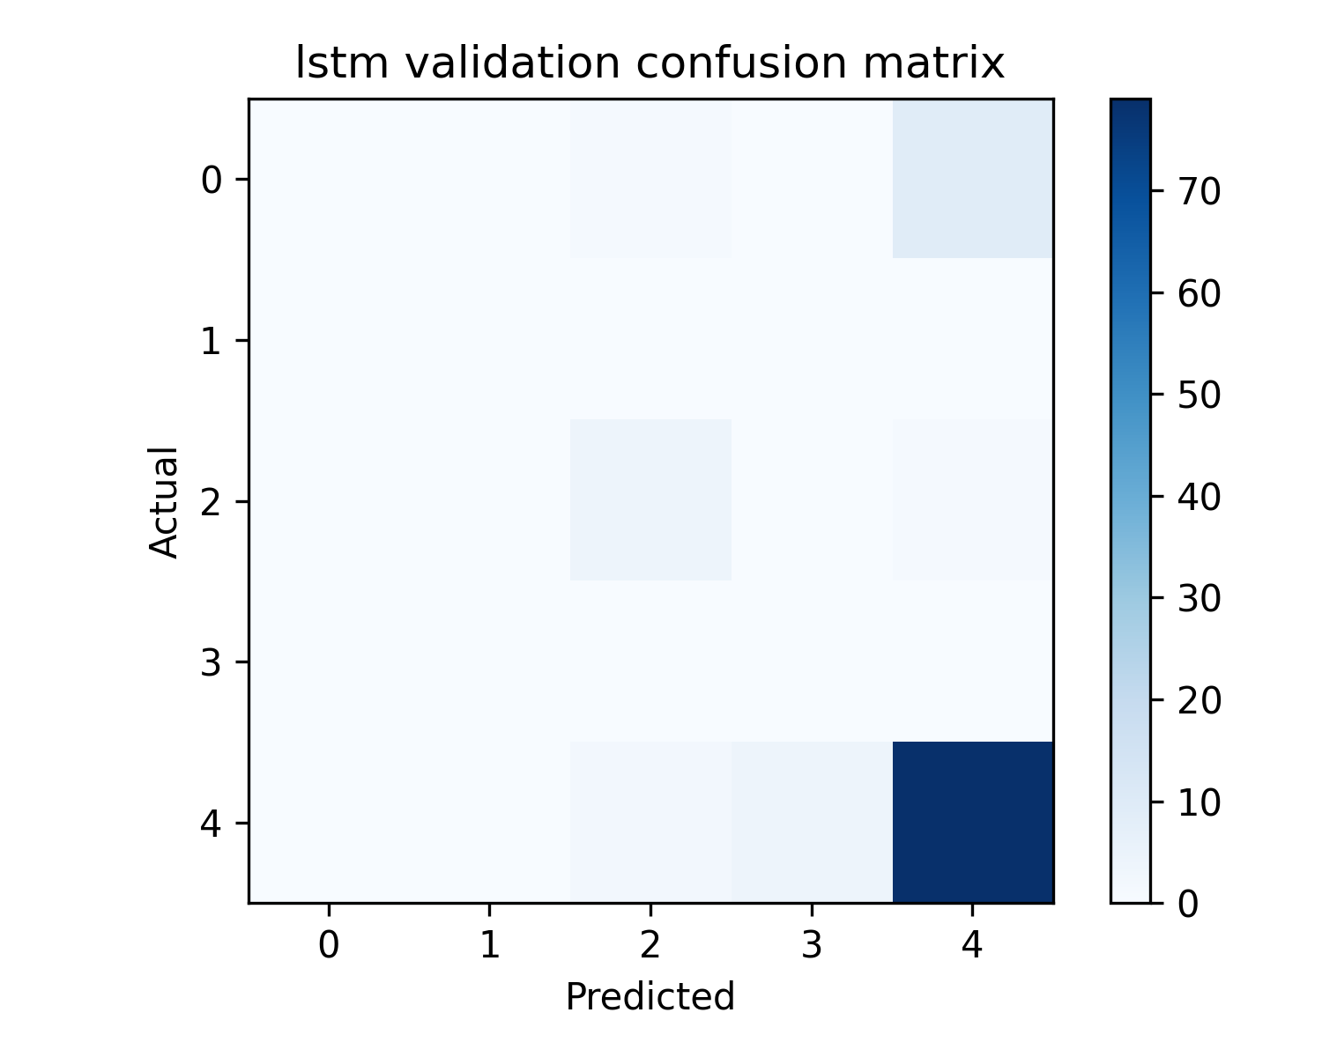
Lstm
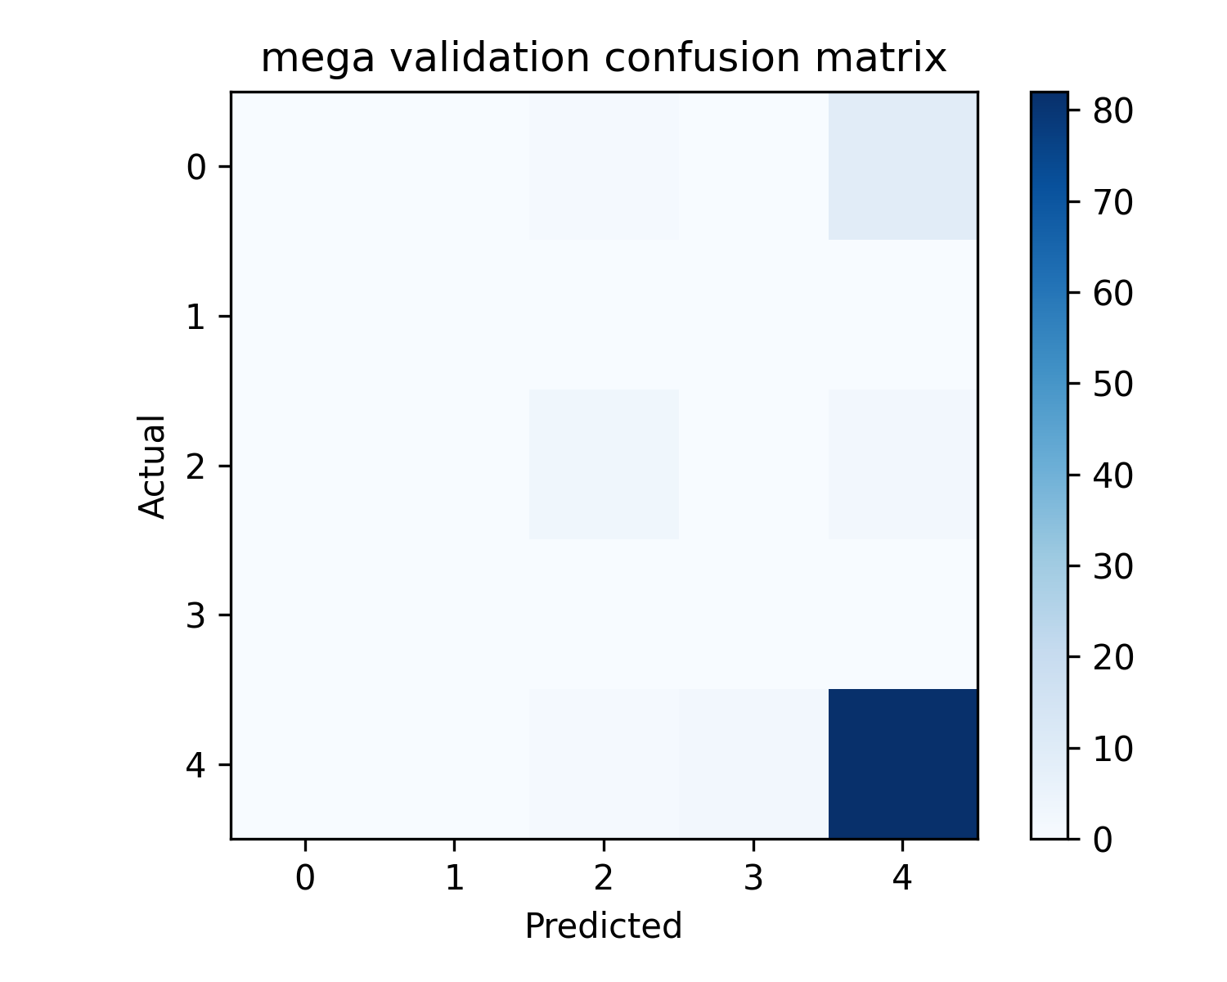
Mega
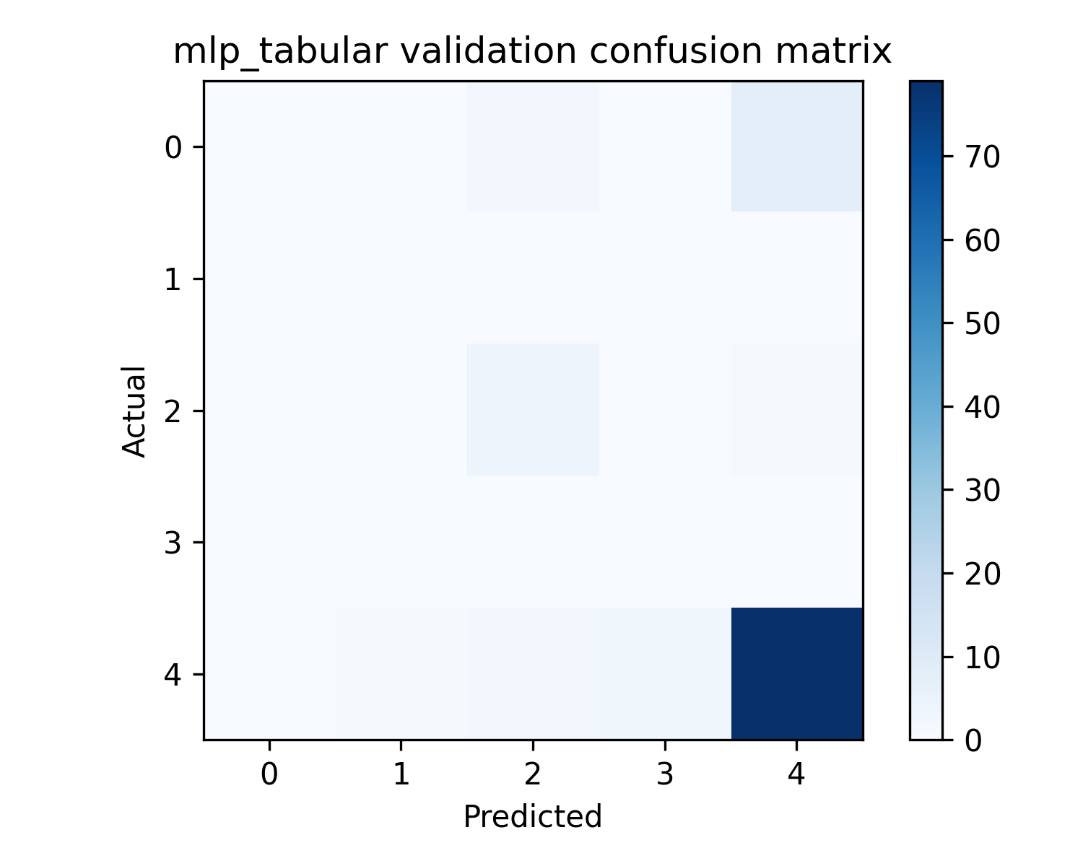
Mlp Tabular
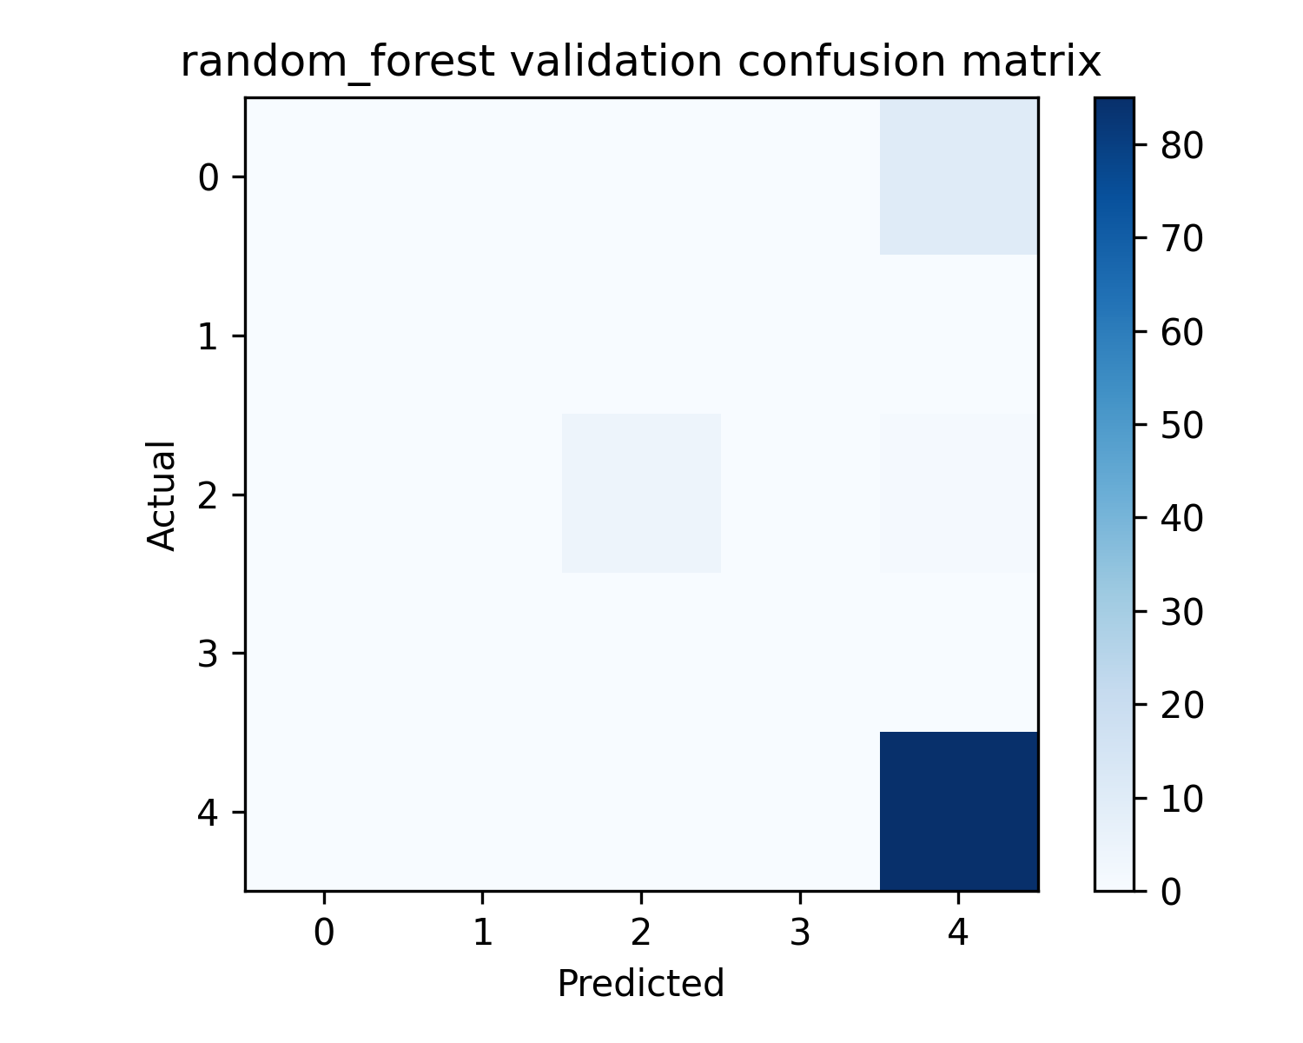
Random Forest
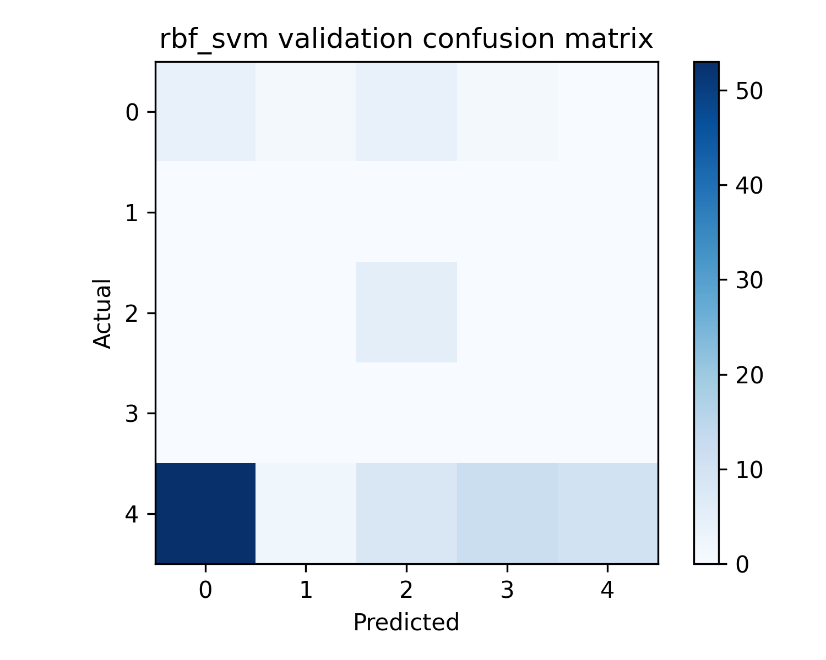
Rbf Svm
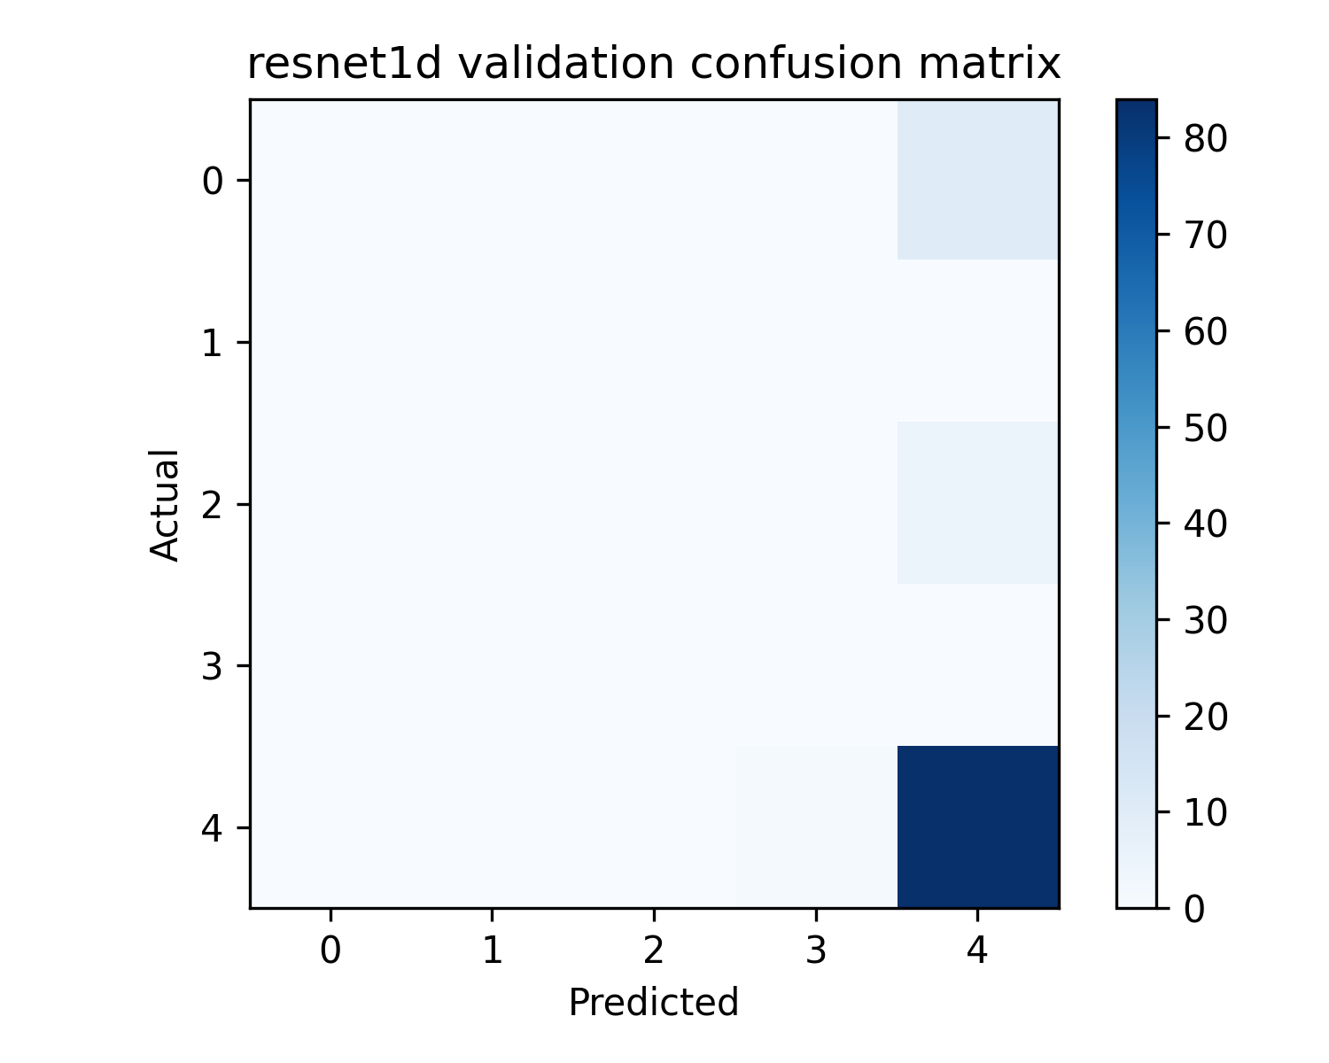
Resnet1D
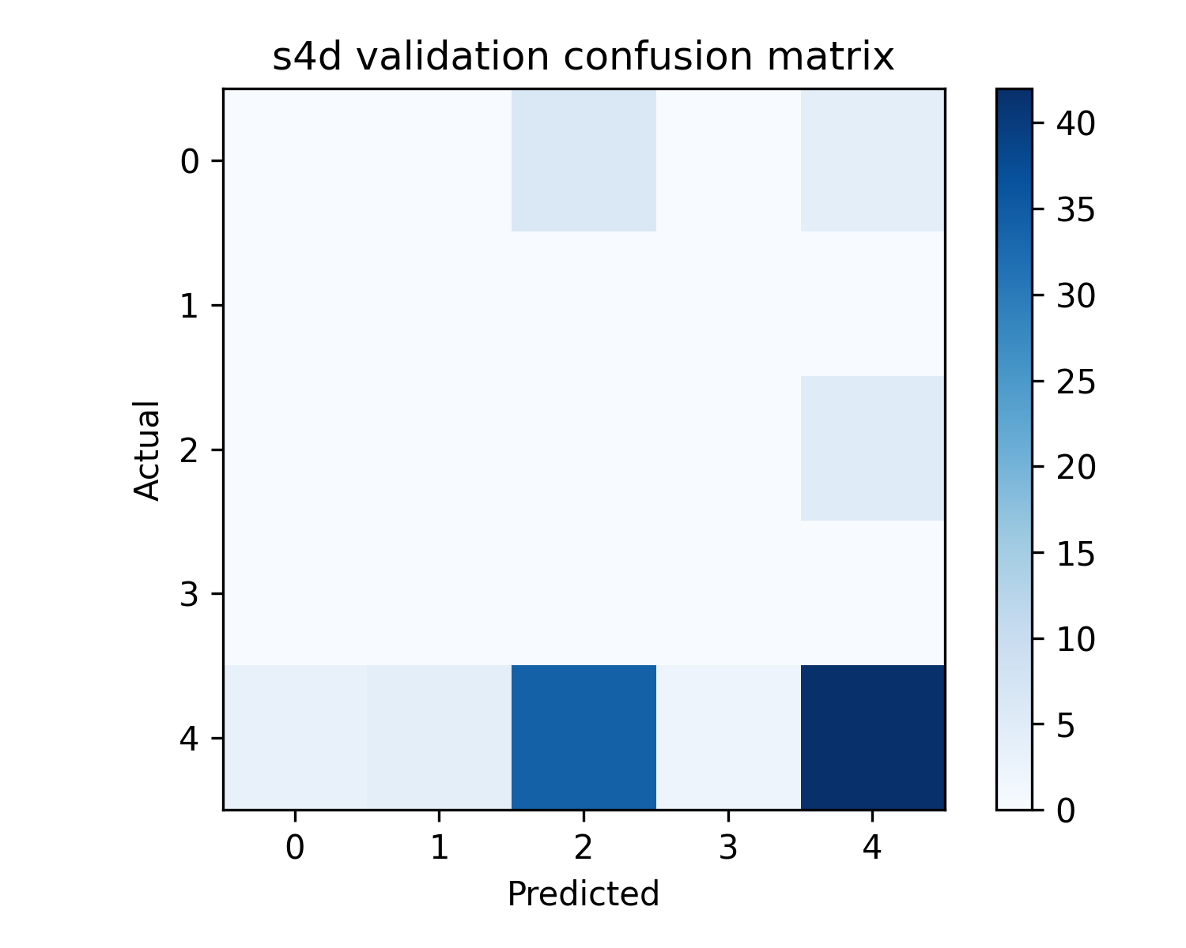
S4D
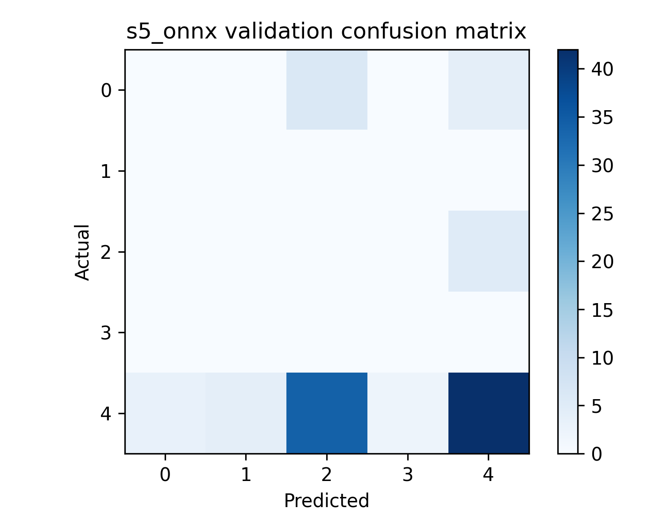
S5 Onnx
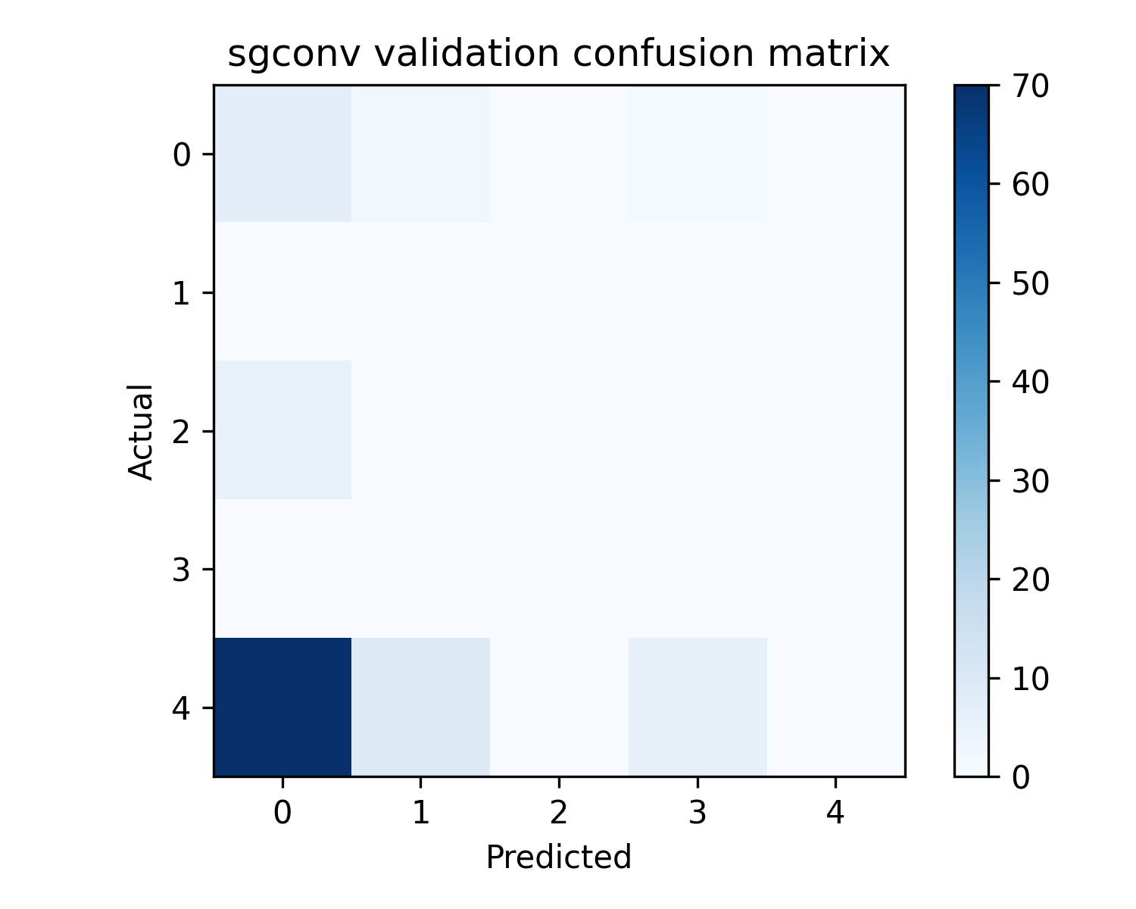
Sgconv
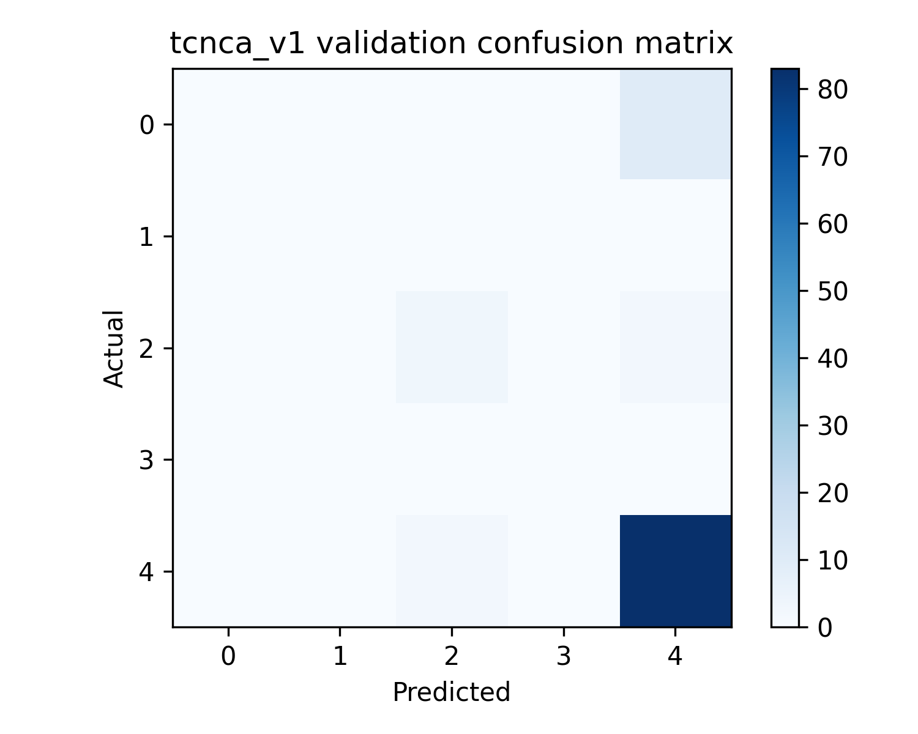
Tcnca V1
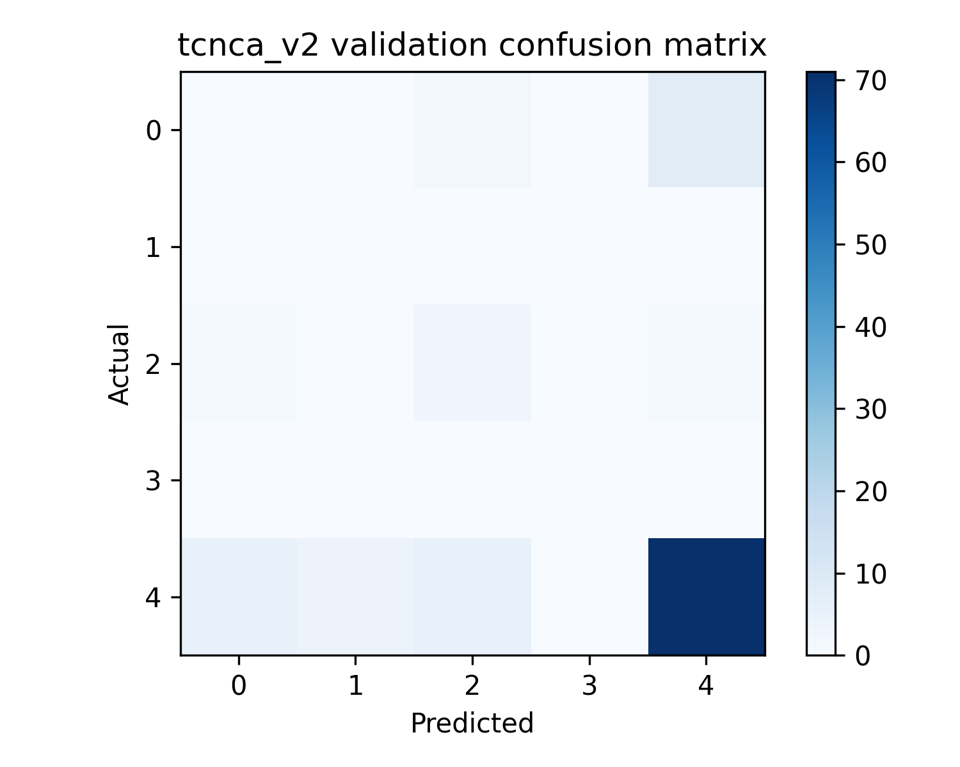
Tcnca V2
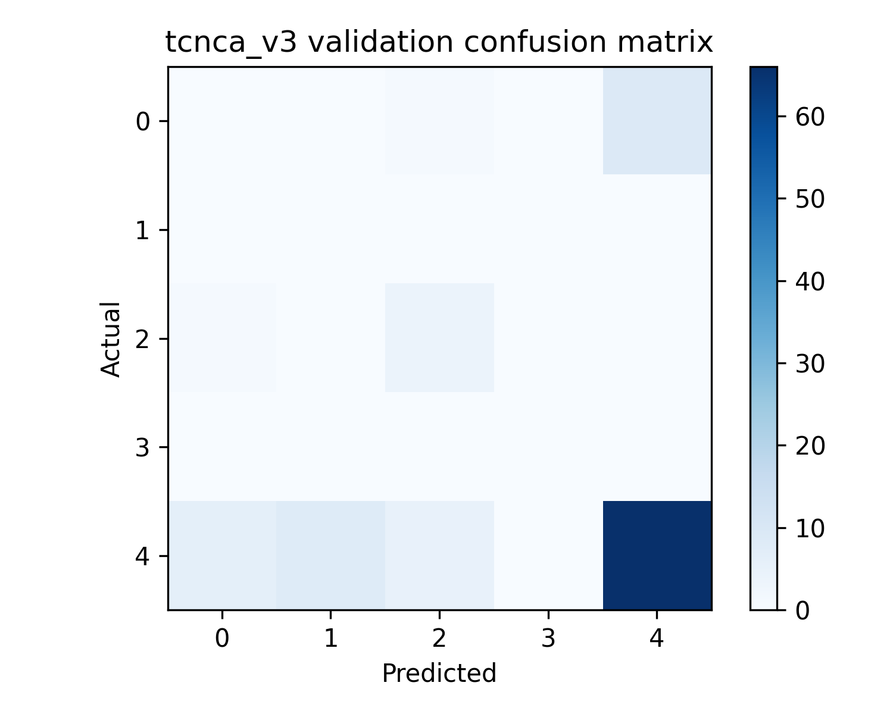
Tcnca V3
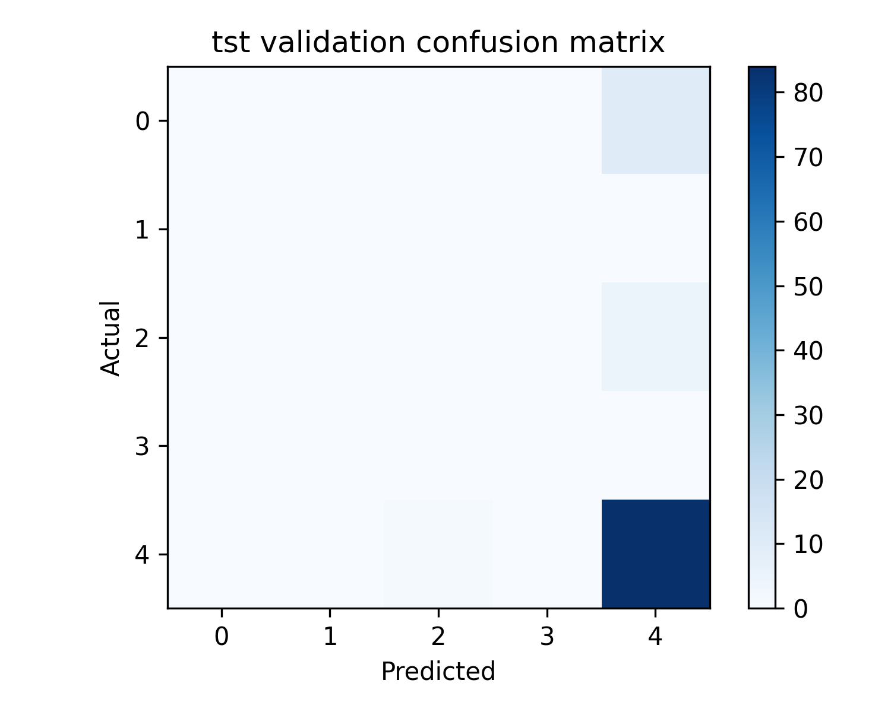
Tst
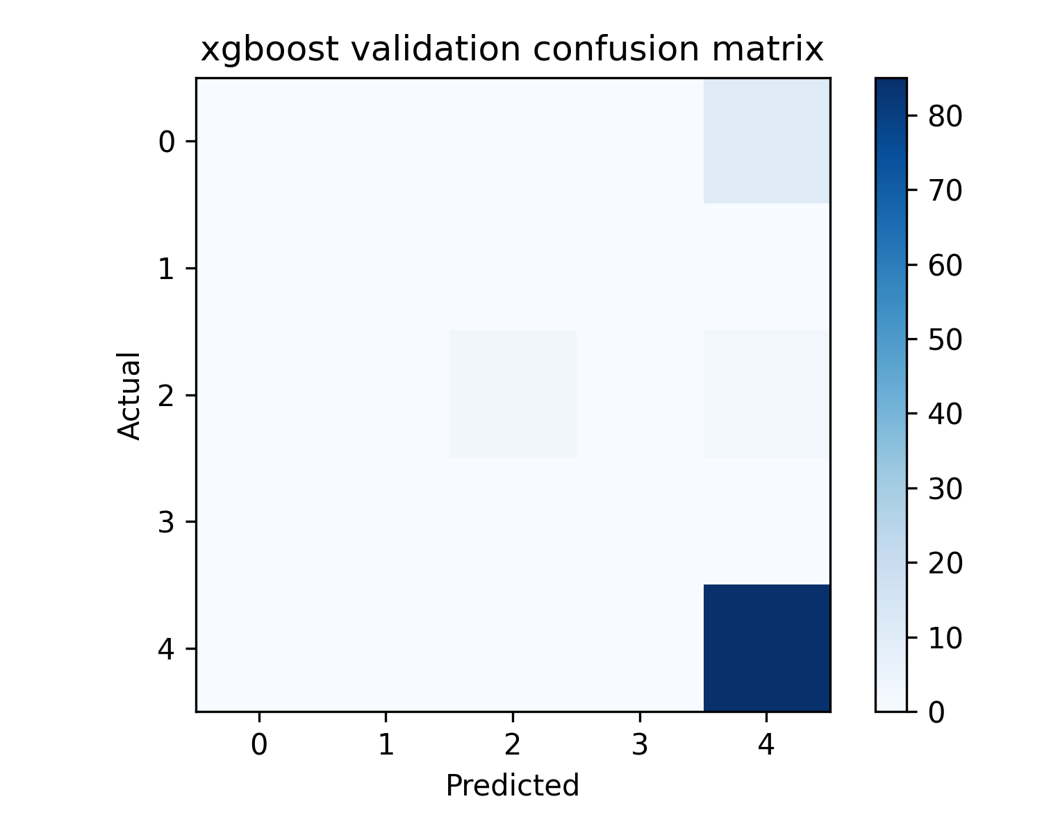
Xgboost

11. All benchmark, latency, robustness, and sensitivity figures
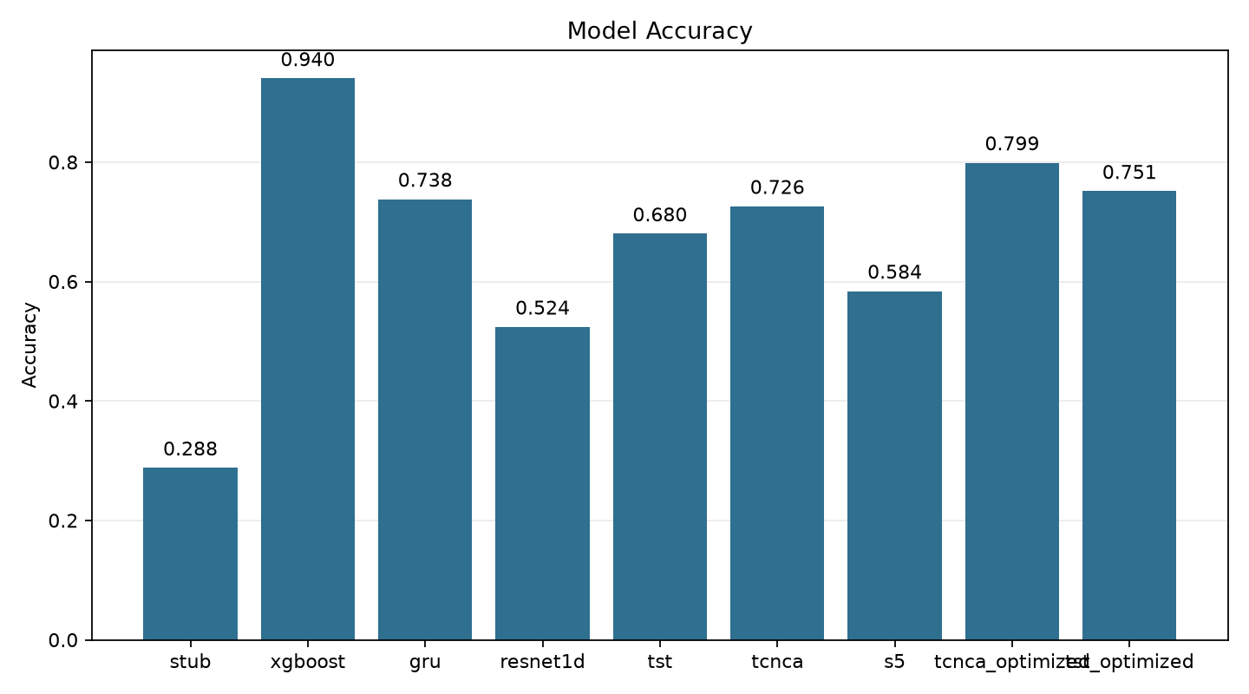
Accuracy
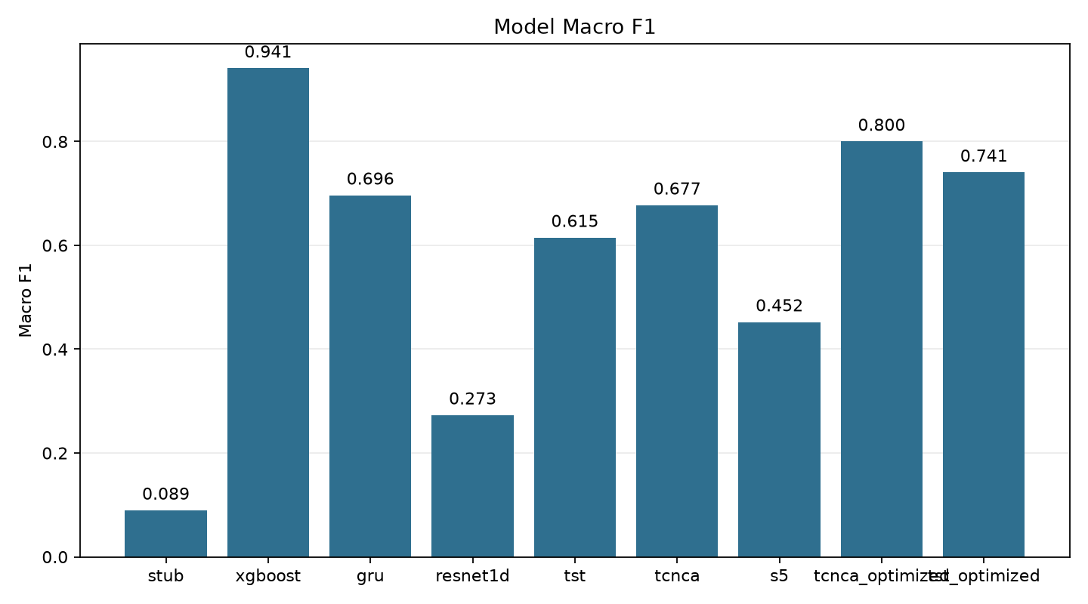
Macro F1
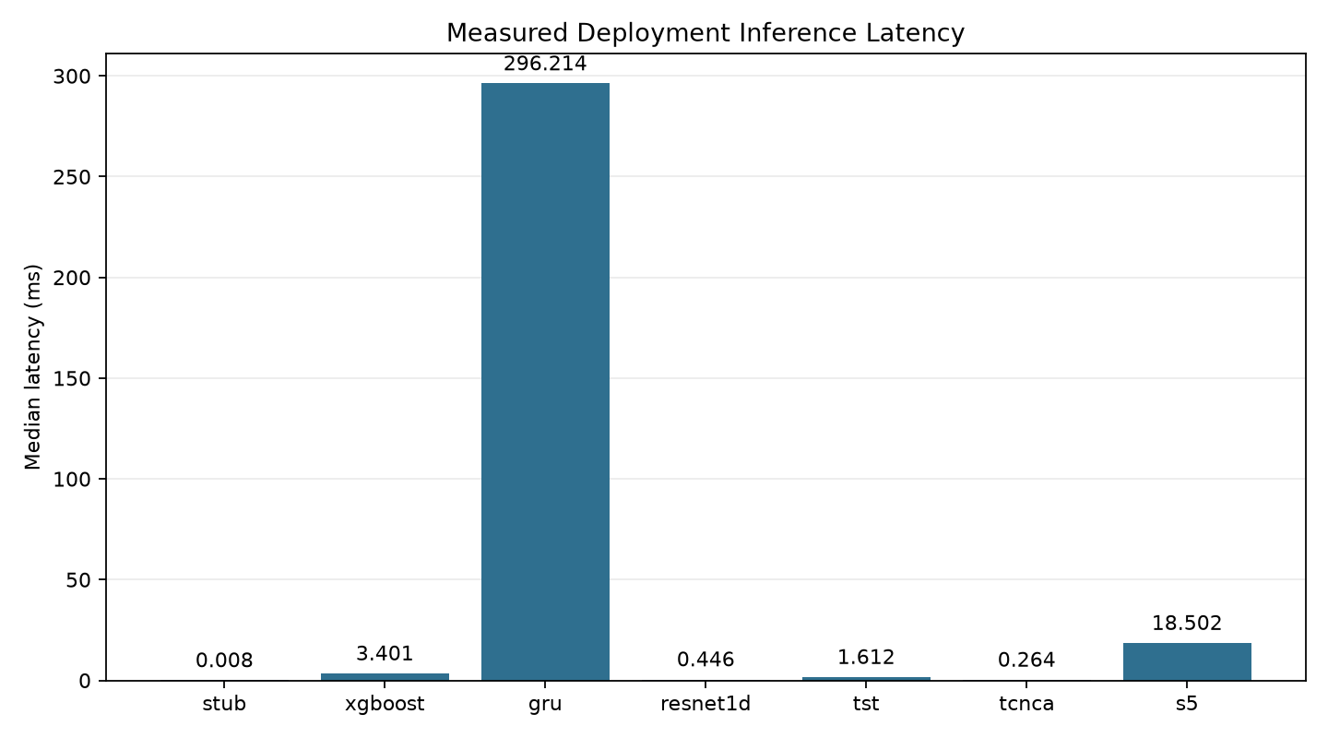
Latency Ms
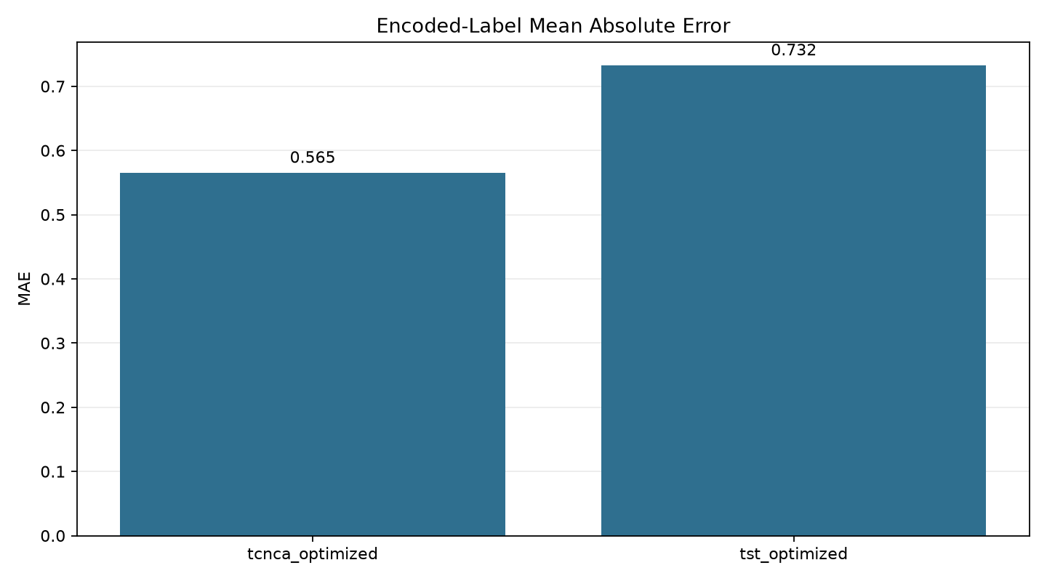
Mae
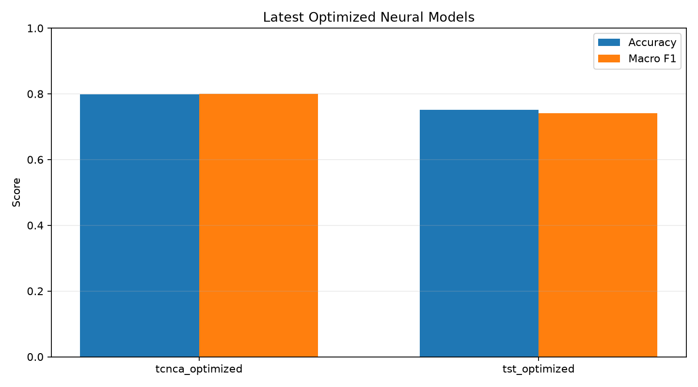
Optimized Neural Comparison
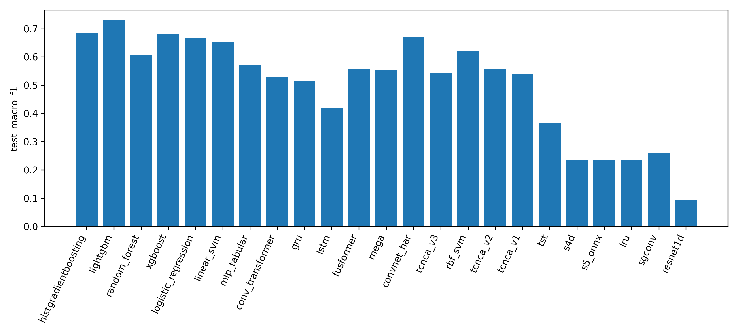
Comprehensive Test Macro F1
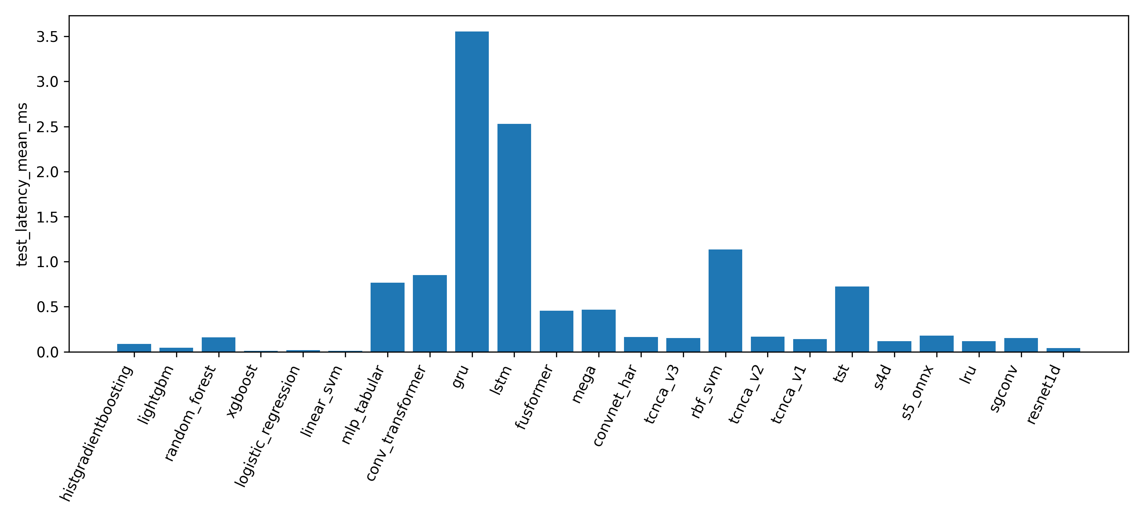
Comprehensive Test Latency Mean Ms
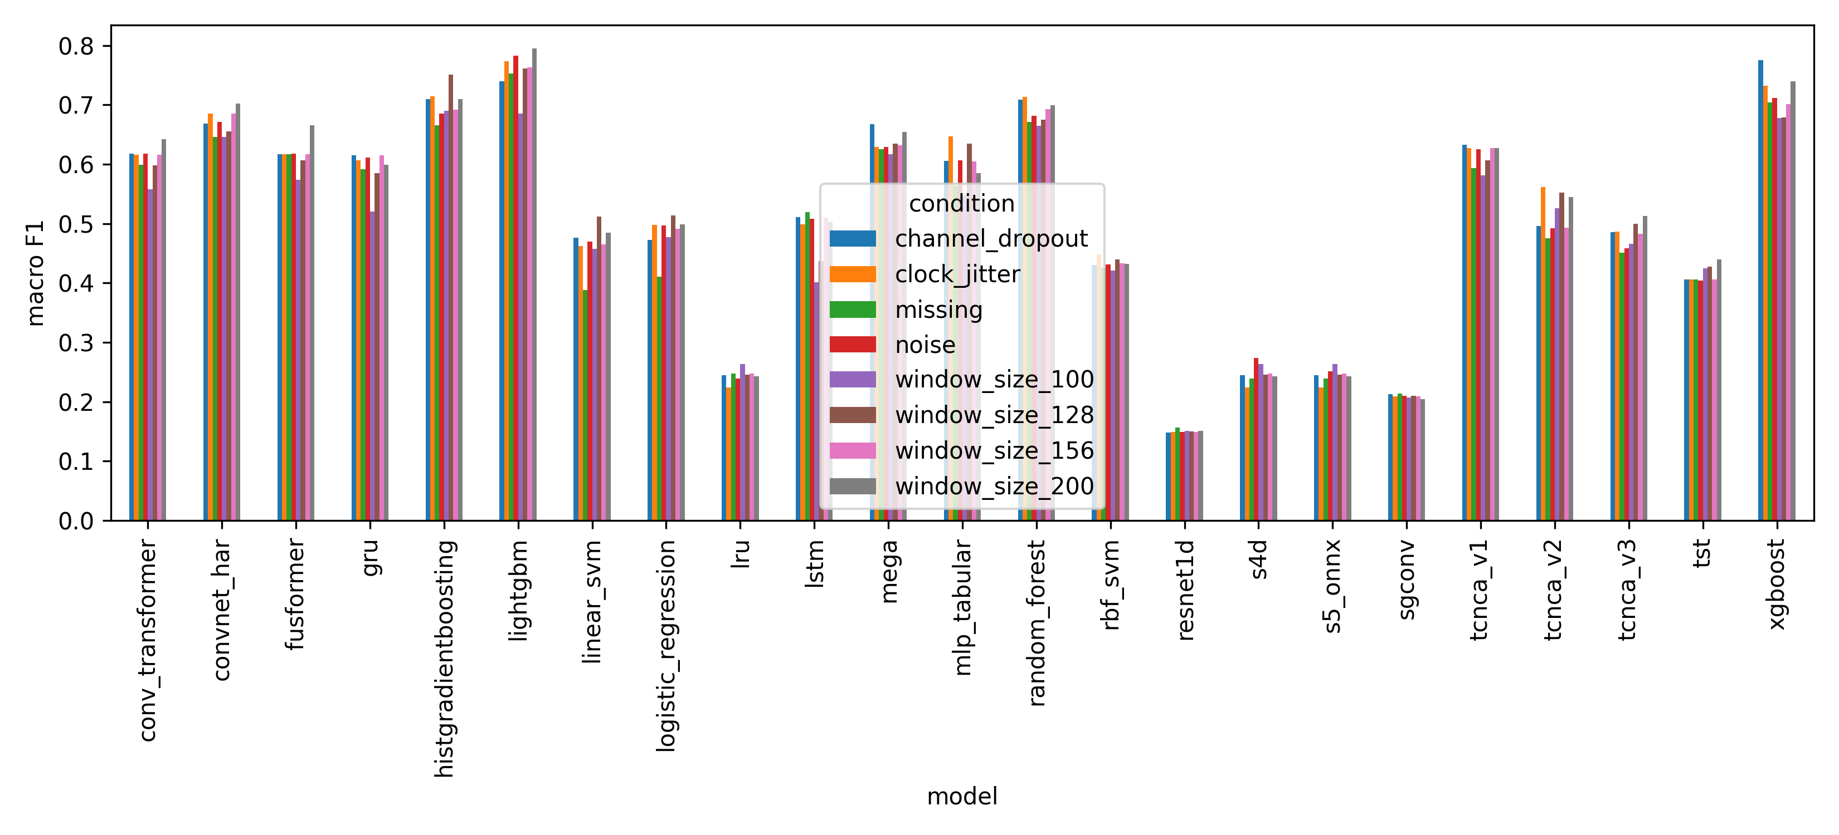
Comprehensive Robustness
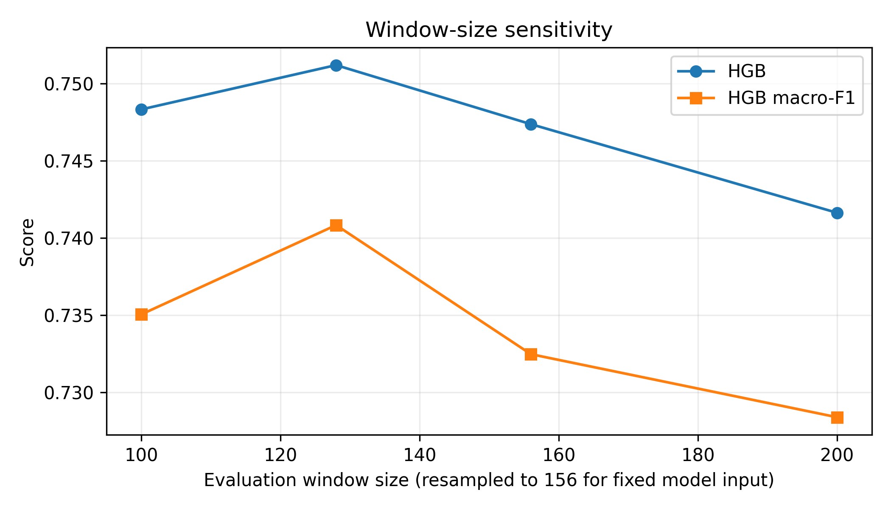
Protocol Window Sensitivity
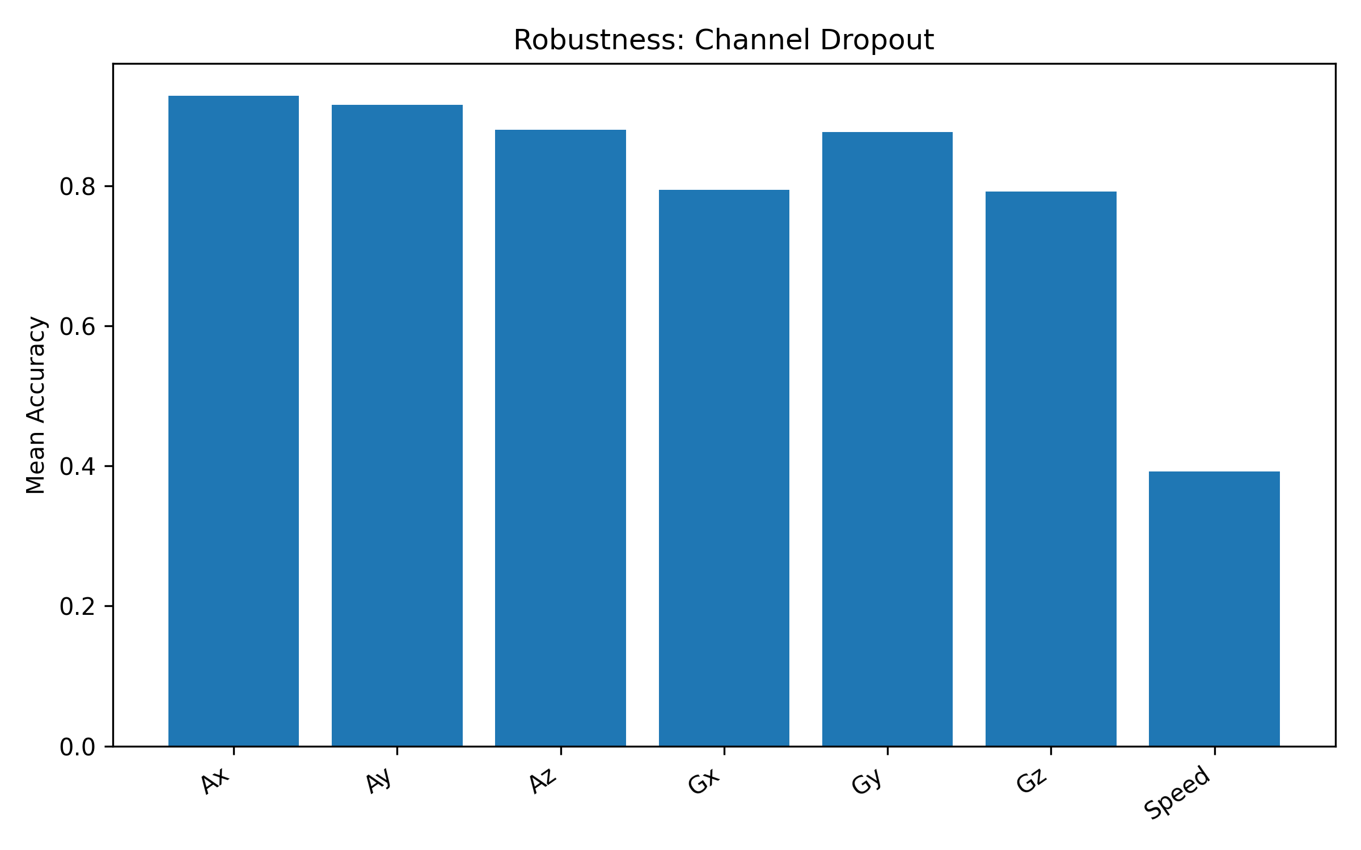
Robustness Channel Dropout
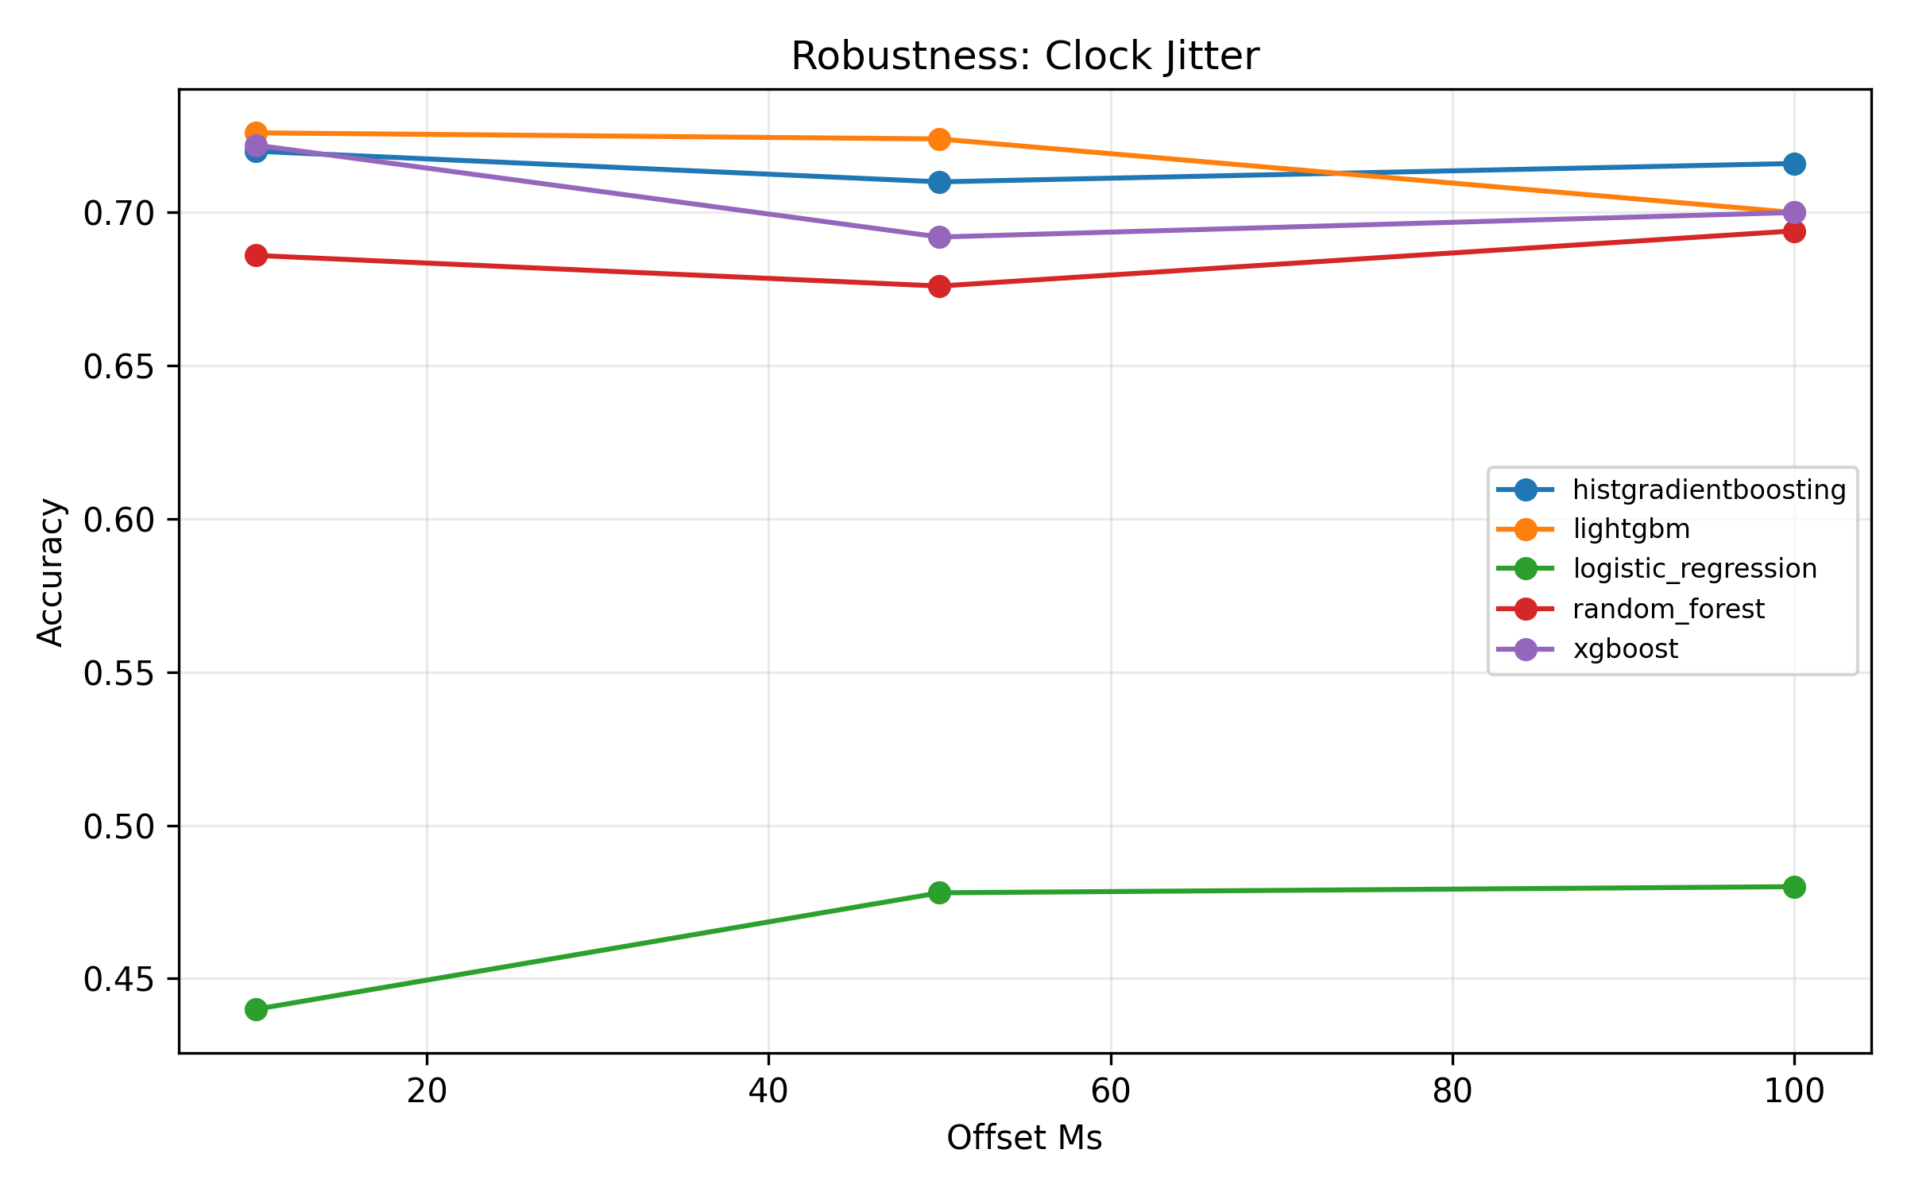
Robustness Clock Jitter
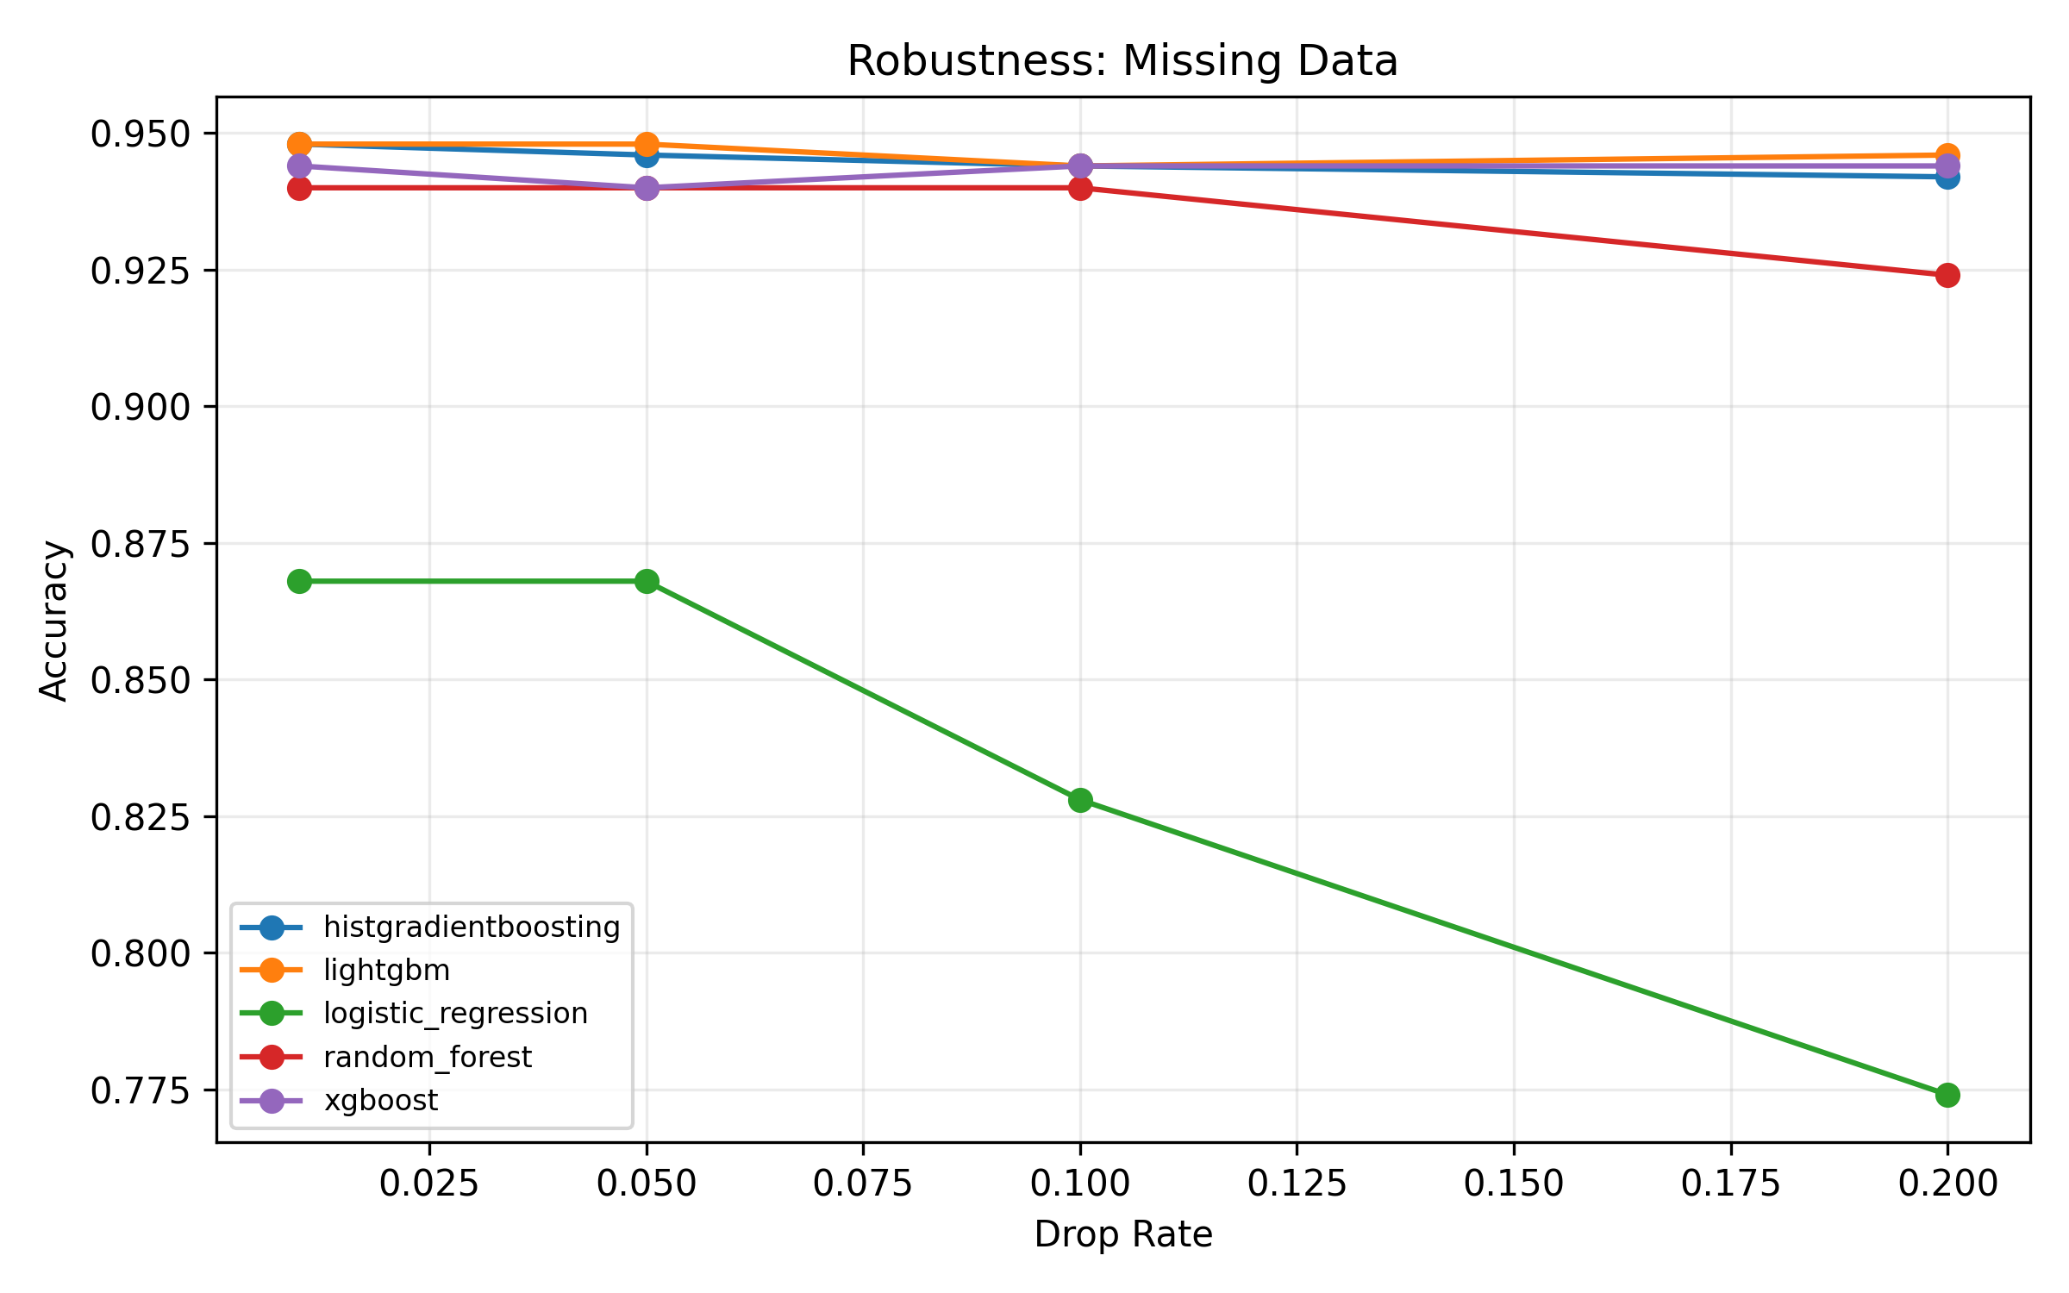
Robustness Missing
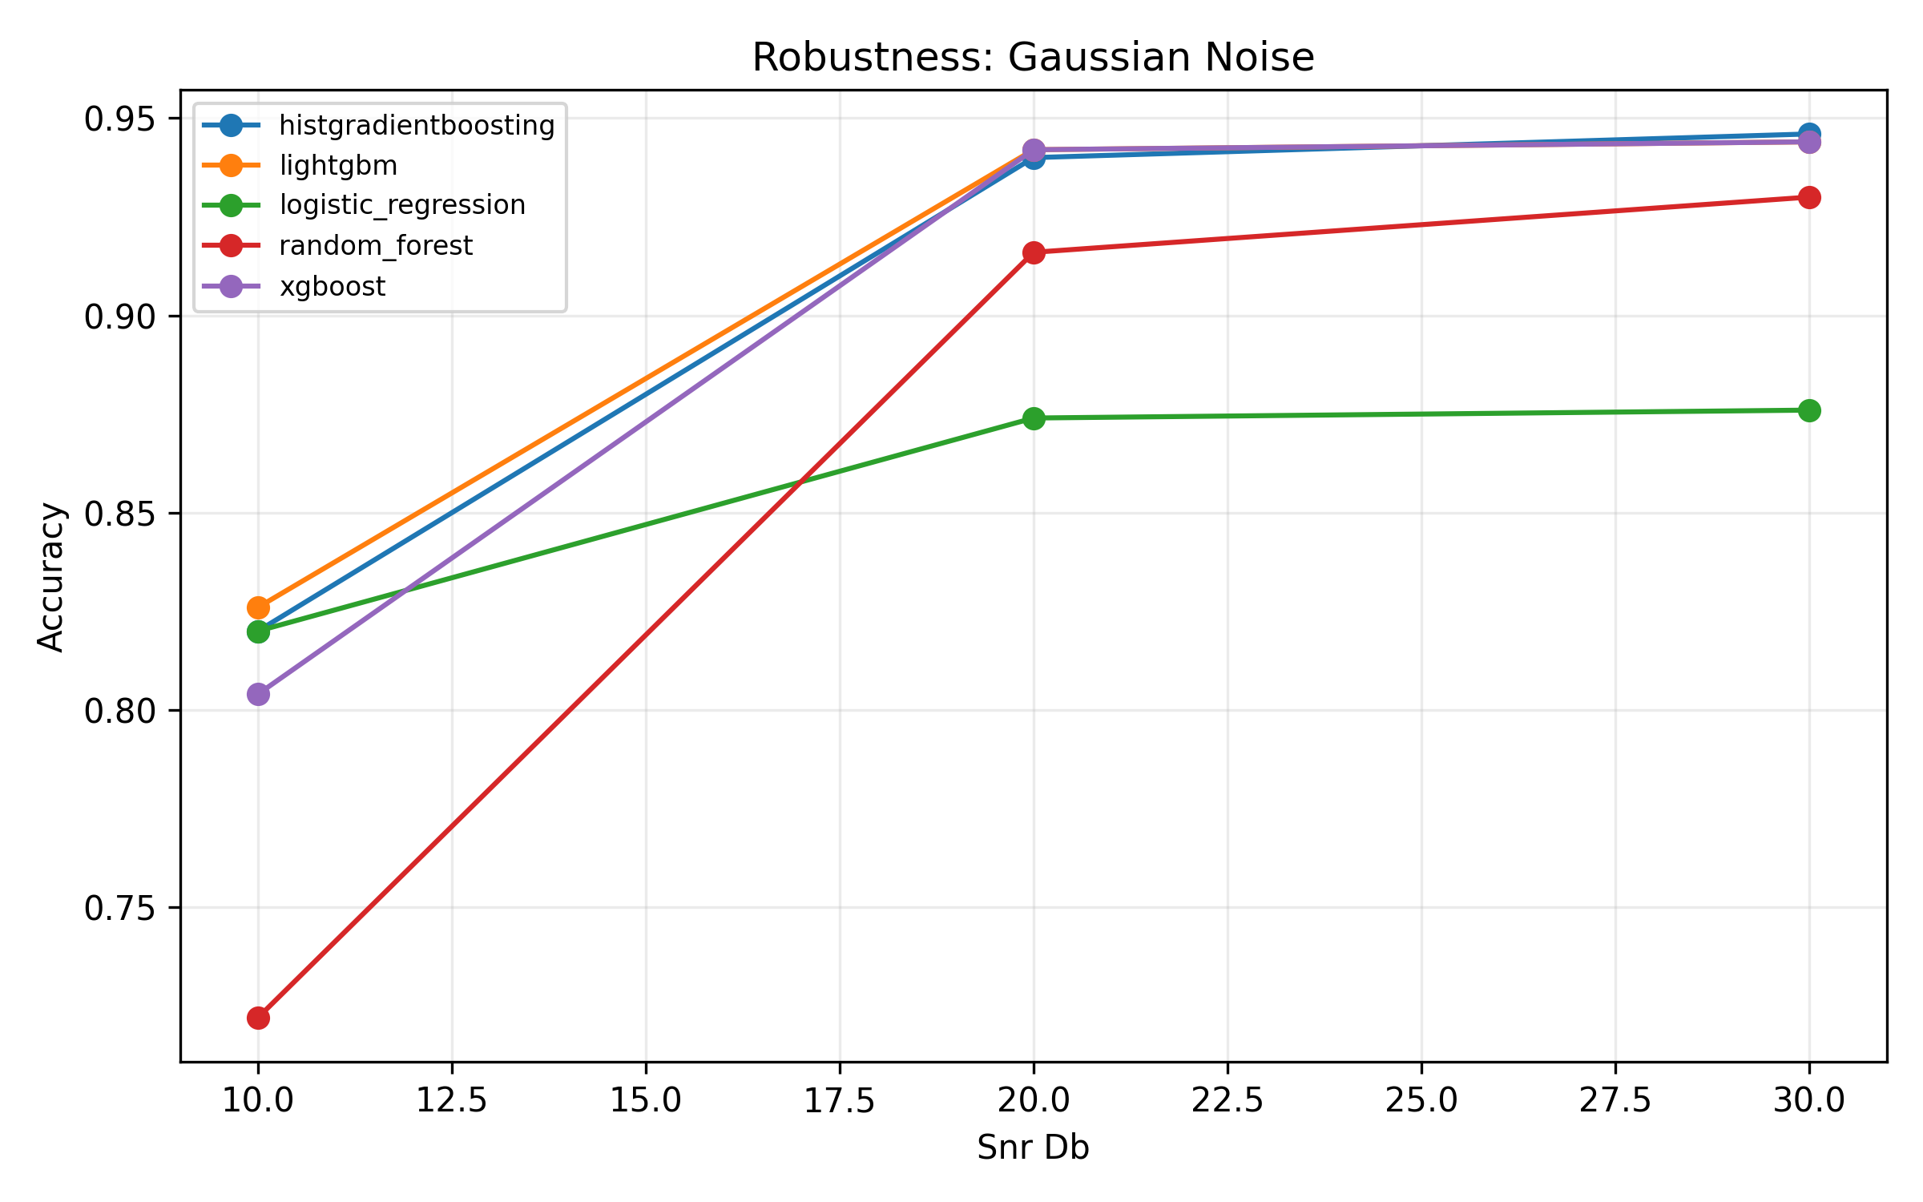
Robustness Noise
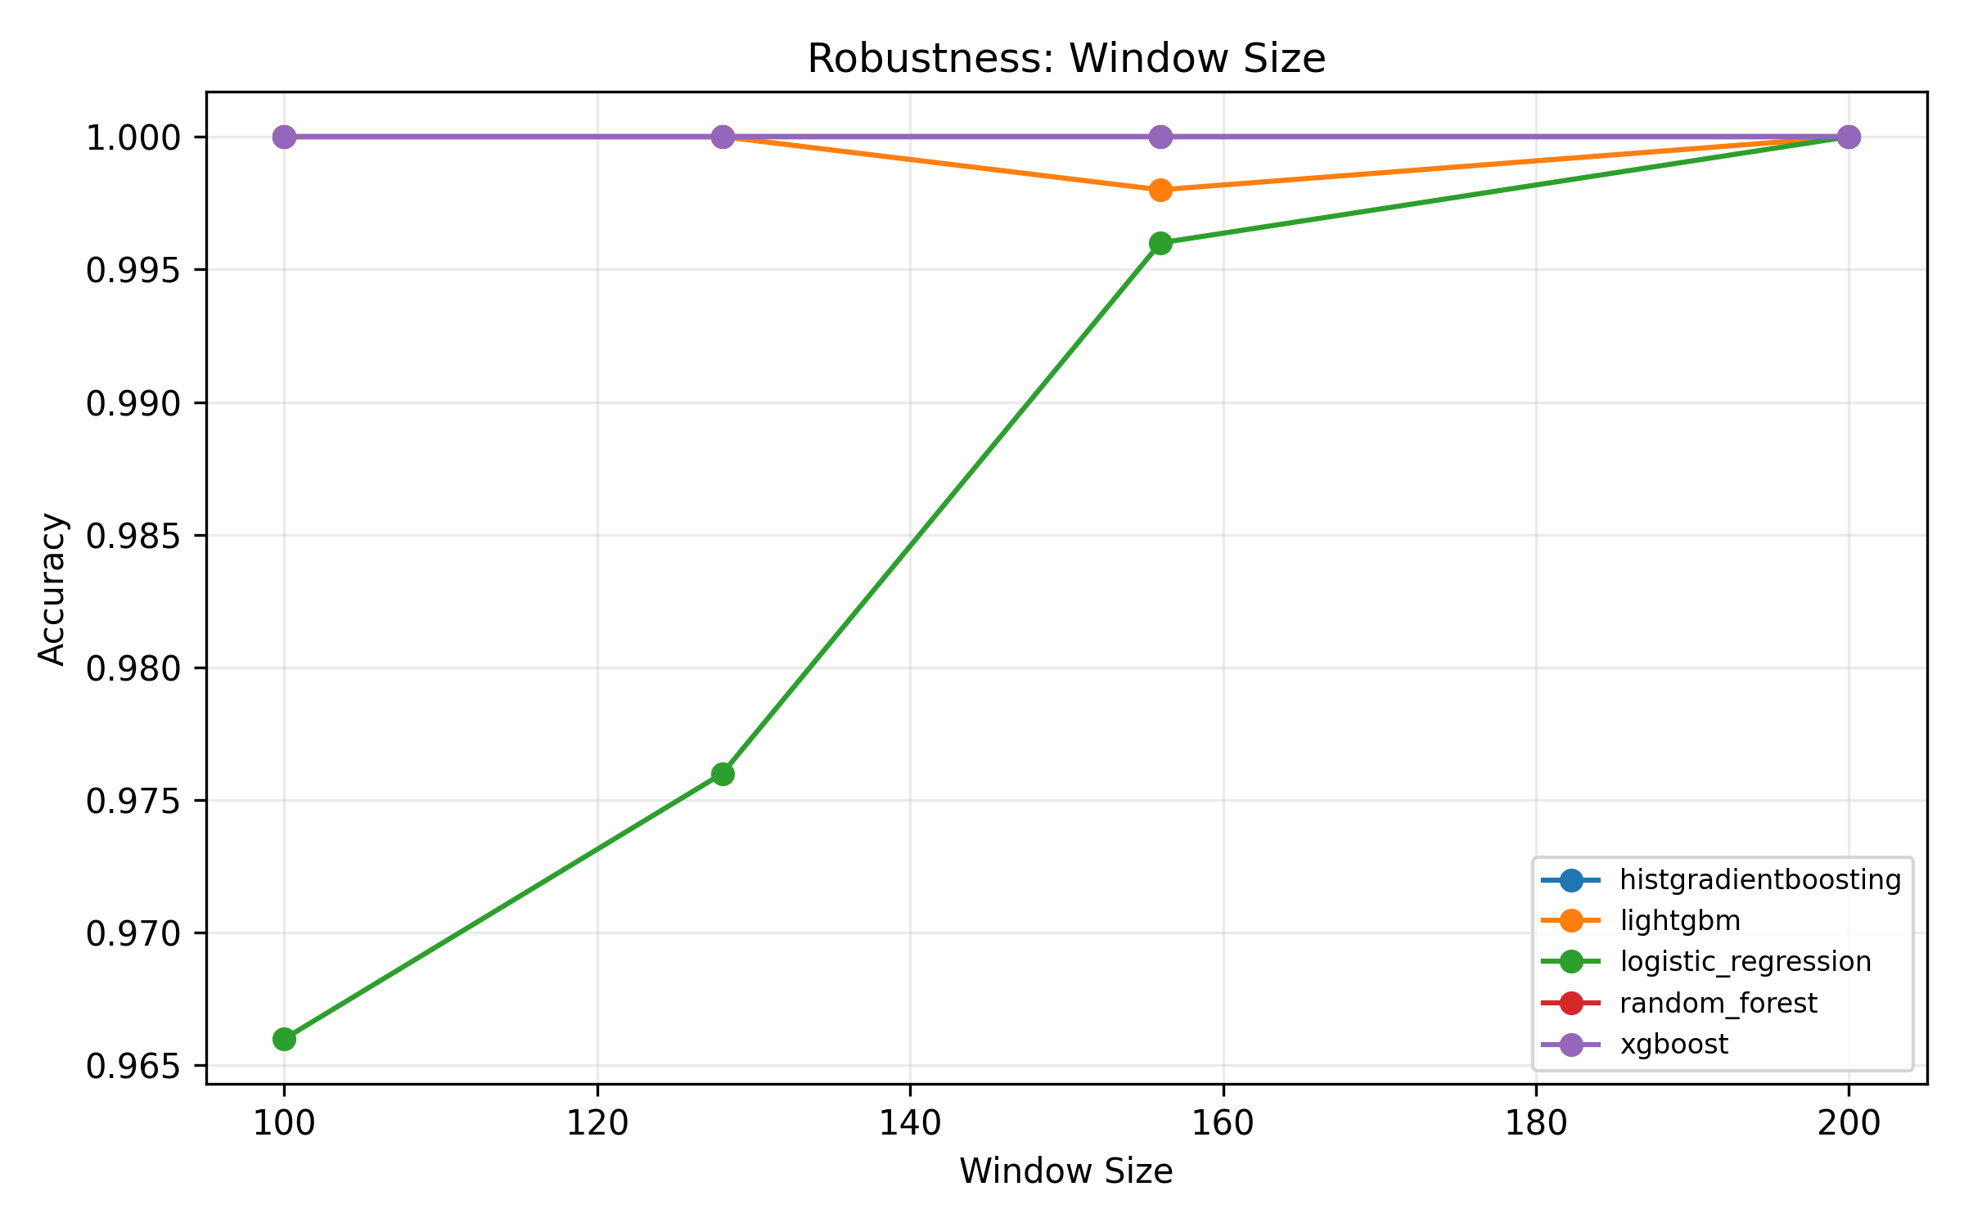
Robustness Window Size

12. Preserved experiment tables

Comprehensive metrics
model | status | error | search_candidates | best_config | artifact | val_accuracy | val_macro_f1 | test_accuracy | test_macro_f1 | test_latency_mean_ms | test_latency_p95_ms | test_windows_evaluated_once
histgradientboosting | evaluated | nan | 2 | {"learning_rate": 0.05, "max_bins": 32, "max_iter": 40, "max_leaf_nodes": 63} | models\workflow_deployment\histgradientboosting.pkl | 0.8469 | 0.6510 | 0.7043 | 0.6838 | 0.0879 | 0.0879 | 1045
lightgbm | evaluated | nan | 2 | {"learning_rate": 0.05, "n_estimators": 120, "num_leaves": 31} | models\workflow_deployment\lightgbm.pkl | 0.8785 | 0.7596 | 0.7455 | 0.7294 | 0.0458 | 0.0458 | 1045
random_forest | evaluated | nan | 2 | {"max_depth": 24, "min_samples_leaf": 2, "n_estimators": 100} | models\workflow_deployment\random_forest.pkl | 0.8488 | 0.6277 | 0.6565 | 0.6078 | 0.1598 | 0.1598 | 1045
xgboost | evaluated | nan | 2 | {"learning_rate": 0.03, "max_depth": 6, "n_estimators": 140} | models\workflow_deployment\xgboost.json | 0.8641 | 0.6900 | 0.7053 | 0.6801 | 0.0111 | 0.0111 | 1045
logistic_regression | evaluated | nan | 2 | {"C": 0.5} | models\workflow_deployment\logistic_regression.pkl | 0.7282 | 0.5683 | 0.6756 | 0.6670 | 0.0175 | 0.0175 | 1045
linear_svm | evaluated | nan | 2 | {"C": 0.5} | models\workflow_deployment\linear_svm.pkl | 0.7120 | 0.5309 | 0.6670 | 0.6536 | 0.0086 | 0.0086 | 1045
mlp_tabular | evaluated | nan | 2 | {"epochs": 2} | models\workflow_deployment\mlp_tabular.keras | 0.7684 | 0.5244 | 0.6373 | 0.5703 | 0.7672 | 0.7672 | 1045
conv_transformer | evaluated | nan | 2 | {"epochs": 2} | models\workflow_deployment\conv_transformer.tflite | 0.8163 | 0.4878 | 0.6239 | 0.5293 | 0.8527 | 2.2665 | 1045
gru | evaluated | nan | 2 | {"epochs": 2} | models\workflow_deployment\gru.tflite | 0.7885 | 0.3813 | 0.6201 | 0.5155 | 3.5532 | 3.5532 | 1045
lstm | evaluated | nan | 2 | {"epochs": 2} | models\workflow_deployment\lstm.tflite | 0.7856 | 0.3406 | 0.5770 | 0.4202 | 2.5292 | 2.5292 | 1045
fusformer | evaluated | nan | 2 | {"epochs": 2} | models\workflow_deployment\fusformer.tflite | 0.8220 | 0.5142 | 0.6354 | 0.5578 | 0.4561 | 1.3801 | 1045
mega | evaluated | nan | 2 | {"epochs": 2} | models\workflow_deployment\mega.tflite | 0.8364 | 0.5783 | 0.6383 | 0.5540 | 0.4662 | 1.3969 | 1045
convnet_har | evaluated | nan | 2 | {"epochs": 2} | models\workflow_deployment\convnet_har.tflite | 0.8067 | 0.4993 | 0.7005 | 0.6697 | 0.1641 | 0.3809 | 1045
tcnca_v3 | evaluated | nan | 2 | {"epochs": 2} | models\workflow_deployment\tcnca_v3.tflite | 0.7359 | 0.2932 | 0.5923 | 0.5422 | 0.1512 | 0.5784 | 1045
rbf_svm | evaluated | nan | 2 | {"C": 8.0, "gamma": "scale"} | models\workflow_deployment\rbf_svm.pkl | 0.3100 | 0.4340 | 0.5990 | 0.6204 | 1.1353 | 1.1353 | 1045
tcnca_v2 | evaluated | nan | 2 | {"epochs": 2} | models\workflow_deployment\tcnca_v2.tflite | 0.7388 | 0.2831 | 0.6163 | 0.5577 | 0.1678 | 0.6041 | 1045
tcnca_v1 | evaluated | nan | 2 | {"epochs": 2} | models\workflow_deployment\tcnca_v1.tflite | 0.8115 | 0.4959 | 0.6258 | 0.5380 | 0.1394 | 0.3937 | 1045
tst | evaluated | nan | 2 | {"epochs": 2} | models\workflow_deployment\tst.tflite | 0.7981 | 0.3660 | 0.5703 | 0.3665 | 0.7246 | 2.0426 | 1045
s4d | evaluated | nan | 2 | {"epochs": 2} | models\workflow_deployment\s4d.onnx | 0.3569 | 0.2248 | 0.2890 | 0.2355 | 0.1170 | 0.1170 | 1045
s5_onnx | evaluated | nan | 2 | {"epochs": 2} | models\workflow_deployment\s5_onnx.onnx | 0.3569 | 0.2248 | 0.2890 | 0.2355 | 0.1785 | 0.1785 | 1045
lru | evaluated | nan | 2 | {"epochs": 2} | models\workflow_deployment\lru.onnx | 0.3569 | 0.2248 | 0.2890 | 0.2355 | 0.1192 | 0.1192 | 1045
sgconv | evaluated | nan | 2 | {"epochs": 2} | models\workflow_deployment\sgconv.onnx | 0.1091 | 0.1850 | 0.3273 | 0.2615 | 0.1537 | 0.1537 | 1045
resnet1d | evaluated | nan | 2 | {"epochs": 2} | models\workflow_deployment\resnet1d.onnx | 0.6411 | 0.1570 | 0.2746 | 0.0930 | 0.0397 | 0.0397 | 1045

Comprehensive class-wise metrics
model | class | precision | recall | f1-score | support
histgradientboosting | BUMP | 66.67% | 20.00% | 0.3077 | 10.0000
histgradientboosting | LEFT | 0.00% | 0.00% | 0.0000 | 0.0000
histgradientboosting | RIGHT | 100.00% | 60.00% | 0.7500 | 5.0000
histgradientboosting | STOP | 0.00% | 0.00% | 0.0000 | 0.0000
histgradientboosting | STRAIGHT | 89.36% | 98.82% | 0.9385 | 85.0000
histgradientboosting | macro avg | 51.21% | 35.76% | 0.3992 | 100.0000
histgradientboosting | weighted avg | 87.62% | 89.00% | 0.8660 | 100.0000
lightgbm | BUMP | 83.33% | 50.00% | 0.6250 | 10.0000
lightgbm | LEFT | 0.00% | 0.00% | 0.0000 | 0.0000
lightgbm | RIGHT | 100.00% | 60.00% | 0.7500 | 5.0000
lightgbm | STOP | 0.00% | 0.00% | 0.0000 | 0.0000
lightgbm | STRAIGHT | 93.18% | 96.47% | 0.9480 | 85.0000
lightgbm | macro avg | 55.30% | 41.29% | 0.4646 | 100.0000
lightgbm | weighted avg | 92.54% | 90.00% | 0.9058 | 100.0000
random_forest | BUMP | 0.00% | 0.00% | 0.0000 | 10.0000
random_forest | LEFT | 0.00% | 0.00% | 0.0000 | 0.0000
random_forest | RIGHT | 100.00% | 80.00% | 0.8889 | 5.0000
random_forest | STOP | 0.00% | 0.00% | 0.0000 | 0.0000
random_forest | STRAIGHT | 88.54% | 100.00% | 0.9392 | 85.0000
random_forest | macro avg | 37.71% | 36.00% | 0.3656 | 100.0000
random_forest | weighted avg | 80.26% | 89.00% | 0.8428 | 100.0000
xgboost | BUMP | 0.00% | 0.00% | 0.0000 | 10.0000
xgboost | LEFT | 0.00% | 0.00% | 0.0000 | 0.0000
xgboost | RIGHT | 100.00% | 60.00% | 0.7500 | 5.0000
xgboost | STOP | 0.00% | 0.00% | 0.0000 | 0.0000
xgboost | STRAIGHT | 87.63% | 100.00% | 0.9341 | 85.0000
xgboost | macro avg | 37.53% | 32.00% | 0.3368 | 100.0000
xgboost | weighted avg | 79.48% | 88.00% | 0.8315 | 100.0000
logistic_regression | BUMP | 0.00% | 0.00% | 0.0000 | 10.0000
logistic_regression | LEFT | 0.00% | 0.00% | 0.0000 | 0.0000
logistic_regression | RIGHT | 30.00% | 60.00% | 0.4000 | 5.0000
logistic_regression | STOP | 0.00% | 0.00% | 0.0000 | 0.0000
logistic_regression | STRAIGHT | 90.00% | 74.12% | 0.8129 | 85.0000
logistic_regression | macro avg | 24.00% | 26.82% | 0.2426 | 100.0000
logistic_regression | weighted avg | 78.00% | 66.00% | 0.7110 | 100.0000
linear_svm | BUMP | 0.00% | 0.00% | 0.0000 | 10.0000
linear_svm | LEFT | 0.00% | 0.00% | 0.0000 | 0.0000
linear_svm | RIGHT | 28.57% | 40.00% | 0.3333 | 5.0000
linear_svm | STOP | 0.00% | 0.00% | 0.0000 | 0.0000
linear_svm | STRAIGHT | 87.32% | 72.94% | 0.7949 | 85.0000
linear_svm | macro avg | 23.18% | 22.59% | 0.2256 | 100.0000
linear_svm | weighted avg | 75.65% | 64.00% | 0.6923 | 100.0000
mlp_tabular | BUMP | 0.00% | 0.00% | 0.0000 | 10.0000
mlp_tabular | LEFT | 0.00% | 0.00% | 0.0000 | 0.0000
mlp_tabular | RIGHT | 50.00% | 80.00% | 0.6154 | 5.0000
mlp_tabular | STOP | 0.00% | 0.00% | 0.0000 | 0.0000
mlp_tabular | STRAIGHT | 89.77% | 92.94% | 0.9133 | 85.0000
mlp_tabular | macro avg | 27.95% | 34.59% | 0.3057 | 100.0000
mlp_tabular | weighted avg | 78.81% | 83.00% | 0.8071 | 100.0000
conv_transformer | BUMP | 0.00% | 0.00% | 0.0000 | 10.0000
conv_transformer | LEFT | 0.00% | 0.00% | 0.0000 | 0.0000
conv_transformer | RIGHT | 75.00% | 60.00% | 0.6667 | 5.0000
conv_transformer | STOP | 0.00% | 0.00% | 0.0000 | 0.0000
conv_transformer | STRAIGHT | 87.50% | 98.82% | 0.9282 | 85.0000
conv_transformer | macro avg | 32.50% | 31.76% | 0.3190 | 100.0000
conv_transformer | weighted avg | 78.12% | 87.00% | 0.8223 | 100.0000
gru | BUMP | 0.00% | 0.00% | 0.0000 | 10.0000
gru | LEFT | 0.00% | 0.00% | 0.0000 | 0.0000
gru | RIGHT | 66.67% | 80.00% | 0.7273 | 5.0000
gru | STOP | 0.00% | 0.00% | 0.0000 | 0.0000
gru | STRAIGHT | 88.64% | 91.76% | 0.9017 | 85.0000
gru | macro avg | 31.06% | 34.35% | 0.3258 | 100.0000
gru | weighted avg | 78.67% | 82.00% | 0.8028 | 100.0000
lstm | BUMP | 0.00% | 0.00% | 0.0000 | 10.0000
lstm | LEFT | 0.00% | 0.00% | 0.0000 | 0.0000
lstm | RIGHT | 57.14% | 80.00% | 0.6667 | 5.0000
lstm | STOP | 0.00% | 0.00% | 0.0000 | 0.0000
lstm | STRAIGHT | 88.76% | 92.94% | 0.9080 | 85.0000
lstm | macro avg | 29.18% | 34.59% | 0.3149 | 100.0000
lstm | weighted avg | 78.31% | 83.00% | 0.8052 | 100.0000
fusformer | BUMP | 0.00% | 0.00% | 0.0000 | 10.0000
fusformer | LEFT | 0.00% | 0.00% | 0.0000 | 0.0000
fusformer | RIGHT | 75.00% | 60.00% | 0.6667 | 5.0000
fusformer | STOP | 0.00% | 0.00% | 0.0000 | 0.0000
fusformer | STRAIGHT | 87.50% | 98.82% | 0.9282 | 85.0000
fusformer | macro avg | 32.50% | 31.76% | 0.3190 | 100.0000
fusformer | weighted avg | 78.12% | 87.00% | 0.8223 | 100.0000
mega | BUMP | 0.00% | 0.00% | 0.0000 | 10.0000
mega | LEFT | 0.00% | 0.00% | 0.0000 | 0.0000
mega | RIGHT | 60.00% | 60.00% | 0.6000 | 5.0000
mega | STOP | 0.00% | 0.00% | 0.0000 | 0.0000
mega | STRAIGHT | 88.17% | 96.47% | 0.9213 | 85.0000
mega | macro avg | 29.63% | 31.29% | 0.3043 | 100.0000
mega | weighted avg | 77.95% | 85.00% | 0.8131 | 100.0000
convnet_har | BUMP | 40.00% | 20.00% | 0.2667 | 10.0000
convnet_har | LEFT | 0.00% | 0.00% | 0.0000 | 0.0000
convnet_har | RIGHT | 60.00% | 60.00% | 0.6000 | 5.0000
convnet_har | STOP | 0.00% | 0.00% | 0.0000 | 0.0000
convnet_har | STRAIGHT | 91.11% | 96.47% | 0.9371 | 85.0000
convnet_har | macro avg | 38.22% | 35.29% | 0.3608 | 100.0000
convnet_har | weighted avg | 84.44% | 87.00% | 0.8532 | 100.0000
tcnca_v3 | BUMP | 0.00% | 0.00% | 0.0000 | 10.0000
tcnca_v3 | LEFT | 0.00% | 0.00% | 0.0000 | 0.0000
tcnca_v3 | RIGHT | 40.00% | 80.00% | 0.5333 | 5.0000
tcnca_v3 | STOP | 0.00% | 0.00% | 0.0000 | 0.0000
tcnca_v3 | STRAIGHT | 88.00% | 77.65% | 0.8250 | 85.0000
tcnca_v3 | macro avg | 25.60% | 31.53% | 0.2717 | 100.0000
tcnca_v3 | weighted avg | 76.80% | 70.00% | 0.7279 | 100.0000
rbf_svm | BUMP | 7.02% | 40.00% | 0.1194 | 10.0000
rbf_svm | LEFT | 0.00% | 0.00% | 0.0000 | 0.0000
rbf_svm | RIGHT | 29.41% | 100.00% | 0.4545 | 5.0000
rbf_svm | STOP | 0.00% | 0.00% | 0.0000 | 0.0000
rbf_svm | STRAIGHT | 100.00% | 11.76% | 0.2105 | 85.0000
rbf_svm | macro avg | 27.29% | 30.35% | 0.1569 | 100.0000
rbf_svm | weighted avg | 87.17% | 19.00% | 0.2136 | 100.0000
tcnca_v2 | BUMP | 0.00% | 0.00% | 0.0000 | 10.0000
tcnca_v2 | LEFT | 0.00% | 0.00% | 0.0000 | 0.0000
tcnca_v2 | RIGHT | 30.00% | 60.00% | 0.4000 | 5.0000
tcnca_v2 | STOP | 0.00% | 0.00% | 0.0000 | 0.0000
tcnca_v2 | STRAIGHT | 88.75% | 83.53% | 0.8606 | 85.0000
tcnca_v2 | macro avg | 23.75% | 28.71% | 0.2521 | 100.0000
tcnca_v2 | weighted avg | 76.94% | 74.00% | 0.7515 | 100.0000
tcnca_v1 | BUMP | 0.00% | 0.00% | 0.0000 | 10.0000
tcnca_v1 | LEFT | 0.00% | 0.00% | 0.0000 | 0.0000
tcnca_v1 | RIGHT | 60.00% | 60.00% | 0.6000 | 5.0000
tcnca_v1 | STOP | 0.00% | 0.00% | 0.0000 | 0.0000
tcnca_v1 | STRAIGHT | 87.37% | 97.65% | 0.9222 | 85.0000
tcnca_v1 | macro avg | 29.47% | 31.53% | 0.3044 | 100.0000
tcnca_v1 | weighted avg | 77.26% | 86.00% | 0.8139 | 100.0000
tst | BUMP | 0.00% | 0.00% | 0.0000 | 10.0000
tst | LEFT | 0.00% | 0.00% | 0.0000 | 0.0000
tst | RIGHT | 0.00% | 0.00% | 0.0000 | 5.0000
tst | STOP | 0.00% | 0.00% | 0.0000 | 0.0000
tst | STRAIGHT | 84.85% | 98.82% | 0.9130 | 85.0000
tst | macro avg | 16.97% | 19.76% | 0.1826 | 100.0000
tst | weighted avg | 72.12% | 84.00% | 0.7761 | 100.0000
s4d | BUMP | 0.00% | 0.00% | 0.0000 | 10.0000
s4d | LEFT | 0.00% | 0.00% | 0.0000 | 0.0000
s4d | RIGHT | 0.00% | 0.00% | 0.0000 | 5.0000
s4d | STOP | 0.00% | 0.00% | 0.0000 | 0.0000
s4d | STRAIGHT | 82.35% | 49.41% | 0.6176 | 85.0000
s4d | macro avg | 16.47% | 9.88% | 0.1235 | 100.0000
s4d | weighted avg | 70.00% | 42.00% | 0.5250 | 100.0000
s5_onnx | BUMP | 0.00% | 0.00% | 0.0000 | 10.0000
s5_onnx | LEFT | 0.00% | 0.00% | 0.0000 | 0.0000
s5_onnx | RIGHT | 0.00% | 0.00% | 0.0000 | 5.0000
s5_onnx | STOP | 0.00% | 0.00% | 0.0000 | 0.0000
s5_onnx | STRAIGHT | 82.35% | 49.41% | 0.6176 | 85.0000
s5_onnx | macro avg | 16.47% | 9.88% | 0.1235 | 100.0000
s5_onnx | weighted avg | 70.00% | 42.00% | 0.5250 | 100.0000
lru | BUMP | 0.00% | 0.00% | 0.0000 | 10.0000
lru | LEFT | 0.00% | 0.00% | 0.0000 | 0.0000
lru | RIGHT | 0.00% | 0.00% | 0.0000 | 5.0000
lru | STOP | 0.00% | 0.00% | 0.0000 | 0.0000
lru | STRAIGHT | 82.35% | 49.41% | 0.6176 | 85.0000
lru | macro avg | 16.47% | 9.88% | 0.1235 | 100.0000
lru | weighted avg | 70.00% | 42.00% | 0.5250 | 100.0000
sgconv | BUMP | 8.54% | 70.00% | 0.1522 | 10.0000
sgconv | LEFT | 0.00% | 0.00% | 0.0000 | 0.0000
sgconv | RIGHT | 0.00% | 0.00% | 0.0000 | 5.0000
sgconv | STOP | 0.00% | 0.00% | 0.0000 | 0.0000
sgconv | STRAIGHT | 0.00% | 0.00% | 0.0000 | 85.0000
sgconv | macro avg | 1.71% | 14.00% | 0.0304 | 100.0000
sgconv | weighted avg | 0.85% | 7.00% | 0.0152 | 100.0000
resnet1d | BUMP | 0.00% | 0.00% | 0.0000 | 10.0000
resnet1d | LEFT | 0.00% | 0.00% | 0.0000 | 0.0000
resnet1d | RIGHT | 0.00% | 0.00% | 0.0000 | 5.0000
resnet1d | STOP | 0.00% | 0.00% | 0.0000 | 0.0000
resnet1d | STRAIGHT | 84.85% | 98.82% | 0.9130 | 85.0000
resnet1d | macro avg | 16.97% | 19.76% | 0.1826 | 100.0000
resnet1d | weighted avg | 72.12% | 84.00% | 0.7761 | 100.0000

Comprehensive robustness
model | condition | accuracy | macro_f1 | requested_window_size
histgradientboosting | channel_dropout | 88.80% | 70.94% | nan
histgradientboosting | clock_jitter | 89.40% | 71.44% | nan
histgradientboosting | missing | 87.40% | 66.58% | nan
histgradientboosting | noise | 88.60% | 68.51% | nan
histgradientboosting | window_size_100 | 88.60% | 68.98% | 100.0000
histgradientboosting | window_size_128 | 90.60% | 75.13% | 128.0000
histgradientboosting | window_size_156 | 88.40% | 69.23% | 156.0000
histgradientboosting | window_size_200 | 89.20% | 70.97% | 200.0000
lightgbm | channel_dropout | 89.40% | 74.00% | nan
lightgbm | clock_jitter | 91.40% | 77.38% | nan
lightgbm | missing | 90.60% | 75.25% | nan
lightgbm | noise | 90.80% | 78.26% | nan
lightgbm | window_size_100 | 87.60% | 68.55% | 100.0000
lightgbm | window_size_128 | 91.20% | 76.13% | 128.0000
lightgbm | window_size_156 | 90.80% | 76.28% | 156.0000
lightgbm | window_size_200 | 91.20% | 79.46% | 200.0000
random_forest | channel_dropout | 89.40% | 70.84% | nan
random_forest | clock_jitter | 89.80% | 71.35% | nan
random_forest | missing | 89.20% | 67.17% | nan
random_forest | noise | 89.40% | 68.14% | nan
random_forest | window_size_100 | 88.40% | 66.44% | 100.0000
random_forest | window_size_128 | 89.40% | 67.49% | 128.0000
random_forest | window_size_156 | 89.20% | 69.32% | 156.0000
random_forest | window_size_200 | 89.40% | 69.90% | 200.0000
xgboost | channel_dropout | 90.20% | 77.55% | nan
xgboost | clock_jitter | 90.00% | 73.19% | nan
xgboost | missing | 89.20% | 70.44% | nan
xgboost | noise | 89.60% | 71.18% | nan
xgboost | window_size_100 | 88.40% | 67.78% | 100.0000
xgboost | window_size_128 | 89.20% | 67.85% | 128.0000
xgboost | window_size_156 | 89.60% | 70.10% | 156.0000
xgboost | window_size_200 | 90.00% | 73.94% | 200.0000
logistic_regression | channel_dropout | 62.60% | 47.28% | nan
logistic_regression | clock_jitter | 74.00% | 49.75% | nan
logistic_regression | missing | 59.00% | 41.10% | nan
logistic_regression | noise | 73.60% | 49.71% | nan
logistic_regression | window_size_100 | 69.80% | 47.70% | 100.0000
logistic_regression | window_size_128 | 74.60% | 51.34% | 128.0000
logistic_regression | window_size_156 | 73.80% | 49.16% | 156.0000
logistic_regression | window_size_200 | 73.80% | 49.87% | 200.0000
linear_svm | channel_dropout | 63.40% | 47.63% | nan
linear_svm | clock_jitter | 71.80% | 46.25% | nan
linear_svm | missing | 58.00% | 38.82% | nan
linear_svm | noise | 71.80% | 46.99% | nan
linear_svm | window_size_100 | 68.40% | 45.72% | 100.0000
linear_svm | window_size_128 | 74.80% | 51.18% | 128.0000
linear_svm | window_size_156 | 72.60% | 46.53% | 156.0000
linear_svm | window_size_200 | 73.20% | 48.49% | 200.0000
mlp_tabular | channel_dropout | 86.60% | 60.55% | nan
mlp_tabular | clock_jitter | 87.40% | 64.67% | nan
mlp_tabular | missing | 85.00% | 56.40% | nan
mlp_tabular | noise | 86.60% | 60.64% | nan
mlp_tabular | window_size_100 | 83.20% | 54.76% | 100.0000
mlp_tabular | window_size_128 | 86.40% | 63.49% | 128.0000
mlp_tabular | window_size_156 | 86.60% | 60.44% | 156.0000
mlp_tabular | window_size_200 | 84.60% | 58.50% | 200.0000
conv_transformer | channel_dropout | 88.40% | 61.78% | nan
conv_transformer | clock_jitter | 88.20% | 61.60% | nan
conv_transformer | missing | 88.00% | 59.91% | nan
conv_transformer | noise | 88.40% | 61.78% | nan
conv_transformer | window_size_100 | 85.80% | 55.74% | 100.0000
conv_transformer | window_size_128 | 87.00% | 59.77% | 128.0000
conv_transformer | window_size_156 | 88.20% | 61.60% | 156.0000
conv_transformer | window_size_200 | 87.80% | 64.18% | 200.0000
gru | channel_dropout | 86.80% | 61.46% | nan
gru | clock_jitter | 86.20% | 60.64% | nan
gru | missing | 86.20% | 59.15% | nan
gru | noise | 86.80% | 61.10% | nan
gru | window_size_100 | 83.40% | 52.05% | 100.0000
gru | window_size_128 | 85.80% | 58.47% | 128.0000
gru | window_size_156 | 86.80% | 61.46% | 156.0000
gru | window_size_200 | 85.80% | 59.87% | 200.0000
lstm | channel_dropout | 85.20% | 51.13% | nan
lstm | clock_jitter | 85.00% | 49.88% | nan
lstm | missing | 85.00% | 51.98% | nan
lstm | noise | 84.80% | 50.81% | nan
lstm | window_size_100 | 82.20% | 40.13% | 100.0000
lstm | window_size_128 | 83.20% | 43.69% | 128.0000
lstm | window_size_156 | 85.00% | 51.01% | 156.0000
lstm | window_size_200 | 84.00% | 50.23% | 200.0000
fusformer | channel_dropout | 88.40% | 61.65% | nan
fusformer | clock_jitter | 88.40% | 61.65% | nan
fusformer | missing | 88.40% | 61.65% | nan
fusformer | noise | 88.40% | 61.78% | nan
fusformer | window_size_100 | 87.20% | 57.38% | 100.0000
fusformer | window_size_128 | 88.00% | 60.69% | 128.0000
fusformer | window_size_156 | 88.40% | 61.65% | 156.0000
fusformer | window_size_200 | 89.20% | 66.59% | 200.0000
mega | channel_dropout | 89.20% | 66.79% | nan
mega | clock_jitter | 88.40% | 62.95% | nan
mega | missing | 88.40% | 62.56% | nan
mega | noise | 88.40% | 62.95% | nan
mega | window_size_100 | 87.20% | 61.65% | 100.0000
mega | window_size_128 | 88.40% | 63.44% | 128.0000
mega | window_size_156 | 88.60% | 63.15% | 156.0000
mega | window_size_200 | 88.80% | 65.48% | 200.0000
convnet_har | channel_dropout | 87.60% | 66.85% | nan
convnet_har | clock_jitter | 88.40% | 68.52% | nan
convnet_har | missing | 85.60% | 64.60% | nan
convnet_har | noise | 87.20% | 67.10% | nan
convnet_har | window_size_100 | 86.20% | 64.59% | 100.0000
convnet_har | window_size_128 | 87.40% | 65.57% | 128.0000
convnet_har | window_size_156 | 88.40% | 68.52% | 156.0000
convnet_har | window_size_200 | 88.40% | 70.21% | 200.0000
tcnca_v3 | channel_dropout | 73.00% | 48.61% | nan
tcnca_v3 | clock_jitter | 72.20% | 48.71% | nan
tcnca_v3 | missing | 72.40% | 45.13% | nan
tcnca_v3 | noise | 71.80% | 45.84% | nan
tcnca_v3 | window_size_100 | 70.60% | 46.64% | 100.0000
tcnca_v3 | window_size_128 | 75.00% | 50.02% | 128.0000
tcnca_v3 | window_size_156 | 73.80% | 48.32% | 156.0000
tcnca_v3 | window_size_200 | 75.20% | 51.31% | 200.0000
rbf_svm | channel_dropout | 40.00% | 43.04% | nan
rbf_svm | clock_jitter | 43.00% | 44.86% | nan
rbf_svm | missing | 38.80% | 42.61% | nan
rbf_svm | noise | 41.00% | 43.12% | nan
rbf_svm | window_size_100 | 39.20% | 42.12% | 100.0000
rbf_svm | window_size_128 | 41.60% | 43.94% | 128.0000
rbf_svm | window_size_156 | 41.00% | 43.33% | 156.0000
rbf_svm | window_size_200 | 41.00% | 43.22% | 200.0000
tcnca_v2 | channel_dropout | 77.00% | 49.58% | nan
tcnca_v2 | clock_jitter | 80.00% | 56.20% | nan
tcnca_v2 | missing | 76.00% | 47.52% | nan
tcnca_v2 | noise | 77.20% | 49.23% | nan
tcnca_v2 | window_size_100 | 76.60% | 52.56% | 100.0000
tcnca_v2 | window_size_128 | 81.60% | 55.18% | 128.0000
tcnca_v2 | window_size_156 | 77.40% | 49.30% | 156.0000
tcnca_v2 | window_size_200 | 79.40% | 54.43% | 200.0000
tcnca_v1 | channel_dropout | 88.40% | 63.31% | nan
tcnca_v1 | clock_jitter | 88.40% | 62.71% | nan
tcnca_v1 | missing | 87.80% | 59.32% | nan
tcnca_v1 | noise | 88.20% | 62.51% | nan
tcnca_v1 | window_size_100 | 86.00% | 58.12% | 100.0000
tcnca_v1 | window_size_128 | 87.00% | 60.70% | 128.0000
tcnca_v1 | window_size_156 | 88.40% | 62.71% | 156.0000
tcnca_v1 | window_size_200 | 88.40% | 62.77% | 200.0000
tst | channel_dropout | 85.60% | 40.58% | nan
tst | clock_jitter | 85.60% | 40.58% | nan
tst | missing | 85.60% | 40.58% | nan
tst | noise | 85.40% | 40.37% | nan
tst | window_size_100 | 85.60% | 42.43% | 100.0000
tst | window_size_128 | 85.80% | 42.75% | 128.0000
tst | window_size_156 | 85.60% | 40.58% | 156.0000
tst | window_size_200 | 86.20% | 43.95% | 200.0000
s4d | channel_dropout | 40.60% | 24.53% | nan
s4d | clock_jitter | 39.00% | 22.43% | nan
s4d | missing | 37.40% | 23.88% | nan
s4d | noise | 41.60% | 27.39% | nan
s4d | window_size_100 | 38.60% | 26.39% | 100.0000
s4d | window_size_128 | 38.80% | 24.56% | 128.0000
s4d | window_size_156 | 39.60% | 24.80% | 156.0000
s4d | window_size_200 | 39.40% | 24.28% | 200.0000
s5_onnx | channel_dropout | 40.60% | 24.53% | nan
s5_onnx | clock_jitter | 39.00% | 22.43% | nan
s5_onnx | missing | 37.60% | 23.89% | nan
s5_onnx | noise | 40.00% | 25.09% | nan
s5_onnx | window_size_100 | 38.60% | 26.39% | 100.0000
s5_onnx | window_size_128 | 38.80% | 24.56% | 128.0000
s5_onnx | window_size_156 | 39.60% | 24.80% | 156.0000
s5_onnx | window_size_200 | 39.40% | 24.28% | 200.0000
lru | channel_dropout | 40.60% | 24.53% | nan
lru | clock_jitter | 39.00% | 22.43% | nan
lru | missing | 37.00% | 24.80% | nan
lru | noise | 38.80% | 23.88% | nan
lru | window_size_100 | 38.60% | 26.39% | 100.0000
lru | window_size_128 | 38.80% | 24.56% | 128.0000
lru | window_size_156 | 39.60% | 24.80% | 156.0000
lru | window_size_200 | 39.40% | 24.28% | 200.0000
sgconv | channel_dropout | 16.80% | 21.33% | nan
sgconv | clock_jitter | 16.60% | 20.87% | nan
sgconv | missing | 16.60% | 21.43% | nan
sgconv | noise | 16.60% | 21.02% | nan
sgconv | window_size_100 | 16.20% | 20.69% | 100.0000
sgconv | window_size_128 | 16.60% | 21.01% | 128.0000
sgconv | window_size_156 | 16.60% | 20.87% | 156.0000
sgconv | window_size_200 | 16.00% | 20.45% | 200.0000
resnet1d | channel_dropout | 58.20% | 14.83% | nan
resnet1d | clock_jitter | 58.60% | 14.89% | nan
resnet1d | missing | 64.20% | 15.68% | nan
resnet1d | noise | 58.60% | 14.89% | nan
resnet1d | window_size_100 | 59.60% | 15.09% | 100.0000
resnet1d | window_size_128 | 59.40% | 15.04% | 128.0000
resnet1d | window_size_156 | 58.60% | 14.89% | 156.0000
resnet1d | window_size_200 | 60.20% | 15.14% | 200.0000

Benchmark results
model | status | accuracy | macro_f1 | per_class_f1 | params | latency_mean_ms | latency_p95_ms | mean_novelty_score | benchmark_source | window_count
logistic_regression | benchmarked | 87.40% | 86.30% | {"BUMP": 0.8745762711864407, "LEFT": 0.8433734939759037, "RIGHT": 0.9032258064516129, "STOP": 0.8041237113402062, "STRAIGHT": 0.8898488120950324} | 5471 | 0.7564 | 1.1771 | nan | full_windows_fallback | 500
linear_svm | benchmarked | 84.40% | 82.80% | {"BUMP": 0.852233676975945, "LEFT": 0.8395061728395061, "RIGHT": 0.896551724137931, "STOP": 0.6785714285714286, "STRAIGHT": 0.8733624454148472} | 5470 | 0.5763 | 1.2555 | nan | full_windows_fallback | 500
rbf_svm | benchmarked | 59.40% | 56.35% | {"BUMP": 0.19653179190751446, "LEFT": 0.7654320987654321, "RIGHT": 0.5714285714285714, "STOP": 0.5945945945945946, "STRAIGHT": 0.689419795221843} | 741048 | 3.4982 | 5.4295 | nan | full_windows_fallback | 500
random_forest | benchmarked | 93.80% | 94.15% | {"BUMP": 0.9264705882352942, "LEFT": 0.963855421686747, "RIGHT": 0.9666666666666667, "STOP": 0.9090909090909091, "STRAIGHT": 0.9416498993963782} | 5 | 71.4838 | 93.2339 | nan | full_windows_fallback | 500
histgradientboosting | benchmarked | 94.60% | 94.61% | {"BUMP": 0.9428571428571428, "LEFT": 0.963855421686747, "RIGHT": 0.9354838709677419, "STOP": 0.9411764705882353, "STRAIGHT": 0.9469387755102041} | 10 | 37.9675 | 34.0814 | nan | full_windows_fallback | 500
lightgbm | benchmarked | 94.40% | 94.43% | {"BUMP": 0.9424460431654677, "LEFT": 0.963855421686747, "RIGHT": 0.9508196721311475, "STOP": 0.9195402298850575, "STRAIGHT": 0.945010183299389} | 5 | 1.4132 | 2.0145 | nan | full_windows_fallback | 500
xgboost | benchmarked | 94.00% | 94.12% | {"BUMP": 0.9361702127659575, "LEFT": 0.963855421686747, "RIGHT": 0.9354838709677419, "STOP": 0.9302325581395349, "STRAIGHT": 0.9404517453798767} | 0 | 0.9403 | 1.4039 | nan | full_windows_fallback | 500
mlp_tabular | benchmarked | 74.80% | 73.63% | {"BUMP": 0.673469387755102, "LEFT": 0.8314606741573034, "RIGHT": 0.5652173913043478, "STOP": 0.8314606741573034, "STRAIGHT": 0.7800829875518672} | 0 | 139.1095 | 323.8781 | nan | full_windows_fallback | 500
gru | benchmarked | 71.40% | 68.28% | {"BUMP": 0.5754716981132075, "LEFT": 0.8085106382978723, "RIGHT": 0.5, "STOP": 0.7692307692307693, "STRAIGHT": 0.7605633802816901} | 0 | 90.2577 | 167.2982 | nan | full_windows_fallback | 500
lstm | benchmarked | 72.60% | 65.04% | {"BUMP": 0.6636771300448431, "LEFT": 0.7272727272727273, "RIGHT": 0.3076923076923077, "STOP": 0.7804878048780488, "STRAIGHT": 0.7728937728937729} | 0 | 80.4598 | 155.6551 | nan | full_windows_fallback | 500
resnet1d | benchmarked | 48.20% | 13.01% | {"BUMP": 0.0, "LEFT": 0.0, "RIGHT": 0.0, "STOP": 0.0, "STRAIGHT": 0.650472334682861} | 3653 | 0.1762 | 0.5144 | nan | full_windows_fallback | 500
convnet_har | benchmarked | 68.20% | 60.23% | {"BUMP": 0.5174129353233831, "LEFT": 0.7764705882352941, "RIGHT": 0.27906976744186046, "STOP": 0.6875, "STRAIGHT": 0.7512355848434926} | 36933 | 0.1306 | 0.2105 | nan | full_windows_fallback | 500
sgconv | benchmarked | 48.20% | 13.01% | {"BUMP": 0.0, "LEFT": 0.0, "RIGHT": 0.0, "STOP": 0.0, "STRAIGHT": 0.650472334682861} | 2437 | 0.2225 | 0.6343 | nan | full_windows_fallback | 500
s4d | benchmarked | 49.80% | 25.41% | {"BUMP": 0.0, "LEFT": 0.0, "RIGHT": 0.0, "STOP": 0.6238532110091743, "STRAIGHT": 0.6466165413533834} | 1829 | 1.0929 | 1.4881 | nan | full_windows_fallback | 500
s5_onnx | benchmarked | 49.80% | 25.41% | {"BUMP": 0.0, "LEFT": 0.0, "RIGHT": 0.0, "STOP": 0.6238532110091743, "STRAIGHT": 0.6466165413533834} | 1829 | 1.1616 | 1.5334 | nan | full_windows_fallback | 500
lru | benchmarked | 49.80% | 25.41% | {"BUMP": 0.0, "LEFT": 0.0, "RIGHT": 0.0, "STOP": 0.6238532110091743, "STRAIGHT": 0.6466165413533834} | 1861 | 1.2199 | 1.6294 | nan | full_windows_fallback | 500
tst | benchmarked | 54.00% | 39.41% | {"BUMP": 0.2391304347826087, "LEFT": 0.3389830508474576, "RIGHT": 0.0, "STOP": 0.75, "STRAIGHT": 0.6426332288401254} | 10109 | 0.2087 | 0.3720 | nan | full_windows_fallback | 500
tcnca_v1 | benchmarked | 57.60% | 44.44% | {"BUMP": 0.23728813559322035, "LEFT": 0.5633802816901409, "RIGHT": 0.0625, "STOP": 0.6739130434782609, "STRAIGHT": 0.6847133757961783} | 9413 | 0.1136 | 0.1346 | nan | full_windows_fallback | 500
tcnca_v2 | benchmarked | 58.60% | 47.46% | {"BUMP": 0.1038961038961039, "LEFT": 0.6521739130434783, "RIGHT": 0.2777777777777778, "STOP": 0.6326530612244898, "STRAIGHT": 0.7064516129032258} | 29285 | 0.1479 | 0.1687 | nan | full_windows_fallback | 500
tcnca_v3 | benchmarked | 60.40% | 56.39% | {"BUMP": 0.40350877192982454, "LEFT": 0.64, "RIGHT": 0.4166666666666667, "STOP": 0.673469387755102, "STRAIGHT": 0.6860254083484574} | 44261 | 0.1752 | 0.3079 | nan | full_windows_fallback | 500
mega | benchmarked | 66.20% | 62.60% | {"BUMP": 0.5213270142180095, "LEFT": 0.7073170731707317, "RIGHT": 0.5217391304347826, "STOP": 0.6597938144329897, "STRAIGHT": 0.7198581560283688} | 10917 | 0.5761 | 1.5632 | nan | full_windows_fallback | 500
fusformer | benchmarked | 67.40% | 64.64% | {"BUMP": 0.5229357798165137, "LEFT": 0.7297297297297297, "RIGHT": 0.4782608695652174, "STOP": 0.7764705882352941, "STRAIGHT": 0.7244367417677643} | 10533 | 0.1714 | 0.2733 | nan | full_windows_fallback | 500
conv_transformer | benchmarked | 75.20% | 72.74% | {"BUMP": 0.7230769230769231, "LEFT": 0.7560975609756098, "RIGHT": 0.6, "STOP": 0.782608695652174, "STRAIGHT": 0.7751937984496124} | 18853 | 0.6551 | 1.1522 | nan | full_windows_fallback | 500
egodrive_rt | benchmarked | 28.80% | 8.94% | {"BUMP": 0.4472049689440994, "LEFT": 0.0, "RIGHT": 0.0, "STOP": 0.0, "STRAIGHT": 0.0} | 0 | 0.0036 | 0.0033 | nan | full_windows_fallback | 500
egodrive_max | benchmarked | 28.80% | 8.94% | {"BUMP": 0.4472049689440994, "LEFT": 0.0, "RIGHT": 0.0, "STOP": 0.0, "STRAIGHT": 0.0} | 0 | 0.0034 | 0.0041 | nan | full_windows_fallback | 500
dtaad | anomaly_only | nan% | nan% | {} | 11399 | 0.3495 | 0.9024 | 0.3951 | full_windows_fallback | 500

Split benchmark results
model | split_type | train_sessions | test_sessions | accuracy | macro_f1 | status | window_count
logistic_regression | random | all | random_test | 52.63% | 53.88% | benchmarked | 209
logistic_regression | session_0_test | 1 | 0 | 87.29% | 63.31% | benchmarked | 118
logistic_regression | session_1_test | 0 | 1 | 87.98% | 88.33% | benchmarked | 233
linear_svm | random | all | random_test | 48.80% | 45.10% | benchmarked | 209
linear_svm | session_0_test | 1 | 0 | 82.20% | 54.03% | benchmarked | 118
linear_svm | session_1_test | 0 | 1 | 84.55% | 85.52% | benchmarked | 233
rbf_svm | random | all | random_test | 66.51% | 61.32% | benchmarked | 209
rbf_svm | session_0_test | 1 | 0 | 80.51% | 36.73% | benchmarked | 118
rbf_svm | session_1_test | 0 | 1 | 53.22% | 51.55% | benchmarked | 233
random_forest | random | all | random_test | 69.38% | 66.40% | benchmarked | 209
random_forest | session_0_test | 1 | 0 | 98.31% | 74.84% | benchmarked | 118
random_forest | session_1_test | 0 | 1 | 93.56% | 94.65% | benchmarked | 233
histgradientboosting | random | all | random_test | 74.16% | 71.93% | benchmarked | 209
histgradientboosting | session_0_test | 1 | 0 | 96.61% | 71.02% | benchmarked | 118
histgradientboosting | session_1_test | 0 | 1 | 94.42% | 95.23% | benchmarked | 233
lightgbm | random | all | random_test | 73.21% | 71.60% | benchmarked | 209
lightgbm | session_0_test | 1 | 0 | 97.46% | 73.41% | benchmarked | 118
lightgbm | session_1_test | 0 | 1 | 93.56% | 94.88% | benchmarked | 233
xgboost | random | all | random_test | 71.77% | 70.55% | benchmarked | 209
xgboost | session_0_test | 1 | 0 | 97.46% | 72.64% | benchmarked | 118
xgboost | session_1_test | 0 | 1 | 93.56% | 94.51% | benchmarked | 233
mlp_tabular | random | all | random_test | 66.03% | 64.26% | benchmarked | 209
mlp_tabular | session_0_test | 1 | 0 | 89.83% | 61.70% | benchmarked | 118
mlp_tabular | session_1_test | 0 | 1 | 69.53% | 67.28% | benchmarked | 233
gru | random | all | random_test | 76.08% | 75.33% | benchmarked | 209
gru | session_0_test | 1 | 0 | 83.05% | 28.10% | benchmarked | 118
gru | session_1_test | 0 | 1 | 64.38% | 61.54% | benchmarked | 233
lstm | random | all | random_test | 74.16% | 69.70% | benchmarked | 209
lstm | session_0_test | 1 | 0 | 81.36% | 21.34% | benchmarked | 118
lstm | session_1_test | 0 | 1 | 69.53% | 63.50% | benchmarked | 233
resnet1d | random | all | random_test | 42.58% | 11.95% | benchmarked | 209
resnet1d | session_0_test | 1 | 0 | 82.20% | 18.05% | benchmarked | 118
resnet1d | session_1_test | 0 | 1 | 38.63% | 11.15% | benchmarked | 233
convnet_har | random | all | random_test | 70.33% | 65.36% | benchmarked | 209
convnet_har | session_0_test | 1 | 0 | 82.20% | 27.22% | benchmarked | 118
convnet_har | session_1_test | 0 | 1 | 62.23% | 52.49% | benchmarked | 233
sgconv | random | all | random_test | 42.58% | 11.95% | benchmarked | 209
sgconv | session_0_test | 1 | 0 | 82.20% | 18.05% | benchmarked | 118
sgconv | session_1_test | 0 | 1 | 38.63% | 11.15% | benchmarked | 233
s4d | random | all | random_test | 53.59% | 27.70% | benchmarked | 209
s4d | session_0_test | 1 | 0 | 73.73% | 21.47% | benchmarked | 118
s4d | session_1_test | 0 | 1 | 43.78% | 24.26% | benchmarked | 233
s5_onnx | random | all | random_test | 53.59% | 27.70% | benchmarked | 209
s5_onnx | session_0_test | 1 | 0 | 73.73% | 21.47% | benchmarked | 118
s5_onnx | session_1_test | 0 | 1 | 43.78% | 24.26% | benchmarked | 233
lru | random | all | random_test | 53.59% | 27.70% | benchmarked | 209
lru | session_0_test | 1 | 0 | 73.73% | 21.47% | benchmarked | 118
lru | session_1_test | 0 | 1 | 43.78% | 24.26% | benchmarked | 233
tst | random | all | random_test | 58.37% | 40.64% | benchmarked | 209
tst | session_0_test | 1 | 0 | 80.51% | 32.78% | benchmarked | 118
tst | session_1_test | 0 | 1 | 47.64% | 39.36% | benchmarked | 233
tcnca_v1 | random | all | random_test | 64.11% | 52.02% | benchmarked | 209
tcnca_v1 | session_0_test | 1 | 0 | 80.51% | 23.53% | benchmarked | 118
tcnca_v1 | session_1_test | 0 | 1 | 48.93% | 40.16% | benchmarked | 233
tcnca_v2 | random | all | random_test | 63.64% | 52.17% | benchmarked | 209
tcnca_v2 | session_0_test | 1 | 0 | 80.51% | 31.67% | benchmarked | 118
tcnca_v2 | session_1_test | 0 | 1 | 50.21% | 39.17% | benchmarked | 233
tcnca_v3 | random | all | random_test | 70.81% | 68.58% | benchmarked | 209
tcnca_v3 | session_0_test | 1 | 0 | 75.42% | 40.91% | benchmarked | 118
tcnca_v3 | session_1_test | 0 | 1 | 51.50% | 48.00% | benchmarked | 233
mega | random | all | random_test | 70.81% | 65.69% | benchmarked | 209
mega | session_0_test | 1 | 0 | 84.75% | 43.01% | benchmarked | 118
mega | session_1_test | 0 | 1 | 59.66% | 54.79% | benchmarked | 233
fusformer | random | all | random_test | 69.38% | 66.08% | benchmarked | 209
fusformer | session_0_test | 1 | 0 | 83.05% | 39.49% | benchmarked | 118
fusformer | session_1_test | 0 | 1 | 62.23% | 57.96% | benchmarked | 233
conv_transformer | random | all | random_test | 77.03% | 73.88% | benchmarked | 209
conv_transformer | session_0_test | 1 | 0 | 87.29% | 52.24% | benchmarked | 118
conv_transformer | session_1_test | 0 | 1 | 69.53% | 65.76% | benchmarked | 233
egodrive_rt | random | all | random_test | 22.49% | 7.34% | benchmarked | 209
egodrive_rt | session_0_test | 1 | 0 | 9.32% | 3.41% | benchmarked | 118
egodrive_rt | session_1_test | 0 | 1 | 33.91% | 10.13% | benchmarked | 233
egodrive_max | random | all | random_test | 22.49% | 7.34% | benchmarked | 209
egodrive_max | session_0_test | 1 | 0 | 9.32% | 3.41% | benchmarked | 118
egodrive_max | session_1_test | 0 | 1 | 33.91% | 10.13% | benchmarked | 233

Latency breakdown
stage | mean_ms | p50_ms | p95_ms | p99_ms | iterations
imu_queue_wait_ms | 0.0242 | 0.0240 | 0.0306 | 0.0534 | 500
sync_forward_fill_ms | 0.0939 | 0.0939 | 0.1313 | 0.1663 | 500
feature_extraction_ms | 0.0039 | 0.0038 | 0.0051 | 0.0074 | 500
model_inference_ms | 1.4037 | 1.4110 | 1.9479 | 2.4242 | 500
fallback_check_ms | 0.0173 | 0.0166 | 0.0220 | 0.0392 | 500
csv_write_buffered_ms | 0.0062 | 0.0059 | 0.0078 | 0.0267 | 500
total_e2e_ms | 1.5695 | 1.5710 | 2.1540 | 2.6204 | 500

Model MAE
model | mae
logistic_regression | 0.3520
linear_svm | 0.3980
rbf_svm | 1.2520
random_forest | 0.1940
histgradientboosting | 0.1680
lightgbm | 0.1680
xgboost | 0.1860
mlp_tabular | 0.8000
gru | 0.9000
lstm | 0.7920
resnet1d | 1.6160
convnet_har | 0.9940
sgconv | 1.6160
s4d | 1.6120
s5_onnx | 1.6120
lru | 1.6120
tst | 1.5020
tcnca_v1 | 1.3340
tcnca_v2 | 1.2720
tcnca_v3 | 1.2500
mega | 1.0300
fusformer | 1.0500
conv_transformer | 0.7520
egodrive_rt | 2.3840
egodrive_max | 2.3840

Protocol comparison metrics
model | accuracy | macro_f1 | protocol | accuracy_percent | macro_f1_percent
TCNCA optimized | 79.90% | 80.00% | Random 80/20 windows | 79.9043 | 79.9979
TST optimized | 75.12% | 74.05% | Random 80/20 windows | 75.1196 | 74.0540
HistGradientBoosting | 74.74% | 73.25% | train/val/combined/test | 74.7368 | 73.2465
Validation ensemble | 75.02% | 73.40% | train/val/combined/test | 75.0239 | 73.4050
TCN | 73.21% | 71.98% | train/val/combined/test | 73.2057 | 71.9801
TST | 69.57% | 68.22% | train/val/combined/test | 69.5694 | 68.2199

Protocol window sensitivity
test | accuracy | macro_f1 | window_size
window_size_100 | 74.83% | 73.50% | 100
window_size_128 | 75.12% | 74.08% | 128
window_size_156 | 74.74% | 73.25% | 156
window_size_200 | 74.16% | 72.84% | 200

Tuning summary
n_estimators | max_depth | learning_rate | subsample | accuracy | macro_f1 | mae | tuning_latency_ms | model | within_10ms | channels | blocks | num_params | d_model | num_heads | feedforward_dim | num_blocks | dropout | gru1 | gru2 | state_size | benchmark_latency_ms
200.0000 | 6.0000 | 0.0500 | 0.9000 | 71.77% | 71.71% | 0.8373 | 2.8994 | xgboost | True | nan | nan | nan | nan | nan | nan | nan | nan | nan | nan | nan | 3.4013
nan | nan | nan | nan | 74.16% | 69.89% | 0.6986 | 83.8800 | tcnca | True | 24.0000 | 2.0000 | 8585.0000 | nan | nan | nan | nan | nan | nan | nan | nan | 0.2641
nan | nan | 0.0010 | nan | 71.29% | 66.54% | 0.7847 | 3079.4402 | gru | False | nan | nan | 23589.0000 | nan | nan | nan | nan | nan | 64.0000 | 32.0000 | nan | 296.2140
nan | nan | nan | nan | 68.42% | 61.15% | 0.9330 | 54.1668 | tst | True | nan | nan | 10109.0000 | 24.0000 | 2.0000 | 48.0000 | 2.0000 | 0.1000 | nan | nan | nan | 1.6122
nan | nan | nan | nan | 56.94% | 34.67% | 1.3589 | 488.2862 | s5 | False | nan | nan | 2117.0000 | nan | nan | nan | nan | nan | nan | nan | 24.0000 | 18.5016
nan | nan | nan | nan | 44.50% | 27.44% | 1.5120 | 5.0211 | resnet1d | True | 24.0000 | 2.0000 | 7781.0000 | nan | nan | nan | nan | nan | nan | nan | nan | 0.4459

TST tuning
d_model | num_heads | feedforward_dim | num_blocks | dropout | accuracy | macro_f1 | mae | latency_ms | num_params
24.0000 | 2.0000 | 48.0000 | 2.0000 | 0.1000 | 68.42% | 61.15% | 0.9330 | 54.1668 | 10109.0000
16.0000 | 2.0000 | 32.0000 | 2.0000 | 0.0000 | 62.20% | 48.34% | 1.1244 | 31.3427 | 4693.0000
16.0000 | 4.0000 | 32.0000 | 2.0000 | 0.1000 | 55.98% | 34.78% | 1.3301 | 88.2162 | 4693.0000

TCNCA tuning
channels | blocks | accuracy | macro_f1 | mae | latency_ms | num_params
24.0000 | 2.0000 | 74.16% | 69.89% | 0.6986 | 83.8800 | 8585.0000
16.0000 | 2.0000 | 63.64% | 55.66% | 1.0431 | 84.4088 | 4061.0000
8.0000 | 1.0000 | 59.33% | 39.65% | 1.2440 | 49.3620 | 761.0000

GRU tuning
gru1 | gru2 | learning_rate | accuracy | macro_f1 | mae | latency_ms | num_params
64.0000 | 32.0000 | 0.0010 | 71.29% | 66.54% | 0.7847 | 3079.4402 | 23589.0000
64.0000 | 32.0000 | 0.0005 | 61.72% | 52.79% | 1.1722 | 2563.4240 | 23589.0000
32.0000 | 16.0000 | 0.0010 | 61.24% | 45.50% | 1.1531 | 3671.7626 | 6421.0000

XGBoost tuning
n_estimators | max_depth | learning_rate | subsample | accuracy | macro_f1 | mae | latency_ms
200.0000 | 6.0000 | 0.0500 | 0.9000 | 71.77% | 71.71% | 0.8373 | 2.8994
100.0000 | 4.0000 | 0.0500 | 0.9000 | 71.29% | 69.75% | 0.8517 | 4.4560

ResNet1D tuning
channels | blocks | accuracy | macro_f1 | mae | latency_ms | num_params
24.0000 | 2.0000 | 44.50% | 27.44% | 1.5120 | 5.0211 | 7781.0000
8.0000 | 1.0000 | 42.58% | 11.95% | 1.5263 | 1.8919 | 645.0000
16.0000 | 2.0000 | 39.23% | 11.27% | 1.5598 | 4.9342 | 3653.0000

S5 tuning
state_size | accuracy | macro_f1 | mae | latency_ms | num_params
24.0000 | 56.94% | 34.67% | 1.3589 | 488.2862 | 2117.0000
16.0000 | 54.55% | 32.81% | 1.3876 | 458.9600 | 1029.0000
8.0000 | 7.66% | 4.54% | 1.8134 | 418.5900 | 325.0000

Neural confusion matrices
architecture | true_class | predictions
tst | BUMP | [154, 26, 20, 1, 34]
tst | LEFT | [7, 94, 5, 0, 9]
tst | RIGHT | [1, 1, 55, 0, 5]
tst | STOP | [3, 2, 12, 155, 16]
tst | STRAIGHT | [57, 40, 70, 9, 269]

Neural full-window accuracy
model | accuracy | macro_f1 | params | status
tcn | 69.09% | 68.37% | 28549 | full_window_batch_evaluation
lstm_attention | 67.75% | 66.52% | 9509 | full_window_batch_evaluation
fusformer | 67.27% | 65.95% | 10533 | full_window_batch_evaluation
mega | 66.99% | 65.96% | 10917 | full_window_batch_evaluation
bilstm_attention | 66.70% | 65.78% | 18917 | full_window_batch_evaluation
gru | 66.32% | 65.33% | 23589 | full_window_batch_evaluation
tst | 65.55% | 64.30% | 4707 | full_window_batch_evaluation
bilstm | 64.98% | 64.36% | 37509 | full_window_batch_evaluation
conv_transformer | 64.88% | 63.74% | 18853 | full_window_batch_evaluation
tcnca_v1 | 64.59% | 64.51% | 9413 | full_window_batch_evaluation
convnet_har | 64.02% | 63.70% | 36933 | full_window_batch_evaluation
tcnca_v2 | 62.30% | 62.29% | 29285 | full_window_batch_evaluation
lstm | 58.47% | 58.32% | 18757 | full_window_batch_evaluation
tcnca_v3 | 57.42% | 57.94% | 44261 | full_window_batch_evaluation

13. Reproducibility and artifact inventory
The report was generated from the repository CSV outputs and figures. The complete source tables, model artifacts, configuration, and report generator are included in the two_wheeler_updated package. No unavailable random 80/20 measurements or unpreserved hyperparameters were inferred.

