Two-Wheeler Behaviour Recognition
Final 27-Model Report
Strict four-file evaluation with separate paper-style 80/20 reference results

1. Executive summary
All 27 requested model entries are listed. Under the required strict protocol, histgradientboosting is the leader at 74.64% accuracy and 73.74% macro-F1. The validation-selected ensemble reached 75.02% accuracy, but it is reported separately from individual models.
The paper-style random 80/20 reference results are not mixed into the strict ranking: TCNCA optimized reached 79.90%, and TST optimized reached 75.12% under that separate protocol.

2. Evaluation protocol
Setting | Value
Features | Ax, Ay, Az, Gx, Gy, Gz, Speed
Window | 156 samples
Stride | 78 samples
Classes | BUMP, LEFT, RIGHT, STOP, STRAIGHT
Strict training | train.csv
Strict selection | val.csv
Strict final retraining | train_val_combined.csv
Strict final test | test.csv, evaluated once after selection
Strict windows | 3,875 train; 1,045 validation; 4,921 combined; 1,045 test

3. Complete 27-model strict comparison
rank | model | family | accuracy | macro_f1 | status
1 | histgradientboosting | Tree boosting | 74.64% | 73.74% | independent_test
2 | lightgbm | Tree boosting | 74.55% | 72.94% | independent_test
3 | rbf_svm | Kernel SVM | 72.63% | 70.45% | independent_test
4 | xgboost | Tree boosting | 71.87% | 69.44% | independent_test
5 | mlp_tabular | Tabular neural network | 71.48% | 68.56% | independent_test
6 | tcn | Temporal convolution | 69.09% | 68.37% | independent_test
7 | random_forest | Tree ensemble | 68.71% | 65.70% | independent_test
8 | lstm_attention | Recurrent + attention | 67.75% | 66.52% | independent_test
9 | fusformer | Transformer | 67.27% | 65.95% | independent_test
10 | mega | Transformer | 66.99% | 65.96% | independent_test
11 | linear_svm | Linear SVM | 66.99% | 65.84% | independent_test
12 | bilstm_attention | Bidirectional recurrent + attention | 66.70% | 65.78% | independent_test
13 | gru | Recurrent neural network | 66.32% | 65.33% | independent_test
14 | bilstm | Bidirectional recurrent | 64.98% | 64.36% | independent_test
15 | conv_transformer | Transformer | 64.88% | 63.74% | independent_test
16 | tcnca_v1 | Temporal convolution/channel attention | 64.59% | 64.51% | independent_test
17 | convnet_har | Temporal CNN | 64.02% | 63.70% | independent_test
18 | tst | Time Series Transformer | 63.25% | 63.43% | independent_test
19 | tcnca_v2 | Temporal convolution/channel attention | 62.30% | 62.29% | independent_test
20 | logistic_regression | Linear baseline | 60.96% | 61.94% | independent_test
21 | lstm | Recurrent neural network | 58.47% | 58.32% | independent_test
22 | tcnca_v3 | Temporal convolution/channel attention | 57.42% | 57.94% | independent_test
23 | s4d | State-space model | 51.20% | 44.91% | independent_test
24 | s5_onnx | State-space model | 51.20% | 44.91% | independent_test
25 | lru | State-space model | 51.20% | 44.91% | independent_test
26 | resnet1d | Residual temporal CNN | 38.47% | 36.03% | independent_test
27 | sgconv | Structured convolution | 33.78% | 26.44% | independent_test

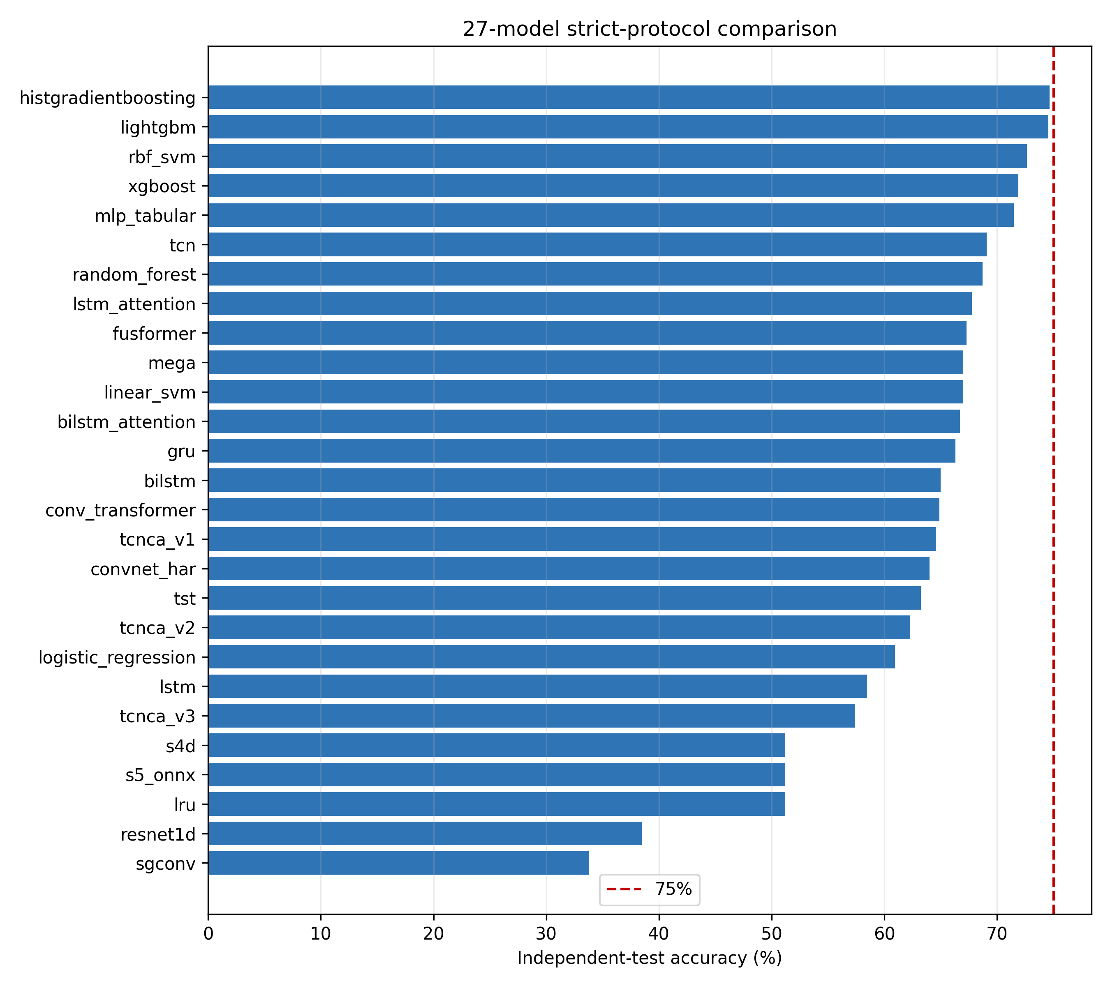

4. Best results by family
family | model | accuracy | macro_f1
Bidirectional recurrent | bilstm | 64.98% | 64.36%
Bidirectional recurrent + attention | bilstm_attention | 66.70% | 65.78%
Kernel SVM | rbf_svm | 72.63% | 70.45%
Linear SVM | linear_svm | 66.99% | 65.84%
Linear baseline | logistic_regression | 60.96% | 61.94%
Recurrent + attention | lstm_attention | 67.75% | 66.52%
Recurrent neural network | gru | 66.32% | 65.33%
Residual temporal CNN | resnet1d | 38.47% | 36.03%
State-space model | s4d | 51.20% | 44.91%
Structured convolution | sgconv | 33.78% | 26.44%
Tabular neural network | mlp_tabular | 71.48% | 68.56%
Temporal CNN | convnet_har | 64.02% | 63.70%
Temporal convolution | tcn | 69.09% | 68.37%
Temporal convolution/channel attention | tcnca_v1 | 64.59% | 64.51%
Time Series Transformer | tst | 63.25% | 63.43%
Transformer | fusformer | 67.27% | 65.95%
Tree boosting | histgradientboosting | 74.64% | 73.74%
Tree ensemble | random_forest | 68.71% | 65.70%

5. Paper-style 80/20 reference results
protocol | model | accuracy | macro_f1
Stratified random 80/20 windows from clean.csv | TCNCA optimized | 79.90% | 80.00%
Stratified random 80/20 windows from clean.csv | TST optimized | 75.12% | 74.05%

These results reproduce the earlier paper-style experiments. Because overlapping windows may appear in both random partitions, they must not be treated as equivalent to the strict independent test.

6. Confusion matrices and class-wise analysis
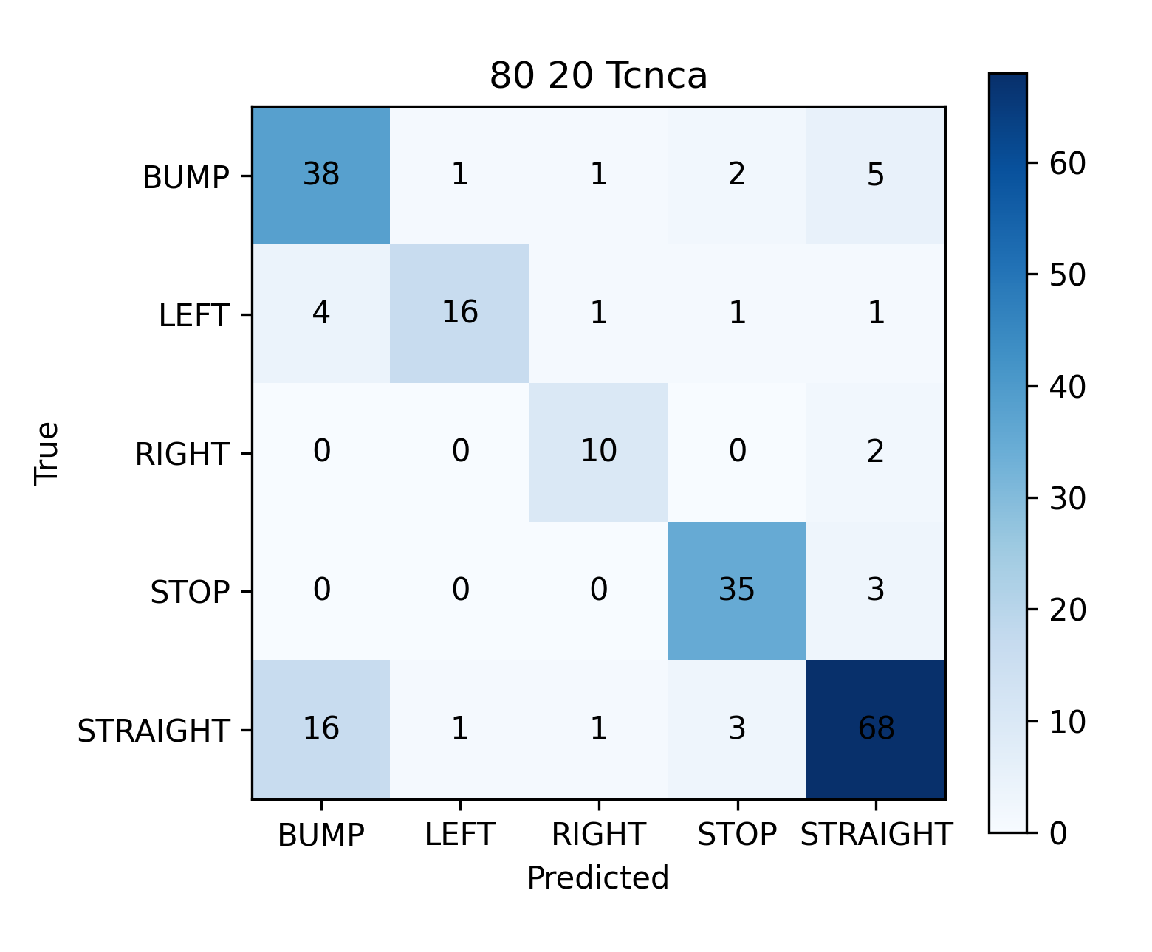
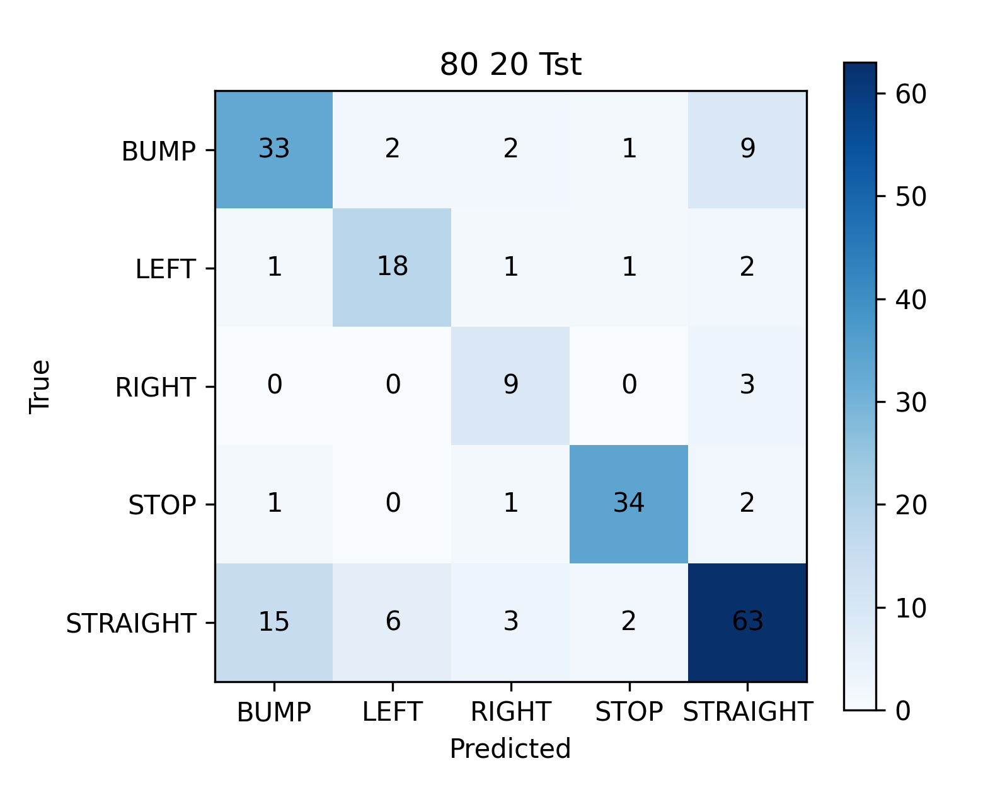
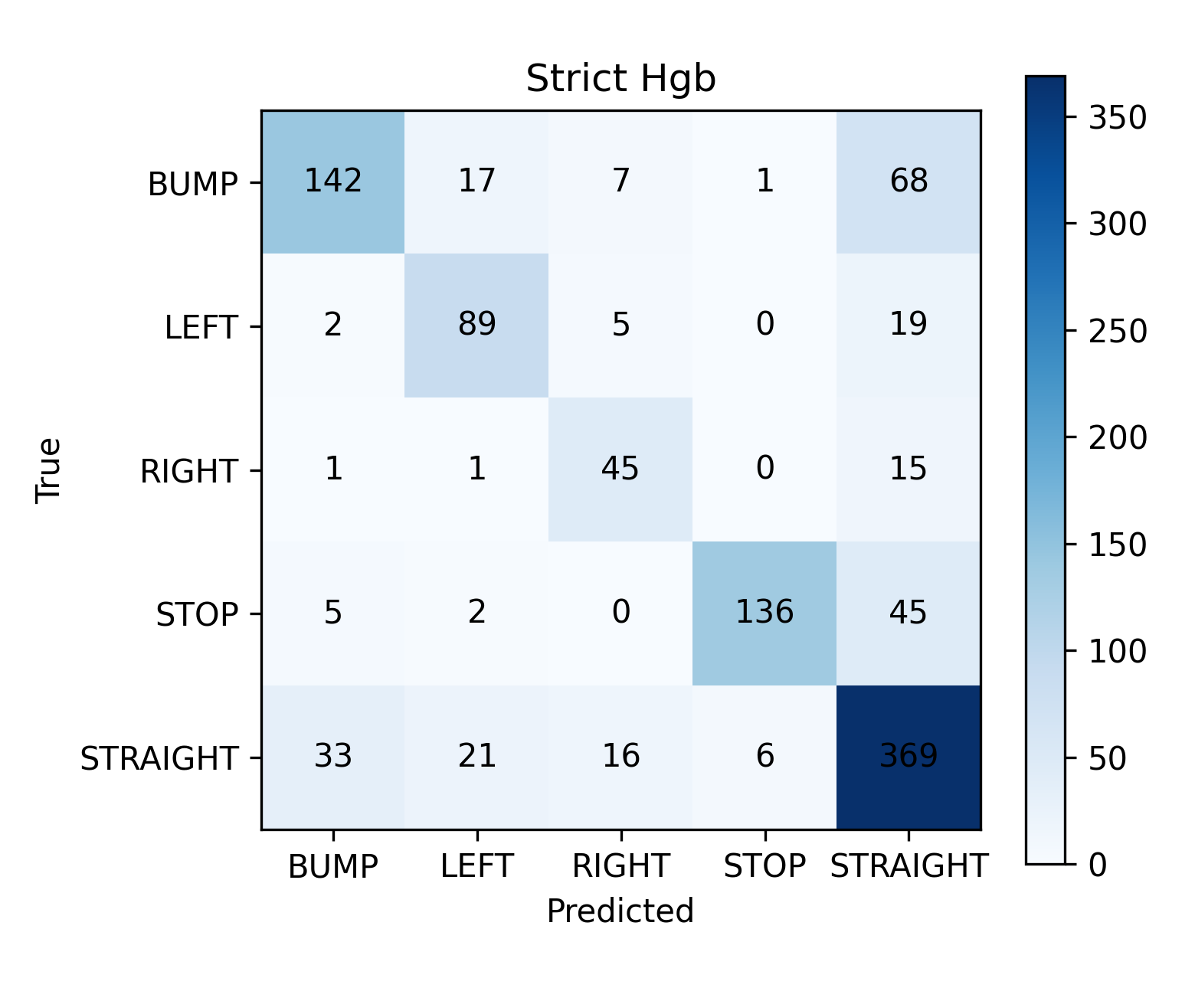
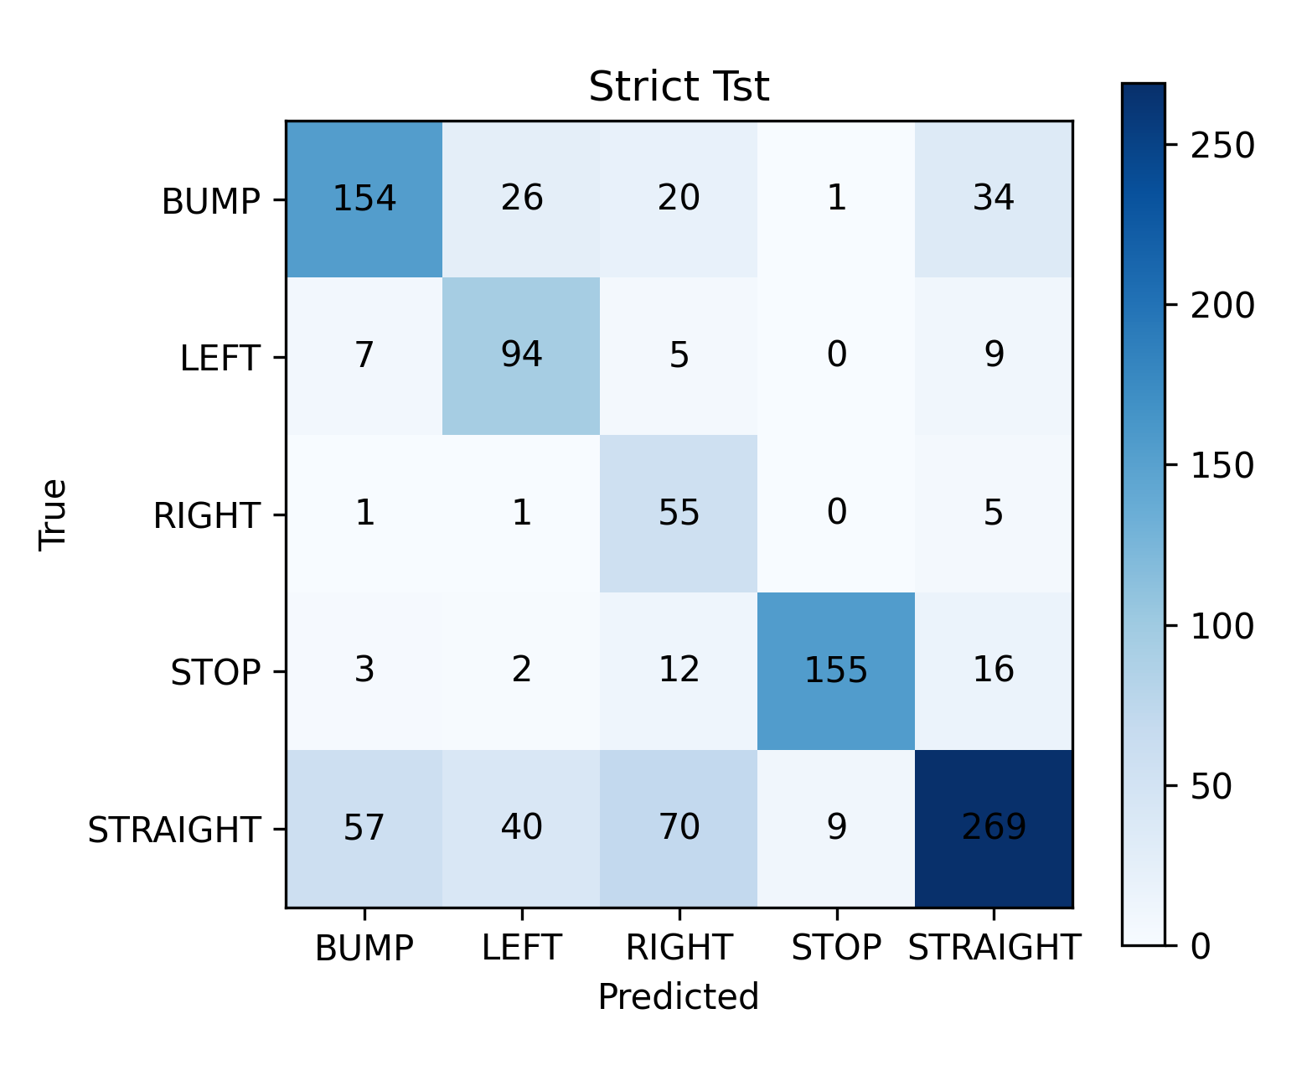
Class-wise metrics for the strict-protocol HistGradientBoosting leader:
class | precision | recall | support
BUMP | 0.7760 | 0.6043 | 235
LEFT | 0.6846 | 0.7739 | 115
RIGHT | 0.6164 | 0.7258 | 62
STOP | 0.9510 | 0.7234 | 188
STRAIGHT | 0.7151 | 0.8292 | 445

7. Robustness and window-size sensitivity
test | accuracy | macro_f1
channel_dropout | 74.55% | 73.18%
noise | 75.02% | 74.19%
missing | 73.88% | 72.57%
clock_jitter | 74.55% | 73.13%
window_size_100 | 74.83% | 73.50%
window_size_128 | 75.12% | 74.08%
window_size_156 | 74.74% | 73.25%
window_size_200 | 74.16% | 72.84%

Window-size rows are diagnostic resampling checks for the fixed-input tabular model. The official comparison remains the 156-sample result.
test | accuracy | macro_f1
window_size_100 | 74.83% | 73.50%
window_size_128 | 75.12% | 74.08%
window_size_156 | 74.74% | 73.25%
window_size_200 | 74.16% | 72.84%

8. Limitations
The random 80/20 and strict four-file results measure different generalization questions. The strict test is the authoritative result for deployment comparison. Robustness perturbations are simulated and are not additional independent holdouts. Raspberry Pi 5 latency and memory must still be measured on hardware.

9. Reproducibility
All models use the same seven raw features and 156-sample windows. Model-specific internal architectures are allowed. Test labels are not used for strict model selection.

