Two-Wheeler Driving Behaviour Recognition
Comprehensive Root-Split Model Report
Train / validation / combined retraining / held-out test evaluation

1. Executive Summary
23 trainable models were evaluated using the supplied split files. The highest validation macro-F1 was 0.7596 (lightgbm); the highest held-out test macro-F1 was 0.7294 (lightgbm) with 74.55% accuracy and 0.05 ms mean measured adapter latency.
The final test set was not used for model selection. Test metrics come from reloaded saved deployment artifacts evaluated once.

2. Dataset and Metrics
Item | Value
Training source | train.csv
Validation source | val.csv
Final fitting source | train_val_combined.csv
Held-out test source | test.csv
Window counts | train=3,875; val=1,045; combined=4,921; test=1,045
Features | Ax, Ay, Az, Gx, Gy, Gz, Speed
Window / stride | 156 samples / 78 samples
Classes | BUMP, LEFT, RIGHT, STOP, STRAIGHT
Metrics | Accuracy, macro-F1, class-wise precision/recall/F1, latency

Windows and majority-vote labels were generated independently within each CSV; no window crosses a split boundary.

3. Model Explanations and Hyperparameters
Model | Family | What it does | Hyperparameters
histgradientboosting | Tree boosting | Histogram gradient boosting over flattened windows. | max_iter=100, random_state=42
lightgbm | Tree boosting | LightGBM multiclass gradient boosting for tabular sensor windows. | n_estimators=200, learning_rate=0.05, num_leaves=31, class_weight=balanced
random_forest | Tree ensemble | Bagged decision trees for nonlinear sensor interactions. | n_estimators=100, class_weight=balanced, n_jobs=-1
xgboost | Tree boosting | Regularized gradient-boosted decision trees. | n_estimators=200, max_depth=6, learning_rate=0.05, subsample=0.9, colsample_bytree=0.8
logistic_regression | Linear baseline | Linear multiclass classifier over flattened windows. | max_iter=300, class_weight=balanced
linear_svm | Linear baseline | Linear maximum-margin classifier over flattened windows. | class_weight=balanced, max_iter=1000
mlp_tabular | Feed-forward neural network | Two-hidden-layer neural network over flattened windows. | Dense 128/64, dropout=0.2, Adam, epochs=10, batch_size=64
conv_transformer | Transformer | Convolutional stem followed by transformer blocks. | Existing project transformer builder, default configuration
gru | Recurrent neural network | Gated recurrent sequence classifier. | Existing GRU builder, default configuration
lstm | Recurrent neural network | Long short-term memory sequence classifier. | Existing LSTM builder, default configuration
fusformer | Transformer | Fusion transformer with short and long temporal branches. | Existing project transformer builder, default configuration
mega | Transformer | Moving-average gated attention model. | Existing project transformer builder, default configuration
convnet_har | Convolutional neural network | Three-block temporal ConvNet with global pooling. | Conv1D filters=64, kernels=7/5/3, epochs=10
tcnca_v3 | Temporal convolution | Dilated temporal convolution variant with channel attention. | Existing TCNCA v3 builder, default configuration
rbf_svm | Kernel baseline | RBF-kernel support-vector classifier. | kernel=rbf, probability=True, class_weight=balanced
tcnca_v2 | Temporal convolution | TCNCA ablation with chunked attention. | Existing TCNCA v2 builder, default configuration
tcnca_v1 | Temporal convolution | TCNCA ablation without the final attention variant. | Existing TCNCA v1 builder, default configuration
tst | Transformer | Temporal-spatial transformer with positional embeddings. | d_model=24, heads=2, feedforward=48, blocks=2, dropout=0.1
s4d | State-space model | Diagonal state-space sequence classifier. | Existing S4D builder, default configuration
s5_onnx | State-space model | ONNX S5 state-space sequence classifier. | Existing S5 ONNX builder, default configuration
lru | State-space model | Linear recurrent unit sequence classifier. | Existing LRU builder, default configuration
sgconv | Structured convolution | Depthwise and dilated convolution classifier. | Existing SGConv builder, default configuration
resnet1d | Convolutional neural network | Residual one-dimensional temporal convolution network. | Residual blocks, Adam, epochs=10
egodrive_rt | Unavailable | No trainable implementation or usable pretrained weights. | Not applicable
egodrive_max | Unavailable | No trainable implementation or usable pretrained weights. | Not applicable

4. Metrics for Every Model
Model | Status | Val accuracy | Val macro-F1 | Test accuracy | Test macro-F1 | Mean latency (ms) | P95 latency (ms) | Test windows | Error
lightgbm | evaluated | 0.8785 | 0.7596 | 0.7455 | 0.7294 | 0.0458 | 0.0458 | 1045 | nan
histgradientboosting | evaluated | 0.8469 | 0.6510 | 0.7043 | 0.6838 | 0.0879 | 0.0879 | 1045 | nan
xgboost | evaluated | 0.8641 | 0.6900 | 0.7053 | 0.6801 | 0.0111 | 0.0111 | 1045 | nan
convnet_har | evaluated | 0.8067 | 0.4993 | 0.7005 | 0.6697 | 0.1641 | 0.3809 | 1045 | nan
logistic_regression | evaluated | 0.7282 | 0.5683 | 0.6756 | 0.6670 | 0.0175 | 0.0175 | 1045 | nan
linear_svm | evaluated | 0.7120 | 0.5309 | 0.6670 | 0.6536 | 0.0086 | 0.0086 | 1045 | nan
rbf_svm | evaluated | 0.3100 | 0.4340 | 0.5990 | 0.6204 | 1.1353 | 1.1353 | 1045 | nan
random_forest | evaluated | 0.8488 | 0.6277 | 0.6565 | 0.6078 | 0.1598 | 0.1598 | 1045 | nan
mlp_tabular | evaluated | 0.7684 | 0.5244 | 0.6373 | 0.5703 | 0.7672 | 0.7672 | 1045 | nan
fusformer | evaluated | 0.8220 | 0.5142 | 0.6354 | 0.5578 | 0.4561 | 1.3801 | 1045 | nan
tcnca_v2 | evaluated | 0.7388 | 0.2831 | 0.6163 | 0.5577 | 0.1678 | 0.6041 | 1045 | nan
mega | evaluated | 0.8364 | 0.5783 | 0.6383 | 0.5540 | 0.4662 | 1.3969 | 1045 | nan
tcnca_v3 | evaluated | 0.7359 | 0.2932 | 0.5923 | 0.5422 | 0.1512 | 0.5784 | 1045 | nan
tcnca_v1 | evaluated | 0.8115 | 0.4959 | 0.6258 | 0.5380 | 0.1394 | 0.3937 | 1045 | nan
conv_transformer | evaluated | 0.8163 | 0.4878 | 0.6239 | 0.5293 | 0.8527 | 2.2665 | 1045 | nan
gru | evaluated | 0.7885 | 0.3813 | 0.6201 | 0.5155 | 3.5532 | 3.5532 | 1045 | nan
lstm | evaluated | 0.7856 | 0.3406 | 0.5770 | 0.4202 | 2.5292 | 2.5292 | 1045 | nan
tst | evaluated | 0.7981 | 0.3660 | 0.5703 | 0.3665 | 0.7246 | 2.0426 | 1045 | nan
sgconv | evaluated | 0.1091 | 0.1850 | 0.3273 | 0.2615 | 0.1537 | 0.1537 | 1045 | nan
s4d | evaluated | 0.3569 | 0.2248 | 0.2890 | 0.2355 | 0.1170 | 0.1170 | 1045 | nan
s5_onnx | evaluated | 0.3569 | 0.2248 | 0.2890 | 0.2355 | 0.1785 | 0.1785 | 1045 | nan
lru | evaluated | 0.3569 | 0.2248 | 0.2890 | 0.2355 | 0.1192 | 0.1192 | 1045 | nan
resnet1d | evaluated | 0.6411 | 0.1570 | 0.2746 | 0.0930 | 0.0397 | 0.0397 | 1045 | nan

5. Benchmark Graphs
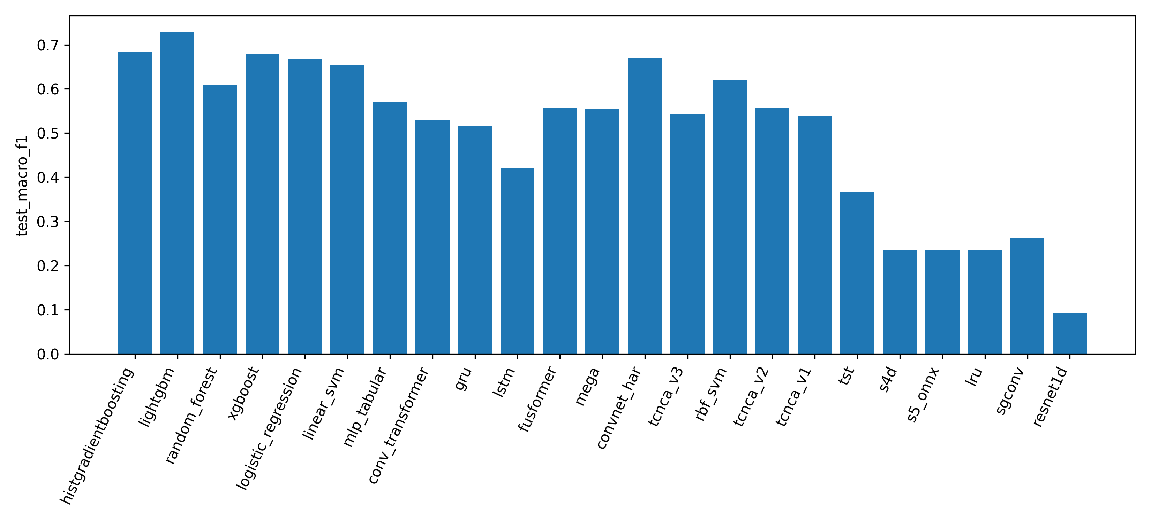
Held-out test macro-F1 comparison
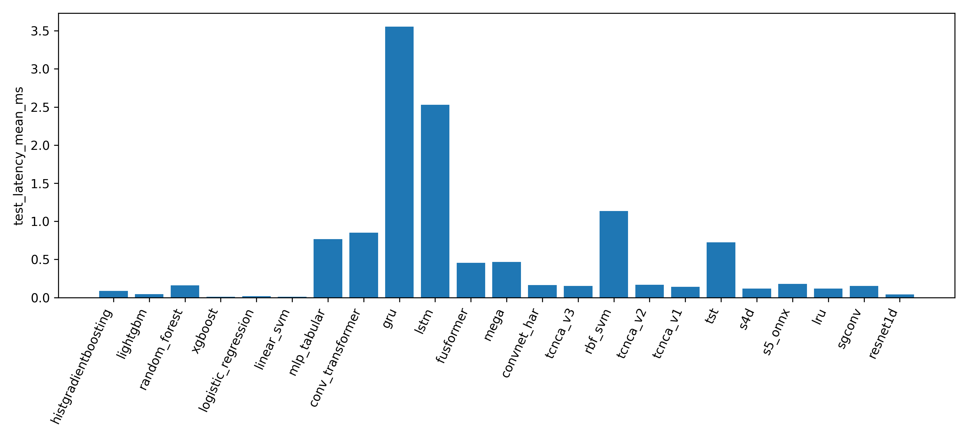
Saved-artifact test latency comparison
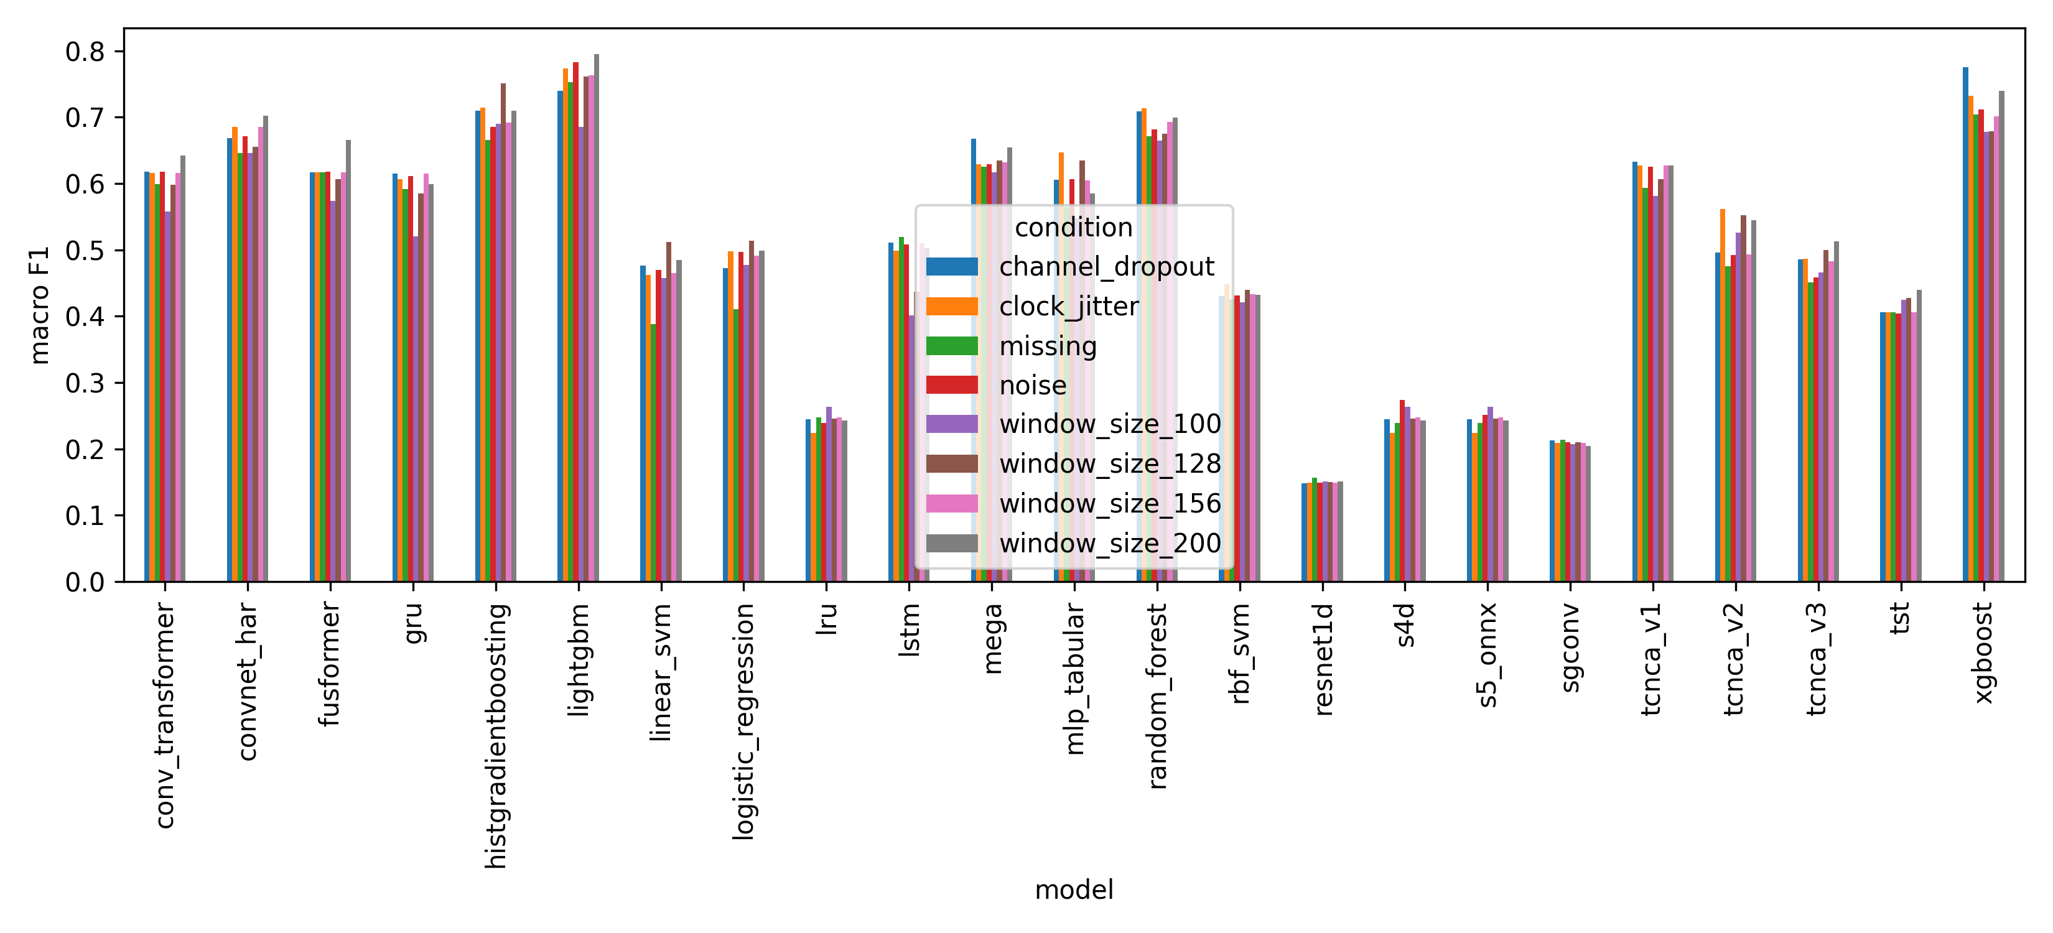
Robustness comparison

6. Confusion Matrices and Class-Wise Results
Model | Class | Precision | Recall | F1 | Support
histgradientboosting | BUMP | 0.6667 | 0.2000 | 0.3077 | 10.0000
histgradientboosting | LEFT | 0.0000 | 0.0000 | 0.0000 | 0.0000
histgradientboosting | RIGHT | 1.0000 | 0.6000 | 0.7500 | 5.0000
histgradientboosting | STOP | 0.0000 | 0.0000 | 0.0000 | 0.0000
histgradientboosting | STRAIGHT | 0.8936 | 0.9882 | 0.9385 | 85.0000
histgradientboosting | macro avg | 0.5121 | 0.3576 | 0.3992 | 100.0000
histgradientboosting | weighted avg | 0.8762 | 0.8900 | 0.8660 | 100.0000
lightgbm | BUMP | 0.8333 | 0.5000 | 0.6250 | 10.0000
lightgbm | LEFT | 0.0000 | 0.0000 | 0.0000 | 0.0000
lightgbm | RIGHT | 1.0000 | 0.6000 | 0.7500 | 5.0000
lightgbm | STOP | 0.0000 | 0.0000 | 0.0000 | 0.0000
lightgbm | STRAIGHT | 0.9318 | 0.9647 | 0.9480 | 85.0000
lightgbm | macro avg | 0.5530 | 0.4129 | 0.4646 | 100.0000
lightgbm | weighted avg | 0.9254 | 0.9000 | 0.9058 | 100.0000
random_forest | BUMP | 0.0000 | 0.0000 | 0.0000 | 10.0000
random_forest | LEFT | 0.0000 | 0.0000 | 0.0000 | 0.0000
random_forest | RIGHT | 1.0000 | 0.8000 | 0.8889 | 5.0000
random_forest | STOP | 0.0000 | 0.0000 | 0.0000 | 0.0000
random_forest | STRAIGHT | 0.8854 | 1.0000 | 0.9392 | 85.0000
random_forest | macro avg | 0.3771 | 0.3600 | 0.3656 | 100.0000
random_forest | weighted avg | 0.8026 | 0.8900 | 0.8428 | 100.0000
xgboost | BUMP | 0.0000 | 0.0000 | 0.0000 | 10.0000
xgboost | LEFT | 0.0000 | 0.0000 | 0.0000 | 0.0000
xgboost | RIGHT | 1.0000 | 0.6000 | 0.7500 | 5.0000
xgboost | STOP | 0.0000 | 0.0000 | 0.0000 | 0.0000
xgboost | STRAIGHT | 0.8763 | 1.0000 | 0.9341 | 85.0000
xgboost | macro avg | 0.3753 | 0.3200 | 0.3368 | 100.0000
xgboost | weighted avg | 0.7948 | 0.8800 | 0.8315 | 100.0000
logistic_regression | BUMP | 0.0000 | 0.0000 | 0.0000 | 10.0000
logistic_regression | LEFT | 0.0000 | 0.0000 | 0.0000 | 0.0000
logistic_regression | RIGHT | 0.3000 | 0.6000 | 0.4000 | 5.0000
logistic_regression | STOP | 0.0000 | 0.0000 | 0.0000 | 0.0000
logistic_regression | STRAIGHT | 0.9000 | 0.7412 | 0.8129 | 85.0000
logistic_regression | macro avg | 0.2400 | 0.2682 | 0.2426 | 100.0000
logistic_regression | weighted avg | 0.7800 | 0.6600 | 0.7110 | 100.0000
linear_svm | BUMP | 0.0000 | 0.0000 | 0.0000 | 10.0000
linear_svm | LEFT | 0.0000 | 0.0000 | 0.0000 | 0.0000
linear_svm | RIGHT | 0.2857 | 0.4000 | 0.3333 | 5.0000
linear_svm | STOP | 0.0000 | 0.0000 | 0.0000 | 0.0000
linear_svm | STRAIGHT | 0.8732 | 0.7294 | 0.7949 | 85.0000
linear_svm | macro avg | 0.2318 | 0.2259 | 0.2256 | 100.0000
linear_svm | weighted avg | 0.7565 | 0.6400 | 0.6923 | 100.0000
mlp_tabular | BUMP | 0.0000 | 0.0000 | 0.0000 | 10.0000
mlp_tabular | LEFT | 0.0000 | 0.0000 | 0.0000 | 0.0000
mlp_tabular | RIGHT | 0.5000 | 0.8000 | 0.6154 | 5.0000
mlp_tabular | STOP | 0.0000 | 0.0000 | 0.0000 | 0.0000
mlp_tabular | STRAIGHT | 0.8977 | 0.9294 | 0.9133 | 85.0000
mlp_tabular | macro avg | 0.2795 | 0.3459 | 0.3057 | 100.0000
mlp_tabular | weighted avg | 0.7881 | 0.8300 | 0.8071 | 100.0000
conv_transformer | BUMP | 0.0000 | 0.0000 | 0.0000 | 10.0000
conv_transformer | LEFT | 0.0000 | 0.0000 | 0.0000 | 0.0000
conv_transformer | RIGHT | 0.7500 | 0.6000 | 0.6667 | 5.0000
conv_transformer | STOP | 0.0000 | 0.0000 | 0.0000 | 0.0000
conv_transformer | STRAIGHT | 0.8750 | 0.9882 | 0.9282 | 85.0000
conv_transformer | macro avg | 0.3250 | 0.3176 | 0.3190 | 100.0000
conv_transformer | weighted avg | 0.7812 | 0.8700 | 0.8223 | 100.0000
gru | BUMP | 0.0000 | 0.0000 | 0.0000 | 10.0000
gru | LEFT | 0.0000 | 0.0000 | 0.0000 | 0.0000
gru | RIGHT | 0.6667 | 0.8000 | 0.7273 | 5.0000
gru | STOP | 0.0000 | 0.0000 | 0.0000 | 0.0000
gru | STRAIGHT | 0.8864 | 0.9176 | 0.9017 | 85.0000
gru | macro avg | 0.3106 | 0.3435 | 0.3258 | 100.0000
gru | weighted avg | 0.7867 | 0.8200 | 0.8028 | 100.0000
lstm | BUMP | 0.0000 | 0.0000 | 0.0000 | 10.0000
lstm | LEFT | 0.0000 | 0.0000 | 0.0000 | 0.0000
lstm | RIGHT | 0.5714 | 0.8000 | 0.6667 | 5.0000
lstm | STOP | 0.0000 | 0.0000 | 0.0000 | 0.0000
lstm | STRAIGHT | 0.8876 | 0.9294 | 0.9080 | 85.0000
lstm | macro avg | 0.2918 | 0.3459 | 0.3149 | 100.0000
lstm | weighted avg | 0.7831 | 0.8300 | 0.8052 | 100.0000
fusformer | BUMP | 0.0000 | 0.0000 | 0.0000 | 10.0000
fusformer | LEFT | 0.0000 | 0.0000 | 0.0000 | 0.0000
fusformer | RIGHT | 0.7500 | 0.6000 | 0.6667 | 5.0000
fusformer | STOP | 0.0000 | 0.0000 | 0.0000 | 0.0000
fusformer | STRAIGHT | 0.8750 | 0.9882 | 0.9282 | 85.0000
fusformer | macro avg | 0.3250 | 0.3176 | 0.3190 | 100.0000
fusformer | weighted avg | 0.7812 | 0.8700 | 0.8223 | 100.0000
mega | BUMP | 0.0000 | 0.0000 | 0.0000 | 10.0000
mega | LEFT | 0.0000 | 0.0000 | 0.0000 | 0.0000
mega | RIGHT | 0.6000 | 0.6000 | 0.6000 | 5.0000
mega | STOP | 0.0000 | 0.0000 | 0.0000 | 0.0000
mega | STRAIGHT | 0.8817 | 0.9647 | 0.9213 | 85.0000
mega | macro avg | 0.2963 | 0.3129 | 0.3043 | 100.0000
mega | weighted avg | 0.7795 | 0.8500 | 0.8131 | 100.0000
convnet_har | BUMP | 0.4000 | 0.2000 | 0.2667 | 10.0000
convnet_har | LEFT | 0.0000 | 0.0000 | 0.0000 | 0.0000
convnet_har | RIGHT | 0.6000 | 0.6000 | 0.6000 | 5.0000
convnet_har | STOP | 0.0000 | 0.0000 | 0.0000 | 0.0000
convnet_har | STRAIGHT | 0.9111 | 0.9647 | 0.9371 | 85.0000
convnet_har | macro avg | 0.3822 | 0.3529 | 0.3608 | 100.0000
convnet_har | weighted avg | 0.8444 | 0.8700 | 0.8532 | 100.0000
tcnca_v3 | BUMP | 0.0000 | 0.0000 | 0.0000 | 10.0000
tcnca_v3 | LEFT | 0.0000 | 0.0000 | 0.0000 | 0.0000
tcnca_v3 | RIGHT | 0.4000 | 0.8000 | 0.5333 | 5.0000
tcnca_v3 | STOP | 0.0000 | 0.0000 | 0.0000 | 0.0000
tcnca_v3 | STRAIGHT | 0.8800 | 0.7765 | 0.8250 | 85.0000
tcnca_v3 | macro avg | 0.2560 | 0.3153 | 0.2717 | 100.0000
tcnca_v3 | weighted avg | 0.7680 | 0.7000 | 0.7279 | 100.0000
rbf_svm | BUMP | 0.0702 | 0.4000 | 0.1194 | 10.0000
rbf_svm | LEFT | 0.0000 | 0.0000 | 0.0000 | 0.0000
rbf_svm | RIGHT | 0.2941 | 1.0000 | 0.4545 | 5.0000
rbf_svm | STOP | 0.0000 | 0.0000 | 0.0000 | 0.0000
rbf_svm | STRAIGHT | 1.0000 | 0.1176 | 0.2105 | 85.0000
rbf_svm | macro avg | 0.2729 | 0.3035 | 0.1569 | 100.0000
rbf_svm | weighted avg | 0.8717 | 0.1900 | 0.2136 | 100.0000
tcnca_v2 | BUMP | 0.0000 | 0.0000 | 0.0000 | 10.0000
tcnca_v2 | LEFT | 0.0000 | 0.0000 | 0.0000 | 0.0000
tcnca_v2 | RIGHT | 0.3000 | 0.6000 | 0.4000 | 5.0000
tcnca_v2 | STOP | 0.0000 | 0.0000 | 0.0000 | 0.0000
tcnca_v2 | STRAIGHT | 0.8875 | 0.8353 | 0.8606 | 85.0000
tcnca_v2 | macro avg | 0.2375 | 0.2871 | 0.2521 | 100.0000
tcnca_v2 | weighted avg | 0.7694 | 0.7400 | 0.7515 | 100.0000
tcnca_v1 | BUMP | 0.0000 | 0.0000 | 0.0000 | 10.0000
tcnca_v1 | LEFT | 0.0000 | 0.0000 | 0.0000 | 0.0000
tcnca_v1 | RIGHT | 0.6000 | 0.6000 | 0.6000 | 5.0000
tcnca_v1 | STOP | 0.0000 | 0.0000 | 0.0000 | 0.0000
tcnca_v1 | STRAIGHT | 0.8737 | 0.9765 | 0.9222 | 85.0000
tcnca_v1 | macro avg | 0.2947 | 0.3153 | 0.3044 | 100.0000
tcnca_v1 | weighted avg | 0.7726 | 0.8600 | 0.8139 | 100.0000
tst | BUMP | 0.0000 | 0.0000 | 0.0000 | 10.0000
tst | LEFT | 0.0000 | 0.0000 | 0.0000 | 0.0000
tst | RIGHT | 0.0000 | 0.0000 | 0.0000 | 5.0000
tst | STOP | 0.0000 | 0.0000 | 0.0000 | 0.0000
tst | STRAIGHT | 0.8485 | 0.9882 | 0.9130 | 85.0000
tst | macro avg | 0.1697 | 0.1976 | 0.1826 | 100.0000
tst | weighted avg | 0.7212 | 0.8400 | 0.7761 | 100.0000
s4d | BUMP | 0.0000 | 0.0000 | 0.0000 | 10.0000
s4d | LEFT | 0.0000 | 0.0000 | 0.0000 | 0.0000
s4d | RIGHT | 0.0000 | 0.0000 | 0.0000 | 5.0000
s4d | STOP | 0.0000 | 0.0000 | 0.0000 | 0.0000
s4d | STRAIGHT | 0.8235 | 0.4941 | 0.6176 | 85.0000
s4d | macro avg | 0.1647 | 0.0988 | 0.1235 | 100.0000
s4d | weighted avg | 0.7000 | 0.4200 | 0.5250 | 100.0000
s5_onnx | BUMP | 0.0000 | 0.0000 | 0.0000 | 10.0000
s5_onnx | LEFT | 0.0000 | 0.0000 | 0.0000 | 0.0000
s5_onnx | RIGHT | 0.0000 | 0.0000 | 0.0000 | 5.0000
s5_onnx | STOP | 0.0000 | 0.0000 | 0.0000 | 0.0000
s5_onnx | STRAIGHT | 0.8235 | 0.4941 | 0.6176 | 85.0000
s5_onnx | macro avg | 0.1647 | 0.0988 | 0.1235 | 100.0000
s5_onnx | weighted avg | 0.7000 | 0.4200 | 0.5250 | 100.0000
lru | BUMP | 0.0000 | 0.0000 | 0.0000 | 10.0000
lru | LEFT | 0.0000 | 0.0000 | 0.0000 | 0.0000
lru | RIGHT | 0.0000 | 0.0000 | 0.0000 | 5.0000
lru | STOP | 0.0000 | 0.0000 | 0.0000 | 0.0000
lru | STRAIGHT | 0.8235 | 0.4941 | 0.6176 | 85.0000
lru | macro avg | 0.1647 | 0.0988 | 0.1235 | 100.0000
lru | weighted avg | 0.7000 | 0.4200 | 0.5250 | 100.0000
sgconv | BUMP | 0.0854 | 0.7000 | 0.1522 | 10.0000
sgconv | LEFT | 0.0000 | 0.0000 | 0.0000 | 0.0000
sgconv | RIGHT | 0.0000 | 0.0000 | 0.0000 | 5.0000
sgconv | STOP | 0.0000 | 0.0000 | 0.0000 | 0.0000
sgconv | STRAIGHT | 0.0000 | 0.0000 | 0.0000 | 85.0000
sgconv | macro avg | 0.0171 | 0.1400 | 0.0304 | 100.0000
sgconv | weighted avg | 0.0085 | 0.0700 | 0.0152 | 100.0000
resnet1d | BUMP | 0.0000 | 0.0000 | 0.0000 | 10.0000
resnet1d | LEFT | 0.0000 | 0.0000 | 0.0000 | 0.0000
resnet1d | RIGHT | 0.0000 | 0.0000 | 0.0000 | 5.0000
resnet1d | STOP | 0.0000 | 0.0000 | 0.0000 | 0.0000
resnet1d | STRAIGHT | 0.8485 | 0.9882 | 0.9130 | 85.0000
resnet1d | macro avg | 0.1697 | 0.1976 | 0.1826 | 100.0000
resnet1d | weighted avg | 0.7212 | 0.8400 | 0.7761 | 100.0000

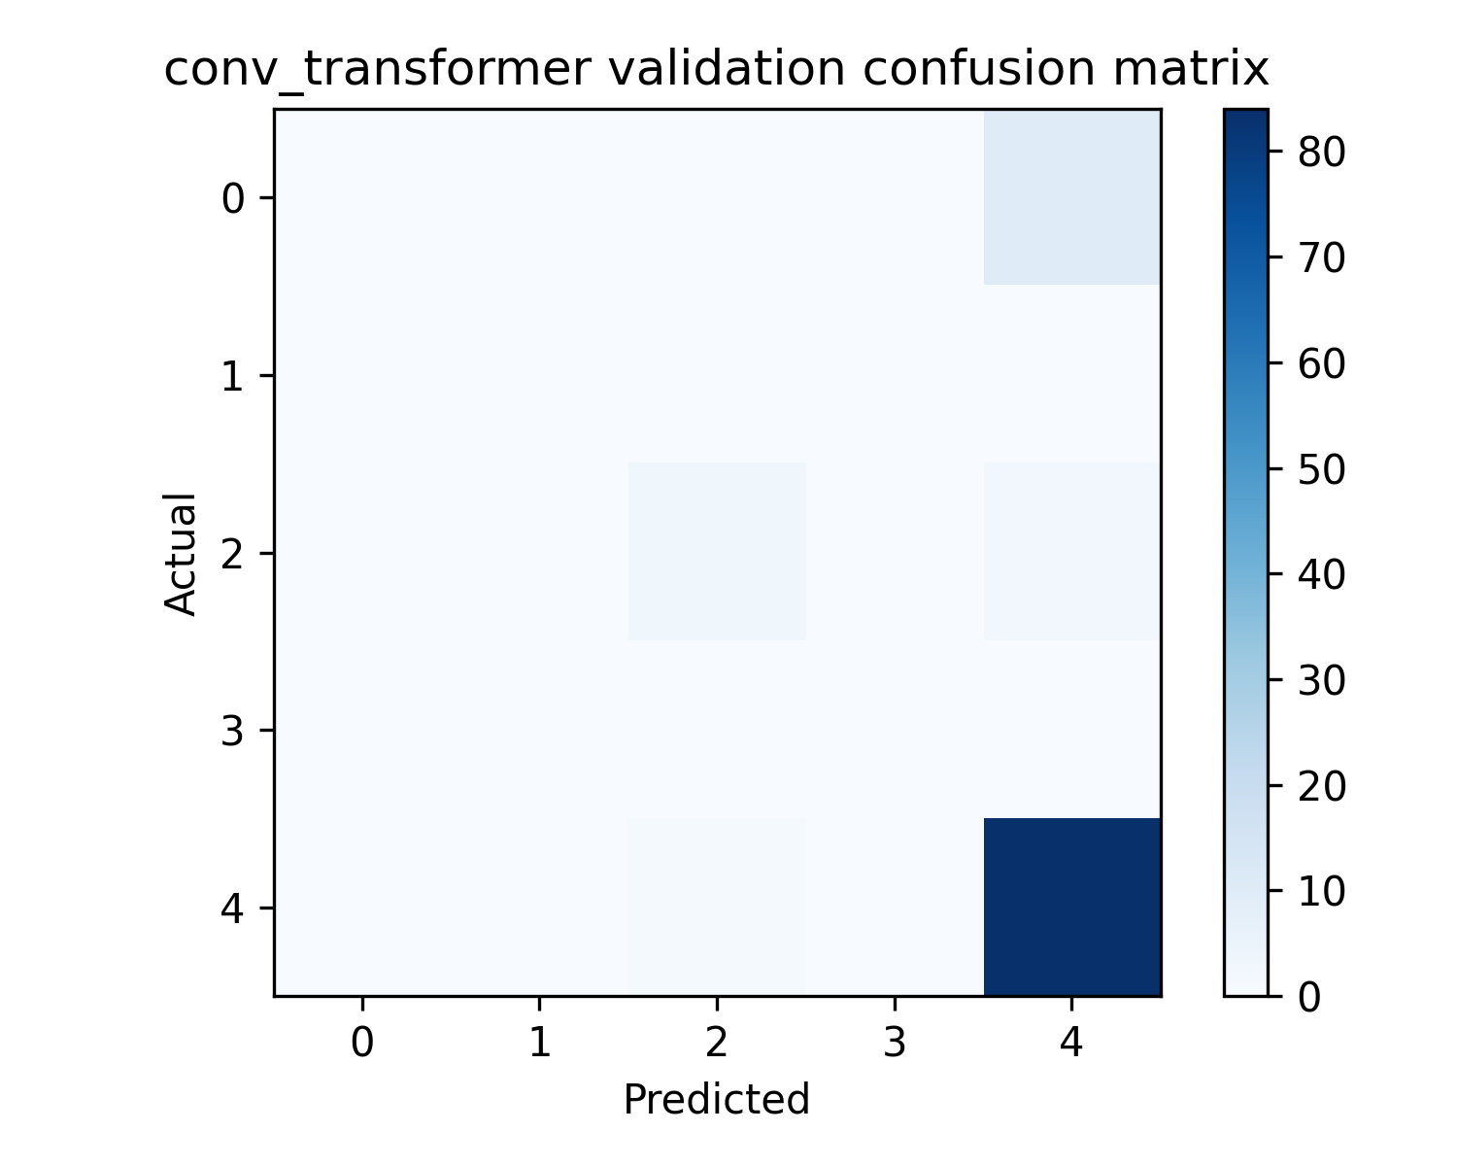
Confusion matrix: Conv Transformer
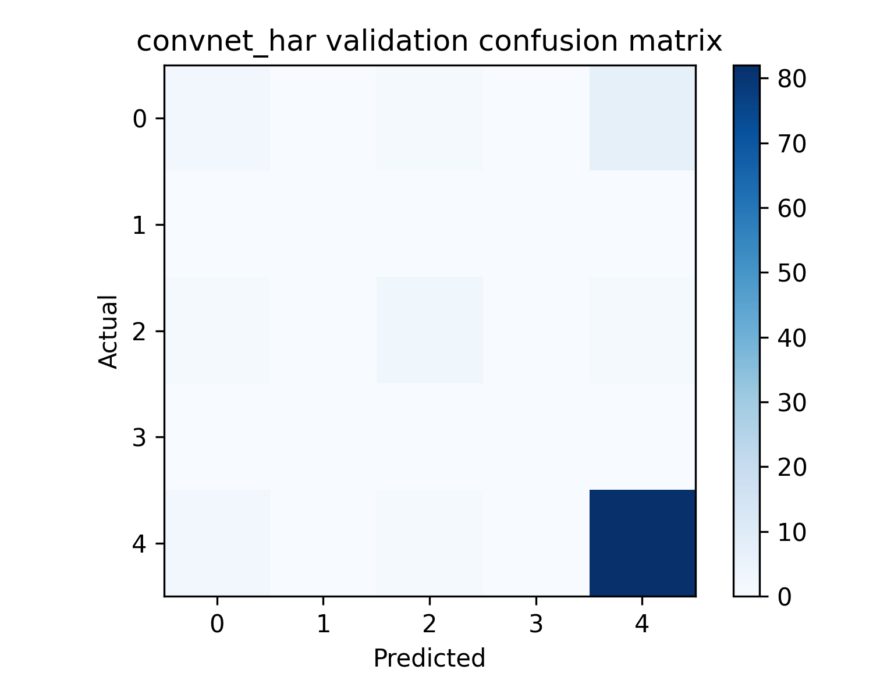
Confusion matrix: Convnet Har
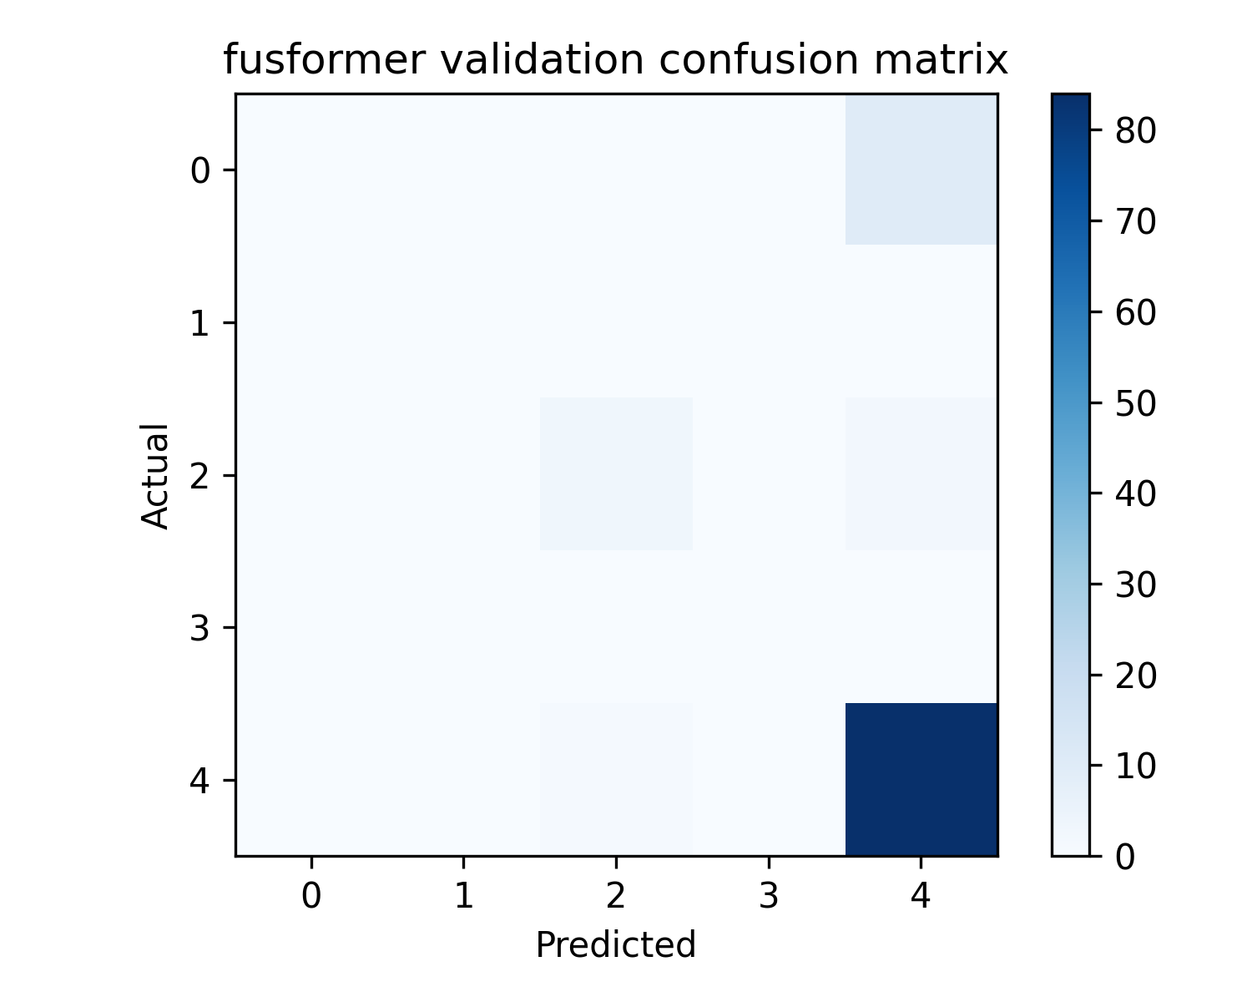
Confusion matrix: Fusformer
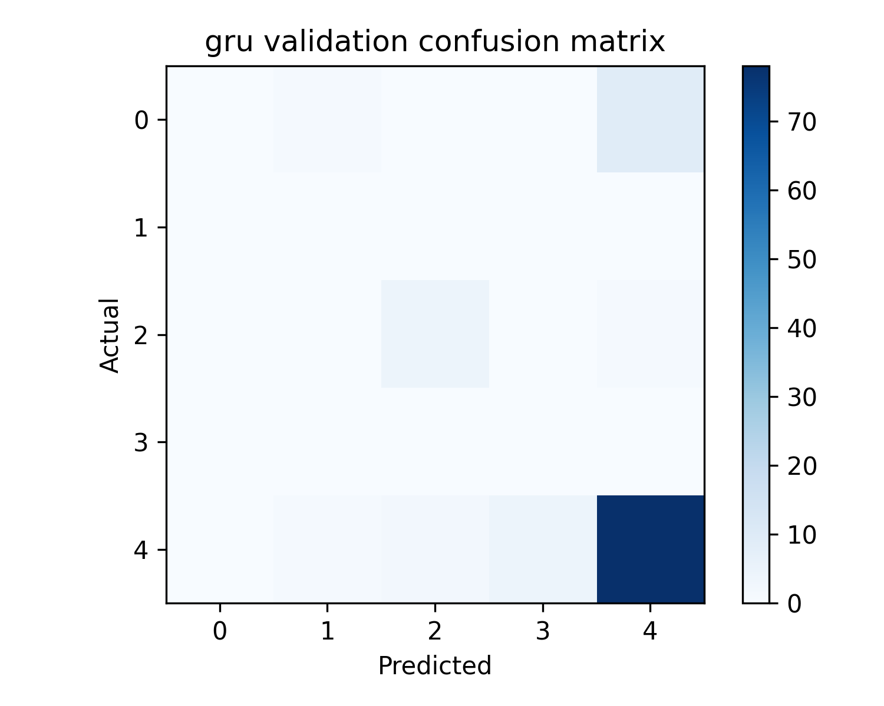
Confusion matrix: Gru
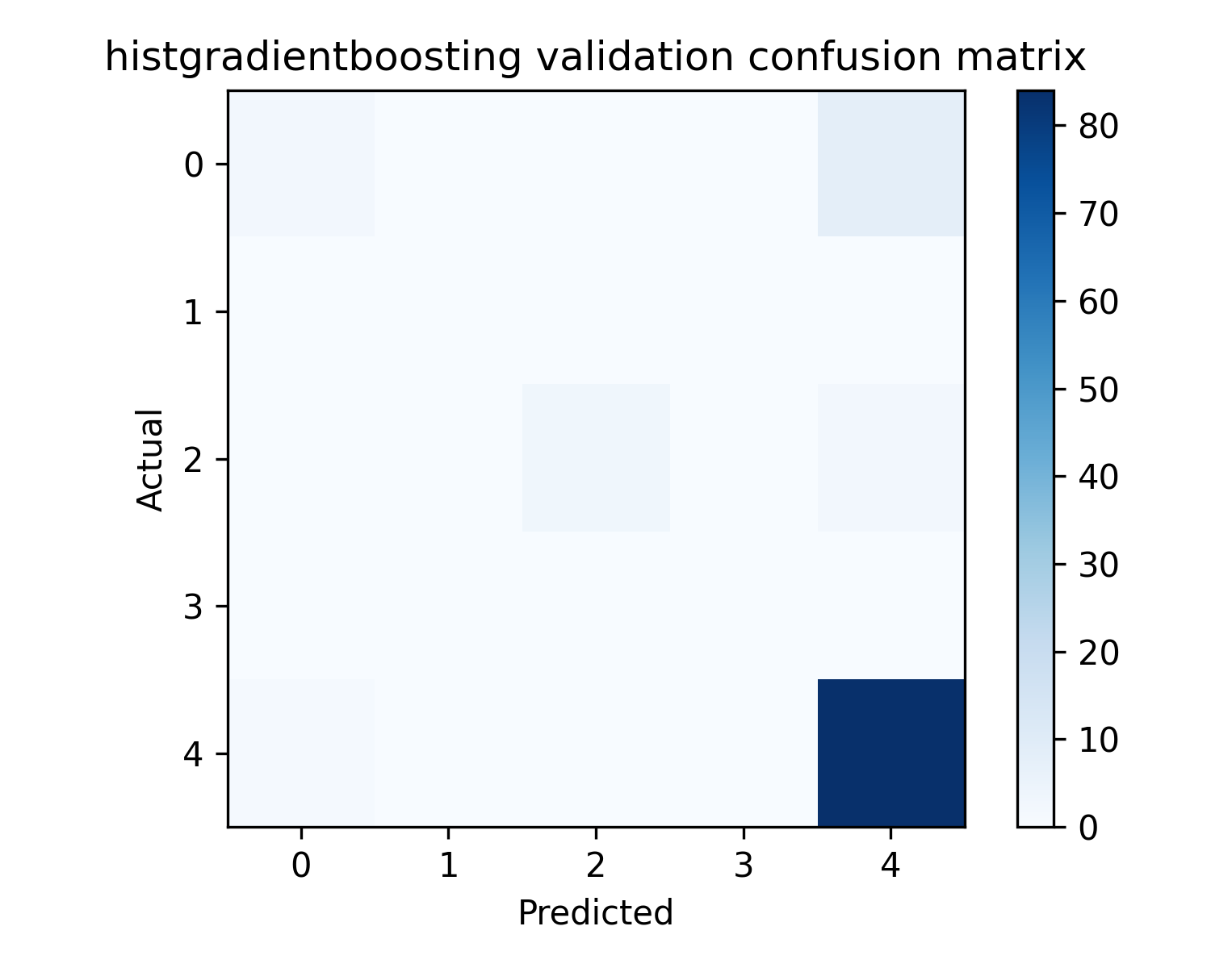
Confusion matrix: Histgradientboosting
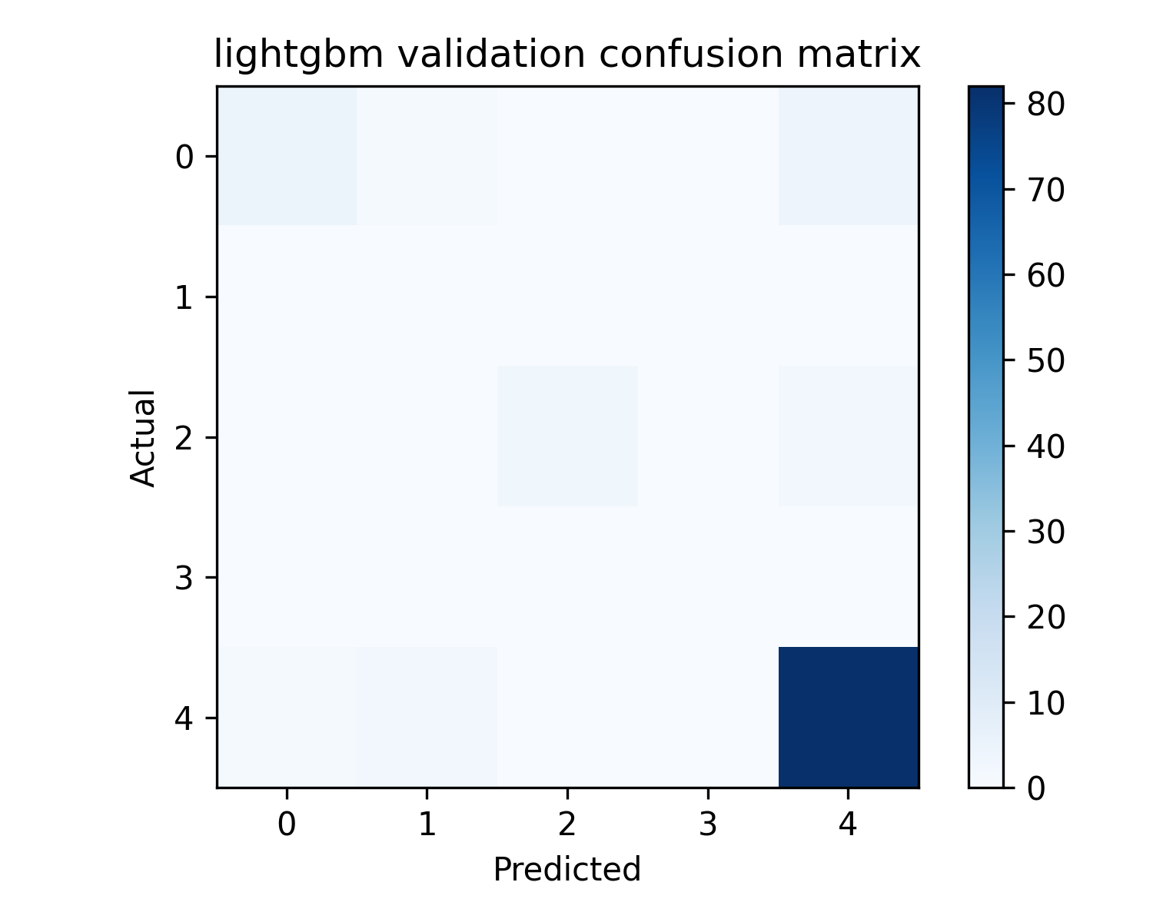
Confusion matrix: Lightgbm
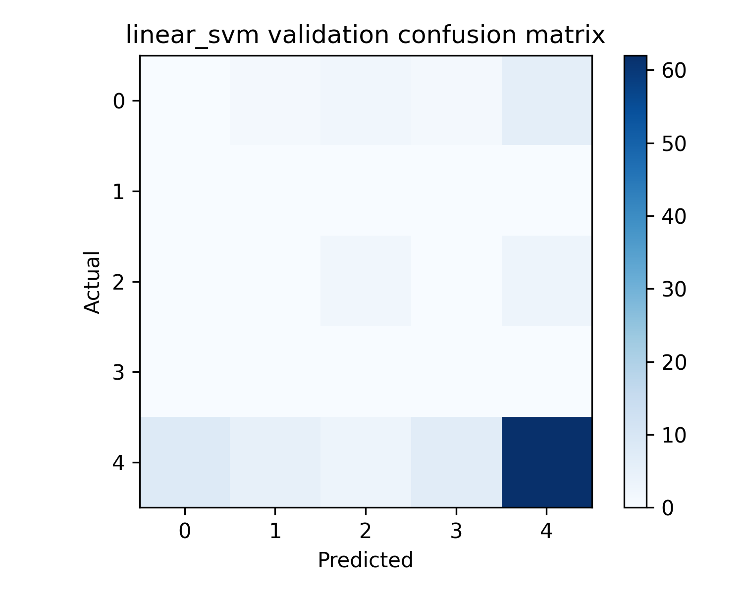
Confusion matrix: Linear Svm
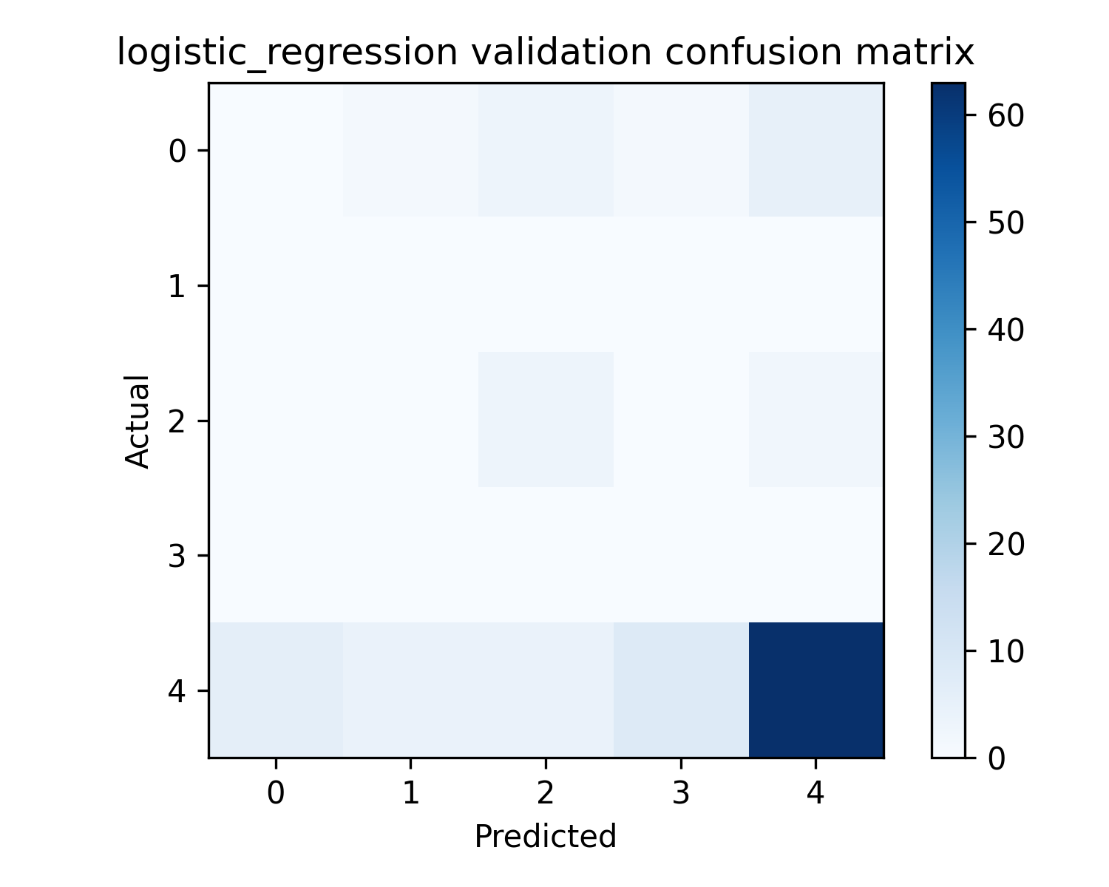
Confusion matrix: Logistic Regression
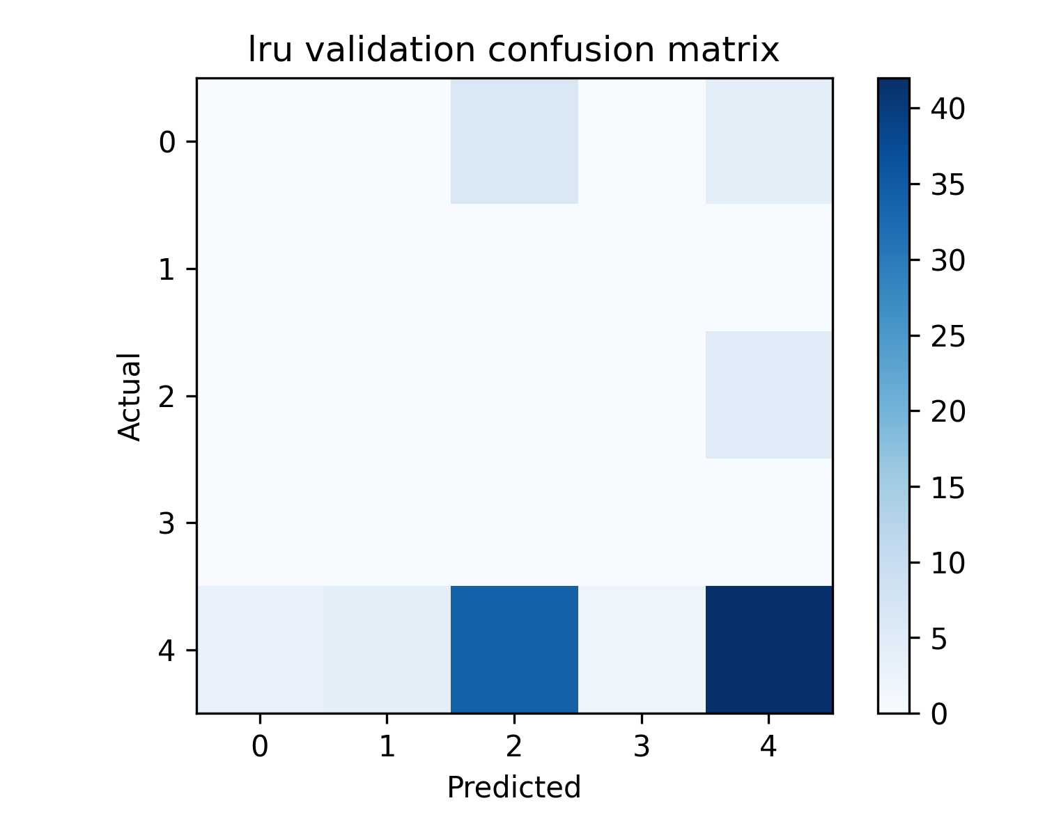
Confusion matrix: Lru
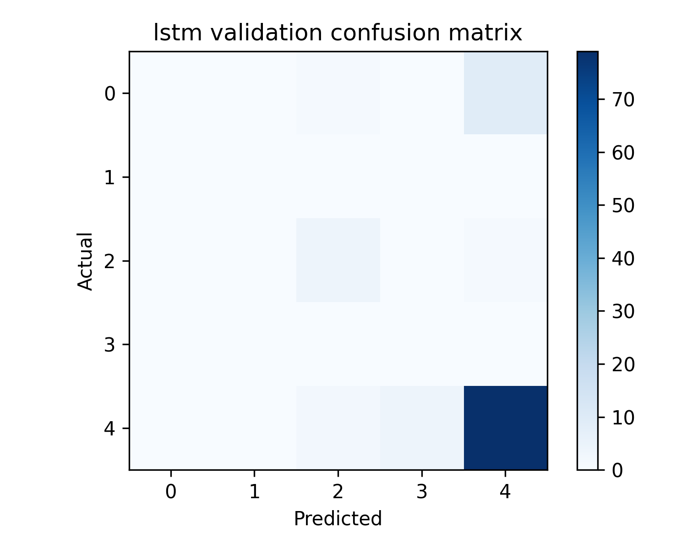
Confusion matrix: Lstm
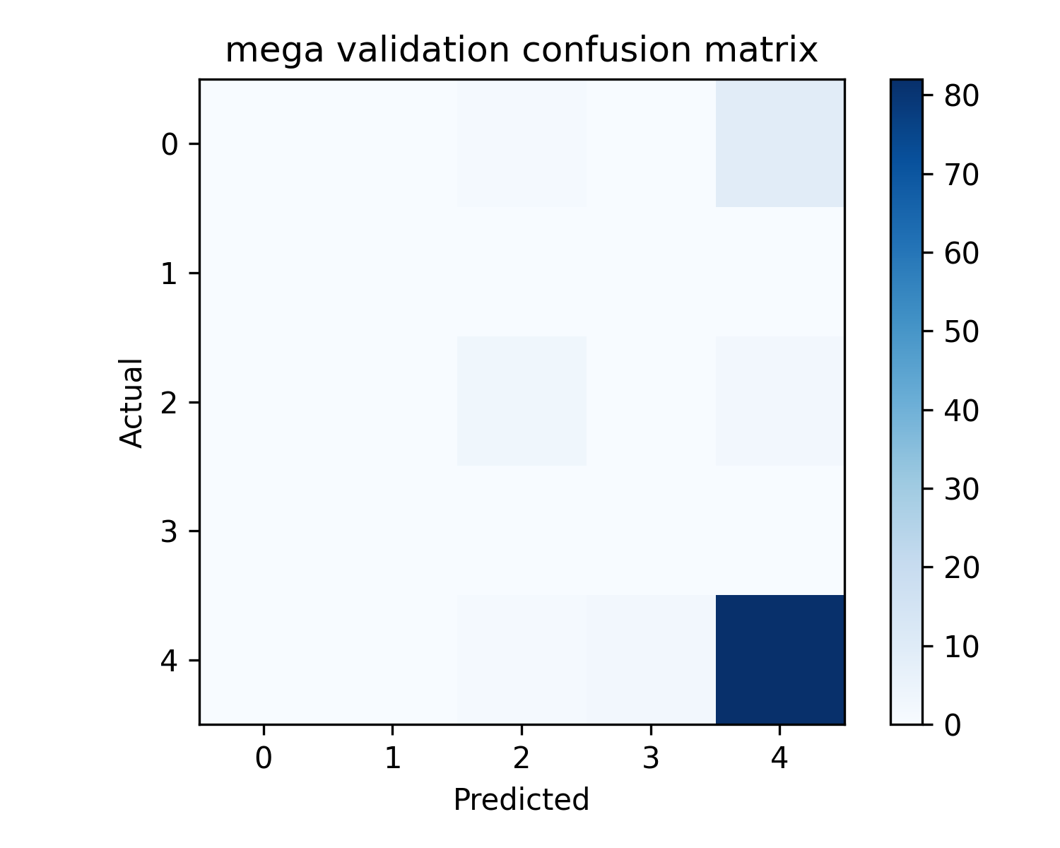
Confusion matrix: Mega
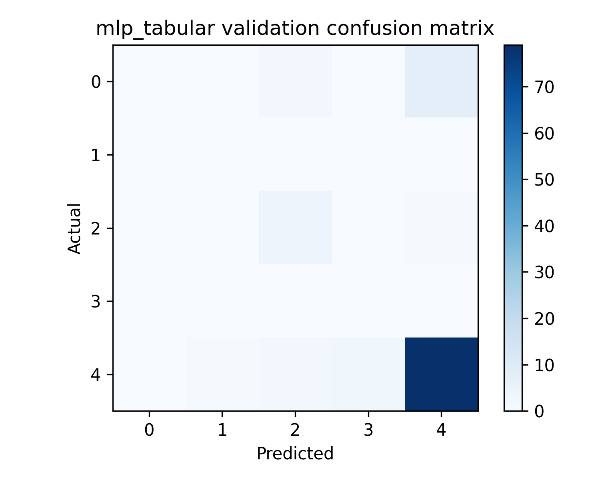
Confusion matrix: Mlp Tabular
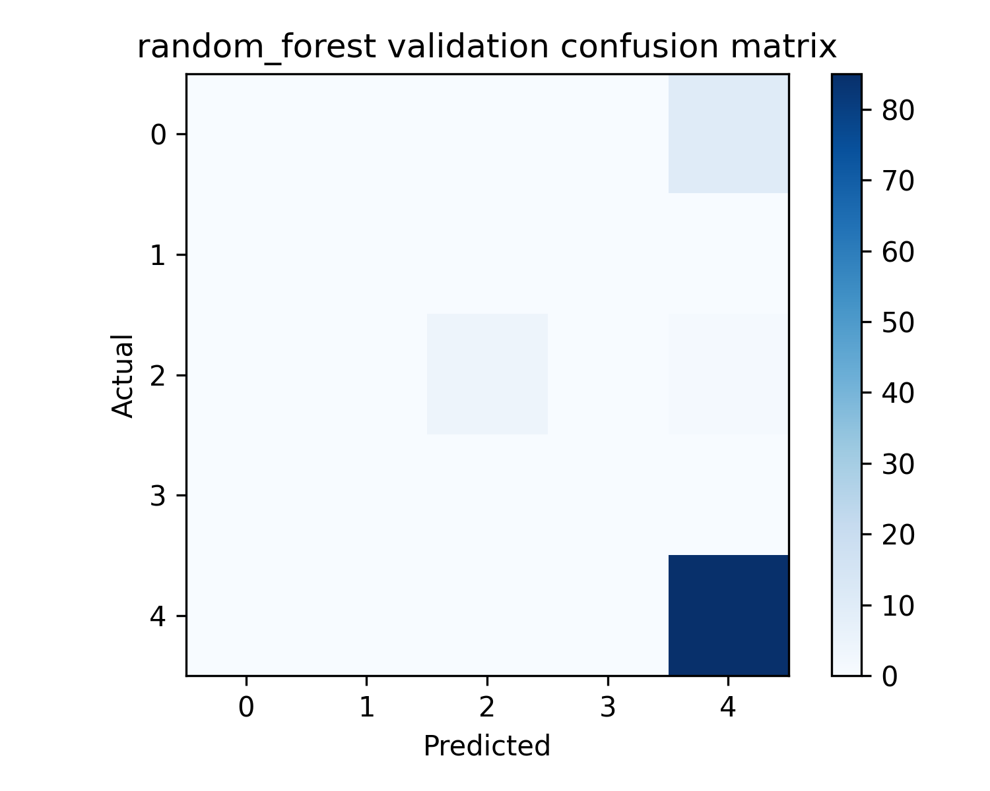
Confusion matrix: Random Forest
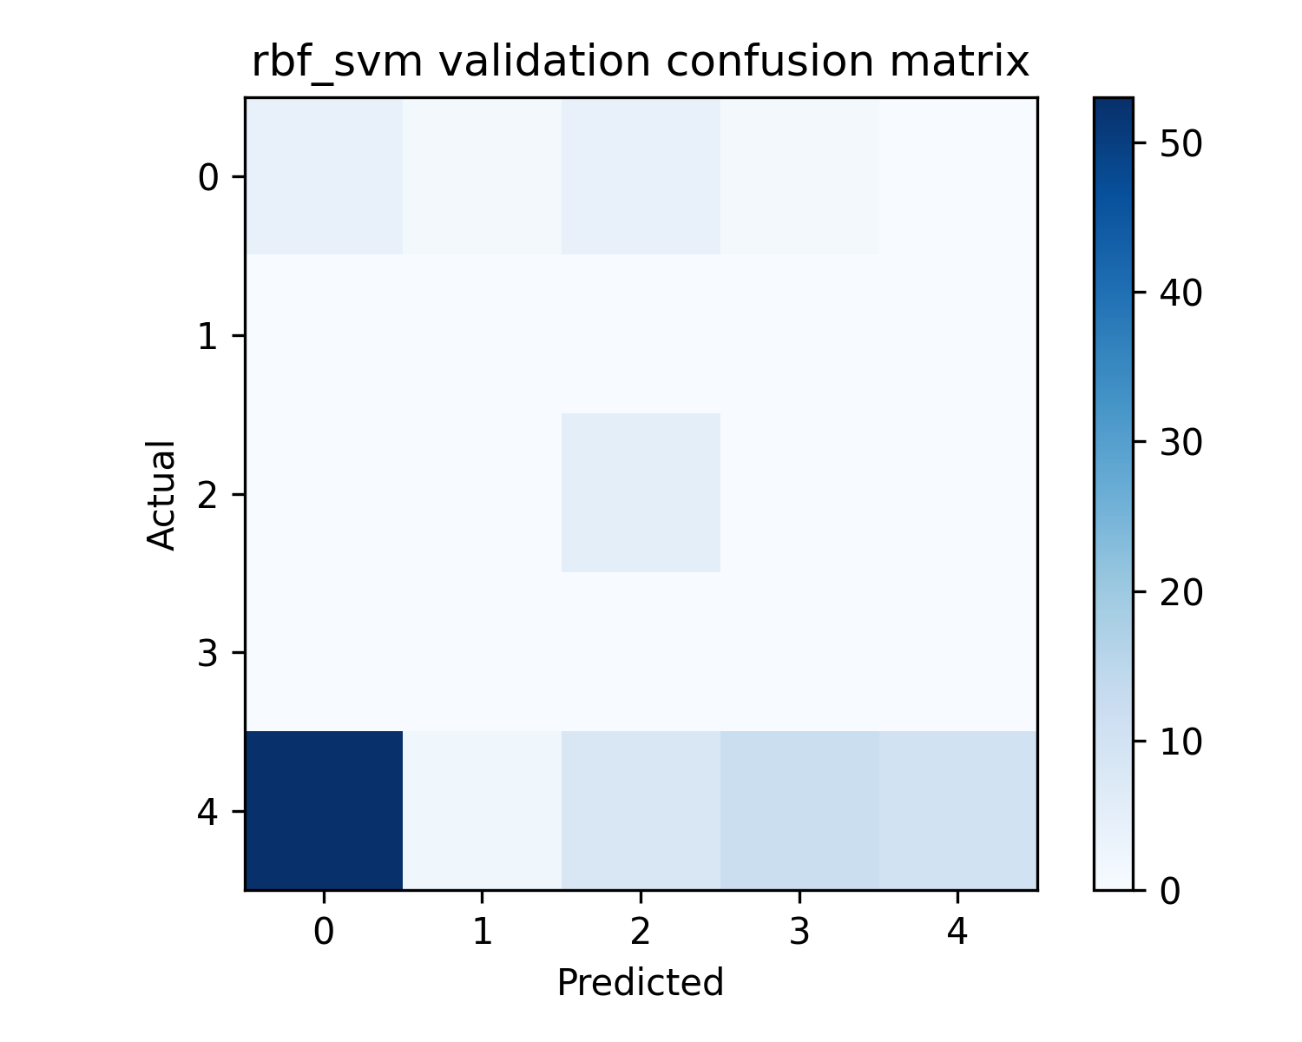
Confusion matrix: Rbf Svm
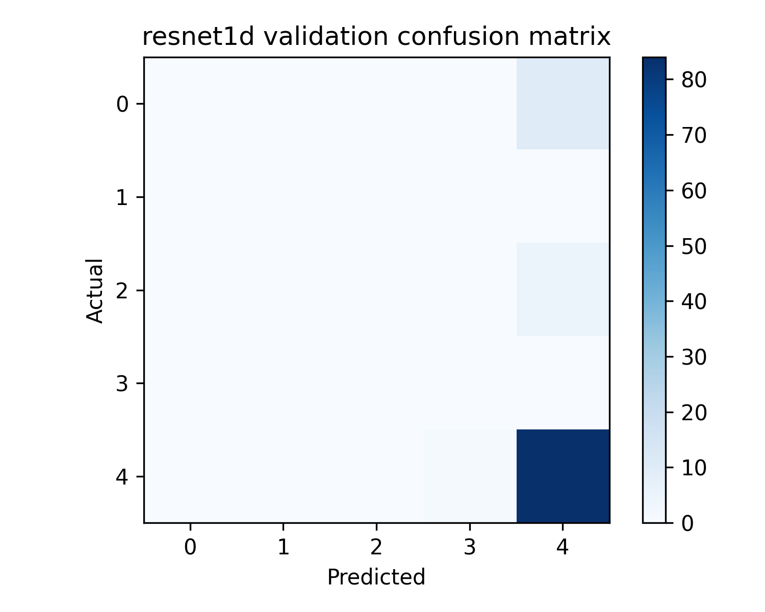
Confusion matrix: Resnet1D
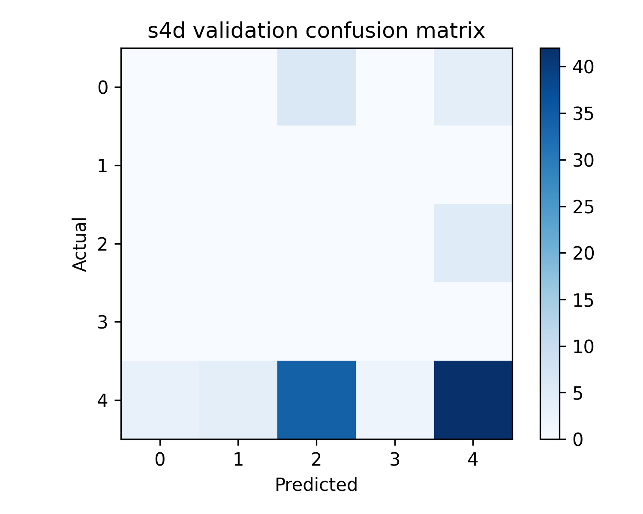
Confusion matrix: S4D
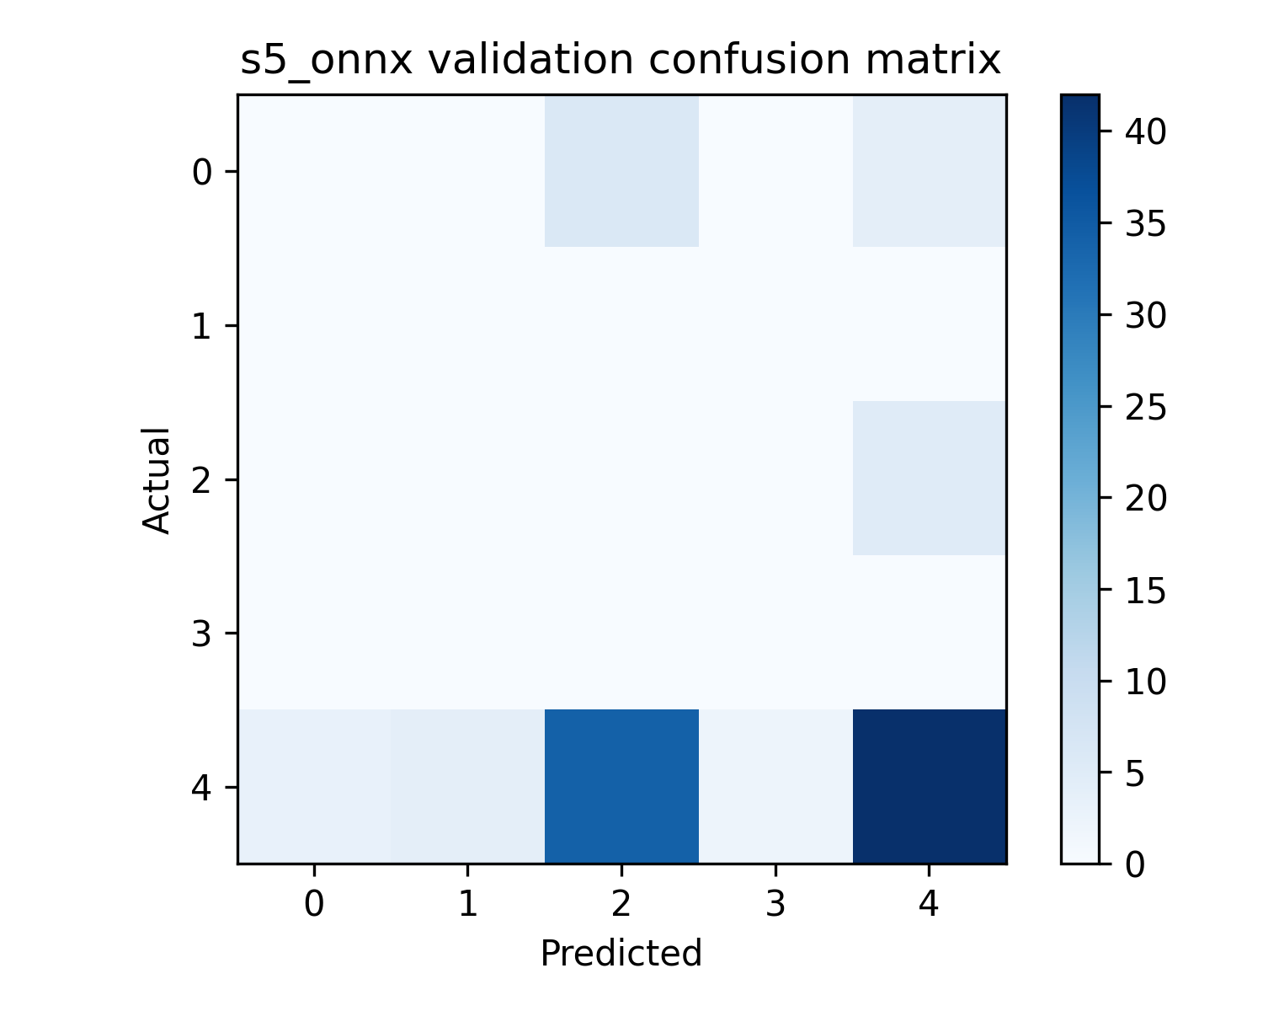
Confusion matrix: S5 Onnx
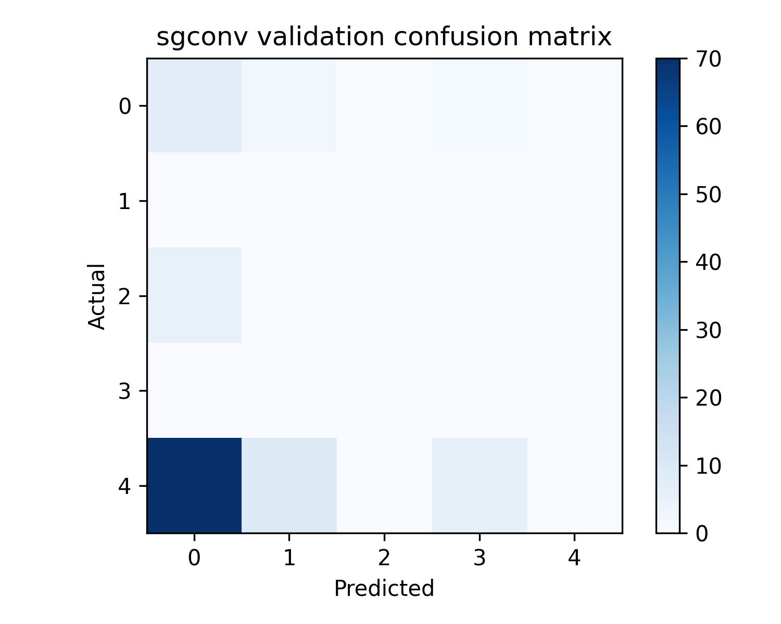
Confusion matrix: Sgconv
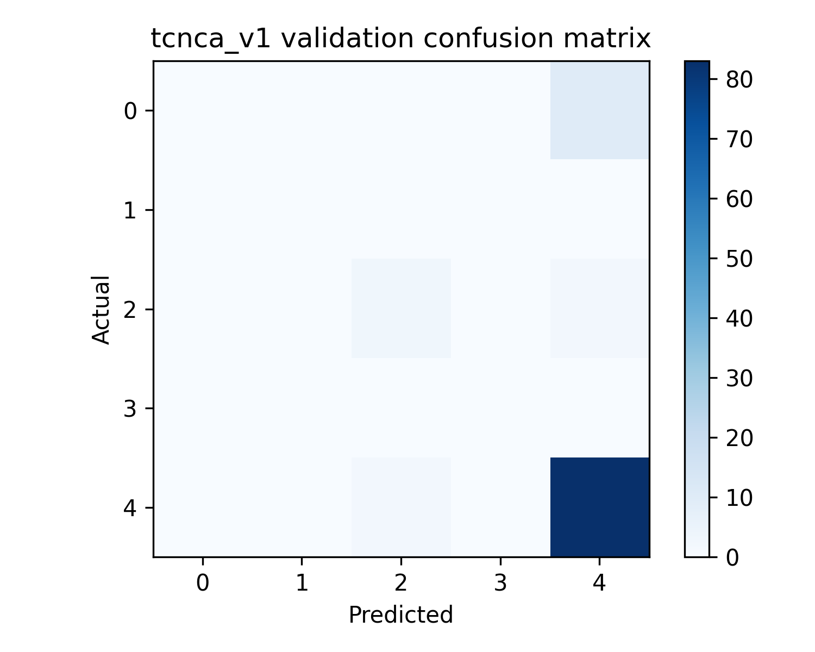
Confusion matrix: Tcnca V1
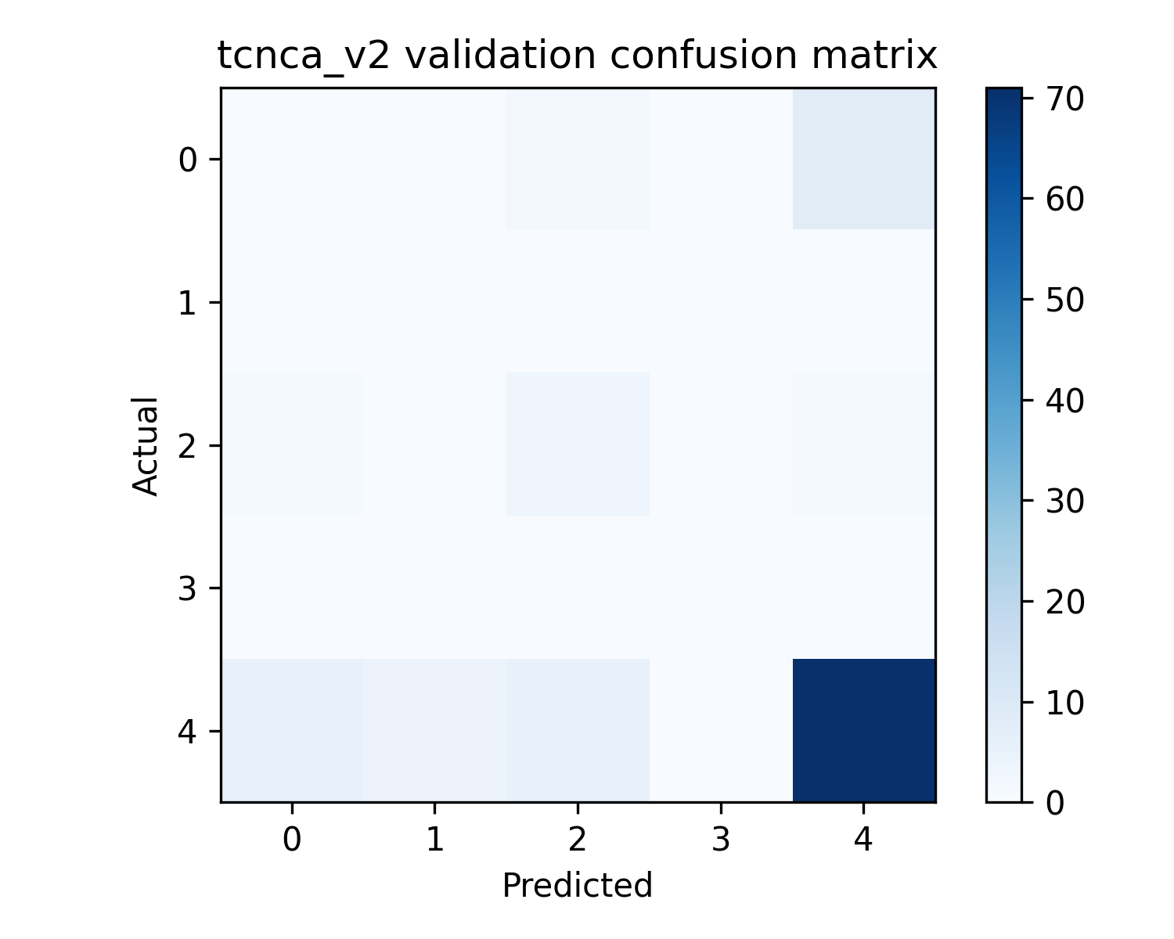
Confusion matrix: Tcnca V2
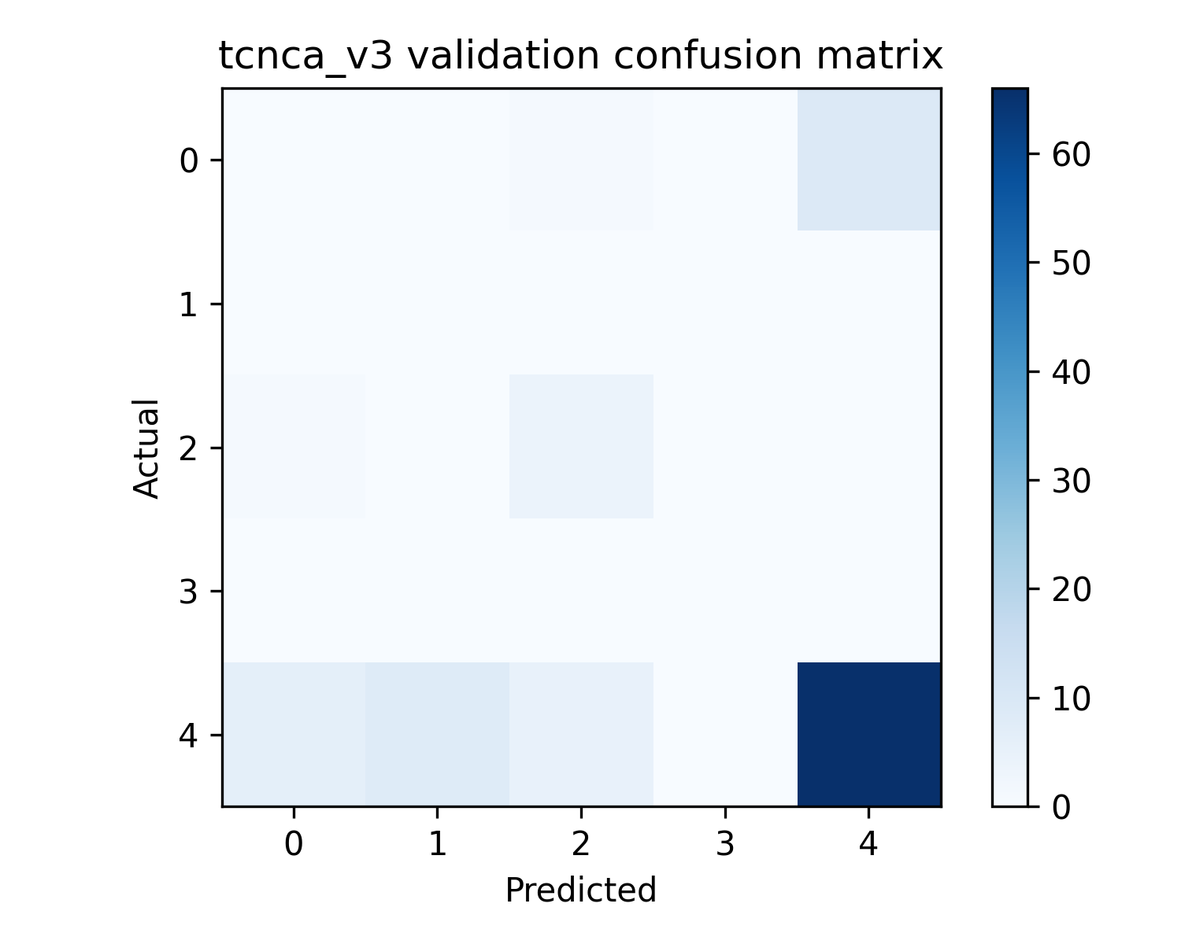
Confusion matrix: Tcnca V3
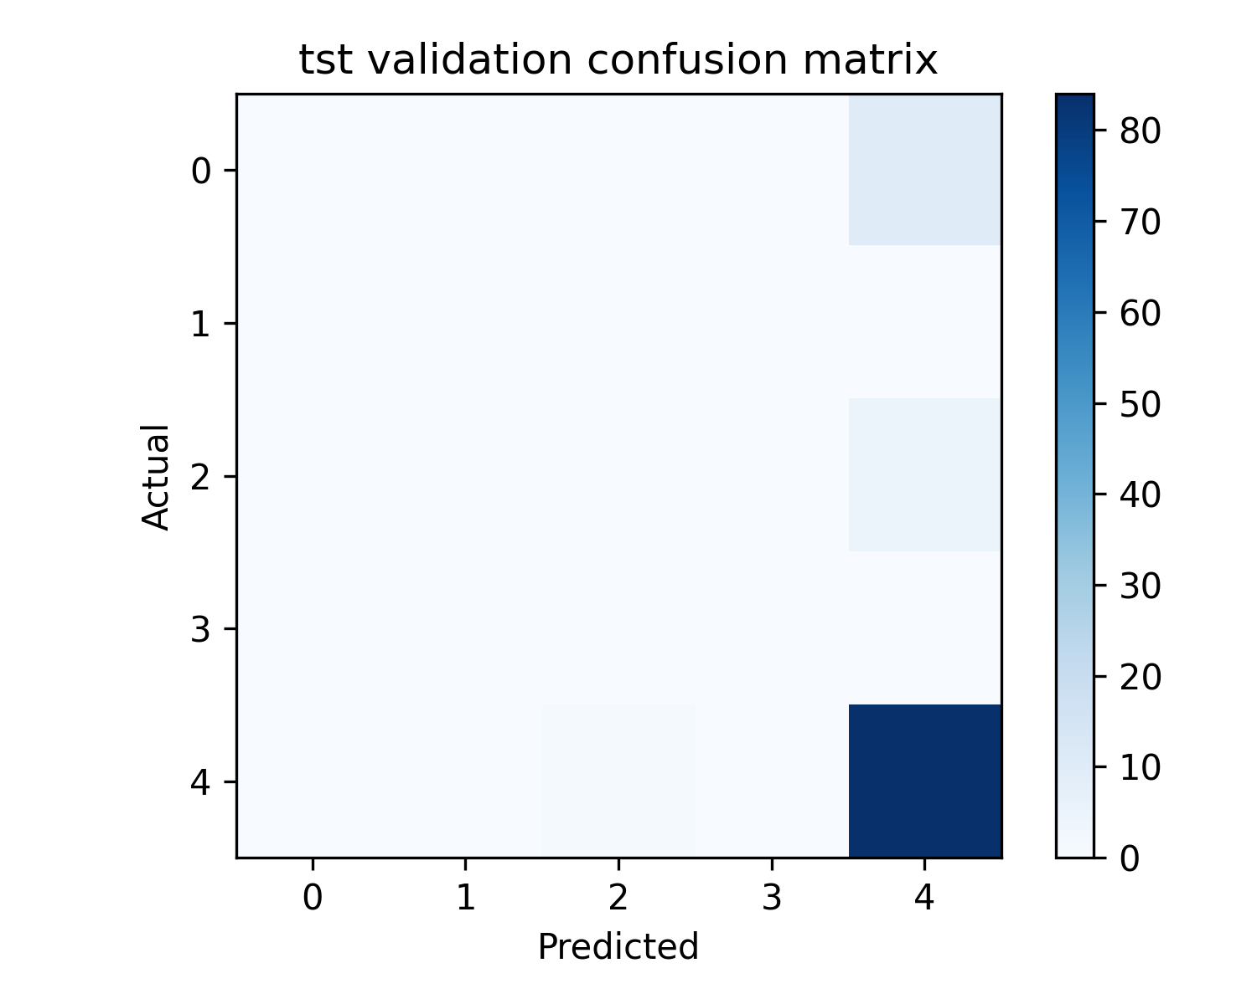
Confusion matrix: Tst
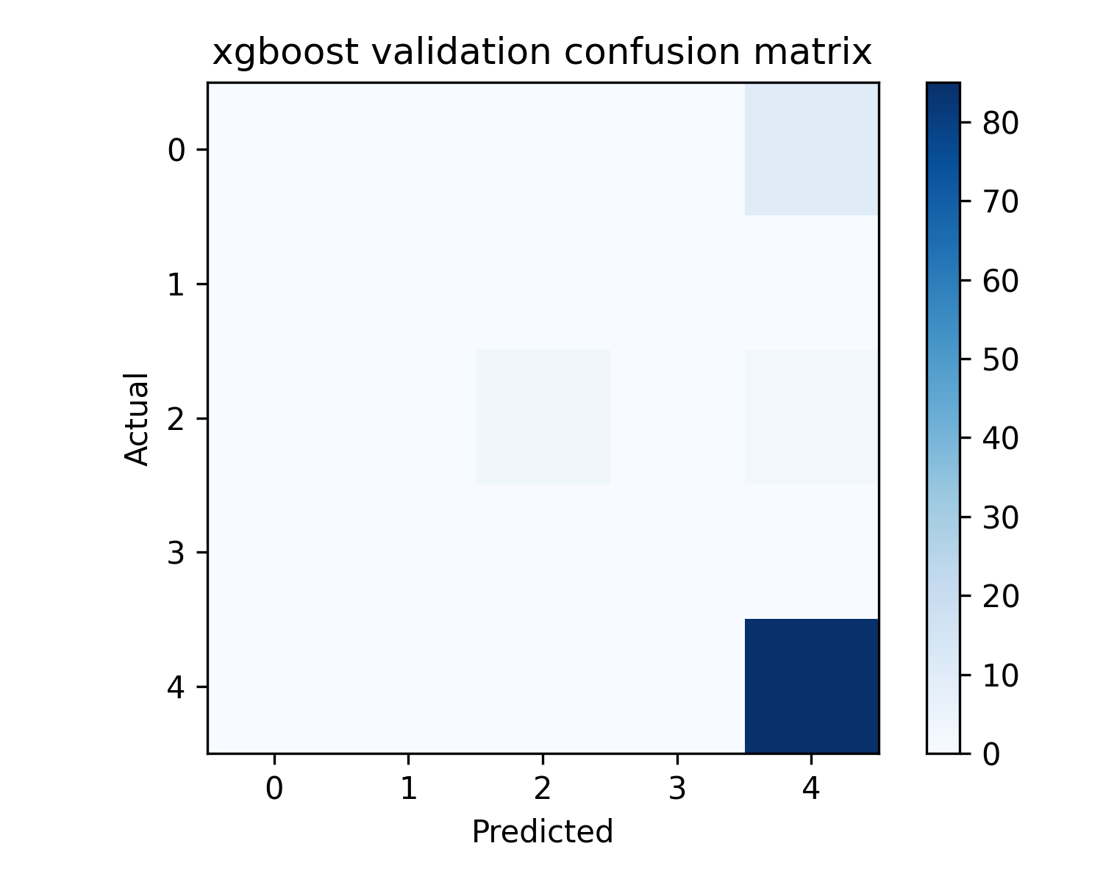
Confusion matrix: Xgboost

7. Robustness Channel Dropout
model | condition | accuracy | macro_f1 | status
histgradientboosting | channel_dropout | 0.8880 | 0.7094
lightgbm | channel_dropout | 0.8940 | 0.7400
random_forest | channel_dropout | 0.8940 | 0.7084
xgboost | channel_dropout | 0.9020 | 0.7755
logistic_regression | channel_dropout | 0.6260 | 0.4728
linear_svm | channel_dropout | 0.6340 | 0.4763
mlp_tabular | channel_dropout | 0.8660 | 0.6055
conv_transformer | channel_dropout | 0.8840 | 0.6178
gru | channel_dropout | 0.8680 | 0.6146
lstm | channel_dropout | 0.8520 | 0.5113
fusformer | channel_dropout | 0.8840 | 0.6165
mega | channel_dropout | 0.8920 | 0.6679
convnet_har | channel_dropout | 0.8760 | 0.6685
tcnca_v3 | channel_dropout | 0.7300 | 0.4861
rbf_svm | channel_dropout | 0.4000 | 0.4304
tcnca_v2 | channel_dropout | 0.7700 | 0.4958
tcnca_v1 | channel_dropout | 0.8840 | 0.6331
tst | channel_dropout | 0.8560 | 0.4058
s4d | channel_dropout | 0.4060 | 0.2453
s5_onnx | channel_dropout | 0.4060 | 0.2453
lru | channel_dropout | 0.4060 | 0.2453
sgconv | channel_dropout | 0.1680 | 0.2133
resnet1d | channel_dropout | 0.5820 | 0.1483

8. Robustness Clock Jitter
model | condition | accuracy | macro_f1 | status
histgradientboosting | clock_jitter | 0.8940 | 0.7144
lightgbm | clock_jitter | 0.9140 | 0.7738
random_forest | clock_jitter | 0.8980 | 0.7135
xgboost | clock_jitter | 0.9000 | 0.7319
logistic_regression | clock_jitter | 0.7400 | 0.4975
linear_svm | clock_jitter | 0.7180 | 0.4625
mlp_tabular | clock_jitter | 0.8740 | 0.6467
conv_transformer | clock_jitter | 0.8820 | 0.6160
gru | clock_jitter | 0.8620 | 0.6064
lstm | clock_jitter | 0.8500 | 0.4988
fusformer | clock_jitter | 0.8840 | 0.6165
mega | clock_jitter | 0.8840 | 0.6295
convnet_har | clock_jitter | 0.8840 | 0.6852
tcnca_v3 | clock_jitter | 0.7220 | 0.4871
rbf_svm | clock_jitter | 0.4300 | 0.4486
tcnca_v2 | clock_jitter | 0.8000 | 0.5620
tcnca_v1 | clock_jitter | 0.8840 | 0.6271
tst | clock_jitter | 0.8560 | 0.4058
s4d | clock_jitter | 0.3900 | 0.2243
s5_onnx | clock_jitter | 0.3900 | 0.2243
lru | clock_jitter | 0.3900 | 0.2243
sgconv | clock_jitter | 0.1660 | 0.2087
resnet1d | clock_jitter | 0.5860 | 0.1489

9. Robustness Missing Values
model | condition | accuracy | macro_f1 | status
histgradientboosting | missing | 0.8740 | 0.6658
lightgbm | missing | 0.9060 | 0.7525
random_forest | missing | 0.8920 | 0.6717
xgboost | missing | 0.8920 | 0.7044
logistic_regression | missing | 0.5900 | 0.4110
linear_svm | missing | 0.5800 | 0.3882
mlp_tabular | missing | 0.8500 | 0.5640
conv_transformer | missing | 0.8800 | 0.5991
gru | missing | 0.8620 | 0.5915
lstm | missing | 0.8500 | 0.5198
fusformer | missing | 0.8840 | 0.6165
mega | missing | 0.8840 | 0.6256
convnet_har | missing | 0.8560 | 0.6460
tcnca_v3 | missing | 0.7240 | 0.4513
rbf_svm | missing | 0.3880 | 0.4261
tcnca_v2 | missing | 0.7600 | 0.4752
tcnca_v1 | missing | 0.8780 | 0.5932
tst | missing | 0.8560 | 0.4058
s4d | missing | 0.3740 | 0.2388
s5_onnx | missing | 0.3760 | 0.2389
lru | missing | 0.3700 | 0.2480
sgconv | missing | 0.1660 | 0.2143
resnet1d | missing | 0.6420 | 0.1568

10. Robustness Noise
model | condition | accuracy | macro_f1 | status
histgradientboosting | noise | 0.8860 | 0.6851
lightgbm | noise | 0.9080 | 0.7826
random_forest | noise | 0.8940 | 0.6814
xgboost | noise | 0.8960 | 0.7118
logistic_regression | noise | 0.7360 | 0.4971
linear_svm | noise | 0.7180 | 0.4699
mlp_tabular | noise | 0.8660 | 0.6064
conv_transformer | noise | 0.8840 | 0.6178
gru | noise | 0.8680 | 0.6110
lstm | noise | 0.8480 | 0.5081
fusformer | noise | 0.8840 | 0.6178
mega | noise | 0.8840 | 0.6295
convnet_har | noise | 0.8720 | 0.6710
tcnca_v3 | noise | 0.7180 | 0.4584
rbf_svm | noise | 0.4100 | 0.4312
tcnca_v2 | noise | 0.7720 | 0.4923
tcnca_v1 | noise | 0.8820 | 0.6251
tst | noise | 0.8540 | 0.4037
s4d | noise | 0.4160 | 0.2739
s5_onnx | noise | 0.4000 | 0.2509
lru | noise | 0.3880 | 0.2388
sgconv | noise | 0.1660 | 0.2102
resnet1d | noise | 0.5860 | 0.1489

11. Robustness Window Size
No data available.

12. Final Comparison and Recommendation
Model | Val macro-F1 | Test accuracy | Test macro-F1 | Mean latency (ms) | P95 latency (ms)
lightgbm | 0.7596 | 0.7455 | 0.7294 | 0.0458 | 0.0458
histgradientboosting | 0.6510 | 0.7043 | 0.6838 | 0.0879 | 0.0879
xgboost | 0.6900 | 0.7053 | 0.6801 | 0.0111 | 0.0111
convnet_har | 0.4993 | 0.7005 | 0.6697 | 0.1641 | 0.3809
logistic_regression | 0.5683 | 0.6756 | 0.6670 | 0.0175 | 0.0175
linear_svm | 0.5309 | 0.6670 | 0.6536 | 0.0086 | 0.0086
rbf_svm | 0.4340 | 0.5990 | 0.6204 | 1.1353 | 1.1353
random_forest | 0.6277 | 0.6565 | 0.6078 | 0.1598 | 0.1598
mlp_tabular | 0.5244 | 0.6373 | 0.5703 | 0.7672 | 0.7672
fusformer | 0.5142 | 0.6354 | 0.5578 | 0.4561 | 1.3801
tcnca_v2 | 0.2831 | 0.6163 | 0.5577 | 0.1678 | 0.6041
mega | 0.5783 | 0.6383 | 0.5540 | 0.4662 | 1.3969
tcnca_v3 | 0.2932 | 0.5923 | 0.5422 | 0.1512 | 0.5784
tcnca_v1 | 0.4959 | 0.6258 | 0.5380 | 0.1394 | 0.3937
conv_transformer | 0.4878 | 0.6239 | 0.5293 | 0.8527 | 2.2665
gru | 0.3813 | 0.6201 | 0.5155 | 3.5532 | 3.5532
lstm | 0.3406 | 0.5770 | 0.4202 | 2.5292 | 2.5292
tst | 0.3660 | 0.5703 | 0.3665 | 0.7246 | 2.0426
sgconv | 0.1850 | 0.3273 | 0.2615 | 0.1537 | 0.1537
s4d | 0.2248 | 0.2890 | 0.2355 | 0.1170 | 0.1170
s5_onnx | 0.2248 | 0.2890 | 0.2355 | 0.1785 | 0.1785
lru | 0.2248 | 0.2890 | 0.2355 | 0.1192 | 0.1192
resnet1d | 0.1570 | 0.2746 | 0.0930 | 0.0397 | 0.0397

Recommendation: lightgbm was selected by validation macro-F1. lightgbm achieved the highest held-out test macro-F1. Final Raspberry Pi 5 deployment choice should consider both held-out macro-F1 and measured end-to-end latency, not adapter latency alone.
Workflow metadata: {'models': ['histgradientboosting', 'lightgbm', 'random_forest', 'xgboost', 'logistic_regression', 'linear_svm', 'mlp_tabular', 'conv_transformer', 'gru', 'lstm', 'fusformer', 'mega', 'convnet_har', 'tcnca_v3', 'rbf_svm', 'tcnca_v2', 'tcnca_v1', 'tst', 's4d', 's5_onnx', 'lru', 'sgconv', 'resnet1d'], 'labels': ['BUMP', 'LEFT', 'RIGHT', 'STOP', 'STRAIGHT'], 'window_counts': {'train': 3875, 'val': 1045, 'combined': 4921, 'test': 1045}, 'test_evaluation': 'saved deployment artifacts evaluated exactly once; robustness uses validation windows', 'report': 'logs\\COMPREHENSIVE_WORKFLOW_REPORT.md'}.

13. Limitations
- Each model used its existing/default configuration; no separate hyperparameter sweep was performed in this run.
- The supplied CSV partitions are treated as fixed train, validation, combined, and test datasets; generalisation beyond their source population is not established.
- Robustness tests are simulated perturbations and do not replace field validation.
- Latency shown is adapter/model inference latency on the current machine, not Raspberry Pi 5 end-to-end latency.
- EgoDrive RT and EgoDrive Max have no available trainable implementation or usable pretrained weights and therefore have no claimed test metrics.

