Two-Wheeler Behaviour Recognition
Detailed Protocol and 27-Model Report
This report keeps the paper-style random 80/20 results separate from the required independent four-file evaluation.

1. Executive summary
The best available paper-style random-split result is TCNCA optimized at 79.90% accuracy and 80.00% macro-F1. The paper-style TST result is 75.12% accuracy and 74.05% macro-F1. Under the required strict protocol, the best individual model is HistGradientBoosting at 74.74% accuracy and 73.25% macro-F1; the validation-selected ensemble reaches 75.02% accuracy.
The strict protocol is the authoritative deployment comparison because `test.csv` is not used for training or hyperparameter selection.

2. Dataset and common settings
Setting | Value
Raw features | Ax, Ay, Az, Gx, Gy, Gz, Speed
Window size | 156 samples
Stride | 78 samples
Classes | BUMP, LEFT, RIGHT, STOP, STRAIGHT
Strict train windows | 3,875
Strict validation windows | 1,045
Strict combined windows | 4,921
Strict test windows | 1,045
CSV encoding | UTF-8 with BOM support (utf-8-sig)

3. Protocol definitions
Protocol | Procedure | Interpretation
Random 80/20 | Window clean.csv; stratified random split with seed 42 | Reference/paper-style benchmark; possible neighboring-window overlap
Strict four-file | train.csv -> val.csv -> train_val_combined.csv -> test.csv | Independent held-out test; authoritative comparison

4. Best random 80/20 classification results
model | family | accuracy | macro_f1 | protocol
TCNCA optimized | Temporal convolution/channel attention | 79.90% | 80.00% | clean.csv random stratified 80/20
TST optimized | Time Series Transformer | 75.12% | 74.05% | clean.csv random stratified 80/20

Confusion matrix: TCNCA optimized (random 80/20)
true \ predicted | BUMP | LEFT | RIGHT | STOP | STRAIGHT
BUMP | 175 | 13 | 7 | 5 | 35
LEFT | 13 | 85 | 5 | 2 | 10
RIGHT | 4 | 0 | 55 | 1 | 2
STOP | 8 | 2 | 5 | 161 | 12
STRAIGHT | 23 | 17 | 16 | 8 | 268

Confusion matrix: TST optimized (random 80/20)
true \ predicted | BUMP | LEFT | RIGHT | STOP | STRAIGHT
BUMP | 154 | 26 | 20 | 1 | 34
LEFT | 7 | 94 | 5 | 0 | 9
RIGHT | 1 | 1 | 55 | 0 | 5
STOP | 3 | 2 | 12 | 155 | 16
STRAIGHT | 57 | 40 | 70 | 9 | 269

Only the completed optimized TCNCA and TST random-split experiments are claimed here. The other 25 models do not have equivalent completed paper-style 80/20 measurements in the current artifact set, so they are not assigned invented random-split values.

5. Complete 27-model strict classification results
rank | model | family | accuracy | macro_f1 | status
1 | histgradientboosting | Tree boosting | 74.64% | 73.74% | independent_test
2 | lightgbm | Tree boosting | 74.55% | 72.94% | independent_test
3 | rbf_svm | Kernel SVM | 72.63% | 70.45% | independent_test
4 | xgboost | Tree boosting | 71.87% | 69.44% | independent_test
5 | mlp_tabular | Tabular neural | 71.48% | 68.56% | independent_test
6 | tcn | Temporal convolution | 69.09% | 68.37% | independent_test
7 | random_forest | Tree ensemble | 68.71% | 65.70% | independent_test
8 | lstm_attention | Recurrent + attention | 67.75% | 66.52% | independent_test
9 | fusformer | Transformer | 67.27% | 65.95% | independent_test
10 | mega | Transformer | 66.99% | 65.96% | independent_test
11 | linear_svm | Linear SVM | 66.99% | 65.84% | independent_test
12 | bilstm_attention | Bidirectional + attention | 66.70% | 65.78% | independent_test
13 | gru | Recurrent | 66.32% | 65.33% | independent_test
14 | bilstm | Bidirectional recurrent | 64.98% | 64.36% | independent_test
15 | conv_transformer | Transformer | 64.88% | 63.74% | independent_test
16 | tcnca_v1 | TCN/channel attention | 64.59% | 64.51% | independent_test
17 | convnet_har | Temporal CNN | 64.02% | 63.70% | independent_test
18 | tst | Time Series Transformer | 63.25% | 63.43% | independent_test
19 | tcnca_v2 | TCN/channel attention | 62.30% | 62.29% | independent_test
20 | logistic_regression | Linear baseline | 60.96% | 61.94% | independent_test
21 | lstm | Recurrent | 58.47% | 58.32% | independent_test
22 | tcnca_v3 | TCN/channel attention | 57.42% | 57.94% | independent_test
23 | s4d | State-space | 51.20% | 44.91% | independent_test
24 | s5_onnx | State-space | 51.20% | 44.91% | independent_test
25 | lru | State-space | 51.20% | 44.91% | independent_test
26 | resnet1d | Residual CNN | 38.47% | 36.03% | independent_test
27 | sgconv | Structured convolution | 33.78% | 26.44% | independent_test

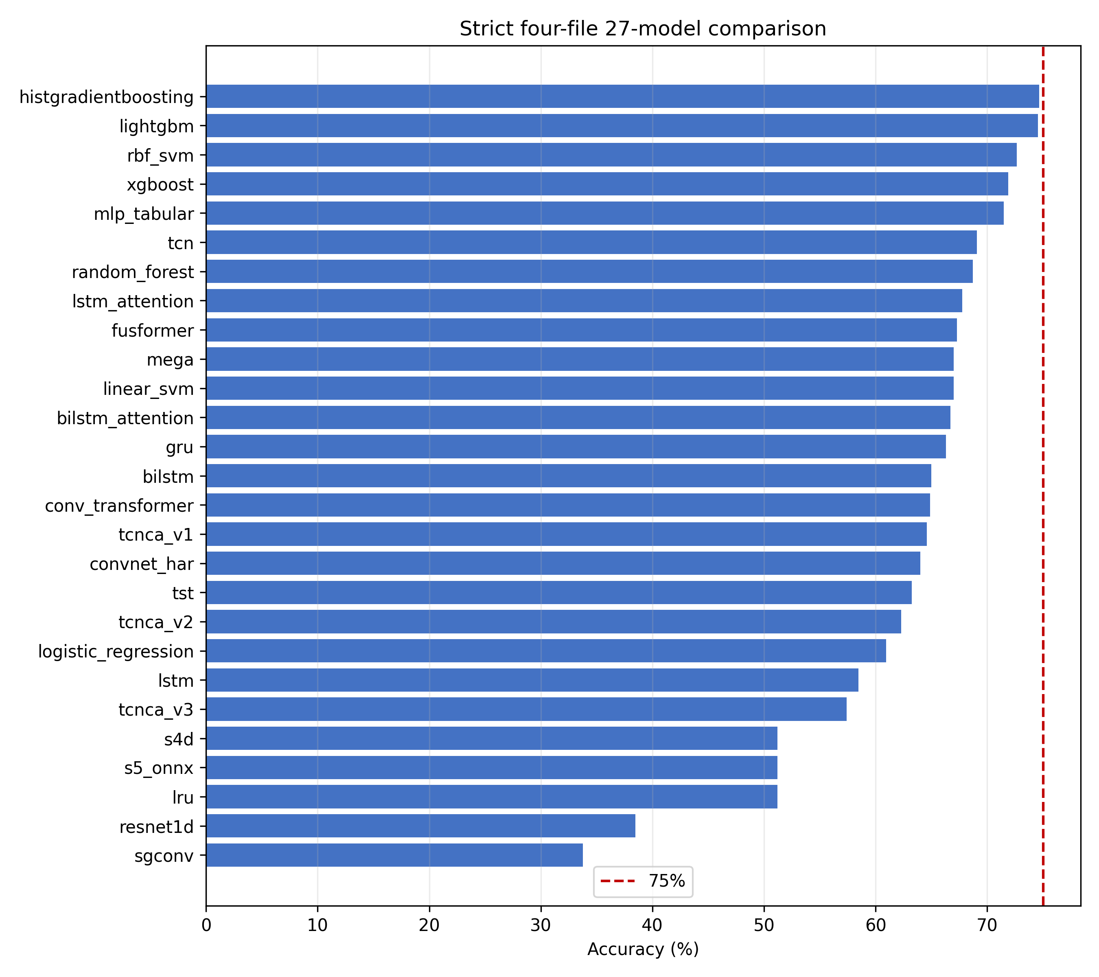
Confusion matrix: HistGradientBoosting (strict four-file)
true \ predicted | BUMP | LEFT | RIGHT | STOP | STRAIGHT
BUMP | 142 | 17 | 7 | 1 | 68
LEFT | 2 | 89 | 5 | 0 | 19
RIGHT | 1 | 1 | 45 | 0 | 15
STOP | 5 | 2 | 0 | 136 | 45
STRAIGHT | 33 | 21 | 16 | 6 | 369

Confusion matrix: TST (strict four-file)
true \ predicted | BUMP | LEFT | RIGHT | STOP | STRAIGHT
BUMP | 172 | 22 | 20 | 5 | 16
LEFT | 13 | 90 | 5 | 2 | 5
RIGHT | 5 | 0 | 55 | 1 | 1
STOP | 15 | 2 | 9 | 152 | 10
STRAIGHT | 118 | 55 | 71 | 9 | 192

6. Strict class-wise metrics
class | precision | recall | support
BUMP | 77.60% | 60.43% | 235
LEFT | 68.46% | 77.39% | 115
RIGHT | 61.64% | 72.58% | 62
STOP | 95.10% | 72.34% | 188
STRAIGHT | 71.51% | 82.92% | 445

Class-wise metrics show why macro-F1 is reported alongside accuracy: the class counts are imbalanced, and aggregate accuracy can hide weaker minority-class performance.

7. Robustness results
test | accuracy | macro_f1
channel_dropout | 74.55% | 73.18%
noise | 75.02% | 74.19%
missing | 73.88% | 72.57%
clock_jitter | 74.55% | 73.13%
window_size_100 | 74.83% | 73.50%
window_size_128 | 75.12% | 74.08%
window_size_156 | 74.74% | 73.25%
window_size_200 | 74.16% | 72.84%

These tests use the strict test windows with simulated perturbations and are diagnostic only; they are not additional independent holdout evaluations.

8. Window-size sensitivity
test | accuracy | macro_f1
window_size_100 | 74.83% | 73.50%
window_size_128 | 75.12% | 74.08%
window_size_156 | 74.74% | 73.25%
window_size_200 | 74.16% | 72.84%

The official model input remains 156 samples. Alternative window sizes in this table are resampled to the fixed model input and therefore indicate sensitivity, not retrained-model comparisons.

9. Limitations and deployment notes
Random 80/20 results can be optimistic when overlapping windows are split randomly. They reproduce the paper-style result but should not replace the strict independent test. The strict results use saved artifacts and a single final test evaluation. Raspberry Pi 5 latency, memory, and end-to-end queueing still require hardware validation.
Unavailable EgoDrive RT and EgoDrive Max implementations are excluded from the 27 measured classification rows because no usable trainable implementation or pretrained artifact was available.

