Two-Wheeler Behaviour Recognition
Protocol Comparison Report
This report separates the paper-style random 80/20 window split from the required train/validation/combined/independent-test protocol.

1. Protocol summary
Protocol | Procedure | Interpretation
Random 80/20 | Windows from clean.csv; stratified random split; seed 42 | Reference reproduction; overlapping windows may cross split
Strict four-file | train.csv -> val.csv -> train_val_combined.csv -> test.csv | Authoritative independent-test comparison

2. Best measured accuracies
protocol | model | accuracy_percent | macro_f1_percent
Random 80/20 windows | TCNCA optimized | 79.9043 | 79.9979
Random 80/20 windows | TST optimized | 75.1196 | 74.0540
train/val/combined/test | HistGradientBoosting | 74.7368 | 73.2465
train/val/combined/test | Validation ensemble | 75.0239 | 73.4050
train/val/combined/test | TCN | 73.2057 | 71.9801
train/val/combined/test | TST | 69.5694 | 68.2199

The 75.12% TST result is reproduced under the random 80/20 protocol. Under the required strict protocol, the best individual model is HistGradientBoosting at 74.74%; the validation-selected ensemble reaches 75.02%.

3. Confusion matrices
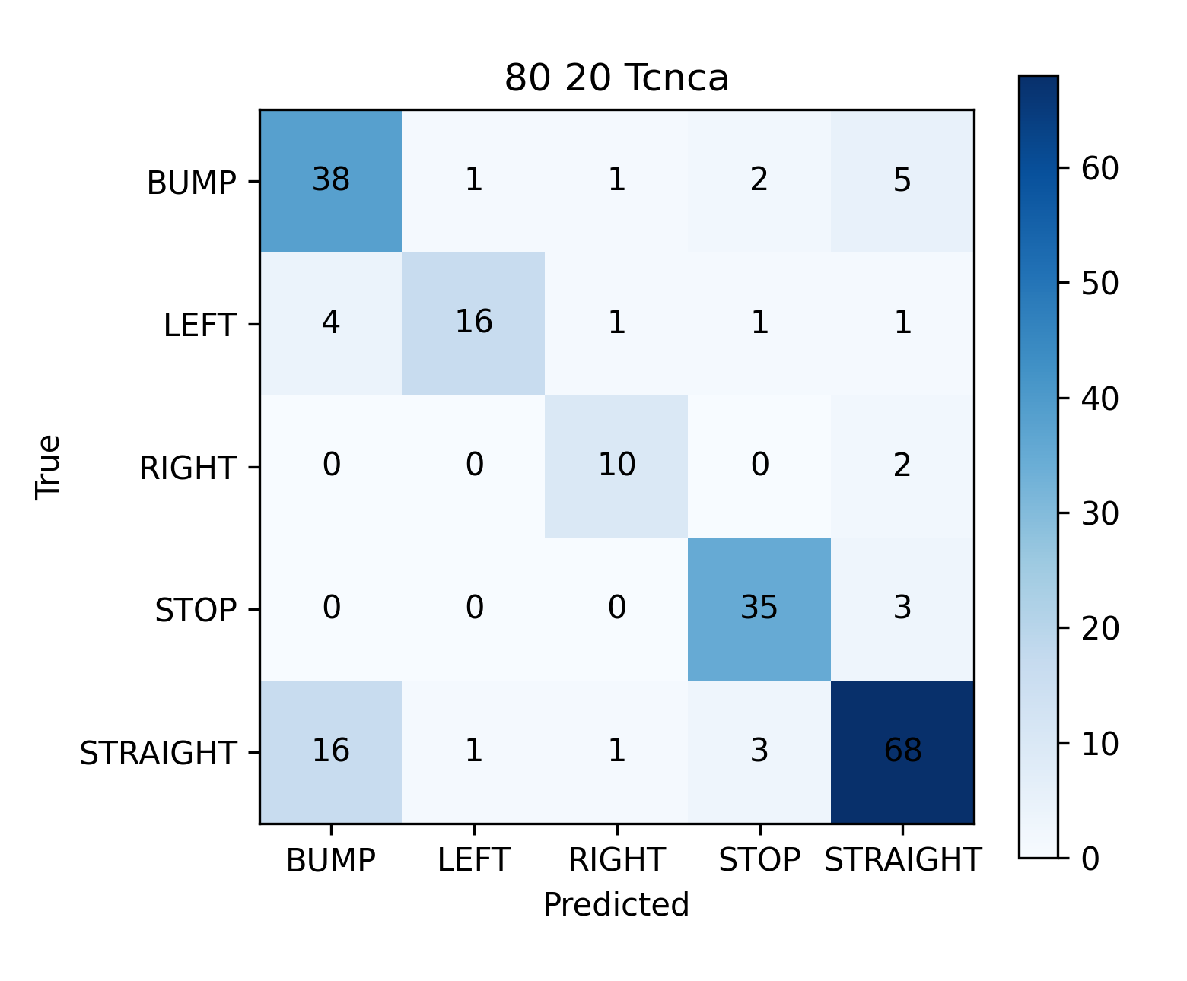
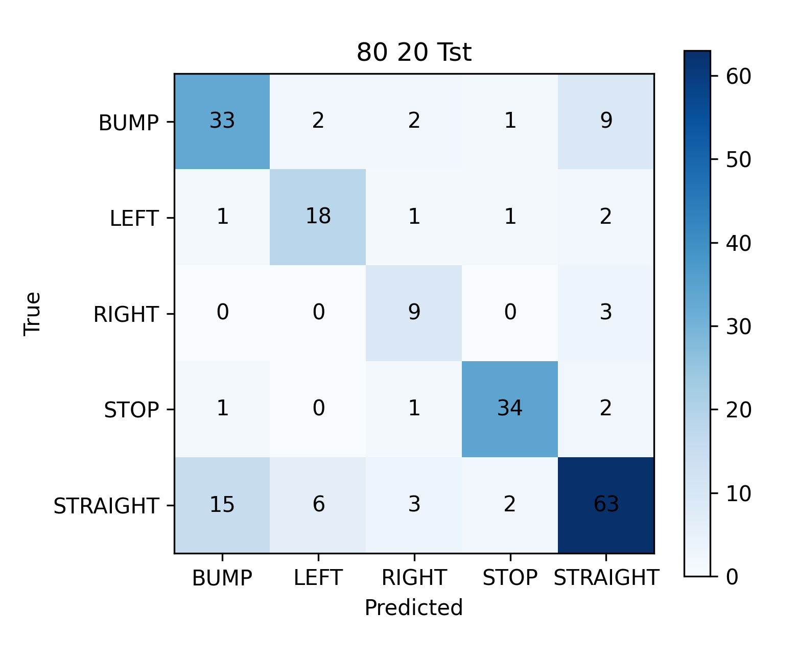
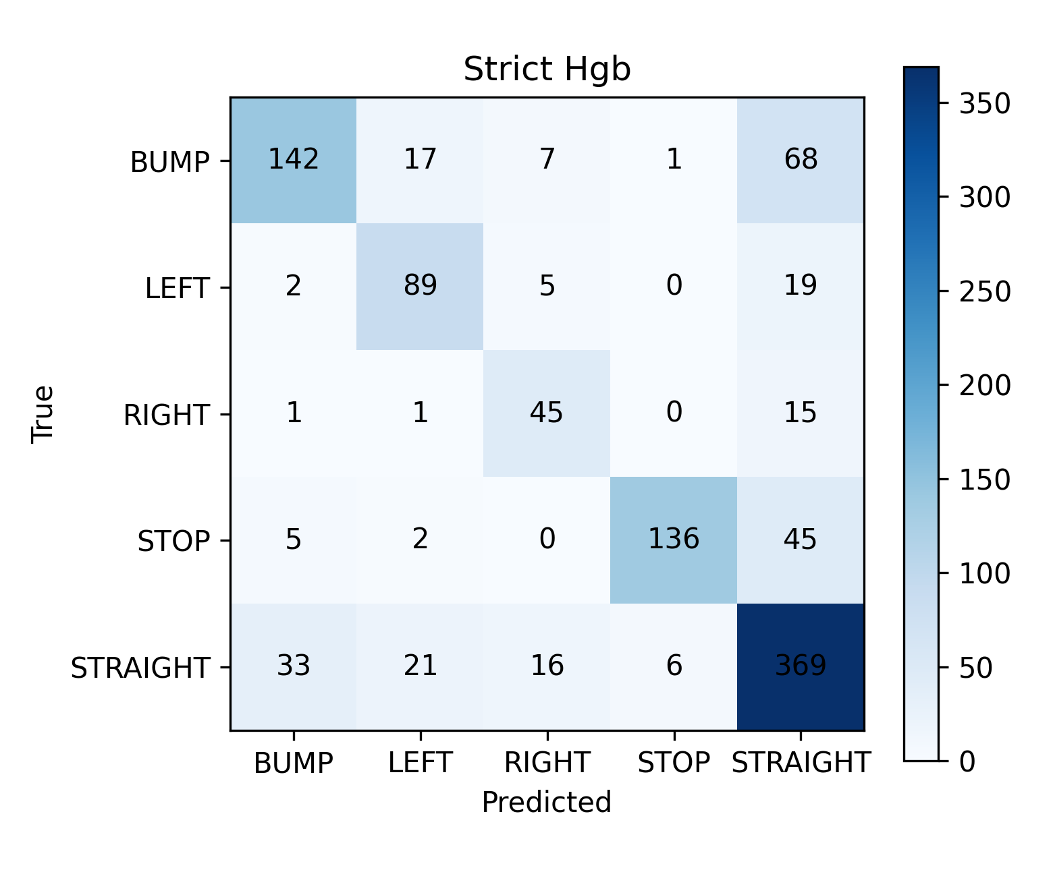
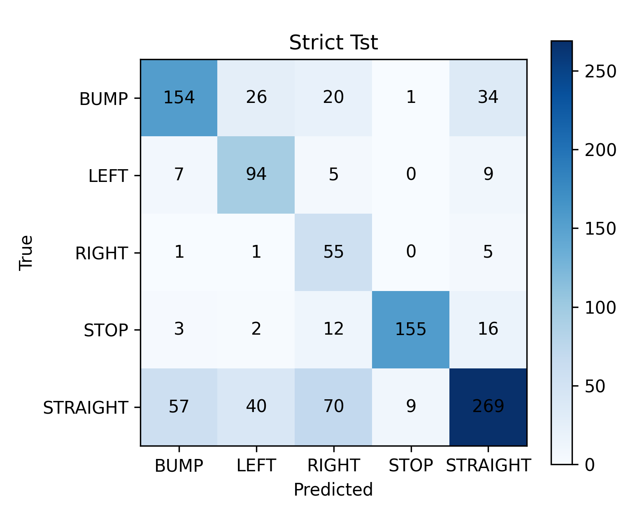

4. Window-size sensitivity
test | accuracy | macro_f1
window_size_100 | 0.7483 | 0.7350
window_size_128 | 0.7512 | 0.7408
window_size_156 | 0.7474 | 0.7325
window_size_200 | 0.7416 | 0.7284

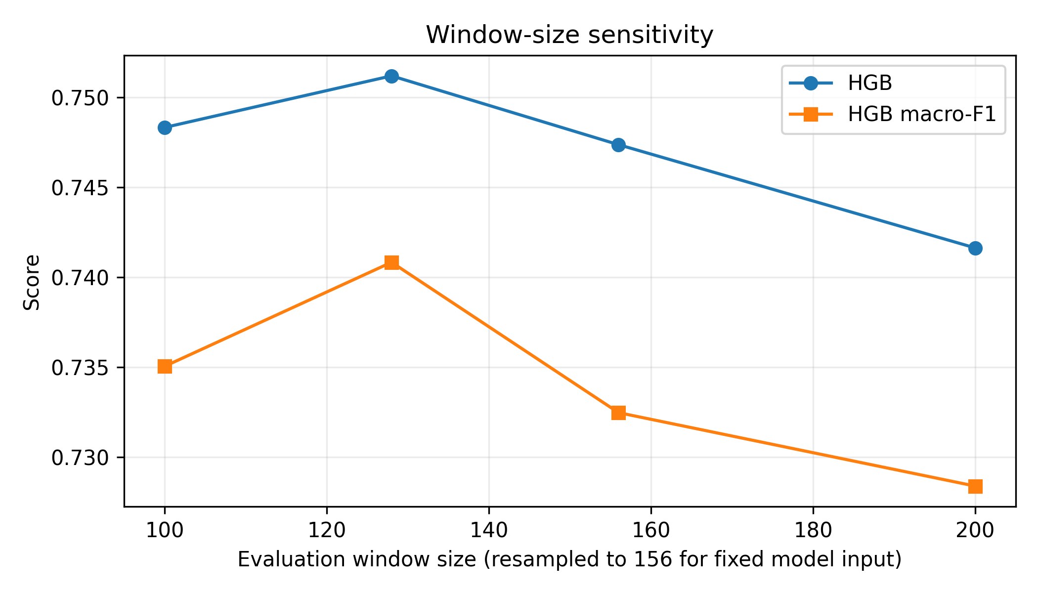
The sensitivity check is descriptive: the trained tabular model requires 156-sample input, so alternative windows are linearly resampled to that input length. These values do not replace the official 156-sample test result and were not used for selection.

5. Robustness
test | accuracy | macro_f1
channel_dropout | 0.7455 | 0.7318
noise | 0.7502 | 0.7419
missing | 0.7388 | 0.7257
clock_jitter | 0.7455 | 0.7313
window_size_100 | 0.7483 | 0.7350
window_size_128 | 0.7512 | 0.7408
window_size_156 | 0.7474 | 0.7325
window_size_200 | 0.7416 | 0.7284

Robustness conditions are simulated channel dropout, noise, missing samples, clock jitter, and window-size changes. They are diagnostic and do not constitute additional independent holdout sets.

6. Dataset and fixed settings
Setting | Value
Features | Ax, Ay, Az, Gx, Gy, Gz, Speed
Window | 156 samples
Stride | 78 samples
Classes | BUMP, LEFT, RIGHT, STOP, STRAIGHT
Strict split windows | Train 3,875; validation 1,045; combined 4,921; test 1,045

7. Limitations
Random-window results are not directly comparable to the strict independent test because overlapping neighboring windows can be distributed across both random partitions. Raspberry Pi 5 latency and memory still require hardware measurement.

