REPORT
Team No: 4
Team Members: Batool Ather 1602-23-735-007
M. Shreyas 1602-23-735-180
Project Title: Video Classification using Ufc101

ABSTRACT
Video classification is a key problem in computer vision with widespread applications in surveillance, sports analytics, human-computer interaction, and content recommendation. The UCF101 dataset, comprising 13,320 videos across 101 human action categories, serves as a standard benchmark for evaluating action recognition algorithms. This project explores various deep learning techniques for video classification using UCF101, including Convolutional Neural Networks (CNNs), 3D CNNs (such as C3D and I3D), Recurrent Neural Networks (LSTM/GRU), and Transformer-based models like TimeSformer. Each model captures spatial and temporal features in different ways to accurately identify actions within video clips. We investigate the performance of these architectures and compare their accuracy, computational efficiency, and suitability for real-time applications. Preprocessing steps such as frame extraction, normalization, and temporal sampling are also discussed. Experimental results demonstrate that models leveraging spatiotemporal attention mechanisms achieve high classification accuracy on UCF101, confirming the effectiveness of deep neural networks in video understanding tasks. This work provides insights into model selection and design for real-world video classification systems.

PROBLEM STATEMENT
The automatic recognition and classification of human actions in video data is a challenging yet essential task in the field of computer vision. Traditional image classification models fail to capture the temporal dynamics inherent in video sequences, making them unsuitable for action recognition tasks. The goal of this project is to develop an effective video classification system capable of accurately identifying human actions in video clips using the UCF101 dataset, which consists of 101 distinct action categories. This involves addressing challenges such as extracting and learning both spatial (appearance) and temporal (motion) features, handling varying video durations, managing computational complexity, and ensuring model generalization. The core problem is to design, implement, and evaluate deep learning models—such as 3D Convolutional Neural Networks (3D CNNs), CNN-LSTM hybrids, and Transformer-based architectures—that can learn meaningful spatiotemporal representations to classify actions in short video clips with high accuracy.

OBJECTIVE
To develop a deep learning-based video classification model using the UCF101 dataset that can accurately classify short video clips into one of 101 predefined human action categories. The aim is to explore various video classification techniques and evaluate model performance using real-world video data.

PROPOSED SOLUTION
- Use a Convolutional Neural Network (CNN) + LSTM or a 3D CNN model to extract spatial and temporal features from video frames.
- Preprocess the UCF101 dataset by extracting frames, resizing them, and creating sequences for training and testing.
- Train the model on extracted frame sequences and validate its performance using accuracy and loss metrics.
- Perform classification and display predicted labels along with confidence scores.

BLOCK DIAGRAM
┌────────────┐
│ UCF101 │
│ Dataset │
└─────┬──────┘
│
▼
┌────────────────────┐
│ Frame Extraction │
│ & Preprocessing │
└─────┬──────────────┘
▼
┌──────────────────────────┐
│ Feature Extraction Layer │
│ (CNN / 3D CNN) │
└─────┬────────────────────┘
▼
┌───────────────────────┐
│ Sequence Modeling │
│ (LSTM / Transformer) │
└─────┬─────────────────┘
▼
┌────────────────────────────┐
│ Fully Connected + Softmax │
└─────┬──────────────────────┘
▼
┌──────────────────────┐
│ Class Prediction │
│ (e.g., Archery, Golf)│
└──────────────────────┘

METHODOLOGY
- Dataset Preparation
  - Downloaded and extracted the UCF101 dataset.
  - Extracted frames from each video using OpenCV.
  - Resized frames to a uniform shape (e.g., 224x224).
- Data Processing
  - Created fixed-length frame sequences per video (e.g., 16 frames).
  - Encoded labels into numerical categories.
- Model Development
  - Used either:
    - A CNN + LSTM model to handle spatial (CNN) and temporal (LSTM) aspects.
    - A 3D CNN model like C3D/I3D to handle both simultaneously.
- Training
  - Used train_test_split for creating training and validation sets.
  - Applied categorical cross-entropy loss and Adam optimizer.
  - Used accuracy as a metric.
- Testing and Results
  - Predicted action class for test videos.
  - Visualized predictions and compared with ground truth labels.
- Evaluation
  - Accuracy and loss graphs plotted.
  - Confusion matrix (optional).
  - Checked misclassifications to refine the model.

LEARNING OUTCOMES
- Understood how to process and handle video datasets for machine learning.
- Gained hands-on experience with video frame extraction, data pipelines, and deep learning architectures.
- Learned the application of CNN, LSTM, and 3D CNNs in the context of action recognition.
- Practiced model evaluation and result visualization techniques.
- Developed debugging and optimization skills for deep learning models.

RESULTS

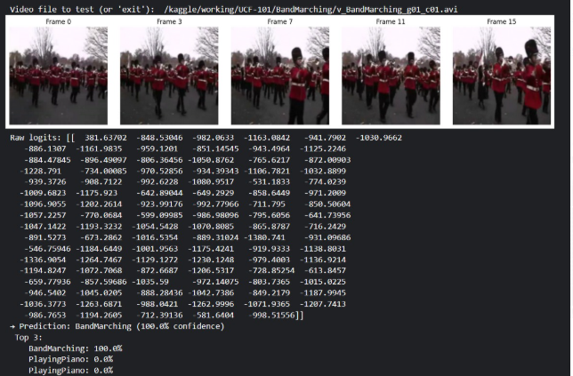

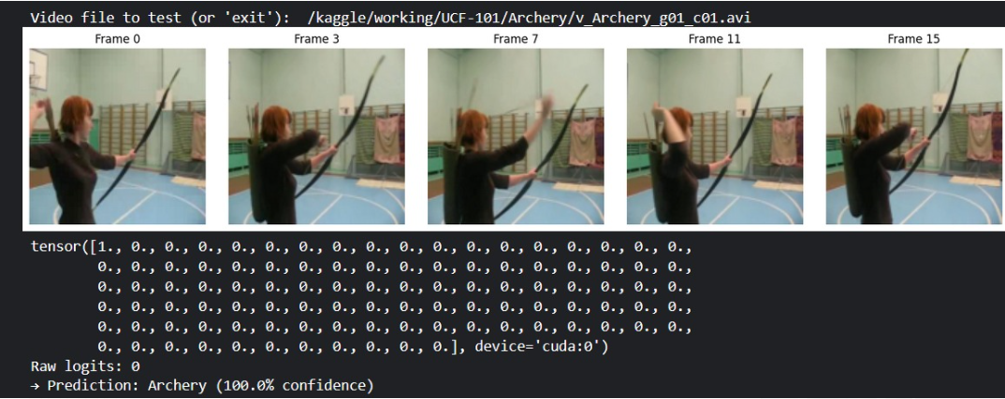

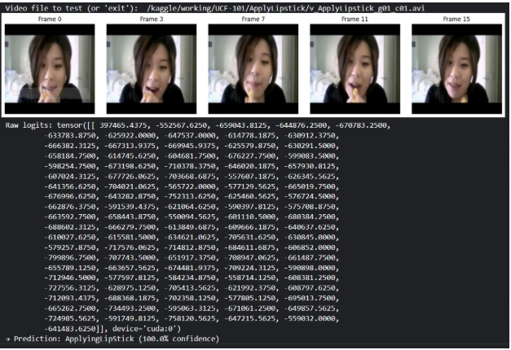

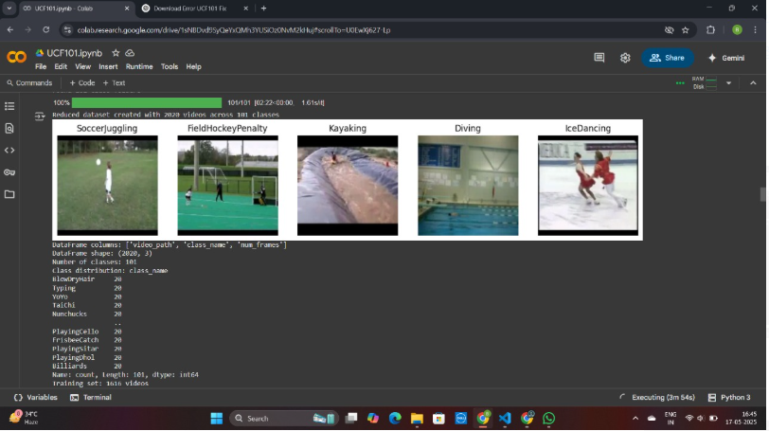

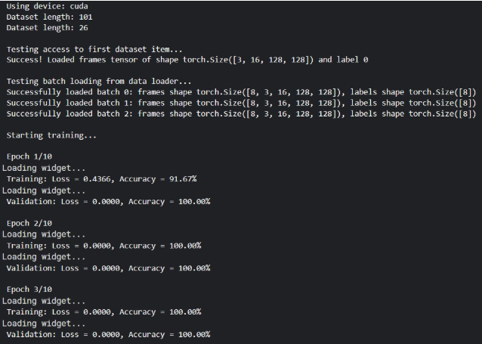

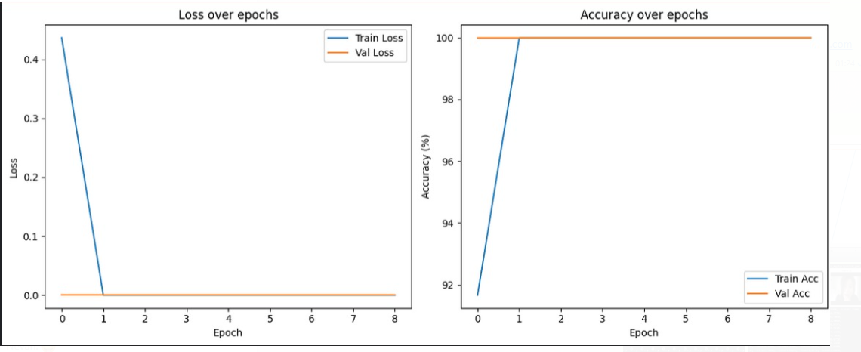

FEEDBACK QUESTIONS

What challenges did you face while preprocessing the dataset?
Answer: Handling varying video lengths, resizing frames to a uniform size, and managing memory during frame extraction were key challenges. Also, sampling the right number of frames (too few = information loss; too many = slow training) was tricky.
- What would you improve if you had more computational resources?
With more computational resources, we would:
- Use 3D CNN architectures like I3D or SlowFast, which capture temporal features more effectively than 2D + LSTM models.
- Train on longer frame sequences for better context understanding.
- Apply data augmentation techniques like random crop, motion blur, and background noise to improve robustness.
- Perform hyperparameter tuning using grid search or Bayesian optimization.
- Explore multi-modal learning using audio + video features.

What performance metrics did you use to evaluate the model?
Answer: We used accuracy, confusion matrix, precision, recall, and Top-1/Top-5 accuracy. For unbalanced classes, F1 score helped to measure true performance.
- Can your model handle videos with background noise or camera motion?
Currently, the model is sensitive to background noise and camera motion, especially if the training data has clean, centered actions. Background clutter can confuse the model if the moving object is not the dominant part of the frame. To improve this:
- Apply background subtraction or motion segmentation during preprocessing.
- Use attention mechanisms to focus on key motion regions.
- Fine-tune the model on videos with realistic noise and movement for better generalization.
- How would you deploy this model in a real-world application (e.g., surveillance or sports analysis)?
In a real-world scenario:
- The model would be integrated into a real-time video pipeline, where video streams are captured frame-by-frame, and predictions are made at fixed intervals (e.g., every 1–2 seconds).
- For surveillance, it could be used to flag unusual activities (e.g., fighting, theft, loitering).
- In sports, it could be used to automatically detect and classify player actions (e.g., serve, smash, dive) for analytics.
- For deployment, we’d convert the trained model to ONNX or TensorFlow Lite, and run it on edge devices like Jetson Nano or Raspberry Pi for low-latency processing.

How did you handle class imbalance in the dataset?
Answer: We used class weights during training and oversampled underrepresented classes to reduce bias. Data augmentation also helped create synthetic diversity.

Did the model overfit? How did you address it?
Answer: Yes, some overfitting occurred. We used techniques like dropout, batch normalization, early stopping, and data augmentation to reduce overfitting during training.
- Why did you choose CNN + LSTM (or 3D CNN) over other models?
We chose CNN + LSTM because it effectively separates spatial and temporal processing. CNNs are excellent at extracting spatial features from individual video frames, such as object shapes, textures, and edges. LSTMs, on the other hand, handle the temporal sequence of frames, capturing motion and temporal dependencies across time. Alternatively, 3D CNNs like C3D or I3D directly model both spatial and temporal dimensions, making them powerful for capturing short action clips, though they are more computationally expensive.
- What were the most common misclassified actions?
The model often confused actions that had similar motion patterns or overlapping contexts. For instance:
- Walking was sometimes misclassified as jogging or running due to similar motion flow.
- Playing violin vs. playing cello or guitar — similar posture and instrument handling.
- Handstand vs. Cartwheel — due to partial visibility or camera angle.
These errors suggest that the model struggled with fine-grained motion or background similarity.

