Deliverable 2: Retrieval Stack and NoSQL Databases
Group 9 : Alanood Saleh , Batool Masadeh , Batool Mourad , Leen Bastati , Noor Al Swailmeen
Deliverable 2 Report

1. Introduction
This deliverable extends the work completed in Deliverable 1 by integrating the retrieval system components developed by the team. The system combines MongoDB for document storage, Qdrant for vector storage, hybrid retrieval using BM25 and dense search, FastAPI for API access, and Neo4j for graph representation. The FastAPI backend serves as the interface layer that allows users to access the retrieval system through REST API endpoints. The goal is to provide an efficient and scalable retrieval system that supports semantic search and prepares the project for future GraphRAG implementation.

2. Ingestion Pipeline
The retrieval system follows a multi-stage ingestion pipeline. Research papers are first processed and converted into text. The extracted text is then divided into smaller chunks. Embeddings are generated for each chunk and stored in Qdrant, while metadata and document content are stored in MongoDB.

Architecture Diagram:
PDF Research Papers
↓
Text Extraction
↓
Document Chunking
↓
MongoDB Storage
(Papers + Chunks)
↓
Embedding Generation
↓
Qdrant Vector Database
↓
Hybrid Retrieval
(BM25 + Dense Search)
↓
FastAPI API Layer
↓
Neo4j Knowledge Graph
↓
Retrieved Results

Figure 1. Overall D2 system architecture showing the ingestion pipeline, storage layers, retrieval components, API layer, and graph database.

Diagram:
PDF Papers
↓
Text Extraction
↓
Chunking
↓
MongoDB Storage
↓
Embedding Generation
↓
Qdrant Vector Database
↓
Hybrid Retrieval
(BM25 + Dense Search)
↓
FastAPI
↓
Neo4j Knowledge Graph
↓
Search Results

3. MongoDB Storage Layer
MongoDB was used as the primary storage layer for research papers and document chunks.
Database Name:
pdf_papers_ai_agent
Two collections were created:
- papers
- chunks
The papers collection stores metadata for each paper.
Schema:
{
"paper_id": "paper_001",
"title": "...",
"pdf_file": "..."
}
The chunks collection stores individual document chunks and metadata.
Schema:
{
"chunk_id": 1,
"paper_id": "paper_001",
"title": "...",
"pdf_file": "...",
"page": 1,
"chunk_number": 1,
"chunk_text": "..."
}
The final database contains:
- 99 papers
- 1,958 chunks
Indexes were created on:
- papers.paper_id
- chunks.chunk_id
- chunks.paper_id
- chunks.page
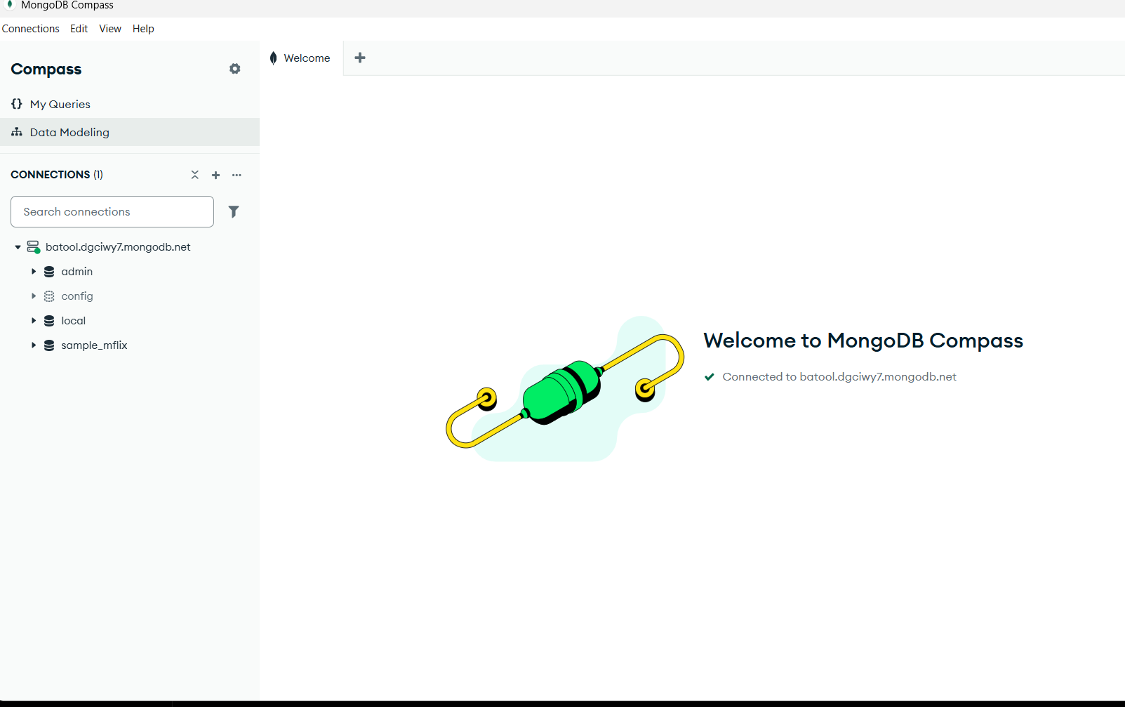
Figure 2. MongoDB Atlas connection used for storing paper metadata and document chunks.
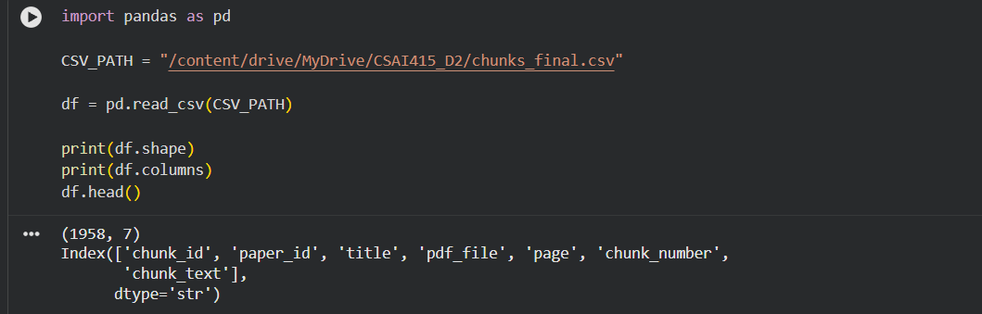
Figure 3. Dataset validation showing the imported CSV file containing 1,958 chunks and seven metadata fields.
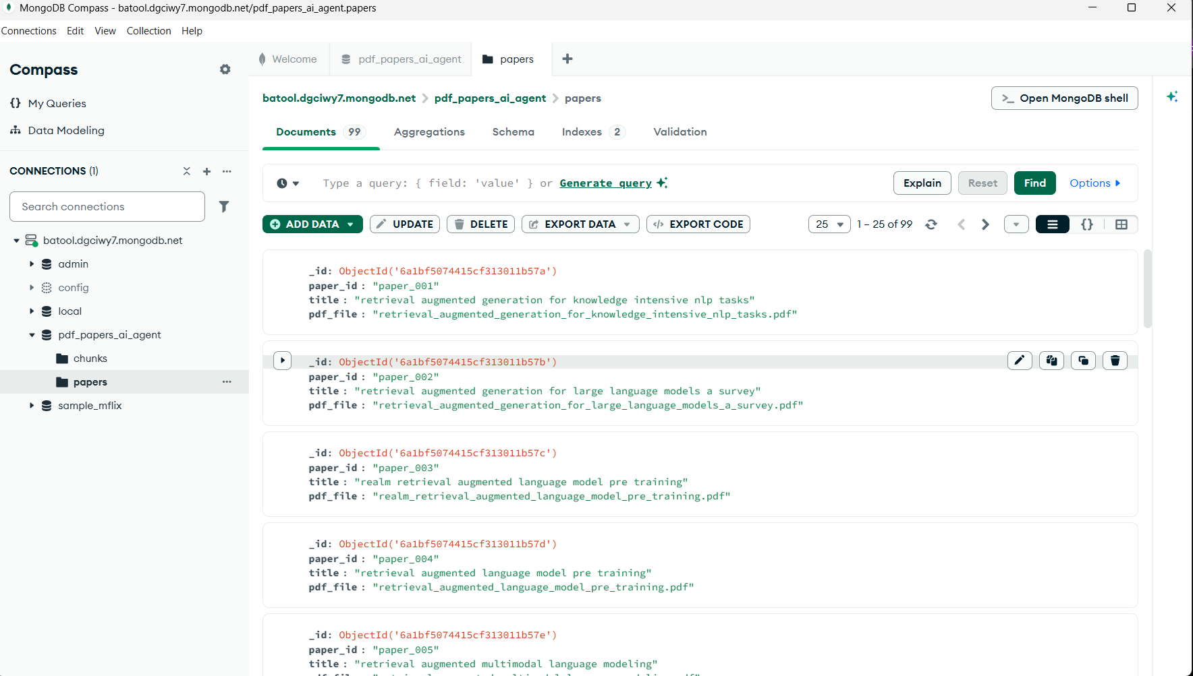
Figure 4. Papers collection in MongoDB containing metadata for 99 research papers.
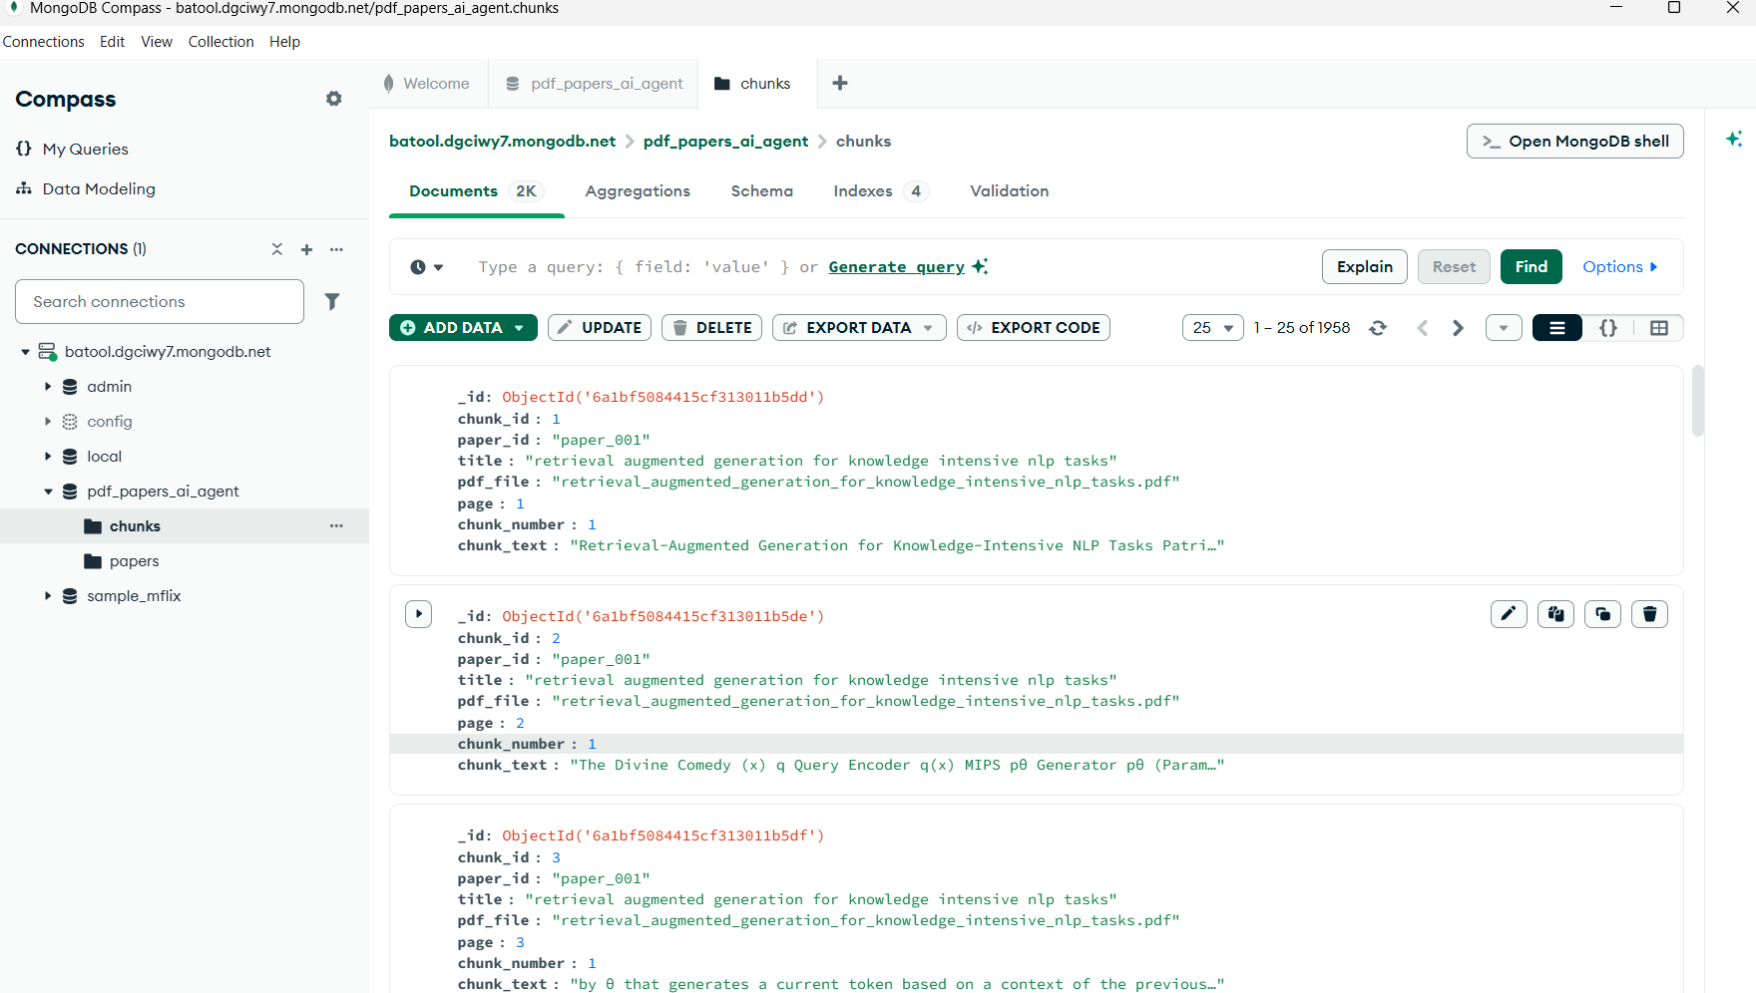
Figure 5. Chunks collection in MongoDB containing 1,958 document chunks with page numbers and chunk text.
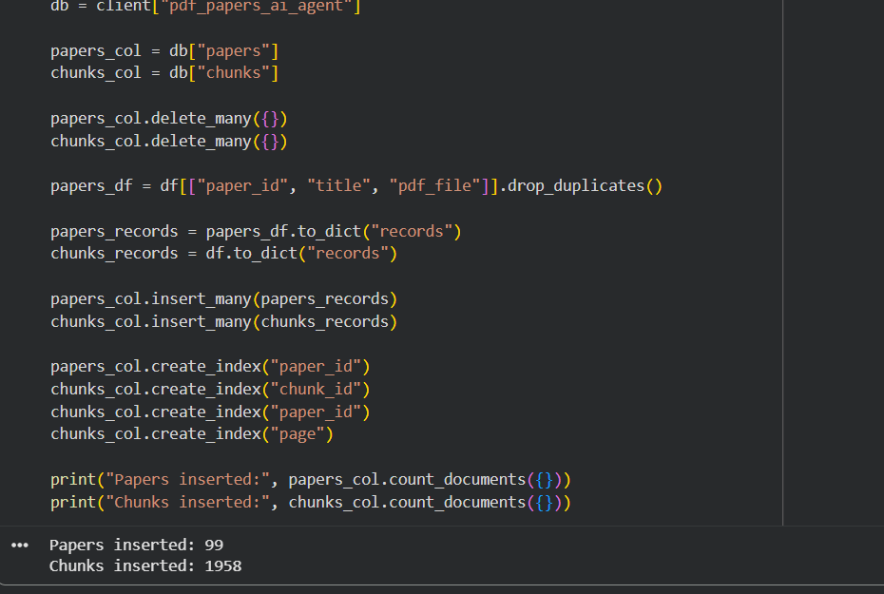
Figure 6. Successful ingestion of the dataset into MongoDB showing 99 papers and 1,958 chunks inserted into the database.

4. Qdrant Vector Database
Qdrant was used as the vector database for semantic retrieval.
Collection Name:
research_papers
Document chunks were converted into embedding vectors and uploaded to Qdrant. These vectors allow semantic similarity search and support dense retrieval.
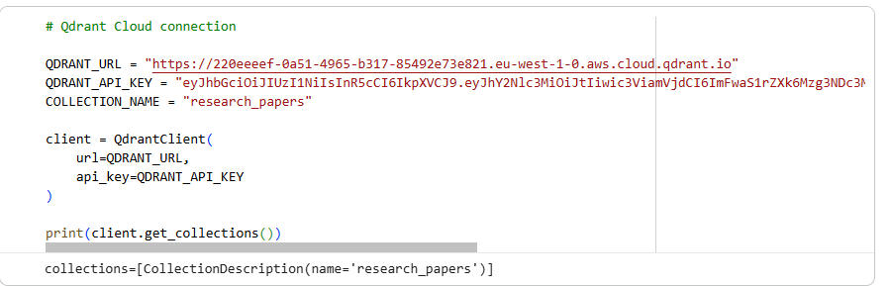
Figure 7. Qdrant vector database configuration showing the research_papers collection used for storing document embeddings.

5. Hybrid Retrieval
The retrieval system combines two retrieval methods:
- BM25 lexical retrieval
- Dense vector retrieval using Qdrant
The final ranking score is calculated using both retrieval methods to improve retrieval quality.
This approach helps return relevant results even when exact keywords are not present in the document.
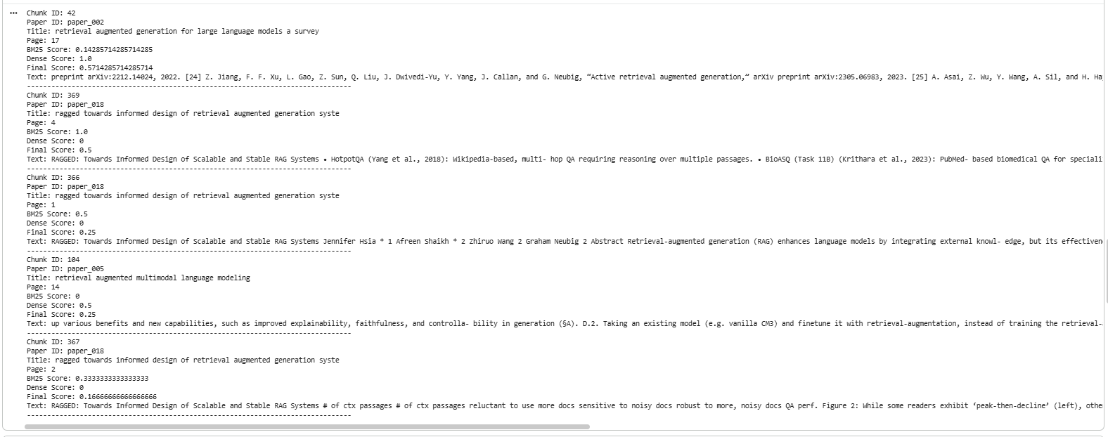
Figure 8. Example hybrid retrieval results showing BM25 scores, dense retrieval scores, and final ranking scores for retrieved document chunks.

6. Retrieval Evaluation
The retrieval system was evaluated using five sample queries.
The evaluation focused on:
- Recall@5
- Query Latency
6.1 Recall@5 Results
Recall@5 measures whether relevant results appear within the top five retrieved documents.
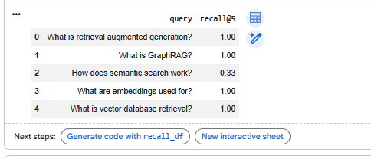
Figure 9. Recall@5 evaluation results for five sample queries.
Query | Recall@5
What is retrieval augmented generation? | 1.00
What is GraphRAG? | 1.00
How does semantic search work? | 0.33
What are embeddings used for? | 1.00
What is vector database retrieval? | 1.00
Average Recall@5:
0.866
The results show strong retrieval performance, with four queries achieving perfect recall.

6.2 Latency Results
Latency measures the response time of the retrieval system.
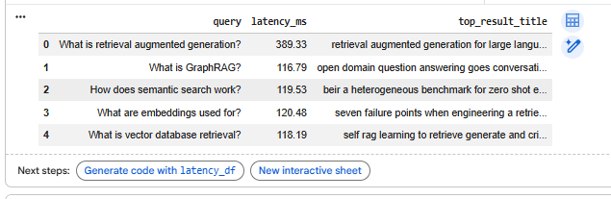
Figure 10. Query latency measurements for the hybrid retrieval system.
Query | Latency (ms)
What is retrieval augmented generation? | 389.33
What is GraphRAG? | 116.79
How does semantic search work? | 119.53
What are embeddings used for? | 120.48
What is vector database retrieval? | 118.19
Average Latency:
172.86 ms
The results demonstrate that the system maintains efficient retrieval performance while returning relevant results.

7. FastAPI Backend
The FastAPI backend serves as the API access layer of the retrieval system. It provides REST API endpoints that allow users and other system components to interact with the document repository and retrieval pipeline.
The implemented endpoints include:
• / – Returns a welcome message and confirms that the API is running successfully.
• /stats – Retrieves system statistics, including the total number of papers and chunks stored in MongoDB.
• /search – Accepts a user query and returns relevant document chunks together with associated metadata such as paper ID, title, page number, chunk number, and chunk text.
• /ingest – Supports document ingestion and integration with the storage layer.
The backend is connected to MongoDB through a dedicated database module and interacts with the retrieval component through a separate retrieval module. This modular design improves maintainability, scalability, and future integration with advanced retrieval methods.
To support deployment and reproducibility, Docker and Docker Compose were used to containerize the application and its dependencies. A README file was also provided to document setup instructions and execution steps.
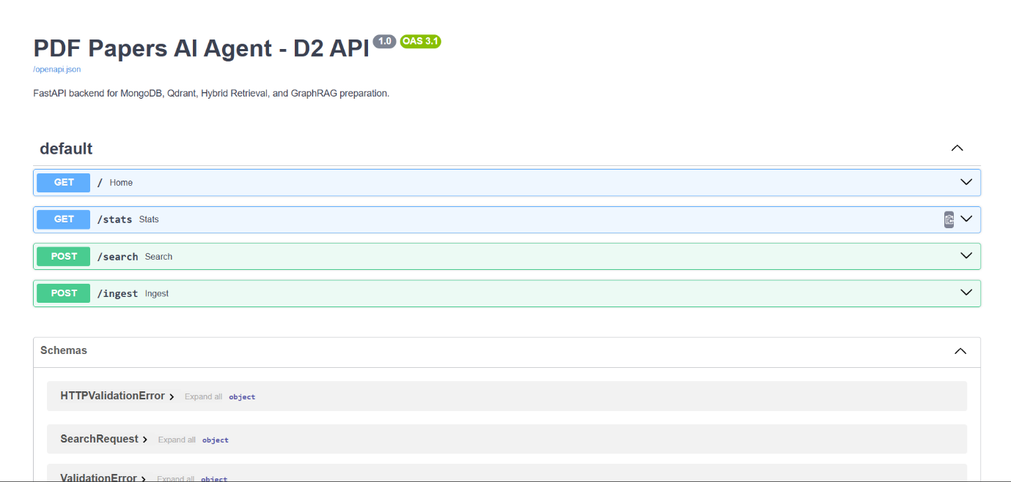
Figure 11. FastAPI Swagger interface showing all implemented API endpoints.
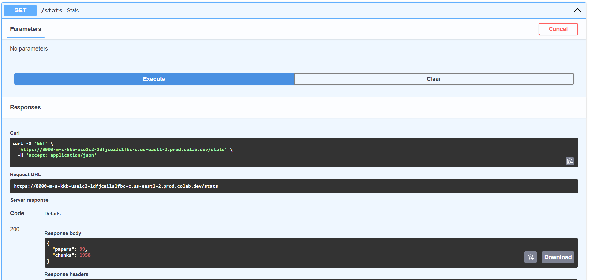
Figure 12. Output of the /stats endpoint showing the number of papers and chunks stored in the system.
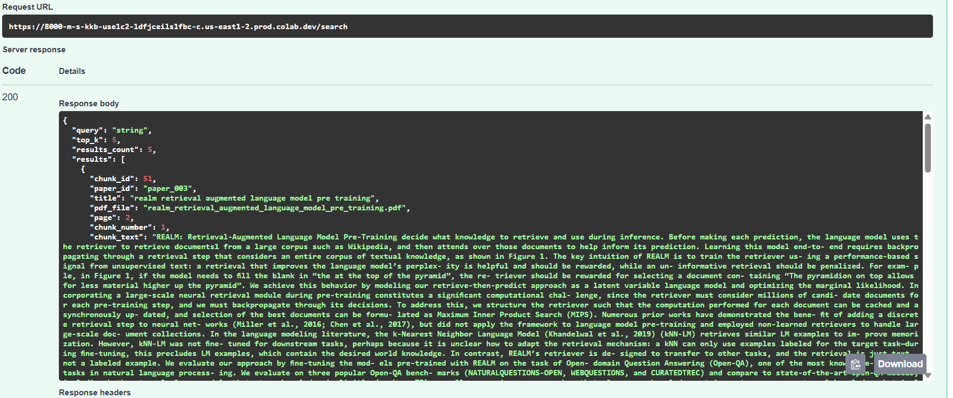Figure 13. Example output from the /search endpoint showing the retrieved document chunks and metadata returned to the user.
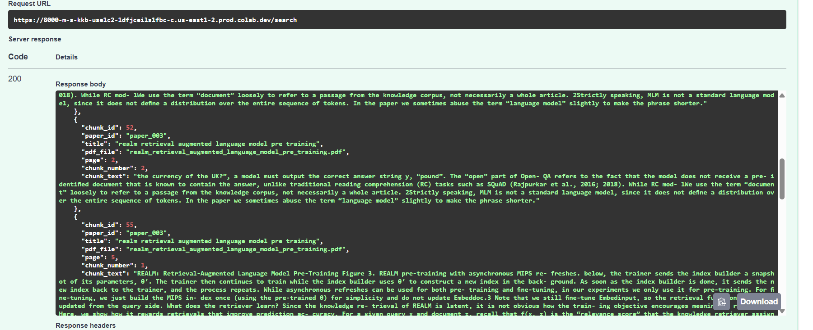
Figure 14. Response from the /ingest endpoint confirming successful ingestion of the D1 dataset into MongoDB.
The API provides a simple interface for accessing the retrieval system and supports future integration with external applications.

8. Neo4j Knowledge Graph
To demonstrate graph-based knowledge representation, a Neo4j graph database was created. The graph contains three main node types:
- Author
- Paper
- Topic
Relationships were created between these nodes using:
- WROTE (Author → Paper)
- ABOUT (Paper → Topic)
The graph allows exploration of relationships between research papers, authors, and research topics using Cypher queries.
Example Cypher Queries:
Query 1: Retrieve all Author–Paper–Topic relationships
MATCH (a:Author)-[:WROTE]->(p:Paper)-[:ABOUT]->(t:Topic)
RETURN a,p,t
Query 2: Retrieve all authors
MATCH (a:Author)
RETURN a
Query 3: Retrieve all papers
MATCH (p:Paper)
RETURN p
Query 4: Retrieve all topics
MATCH (t:Topic)
RETURN t
Query 5: Count all nodes in the graph
MATCH (n)
RETURN count(n)
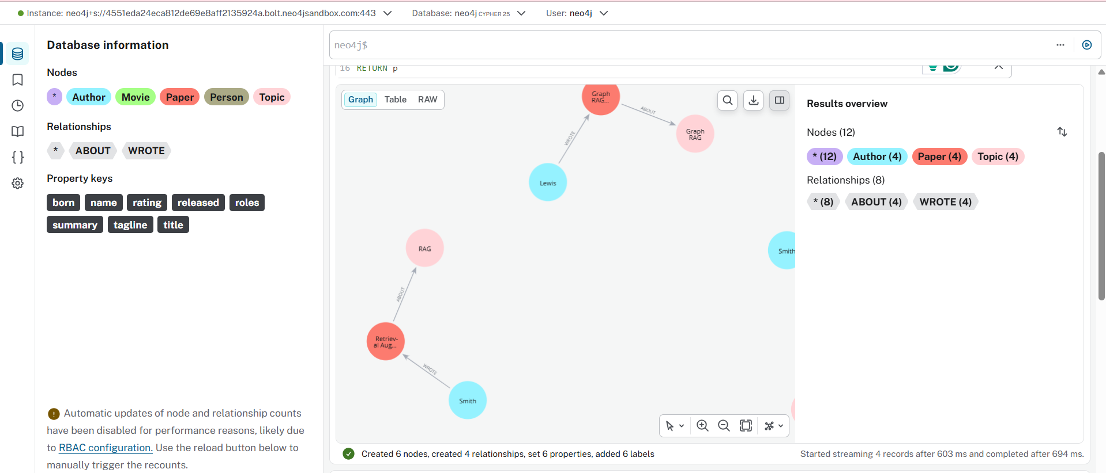
Figure 15. Neo4j knowledge graph showing Author, Paper, and Topic nodes connected through WROTE and ABOUT relationships.
Cypher Query 1
MATCH (a:Author)-[:WROTE]->(p:Paper)
RETURN a,p
Purpose:
Returns all author-paper relationships stored in the graph.
Cypher Query 2
MATCH (p:Paper)-[:ABOUT]->(t:Topic)
RETURN p,t
Purpose:
Returns papers and their associated research topics.
Cypher Query 3
MATCH (a:Author)-[:WROTE]->(p:Paper)-[:ABOUT]->(t:Topic)
RETURN a,p,t
Purpose:
Returns complete Author–Paper–Topic paths.

9. Top-k Retrieval Examples
The retrieval system returns the top-k most relevant document chunks for a given query.
Example queries used during testing include:
- What is retrieval augmented generation?
- What is GraphRAG?
- How does semantic search work?
- What are embeddings used for?
- What is vector database retrieval?
The returned results include:
- Paper ID
- Title
- Page Number
- Chunk Number
- Chunk Text
- Retrieval Score
The examples demonstrate that the retrieval system can successfully identify relevant information from the research paper collection.

10. Conclusion
This deliverable successfully transformed the initial retrieval prototype into a complete retrieval stack. MongoDB was used for structured document storage, Qdrant enabled semantic vector retrieval, hybrid search improved retrieval quality, FastAPI provided API access, and Neo4j introduced graph-based knowledge representation.
The system achieved an average Recall@5 of 0.866 and an average latency of 172.86 ms, demonstrating strong retrieval performance while maintaining efficient response times.
The completed retrieval stack provides a solid foundation for future GraphRAG development and advanced retrieval-augmented generation systems.

