Suzlon Energy Limited is a prominent Indian renewable energy company specializing in wind power solutions.

Founded in 1995, headquartered in Pune.

Capacity - capable of producing wind energy in excess of 23,000 MW.

Presence in more than 30 countries

# Global wind energy industry Outlook

* + Global commitment towards renewable energy
    - As of 30 September 2021, 120 countries, representing just over half of global greenhouse gas emissions, had communicated new or updated NDCs (Nationally Determined Contributions). In addition, three G20 members have announced other new mitigation pledges for 2030. As an outcome of COP26, a total of 49 countries plus the EU have pledged to a net-zero target, including 12 of the G20 members. Wind energy is poised to play a vital role in accelerating the global energy transition.
  + Current Status
    - wind energy installations 93.6 GW, 3x of 2020. Registered growth of 12% during 2021, which is more than the renewable energy sector growth of 9.1% during the same period. Renewable energy sector investment grew by 6.5% to $366 Billion.
  + Future Outlook
    - The wind energy sector CAGR for the next five years under current policies is forecast as 6.6% that means 557 GW of new capacity will be added in the next five years – which equates to more than 110 GW of new installations each year until 2026.
  + 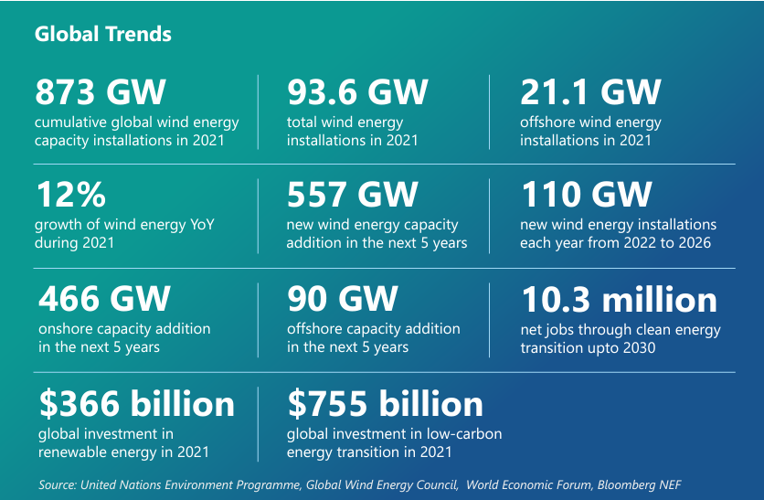

# Indian wind energy industry Outlook

* + India’s commitment towards renewable energy
    - At COP26, India’s commitment
      * Indian government has set a goal to achieve "Net Zero" status by 2070.
      * India committed to build 500 GW of renewable energy capacity by 2030, which will amount to 50% renewables in the energy mix. To meet this target, wind energy will have to contribute **140 GW.**
  + Current Status
    - As of FY22, India are the third-largest producer and second-largest consumer of electricity globally. India is the world's fourth-largest emitter of carbon dioxide.
    - India's installed renewable energy capacity stood at 161 GW in June 2022, amounting to 39.8% of the overall installed power capacity in the country. Within renewable energy, the contribution of wind energy currently stands at over 25%.
  + Future Outlook
    - Wind energy potential
      * India with its 7,600 kilometers of coastline, has substantial untapped onshore and offshore wind resources.
      * According to National Institute of Wind Energy (NIWE) assessment, India has more than 302 GW of onshore wind potential and 695 GW of onshore wind potential.
    - Renewable Energy Drivers
      * Rising energy demand (2x in 20 yrs)
      * Commitments towards net zero.
      * Abundant availability of renewable sources
      * Increasing climate change adverse events.
      * Facilitative policies accelerating energy transition.
      * Mature Tech -- high PLF, and up to 80-90 percent indigenous content and a thriving domestic value chain supporting Make in India Vision.

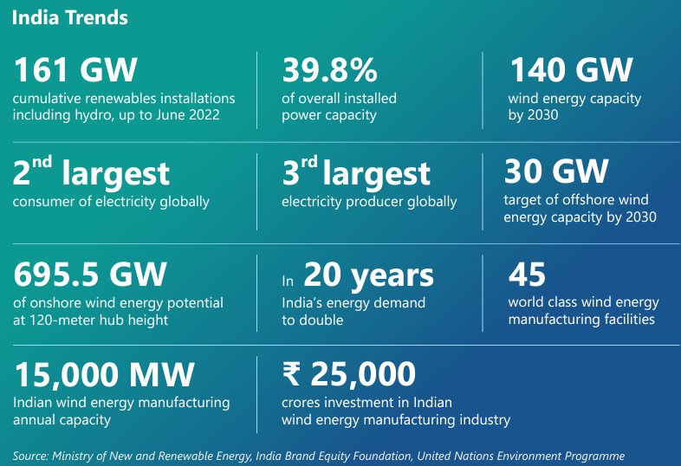

# Suzlon FY 22 Performance

* + FY22
    - Turnover increase by 98% over FY21, while our EBITDA (828 Cr) rose by 54% over FY21.
    - EDITDA Margin = EDITDA/Net Sales = 12.7%
    - PAT -166 Crores.
      * disrupted global supply chain and unavailability of raw materials augmented by exponential rise in prices of commodities and logistics services which was worsened by the increase in GST from 5% to 12% on renewable energy equipment.
  + Future
    - Govt push
      * (Renewable Purchase Obligation) RPO order ensures the sustainable growth of the wind energy industry from 0.81% in 2023 to 6.94% by 2030.
      * ISTS (Inter-State Transmission System) waivers
      * Promoting Renewable Energy through Green Energy Open Access.

Qualitative Analysis:

1. According to Pecking Order Theory, if a company finances itself internally, that means it is strong. If a company finances itself through debt, it is a signal that management is confident the company can meet its monthly obligations.