Instructions

T.E.D.

# ESP32 Install

The Device will need the following libraries.

Load Cell Library – HX711: <https://github.com/bogde/HX711>

LCD Library - LiquidCrystal_I2C: <https://github.com/ribasco/new-liquidcrystal>

# Android Install

1. Locate the EE537AppV2.apk file downloaded on your phone.
2. Start the install process by tapping the apk and clicking install.

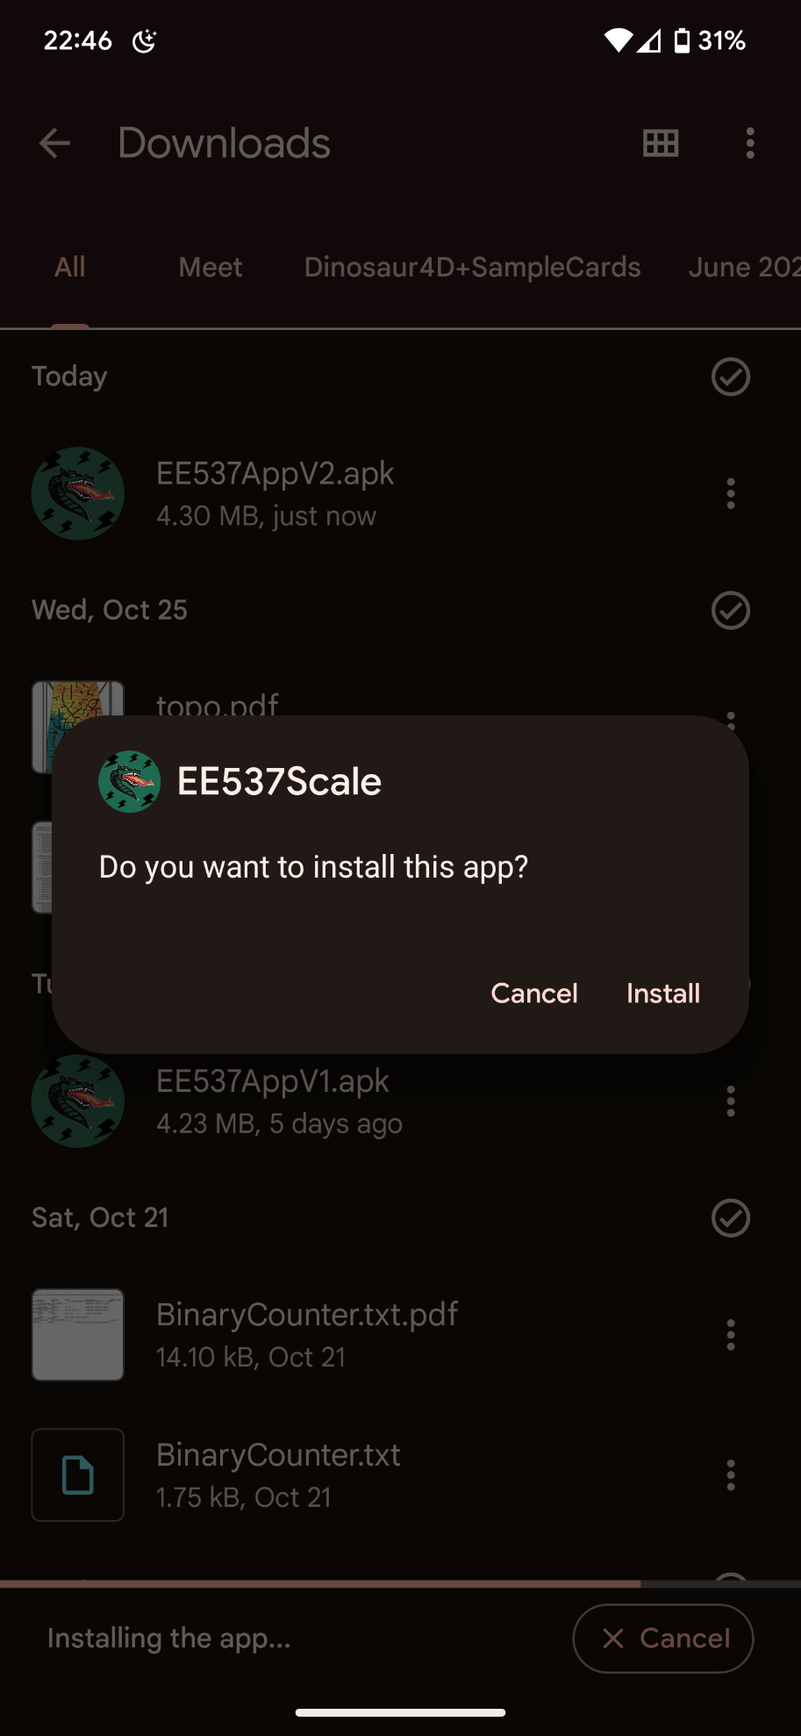

1. If installation permissions are requested, accept them.

# ThingSpeak Setup

1. Sign into [ThingSpeak](https://thingspeak.com/channels) using your MathWorks account credentials.
2. Click **Channels** > **My Channels**. A screenshot of a computer

   Description automatically generated
3. On the Channels page, click **New Channel**.
4. Name the new channel **Measurement**.
5. Name Field 1 **Weight**.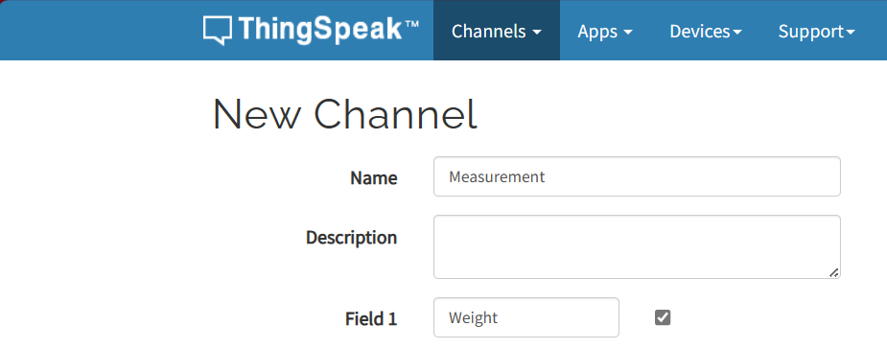
6. Click **Save Channel** at the bottom of the settings.
7. The following screen should be visible. Click API Keys. 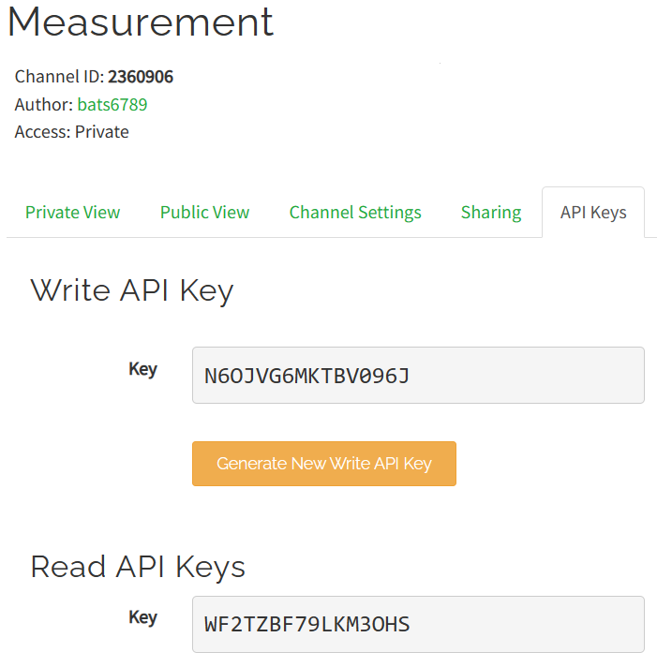
8. Note your **Channel ID** and your **Write API Key**. They will be needed for setup.

# Project Setup

1. Follow the circuit schematic for setting up the hardware. These instructions will focus on the software side of things.
2. Load ESPCalibration.ino onto the ESP32. Instructions will be displayed on the LCD.
3. Note the calibration number obtained.
4. Navigate to ESPSoftware.ino to change the following parameters:
   1. On line 23, replace <factor> with your calibration number obtained in step 3.
   2. On line 26, modify <WiFi-Name> to your WiFi networks name.
   3. On line 27, modify <WiFi-Password> to your WiFi password.
   4. On line 30, modify <API-KEY> with your write API-KEY obtained in the ThingSpeak setup.
   5. On line 31, modify <channel-ID> to contain your channel ID obtained in the ThingSpeak setup.
5. Save and load the file onto the ESP32. The device is now ready for use.

# Test instructions

1. Upon opening the app, you will be greeted with a profile creation screen.

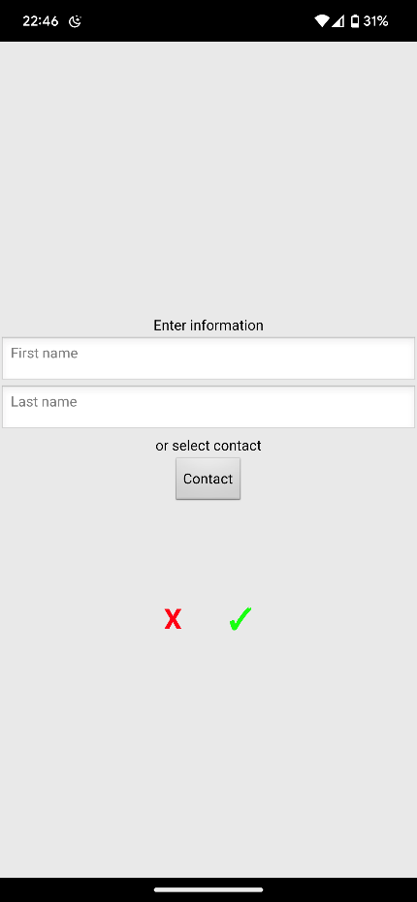

1. Either enter your name manually or select a contact to populate the fields.
2. Tap the checkmark after the fields are populated.

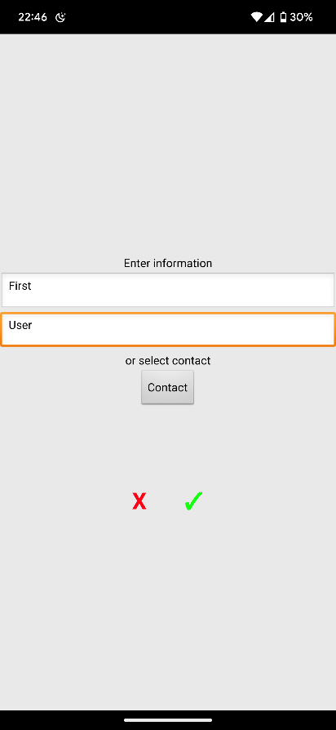

* 1. Tap the Wi-Fi

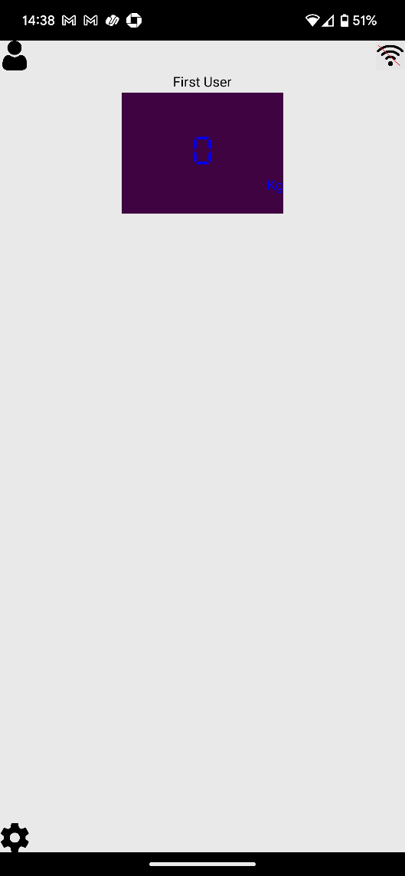

1. Accept all permission

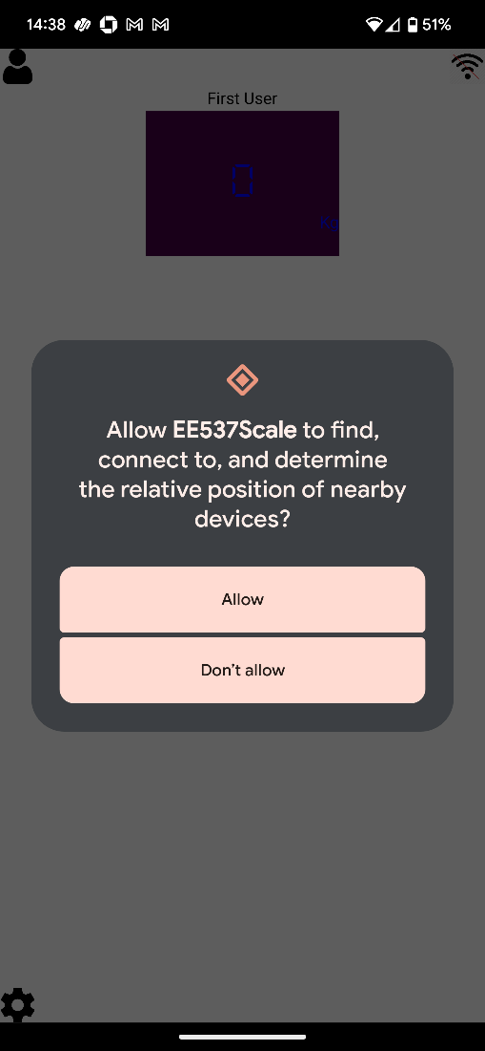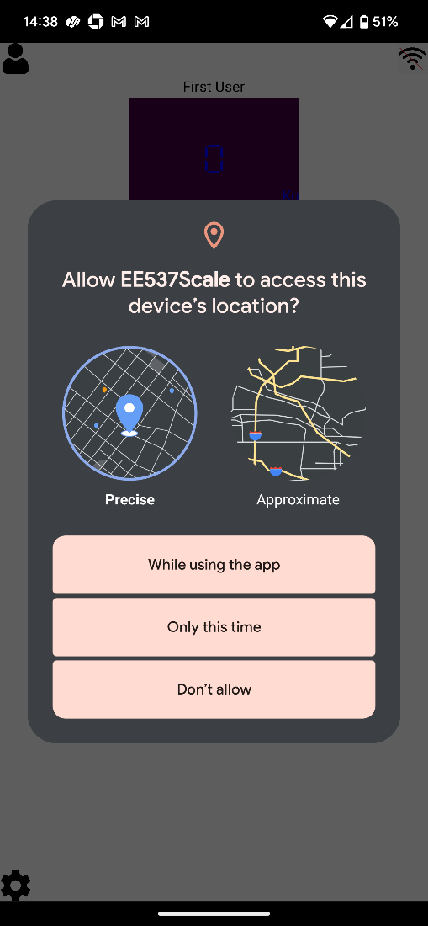

1. The device should connect as indicated by the green dot on the Wi-Fi symbol.

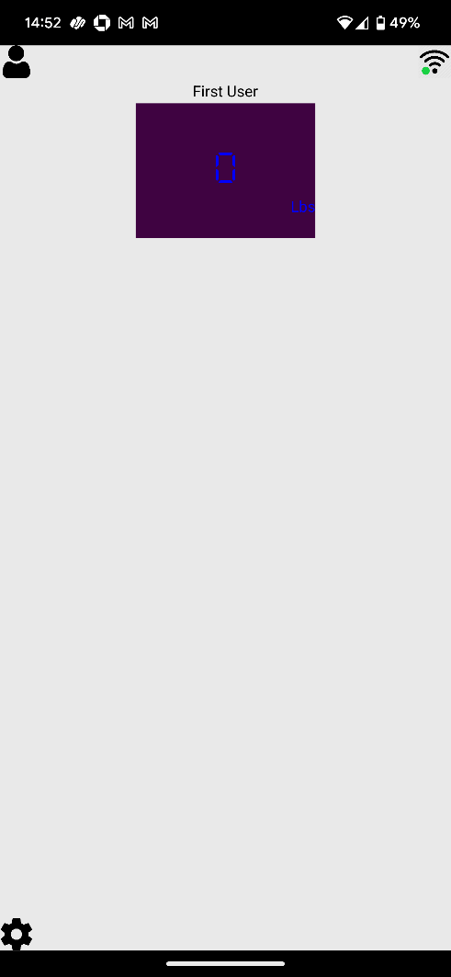

7. Step on scale to acquire weight.

