1st Project Meeting “Real-time Stereo Matching”

12. April 2019

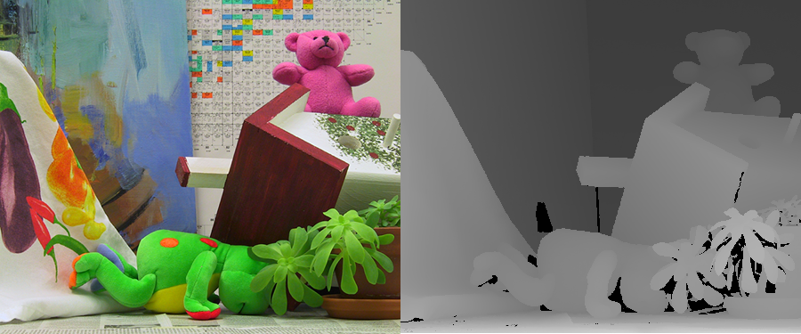

**Access to DBL computers**:

* + **User**: project
  + **Password**: keins.2017

**GitLab repository**:

http://gropius.medien.uni-weimar.de:8081/kaisheva/real-time-stereo-matching-2019.git

**Talk topics**:

1. **OpenCL – best practices and core concepts**
   1. Platform model (host vs device)
   2. Memory model (global, constant, local, private memory)
   3. Index spaces
   4. Coalesced access to global memory
   5. Pinned memory vs. Paged Memory

Readings (see folder OpenCL):

* Lecture slides from the course Parallele und verteilte Systeme
* 2011_NVidia_Best_Practice_Guide.pdf
* 2013_AMD_OpenCL_Programming_Guide.pdf

1. **Overview of epipolar geometry, image rectification and triangulation**
   1. What is the Fundamental Matrix?
   2. Explain the main concept of epipolar geometry (what does it represent? How is it useful?)
   3. High-level explanation of image rectification (Why is it useful?)
   4. Triangulation
   5. Relationship between 3D depth and disparites

Material (see folder Photogrammetric_Computer_Vision):

* Computer Vision: Algorithms and Applications (http://szeliski.org/Book/drafts/SzeliskiBook_20100903_draft.pdf)

[**only** **Chapters 11.1.1 and 11.1.2**]

* Multiple_View_Geometry_in_Computer_Vision_(Second_Edition).pdf [**only** **Chapters 9.1 and 10.1**]

1. **Taxonomy of stereo matching and cost aggregation functions**
   1. Explain the 4 major steps found in stereo matching algorithms according to Szeliski’s taxonomy
   2. Differences between local and global disparity computation algorithms
   3. Overview of most common cost aggregation functions; computational cost of these functions

Material (see folder Taxonomy_and_analysis_papers):

* A_Taxonomy_and_Evaluation_of_Dense_Two_Frame_Stereo_Correspondence_Algorithms.pdf [2002]
* A_Performance_Study_On_Different_Cost_Aggregation_Approaches.pdf [2007]

1. **Overview of real-time stereo matching algorithms** 
   1. Brief description of the matching algorithms and the post-refinement steps described in the papers
   2. How suitable is each algorithm for parallelization?
   3. Information about processing accuracy and speed
   4. What types of cost functions and aggregation techniques are used?

Material (see folder StereoMatching_Algorithms):

* + - * PatchMatch_Stereo.pdf [2011]
      * Efficient_Large-Scale_Stereo-Matching.pdf [2010]
      * Accurate_Stereo-Matching_System_on_Graphics_Hardware.pdf [2011]

**Next Meeting (next Meeting):**

- What did you read so far?

- What is there left to do for your presentations?

- Are there any questions or problems regarding your topics?