**ARITHMETIC CALCULATOR**

**OUTPUT SCREEN SHOTS**

**DIVISION**

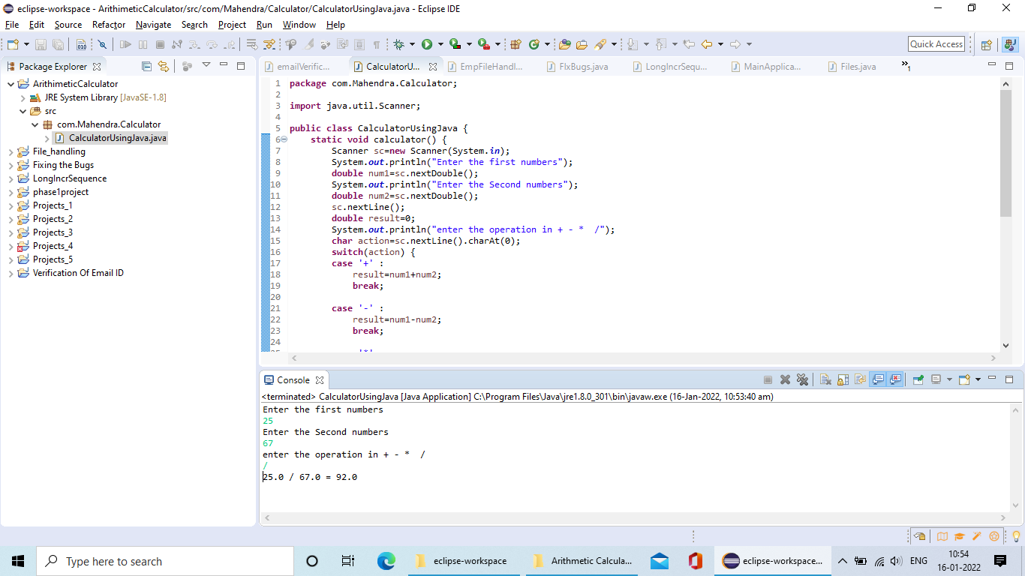

**ADDITION**

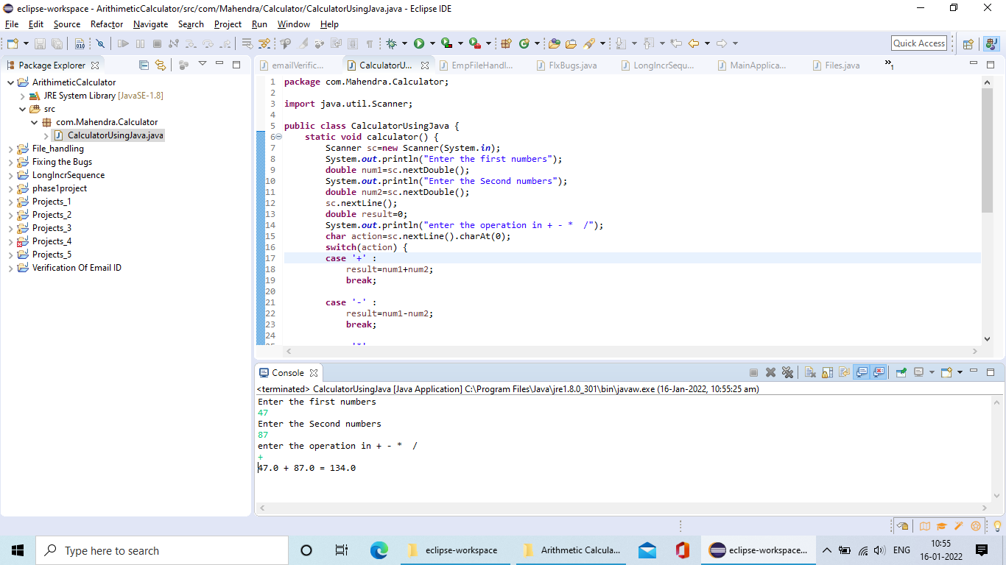

**MULTIPLICATION**

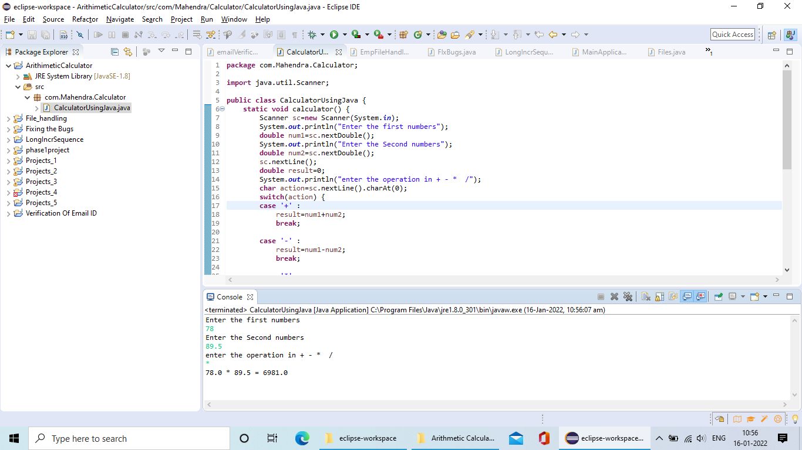

**SUBTRACTION**

