**PROJECT : EMAIL ID VERIFICATION USING JAVA**

**DEVELOPER : B.MAHENDRA**

**PROJECT DESCRIPTION :**

In this program I used a class and a method to develop a simple Email verfier. The class name is emailVerification and I used a methodsearchMail to verify the given mail. In that I used String array to store the various emails. I used for loop of array to search the given mail id. I gave input from main class using scanner class and I called searchMail method and passed given mail id as parameter.

**FLOW CHART**

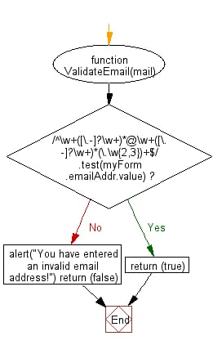

**CONCLUSION :** it successfully verified given mail if it is present in the list. If it is not present in the list it displayed error message.