**FILE_HANDLING**

**ADDING AN EMPLOYEE**

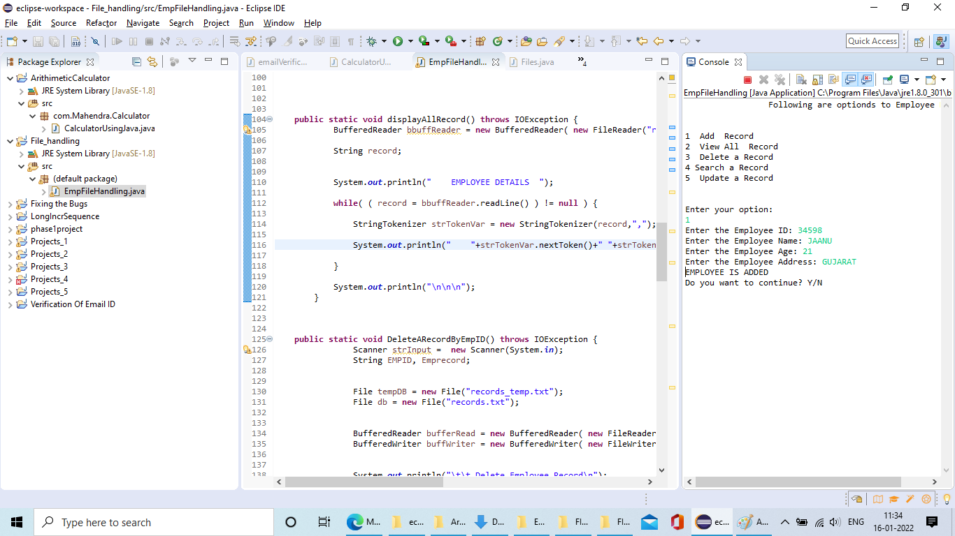

**DELETING_A_RECORD**

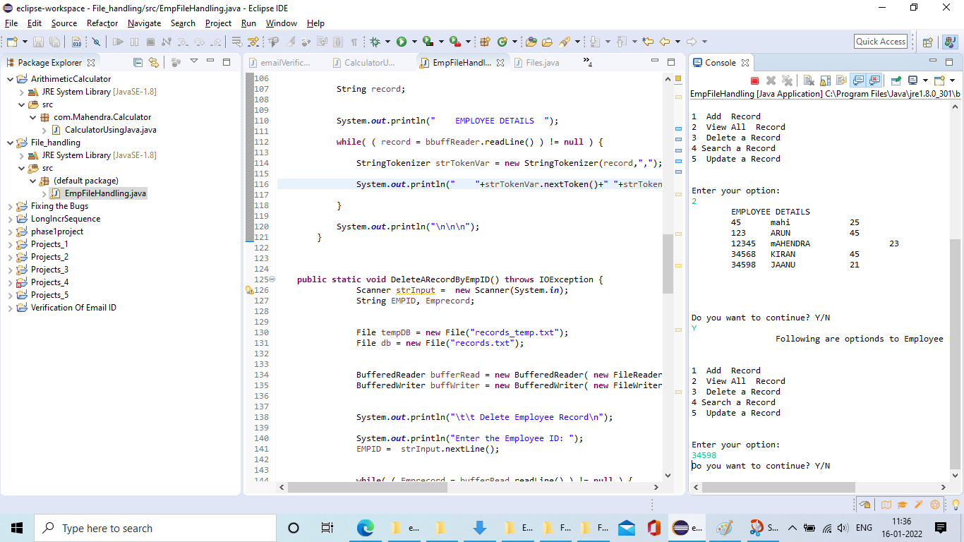

**SEARCHING A RECORD**

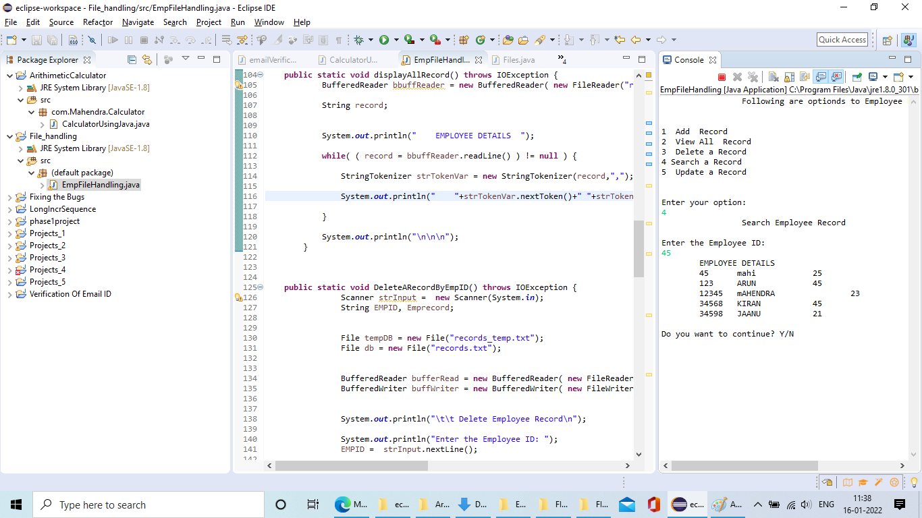

**VIEWING ALL RECORDS**

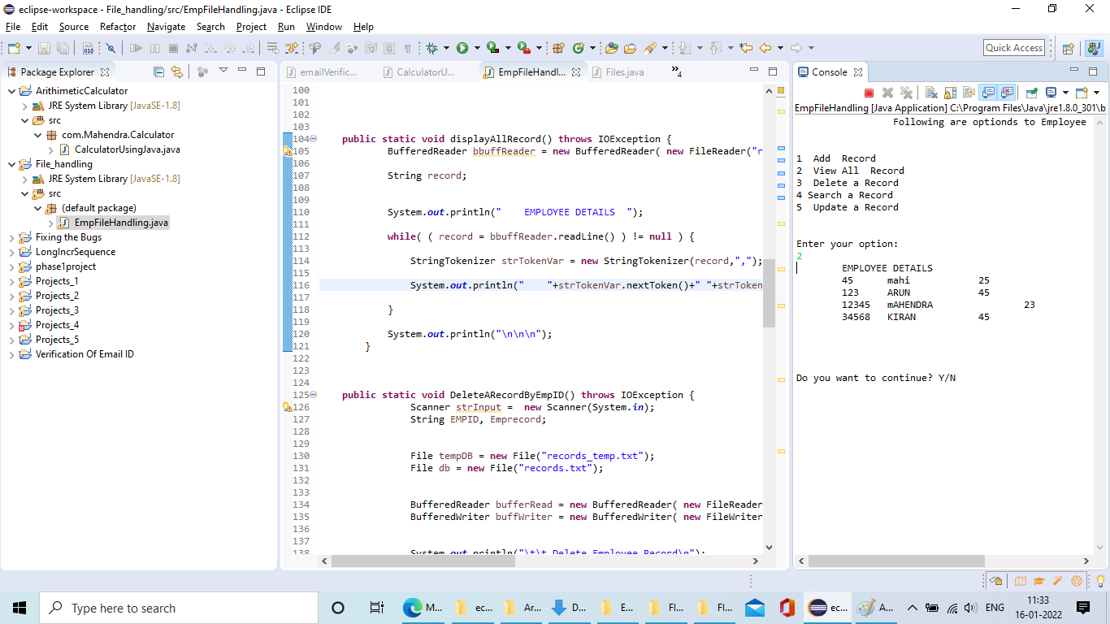

**UPDATING RECORD**

