**FIXING BUGS**

**ADDING AN EXPENDUTURE**

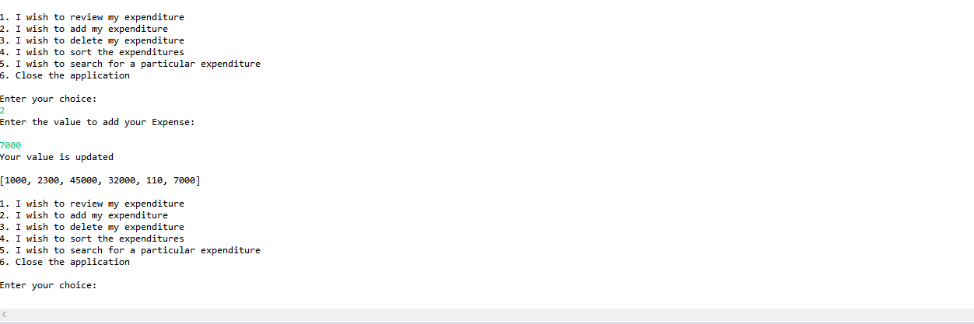

**DELETING**

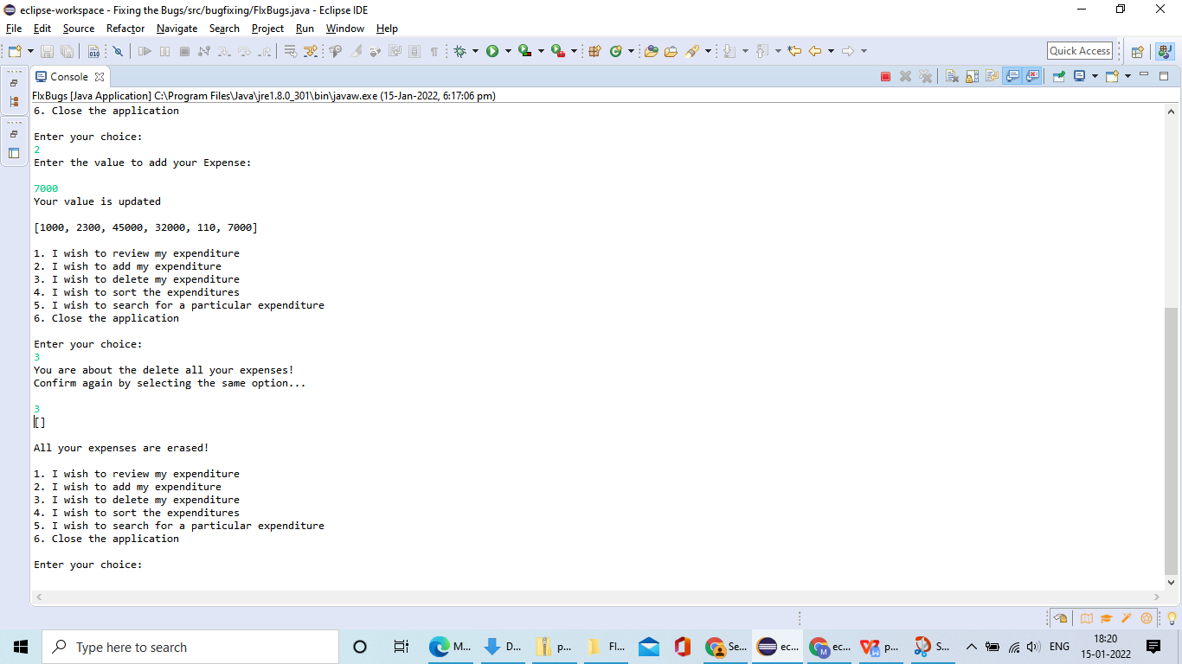

**DISPLAYING FILES**

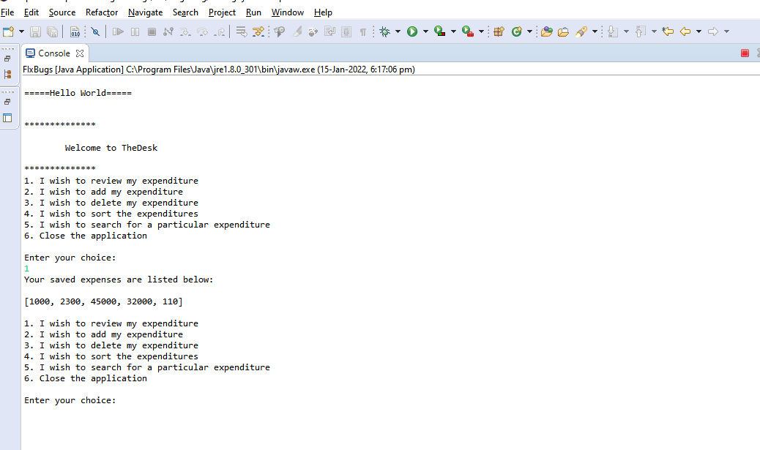

**SORTING**

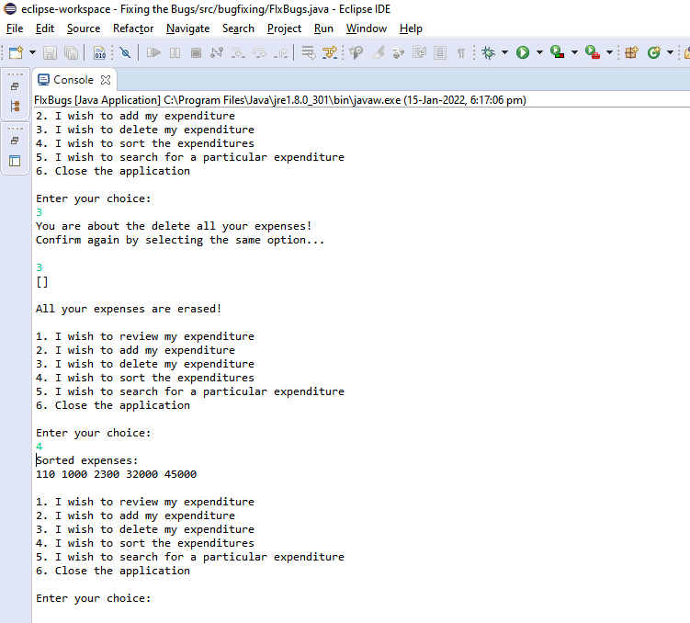

**UPADATING AND CLOSING**

