**PROJECT : LONGEST INCREASING SEQUENCE USING JAVA**

**DEVELOPER : B.MAHENDRA**

**PROJECT DESCRIPTION :**

In this program I used a class and a few methods to develop a program to find longest increasing sequence. The class name is LongIncrSequence and I used a few methods to perform operations. I used two methods and in main method I used Scanner class to take input from user or to pass a array to methods lis_1(int array[], int n) , lis(int arr[], int n). I used recursion techniques and a few for loops in the methods.

**FLOW CHART**

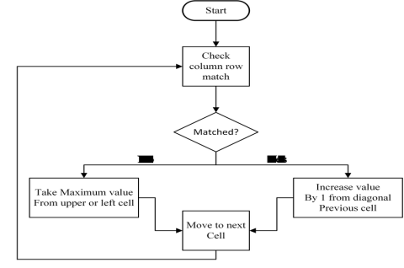

**CONCLUSION :** Finding out Longest Increasing sequenceof an given arrayby java is successfully carried out.