**3D数学，英语，GPU渲染流程，C++，****最长的一帧，OpenGL，OpenSceneGraph，shader**

打印到屏幕

FString str;

str = FString::SanitizeFloat(VectorAngleLevel);

GEngine->AddOnScreenDebugMessage(-1, 5.0f, FColor::Yellow, str );

GEngine->AddOnScreenDebugMessage(-1, 10000.f, FColor::Yellow, TEXT("Begin__________________________________"));

GEngine->AddOnScreenDebugMessage(-1, 10000.f, FColor::Yellow, TEXT("End___________________________________"));

射线距离

LineTrace

获得某个类在场景中的所有实例

GetAllActorsOfClass

类型转换

FString str;

str = FString::SanitizeFloat(TankBarrel->GetComponentLocation().X);

三点求夹角

void ATank::Angle(AActor* OtherActor)

{

//Self location 3D

FVector SelfLocation3D;

SelfLocation3D = GetActorLocation();

//TankBarrel location 3D

FVector BarrelLocation3D;

BarrelLocation3D = TankBarrel->GetComponentLocation();

//OtherAActor

FVector OtherActorLocation3D;

OtherActorLocation3D = OtherActor->GetActorLocation();

//BarrelVector

FVector BarrelVector;

BarrelVector = BarrelLocation3D - SelfLocation3D;

//ActorVector

FVector ActorVector;

ActorVector = OtherActorLocation3D - SelfLocation3D;

//判断向量夹角,大于零则大于180

if ((BarrelVector.X * ActorVector.Y - ActorVector.X * BarrelVector.Y)>0)

{

_Greater180 = true;

}

else

{

_Greater180 = false;

}

//VectorAngle

double VectorAngleLevel, VectorAngleVertical;

VectorAngleLevel = acos((BarrelVector.X*ActorVector.X + BarrelVector.Y*ActorVector.Y) / ((sqrt(BarrelVector.X*BarrelVector.X + BarrelVector.Y*BarrelVector.Y)*sqrt(ActorVector.X*ActorVector.X + ActorVector.Y*ActorVector.Y))))*(180.0 / 3.141592654);

VectorAngleVertical = acos((BarrelVector.X*ActorVector.X + BarrelVector.Z*ActorVector.Z) / ((sqrt(BarrelVector.X*BarrelVector.X + BarrelVector.Z*BarrelVector.Z)*sqrt(ActorVector.X*ActorVector.X + ActorVector.Z*ActorVector.Z))))*(180.0 / 3.141592654);

}

强制类型转换

AFixedActor * FixedActor = Cast<AFixedActor>(Target);

//缩小放大的动态效果

FVector NewScale = GetActorScale3D();

float Delta = (FMath::Sin(RunningTime + DeltaTime) - FMath::Sin(RunningTime));

FString str;

str = FString::SanitizeFloat(Delta);

GEngine->AddOnScreenDebugMessage(-1, 5.0f, FColor::Yellow, str);

NewScale.X += Delta * 1.f ;

NewScale.Y += Delta* 1.f;

NewScale.Z += Delta* 1.f;

RunningTime += DeltaTime;

SetActorScale3D(NewScale);

查找战场中所有指定类实例

UGameplayStatics::GetAllActorsOfClass(GetWorld(), ATank::StaticClass(), FoundEnemies);

创建组件

AttachTo只能在构造函数中使用

可以在函数中创建

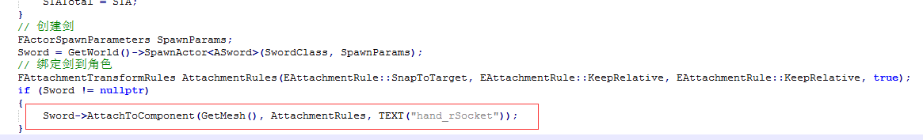

将函数暴露给蓝图

1. UFUNCTION(BlueprintImplementableEvent)
2. **void** OnDepleted();

将参数暴露给蓝图

UPROPERTY(EditDefaultsOnly, Category = Projectile)

关闭渲染

GEngine->RedrawViewports(false);

当报错物体超出世界范围时，在世界设置中把这个关掉

Enable World Bounds Checks

从蓝图类生成实例

*UClass*\* TEXT1 = *LoadClass*<ATank>(*NULL*, *TEXT*("Blueprint'/Game/StarterContent/Blueprint/MyTank.MyTank_C'"));

ATank* SpawnedActor1 = (ATank*)*GetWorld*()->*SpawnActor*(TEXT1, &_Location);

当前运行时间

*GetWorld*()->*RealTimeSeconds*;

目标向前移动，方向为向量方向

*GetActorForwardVector*() * _MovementInput.*X* * DeltaTime

打印数据

.h文件的头文件下面

*DECLARE_LOG_CATEGORY_EXTERN*(LogTank, *Log*, *All*);

.cpp文件头文件下面

*DEFINE_LOG_CATEGORY*(LogTank);

使用

*UE_LOG*(LogTank, *Warning*, *TEXT*("33333333，pitch %f, yaw %d, roll %f"), _BarrelRotation.*Pitch*, _BarrelRotation.*Yaw*, _BarrelRotation.*Roll*);

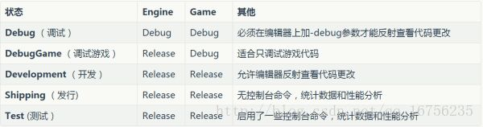

**按键绑定**

InputComponent->BindAction("Jump", IE_Pressed, **this**, &AFPSCharacter::StartJump);

InputComponent->BindAction("Jump", IE_Released, **this**, &AFPSCharacter::StopJump);

InputComponent->BindAxis("UpDown", this, &ARoamingCamera::CameraUp);

//控制默认玩家

AutoPossessPlayer = EAutoReceiveInput::Player0;

**MVC架构**

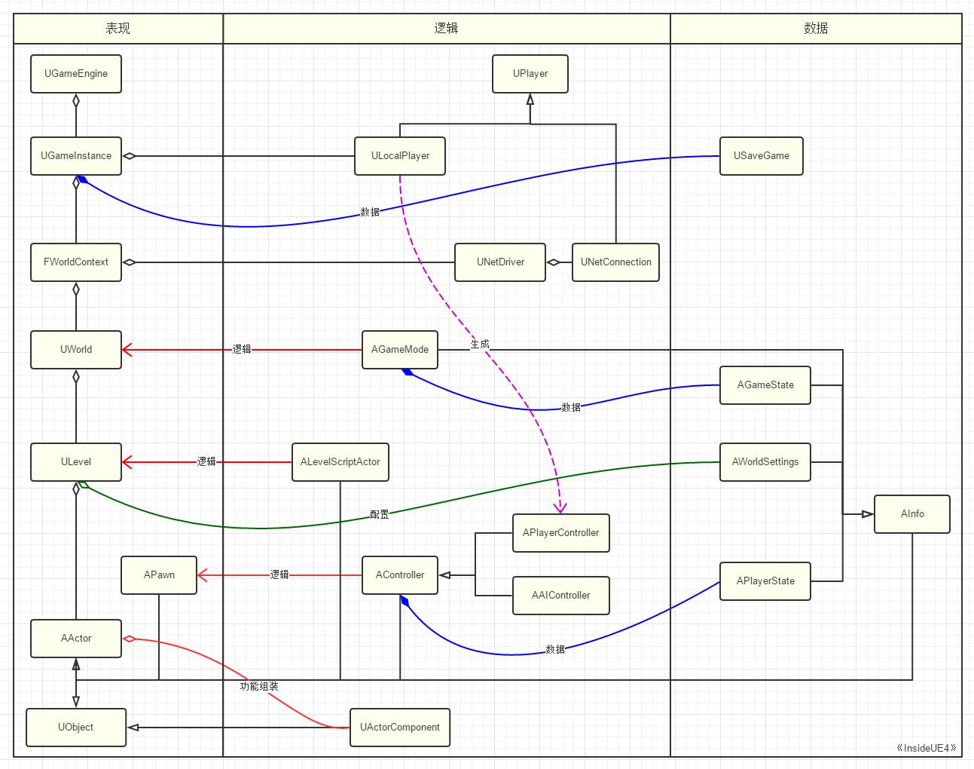

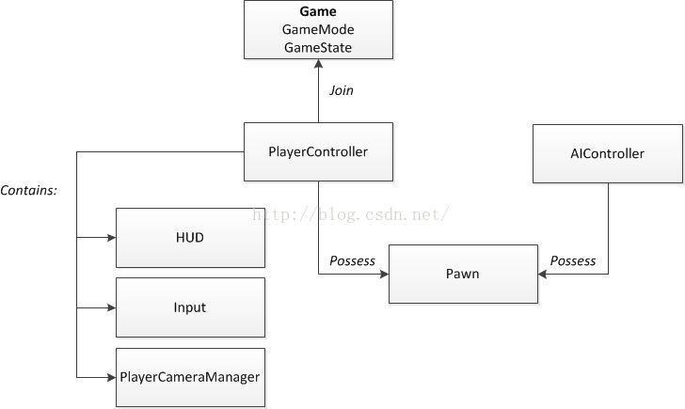

**判断Pawn是否被控制,可用于AI与Player控制的判断**

FConstPlayerControllerIterator It = GetWorld()->GetPlayerControllerIterator();

APlayerController* MyController = Cast<APlayerController>(*It);

if (!(MyController == Controller))

{

}

动态修改碰撞类型

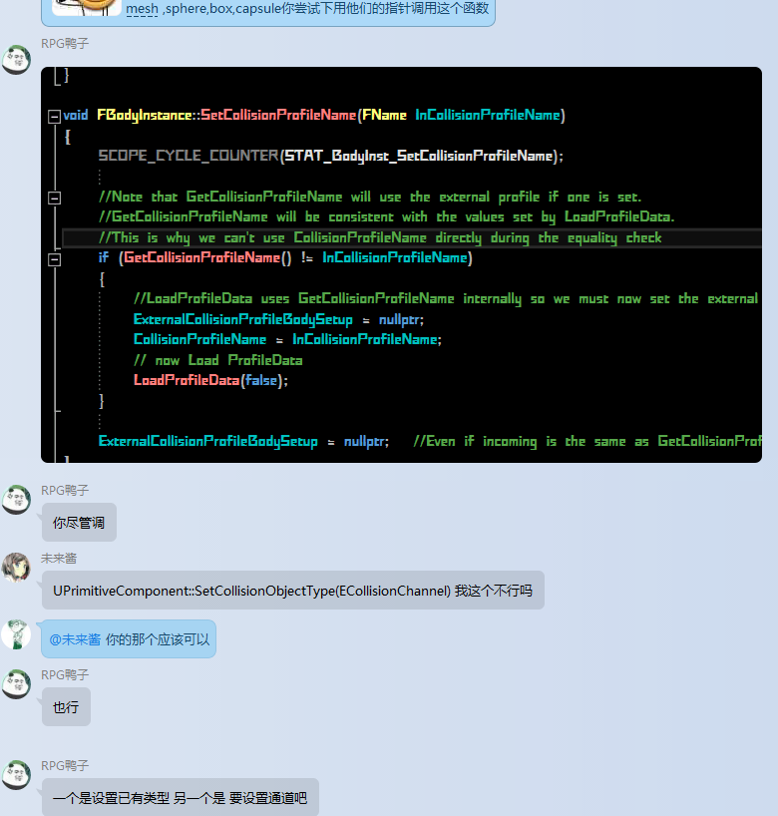

**UE4：C++动态添加UStaticMeshComponent**

**1. 构造函数内添加**   
xxActor::xxActor()   
{   
//tank mesh   
static ConstructorHelpers::FObjectFinder TankStaticMesh(TEXT(“/Game/Meshs/TwinStick/TwinStickUFO.TwinStickUFO”));   
TankMesh = CreateDefaultSubobject(TEXT(“TankMesh”));   
TankMesh->SetStaticMesh(TankStaticMesh.Object);   
TankMesh->SetCollisionProfileName(UCollisionProfile::Pawn_ProfileName);   
RootComponent = TankMesh;   
}

**2. 构造函数外添加（一定要添加RegisterComponent(),否则不会显示！）**   
bool AItemActor::InitComponent(FVector loc, FRotator rot)   
{   
bool bRtn = false;   
//mesh   
m_pMeshComponent = (UStaticMeshComponent*)NewObject(this, TEXT(“Mesh”));   
m_pStaticMesh = CreateStaticMesh(m_ItemType);   
if (m_pMeshComponent && m_pStaticMesh)   
{   
m_pMeshComponent->SetStaticMesh(m_pStaticMesh);   
m_pMeshComponent->SetCollisionProfileName(UCollisionProfile::Pawn_ProfileName);   
m_pMeshComponent->SetRelativeRotation(rot);   
m_pMeshComponent->SetRelativeLocation(loc);   
m_pMeshComponent->RegisterComponent();   
m_pMeshComponent->OnComponentHit.AddDynamic(this, &AItemActor::OnHit);

RootComponent = m_pMeshComponent;

bRtn = true;

}

return bRtn;

Actor设置碰撞

TArray < UStaticMesh *> &AllComponent = OtherActor->GetComponents;

for (int i = 0;i < AllComponent.GetTypeSize;i++)

{

if (AllComponent[i] )

{

_TankBody->SetCollisionObjectType();

}

}

Actor设置隐藏

OtherActor ->SetActorHiddenInGame(true);

Actor设置无碰撞

OtherActor->SetActorEnableCollision(false);

良好的编码规范在保证代码在高质量完成需求的同时具备良好的可读性、可维护性。如成员变量前要加下划线，首字母要大写；成员函数要首字母大写并且有意义，注意语态；系统头文件应用#include <xxx.h>；自定义同文件应用#include "xxx.h"；头文件对变量函数声明，CPP文件进行定义；局部变量小写，开头不加下划线等要点。

**关于PlayerController**

