**编辑动画序列**

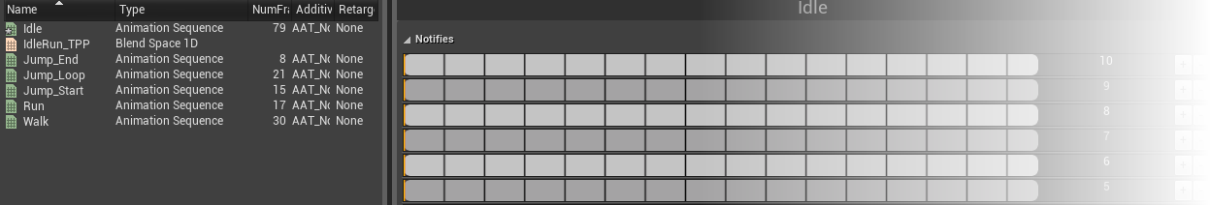

**本页面的内容：**

* [Interface](http://api.unrealengine.com/CHN/Engine/Animation/Sequences/Editor/index.html#interface)
* [Notifies](http://api.unrealengine.com/CHN/Engine/Animation/Sequences/Editor/index.html#notifies)
* [Notify Tracks](http://api.unrealengine.com/CHN/Engine/Animation/Sequences/Editor/index.html#notifytracks)
* [Working with Notifies](http://api.unrealengine.com/CHN/Engine/Animation/Sequences/Editor/index.html#workingwithnotifies)
* [Timeline](http://api.unrealengine.com/CHN/Engine/Animation/Sequences/Editor/index.html#timeline)

**动画序列编辑器** 提供了预览及编辑单独的 *动画序列* 资源的功能。在其属性中可以设置 *动画序列* 的压缩机制，可以添加动画通知事件(也称为通知)来基于动画触发相机特效、粒子特效、声效等。

**Interface**

The **Animation Sequence Editor** consists of the following:

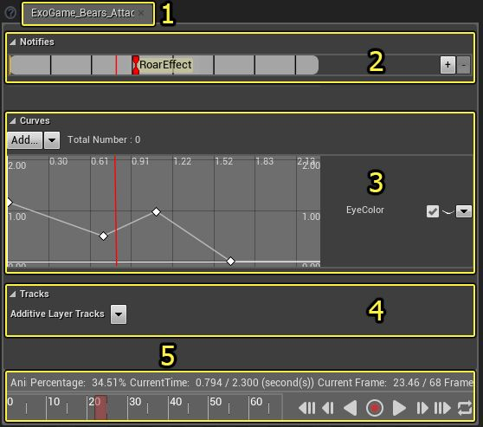

1. **Toolbar** - Displays the name of the *AnimationSequence* currently being edited.
2. **Track List** - Editable list of tracks for creating/editing notifies. See below for instructions on creating and removing tracks as well as creating and working with notifies.
3. **Timeline** - Displays information about, and provides controls for, playback of the preview in the **Viewport** panel of **Persona**.

**Notifies**

An animation *Notify* is an event along a particular animation at which you can cause something to happen. For instance, the moment a character's foot hits the floor, you can create a Notify along the timeline to play a footstep sound. Other notifies are available as well, allowing for particle, camera, and sound effects. You may also create custom notifies that trigger your own events.

For more information on Animation Notifies, please see the [动画通知 (通知)](http://api.unrealengine.com/CHN/Engine/Animation/Sequences/Notifies/index.html) page.

**Notify Tracks**

Notifies are stored in **Tracks** within *AnimationSequences*. A track is essentially a container that can hold any number of Notifies, and an *AnimationSequence* can have any number of tracks. Using multiple tracks makes it easier to organize and visualize Notifies, especially in cases where an *AnimationSequence* requires large numbers or several different types of Notifies.

Every *AnimationSequence* has a single track by default; however, additional tracks can be added to the sequence and existing tracks can be removed using the controls to the right of the tracks.

**Adding a new track**

In the **Track List**, click the button_track_add.png button next to an existing track:

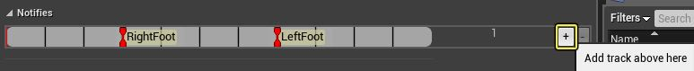

A new track is added above the existing track in the list:

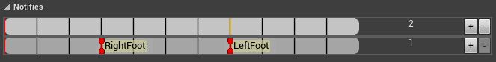

**Removing an existing track**

In the **Track List**, click the button_track_remove.png button next to the track you want to remove:

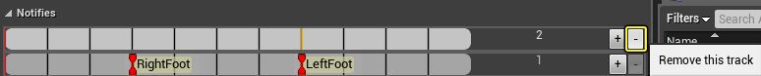

The track is removed from the list:

TrackRemoved.png

**Working with Notifies**

Notifies can be added to tracks, moved around inside a track, and moved back and forth between different tracks within the **Track List**. This makes it extremely easy to tweak the position of a Notify or quickly arrange them logically.

**Creating a Notify**

Notifies of any existing type or custom Notifies can be added through the context menu. Right-clicking on a track displays the context menu. All available types of Notifies are listed in the **Add a notify** flyout menu. Select the type of notify to add to the track:

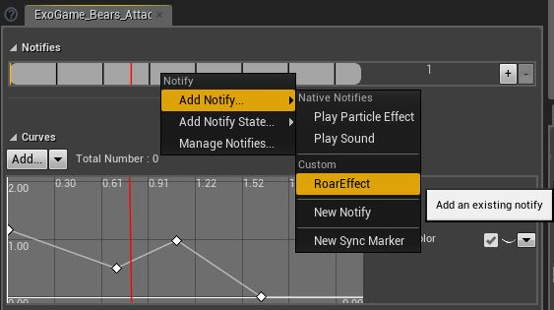

The new Notify is added to the track at the location where you right-clicked:

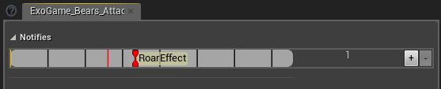

**Positioning a Notify**

The position of a Notify within the track is extremely important as it determines when the event that corresponds to the Notify is triggered. Moving a Notify around is easy; just click and hold the **Left Mouse Button** on the Notify and drag the mouse.

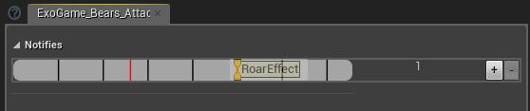

Release the **Left Mouse Button** to drop the Notify at that location:

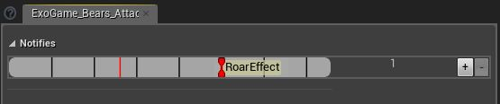

**Switching Tracks**

Moving notifies between tracks is extremely easy. In fact, it is essentially the same as the process for positioning Notifies described above. The only difference is you release the notify on a different track than where it started.

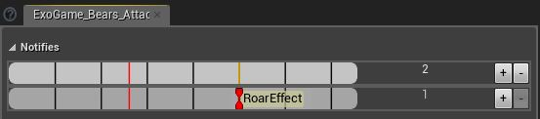

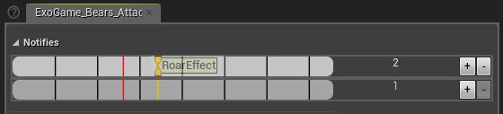

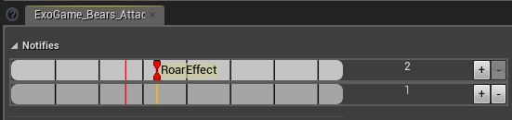

**Timeline**

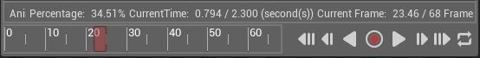

The information bar in the **Timeline** displays the following playback information:

| **Info** | **Description** |
| --- | --- |
| **Animation** | The name of the *AnimationSequence* currently being edited. |
| **Percentage** | The current playback position expressed as a percentage of the whole animation. |
| **Current Time** | The current playback position expressed in seconds. |
| **Current Frame** | The current playback position expressed in frames. |

**时间轴** 和 **控制栏** 包含以下功能：

| **控件** | **描述** |
| --- | --- |
| Control bar - Timeline（控件条-时间轴） | 时间轴显示了 *动画序列* 或 *混合空间* 的帧，并允许滑过帧来进行预览。在当前位置显示了一个红条。**左击该红条并进行拖拽** 就可以浏览帧。 |
| Control bar - Skip to Beginning（控制条 - 跳转到开头） | 跳转到 *动画序列* 或 *混合空间* 的第一帧。 |
| Control bar - Step Backward（控制条 - 逐帧倒放） | 跳转到 *动画序列* 或 *混合空间* 中的前一帧。 |
| Control bar - Play in Reverse(控制条- 反向播放) Control bar - Pause | 开始反向播放 *动画序列* 或 *混合空间* 。当播放动画时，会显示暂停按钮。 |
| Control bar - Play Forward（控制条- 正向播放） Control bar - Pause | 开始正向播放 *动画序列* 或 *混合空间* 。当播放动画时，会显示暂停按钮。 |
| Control bar - Step Forward（控制条 - 逐帧向前播放） | 跳转到 *动画序列* 或 *混合空间* 的下一帧。 |
| Control bar - Skip to End（控制条 -跳转到结尾处） | 跳转到 *动画序列* 或 *混合空间* 的最后一帧。 |
| Control bar - Enable Looping(控制条 - 启用循环) Control bar - Disable Looping | 在播放一次和循环播放之间进行切换。当启用循环播放时，该按钮变为红色。 |

如果打开一个混合空间资源或者动画偏移资源，如果预览开启的话，该动画会自动播放。如果在 AnimationSequence 或是 AnimationMontage 中暂停或禁用循环播放选项并此时打开混合空间或动画偏移的话，动画将不会自动播放。如果需要自动播放的话则需启用 播放/循环 的选项。

这个控制条包含了以下控件：

| **控件** | **描述** |
| --- | --- |
| Control bar - Timeline（控件条-时间轴） | 时间轴显示了 *动画序列* 或 *混合空间* 的帧，并允许滑过帧来进行预览。在当前位置显示了一个红条。**左击该红条并进行拖拽** 就可以浏览帧。 |
| Control bar - Skip to Beginning（控制条 - 跳转到开头） | 跳转到 *动画序列* 或 *混合空间* 的第一帧。 |
| Control bar - Step Backward（控制条 - 逐帧倒放） | 跳转到 *动画序列* 或 *混合空间* 中的前一帧。 |
| Control bar - Play in Reverse(控制条- 反向播放) Control bar - Pause | 开始反向播放 *动画序列* 或 *混合空间* 。当播放动画时，会显示暂停按钮。 |
| Control bar - Play Forward（控制条- 正向播放） Control bar - Pause | 开始正向播放 *动画序列* 或 *混合空间* 。当播放动画时，会显示暂停按钮。 |
| Control bar - Step Forward（控制条 - 逐帧向前播放） | 跳转到 *动画序列* 或 *混合空间* 的下一帧。 |
| Control bar - Skip to End（控制条 -跳转到结尾处） | 跳转到 *动画序列* 或 *混合空间* 的最后一帧。 |
| Control bar - Enable Looping(控制条 - 启用循环) Control bar - Disable Looping | 在播放一次和循环播放之间进行切换。当启用循环播放时，该按钮变为红色。 |