1. **打印四个朝向的等腰三角形**

顶角朝下

line=10

for i in range(line):

for j in range(i+1):

print(" ",end="")

for n in range(line-i-1):

print("0",end=" ")

print("\n")

顶角朝上

line=10

for i in range(line):

for j in range(line-i-1):

print(" ",end="")

for n in range(i+1):

print("0",end=" ")

print("\n")

顶角朝右

line=10

for i in range(line):

for n in range(i+1):

print("0",end=" ")

print("\n")

for i in range(line):

for n in range(line-i-1):

print("0",end=" ")

print("\n")

顶角朝左

line=10

for i in range(line):

for j in range(line-i-1):

print(" ",end="")

for n in range(i+1):

print("0",end=" ")

print("\n")

for i in range(line):

for j in range(i+1):

print(" ",end="")

for n in range(line-i-1):

print("0",end=" ")

print("\n")

1. **打印沙漏**

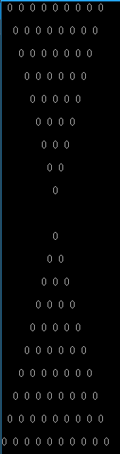

line=10

for i in range(line):

for j in range(i):

print(" ",end="")

for n in range(line-i):

print("0",end=" ")

print("\n")

for i in range(line):

for j in range(line-i-1):

print(" ",end="")

for n in range(i+1):

print("0",end=" ")

print("\n")

1. **打印菱形**

line=10

for i in range(line):

for j in range(line-i-1):

print(" ",end="")

for n in range(i+1): #10个数

print("0",end=" ")

print("\n")

for i in range(line):

for j in range(i+1):

print(" ",end="")

for n in range(line-i-1): #9个数

print("0",end=" ")

print("\n")

1. **打印九九乘法表**

由小到大

i=j=1

for i in range(1,10):

for j in range(1,i+1):

str='%s*%s=%s'%(i,j,i*j)

print(str,end=" ")

print("\n")**由大到小**

由大到小

i=j=1

for i in range(9,0,-1):

for j in range(9,i-1,-1):

str='%s*%s=%s'%(i,j,i*j)

print(str,end=" ")

print("\n")

1. **打印X形图像**

X为实心

line=5

for i in range(line):

for j in range(line):

if i==j:

print("*",end=" ")

elif line-j==i+1:

print("*",end=" ")

else:

print(" ",end="")

print("\n")

X为空心

line=10

for i in range(line):

for j in range(line):

if i==j:

print(" ",end="")

elif line-j==i+1:

print(" ",end="")

else:

print("*",end=" ")

print("\n")

1. **分析行**
2. **分析有没有空格**
3. **分析打印的内容**