‘Weapon Detection in Real-Time CCTV Videos Using Deep Learning

In this paper author is experimenting with various deep learning algorithms to detect weapons from CCTV videos to provide security to civilians or tourist. All public places are equipped with CCTV and this CCTV can be monitor by using this deep learning algorithms to detect person with weapon. In propose paper author has various object detection and classification models called VGG16, Yolov3, Yolov4, faster RCNN, Inception, Resnet and few others. In all algorithms Yolov4 is giving more than 90% accuracy and FSCORE.

To train all those algorithms there is no public dataset available so author of this paper is creating his own dataset from CCTV images. We also downloaded few KNIVES and GUNS images from Google to train algorithms.

Training all algorithms may take days of time and it’s not possible to train all algorithms so we have trained YoloV4 model and then this model can be applied on images and videos to detect weapon.

Below screen showing images from dataset used to train YOLO algorithm

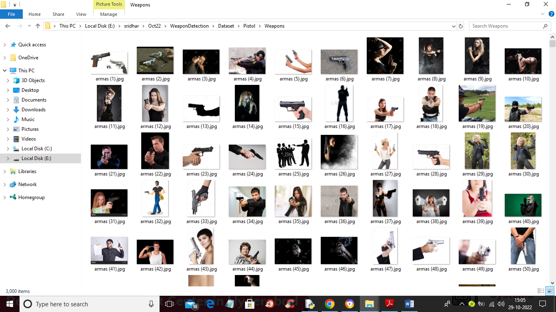

So by using above images will trained algorithm

To implement this project we have designed following modules

1. Upload Weapon Dataset: using this module we will upload dataset to application
2. Load Yolov4 Weapon Detection Model: this will read dataset images and then trained or load Yolov4 model and then calculate its prediction accuracy
3. Upload Image: using this module we will upload test image
4. Detect Weapon from Image: using this module we will apply Yolov4 model on loaded image to detect weapon
5. Detect Weapon from Video: using this module we will upload video and then YoloV4 will analyse each frame in the video to detect weapon
6. Weapon Detection Training Accuracy-Loss Graph: using this module we will plot YoloV4 training accuracy and loss graph

SCREEN SHOTS

To run project double click on ‘run.bat’ file to get below screen

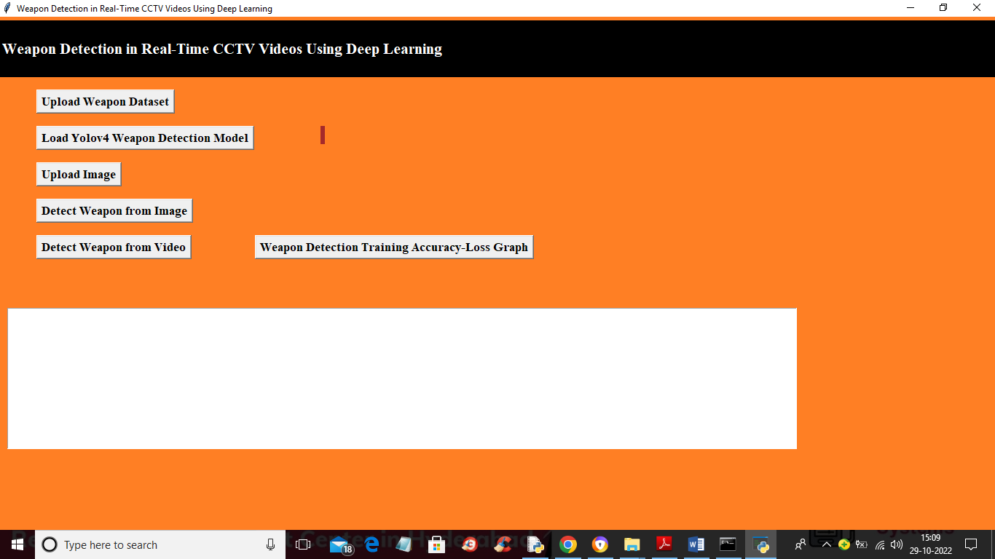

In above screen click on ‘Upload Weapon Dataset’ button to upload dataset and get below output

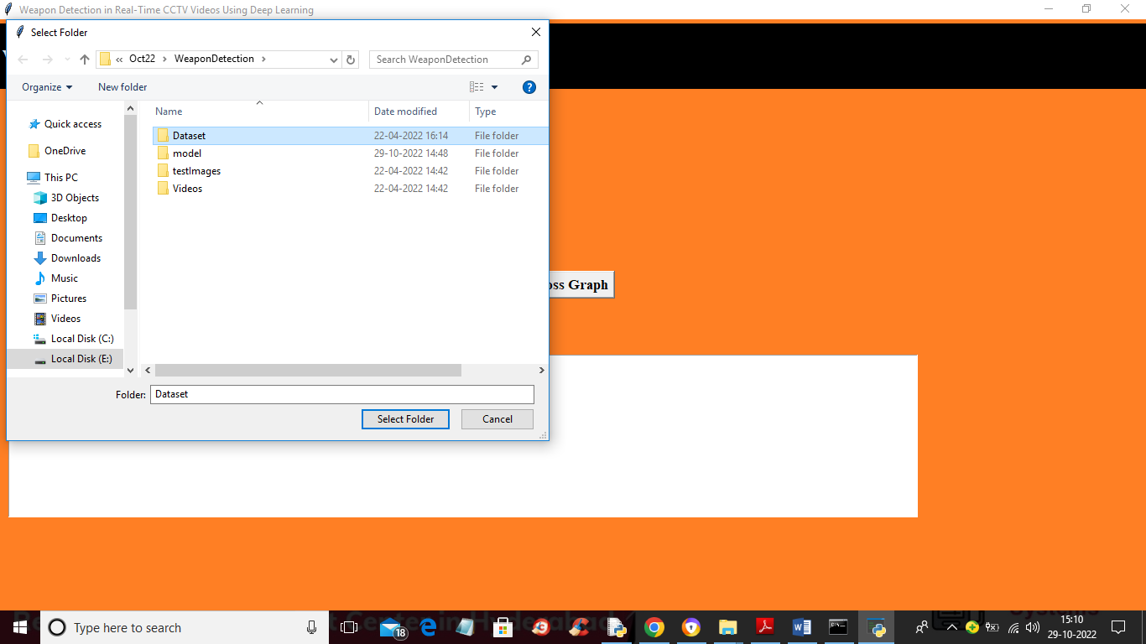

In above screen selecting and uploading ‘Dataset’ folder and then click on ‘Select Folder’ button to load dataset and get below output

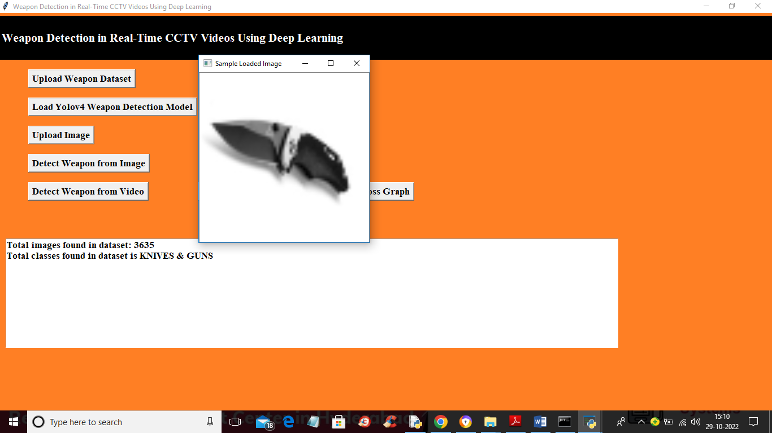

In above screen we can see dataset loaded and dataset contains 2 classes called Guns and Knives and dataset contains total 3635 images and now close above image and then click on ‘Load Yolov4 Weapon Detection Model’ button to load YoloV4 model and calculate accuracy

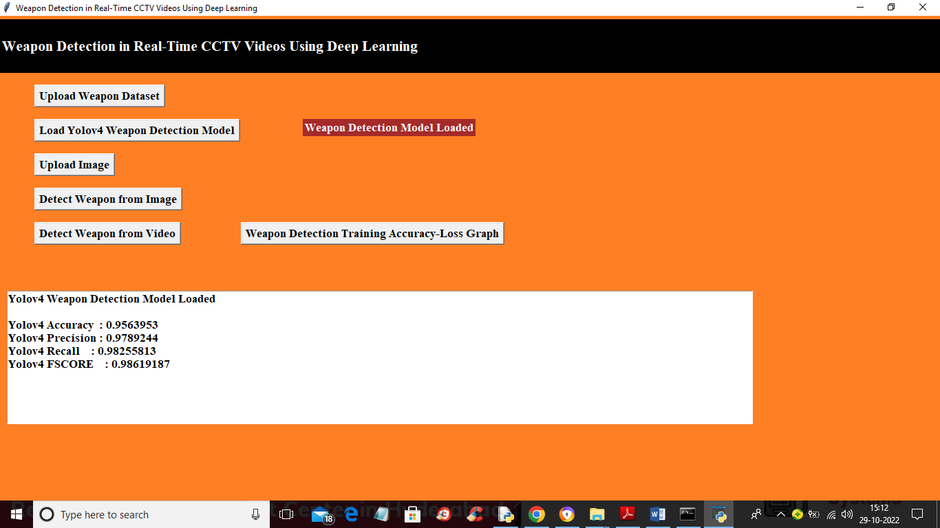

In above screen YoloV4 model loaded and we got its prediction accuracy as 95% and now model is loaded and now click on ‘Upload Image’ button to upload test image like below screen

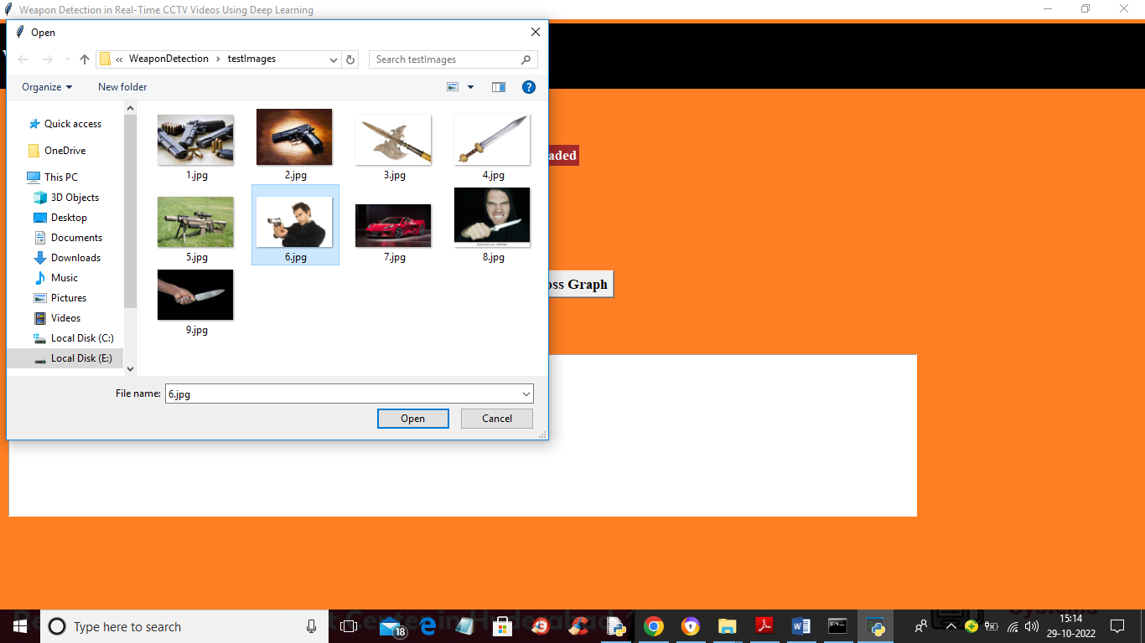

In above screen selecting and uploading ‘6.jpg’ image and then click on ‘Open’ button to load image and then click on ‘Detect Weapon from Image’ button to detect weapon and get below output

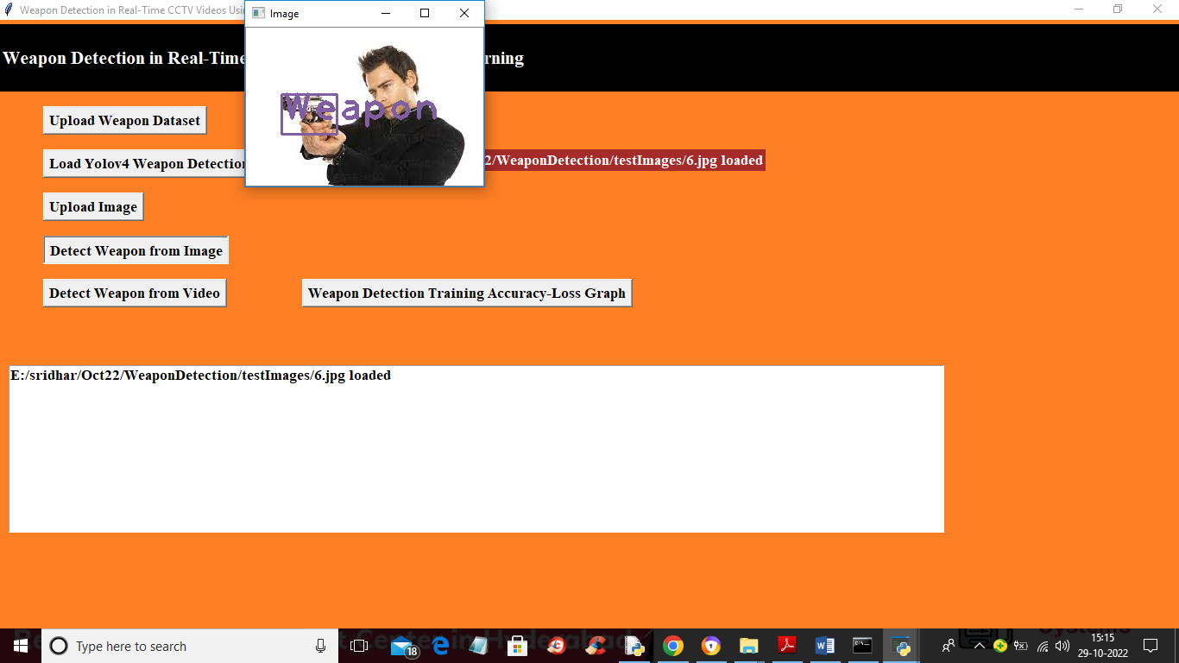

In above screen we got bounding box with label as ‘Weapon’ detect and will get beep sound also and similarly you can upload any image and get detection

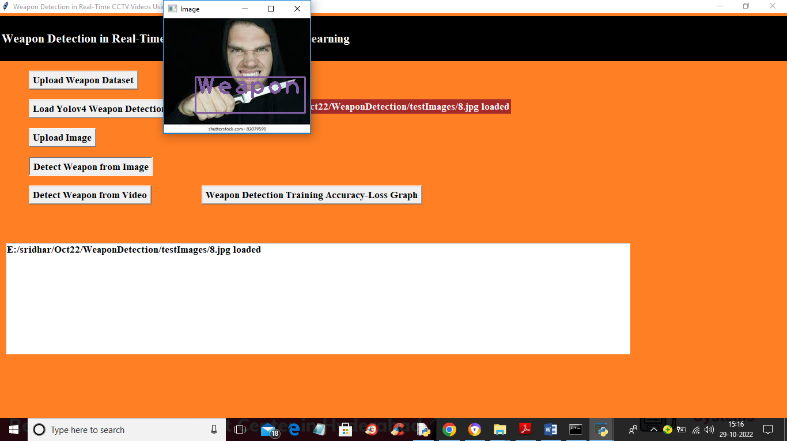

In above image also weapon detected and now close above image and then click on ‘Detect Weapon from Video’ button to upload video and detect weapon from it

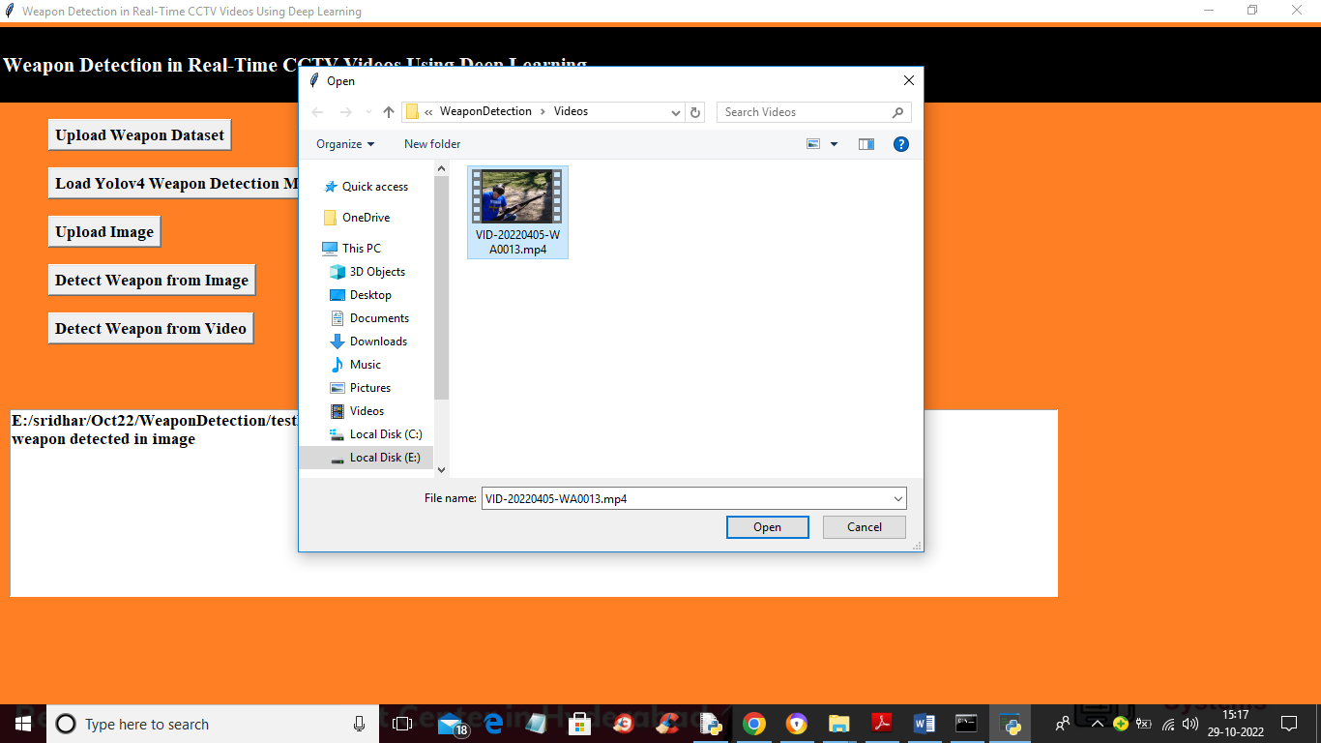

In above screen selecting and uploading video file and then will get below output and this video will play slowly due to processing and if your system speed good then it will play faster

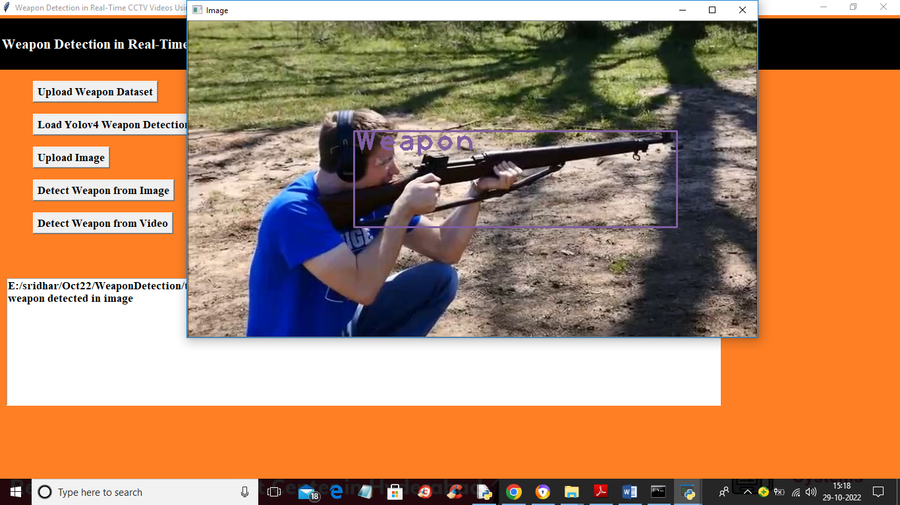

In above screen from video also model is detecting weapon and now close above video and then click on ‘Weapon Detection Training Accuracy-Loss Graph’ button to get Yolov4 training accuracy and loss graph

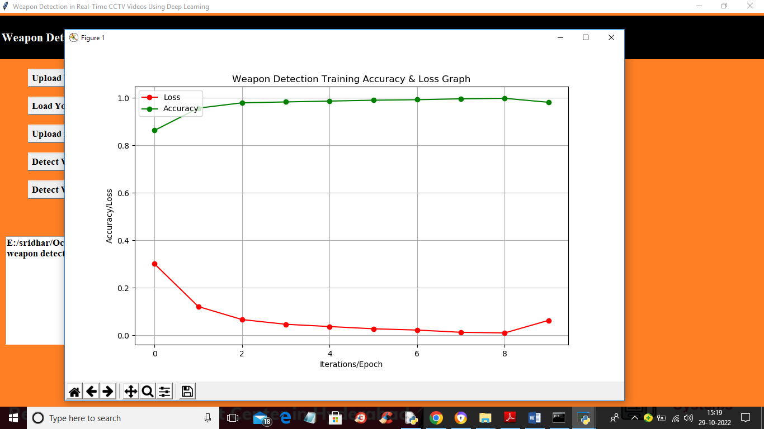

In above graph x-axis represents training epoch and y-axis represents accuracy and loss values and green line represents accuracy and red line represents loss values and we can see with each increasing epoch accuracy got increase and reached closer to 1 and loss get decrease and reached closer to 0. Any model with increasing accuracy and decreasing loss consider as best model