**Triggering PD Patches from Unity:**

Example with Ball Patch:

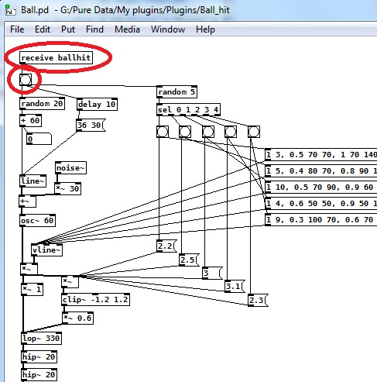

Look at [receive “name”] object. It’s connected to object that have circle in the box – this is trigger

Then in C# in example for OnCollisionEnter:

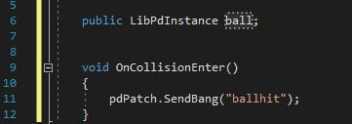

**Controlling Patch variables:**

Look at parameters like these:

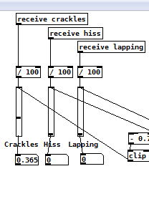

Objects “crackles”, “hiss”, “lapping” are connected to sliders which are exposed in Unity. In boxes below sliders you can see minimum and maximum values by moving sliders up and down.

In C# script you can use these parameters by setting default value and range (minimum, maximum).

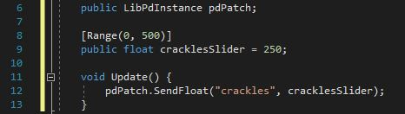

“cracklesSlider” is a name that will be visible in Unity. “crackles” is the name given in PD Patch.