**Normal Enemies:**

1. Skeleton
   1. 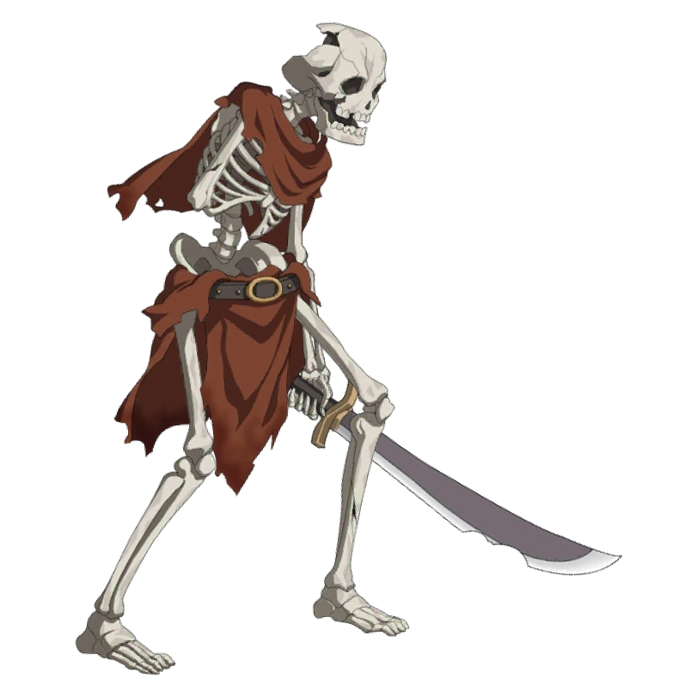
   2. An undead bone patron/warrior. The most basic of enemy types. Low health and damage, basically cannon fodder. Usually will carry no weapon or just a broken sword to attack the player. Very low threat level.
2. Mutated Rats
   1. 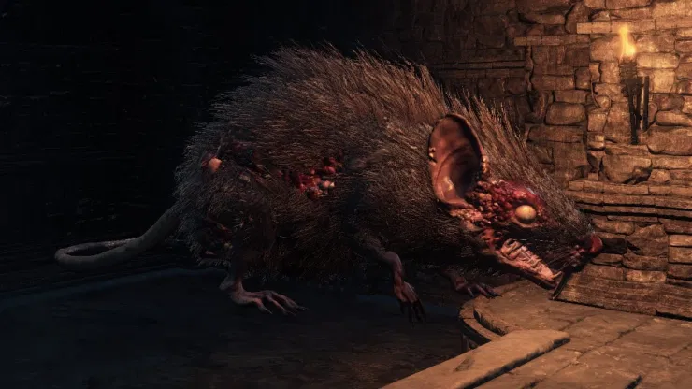
   2. A rat enemy mutated by dark energy and turned feral. Will attack anything on sight. Can have multitudes of sizes. The larger the size, the larger the HP. Low damage, maybe some poison, but will have medium health pools. Low threat.
3. Cultists
   1. 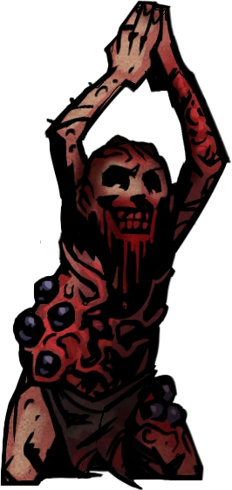
   2. An unholy and infected person who worshipped dark gods and uses dark magic. Cultists would use relatively weak spell types and do low damage as well as having low HP. Could carry daggers and vary with their design, focusing more on magic or weapons. Low threat level. (Can maybe cause insanity?)
4. Madmen
   1. 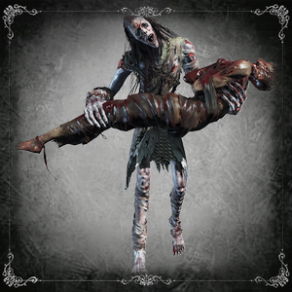
   2. Other adventurers that have been lost to the catacombs, completely insane, feral and violent. Demonic powers have warped their minds and give them animalistic behavior. Medium damage and low health. Somewhat easy to kill but also hits hard. Threat level low.
5. Necromancers
   1. 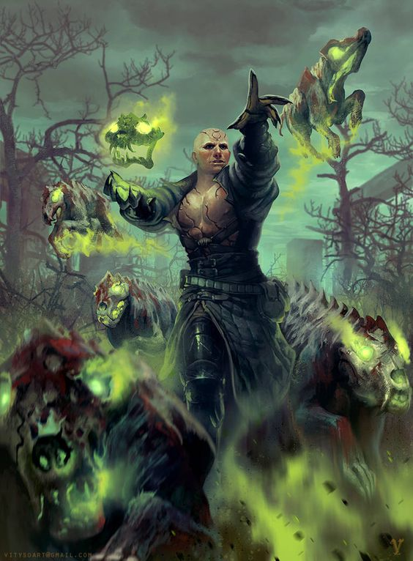
   2. Other adventurers that have NOT succumbed to the influence of the owners catacombs and dark magic. They have learned to harness the power of dark magic and use it to begin hoarding their own power. Uses medium damage dark spells, no physical weapon. Will summon skeletons and other mobs to attack the player as well. High threat level.

**Bosses:**

1. First Boss - Fully Mutated Rat Man
   1. 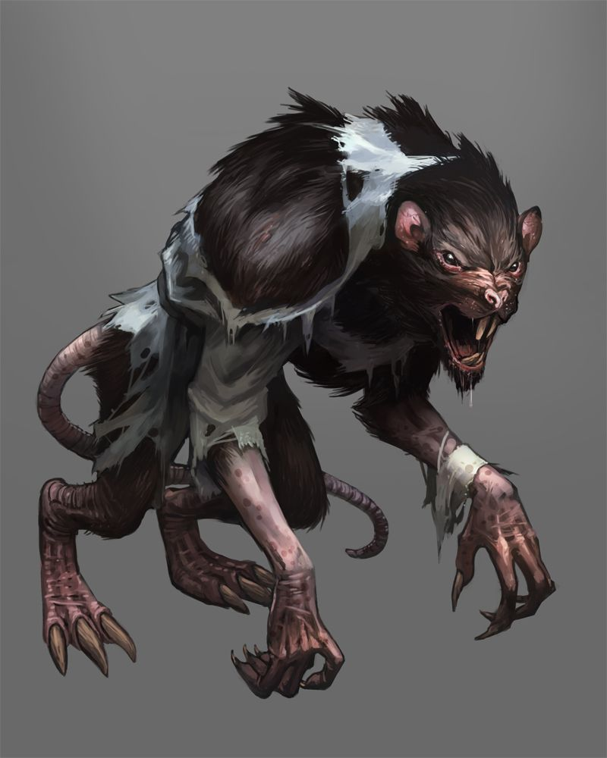
   2. Akin to a werewolf, a normal rat that has been so heavily experimented on and mutated through dark magic and sorcery that it has become fully sentient and violent. Acts like a hungry creature that’s always starving. Attacks for medium damage with long claws. Only has basic attacks to use like scratching and clawing and biting. Has a low-medium health pool. Low threat level.
2. Second Boss - Cultist Leader
   1. 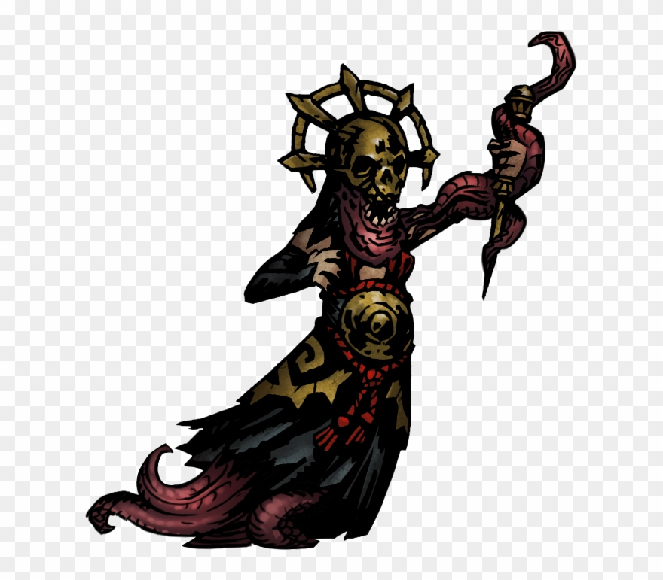
   2. A leader of the demonic cult within the catacombs. Uses a small variety of spells on the player. Also summons cultists to their side to use as protection. Buffs cultists with demonic strength. Medium sized health pool, low damage, yet higher than common mobs. Uses buffs on fellow cultists for main damage. Medium threat.

3. Final Boss - Mansion Owner

* 1. 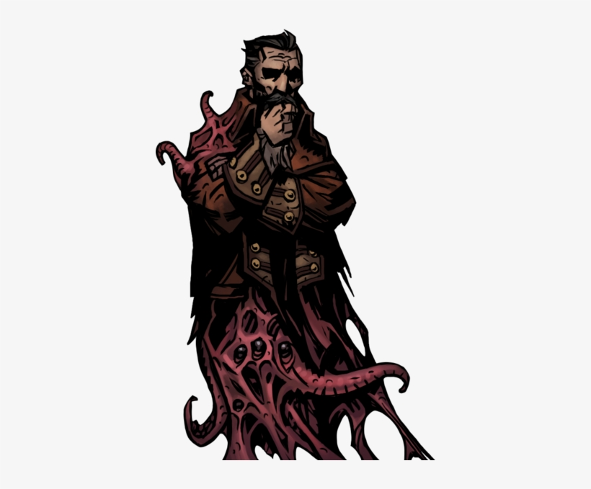
  2. 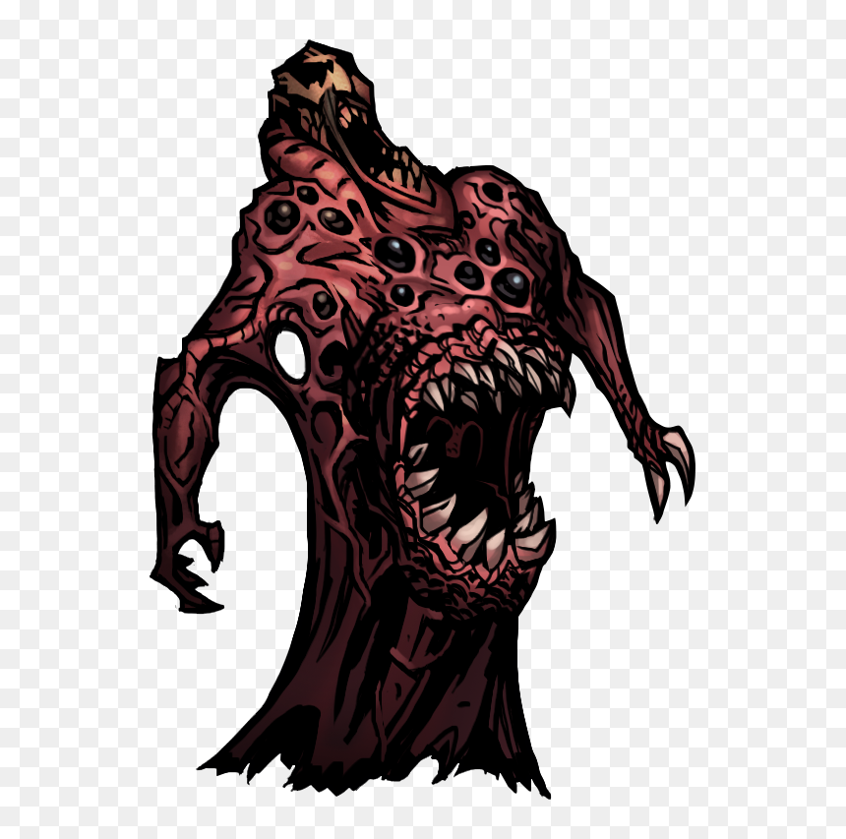
  3. The mansion and fortune owner. Like a dragon and it’s pile of gold, the owner hoards the wealth and dark magic all to himself in the very bottom of the Catacombs (could be in a throne room made of corpses, bone, and magic). Wields extremely powerful dark magic and abilities. Can regenerate health and deal large chunks of damage to the player. Has a high health pool and is resistant to dark magics used against him. Very high threat level.