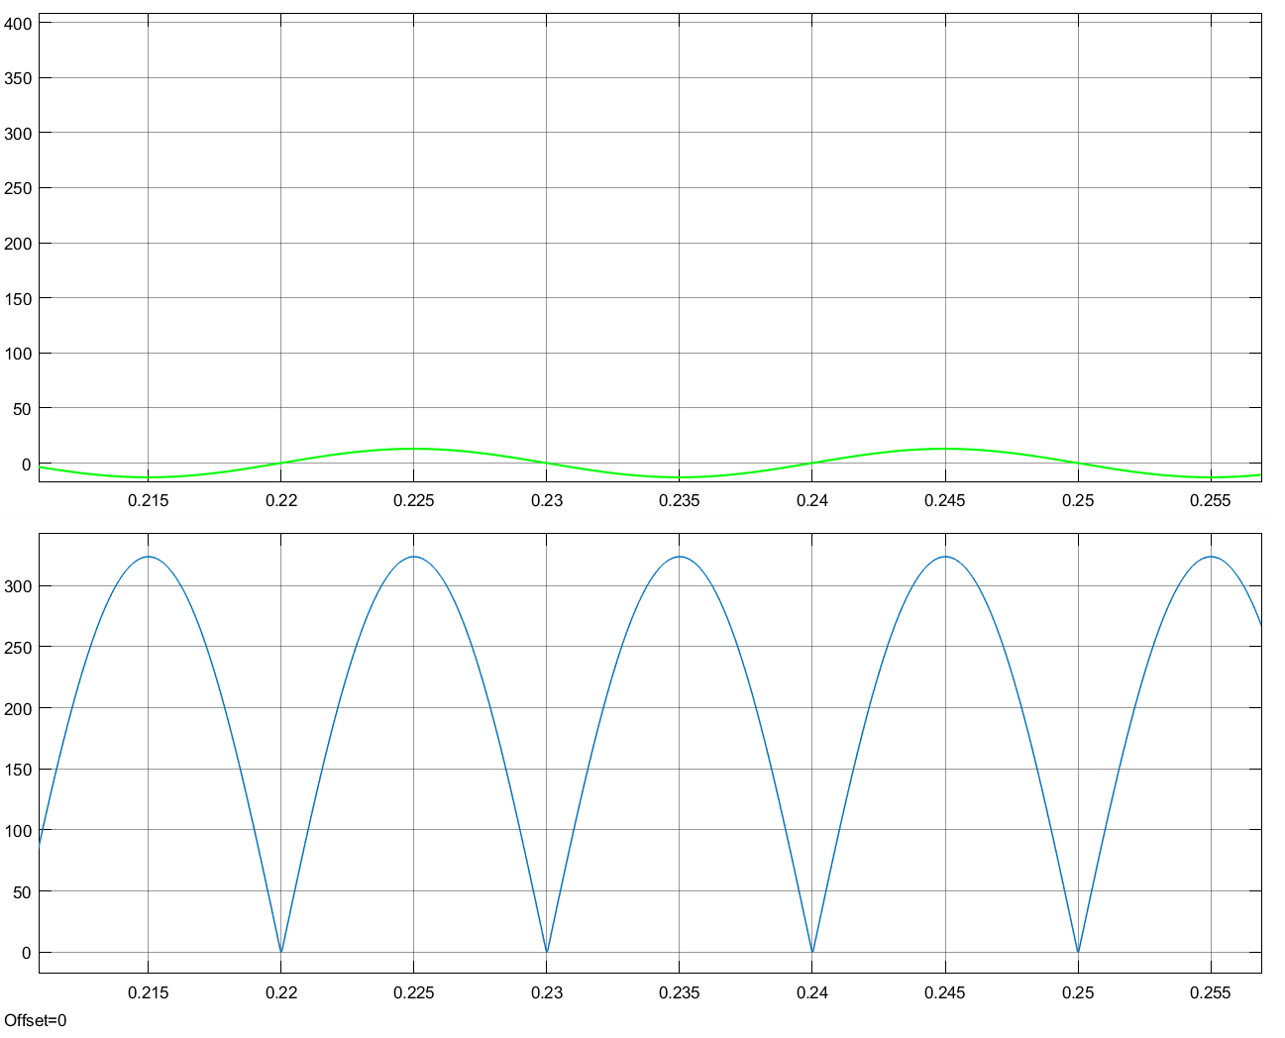

Output voltage waveform with R Load = 25 Ω

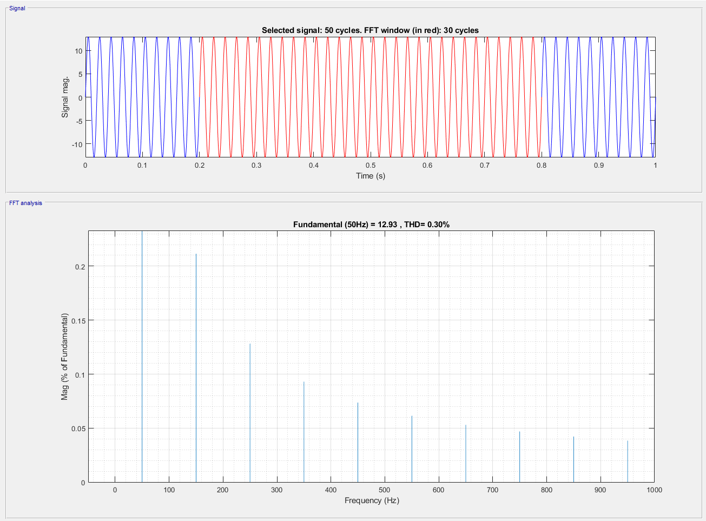

THD=0.3% with R=25 Ω

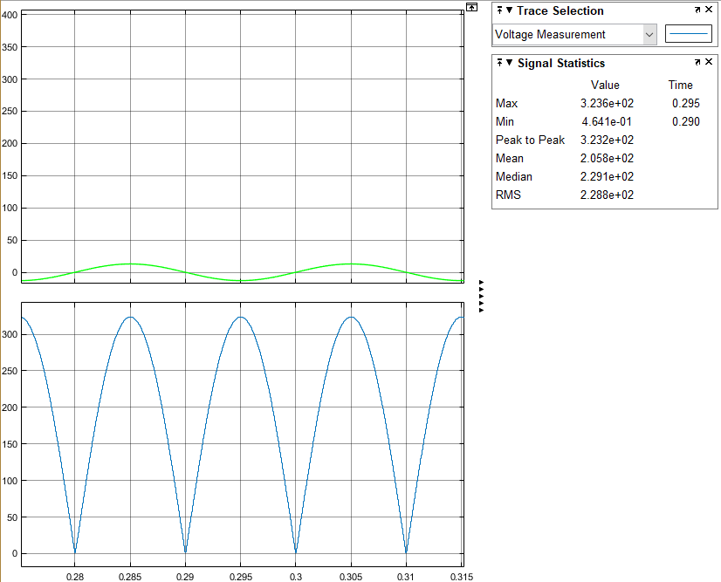

Average output voltage is 205.8V with R=25 Ω

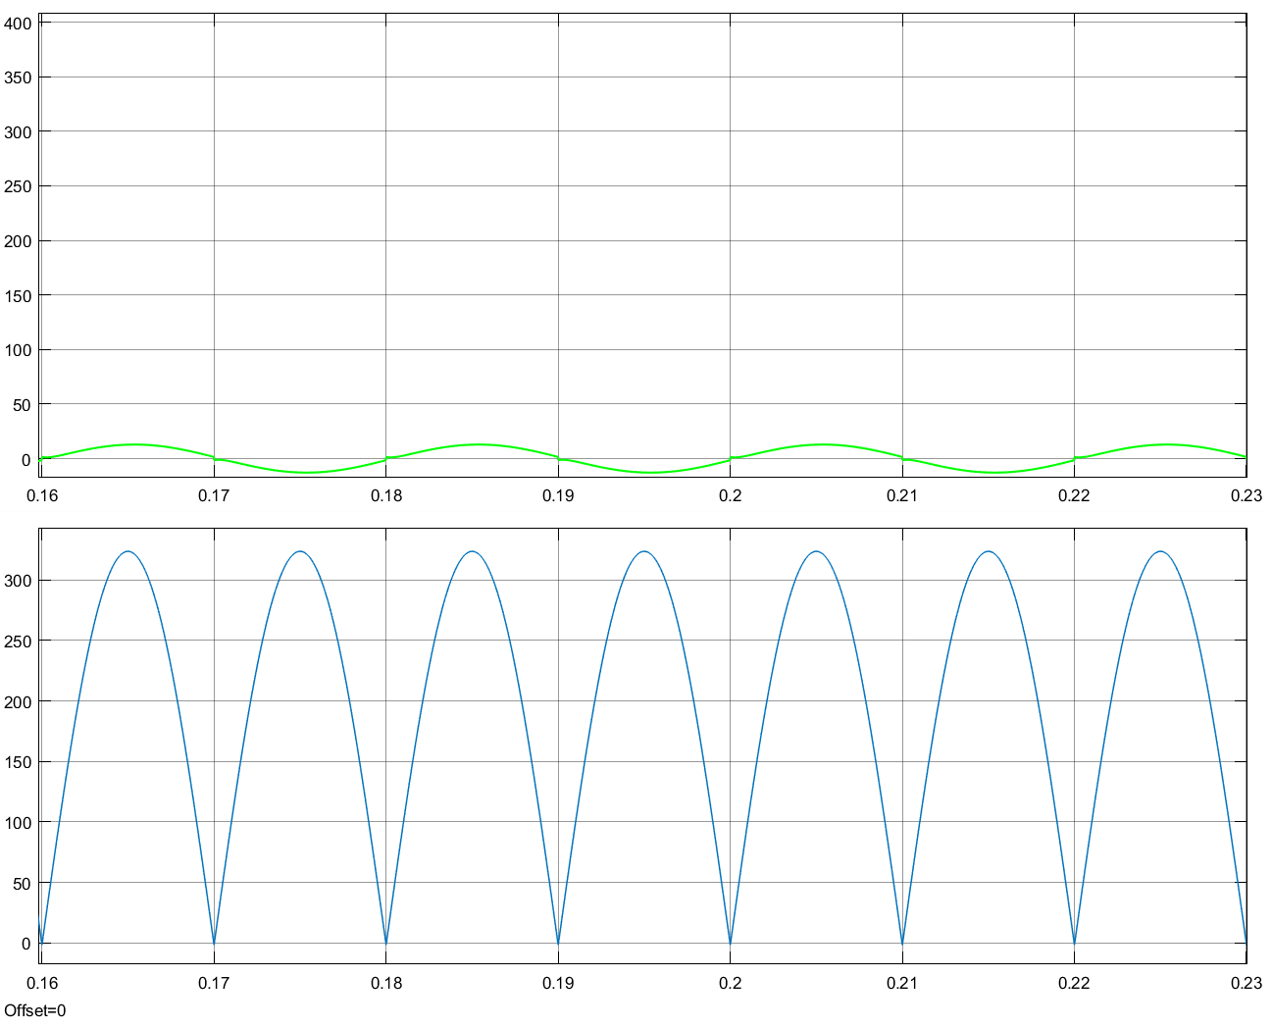

Output voltage waveform with R Load = 25 Ω L=10mH

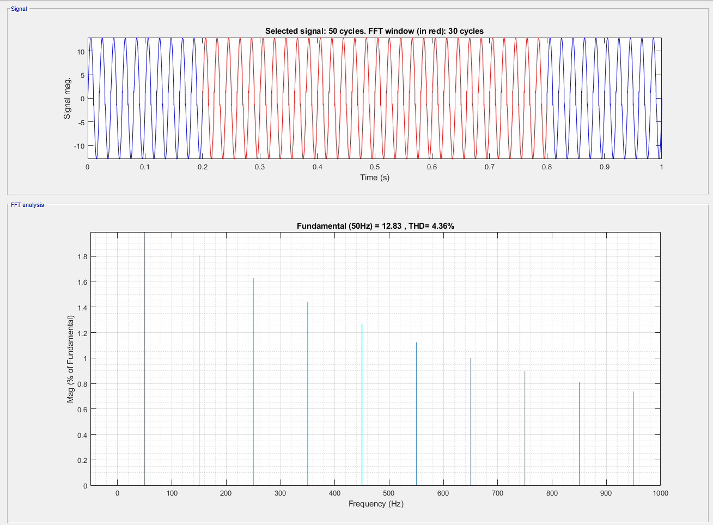

THD= 4.36% with RL Load R=25 Ω L=10mH

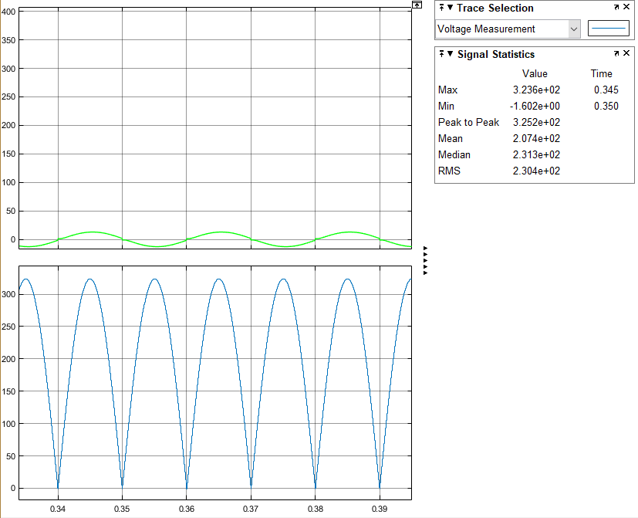

Average output voltage is 207.4V with RL Load R=25 Ω L=10mH

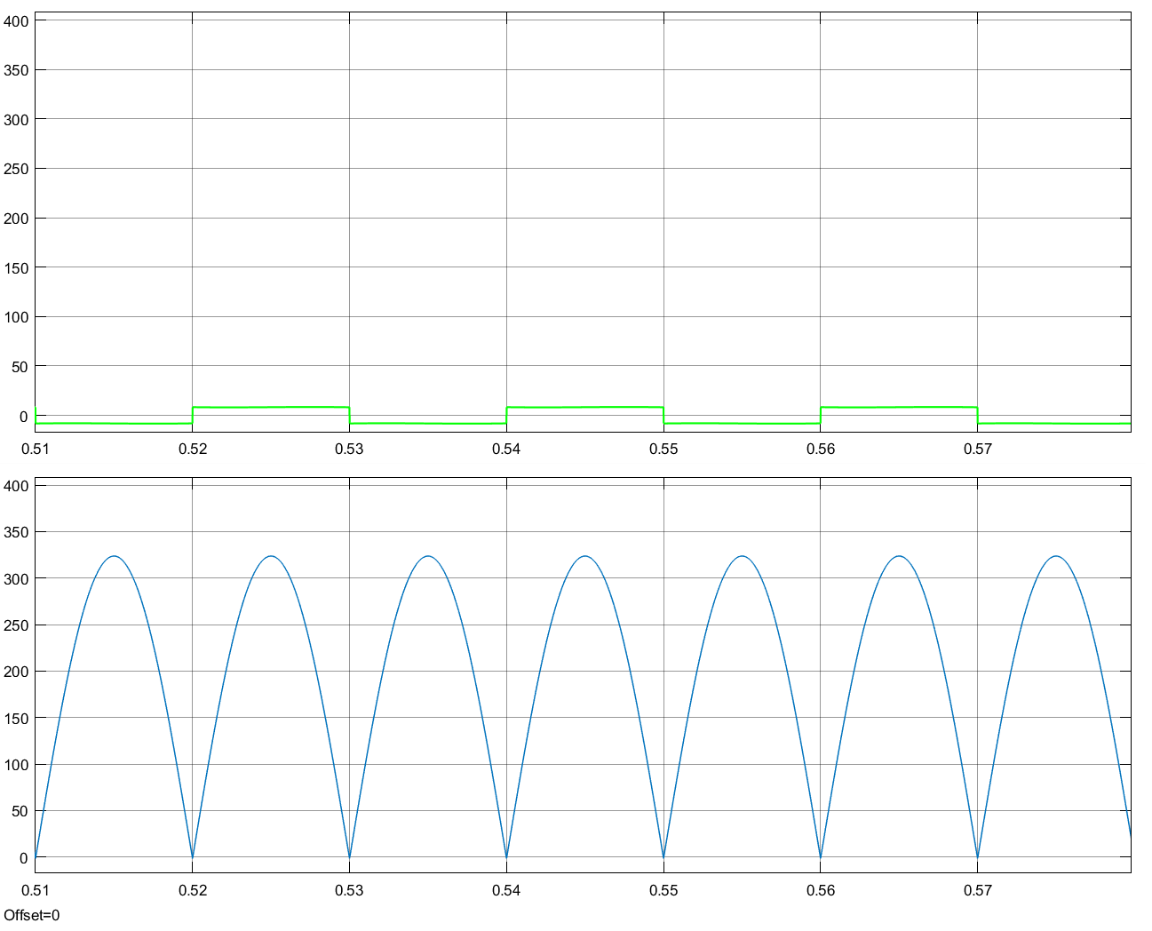

Output voltage waveform with R Load = 25 Ω L=1H

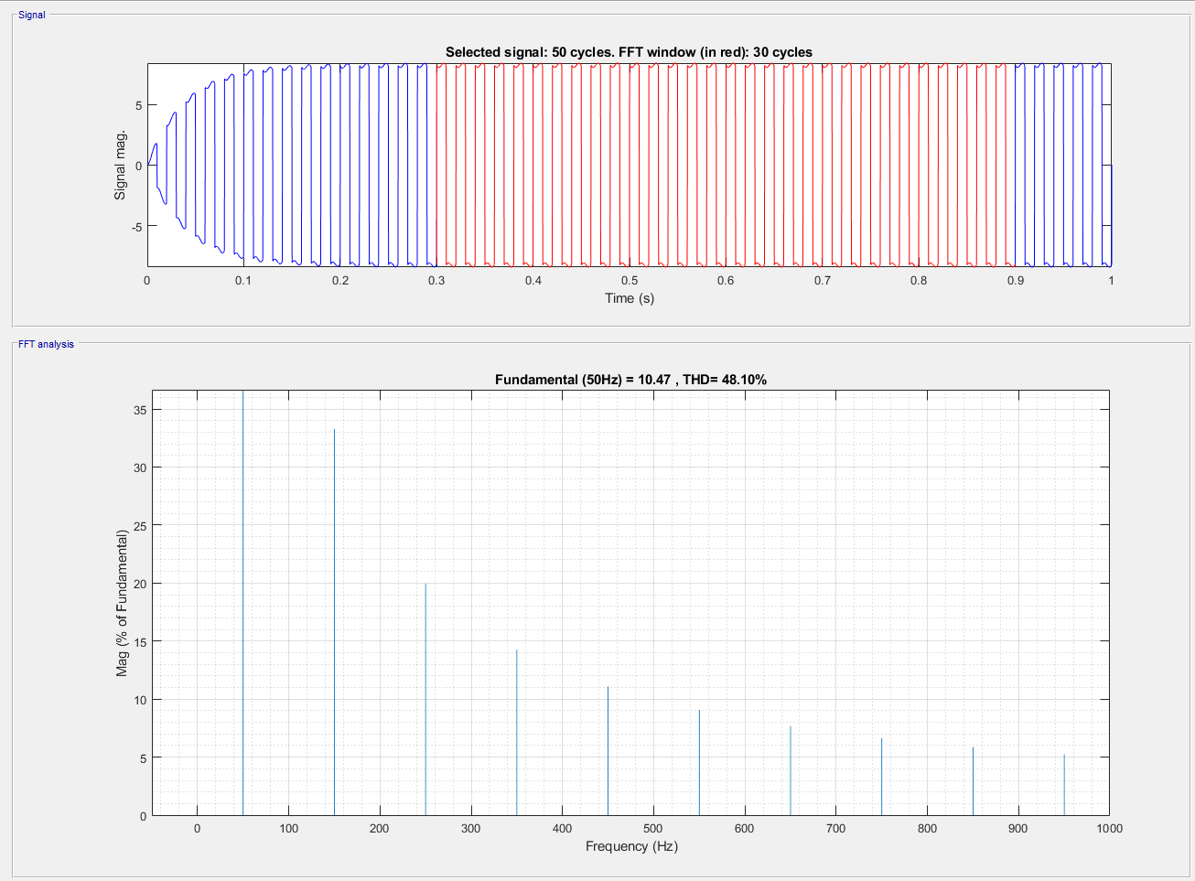

THD= 48.1% with RL Load R=25 Ω L=1H

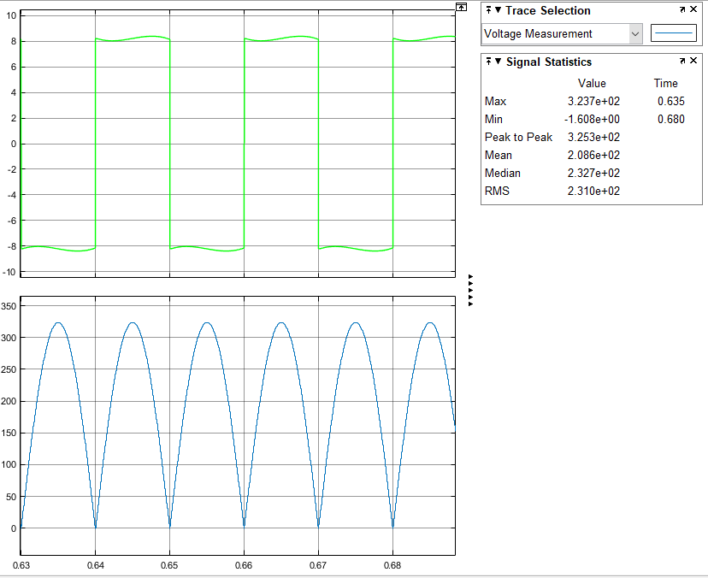

Average output voltage is 208.6V with RL Load R=25 Ω L=1H