**WEEK 4 MODEL DEPLOYMENT ON FLASK SCREEN SHOTS**

- A directory named “**week4**” is created,

- virtual environment named “**week-4-model-deployment**” was created.

- Libraries for the app was downloaded to virtual env.

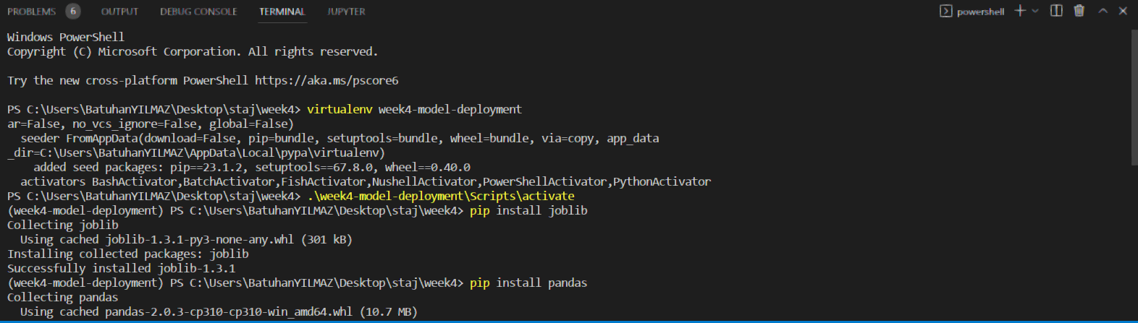

* App.py file and a simple .html and .css code was provided in order to get the input from the user and predict the output according to the model.
* Model was created with “heightweight.csv” data. It predicts the weight of females with given heights.

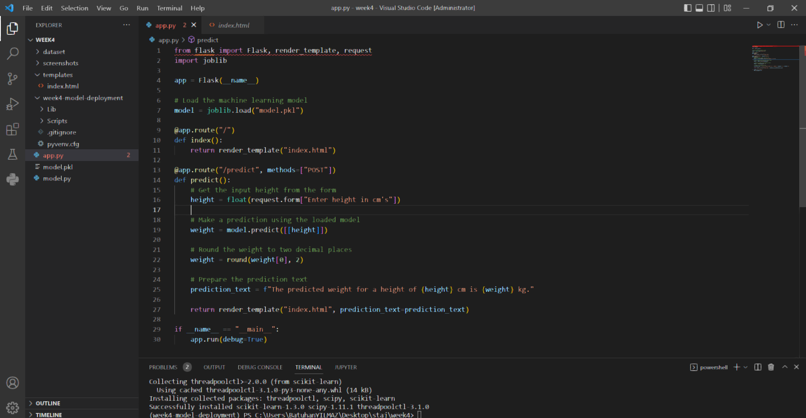

* Here is how the input is taken from user with a simple html form:

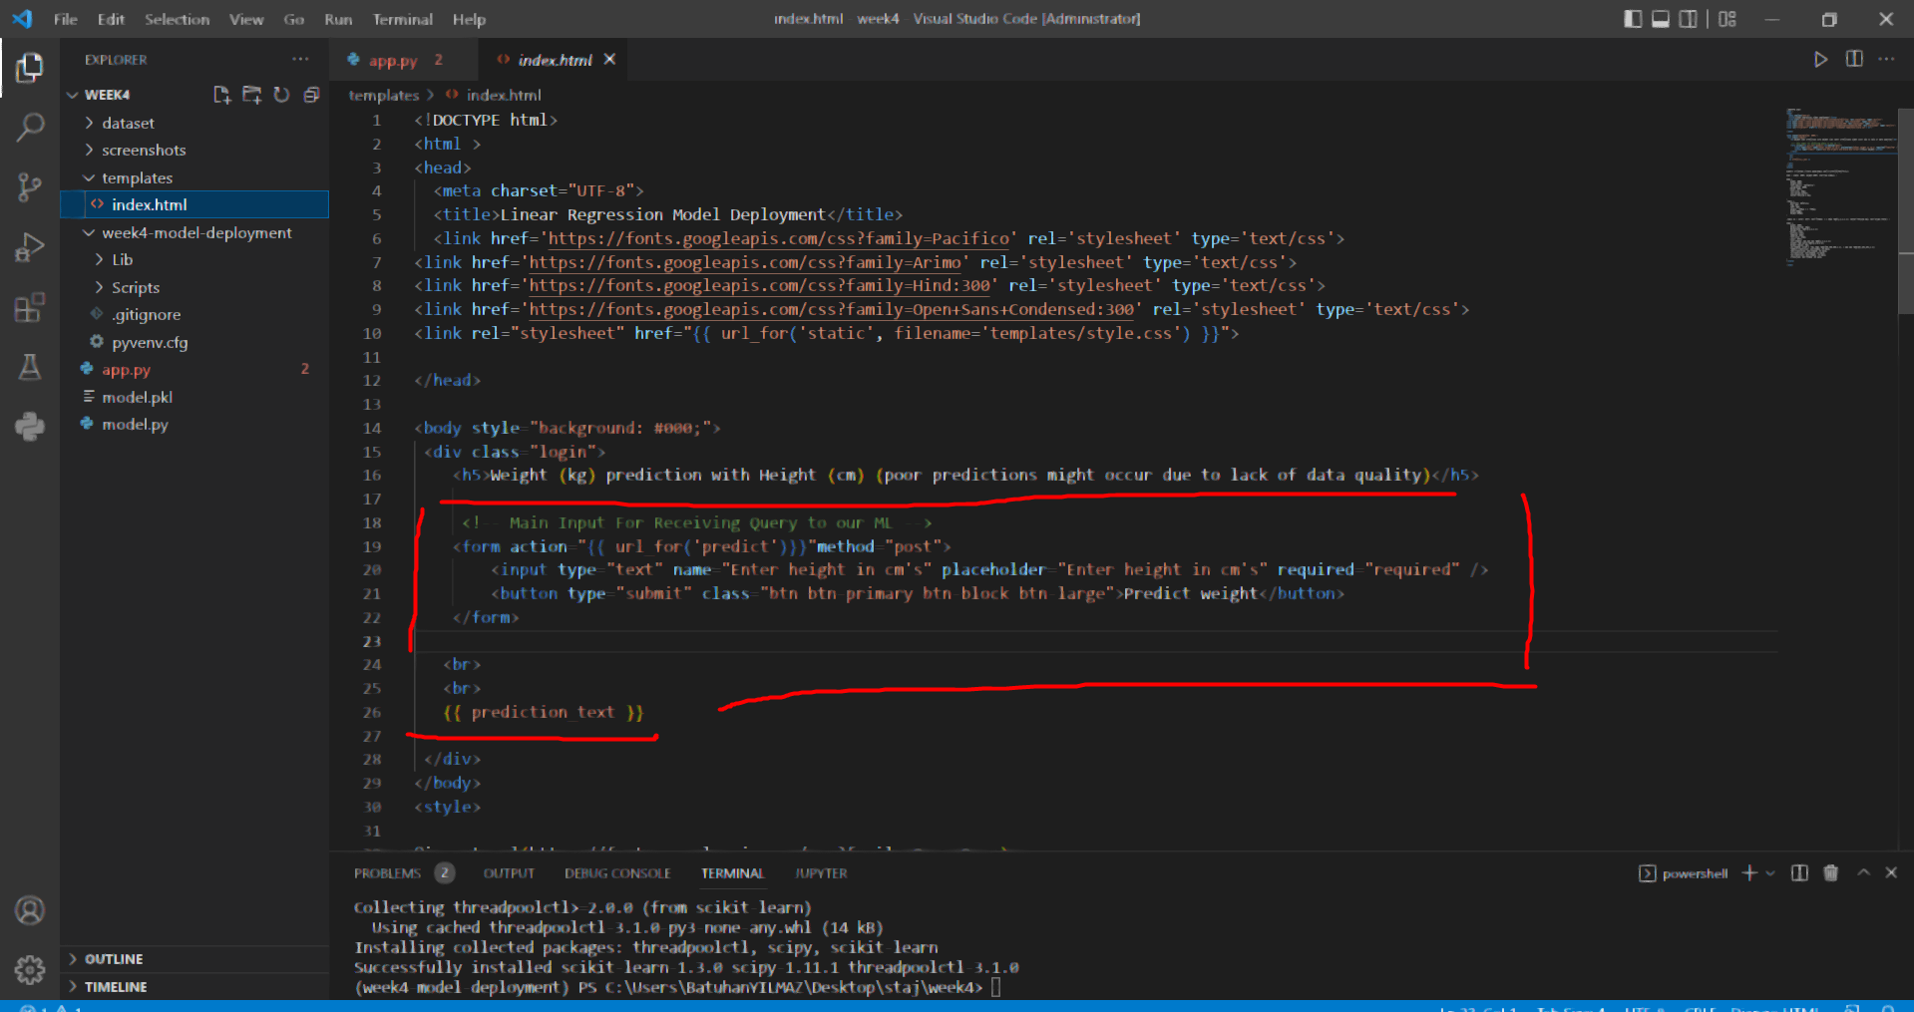

* Configuration page of app: ( for verificaiton)

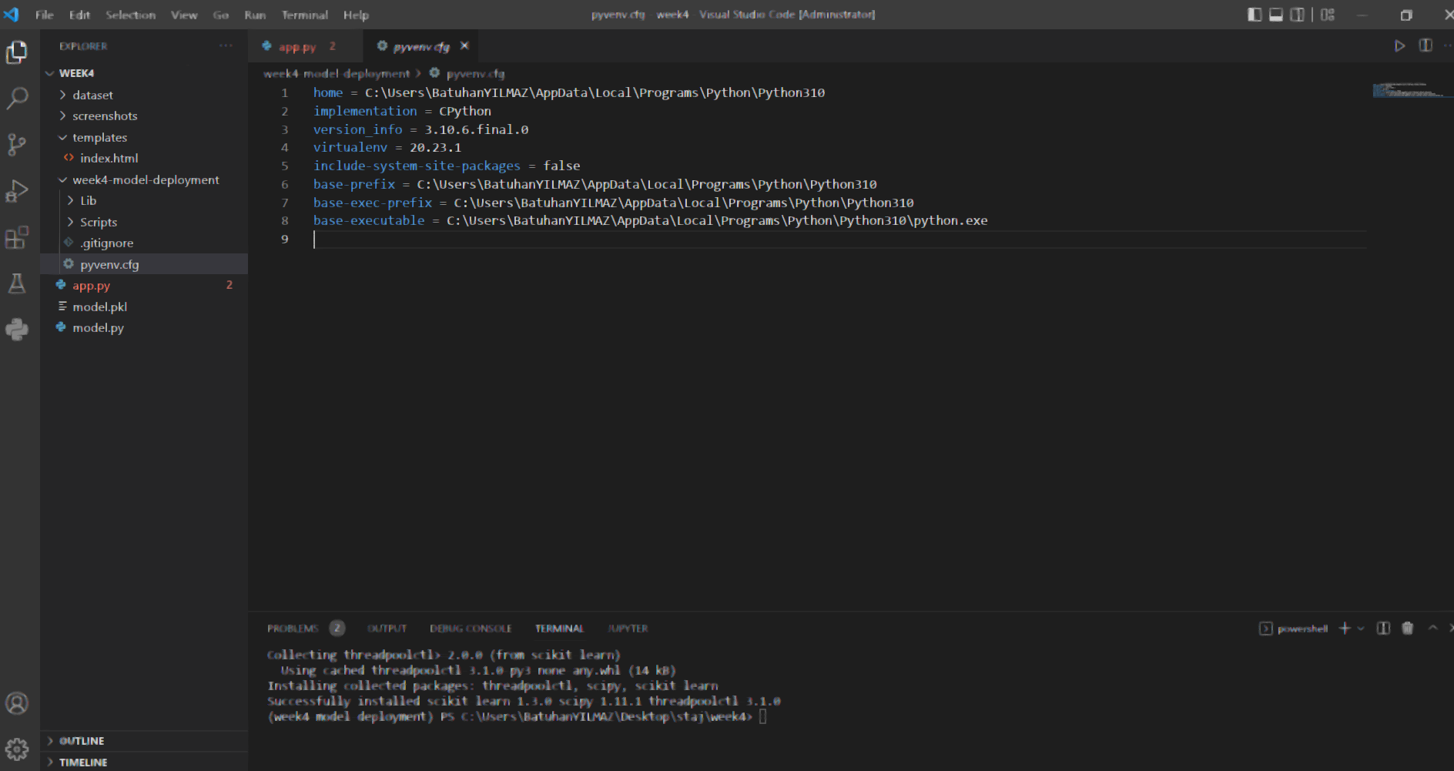

* App running through the local host server:

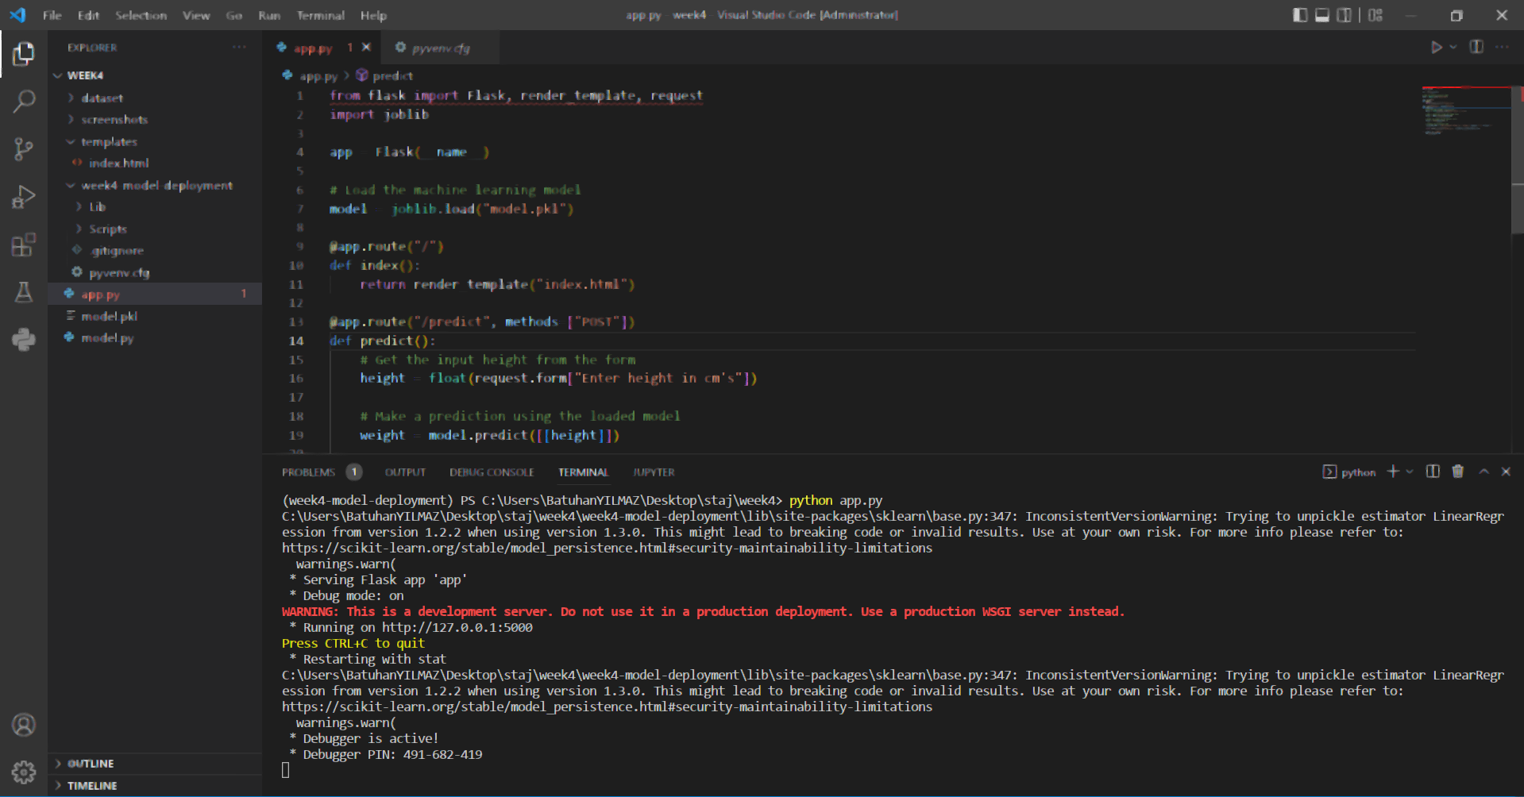

* App running in the web server ( plain form ) and with predicted output form:

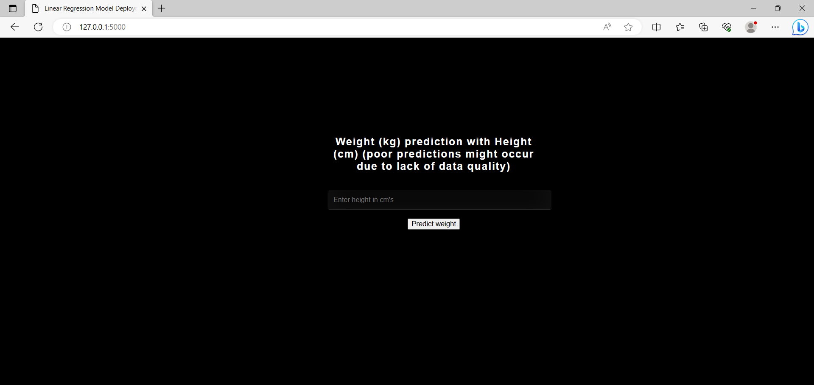

* Output of the model prediction for a random height:

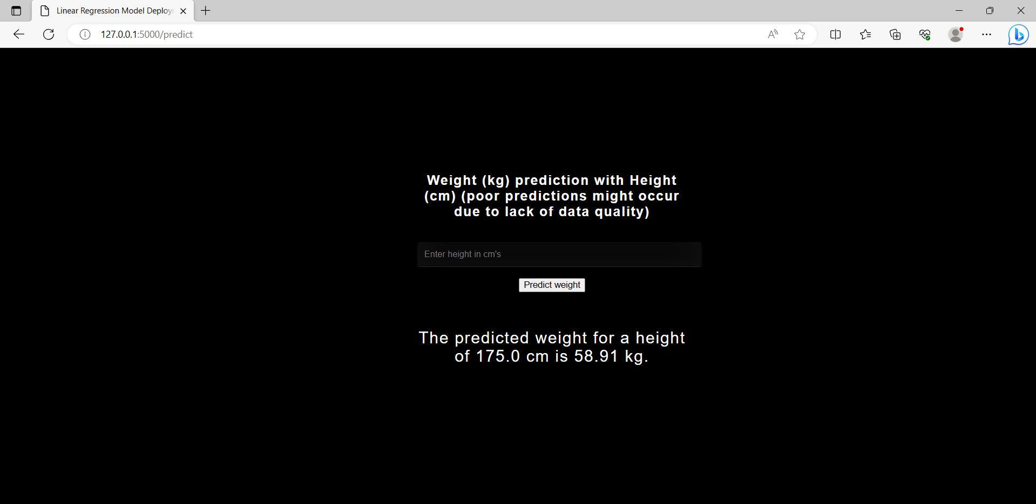

* Log files during the working time of flask app:

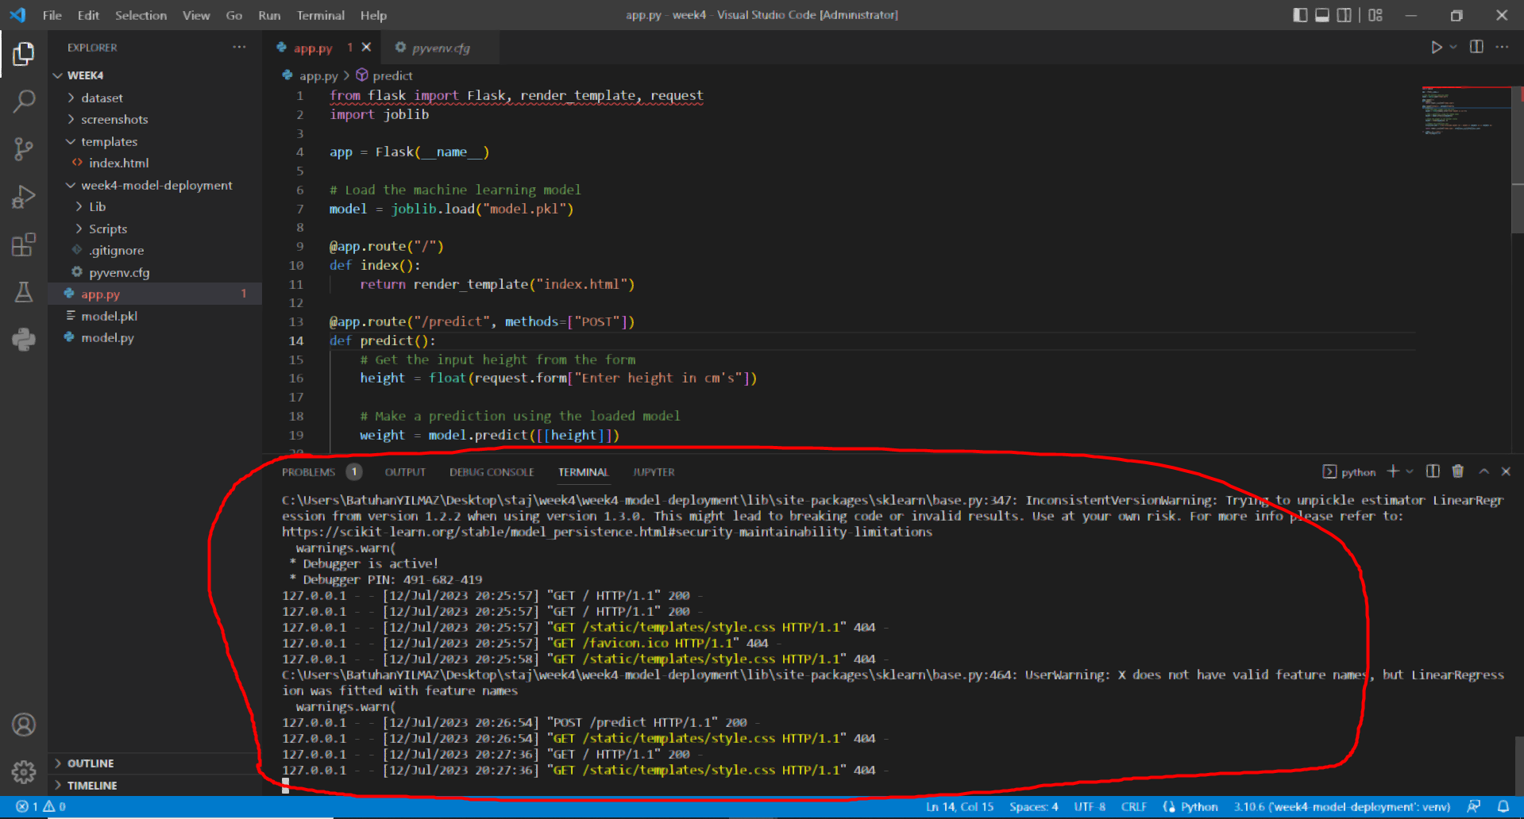

(trivials errors occured since some of the ready .css scripts could not be reached.)

**Name** : Batuhan YILMAZ

**Batch Code** : LISUM22

**Submission Date** : 12.07.2023

**Submitted to :** Github

DataGlacier Remote Internship on Data Science