

QUOTATION DOCUMENT


Date: 15.05.2026
Quotation no:
Customer: Balkan Süt
Contact Person: Sistem Yöneticisi

For the Attention of John Wick
We are delighted to introduce our comprehensive processing solution proposal, which not only showcases our expertise in providing top-tier equipment for your process request but also offers a unique advantage – the ability to expand our production lines by a significant percentage. This expandable capacity is more than just a feature – it's a strategic advantage. It means that as your partner, we are equipped to grow with you, ensuring a steady and reliable supply of high-quality products for your clients regardless of market fluctuations.
Our approach goes beyond the ordinary. We are not just suppliers of processing equipment; we are partners in your growth and success, driven by a deep understanding of market dynamics. The food market is a dynamic landscape, constantly evolving, and we've invested time and resources into researching and analyzing market trends to ensure that our equipment not only meets current demands but also anticipates future shifts.
Quality is at the heart of everything we do, and it's underpinned by rigorous quality assurance processes in the design and manufacturing of our equipment. Our products are a testament to our unwavering commitment to excellence. They are not just tools; they represent our dedication to delivering only the finest and most reliable equipment to facilitate your production process.
By choosing our proposal, you are not just investing in exceptional production equipment but also securing a
partner who is committed to your long-term success. We are ready to discuss how this expandable capacity can be tailored to your specific needs and growth plans.
As you review our preliminary proposal, you'll gain insight into our approach and our dedication to ensuring top-notch quality. We look forward to discussing in greater depth how these aspects can benefit your business.
Thank you for considering HEMISAN as your partner in the process equipment industry. We are excited about the possibility of collaborating with you to unlock the full potential of your business and provide your clients with exceptional process solutions that stand out in the market. Your success is our success, and we are here to make it happen.
We hope that this offer includes all the technical details you require, and we look forward to your positive reply.

Şuayip ÖZTÜRK Elvan Gürsu Ören
Project & Component Sales Director Project & Component Sales Engineer suayip.ozturk @apvhemisan.com elvan.gursu@apvhemisan.com

1. GENERAL INFORMATION

Some or all of the information contained in this offer may not be given to third parties or used by the customer for any other purpose without the prior written consent of Hemisan. All specifications, drawings and information belong to Hemisan and Hemisan reserves the right to recall them any time.

Item | Specification
Product Contact Materials | AISI 316 Stainless Steel
Non-Product Contact Materials | AISI 304 Stainless Steel
Air Hoses | PTFE (Teflon)
Process Equipment Brands and CIP lines | APV / SPX Flow
Piping Standard
Equipment Supply | Pre-assembled Skid Units
Control Unit | AS-i

All belows items included into our quotation | All below items excluded from our quotation
Skid installation as shown in PID | Site Mechanical Installation and materials
Automation Programming | Site Electrical Installation and materials
Scada Programming | Mechanical & Electrical Installation Supervisor for site
Software FAT
Hydraulic Commissioning
Automation Commissioning
MCC (motor control) Cabinets If needed
RIO (remote I/O) Cabinets If needed
Commissioning time is limited weeks, specified below

This proposal is provided as a binding proposal, open for acceptance by the buyer for a period of 30 calendar days from the date of this proposal. If no order has been received by HEMİSAN within this period, the proposal shall no longer be open for acceptance, and any order received by HEMİSAN after this period is subject to HEMİSAN’s written confirmation.

Version | Description of revision | Date
0 | Binding Bid | 15.05.2026

Any changes to the content of this proposal will require a revision. In case of revised proposals, the latest revision shall prevail whether referenced as such in the Order and/or an Order confirmation or not.

2. DESCRIPTION

RAW MILK STORAGE

Dolum Hatları
# | Hat | Kapasite (L/h) | Vana Tipi | Seçilen DN
1 | raw milk reception line 1 | 10.000 | D44 | 63 SMS (2"1/2)
2 | raw milk reception line 2 | 10.000 | D44 | 63 SMS (2"1/2)

Boşaltım Hatları
# | Hat | Kapasite (L/h) | Basınç (Bar) | Pompa | Flow Meter
1 | P1 Pasteuriser | 10.000 | 2 | W+22/20 | 38 SMS (1"1/2)
2 | P2 Pasteuriser | 10.000 | 2 | W+22/20 | 38 SMS (1"1/2)

Tanklar
# | Tank | Hacim (L) | Sensörler | Agitatör
1 | RMT 1 | 60.000 | LSH, LSM, LSL, TT, PT | Var (1.5 kW, 900 rpm, Yan)
2 | RMT 2 | 60.000 | LSH, LSL, TT | Var (1.5 kW, 900 rpm, Yan)
3 | RMT 3 | 60.000 | LSH, LSL, TT | Var (1.5 kW, 900 rpm, Yan)
4 | RMT 4 | 60.000 | LSH, LSL, TT | Var (1.5 kW, 900 rpm, Yan)

Ekipman
Equipment | Purpose | Quantity
Valves | To control and direct the product flow throughout the process line. | 34
Storage Tanks | To store the product under hygienic conditions. | 4
Agitators | To keep the product homogeneous inside the tanks. | 4
CIP Spray Balls | To clean the tank interior during the CIP cycle. | 4
Pumps | To transfer the product through the process lines. | 3
Flow Meters | To measure the product flow rate. | 2
Sensors | To monitor process parameters such as level, pressure, temperature, and position. | 16

P&ID Şematik Diyagram
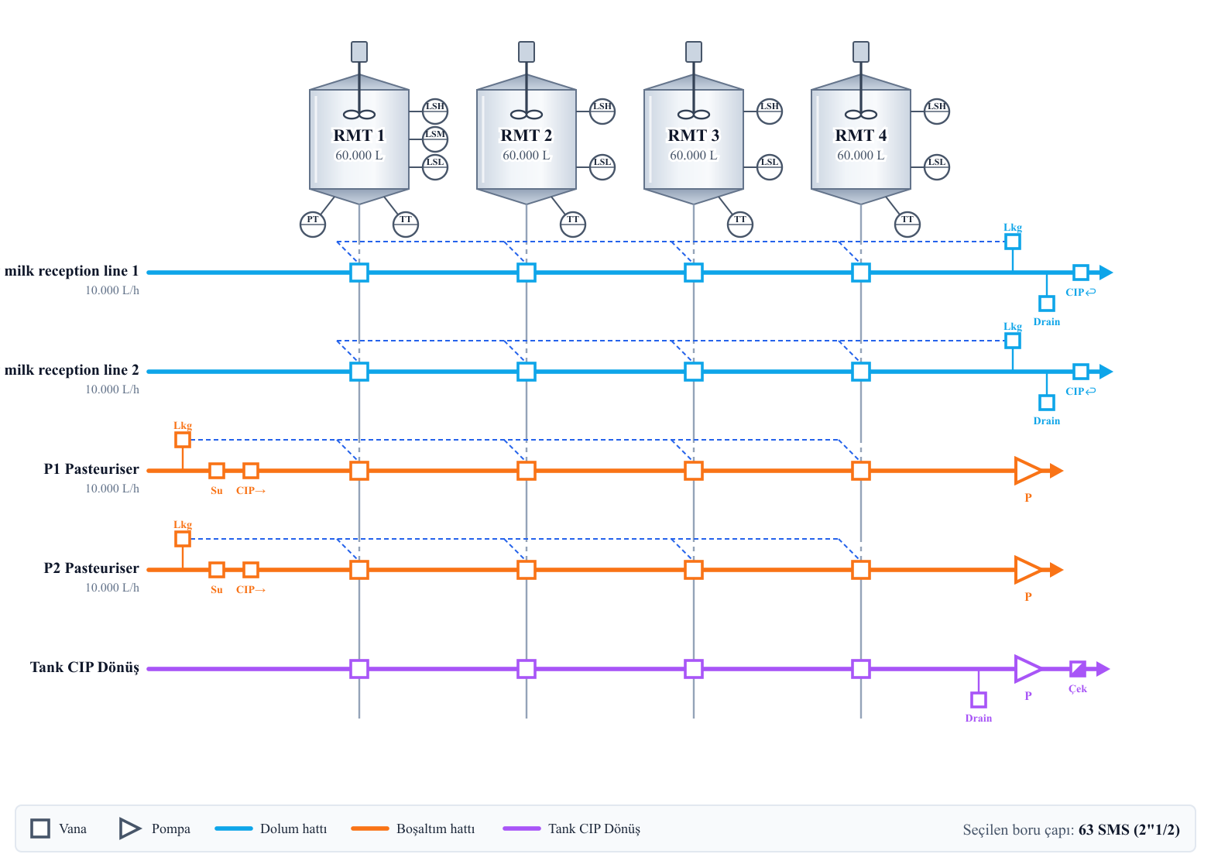

3. PRICING
Price for the Goods and technical documentation, delivered to EX-WORKS-Turkish City factory, including necessary packing,

 | TOTAL FIRM BID - Version 0 |  |  |  |  |  | 111.125,14 EURO

SITE MECHANICAL SUPERVISION 4800 EURO/week
priced weekly and invoiced monthly

SITE ELECTRICAL SUPERVISION 2500 EURO/week
priced weekly and invoiced monthly

If, due to circumstances beyond our control (e.g. lack of service facilities), the commissioning period exceeds the above-mentioned number of days, or if the customer requires additional plant adjustment for other specific services the customer shall pay for the extra time. In such cases the extra 830 Euro/day site supervision time will be invoiced.

Prices exclude all applicable taxes.

Grand total is Net EURO without VAT and invoice will be issued in Euro.

PAYMENT :
%30 of the total value will be paid with order.
%60 of the total value will be paid with delivery notice of materials.
%10 of the total value will be paid after commissioning.

Under which the contract enters into force:
- Signing the deal
- Receiving the prepayment bank receipt
ORDER APPROVAL

DATE:

SIGNATURE:

STAMP:

ESTIMATED DELIVERY WEEK: Can be delivered within 5 weeks
DELIVERY PLACE: ADRES GIRILECEKTIR
OFFER VALIDITY DAYS: 30 days

