İstinye University
Faculty of Engineering and Natural Sciences
Department of Software Engineering
SWE210 — Software Security
GROUP PROJECT
Secure Web Application
Student Number | Student Name | Section (As per OIS)
2509111047 | Mustafa Batuhan Yeşilkaya | 1

Spring 2025

1. Introduction

1.1 Project Description
This project presents a secure web application developed as part of the SWE210 Software Security course. The application is built using Python and the Flask micro-framework, demonstrating real-world implementation of industry-standard security mechanisms in a web environment. The system simulates a multi-user platform where different types of users — administrators and regular users — interact with the system under strict security controls.

1.2 Objective of the System
The primary objective of this project is to design and implement a web application that enforces security at every layer. The system aims to:
- Authenticate users securely using modern cryptographic hashing techniques
- Protect sensitive user data through symmetric encryption stored in the database
- Enforce Role-Based Access Control (RBAC) to limit what each user can access
- Demonstrate how unauthorized access is prevented at the application layer
- Provide a clear, visual demonstration of encryption and decryption in action

1.3 Security Features Implemented
Authentication | PBKDF2-HMAC-SHA256 with 100,000 iterations and random 256-bit salt
Password Storage | Salted hashes only — plaintext passwords are never stored
Data Encryption | AES-256-CBC with random 128-bit IV per encryption operation
Access Control | RBAC with two roles: Admin and User
Session Management | Flask server-side sessions protected by a secret key
Timing Safety | Constant-time comparison (hmac.compare_digest) to prevent timing attacks

2. System Design

2.1 Application Architecture
The application follows a standard Model-View-Controller (MVC) architecture implemented with Flask. The backend handles all business logic and security operations, while the frontend (HTML/CSS templates) handles presentation. No JavaScript frameworks are used — the application is server-side rendered for simplicity and security.

Framework | Python 3 + Flask 3.1
Hashing Library | Python standard library: hashlib (PBKDF2), hmac (constant-time compare)
Encryption Library | cryptography (PyCA) — AES-256-CBC via hazmat primitives
Data Storage | In-memory dictionary (simulates a database for demo purposes)
Templates | Jinja2 (built into Flask)
Session | Flask server-side session with randomly generated 24-byte secret key

2.2 Login System
The login system is the entry point of the application. When a user submits their credentials, the backend looks up the username in the user store, retrieves the stored password hash, and uses PBKDF2 verification to compare the submitted password against the hash. On success, the user's username and role are stored in the server-side session. On failure, a generic error message is shown (no indication of whether username or password was wrong, to prevent enumeration attacks).

2.3 Dashboard
After a successful login, all users are directed to the dashboard. The dashboard displays the user's profile information — username, role, email, and phone number. It also includes an Encryption Demonstration panel that shows the user's data both in its AES-256 encrypted form (as stored in the database) and in its decrypted plaintext form. This clearly illustrates that sensitive data is protected at rest.

2.4 Admin Access
The Admin Panel is an additional route (/admin) that is protected by two layers of access control: the user must be logged in (login_required decorator) and must hold the 'admin' role (admin_required decorator). Admin users can view all registered users, their decrypted contact information, and the system's full security configuration. Regular users who attempt to navigate to /admin are redirected to the dashboard with an "Access Denied" message.

3. Authentication Implementation

3.1 How Login Works
The authentication flow follows these steps:
- The user navigates to the /login page and submits their username and password via an HTML form (HTTP POST).
- The backend retrieves the stored user record by username. If no such user exists, authentication fails.
- The submitted password is hashed using PBKDF2-HMAC-SHA256 with the same salt that was used during registration, and the result is compared to the stored hash using hmac.compare_digest (constant-time comparison).
- If the hashes match, the user's username and role are written to the Flask session, and the user is redirected to the dashboard.
- If they do not match, the user is shown a generic error message and remains on the login page.
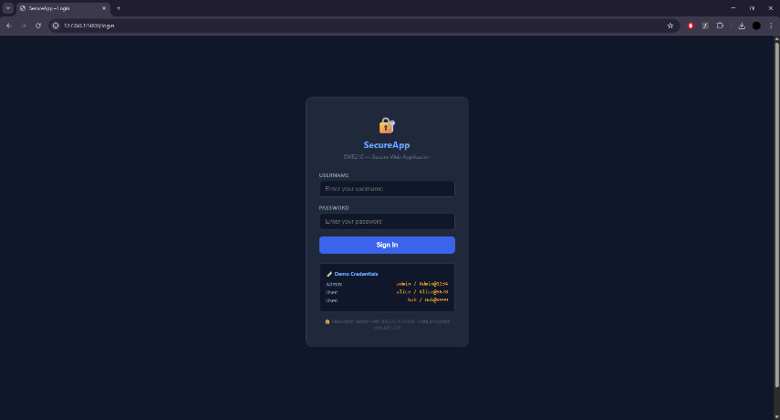
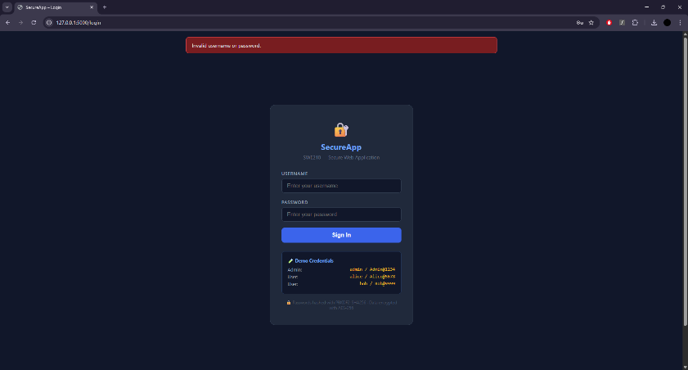

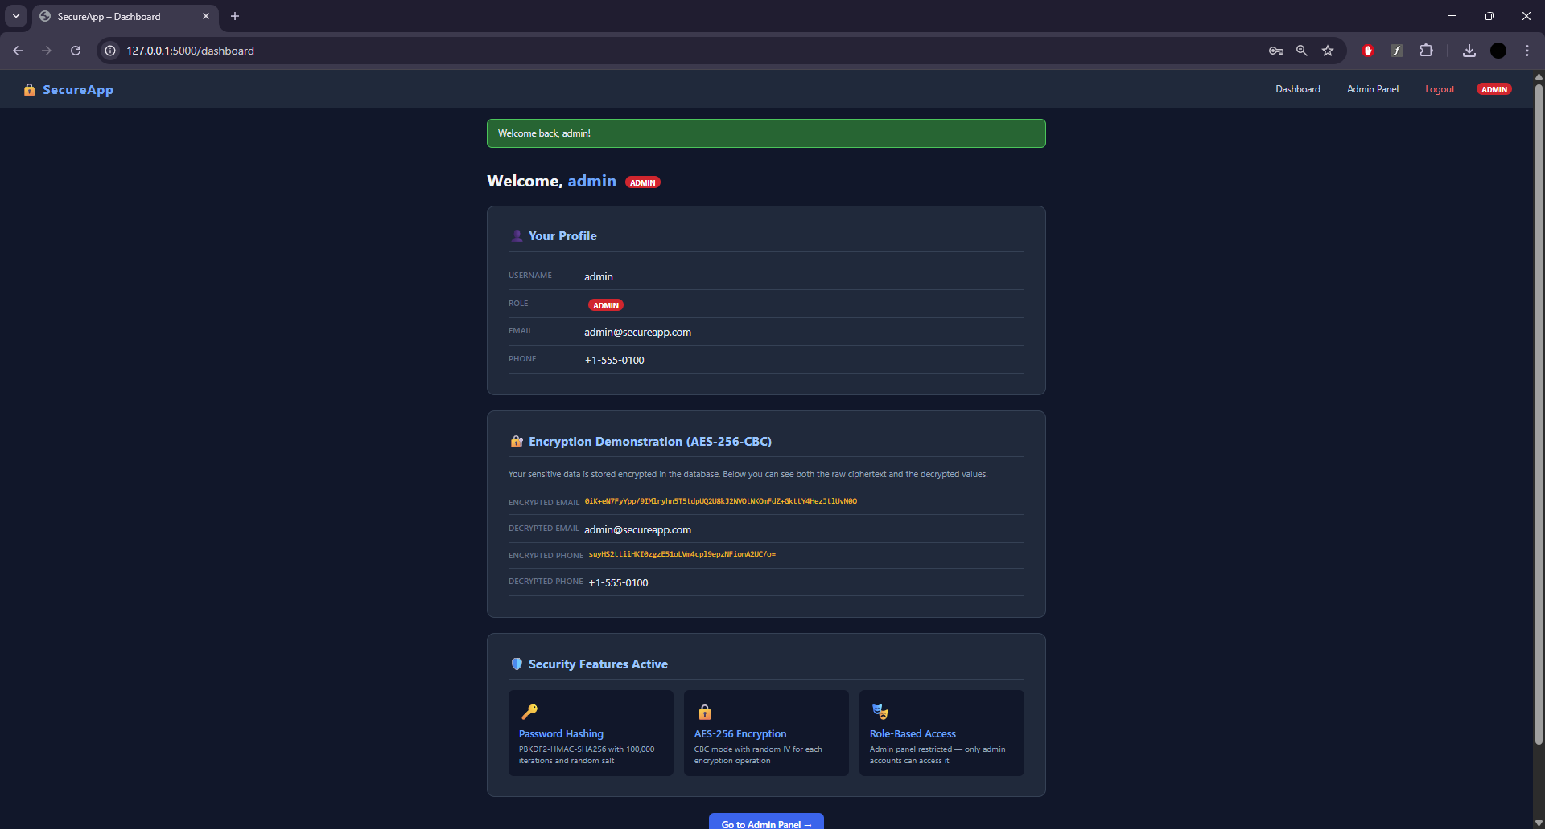

3.2 Password Hashing Algorithm: PBKDF2-HMAC-SHA256

The application uses PBKDF2 (Password-Based Key Derivation Function 2) with the SHA-256 hash function, implemented via Python's built-in hashlib.pbkdf2_hmac. The hashing configuration is:
Algorithm | PBKDF2-HMAC-SHA256
Iterations | 100,000
Salt | 256 bits (32 bytes), randomly generated per user via os.urandom(32)
Output length | 256 bits (32 bytes)
Storage format | Base64-encoded(salt || hash)

The hash_password and verify_password functions are implemented as follows:
def hash_password(password: str) -> str:
salt = os.urandom(32) # 256-bit random salt
key = hashlib.pbkdf2_hmac('sha256', password.encode(), salt, 100_000)
return base64.b64encode(salt + key).decode()

def verify_password(password: str, stored_hash: str) -> bool:
decoded = base64.b64decode(stored_hash.encode())
salt, key = decoded[:32], decoded[32:]
new_key = hashlib.pbkdf2_hmac('sha256', password.encode(), salt, 100_000)
return hmac.compare_digest(key, new_key) # constant-time compare

3.3 Why Hashing Instead of Plaintext Storage

Storing passwords in plaintext is a critical security vulnerability. If the database is ever compromised through a SQL injection attack, a data breach, or insider threat, all user passwords are immediately exposed. Hashing addresses this problem in the following ways:
- One-way function: A cryptographic hash function cannot be reversed. Even with the hash value, an attacker cannot recover the original password mathematically.
- Salt prevents rainbow tables: A unique random salt is added to each password before hashing. This means that even two users with the same password will have completely different hash values, making precomputed rainbow table attacks ineffective.
- Key stretching via iterations: PBKDF2 applies the hash function 100,000 times, making brute-force attacks extremely slow and computationally expensive for an attacker.
- Constant-time comparison: The hmac.compare_digest function ensures that the comparison takes the same amount of time regardless of where the values differ, preventing timing side-channel attacks.

Note: Screenshots of the login page, successful authentication, and failed authentication are shown in the submitted application demonstration. Please refer to the live running application at http://127.0.0.1:5000.

4. Access Control (RBAC)

4.1 Roles Used
The application implements Role-Based Access Control (RBAC) with two distinct roles:
Admin | Full access: dashboard, admin panel, all user data, system configuration
User | Restricted access: dashboard and own profile data only

The role is assigned at the time of user creation and stored both in the user record and in the session cookie after login.

4.2 How Access is Restricted
Access restriction is implemented using Python decorator functions that wrap route handlers. Two decorators are defined:
def login_required(f):
# Redirects to /login if session has no 'username' key

def admin_required(f):
# Redirects to /dashboard if session role != 'admin'

These decorators are applied to route functions:
@app.route('/dashboard')
@login_required # Any authenticated user
def dashboard(): ...

@app.route('/admin')
@login_required # Must be logged in
@admin_required # AND must be admin
def admin_panel(): ...

4.3 Prevention of Unauthorized Access
Unauthorized access is prevented through several mechanisms:
- Session validation: Every protected route checks for the presence of the username key in the session. If missing, the user is immediately redirected to /login.
- Role enforcement: The admin panel additionally checks that the session role is exactly 'admin'. Any other value — including an absent role — results in redirection and a flash error message.
- No client-side trust: The role is stored server-side in the Flask session, which is signed with the server's secret key. Clients cannot modify the session data without invalidating the signature.
- Generic error messages: Failed login attempts do not reveal whether the username or password was incorrect, preventing username enumeration attacks.
- No security by obscurity: Routes are not simply hidden — they are actively protected by server-side checks that execute on every request.

Note: Screenshots demonstrating admin access, regular user restriction, and the access denied message are visible in the running application.

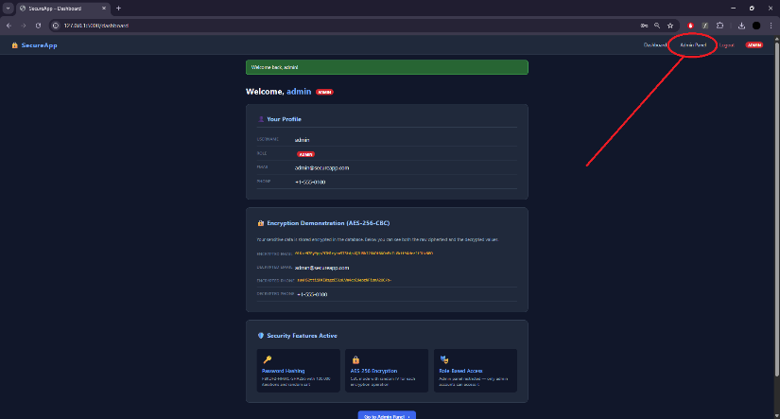
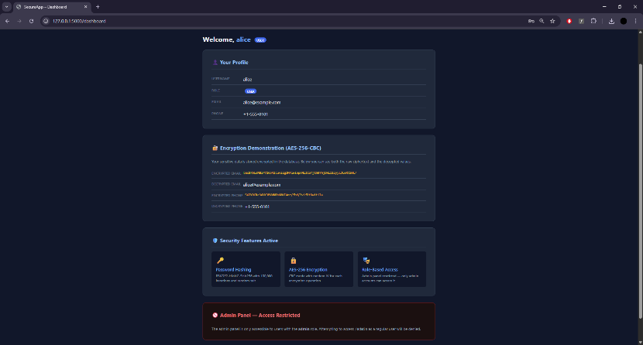
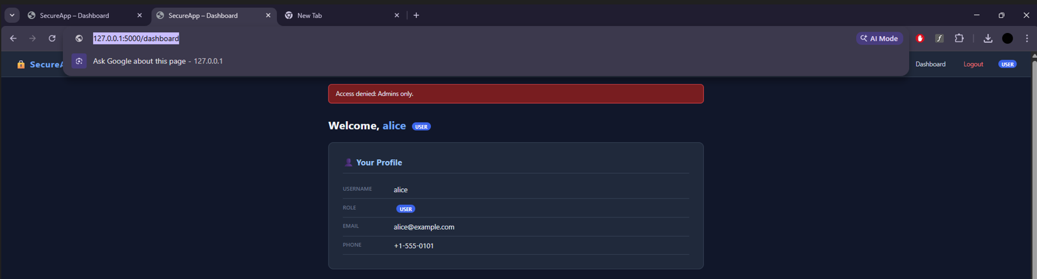

5. Encryption Implementation
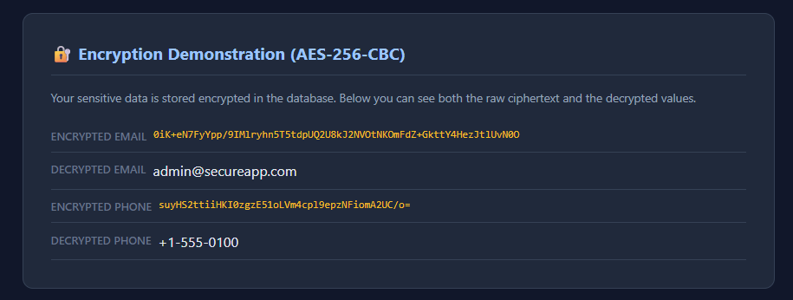

5.1 What Data is Encrypted
Sensitive user information is encrypted before being stored in the user database. In this application, each user's email address and phone number are encrypted. This simulates a real-world scenario where personally identifiable information (PII) must be protected at rest, ensuring that even if the database is compromised, the attacker cannot read the sensitive data without the encryption key.

5.2 Encryption Algorithm: AES-256-CBC
The application uses AES (Advanced Encryption Standard) with a 256-bit key in CBC (Cipher Block Chaining) mode. AES-256 is a symmetric-key block cipher that is approved by NIST and widely considered the gold standard for data encryption.
Algorithm | AES (Advanced Encryption Standard)
Key size | 256 bits (32 bytes)
Mode | CBC (Cipher Block Chaining)
IV (Initialization Vector) | 128 bits (16 bytes), randomly generated per operation
Padding | PKCS7
Library | cryptography (PyCA) — hazmat.primitives
Key generation | os.urandom(32) — generated once at application startup

5.3 Encryption Process
When a user's sensitive data is stored, the following steps take place:
- Step 1 — Generate IV: A random 16-byte initialization vector is generated using os.urandom(16). A new IV is generated for every encryption operation, ensuring that encrypting the same value twice produces different ciphertext.
- Step 2 — PKCS7 Padding: The plaintext is padded to a multiple of 16 bytes (AES block size) using PKCS7 padding. The padding value equals the number of bytes added.
- Step 3 — AES-CBC Encryption: The padded plaintext is encrypted using AES-256 in CBC mode. CBC mode XORs each plaintext block with the previous ciphertext block before encryption, making identical plaintext blocks produce different ciphertext blocks.
- Step 4 — Storage: The IV and ciphertext are concatenated (IV || ciphertext) and Base64-encoded for safe text storage. The format is: Base64(IV + ciphertext).

def encrypt_data(plaintext: str) -> str:
iv = os.urandom(16) # Random IV
# PKCS7 pad to 16-byte boundary
pad_len = 16 - (len(plaintext.encode()) % 16)
padded = plaintext.encode() + bytes([pad_len] * pad_len)
cipher = Cipher(algorithms.AES(AES_KEY), modes.CBC(iv))
enc = cipher.encryptor()
ct = enc.update(padded) + enc.finalize()
return base64.b64encode(iv + ct).decode()

5.4 Decryption Process
When the application needs to display a user's data, the reverse process is applied:
- Step 1 — Base64 Decode: The stored ciphertext string is Base64-decoded back to raw bytes.
- Step 2 — IV Extraction: The first 16 bytes of the decoded data are the IV used during encryption.
- Step 3 — AES-CBC Decryption: The remaining bytes (the actual ciphertext) are decrypted using AES-256-CBC with the same key and the extracted IV.
- Step 4 — Remove Padding: The PKCS7 padding is removed by reading the last byte value, which indicates how many padding bytes were added.

def decrypt_data(ciphertext: str) -> str:
raw = base64.b64decode(ciphertext.encode())
iv, ct = raw[:16], raw[16:] # Split IV and ciphertext
cipher = Cipher(algorithms.AES(AES_KEY), modes.CBC(iv))
dec = cipher.decryptor()
padded = dec.update(ct) + dec.finalize()
pad_len = padded[-1] # PKCS7: last byte = pad length
return padded[:-pad_len].decode()

5.5 Why AES-256-CBC
AES-256 was chosen for the following reasons:
- Security: 256-bit keys provide 2^256 possible keys, making brute-force attacks computationally infeasible with any known or foreseeable technology.
- Standard: AES is standardized by NIST (FIPS 197) and is used worldwide in government, banking, and commercial applications.
- CBC mode with random IV: CBC mode ensures that identical plaintext blocks produce different ciphertext, and the random IV ensures that encrypting the same value twice always produces different output, preventing pattern analysis.
- Reversible: Unlike hashing, encryption is reversible — the application must be able to display the original email and phone number to authorized users.

Note: The Encryption Demonstration section of the dashboard visually shows both the Base64-encoded AES-256 ciphertext and the successfully decrypted plaintext, clearly confirming that the encryption and decryption pipeline functions correctly.

