Azure assignment
Barnabas Galacz

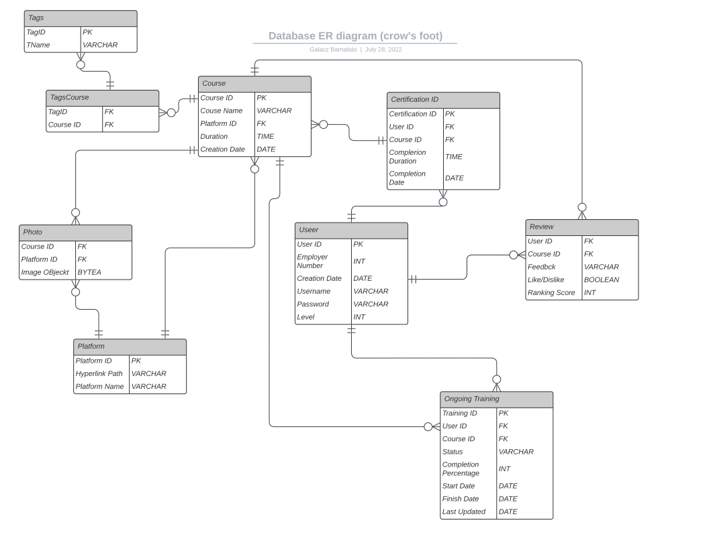
I made 2 bash scripts 1 for permanent deletion and I set permissions for that and another for generating database that creates tables and fills them with data.

I am not sure if this was the assignment or making a bashscript for each function.
You can call permanent deletion with this code for example.

./delete_function.sh '"users"' '["userid","userid"]' '[950,993]' '["=","<"]' '["or"]'

DataBricks

I managed to connect and upload something to cosmos db with the code under this but I had problems uploading pictures. The 2 ways I found to do this is adding them as attachment which is from what I saw not good practice. (I tried anyway with no success since the tutorials are outdated.) And the other is converting them to Json which is not really uploading png s at that point.

cosmosEndpoint = "https://azureadmin2.documents.azure.com:443/"
cosmosMasterKey = "hFM7xALLkJ3MvP6sTXBKipHZYwCrMyDZZCWIqlJLNB5WtFb5425W71go1qW3jTlHSRhjqVX7BpAAo1ejN1uNsw=="
cosmosDatabaseName = "Jpegs"
cosmosContainerName = "Jpeg"

cfg = {
"spark.cosmos.accountEndpoint" : cosmosEndpoint,
"spark.cosmos.accountKey" : cosmosMasterKey,
"spark.cosmos.database" : cosmosDatabaseName,
"spark.cosmos.container" : cosmosContainerName,
}

cosmosEndpoint = "https://azureadmin2.documents.azure.com:443/"
cosmosMasterKey = "hFM7xALLkJ3MvP6sTXBKipHZYwCrMyDZZCWIqlJLNB5WtFb5425W71go1qW3jTlHSRhjqVX7BpAAo1ejN1uNsw=="
cosmosDatabaseName = "Jpegs"
cosmosContainerName = "Jpeg"

cfg = {
"spark.cosmos.accountEndpoint" : cosmosEndpoint,
"spark.cosmos.accountKey" : cosmosMasterKey,
"spark.cosmos.database" : cosmosDatabaseName,
"spark.cosmos.container" : cosmosContainerName,
}

spark.createDataFrame((("cat-alive", "Schrodinger cat", 2, True), ("cat-dead", "Schrodinger cat", 2, False)))\
.toDF("id","name","age","isAlive") \
.write\
.format("cosmos.oltp")\
.options(**cfg)\
.mode("APPEND")\
.save()

