Linux Assignment
Galacz Barnabas

Task 1

mkdir test

touch etc_log.txt

ls -l /etc > etc_log.txt

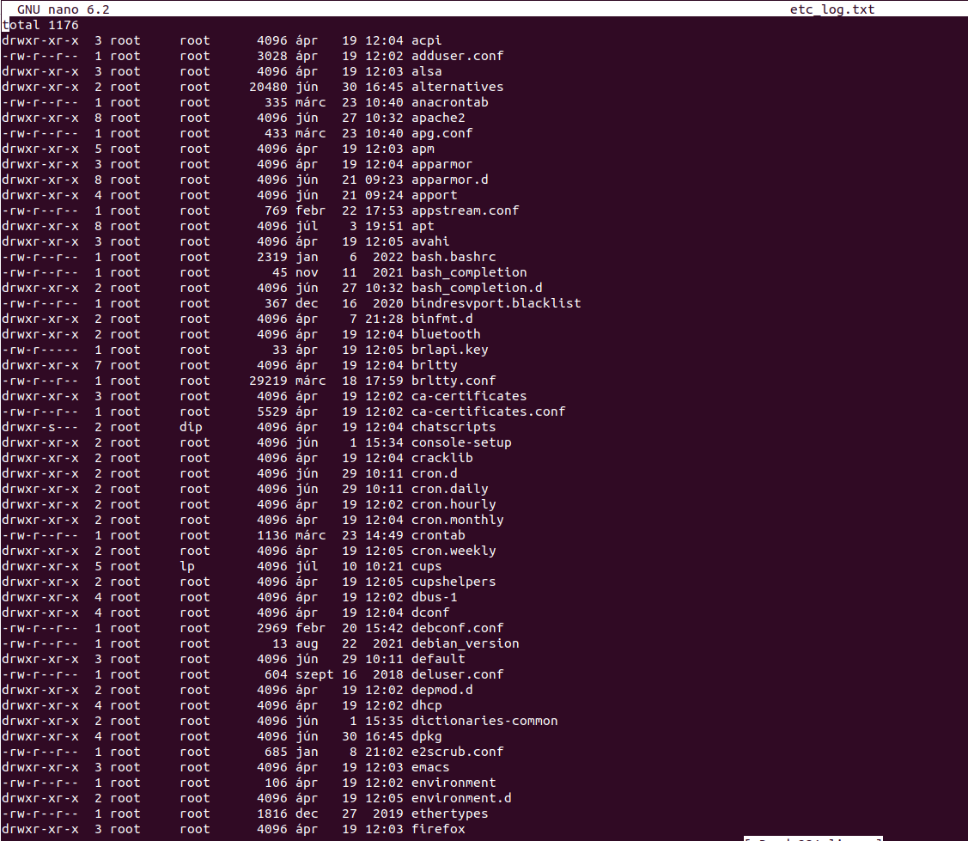
ls -l /run > run_log.txt

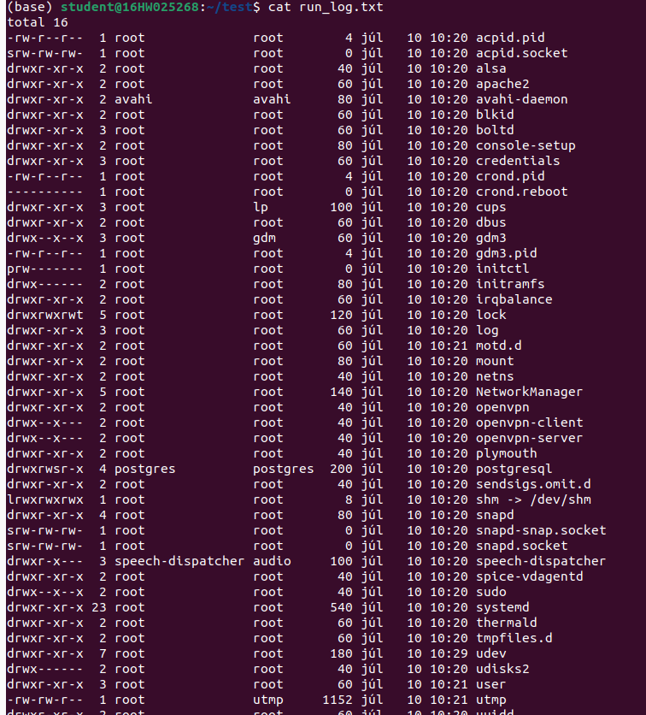
cat run_log.txt etc_log.txt | tee unsorted.txt | sort -r unsorted.txt > reversed.txt

For some reason this doesn’t write the contents of unsorted to the screen even if I put a cat to the end. Also it sorts the lines alphabetically not the names but the task didn’t say to sort by names so I went with this.

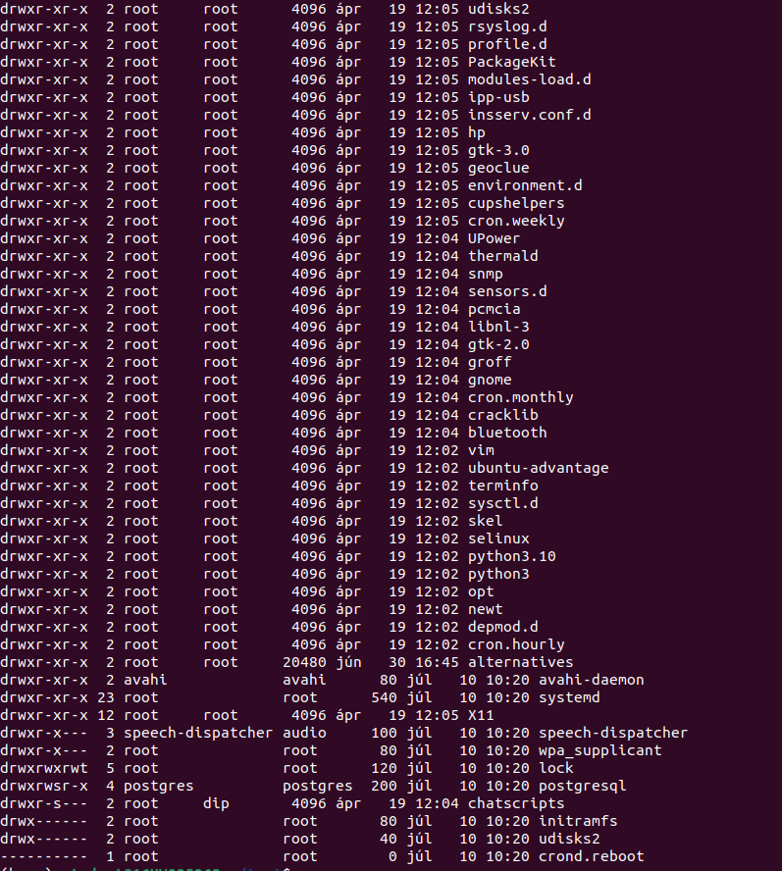
Screenshot of reversed
Task 2

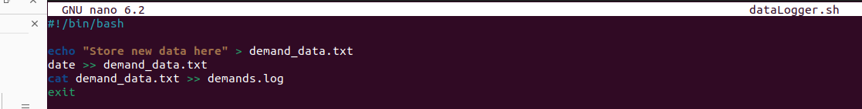
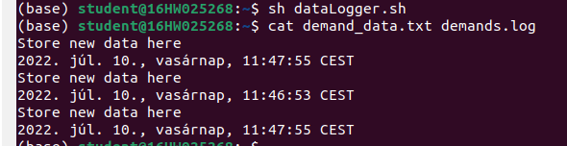
Task 3

I am not exactly sure I understood the tasks here but the end result is what what required.

