Project 2 – Team 3

**Project Title:**  Cryptocurrency Interactive Dashboard

**Teams Members:**

Yakov Krasnikov

Justin Merryman

Charles Philpott

Alex Jones

Jessica Pardo

**Project Description/Outline** : A cryptocurrency is a digital currency in which encryption techniques are used to regulate the generation of units of currency and verify the transfer of funds, operating independently of a central bank.

**Work Scope:**

Importing Kaggle data into database.

Find and import another source of data for the market indices.

Create database server for data (Mongo Atlas.) -> Charles, Justin

Put together a flask app to access data create endpoints. -> Yakov

Designing dashboard using bootstrap HTML and CSS. -> Alex, Jessica

Create D3.js charts/visualizations. -> Everybody

Deploy dashboard and visualizations on Heroku. -> Jessica

Why is Crypto so important and should I care?

1. The cryptocurrency markets are currently all over the place. There are a number of high-quality digital token and coin issuers, with excellent backers and management, with very good AML procedures in place, a great business model, etc.
2. Some economic analysts predict a big change in crypto is forthcoming as institutional money enters the market.
3. Moreover, there is the possibility that crypto will be floated on the Nasdaq, which would further add credibility to blockchain and its uses as an alternative to conventional currencies.
4. Cryptocurrencies have the potential to enable social and economic growth throughout the world, including in developing countries, by offering easier access to capital and financial services.

There are various types of cryptocurrencies, and for this project, we will focus on easy the most mentioned and used: Bitcoin (BTC), Ethereum (ETH) and Litecoin (LTC).

**Dataset to Be Used:**

- Cryptocurrency Historical Prices:

<https://www.kaggle.com/sudalairajkumar/cryptocurrencypricehistory>

* Bitcoin :

https://www.kaggle.com/sudalairajkumar/cryptocurrencypricehistory?

select=coin_Bitcoin.csv

* Ethereum:

https://www.kaggle.com/sudalairajkumar/cryptocurrencypricehistory?

select=coin_Ethereum.csv

* Litecoin:

https://www.kaggle.com/sudalairajkumar/cryptocurrencypricehistory?

select=coin_Litecoin.csv

- Optional: Global Bitcoin Legality. <https://coin.dance/poli>

- Optional: Cryptocurrency ATM Maps.

https://coinatmradar.com/country/226/bitcoin-atm-united-states/

**Project category:**

- A dashboard page with multiple charts that update from the same data.

Inspirational “Sketch” visualization:

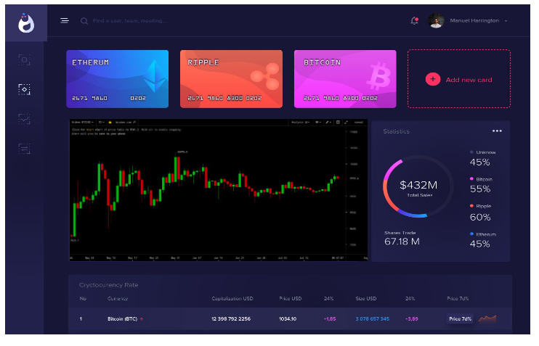

References:

[1] Why is Crypto so important and should I care?

(https://www.conyers.com/publications/view/why-is-crypto-so-important-and-should-

i-care/). Accessed March 19, 2021.

[2] How Cryptocurrencies Can Help Global Economy and Build a Better Future

(https://www.finextra.com/blogposting/18159/how-cryptocurrencies-can-help-global-

economy-and-build-a-better-future). Accessed March 19, 2021.

[3] Coin Desk. "Institutional Investment in Crypto: Top 10 Takeaways of

2019."( https://www.coindesk.com/institutional-investment-in-crypto-top-10-

takeaways-of-2019). Accessed March 19, 2021.