 The paper should describe the chosen methods and compare them analytically and emprically. Based on this analysis you should draw some generic conclusions. For this you should take (at least) the 4 bots you implemented and compare their performance by having them systematically play against each other. According to the different environments (but possibly not) different bots might outperform others. Define some interesting hypotheses and research questions, and use your analysis to verify or falsify them

1. Title page with title and authors, and an abstract of 2-3 paragraphs
2. Introduction (to the problem, but also your solution, en some results. 2 pages)
3. Background information: description of the game, the challenge, the IS framework, whatever is necessary to understand your paper. Here you would normally also summarise related work, but this is not required here as all the methods are in the textbook (1-2 pages)
4. Research question: Explain what you did, and what possible outcomes of your setup and contribution. That could e.g. be that you want to find out whether one methods works, or that it works better than other.  What do you mean by works better: Wins once, wins all the time, wins mostly, not alway loose, works faster, works better when time is restricted etc. (1 page)
5. Experimental setup: Explain how you set up your experiments. What did you do, e.g. in terms of implementation (brief), but mostly in order to compare your different methods. Define your metrics. (2 pages)
6. Results: describe your results in some kind of overview tables, and point the reader to the most significant and interesting results in a short text. (2 pages)
7. Findings: As a separate step interpret the results, and give explanations for the results. (1 page)
8. Conclusions: summarise what you did, and highlight the most inportant findings. (1 page)

Intelligent Systems 2013

Planet Wars Bots

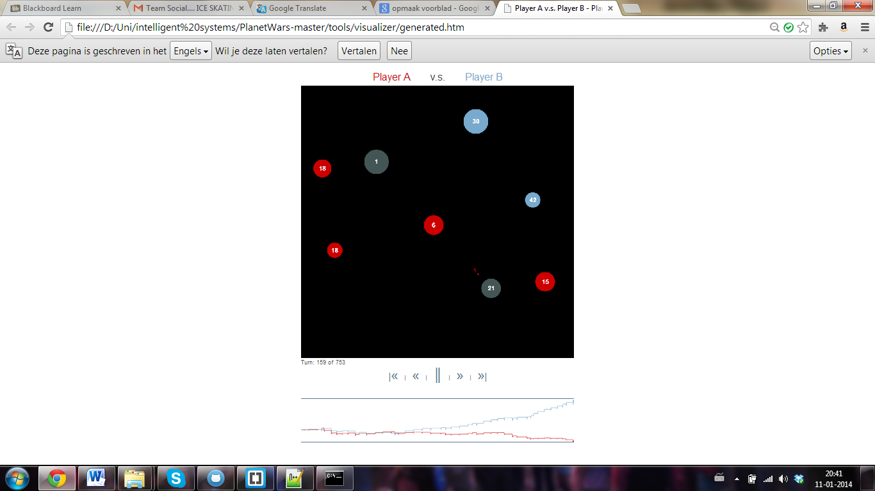

**Authors**

Anouk Boukema

Baudouin Duthoit

Gossa Lô

# Abstract

of 2-3 paragraphs

# Introduction

Introduction (to the problem, but also your solution, en some results. 2 pages)

# Background information

Background information: description of the game, the challenge, the IS framework, whatever is necessary to understand your paper. Here you would normally also summarise related work, but this is not required here as all the methods are in the textbook (1-2 pages)

## The game

## The challenge

## The IS framework

## More???

# Research questions

Research question: Explain what you did, and what possible outcomes of your setup and contribution. That could e.g. be that you want to find out whether one methods works, or that it works better than other.  What do you mean by works better: Wins once, wins all the time, wins mostly, not alway loose, works faster, works better when time is restricted etc. (1 page)

# Experimental setup

We have made 4 different bots. Each of them is specialised in a different way. We will explain per bot how they are specialised and on what theory there speciality is based on (out of the lectures)

Experimental setup: Explain how you set up your experiments. What did you do, e.g. in terms of implementation (brief), but mostly in order to compare your different methods. Define your metrics. (2 pages)

## FirstBot

### Implementation

## HillclimbingBot

The basics of this bot are based on the hillclimbing search principle. For this search method

### Implementation

## Comparing the methods

# Results

Results: describe your results in some kind of overview tables, and point the reader to the most significant and interesting results in a short text. (2 pages)

# Findings

Findings: As a separate step interpret the results, and give explanations for the results. (1 page)

# Conclusion

Conclusions: summarise what you did, and highlight the most inportant findings. (1 page)