**Planning – Planung**

You will find out, that many of the planning tools are the same as the once we used in marketing. The reason is that you can´t do planning without marketing and vice verse. You always have to find out what the status of the company is and where you want to be in the future.

Planning is an activity which involves thinking and decisions about objectives, policies and strategies how to meet the objectives.

|  |  |
| --- | --- |
| Describe the two types of planning: | |
| Strategic planning | Long term (5+ years)  should be visionary or directionally  should not be too detailed  aims are qualitative |
| Operative planning | Short term ( up to 1 year) or medium term (1 to 5 years)  should be tactical focused, implementable, measurable, contain lots of details |
| Describe the principles of planning: | |
| **Completeness** | Planning has to include all data and information relevant for the future |
| **Clearness** | Every employee should be able to understand the plans and has to be able to fulfill them |
| **Continuity** | Planning should be done permanently and not occasionally |
| **Flexibility** | Planning should be future-oriented and should include alternative objectives in case external factors change |
| **Economic efficiency** | Costs and efforts of developing plans must be in relation to their significance and apply-ability |

*Planung ist die gedankliche Vorwegnahme der Ziele, Maßnahmen zur Erreichung der Ziele und der Kontrolle. Man unterscheidet folgende Planungsarten:*

* *Strategische Planung: ist langfristig (5 Jahre oder länger) und sollte visionär und richtungsweisend sein. Sie ist grob und qualitativ.*
* *Operative Planung: ist kurz- bis mittelfristig (1-5 Jahre) machbar und zielgerichtet. Sie ist fein und quantitative*
  1. **Strategic planning**

Any company should have a strategic plan! It is not at guarantee for success, but if you don´t have one, it is more likely to fail.

What characteristics should a strategic plan have?

|  |
| --- |
| Serve as a general framework |
| Provide a basis for more detailed planning (operational planning) |
| Explain business to other in order to inform, motivate or involve them |
| Assist benchmarking and performance monitoring |

To make a strategic plan is a lot of work and takes some time!

This is the structure in the process of strategic planning you should follow:

|  |
| --- |
| company’s mission |
| Strategic audits to analyse a company’s environment and a company’s strengths and weaknesses (SWOT) |
| Development of business portfolios and scenarios |
| Setting of strategic objectives and policies |
| Break down into operational objectives and policies |

First a company´s **mission and vision** is needed. Describe the vision and mission statement and find the German expressions:

|  |
| --- |
| **Vision: - Vision**  .A realistic vision should present a picture of a company in five or more years, t should be in the terms of it’s likely physical appearance, size or activities. It might consider it’s product’s markets or customers, should be a bit cloudy and open for changes |
| **Mission statement: - Unternehmensleitbild**  is the statement of the company’s purposes, what it wants to accomplish in the larger environment |

Please read through the example 3M on page 10. Glue, Post it, Scotch

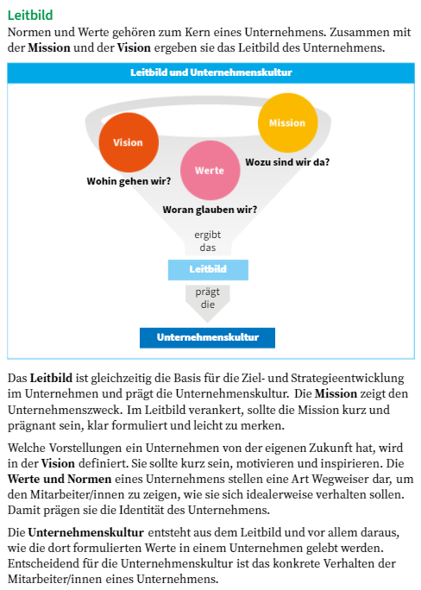

Ein Bild, das Text enthält.

Ein Bild, das Text enthält.

Ein Bild, das Text enthält.
