

**Assignment №1**

**Prepared by Azimkhanov Bauyrzhan**

**Almaty, 2024**

**Part 1 - Installing Docker**

**Exercise 1: Installing Docker**

1. **Objective**: Install Docker on your local machine.
2. **Steps**:
   * Follow the installation guide for Docker from the official website, choosing the appropriate version for your operating system (Windows, macOS, or Linux).
   * After installation, verify that Docker is running by executing the command docker --version in your terminal or command prompt.
   * Run the command docker run hello-world to verify that Docker is set up correctly.
3. **Questions**:
   * What are the key components of Docker (e.g., Docker Engine, Docker CLI)?
   * How does Docker compare to traditional virtual machines?
   * What was the output of the docker run hello-world command, and what does it signify?



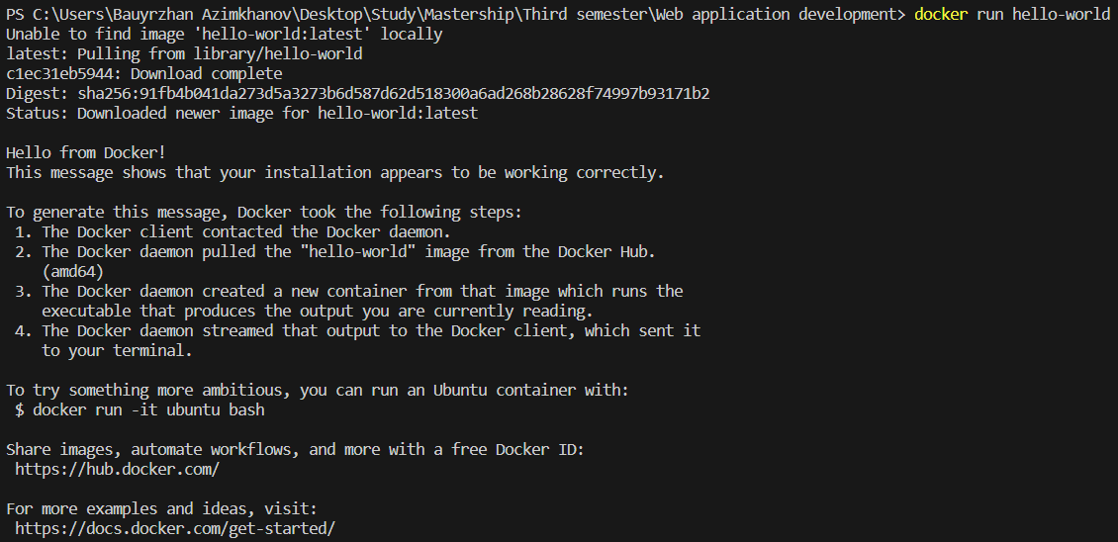

1. Docker consists of several key components:

* Docker Engine: This is the core part of Docker, which includes:
* Docker Daemon (dockerd): Manages Docker objects like images, containers, networks, and volumes.
* REST API: Allows programs to interact with the Docker daemon and instruct it on what to do.
* Docker CLI (Command Line Interface): A client that allows users to interact with Docker using commands.
* Docker Client: The primary way users interact with Docker. It sends commands to the Docker daemon.
* Docker Registries: Locations where Docker images are stored. Docker Hub is the default public registry, but private registries can also be used.
* Docker Objects: These include images, containers, networks, and volumes.

1. Docker and traditional virtual machines (VMs) both provide isolated environments for running applications, but they do so in different ways:

Virtual Machines:

* Each VM runs a full operating system, including its own kernel, on top of a hypervisor.
* VMs are heavier and take longer to start because they need to boot an entire OS.
* They provide strong isolation as each VM is completely separate from others.

Docker Containers:

* Containers share the host OS kernel and run as isolated processes in user space.
* They are lightweight and start almost instantly because they don’t need to boot an OS.
* Containers are more efficient in terms of resource usage and can run more instances on the same hardware compared to VMs.

1. This signifies that Docker is installed correctly and is able to pull images and run containers.

**Exercise 2: Basic Docker Commands**

1. **Objective**: Familiarize yourself with basic Docker commands.
2. **Steps**:
   * Pull an official Docker image from Docker Hub (e.g., nginx or ubuntu) using the command docker pull <image-name>.
   * List all Docker images on your system using docker images.
   * Run a container from the pulled image using docker run -d <image-name>.
   * List all running containers using docker ps and stop a container using docker stop <container-id>.
3. **Questions**:
   * What is the difference between docker pull and docker run?
   * How do you find the details of a running container, such as its ID and status?
   * What happens to a container after it is stopped? Can it be restarted?

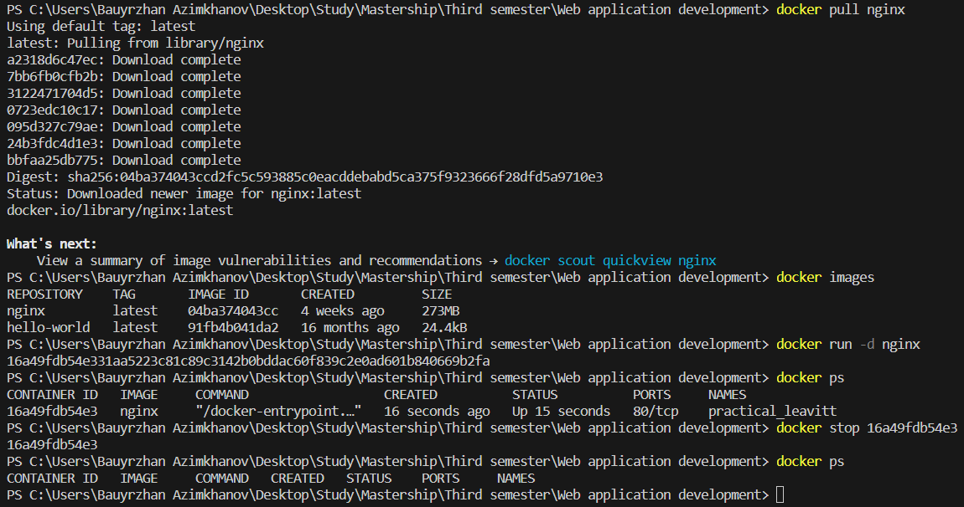

1. Difference between docker pull and docker run:

* docker pull: Downloads a Docker image from a registry (like Docker Hub) to your local machine.
* docker run: Creates and starts a container from a specified image. If the image is not already downloaded, it will pull the image first.

2. Finding details of a running container:

* You can use the docker ps command to find details of running containers. This command lists container IDs, names, statuses, and other information.

3. What happens to a stopped container:

* When a container is stopped, it remains on your system in a stopped state.

#### Exercise 3: Working with Docker Containers

1. **Objective**: Learn how to manage Docker containers.
2. **Steps**:
   * Start a new container from the nginx image and map port 8080 on your host to port 80 in the container using docker run -d -p 8080:80 nginx.
   * Access the Nginx web server running in the container by navigating to http://localhost:8080 in your web browser.
   * Explore the container's file system by accessing its shell using docker exec -it <container-id> /bin/bash.
   * Stop and remove the container using docker stop <container-id> and docker rm <container-id>.
3. **Questions**:
   * How does port mapping work in Docker, and why is it important?
   * What is the purpose of the docker exec command?
   * How do you ensure that a stopped container does not consume system resources?

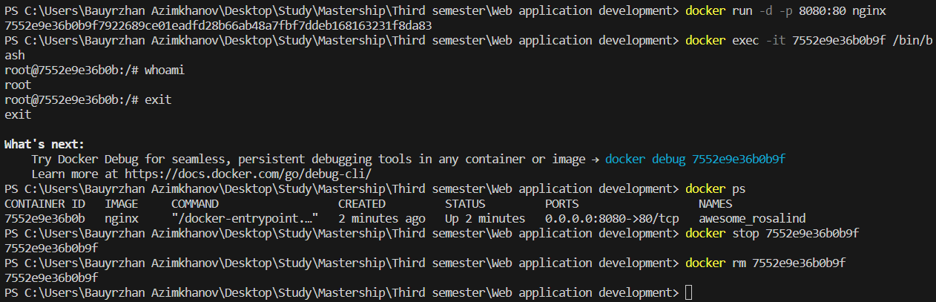

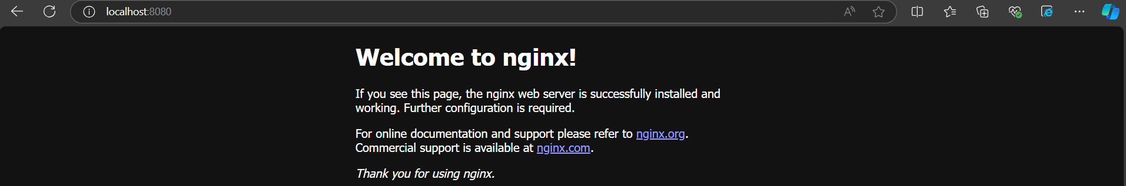

1. How port mapping works in Docker:

* Port mapping in Docker allows you to connect the ports of a Docker container to ports on the host machine. This is important because it enables external access to the services running inside the container. For example, using -p 8080:80 in the docker run command maps port 80 in the container to port 8080 on the host.

2. Purpose of the docker exec command:

* The docker exec command is used to run commands inside an already running container. This is useful for tasks like debugging, running additional processes, or interacting with the container’s environment.

3. Ensuring a stopped container does not consume system resources:

* To ensure a stopped container does not consume system resources, you can remove it using the docker rm <container_id> command. This deletes the container and frees up the resources it was using.

**Part 2 - Dockerfile**

**Exercise 1: Creating a Simple Dockerfile**

1. **Objective**: Write a Dockerfile to containerize a basic application.
2. **Steps**:
   * Create a new directory for your project and navigate into it.
   * Create a simple Python script (e.g., app.py) that prints "Hello, Docker!" to the console.
   * Write a Dockerfile that:
     + Uses the official Python image as the base image.
     + Copies app.py into the container.
     + Sets app.py as the entry point for the container.
   * Build the Docker image using docker build -t hello-docker ..
   * Run the container using docker run hello-docker.
3. **Questions**:
   * What is the purpose of the FROM instruction in a Dockerfile?
   * How does the COPY instruction work in Dockerfile?

What is the difference between CMD and ENTRYPOINT in Dockerfile?

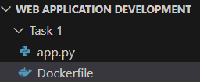



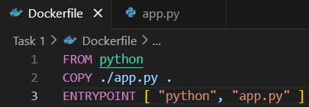





1. Purpose of the FROM instruction:

* The FROM instruction specifies the base image for building a new Docker image. It must be the first instruction in a Dockerfile.

2. How the COPY instruction works:

* The COPY instruction copies files or directories from the host machine into the Docker image at a specified path.

3. Difference between CMD and ENTRYPOINT:

* CMD: Sets default commands and/or parameters for a container, which can be overridden when starting the container.
* ENTRYPOINT: Defines a fixed command that will always run when the container starts. It is not easily overridden.

**Exercise 2: Optimizing Dockerfile with Layers and Caching**

1. **Objective**: Learn how to optimize a Dockerfile for smaller image sizes and faster builds.
2. **Steps**:
   * Modify the Dockerfile created in the previous exercise to:
     + Separate the installation of Python dependencies (if any) from the copying of application code.
     + Use a .dockerignore file to exclude unnecessary files from the image.
   * Rebuild the Docker image and observe the build process to understand how caching works.
   * Compare the size of the optimized image with the original.
3. **Questions**:
   * What are Docker layers, and how do they affect image size and build times?
   * How does Docker's build cache work, and how can it speed up the build process?

What is the role of the .dockerignore file?

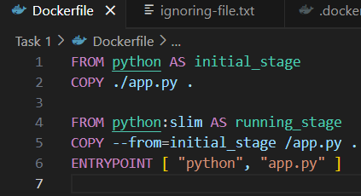

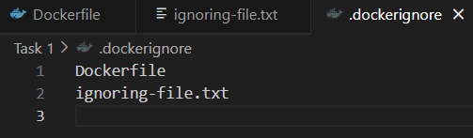

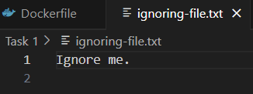





1. Docker layers:

* Docker images are made up of multiple layers, each representing a set of filesystem changes. Layers are created by instructions in the Dockerfile (e.g., RUN, COPY). Fewer layers generally result in smaller image sizes and faster builds.

2. Docker’s build cache:

* Docker’s build cache stores intermediate layers created during the build process. If a layer hasn’t changed, Docker reuses it from the cache, speeding up subsequent builds by avoiding redundant steps.

#### Exercise 3: Multi-Stage Builds

1. **Objective**: Use multi-stage builds to create leaner Docker images.
2. **Steps**:
   * Create a new project that involves compiling a simple Go application (e.g., a "Hello, World!" program).
   * Write a Dockerfile that uses multi-stage builds:
     + The first stage should use a Golang image to compile the application.
     + The second stage should use a minimal base image (e.g., alpine) to run the compiled application.
   * Build and run the Docker image, and compare the size of the final image with a single-stage build.
3. **Questions**:
   * What are the benefits of using multi-stage builds in Docker?
   * How can multi-stage builds help reduce the size of Docker images?
   * What are some scenarios where multi-stage builds are particularly useful?

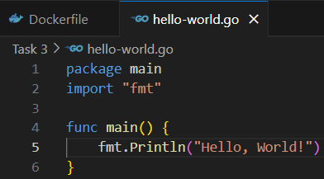

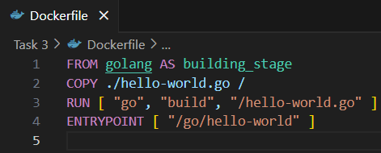

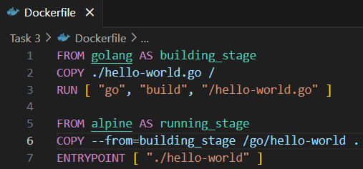



1. Benefits of using multi-stage builds:

* Multi-stage builds allow you to use multiple FROM statements in a Dockerfile to create intermediate images. This helps in separating build dependencies from runtime dependencies, leading to cleaner and more efficient builds.

2. Reducing Docker image size:

* By using multi-stage builds, you can copy only the necessary artifacts from the intermediate stages to the final image, excluding unnecessary build tools and dependencies. This significantly reduces the final image size.

3. Useful scenarios for multi-stage builds:

* You need to compile code (e.g., Go, Java) and only want to include the compiled binaries in the final image.
* You want to run tests in one stage and only proceed to the next stage if tests pass.
* You need to build complex applications with multiple dependencies.

**Exercise 4: Pushing Docker Images to Docker Hub**

1. **Objective**: Learn how to share Docker images by pushing them to Docker Hub.
2. **Steps**:
   * Create an account on Docker Hub.
   * Tag the Docker image you built earlier with your Docker Hub username (e.g., docker tag hello-docker <your-username>/hello-docker).
   * Log in to Docker Hub using docker login.
   * Push the image to Docker Hub using docker push <your-username>/hello-docker.
   * Verify that the image is available on Docker Hub and share it with others.
3. **Questions**:
   * What is the purpose of Docker Hub in containerization?
   * How do you tag a Docker image for pushing to a remote repository?
   * What steps are involved in pushing an image to Docker Hub?

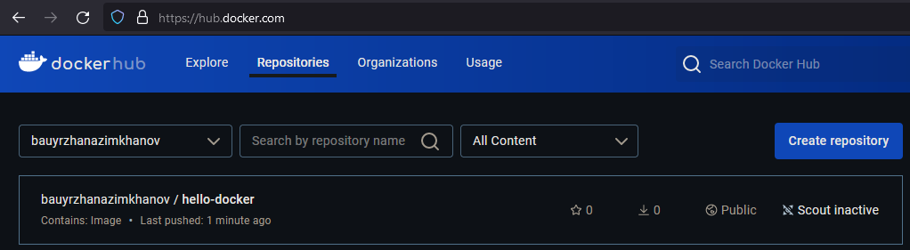

1. Purpose of Docker hub:

* Docker Hub is a cloud-based repository where you can find, share, and store Docker images. It serves as a central hub for container images, making it easier for developers to distribute and collaborate on their containerized applications.

2. Tagging a Docker image:

* To tag a Docker image for pushing to a remote repository, use the docker tag command:

docker tag <image_id> <repository_name>:<tag>

For example:

docker tag my-image my-repo/my-image:latest

3. Steps to push an image to Docker hub:

* Log in to Docker hub:

docker login

* Tag the image (if not already tagged):

docker tag my-image my-repo/my-image:latest

* Push the image:

docker push my-repo/my-image:latest