**Sequence Diagram**

Patient Interacting with Hospital Management System

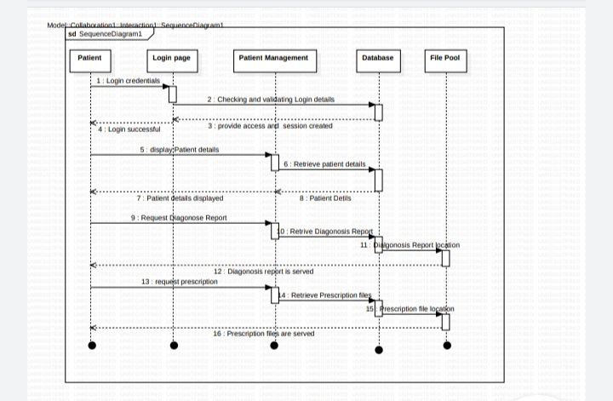

Doctor Interacting with Hospital Management System

Lab technicians interacting with Hospital Management System

Component Diagram

Deployment diagram

