4. Results

4.1 Descriptive and Diagnostic Analysis
This section presents the descriptive and diagnostic results for both CMS datasets. It begins with summary statistics for the ten states common to all three datasets, followed by column-wise bar charts that show how all available states compare on each quality measure, with those ten states highlighted. Pearson correlation analysis is then presented for both datasets, and the section closes with the scatter matrix trendline analysis.

4.1.1 Summary Statistics
Figures 4.1 and 4.2 show the distribution of state-level median values across the ten states common to all three datasets for the Hospital General Information and OAS CAHPS Survey datasets respectively, presented as column-wise bar charts across all available states.
For the Hospital General dataset, several variables show no variation at all across the ten states — Count of MORT Measures Better, Count of MORT Measures Worse, Count of Safety Measures Better, and Count of Safety Measures Worse all return the same median value in every state. This uniformity limits their analytical usefulness and explains why they produce no meaningful correlation coefficients in the subsequent analysis. The Overall Star Rating ranges from 3 to 4 across the ten states with a mean of 3.2, reflecting a moderate and tightly grouped quality profile. For the Survey dataset, values are uniformly high across positive response dimensions. The median percentage of patients who reported staff definitely gave professional care stands at 98%, and the median definite recommendation rate at 88.25%. Standard deviations are small throughout, confirming the ten states are closely grouped in their survey profiles.

4.1.2 Column-wise State Comparison Plots
The following figures present one bar chart per quality measure, showing the median value for all available states. The darker blue bars identify the ten states that were found to be common across all three datasets used in this study. All remaining states are shown in light blue. The dashed horizontal line in each chart marks the national median across all plotted states, providing a reference point for gauging where the states common to all three datasets sit relative to the broader national distribution.
Figure 4.1: Column-wise State Comparison — Hospital General Information Dataset
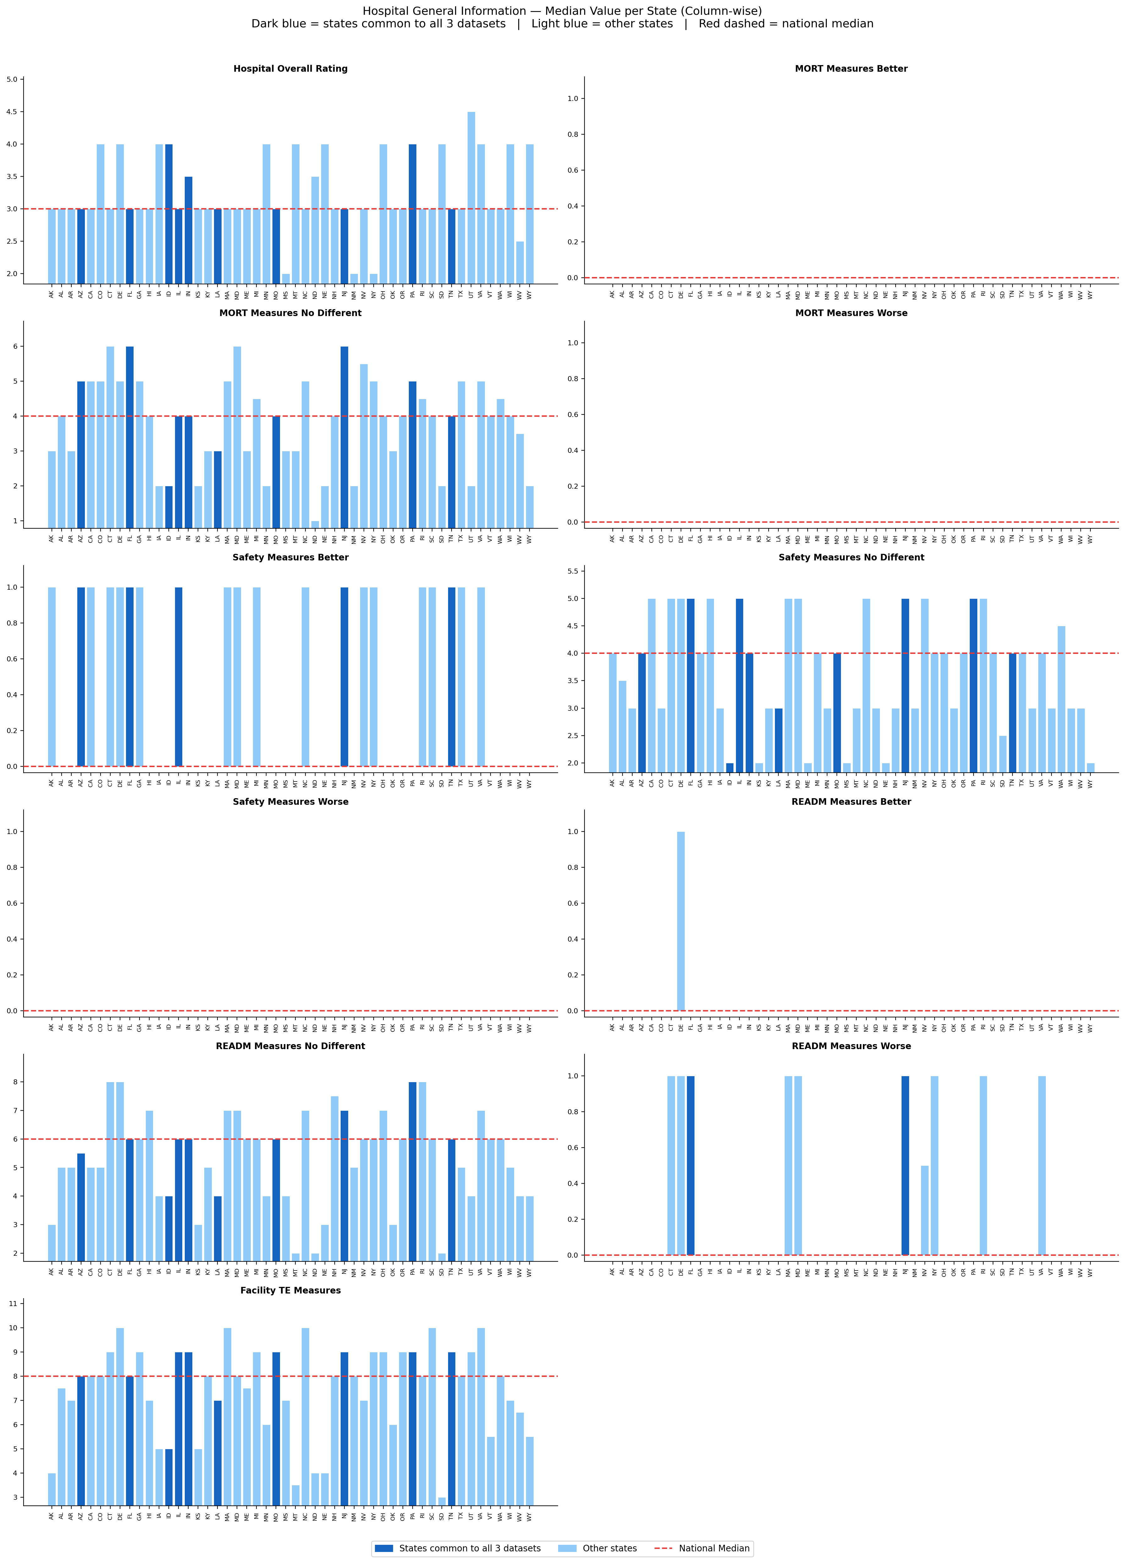
Across most Hospital General measures, the states common to all three datasets sit broadly in line with the national median. The Overall Star Rating chart shows that Idaho and Pennsylvania both return a rating of 4, standing above the majority of states which sit at 3. On the Count of MORT Measures No Different dimension, Arizona, Florida, and New Jersey sit at the higher end of the national distribution, while Idaho returns a notably lower value consistent with its stronger overall rating. On Count of READM Measures No Different, the common states are generally distributed around the national median with modest variation between them.
Figure 4.2: Column-wise State Comparison — OAS CAHPS Survey Dataset
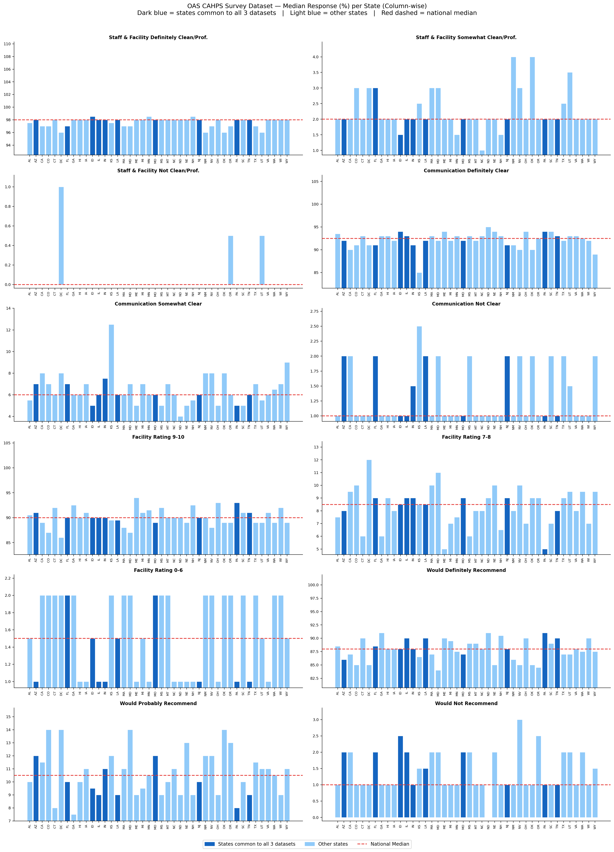
The Survey column-wise charts show all 42 states for which data was available, with the states common to all three datasets shown in darker blue. Across most dimensions, these states sit close to the national median, reflecting the overall uniformity of survey response percentages noted in the summary statistics. Idaho stands out on the Communication Definitely Clear dimension, returning one of the higher values among all states, while Pennsylvania and Tennessee also sit above the national median on both that dimension and Facility Rating 9 to 10. Missouri and Arizona both fall below the national median on the Would Definitely Recommend dimension, while Pennsylvania and Illinois sit slightly above it. Florida returns a below average definite communication rate while sitting at the median on overall facility ratings. The narrow spread across almost all states on the Staff and Facility dimensions confirms that this measure offers little differentiation and the real variation is concentrated in the communication and recommendation columns.

4.1.3 Pearson Correlation Analysis
Pearson correlation analysis was conducted on the state-level median values for both datasets. Blank cells in the correlograms represent pairs where one or both variables had zero variance and a coefficient could not be computed. Statistically significant results (p < 0.05) are summarised in the tables below each correlogram.
Figure 4.3: Correlogram — Hospital General Information Dataset
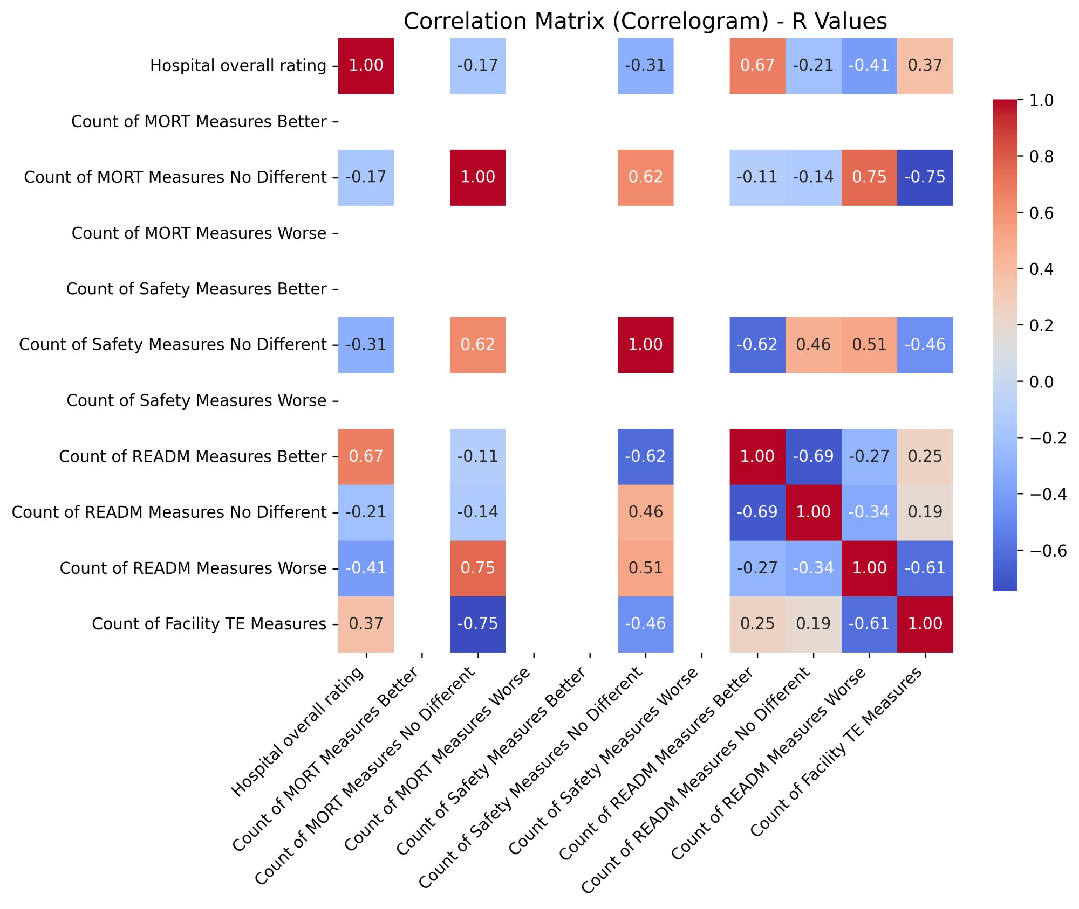
Table 4.1: Statistically Significant Correlations (p < 0.05) — Hospital General Information Dataset
Variable 1 | Variable 2 | R Value | P Value | Interpretation
Hospital Overall Rating | Count of READM Measures Better | 0.667 | 0.035 | Moderate positive — states with stronger readmission performance tend to carry higher composite ratings
Count of MORT Measures No Different | Count of READM Measures Worse | 0.748 | 0.013 | Strong positive — average mortality performance coexists with weaker readmission outcomes
Count of MORT Measures No Different | Count of Facility TE Measures | -0.745 | 0.013 | Strong negative — higher average mortality performance is associated with fewer TE measures reported
Count of READM Measures Better | Count of READM Measures No Different | -0.692 | 0.027 | Moderate negative — as above-average readmission performers increase, average performers decrease

The strongest finding is the positive relationship between Hospital Overall Rating and Count of READM Measures Better (r = 0.667, p = 0.035), indicating that states where more hospitals outperform the national average on readmissions also tend to carry higher composite quality ratings. The pairing of Count of MORT Measures No Different with both Count of READM Measures Worse and Count of Facility TE Measures suggests a pattern where middle-ground mortality performance coexists with weaker readmission outcomes and fewer timely and effective care measures, pointing to states that perform adequately across most domains without excelling in any.
Figure 4.4: Correlogram — OAS CAHPS Survey Dataset
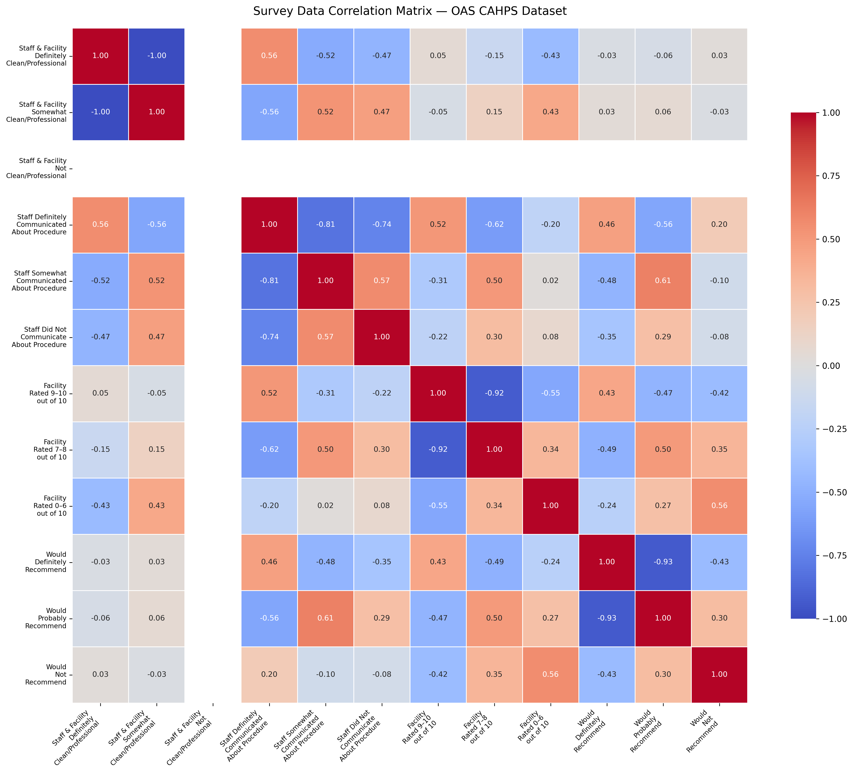
Table 4.2: Statistically Significant Correlations (p < 0.05) — OAS CAHPS Survey Dataset
Variable 1 | Variable 2 | R Value | P Value | Interpretation
Staff Definitely Communicated | Staff Somewhat Communicated | -0.814 | 0.004 | Strong negative — states with high definite communication rates have fewer partial reports
Staff Definitely Communicated | Staff Did Not Communicate | -0.742 | 0.014 | Strong negative — clear communication leaves little room for absent communication at state level
Facility Rated 9-10 | Facility Rated 7-8 | -0.923 | <0.001 | Very strong negative — top ratings and moderate ratings are polarised across states
Would Definitely Recommend | Would Probably Recommend | -0.935 | <0.001 | Very strong negative — strong and tentative endorsement move in opposite directions

The survey correlations reveal a consistent polarisation pattern. The near-perfect inverse relationship between patients rating the facility 9 or 10 and those rating it 7 or 8 (r = -0.923, p < 0.001), and between definite and probable recommendation (r = -0.935, p < 0.001), confirm that states lean decisively toward either strong or moderate patient satisfaction. The communication correlations similarly show that definite and absent or partial communication are inversely linked at the state level, suggesting communication quality is a systemic characteristic that tends to be consistent within a state rather than variable across its facilities.

4.1.4 Scatter Matrix with Polynomial Trendlines
A scatter matrix with degree-2 polynomial trendlines was generated for both datasets to examine pairwise relationships between variables and detect any non-linear patterns. For the Hospital General dataset, the trendlines were effectively straight lines across all variable pairs, a direct consequence of the very low variance in the data where most variables take only two or three distinct values across ten states. The OAS CAHPS Survey dataset produced visibly curved trendlines across several variable pairs, particularly among the rating and recommendation columns. The full scatter matrix for the Survey dataset is shown in Figure 4.5.
Figure 4.5: Scatter Matrix with Polynomial Trendlines — OAS CAHPS Survey Dataset


