5. Methodology

5.1 Pearson Correlation Analysis
The first analytical step applied to both datasets was a Pearson correlation analysis, conducted to examine the linear relationships between the selected state-level median variables within each dataset. This analysis was performed using a custom Python script that made use of three core scientific computing libraries: Pandas, SciPy, and Seaborn. The same algorithmic approach was applied consistently to both datasets, with the only differences being the input data and the variable set specific to each source.
Pandas is an open-source data manipulation library for Python that provides high-performance data structures, most notably the DataFrame, which organises tabular data into rows and columns in a manner analogous to a spreadsheet or relational database table. In this analysis, Pandas was used to load each state-level median dataset from its Excel format and to construct the output correlation matrices for export.
SciPy is a scientific computing library that provides a comprehensive suite of mathematical, statistical, and signal processing functions. The specific function employed in this analysis was scipy.stats.pearsonr, which computes the Pearson correlation coefficient (r) and the associated two-tailed p-value for two input variables. The Pearson coefficient quantifies the strength and direction of the linear relationship between two continuous variables, ranging from -1 (perfect negative correlation) to +1 (perfect positive correlation), with 0 indicating no linear relationship. The p-value tests the null hypothesis that the true correlation is zero; a p-value below 0.05 indicates that the observed correlation is statistically significant at the 95% confidence level.
Seaborn is a statistical data visualisation library built on top of Matplotlib. It was used to generate the correlogram — a heatmap representation of the full correlation matrix — in which each cell is colour-coded by its r value using a diverging colour scale ranging from deep blue (strong negative correlation) to deep red (strong positive correlation). Annotating each cell with its numeric r value allows for simultaneous visual and quantitative interpretation of the correlation structure across all variable pairs.

5.1.1 Hospital General Information Dataset
The Pearson correlation was computed pairwise across all eleven selected variables for the ten states in the dataset: Arizona, Indiana, Florida, Idaho, Tennessee, Pennsylvania, New Jersey, Missouri, Louisiana, and Illinois. The state-level median values used as input to this analysis are presented in Table 1 below.
Table 1: State-Level Median Values — Hospital General Information Dataset
State | Overall Rating | MORT Better | MORT No Diff | MORT Worse | Safety Better | Safety No Diff | Safety Worse | READM Better | READM No Diff | READM Worse | Facility TE
AZ | 3 | 0 | 6 | 0 | 1 | 5.0 | 0 | 0 | 7.0 | 1 | 9
IN | 3 | 0 | 5 | 0 | 1 | 5.0 | 0 | 0 | 8.0 | 0 | 10
FL | 3 | 0 | 6 | 0 | 1 | 5.0 | 0 | 0 | 7.0 | 1 | 8
ID | 4 | 0 | 5 | 0 | 1 | 4.0 | 0 | 1 | 6.0 | 0 | 10
TN | 3 | 0 | 4 | 0 | 1 | 4.0 | 0 | 0 | 7.0 | 0 | 10
PA | 4 | 0 | 5 | 0 | 1 | 5.0 | 0 | 0 | 8.0 | 0 | 10
NJ | 3 | 0 | 6 | 0 | 1 | 5.0 | 0 | 0 | 7.0 | 1 | 9
MO | 3 | 0 | 5 | 0 | 1 | 4.5 | 0 | 0 | 8.0 | 0 | 10
LA | 3 | 0 | 5 | 0 | 1 | 5.0 | 0 | 0 | 7.5 | 0 | 9
IL | 3 | 0 | 5 | 0 | 1 | 5.0 | 0 | 0 | 7.0 | 1 | 10

It is notable that several variables — specifically Count of MORT Measures Better, Count of MORT Measures Worse, Count of Safety Measures Better, and Count of Safety Measures Worse — exhibited no variation across the ten states, with all states returning a median value of zero or one uniformly. For these variables, the Pearson coefficient is mathematically undefined, as the formula requires variance in both variables. Consequently, these pairs are represented as blank cells in the correlation matrix and were excluded from interpretive analysis. This outcome reflects not a limitation of the methodology but rather a genuine characteristic of the data: these particular quality domains did not differentiate the ten states in this study.
The Pearson r values and their corresponding p-values were computed for all remaining variable pairs and are visualised in the correlogram presented in Figure 1 below. Statistically significant correlations (p < 0.05) are summarised in Table 2.
Figure 1: Correlogram — Pearson R Values, Hospital General Information Dataset
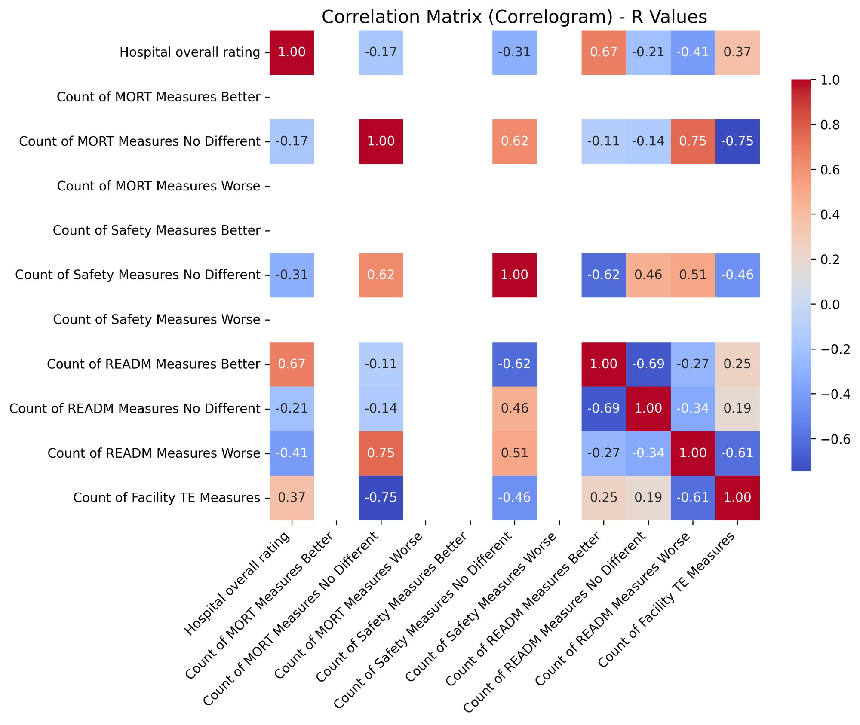
Table 2: Statistically Significant Pearson Correlations (p < 0.05) — Hospital General Information Dataset
Variable 1 | Variable 2 | R Value | P Value | Interpretation
Hospital Overall Rating | Count of READM Measures Better | 0.667 | 0.035 | Moderate positive — states with more hospitals performing better on readmissions tend to have higher overall ratings
Count of MORT Measures No Different | Count of READM Measures Worse | 0.748 | 0.013 | Strong positive — states where mortality is broadly average also tend to have more poor readmission performers
Count of MORT Measures No Different | Count of Facility TE Measures | -0.745 | 0.013 | Strong negative — as average mortality performance increases, timely & effective care measure count decreases
Count of READM Measures Better | Count of READM Measures No Different | -0.692 | 0.027 | Moderate negative — states with more readmission high-performers have fewer average performers

The most notable finding from the correlation analysis is the statistically significant positive relationship between Hospital Overall Rating and Count of READM Measures Better (r = 0.667, p = 0.035). This indicates that states in which a greater number of hospitals perform above the national average on readmission measures also tend to have higher median hospital quality ratings overall. This is an intuitive and clinically meaningful finding, as readmission rates are widely recognised as a proxy for the quality of the discharge process, post-acute care coordination, and overall care continuity.
A strong positive correlation was also observed between Count of MORT Measures No Different and Count of READM Measures Worse (r = 0.748, p = 0.013), suggesting that states where hospitals broadly perform at the national average on mortality tend to have more hospitals underperforming on readmissions. This may reflect a pattern in which states achieve adequate but not exceptional outcomes across quality domains. The strong negative correlation between Count of MORT Measures No Different and Count of Facility TE Measures (r = -0.745, p = 0.013) further supports this interpretation, indicating a potential trade-off between mortality performance and the capacity to report on timely and effective care measures. Finally, the moderate negative correlation between Count of READM Measures Better and Count of READM Measures No Different (r = -0.692, p = 0.027) is expected by construction — as more hospitals in a state perform above average on readmissions, fewer will be classified as average performers.

5.1.2 OAS CAHPS Survey Dataset
The same Pearson correlation methodology was subsequently applied to the state-level median values derived from the OAS CAHPS Ambulatory Surgical Centre survey dataset, across the twelve selected survey response columns and the same ten states. The state-level median values are presented in Table 3 below. The column representing patients who reported that staff did not give care professionally and that the facility was not clean returned a uniform median value of zero across all ten states and was therefore excluded from the correlation computation, consistent with the approach applied to the zero-variance columns in the Hospital General Information dataset.
Table 3: State-Level Median Values — OAS CAHPS Survey Dataset
State | Staff & Facility Definitely Clean/Prof. (%) | Staff & Facility Somewhat Clean/Prof. (%) | Staff & Facility Not Clean/Prof. (%) | Staff Definitely Communicated About Procedure (%) | Staff Somewhat Communicated About Procedure (%) | Staff Did Not Communicate About Procedure (%) | Facility Rated 9–10 out of 10 (%) | Facility Rated 7–8 out of 10 (%) | Facility Rated 0–6 out of 10 (%) | Would Definitely Recommend (%) | Would Probably Recommend (%) | Would Not Recommend (%)
AZ | 98.0 | 2.0 | 0 | 92 | 7.0 | 2.0 | 91.0 | 8.0 | 1.0 | 86.0 | 12.0 | 2.0
FL | 97.0 | 3.0 | 0 | 91 | 7.0 | 2.0 | 90.0 | 9.0 | 2.0 | 88.5 | 10.0 | 2.0
ID | 98.5 | 1.5 | 0 | 94 | 5.0 | 1.0 | 90.0 | 8.5 | 1.5 | 88.0 | 9.5 | 2.5
IL | 98.0 | 2.0 | 0 | 93 | 6.0 | 1.0 | 90.0 | 9.0 | 1.0 | 90.0 | 9.0 | 2.0
IN | 98.0 | 2.0 | 0 | 91 | 7.5 | 1.5 | 90.0 | 9.0 | 1.0 | 88.0 | 11.0 | 1.0
LA | 98.0 | 2.0 | 0 | 92 | 6.0 | 2.0 | 89.5 | 8.5 | 1.5 | 90.0 | 9.0 | 1.5
MO | 98.0 | 2.0 | 0 | 92 | 6.0 | 1.0 | 89.0 | 9.0 | 2.0 | 87.0 | 12.0 | 2.0
NJ | 98.0 | 2.0 | 0 | 91 | 6.0 | 2.0 | 90.0 | 9.0 | 1.0 | 88.0 | 10.0 | 1.0
PA | 98.0 | 2.0 | 0 | 94 | 5.0 | 1.0 | 93.0 | 5.0 | 1.0 | 91.0 | 8.0 | 1.0
TN | 98.0 | 2.0 | 0 | 93 | 6.0 | 1.0 | 91.0 | 8.0 | 1.0 | 90.0 | 9.0 | 1.0

The Pearson r values and their corresponding p-values were computed for all variable pairs with sufficient variance and are visualised in the correlogram presented in Figure 2 below. Statistically significant correlations (p < 0.05) are summarised in Table 4.
Figure 2: Correlogram — Pearson R Values, OAS CAHPS Survey Dataset
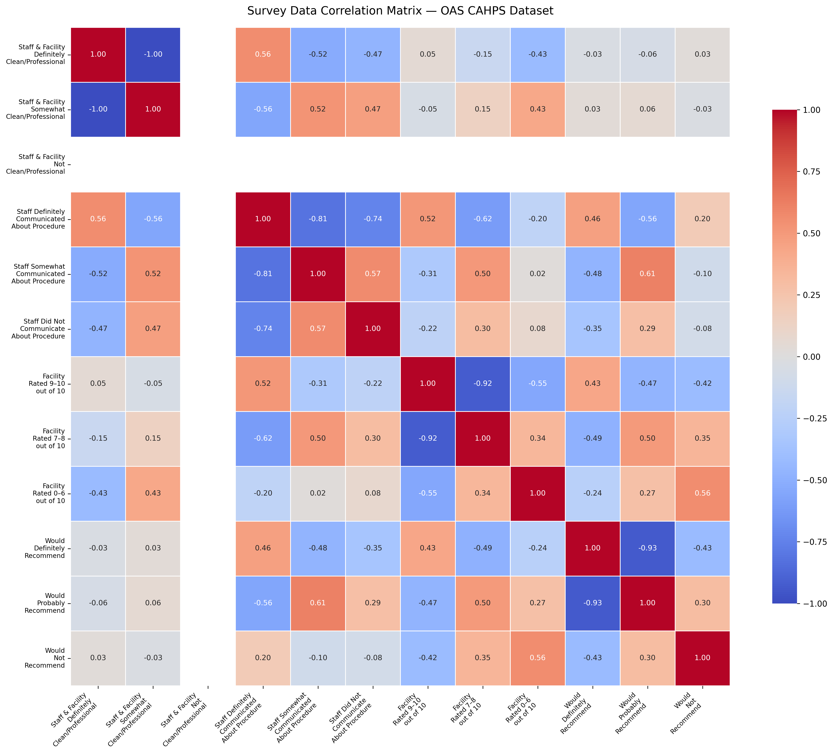
Table 4: Statistically Significant Pearson Correlations (p < 0.05) — OAS CAHPS Survey Dataset
Variable 1 | Variable 2 | R Value | P Value | Interpretation
Staff Definitely Communicated About Procedure | Staff Somewhat Communicated About Procedure | -0.814 | 0.004 | Strong negative — states where more patients report definite communication have fewer reporting only partial communication, indicating clear polarisation in communication quality
Staff Definitely Communicated About Procedure | Staff Did Not Communicate About Procedure | -0.742 | 0.014 | Strong negative — states with high definite communication rates have very few patients reporting no communication at all
Facility Rated 9–10 out of 10 | Facility Rated 7–8 out of 10 | -0.923 | <0.001 | Very strong negative — states with more top-rated facilities have markedly fewer moderately rated facilities, indicating a high-performance cluster pattern
Would Definitely Recommend | Would Probably Recommend | -0.935 | <0.001 | Very strong negative — as the proportion of patients who would definitely recommend rises, those who would only probably recommend falls, reflecting a consistent shift toward strong endorsement

The most striking finding from the OAS CAHPS correlation analysis is the very strong negative relationship between patients who rated the facility 9 or 10 out of 10 and those who rated it 7 or 8, yielding an r value of -0.923 (p < 0.001). This near-perfect inverse relationship indicates that across the ten states, higher proportions of top-rated facilities are consistently associated with lower proportions of moderately rated facilities. Rather than a gradual distribution of ratings, this pattern suggests a clear bifurcation in patient satisfaction at the state level — states tend to cluster either toward predominantly excellent or predominantly adequate performance, with little middle ground.
An equally strong negative correlation was observed between patients who would definitely recommend the facility and those who would probably recommend it, with r = -0.935 (p < 0.001). This finding reinforces the same polarisation pattern seen in the facility ratings: states in which a greater share of patients express strong endorsement have proportionally fewer patients expressing only tentative endorsement. Taken together, these two correlations suggest that the ten states in this study are meaningfully differentiated by the intensity of patient satisfaction, not merely its presence or absence.
Within the communication dimension, statistically significant negative correlations were found between patients who reported definite communication and those who reported only partial communication (r = -0.814, p = 0.004) or no communication at all (r = -0.742, p = 0.014). These findings indicate that procedural communication quality is a relatively consistent state-level characteristic — states in which ambulatory centres communicate clearly tend to show this across the board, while states with weaker communication performance show a corresponding elevation in partial or absent communication reporting.

