5.5 Text Mining Analysis — Yelp Open Dataset
The text mining analysis was applied to the Yelp Open Dataset reviews associated with hospital-categorised businesses, grouped according to the six cluster definitions established in Section 5.4 — three clusters from the Hospital General Information dataset (HG-C1, HG-C2, HG-C3) and three from the OAS CAHPS Survey dataset (S-C1, S-C2, S-C3). Each cluster's review corpus was treated as a unified body of consumer-generated text representing the collective patient voice for the states in that cluster. The analysis spans six distinct analytical dimensions: overall sentiment, attribute-level net scores, emotion distribution, the Passion Index, word association networks, and word clouds. Each dimension was computed using a dedicated Python program and the outputs are presented and interpreted in the subsections below.

5.5.1 Overall Sentiment Analysis
The overall sentiment analysis was performed using NLTK's VADER (Valence Aware Dictionary and sEntiment Reasoner) sentiment analyzer. NLTK, the Natural Language Toolkit, is a foundational Python library for natural language processing that provides a comprehensive suite of tools for text classification, tokenisation, tagging, and sentiment analysis. VADER is a rule-based sentiment analysis tool specifically designed and validated for social media and consumer review text. Unlike machine learning models that require training data, VADER uses a pre-built lexicon of words and phrases annotated with sentiment valence scores, and applies a set of grammatical and syntactical rules to account for context effects such as negation, intensifiers, and punctuation. For each review, VADER computes a compound score ranging from -1 (maximally negative) to +1 (maximally positive). Reviews with a compound score of 0.05 or above were classified as positive, those at or below -0.05 as negative, and those in between as neutral. Neutral reviews were excluded from the percentage calculation, and the final output for each cluster is expressed as the percentage of sentiment-bearing reviews that are positive versus negative, along with the absolute review count.
The results across all six clusters are summarised in Table 11 below, and the individual cluster charts are presented in Figures 27 through 32.
Table 11: Overall Sentiment Summary — All Clusters
Cluster | States | Positive | Negative
HG-C1 | AZ, FL, NJ, IL | 66.2% (247) | 33.8% (126)
HG-C2 | ID, TN | 60.6% (77) | 39.4% (50)
HG-C3 | IN, PA, MO, LA | 62.3% (425) | 37.7% (257)
S-C1 | ID, IL, LA, PA, TN | 60.1% (369) | 39.9% (245)
S-C2 | AZ, IN, NJ | 65.6% (250) | 34.4% (131)
S-C3 | FL, MO | 70.2% (165) | 29.8% (70)

Figure 27: Overall Sentiment — HG-C1 (AZ, FL, NJ, IL)
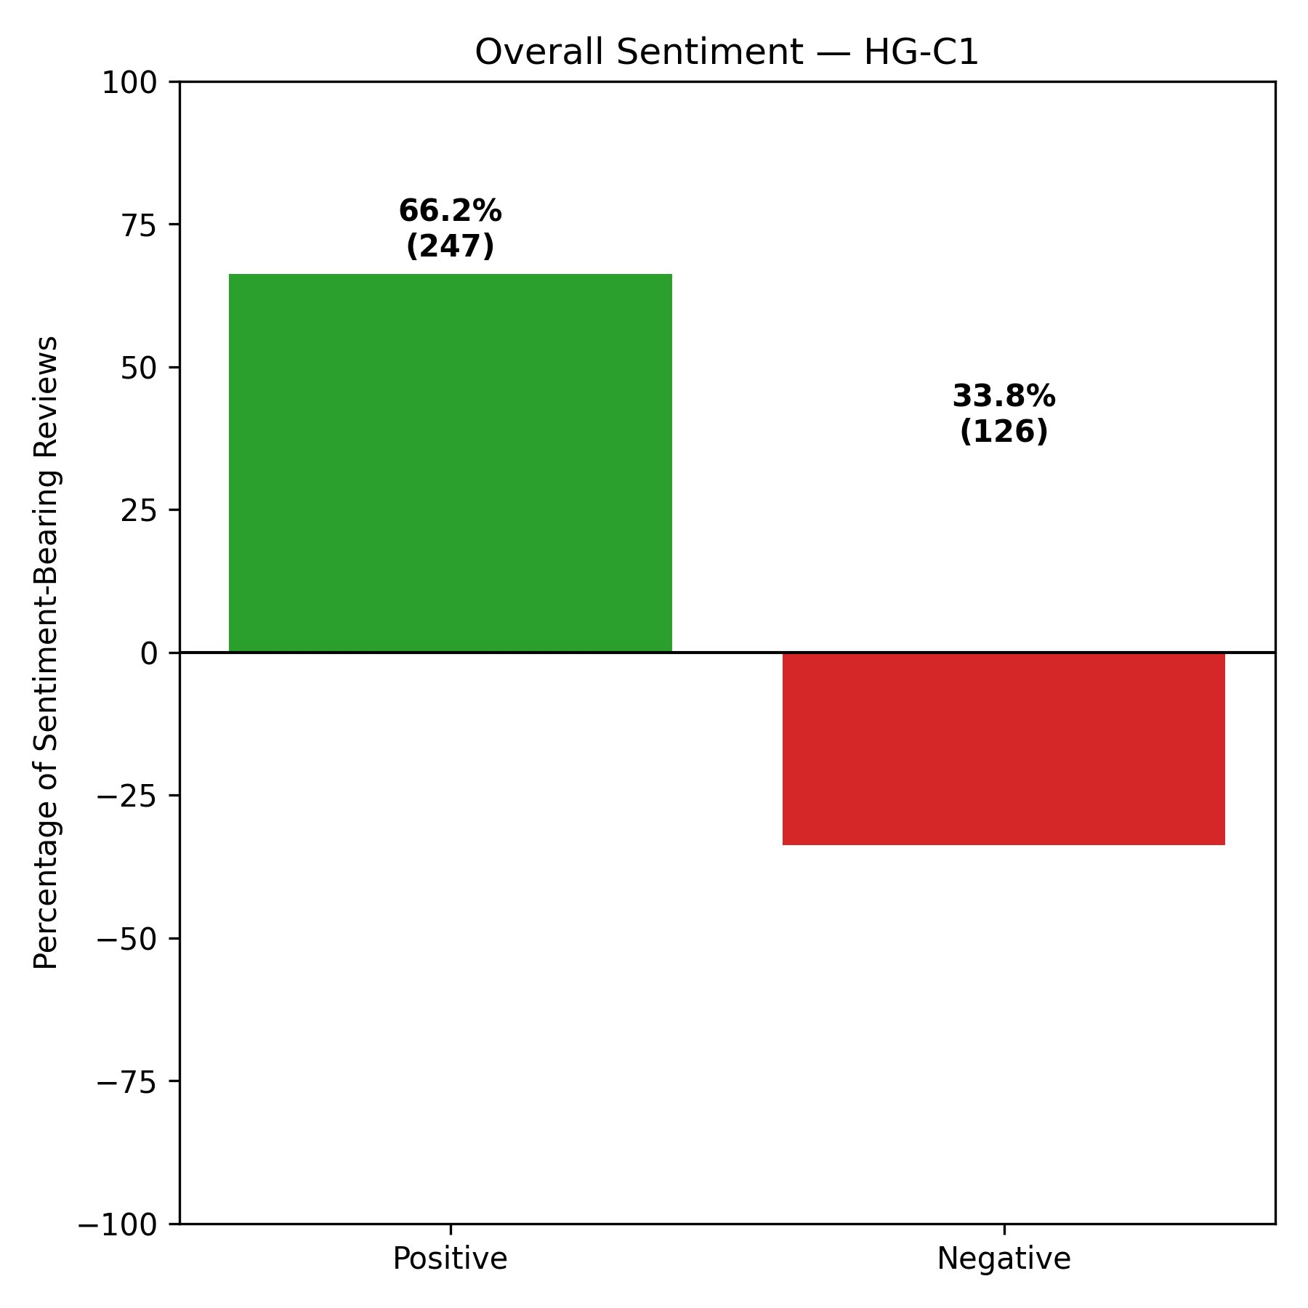
Figure 28: Overall Sentiment — HG-C2 (ID, TN)
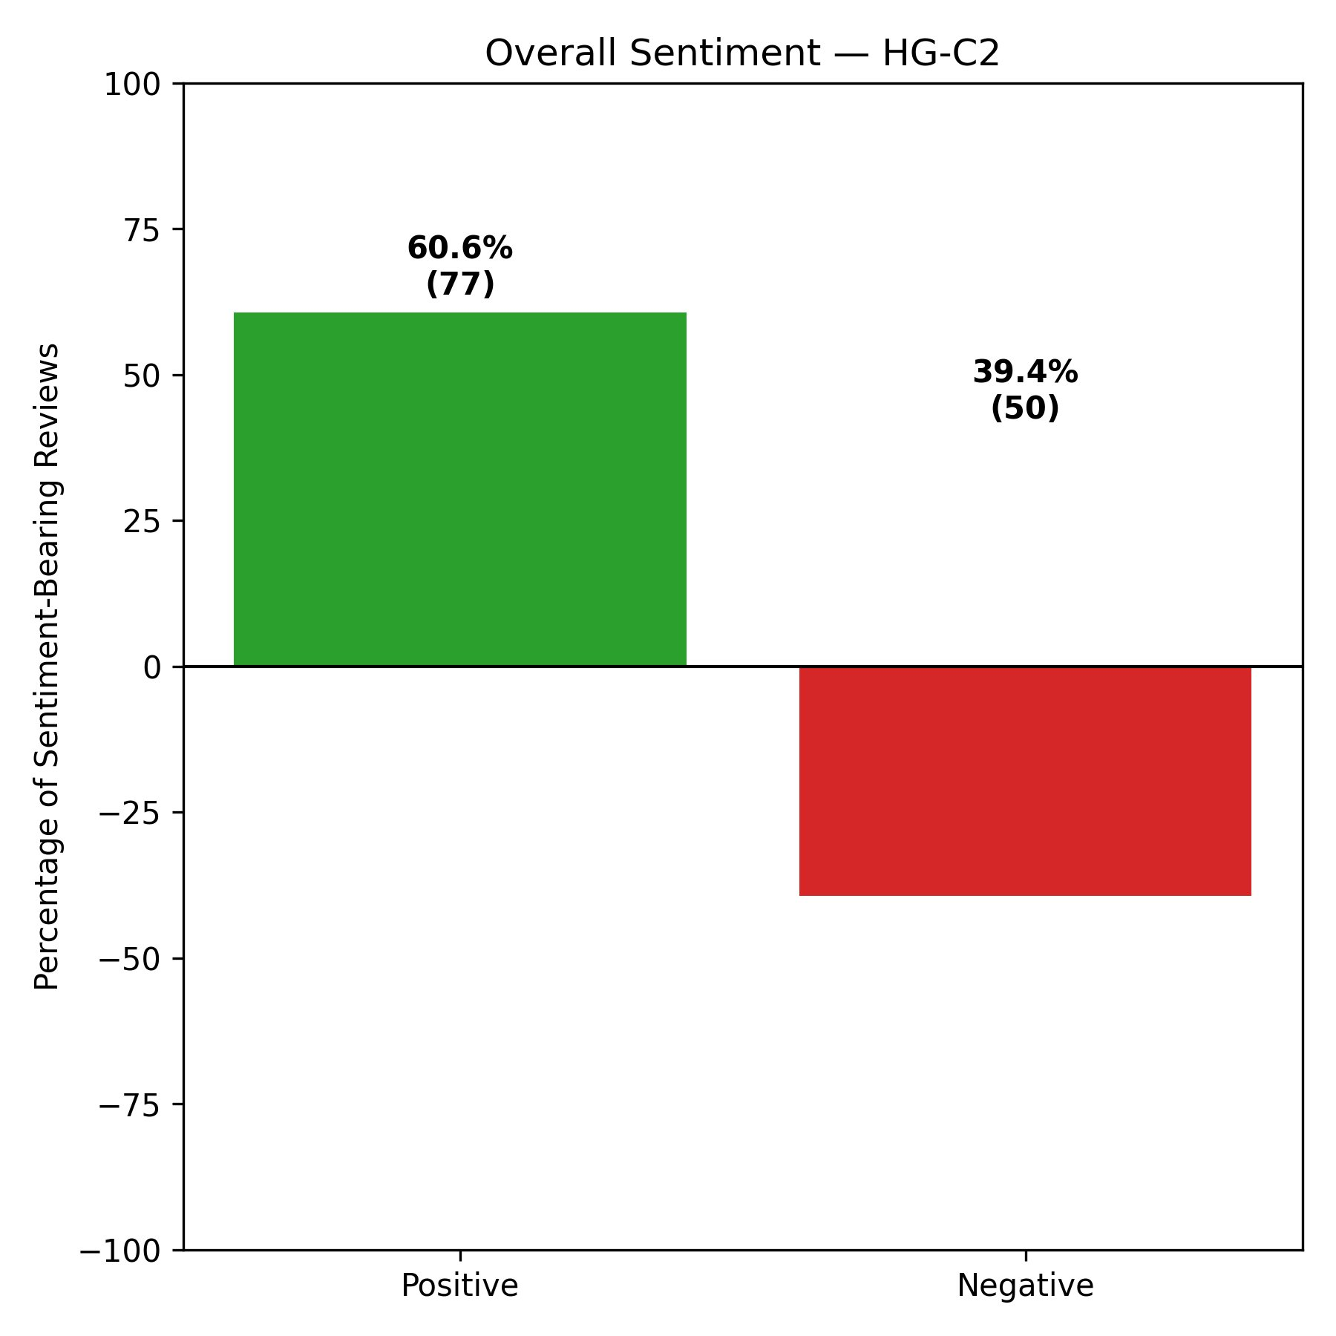
Figure 29: Overall Sentiment — HG-C3 (IN, PA, MO, LA)
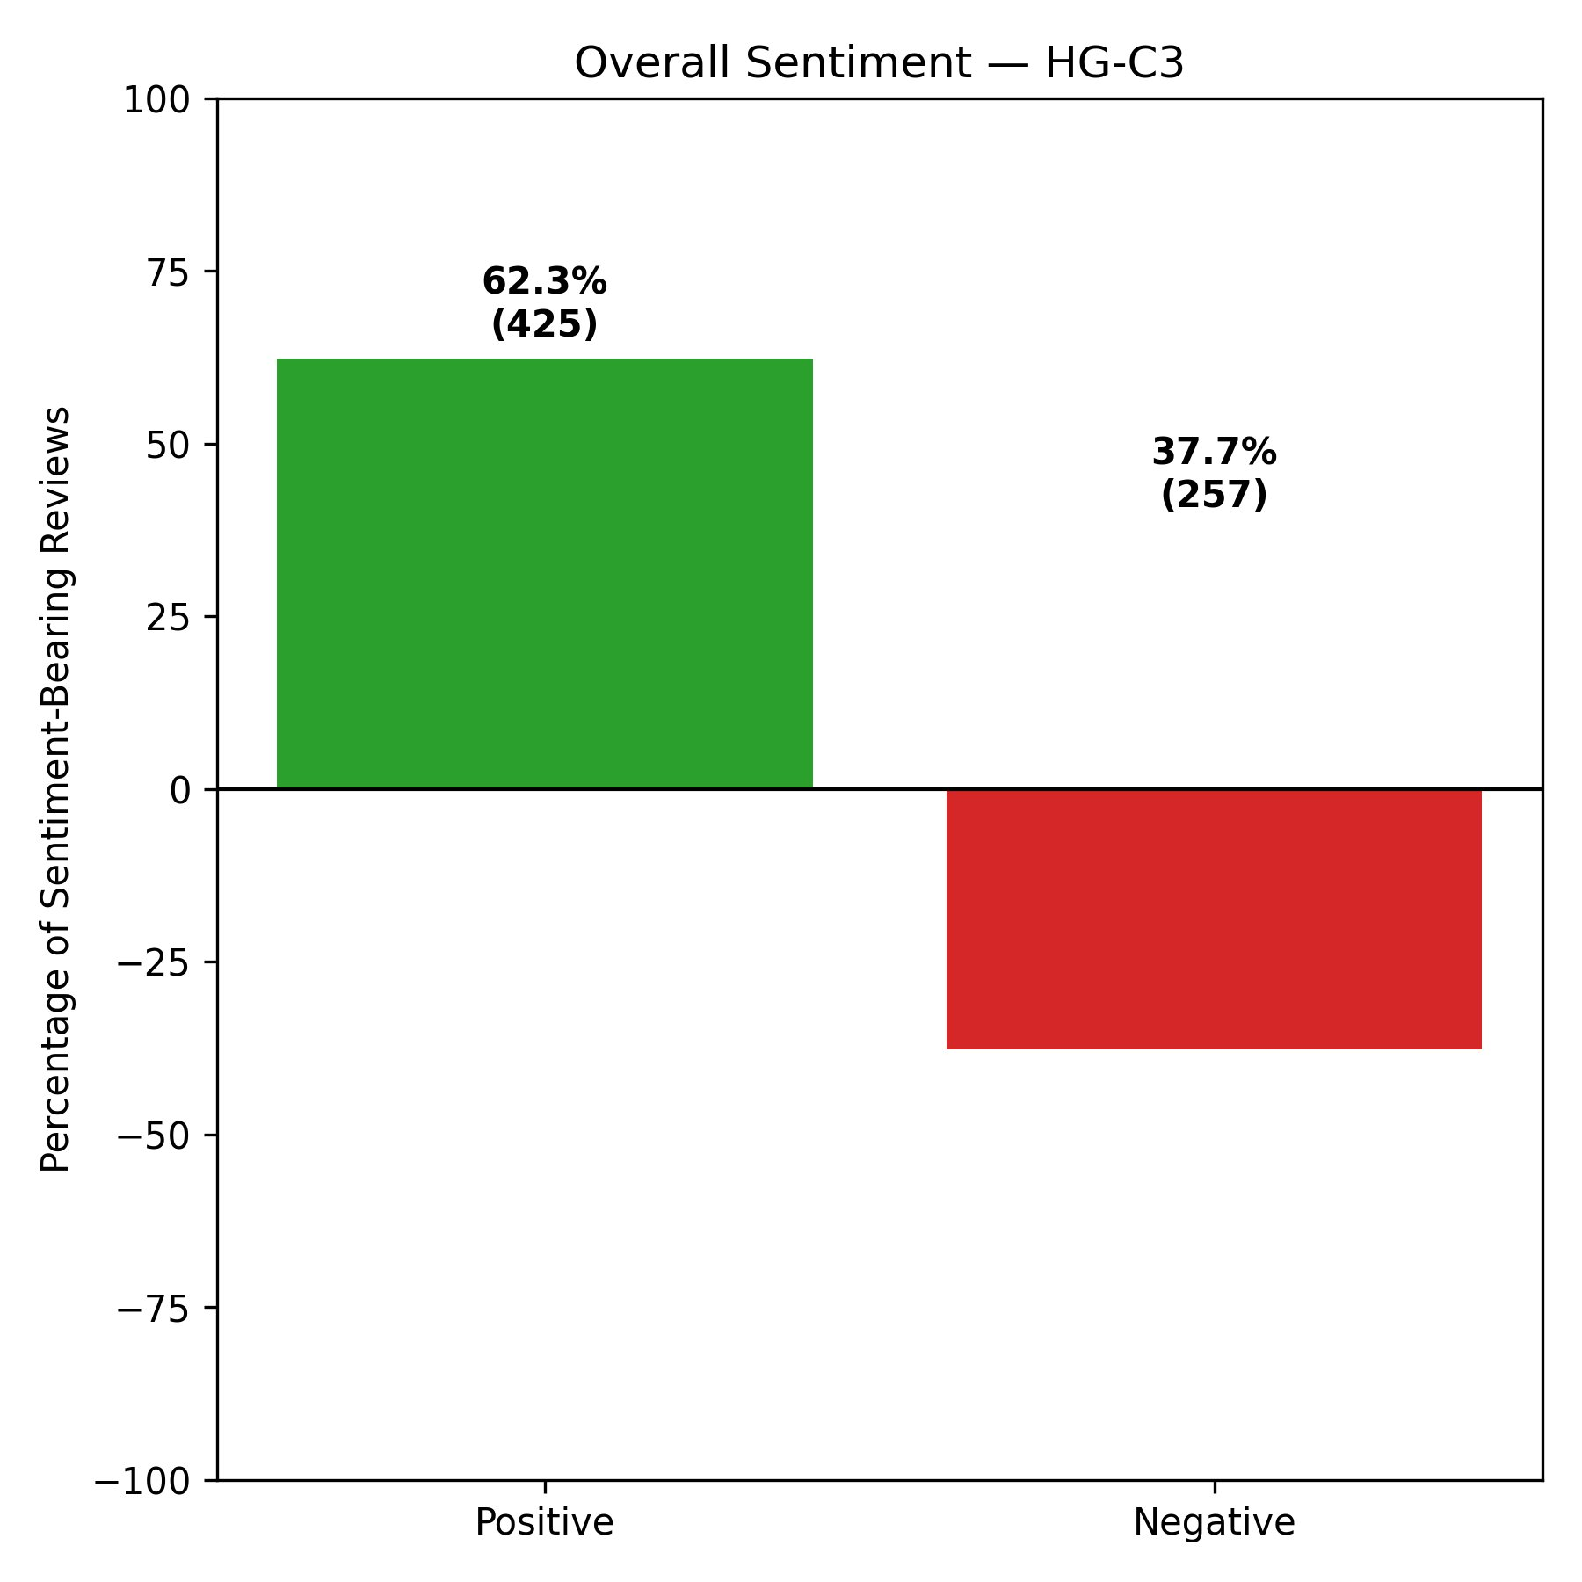
Figure 30: Overall Sentiment — S-C1 (ID, IL, LA, PA, TN)
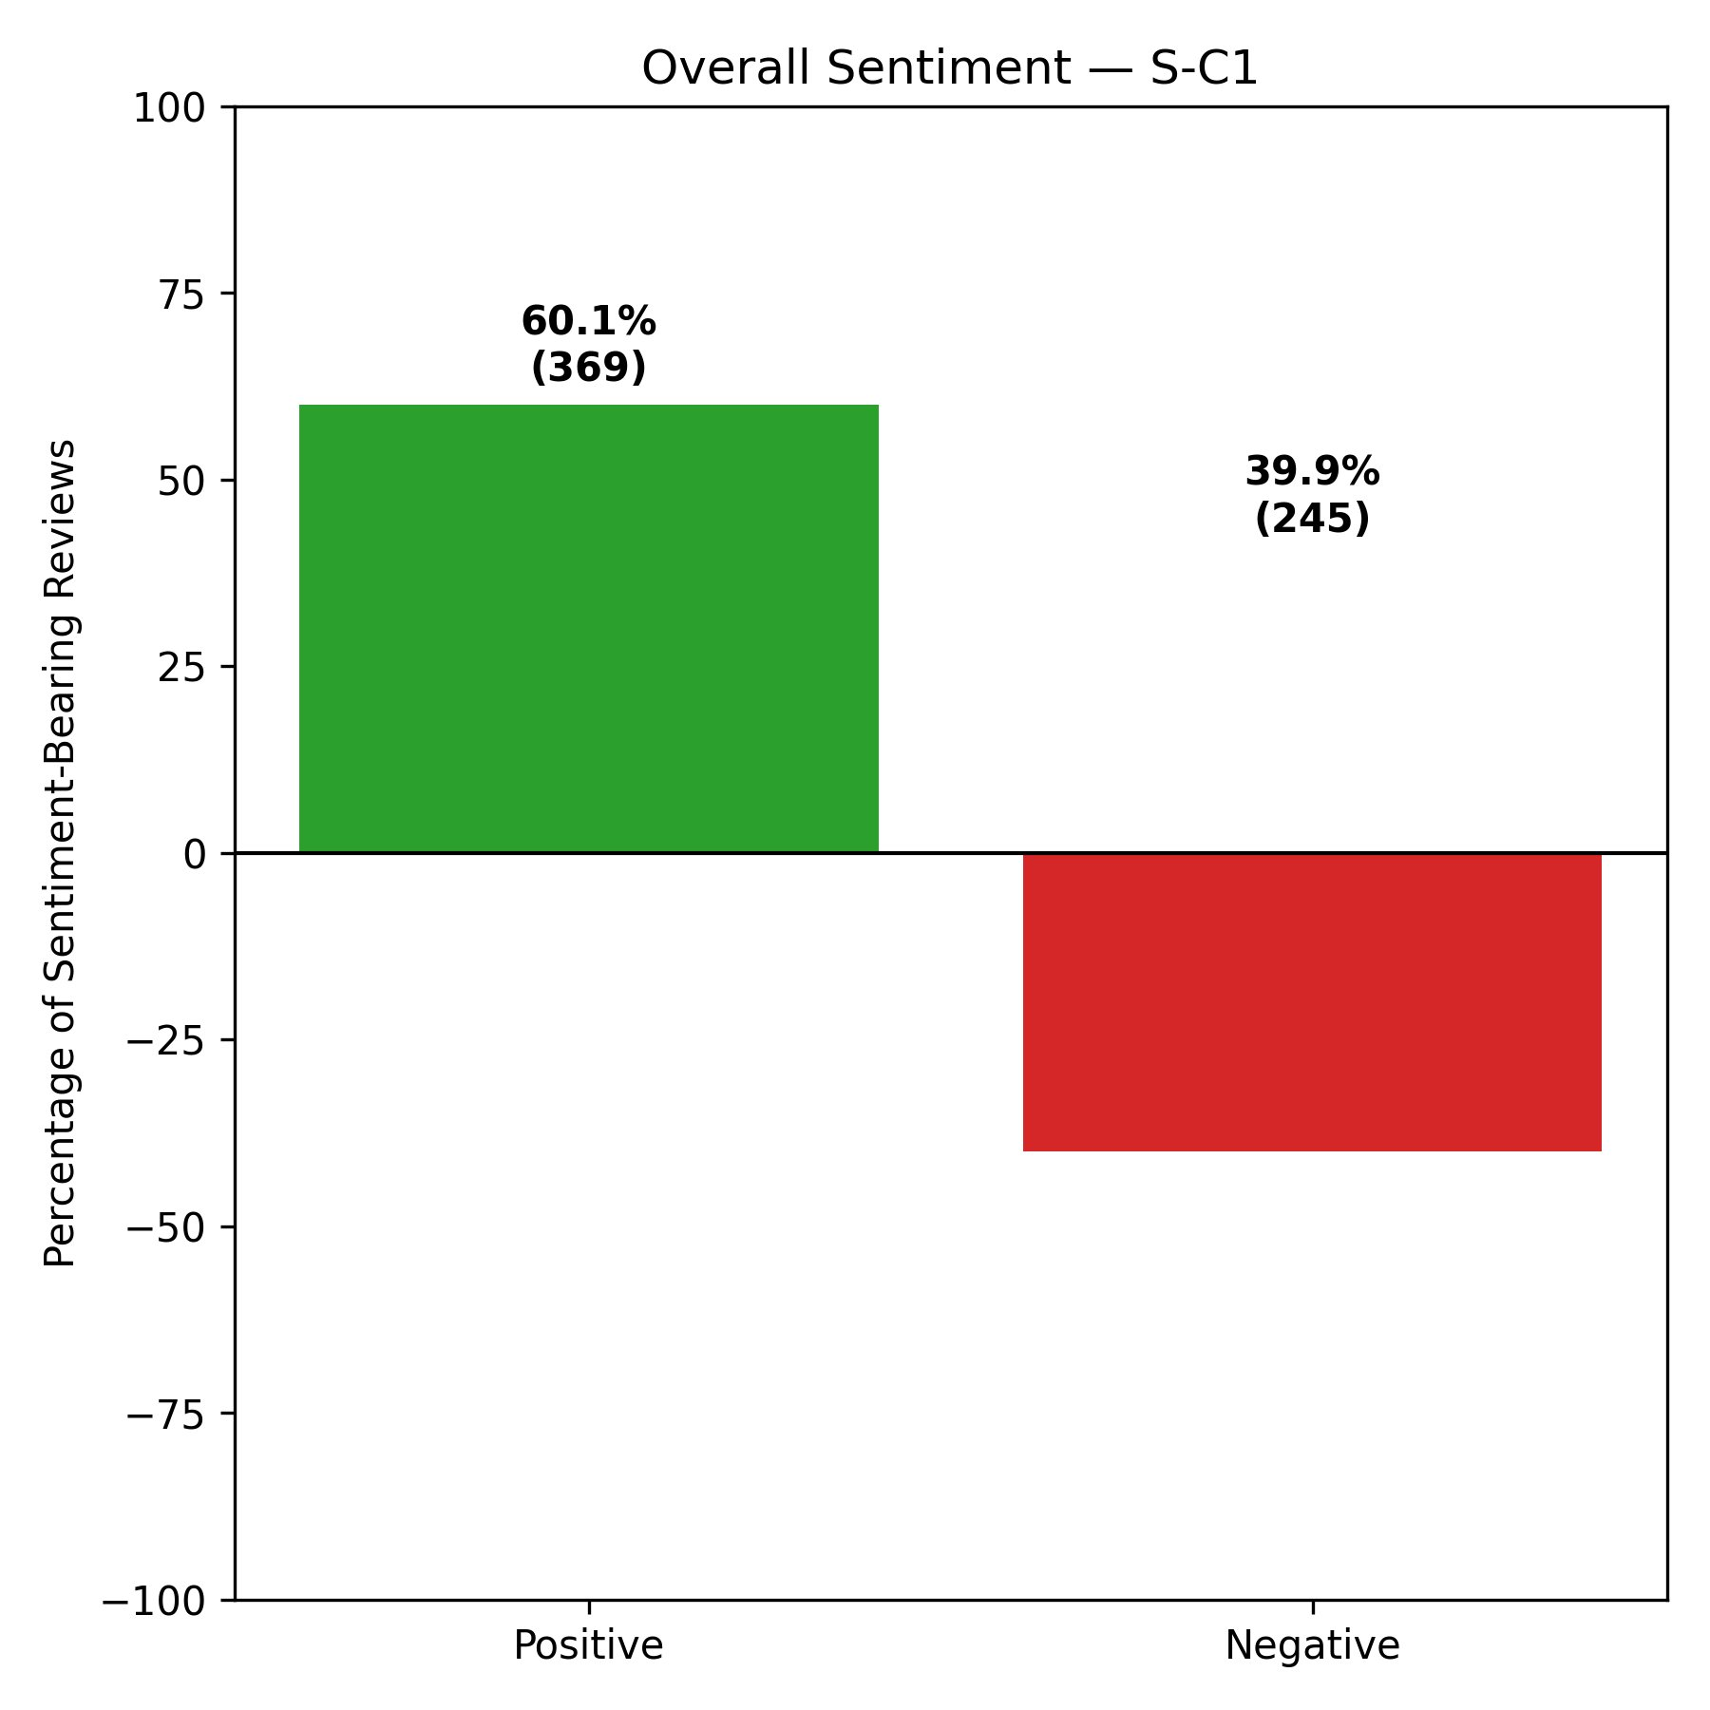
Figure 31: Overall Sentiment — S-C2 (AZ, IN, NJ)
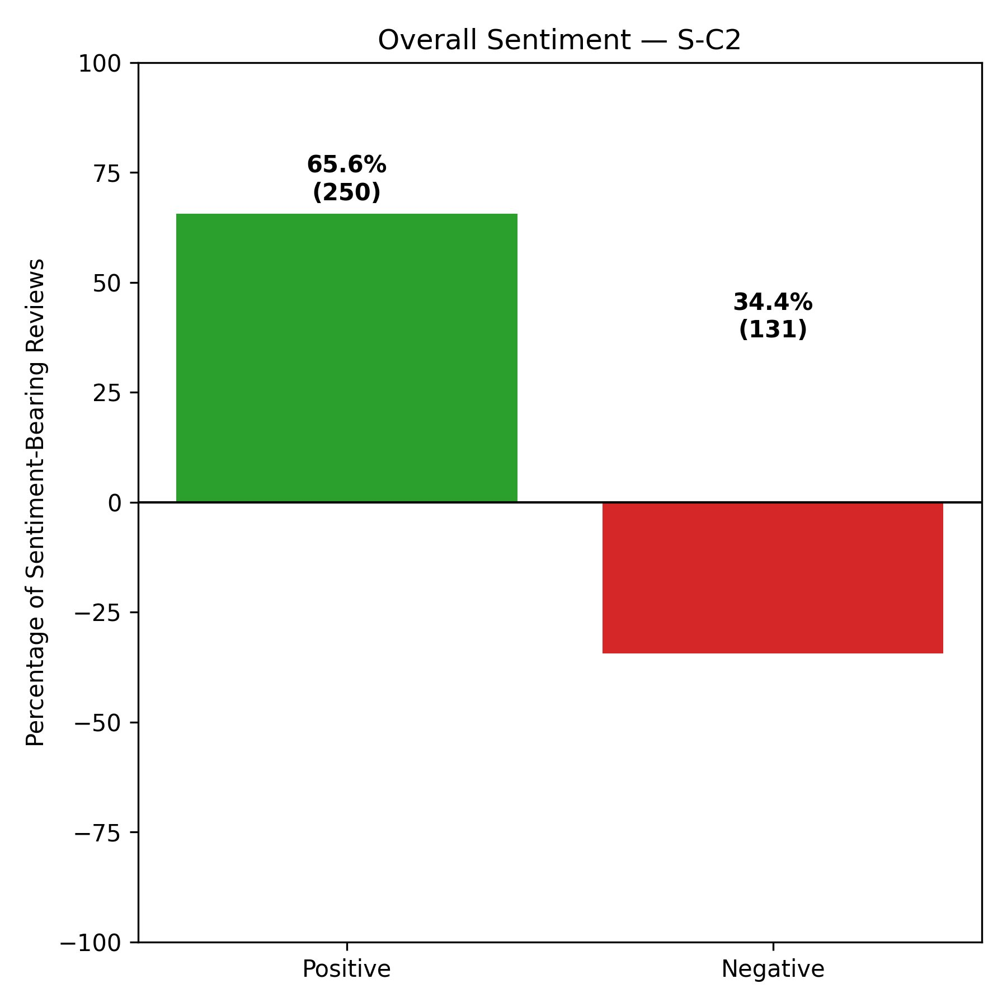
Figure 32: Overall Sentiment — S-C3 (FL, MO)
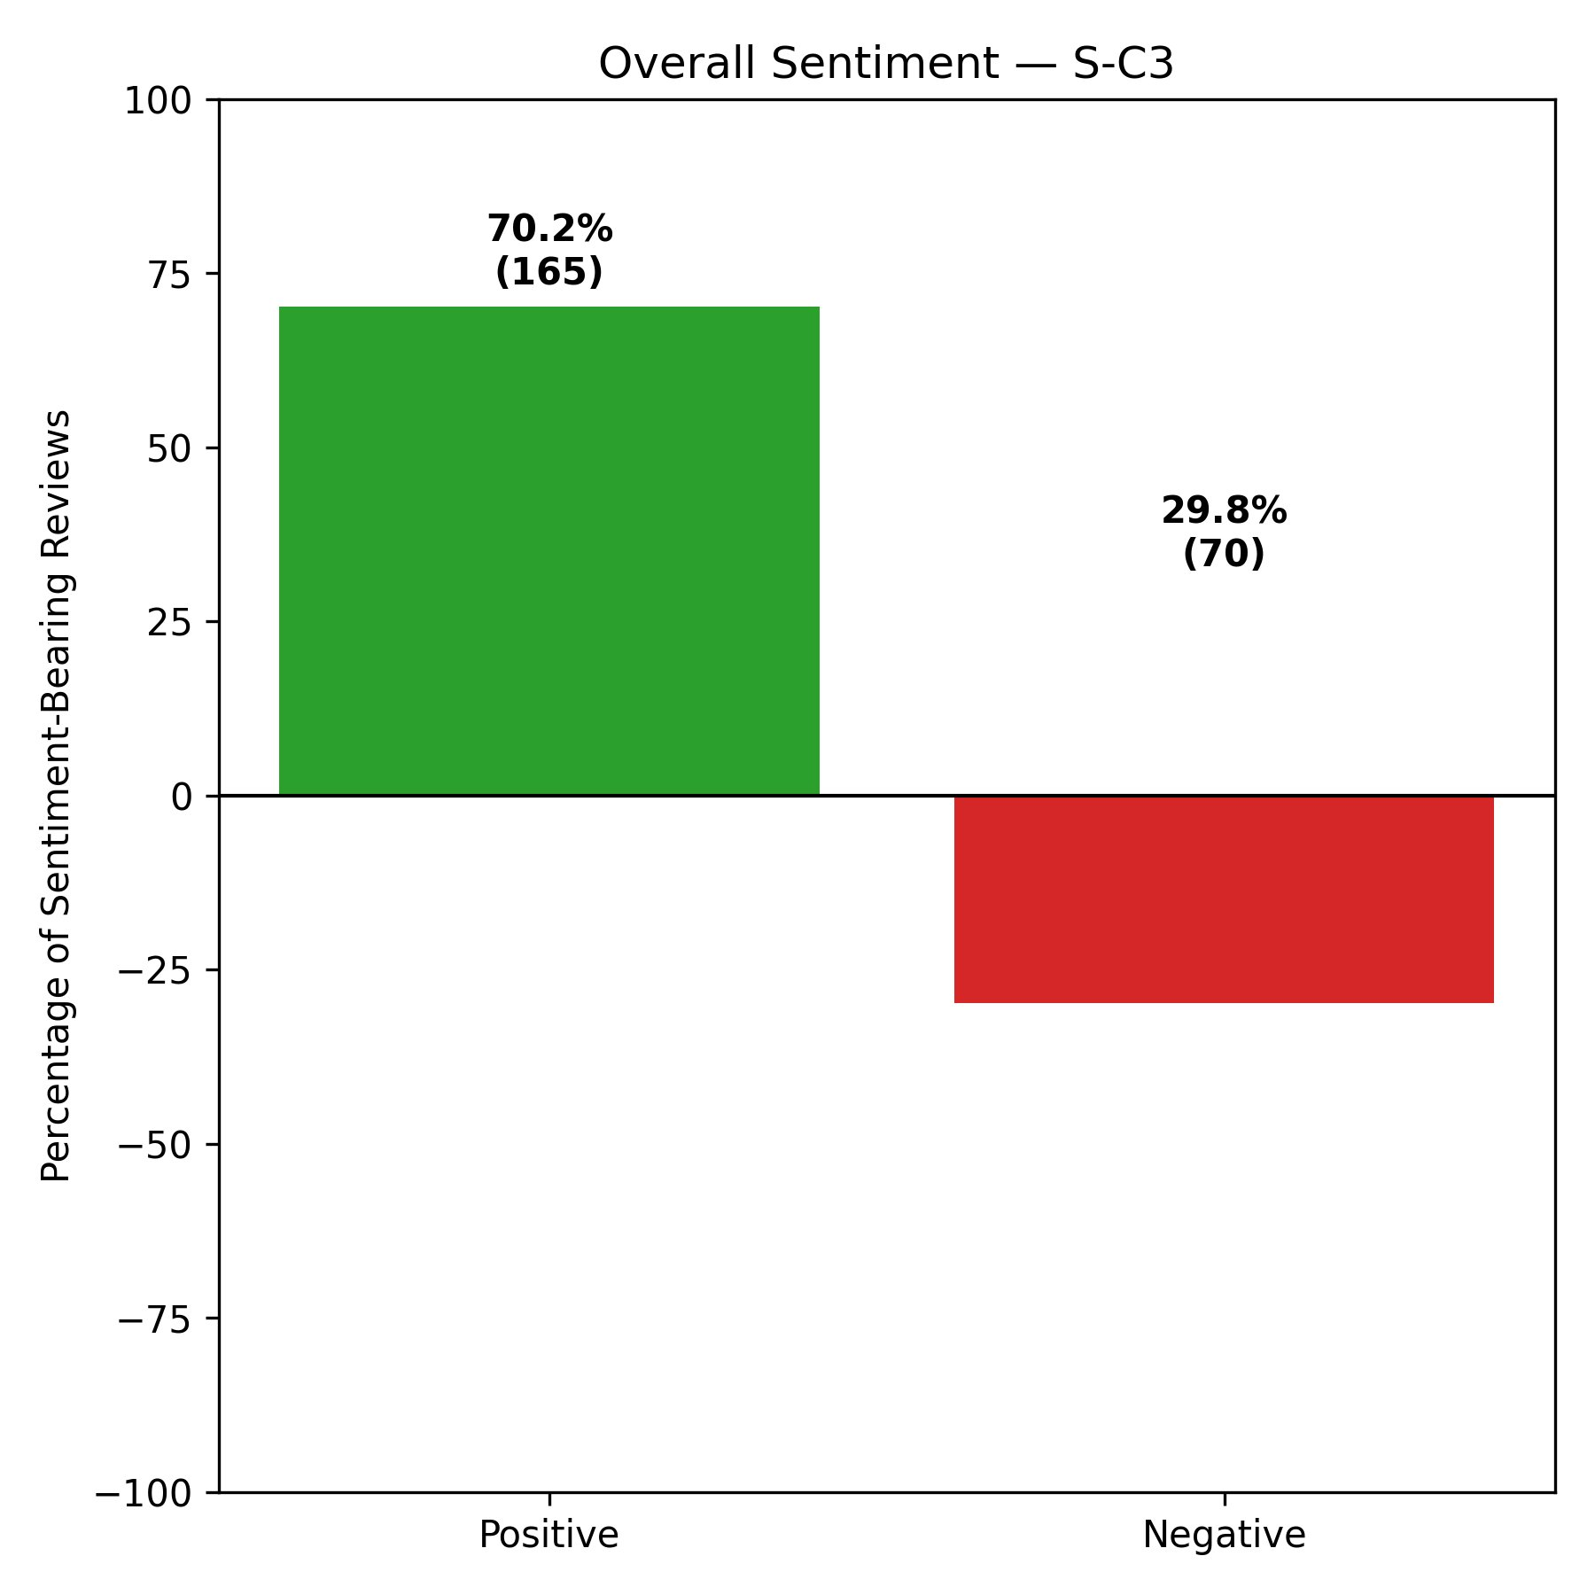
Across all six clusters, positive sentiment consistently exceeds negative sentiment, indicating that the majority of patients who leave sentiment-bearing reviews of hospital facilities on Yelp express a net positive experience. The highest positive sentiment is observed in S-C3 (Florida and Missouri) at 70.2%, followed by HG-C1 (Arizona, Florida, New Jersey, and Illinois) at 66.2%, and S-C2 (Arizona, Indiana, and New Jersey) at 65.6%. The lowest positive sentiment is found in S-C1 (Idaho, Illinois, Louisiana, Pennsylvania, and Tennessee) at 60.1% and HG-C2 (Idaho and Tennessee) at 60.6%, both of which also exhibit the highest negative sentiment proportions at 39.9% and 39.4% respectively. Notably, S-C3's strong positive sentiment is consistent with its dominant position in the LOVE quadrant of the Passion Index, discussed in Section 5.5.4, suggesting a coherent pattern of both high frequency and high intensity of positive patient expression in this cluster.

5.5.2 Attribute Net Score Analysis
The attribute net score analysis examined patient sentiment at a more granular level by isolating six healthcare-specific dimensions: Effectiveness, Wait Time, Staff, Cleanliness, Cost, and Communication. For each review, the presence of attribute-relevant keywords was detected using string matching — for example, Effectiveness was identified by terms such as effective, worked, improved, care, and treatment; Wait Time by wait, waiting, delay, and long; Staff by staff, doctor, nurse, rude, and kind; Cleanliness by clean, dirty, and hygiene; Cost by cost, bill, expensive, and insurance; and Communication by explain, communication, and informed. VADER's compound score was then applied to each matched review and classified as positive, negative, or neutral using the same thresholds as in the overall sentiment analysis. The Net Score for each attribute is computed as the percentage excess of positive over negative mentions among all sentiment-bearing matched reviews, expressed as ((positive − negative) / (positive + negative)) × 100. A positive net score indicates that patient mentions of that attribute are predominantly favourable, while a negative score indicates predominantly unfavourable mentions.
The net scores across all six attributes and all six clusters are presented in Table 12 and visualised in Figures 33 through 38.
Table 12: Attribute Net Scores (%) — All Clusters
Cluster | Effectiveness | Wait Time | Staff | Cleanliness | Cost | Communication
HG-C1 | 42.5% | 19.1% | 33.8% | 56.8% | -6.7% | 25.0%
HG-C2 | 25.9% | 5.9% | 29.9% | 28.6% | -29.4% | 23.1%
HG-C3 | 30.2% | 7.5% | 23.2% | 50.0% | -3.4% | 16.3%
S-C1 | 27.5% | 3.6% | 24.8% | 38.5% | -16.2% | 7.5%
S-C2 | 39.8% | 23.1% | 30.4% | 55.6% | 13.7% | 21.4%
S-C3 | 43.1% | 19.3% | 34.6% | 72.4% | -6.7% | 37.9%

Figure 33: Attribute Net Scores — HG-C1 (AZ, FL, NJ, IL)
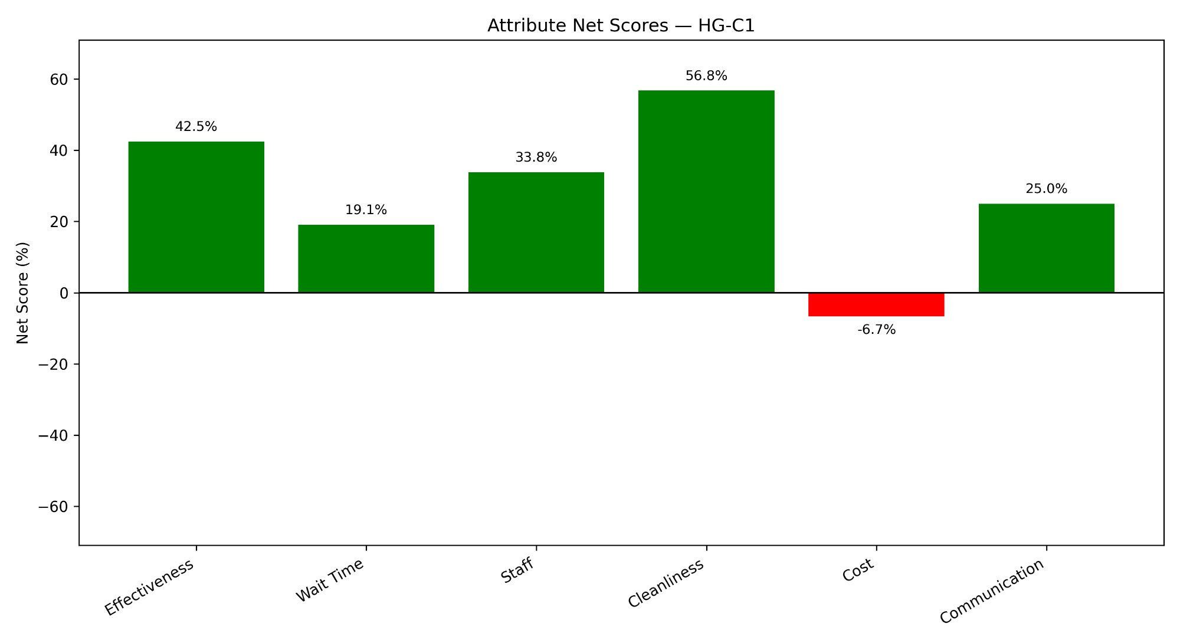
Figure 34: Attribute Net Scores — HG-C2 (ID, TN)
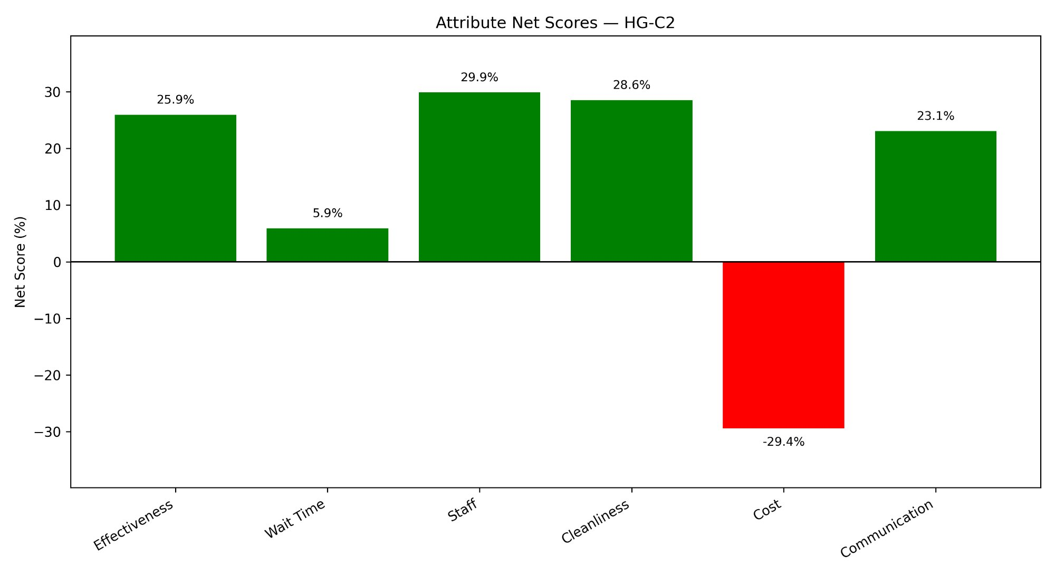
Figure 35: Attribute Net Scores — HG-C3 (IN, PA, MO, LA)
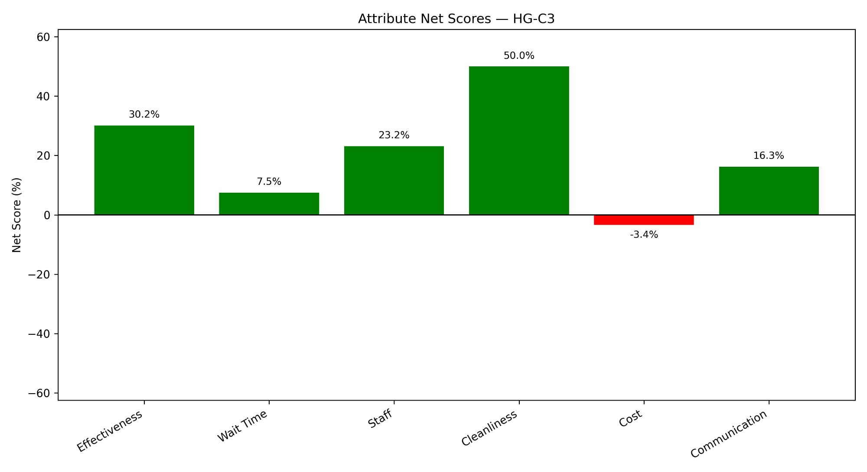
Figure 36: Attribute Net Scores — S-C1 (ID, IL, LA, PA, TN)
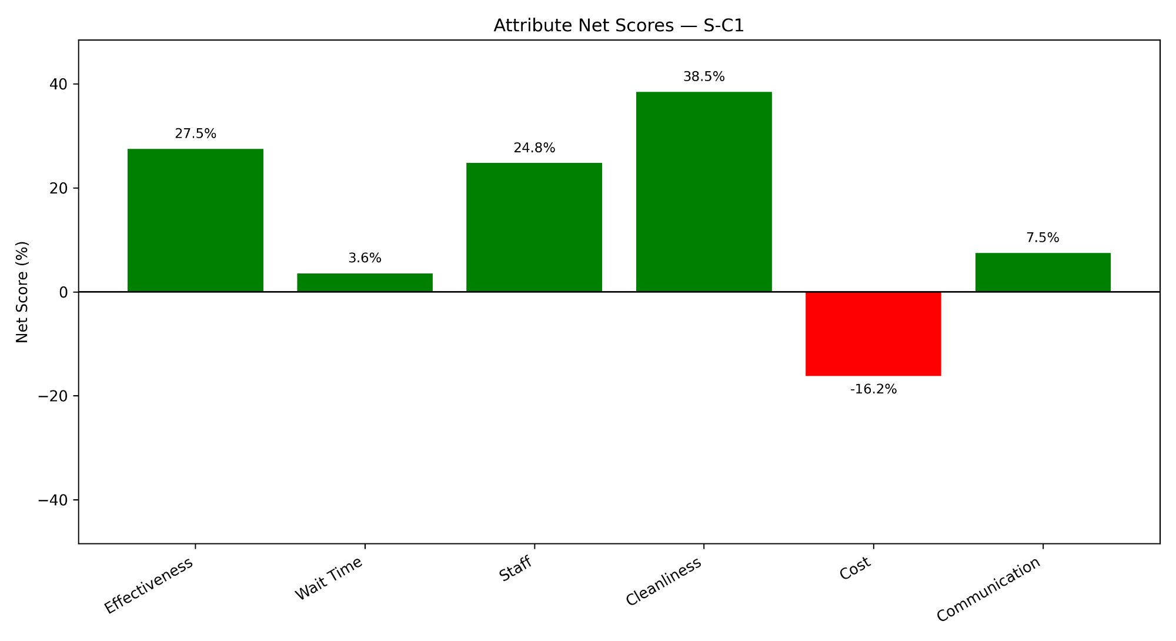
Figure 37: Attribute Net Scores — S-C2 (AZ, IN, NJ)
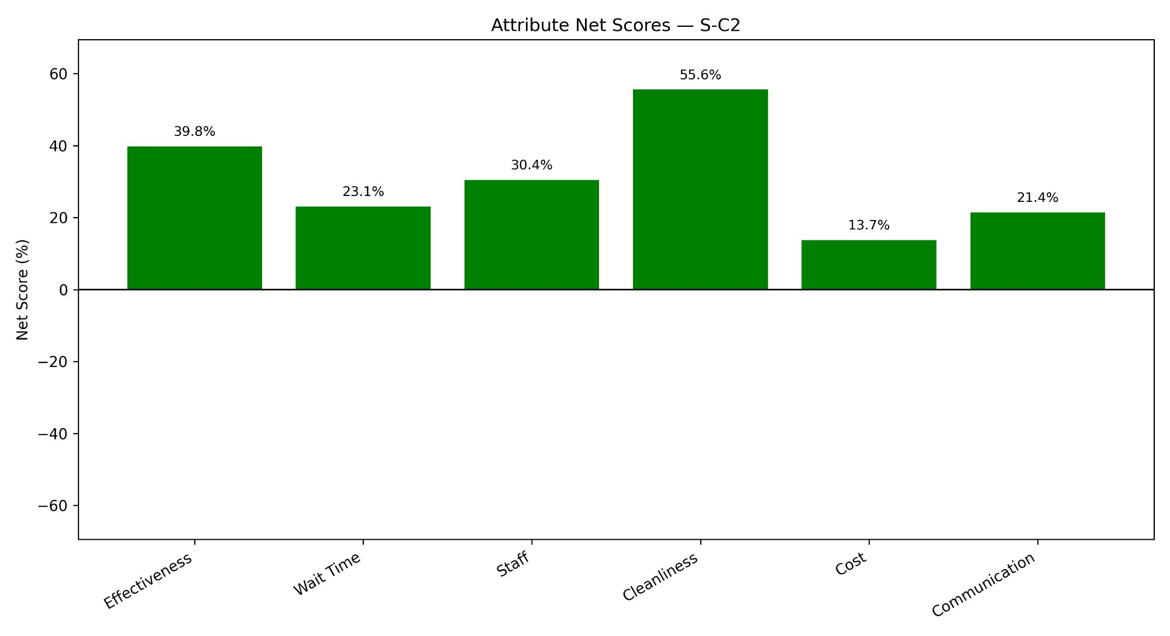
Figure 38: Attribute Net Scores — S-C3 (FL, MO)
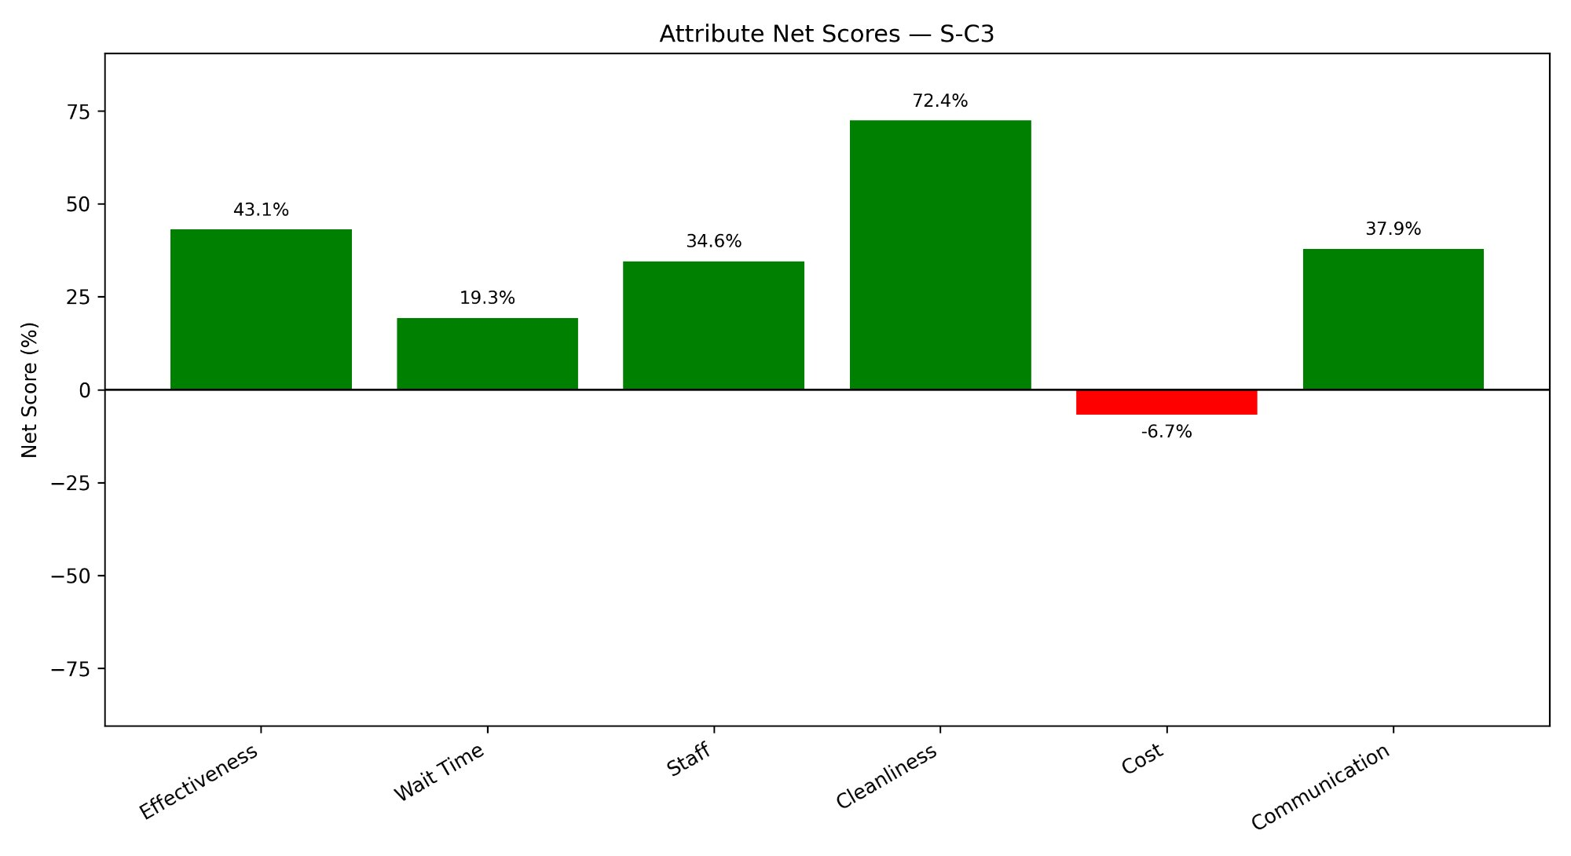
Two consistent patterns emerge across all six clusters. First, Cleanliness consistently records the highest positive net score of all attributes — ranging from 28.6% in HG-C2 to 72.4% in S-C3 — indicating that patients across all state groupings tend to mention cleanliness in a predominantly positive context. S-C3 stands out as exceptional in this regard, with a Cleanliness net score nearly 17 percentage points higher than any other cluster. S-C2 also records strong Cleanliness and Effectiveness scores at 55.6% and 39.8% respectively, consistent with its overall higher positive sentiment profile. Second, Cost is the only attribute that returns a negative net score in five of the six clusters, indicating that when patients mention financial aspects of their hospital experience, the sentiment is more often unfavourable than favourable. The most pronounced negative Cost score is observed in HG-C2 (Idaho and Tennessee) at -29.4%, more than four times the magnitude of the next most negative cluster. S-C2 is the sole exception, recording a positive Cost net score of 13.7%, suggesting that patients in Arizona, Indiana, and New Jersey perceive the cost of care in a relatively more favourable light compared to other clusters.

5.5.3 Emotion Analysis
The emotion analysis was conducted using NRCLex, a Python library built on the NRC Word-Emotion Association Lexicon (also known as the EmoLex) developed by Saif Mohammad and Peter Turney. The NRC Lexicon is a crowd-sourced lexicon of over 14,000 English words, each annotated for association with one or more of eight primary emotions — anger, anticipation, disgust, fear, joy, sadness, surprise, and trust — as well as binary positive and negative sentiment. NRCLex processes each review by tokenising the text and looking up each token in the NRC Lexicon, accumulating raw counts for each of the eight emotions across all reviews in a cluster. The library provides direct access to raw emotion scores through its raw_emotion_scores attribute, which returns a dictionary of emotion-to-count mappings for each processed text.
For each cluster, two plots were generated: a bar chart of absolute emotion counts reflecting the total volume of emotion-bearing words across all reviews, and a sorted horizontal bar chart of emotion proportions — the share of each emotion as a percentage of the total emotion word count — which normalises the emotion profile to allow comparison across clusters of different sizes. The emotion count charts are presented in Figures 39 through 44, and the emotion distribution percentage charts in Figures 45 through 50.
Figure 39: Emotion Counts — HG-C1 (AZ, FL, NJ, IL)
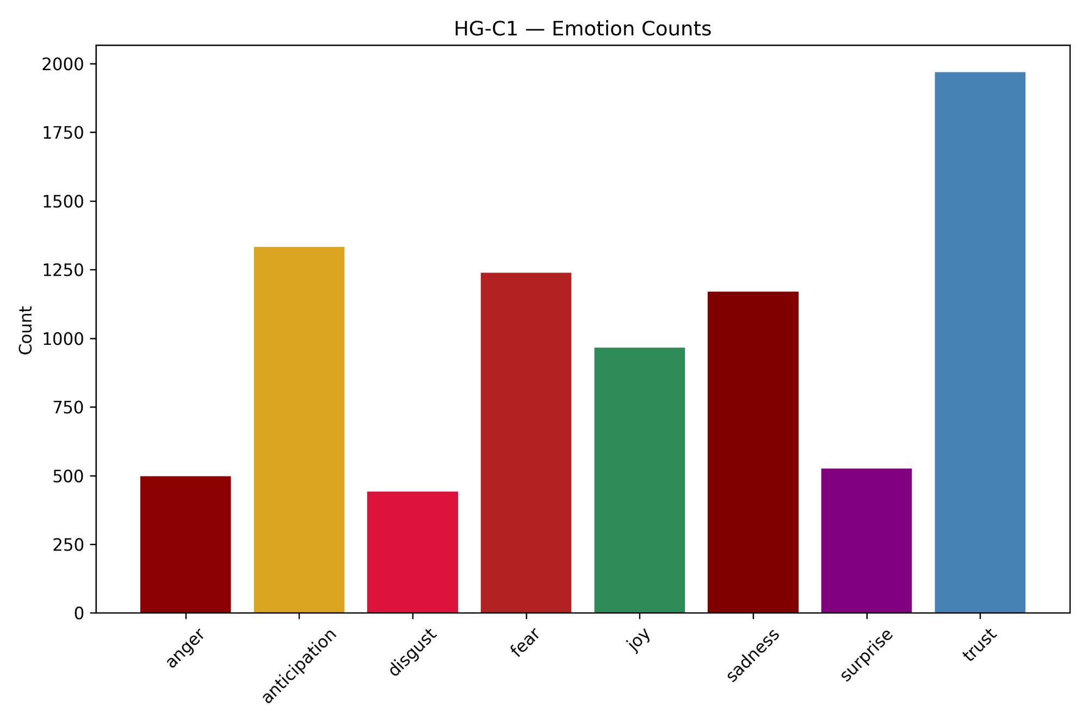
Figure 40: Emotion Counts — HG-C2 (ID, TN)
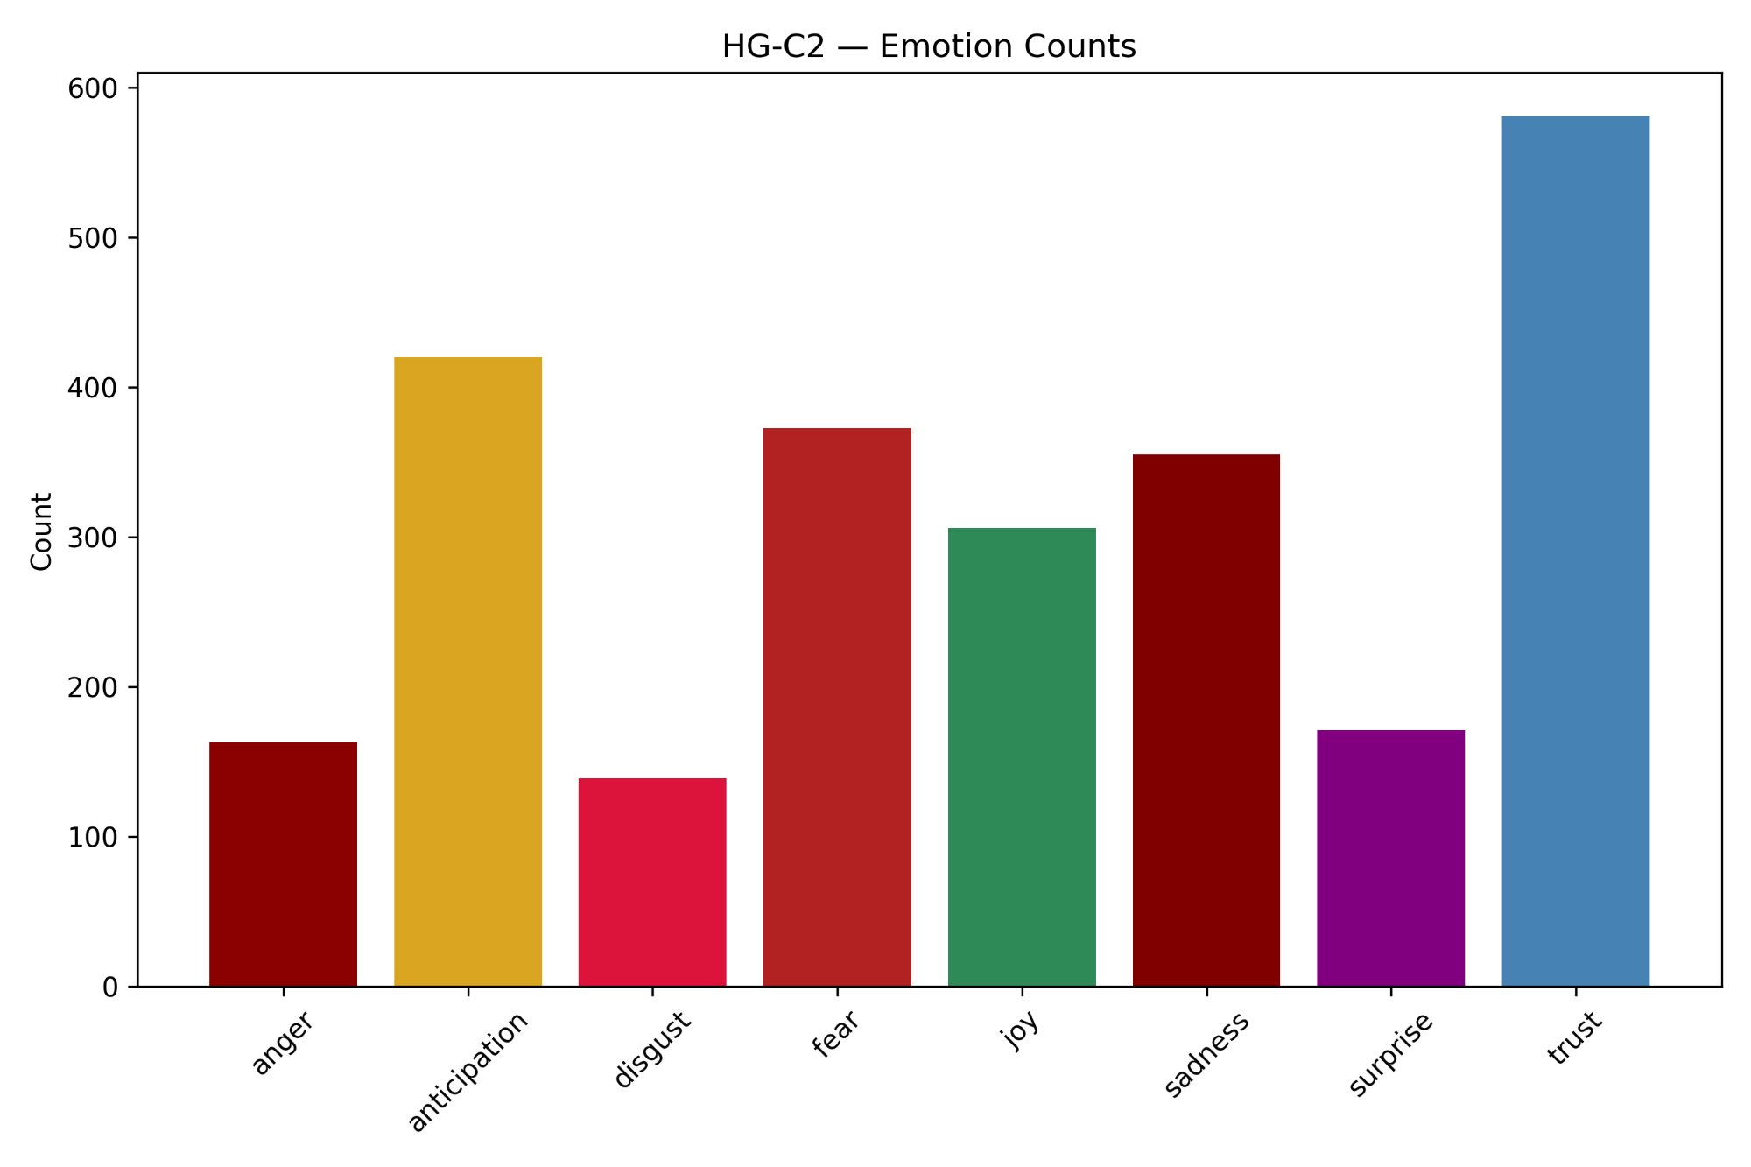
Figure 41: Emotion Counts — HG-C3 (IN, PA, MO, LA)
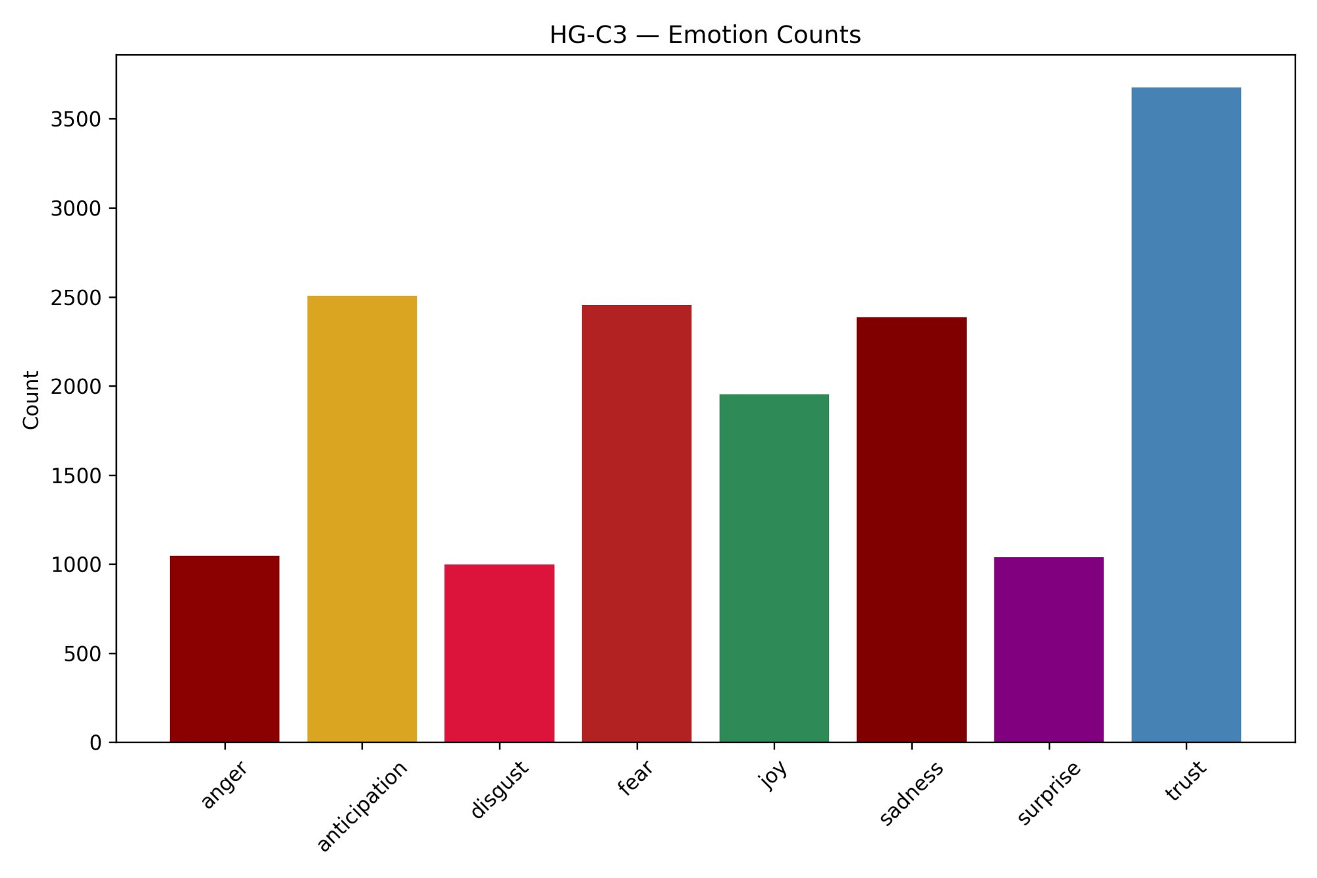
Figure 42: Emotion Counts — S-C1 (ID, IL, LA, PA, TN)
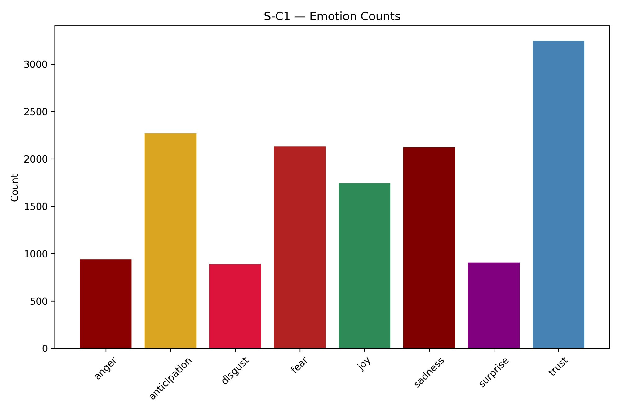
Figure 43: Emotion Counts — S-C2 (AZ, IN, NJ)
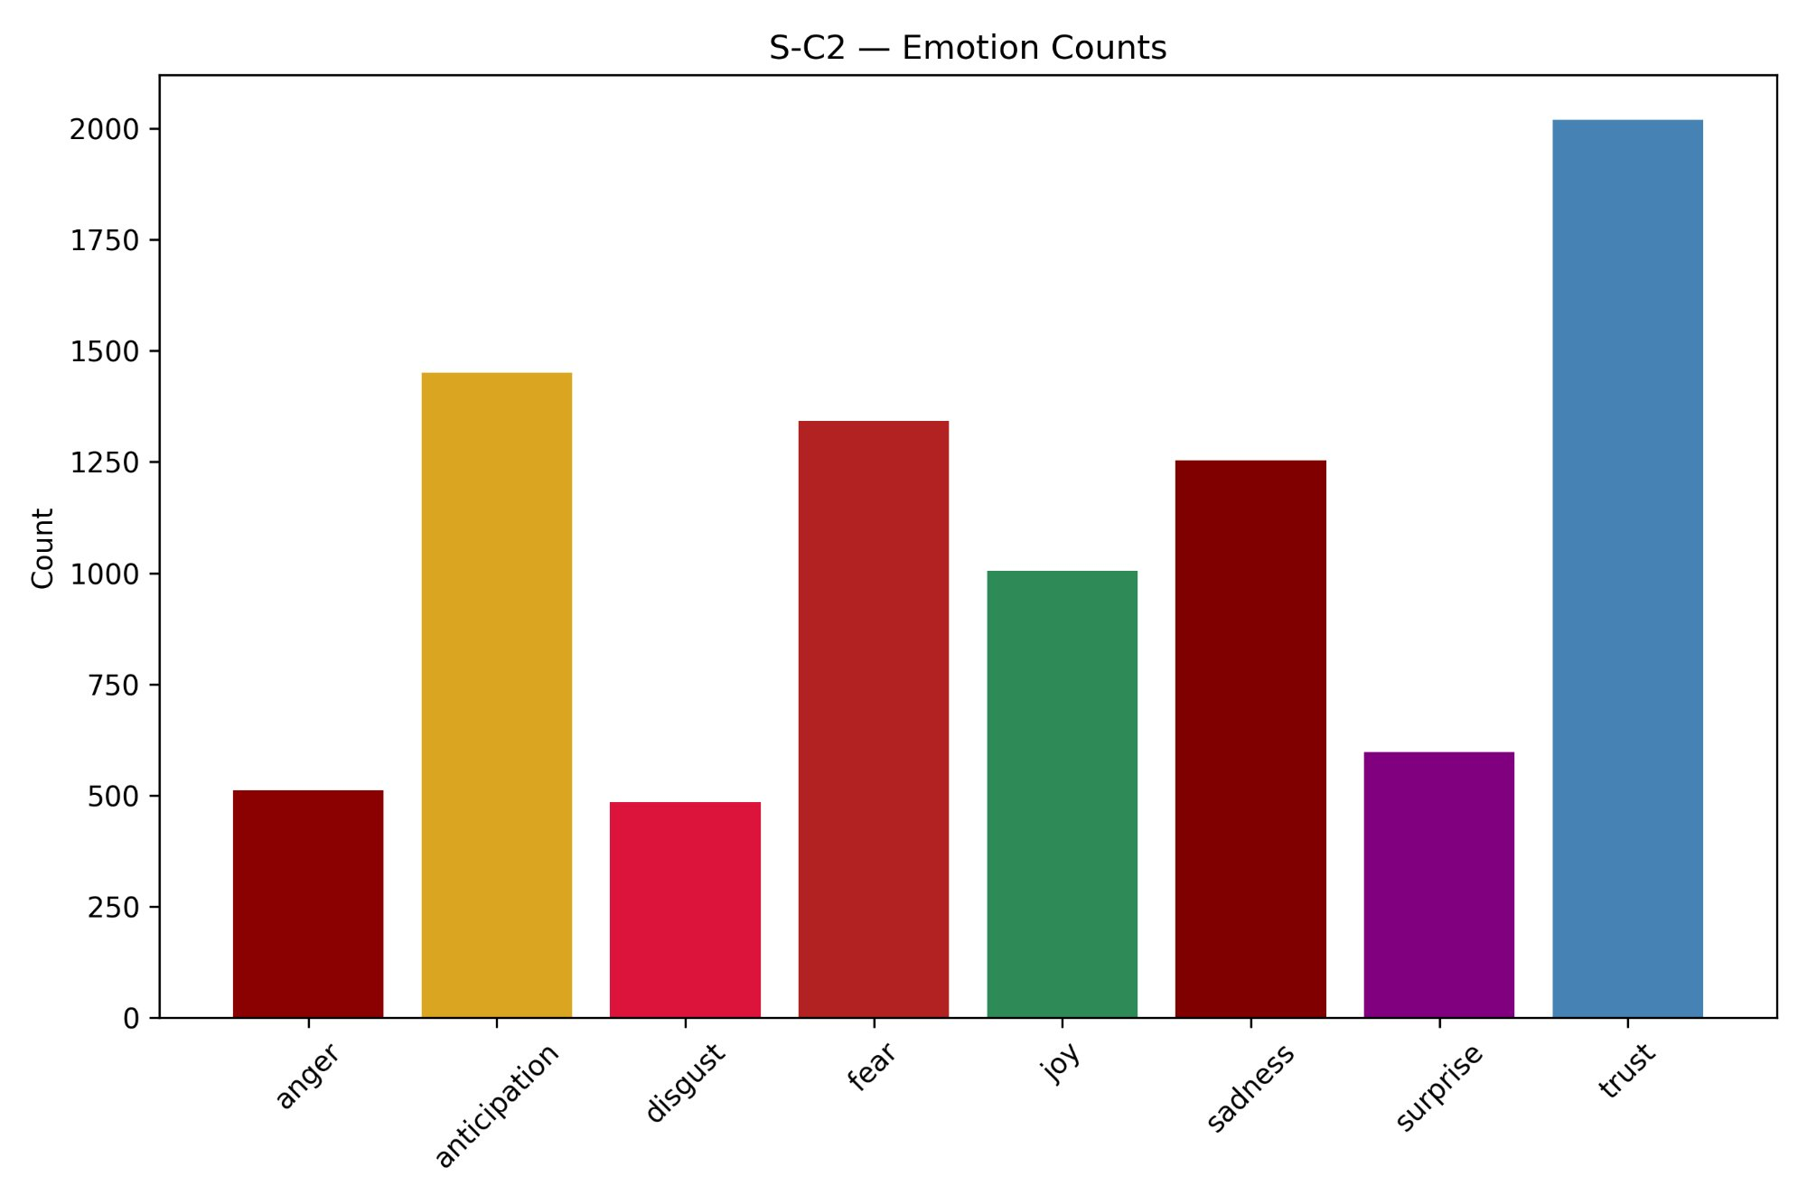
Figure 44: Emotion Counts — S-C3 (FL, MO)
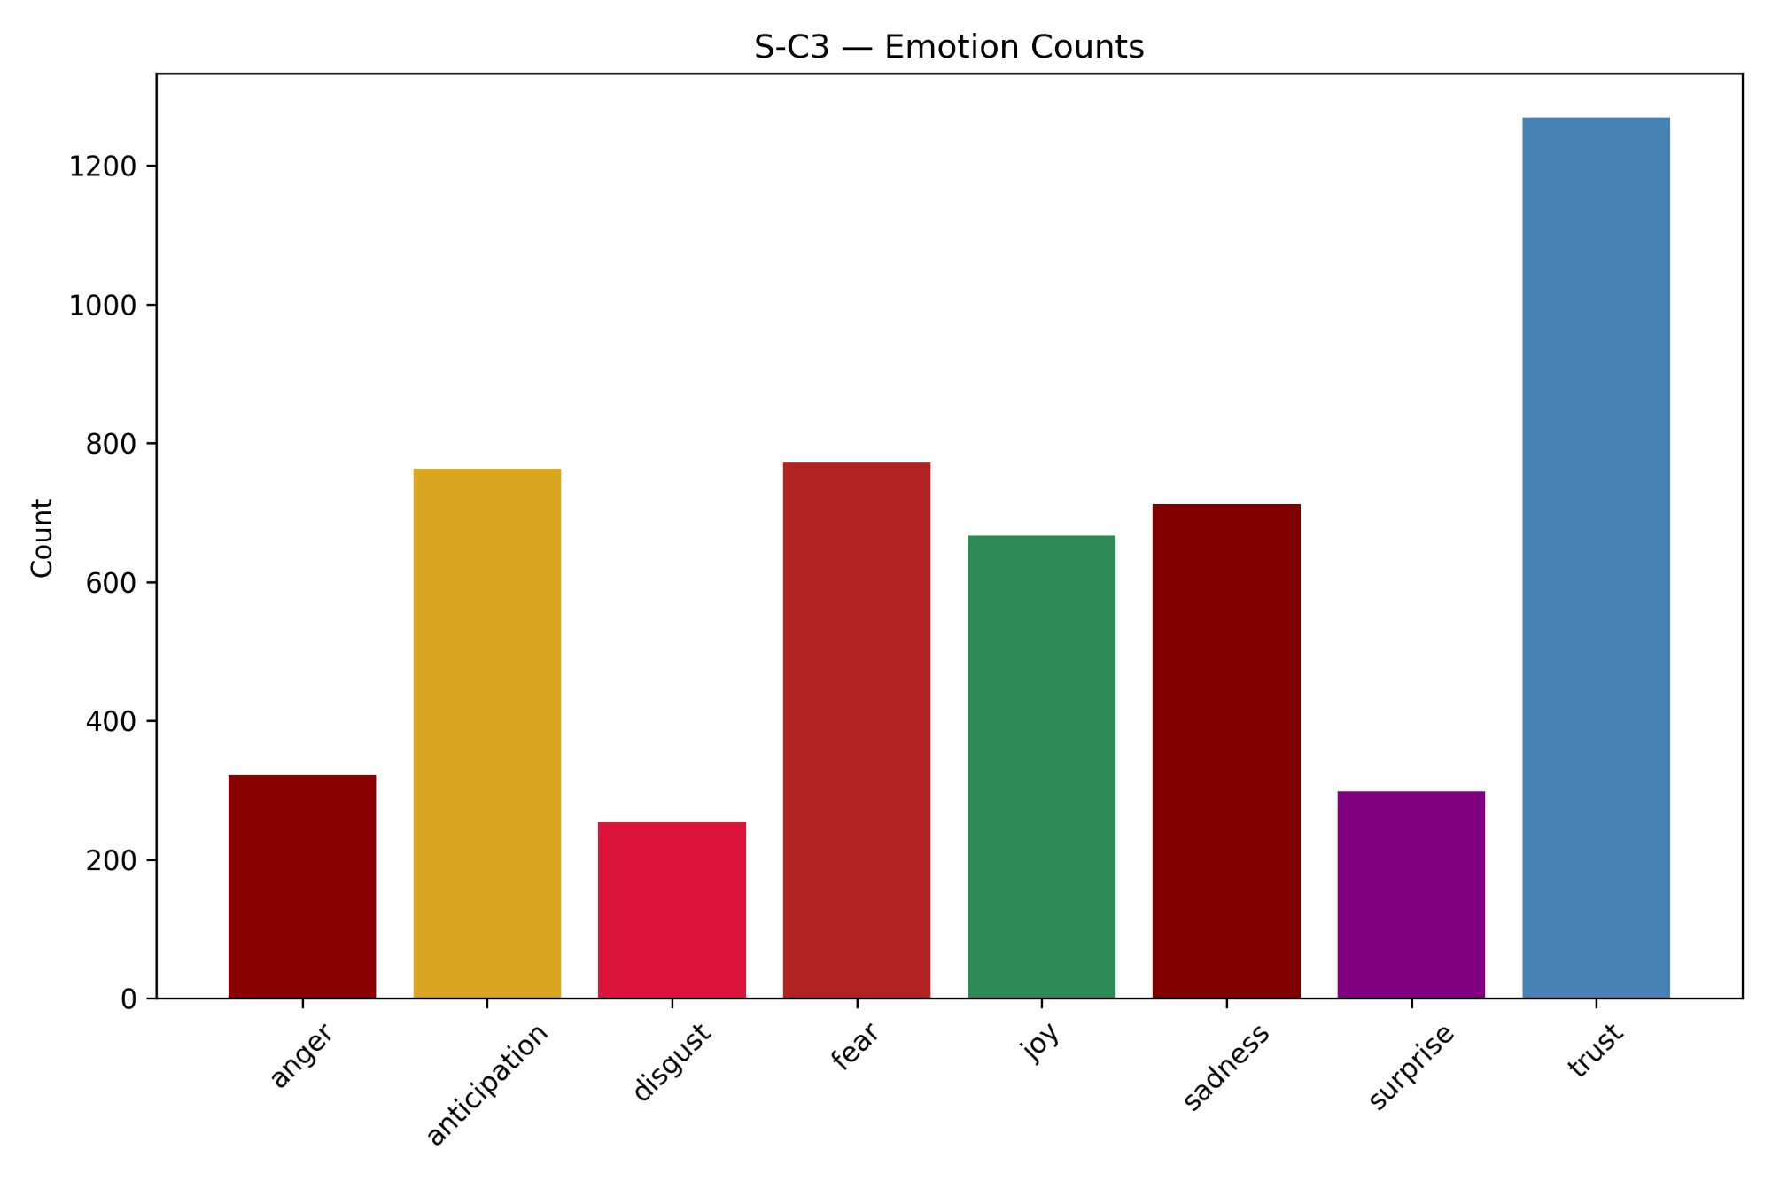
Figure 45: Emotion Distribution — HG-C1 (AZ, FL, NJ, IL)
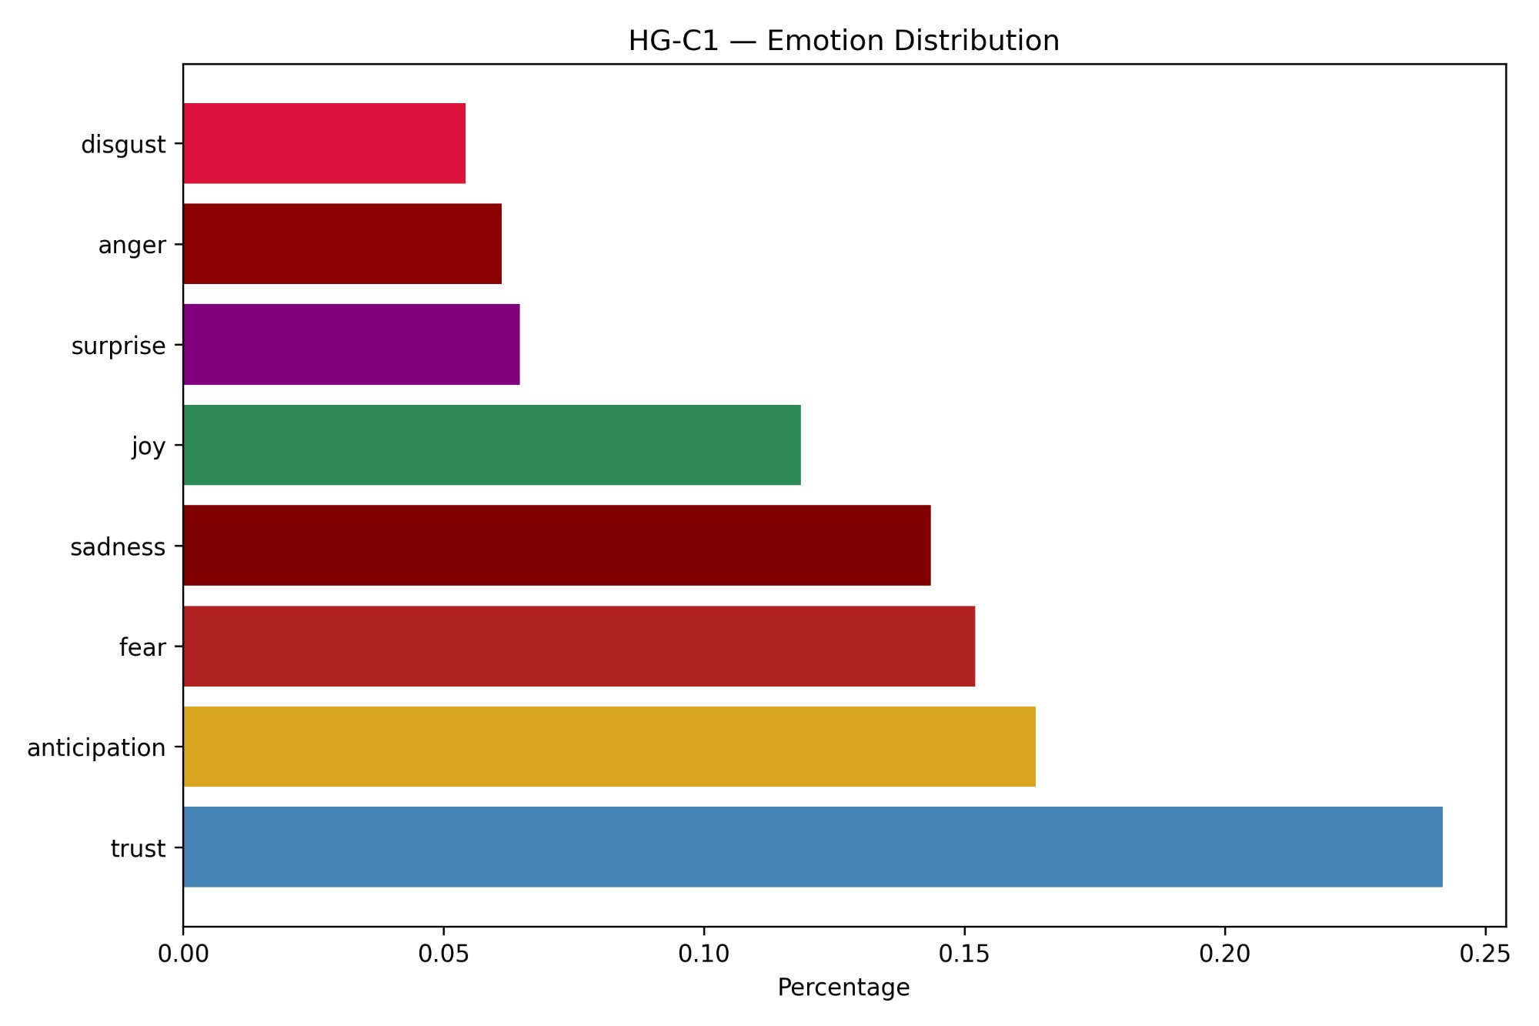
Figure 46: Emotion Distribution — HG-C2 (ID, TN)
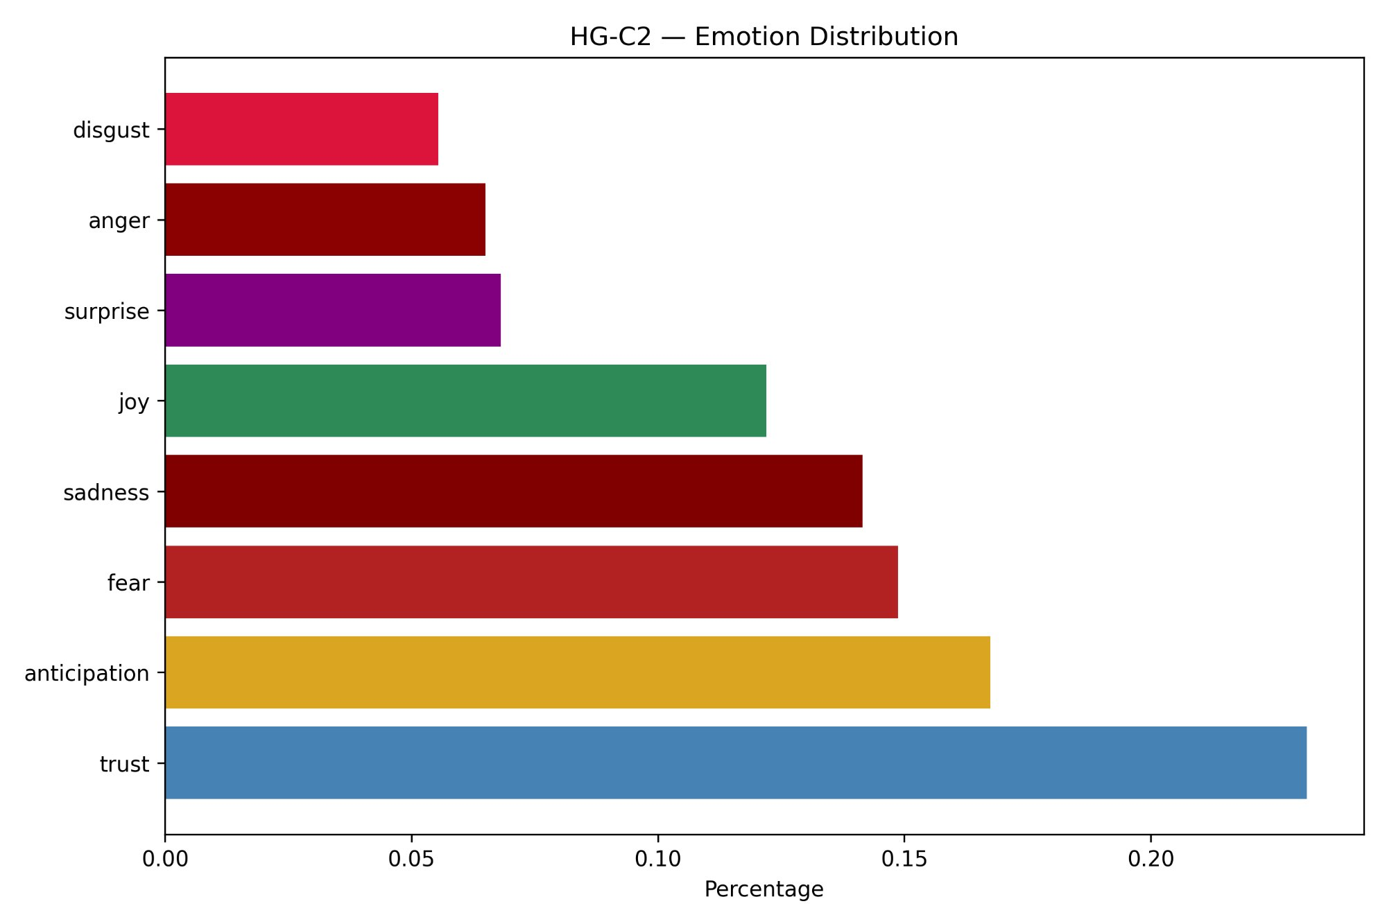
Figure 47: Emotion Distribution — HG-C3 (IN, PA, MO, LA)
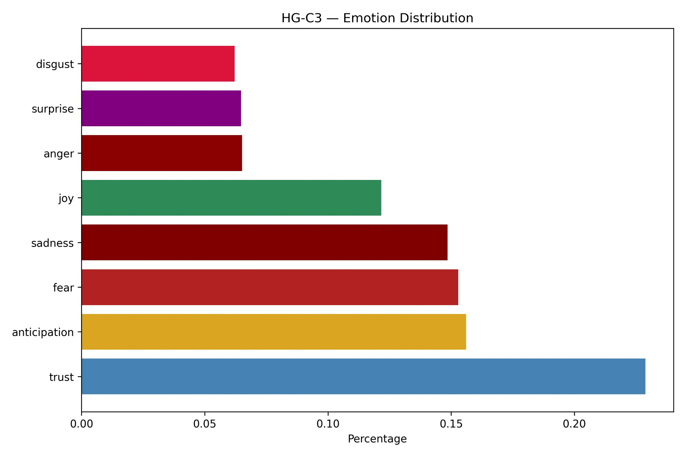
Figure 48: Emotion Distribution — S-C1 (ID, IL, LA, PA, TN)
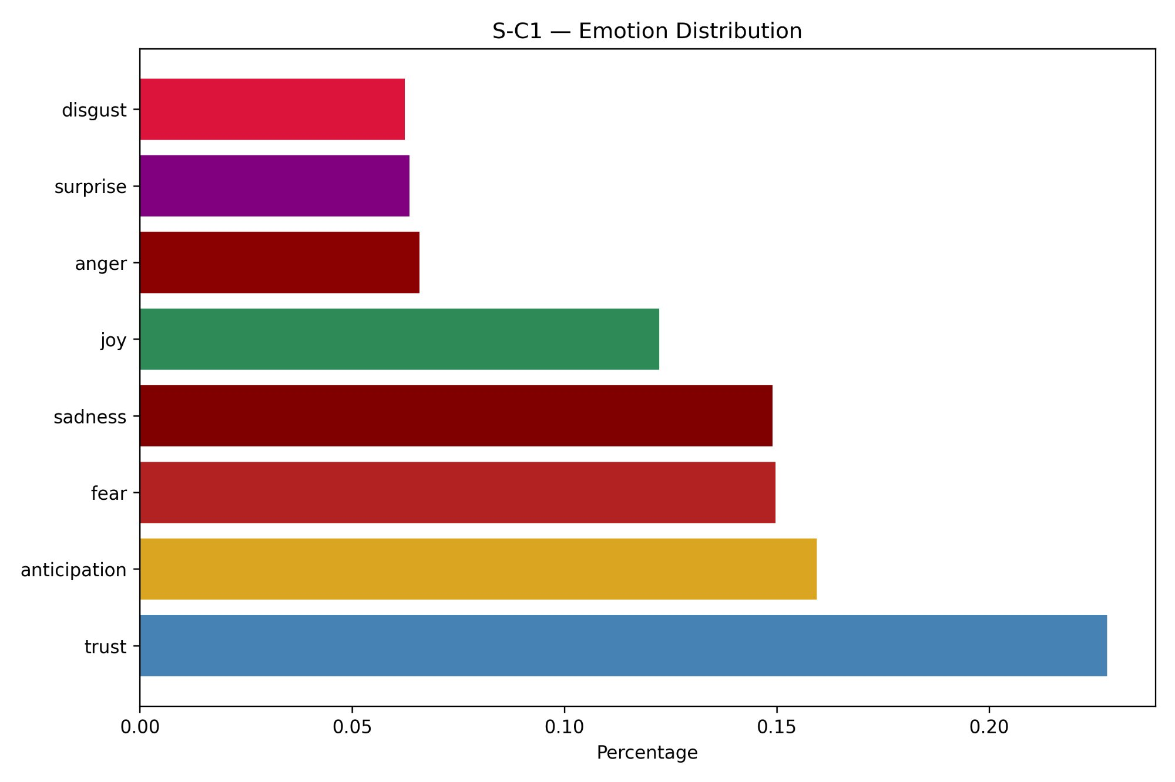
Figure 49: Emotion Distribution — S-C2 (AZ, IN, NJ)
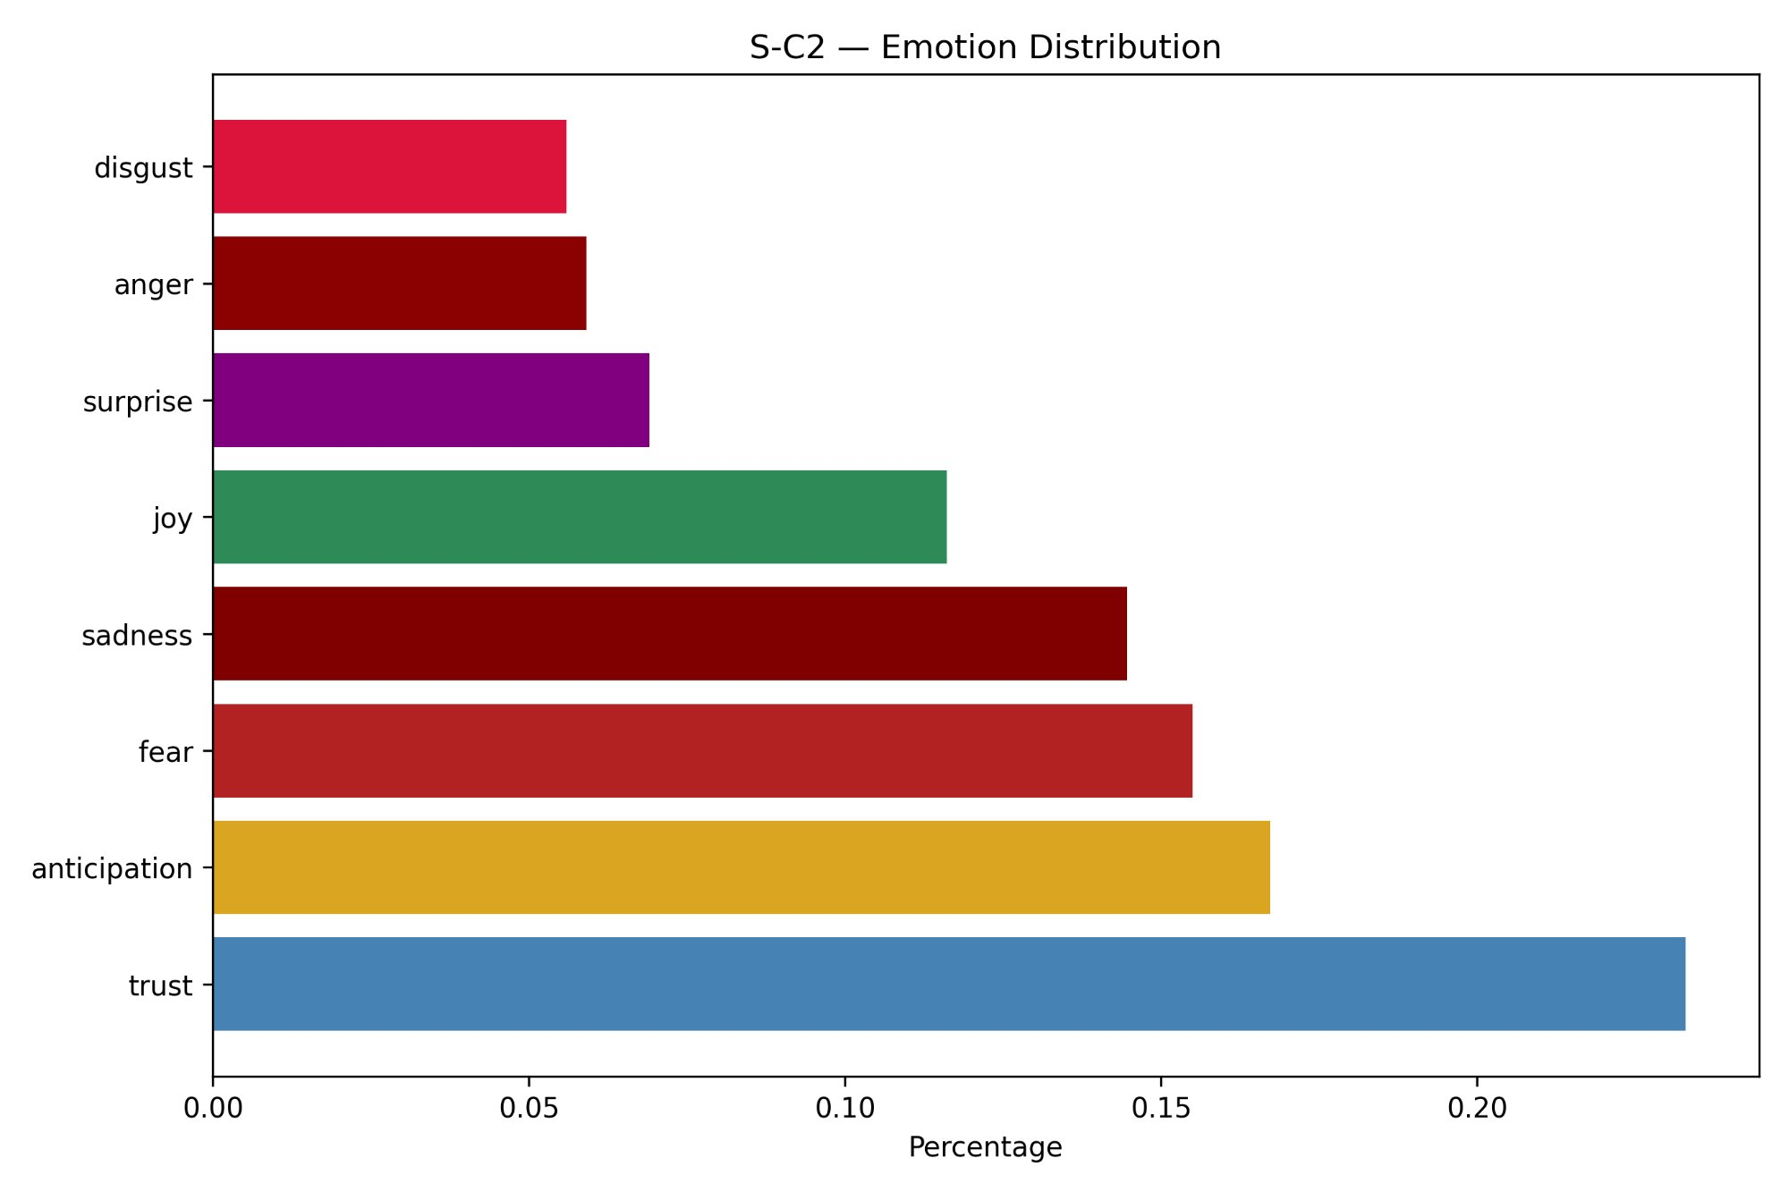
Figure 50: Emotion Distribution — S-C3 (FL, MO)
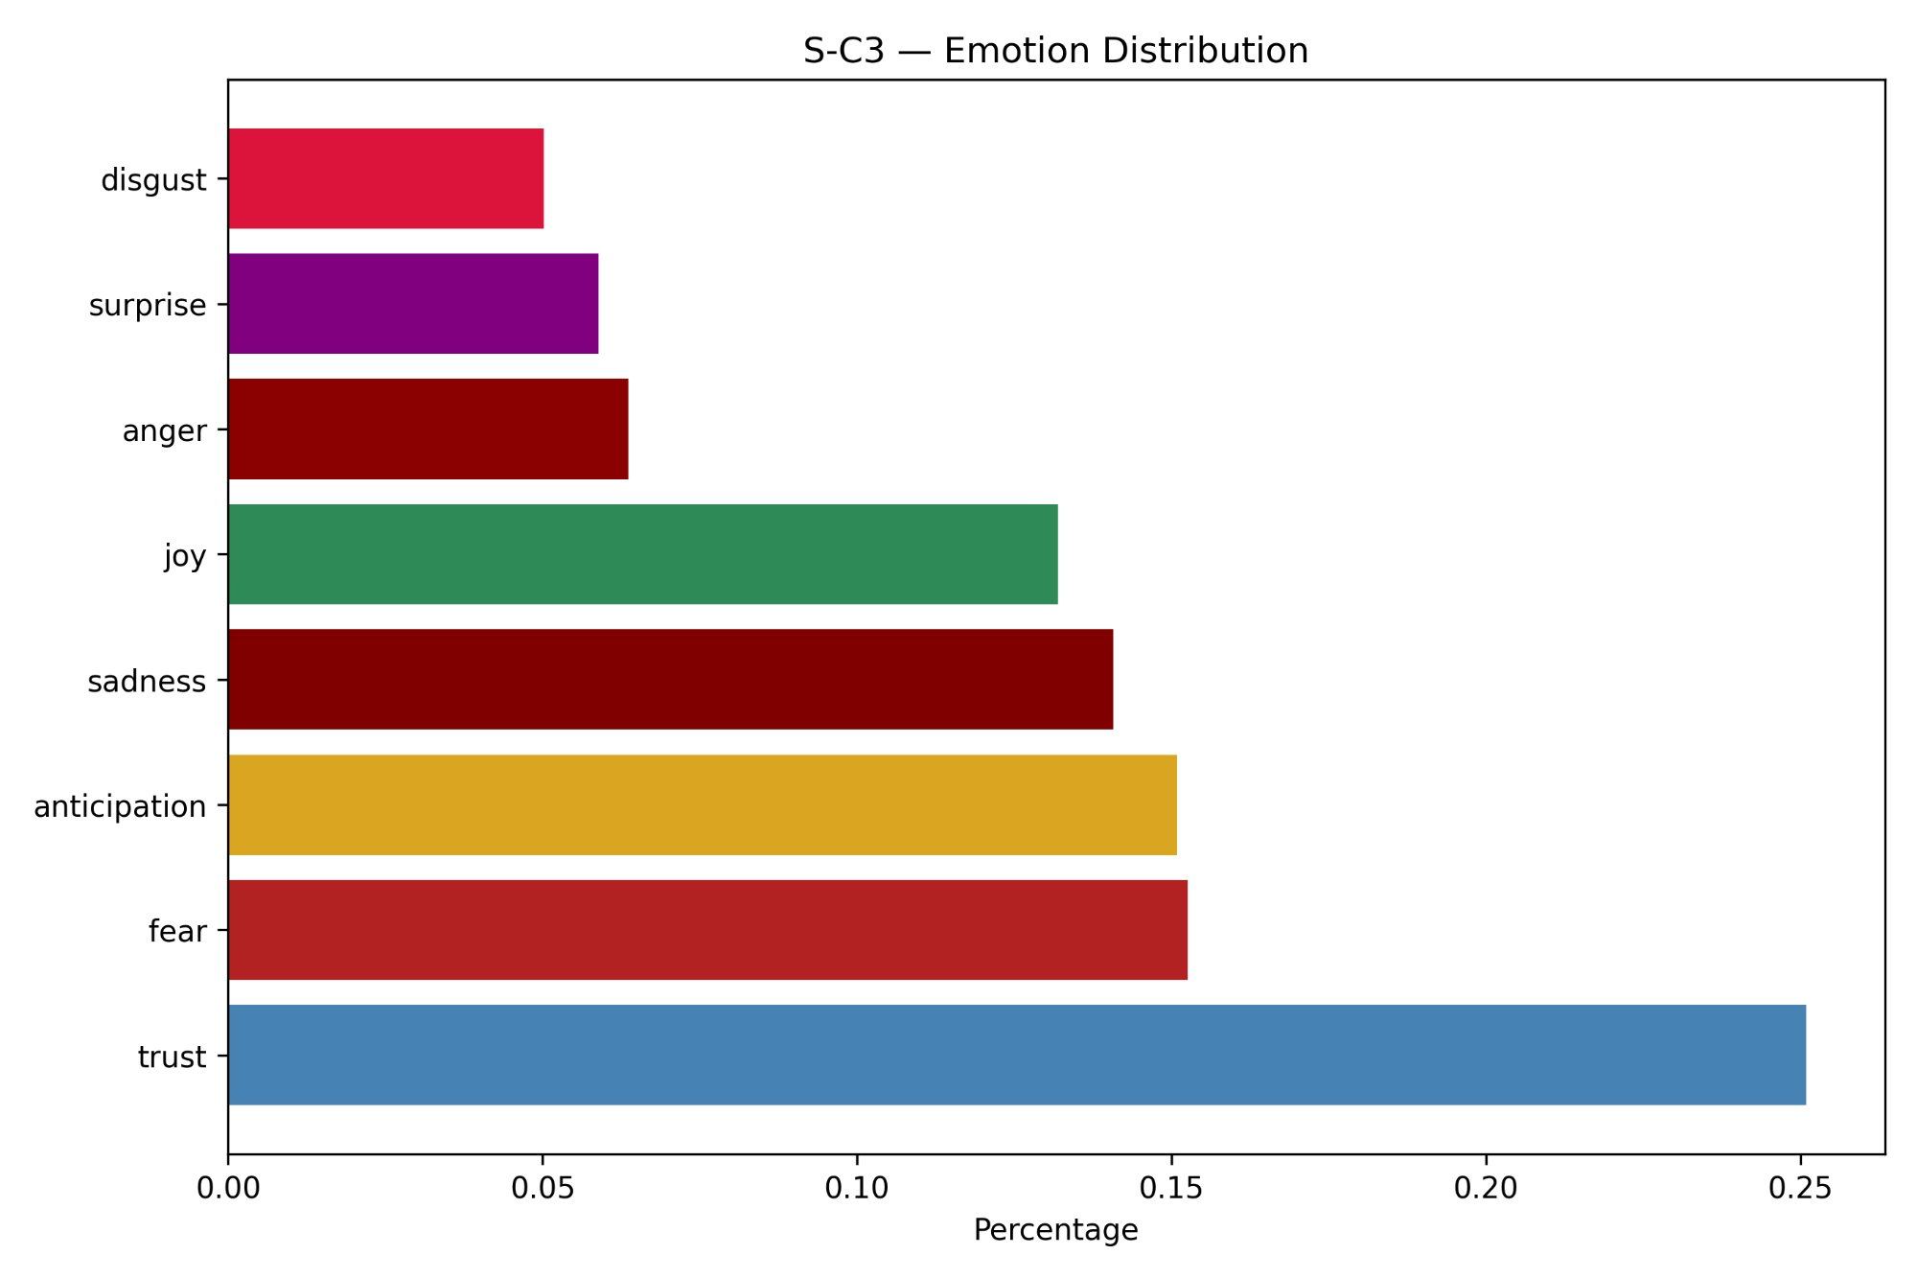
The emotion distribution is remarkably consistent across all six clusters. In every cluster, trust is the dominant emotion, accounting for approximately 23% to 25% of the total emotion word count, followed by anticipation at approximately 16% to 17%, and fear and sadness each at approximately 14% to 15%. Joy accounts for approximately 12% across all clusters, while anger, surprise, and disgust each constitute approximately 5% to 7%. The ordering of emotions from most to least prevalent is virtually identical across all six clusters, with only marginal variation in their relative proportions.
S-C3 (Florida and Missouri) exhibits the highest trust proportion at approximately 25% and the lowest disgust proportion at approximately 5%, making it the emotionally most positive cluster by relative composition. This is consistent with S-C3's position as the highest overall sentiment cluster (70.2% positive) and its LOVE quadrant placement in the Passion Index. Conversely, the presence of fear and sadness at consistently high proportions across all clusters — collectively accounting for approximately 29% to 30% of all emotion words — reflects the inherent emotional gravity of healthcare experiences, where patients frequently express anxiety, concern, and vulnerability regardless of whether their overall review sentiment is positive or negative. This finding is important: it demonstrates that even predominantly positive healthcare reviews contain substantial fear and sadness content, which is consistent with the context of illness, treatment, and uncertainty that characterises hospital experiences.

5.5.4 Passion Index
The Passion Index is a two-dimensional analytical framework that simultaneously characterises both the direction and the intensity of patient sentiment at the cluster level. The framework plots each cluster on a bubble chart using two metrics derived from VADER compound scores: the mean compound score across all reviews in a cluster, representing average sentiment polarity and plotted on the Y-axis; and the mean of the absolute values of the compound scores, representing average sentiment intensity regardless of direction, plotted on the X-axis. The bubble size for each cluster is scaled proportionally to the square root of the total review count, reflecting the relative volume of reviews contributing to each cluster's sentiment position.
The chart is divided into four quadrants by two crosshair lines. Consistent with the importance-performance analysis methodology employed in healthcare quality research, the crosshair lines in this study were positioned at the mean values of the plotted cluster metrics rather than at fixed midpoints of the axis range. This mean-based crosshair placement was adopted following the approach described by Carse et al. (2021), who applied a data-centred diagonal line model in which the mean scores of the measured variables were used as the cross-point for quadrant division, as this approach more accurately reflects the distribution of the actual data rather than an arbitrary scale midpoint. The four quadrants are labelled LIKE (high polarity, low intensity), LOVE (high polarity, high intensity), DISLIKE (low polarity, low intensity), and HATE (low polarity, high intensity).
Figure 51: Passion Index — Cluster-wise Sentiment Positioning (Mean-Based Crosshairs)
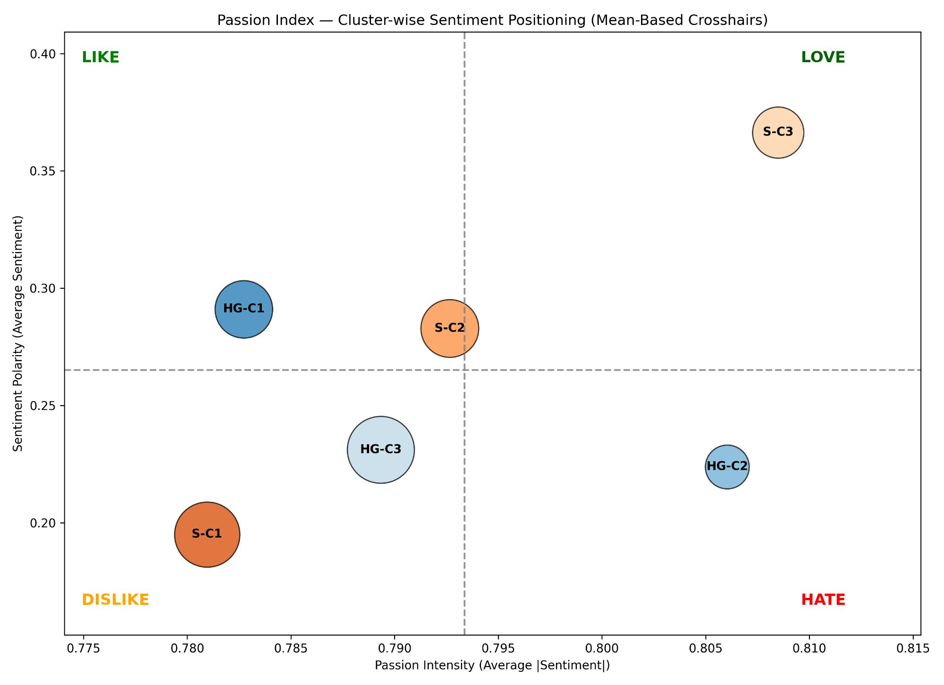
The Passion Index plot reveals meaningful differentiation across the six clusters. S-C3 (Florida and Missouri) occupies the LOVE quadrant, exhibiting both the highest polarity (approximately 0.37) and above-average intensity (approximately 0.808), indicating that patients in this cluster not only express predominantly positive sentiment but do so with notable emotional strength. This is the most desirable quadrant position and is consistent with S-C3's leading performance across all other text mining dimensions, including the highest overall positive sentiment at 70.2%, the highest Cleanliness net score at 72.4%, and the highest trust proportion in the emotion analysis.
HG-C1 (Arizona, Florida, New Jersey, and Illinois) and S-C2 (Arizona, Indiana, and New Jersey) both fall in the LIKE quadrant or on its boundary with LOVE, indicating positive sentiment that is somewhat less intense. S-C2 sits almost precisely on the mean crosshair, occupying the central position across all clusters, while HG-C1 shows good polarity with lower intensity, suggesting that positive reviews in this cluster are somewhat more measured in their expression. HG-C3 (Indiana, Pennsylvania, Missouri, and Louisiana) falls in the DISLIKE quadrant, with below-average polarity and below-average intensity, reflecting a more muted and mixed patient sentiment profile. S-C1 (Idaho, Illinois, Louisiana, Pennsylvania, and Tennessee) also occupies the DISLIKE quadrant with the lowest polarity of all clusters, consistent with its lowest overall positive sentiment percentage at 60.1%. HG-C2 (Idaho and Tennessee) occupies the HATE quadrant, characterised by below-average polarity but above-average intensity — meaning that reviews in this cluster, while more often negative in direction, are expressed with relatively strong emotional force, which is consistent with HG-C2's pronounced negative Cost net score of -29.4% observed in the attribute analysis.

5.5.5 Word Association Networks
The word association network analysis examined which words co-occur within the same review across each cluster's corpus, providing a visual representation of the thematic connections that patients draw between concepts when writing about their hospital experiences. The analysis was performed using three Python libraries working in combination: spaCy, NetworkX, and Matplotlib.
spaCy is an industrial-strength natural language processing library that provides pre-trained statistical language models for English. In this analysis, spaCy's en_core_web_sm model was used to process each review through a full NLP pipeline, performing tokenisation, part-of-speech tagging, lemmatisation, and named entity recognition. Only tokens classified as nouns, adjectives, or verbs were retained, as these carry the primary semantic content of reviews. Stop words, punctuation, and named entities (such as proper nouns identifying specific locations or people) were excluded to ensure the vocabulary reflects thematic content rather than incidental references. Each token was reduced to its lemma — the base dictionary form — to consolidate morphological variants such as waited and waiting into a single form.
NetworkX is a Python library for the creation, analysis, and visualisation of complex networks and graphs. In this analysis, it was used to construct an undirected weighted graph where each node represents a word that appears with sufficient frequency across the cluster's reviews (minimum frequency threshold of ten occurrences), and each edge connecting two nodes represents a co-occurrence relationship. The edge weight is the co-occurrence association score, computed as the number of reviews in which both words appear together divided by the total number of reviews in the cluster, normalising for cluster size. Only the top thirty edges by association score were retained for visualisation, ensuring the network captures the most meaningful and frequent thematic connections without becoming visually cluttered. The spring layout algorithm was used to position nodes, which places highly connected nodes closer to the centre of the network.
The word association networks for all six clusters are presented in Figures 52 through 57.
Figure 52: Word Association Network — HG-C1 (AZ, FL, NJ, IL)
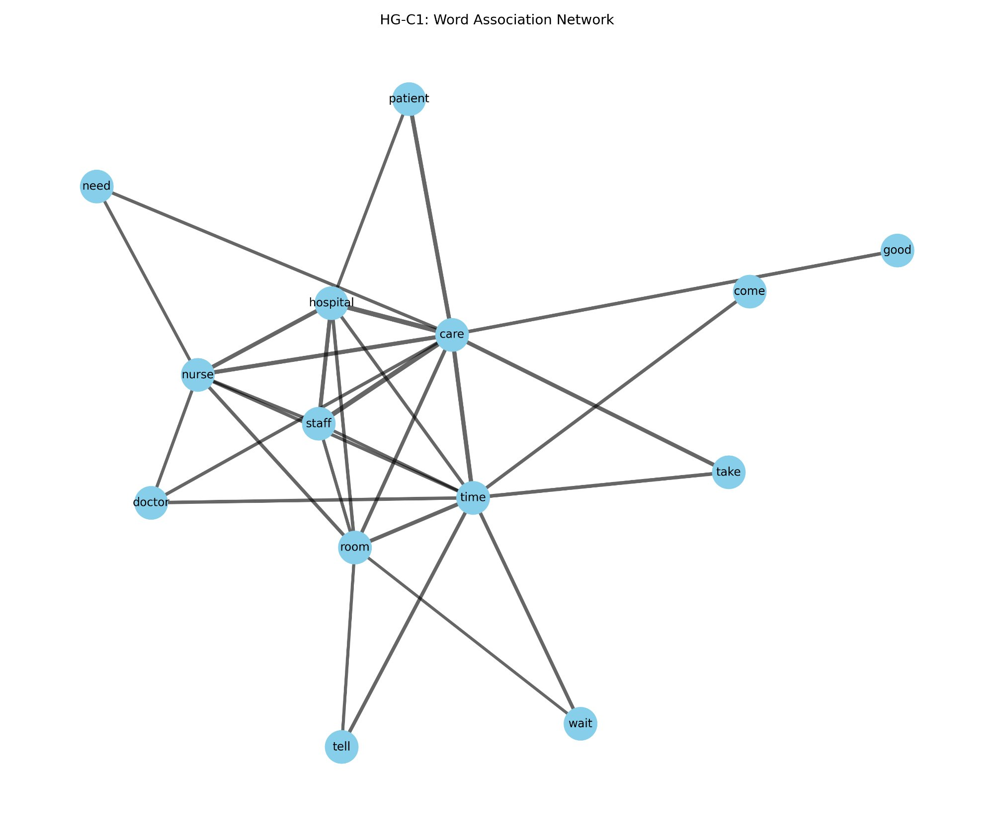
Figure 53: Word Association Network — HG-C2 (ID, TN)
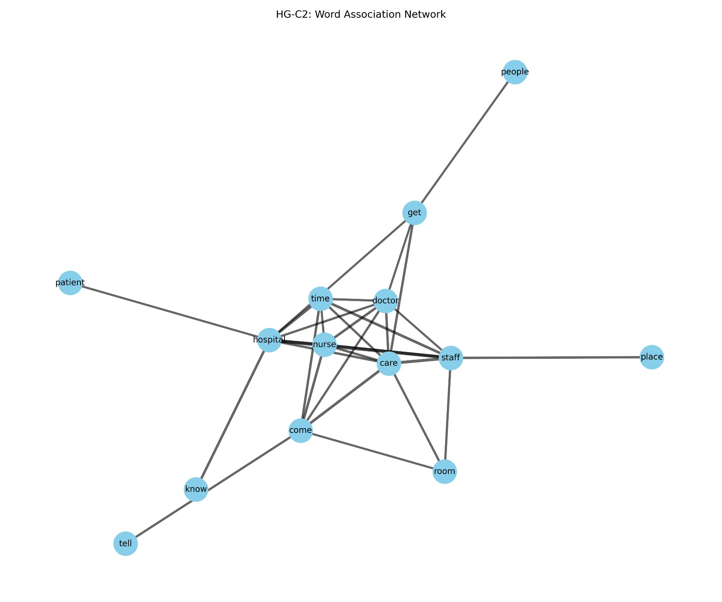
Figure 54: Word Association Network — HG-C3 (IN, PA, MO, LA)
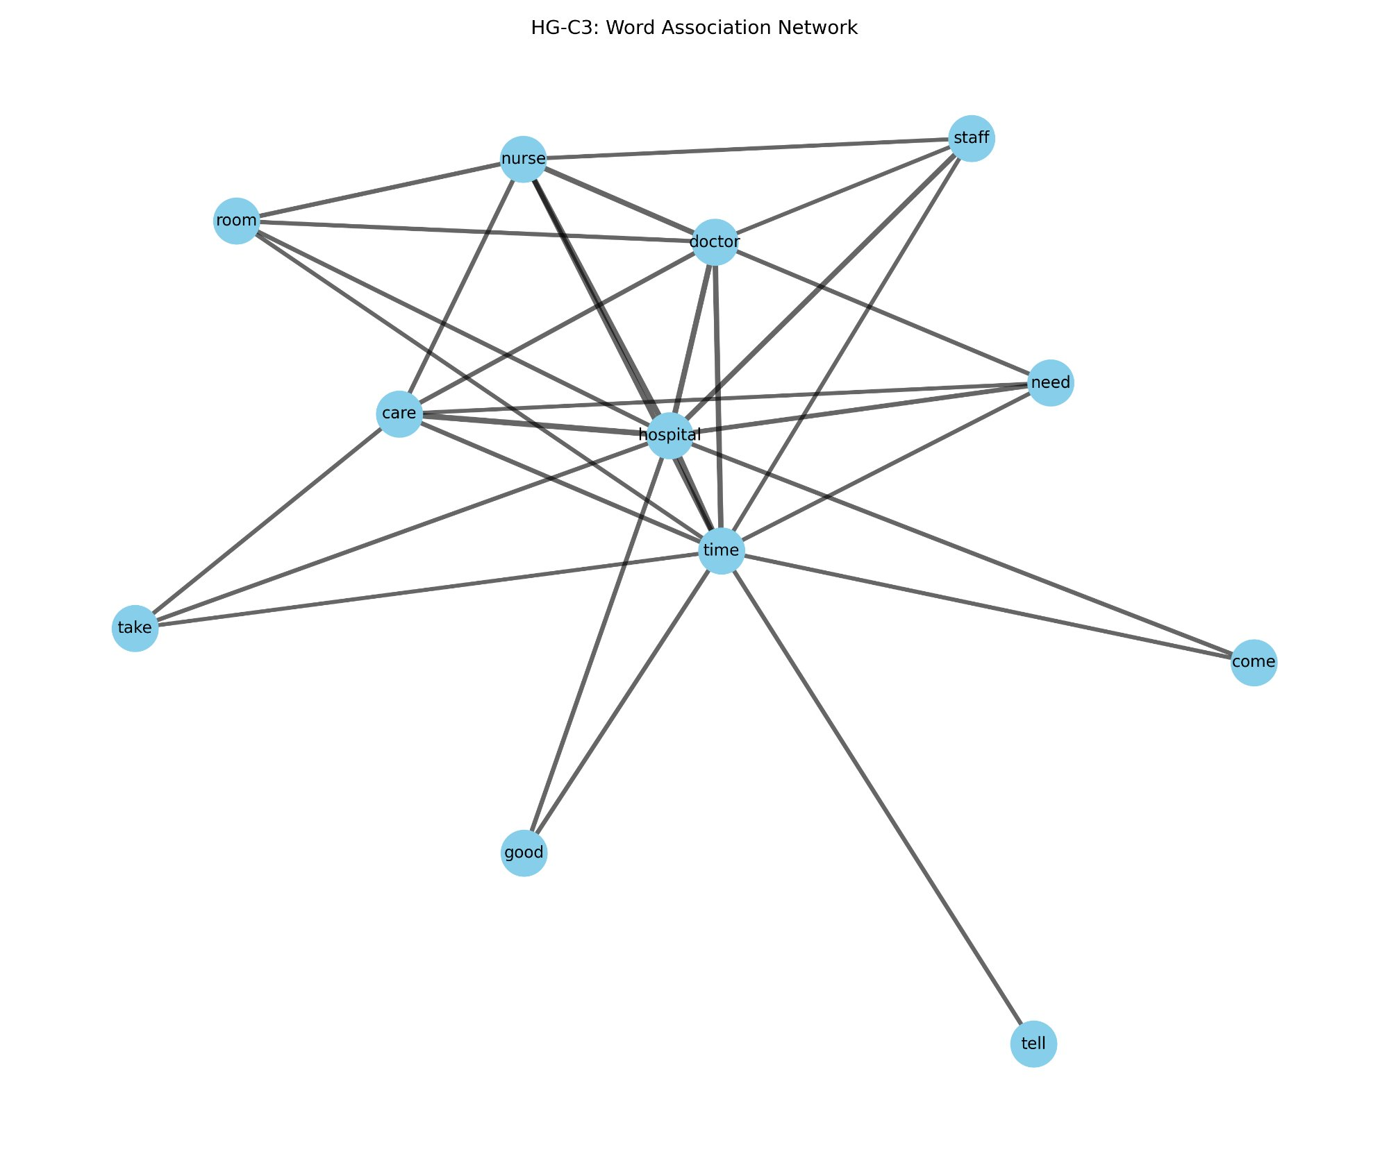
Figure 55: Word Association Network — S-C1 (ID, IL, LA, PA, TN)
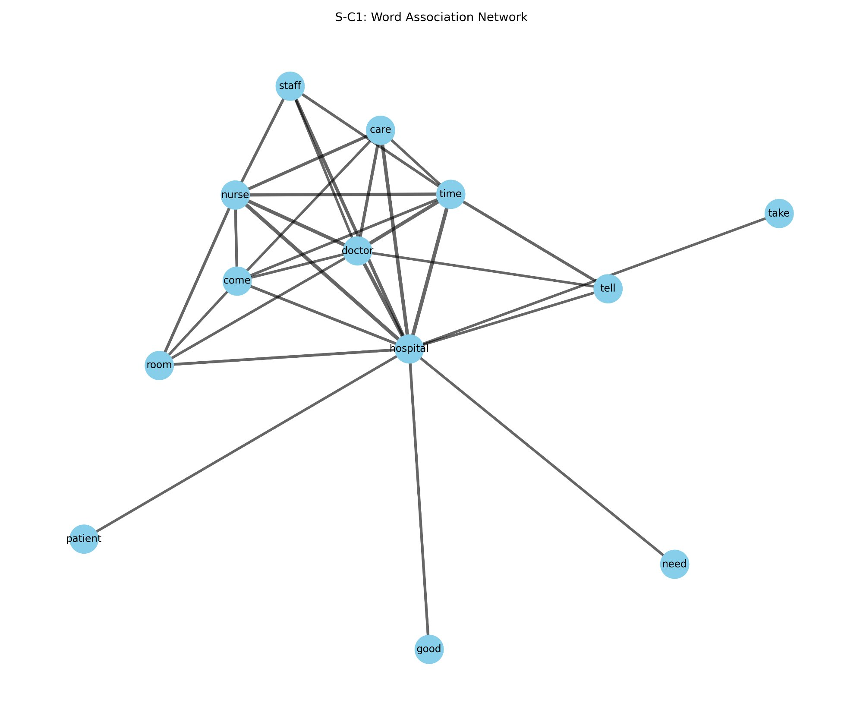
Figure 56: Word Association Network — S-C2 (AZ, IN, NJ)
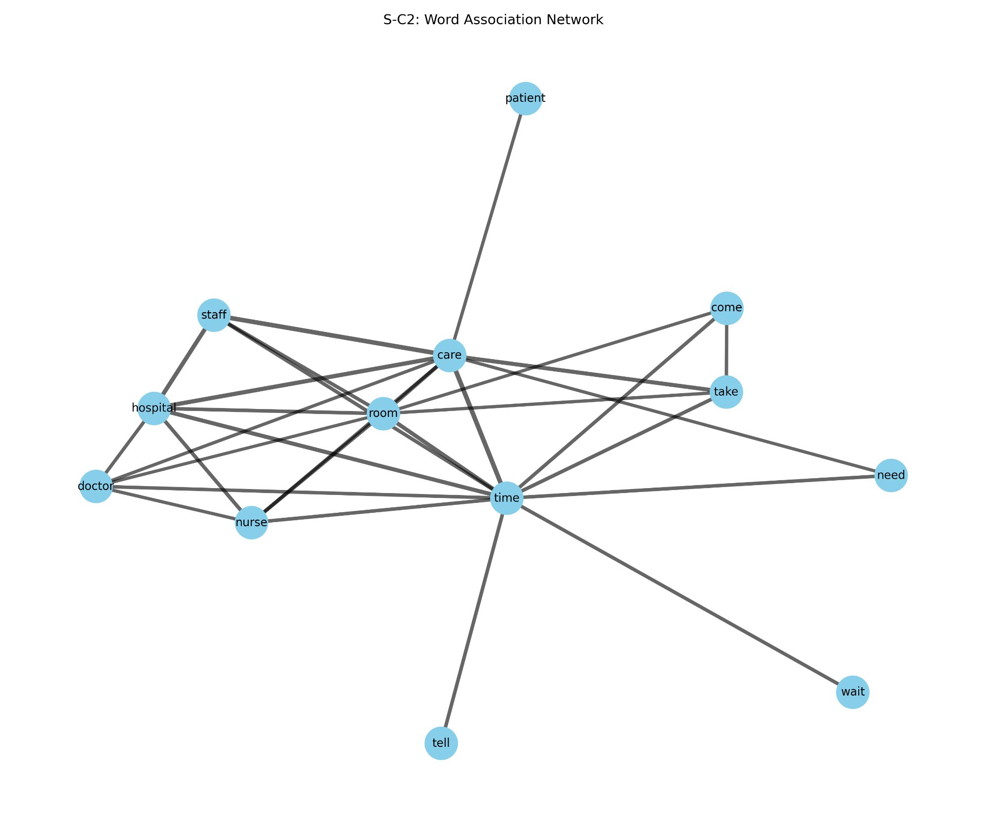
Figure 57: Word Association Network — S-C3 (FL, MO)
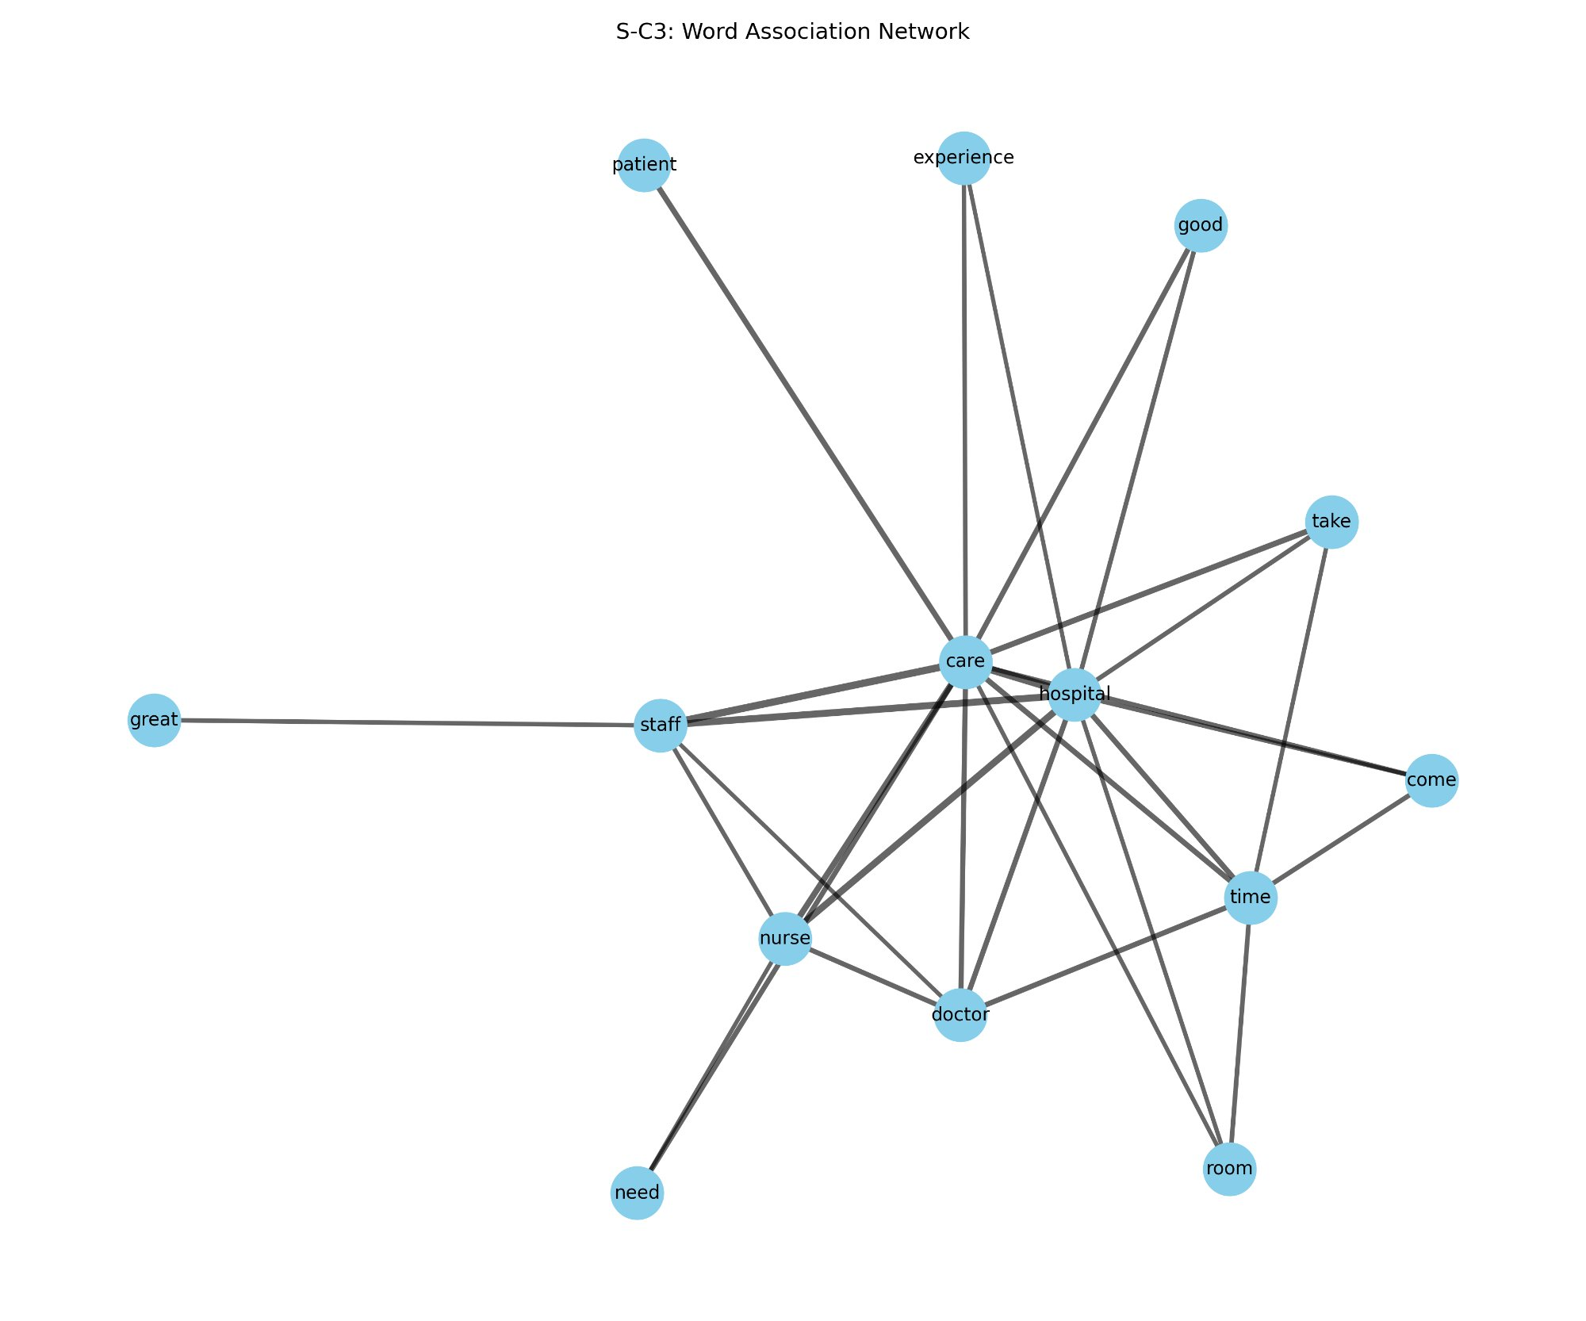
The word association networks reveal a shared core vocabulary across all six clusters. The terms hospital, care, staff, nurse, doctor, time, and room appear as central, highly connected nodes in every cluster, reflecting the universal thematic concerns of patients writing about hospital experiences: the institution, the clinical personnel, the quality of care received, temporal dimensions of the visit, and the physical environment. This consistency is expected given the shared context of all reviews.
The distinguishing feature across clusters lies in the peripheral vocabulary and in the strength of specific associations. S-C3 (Florida and Missouri) is the only cluster in which the words great, experience, and good appear in the network as connected nodes alongside the clinical core terms, reflecting the evaluatively positive language that characterises this cluster's reviews and is consistent with its LOVE quadrant position and highest positive sentiment score. HG-C2 (Idaho and Tennessee) is notable for the appearance of place as a connected node, which may indicate that patients in this cluster make more explicit reference to the physical setting of the hospital, potentially in the context of either positive or negative assessments of the facility environment. The term wait appears in the networks of HG-C1 and S-C2, reflecting the salience of waiting time as a co-occurring concern alongside staff and care in those clusters.

5.5.6 Word Clouds
Word clouds were generated for each cluster to provide a high-level visual overview of the most frequently occurring terms in the review corpus, with word size scaled proportionally to term frequency. The word clouds were produced using the WordCloud Python library in conjunction with NLTK's stopword list and WordNetLemmatizer for text preprocessing. Each review was converted to lowercase, non-alphabetic characters were removed, stopwords were filtered out, and all tokens were lemmatised before concatenation into a single text string per cluster. The WordCloud library then computed word frequencies across this string and rendered up to 150 unique words using the tab10 colour palette on a white background. The word clouds for all six clusters are presented in Figures 58 through 63.
Figure 58: Word Cloud — HG-C1 (AZ, FL, NJ, IL)
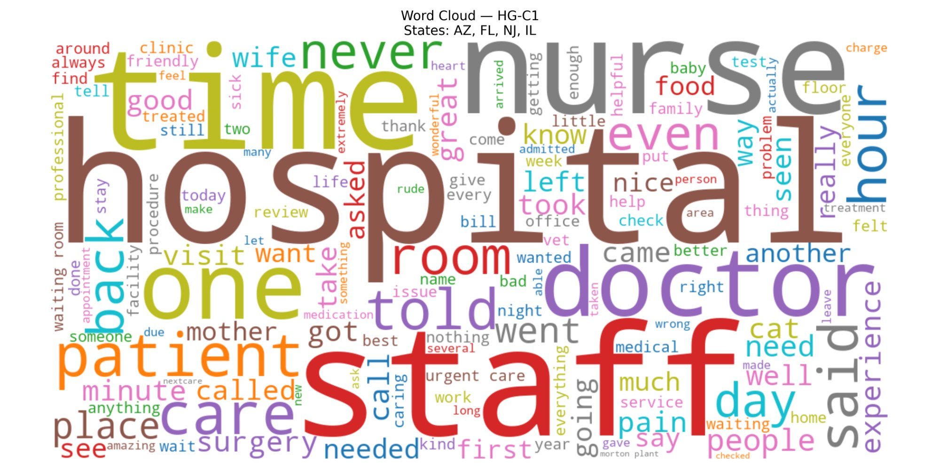
Figure 59: Word Cloud — HG-C2 (ID, TN)
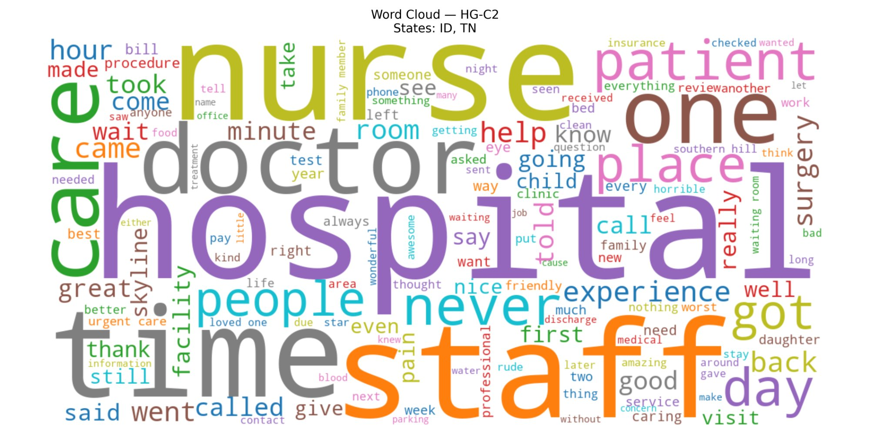
Figure 60: Word Cloud — HG-C3 (IN, PA, MO, LA)
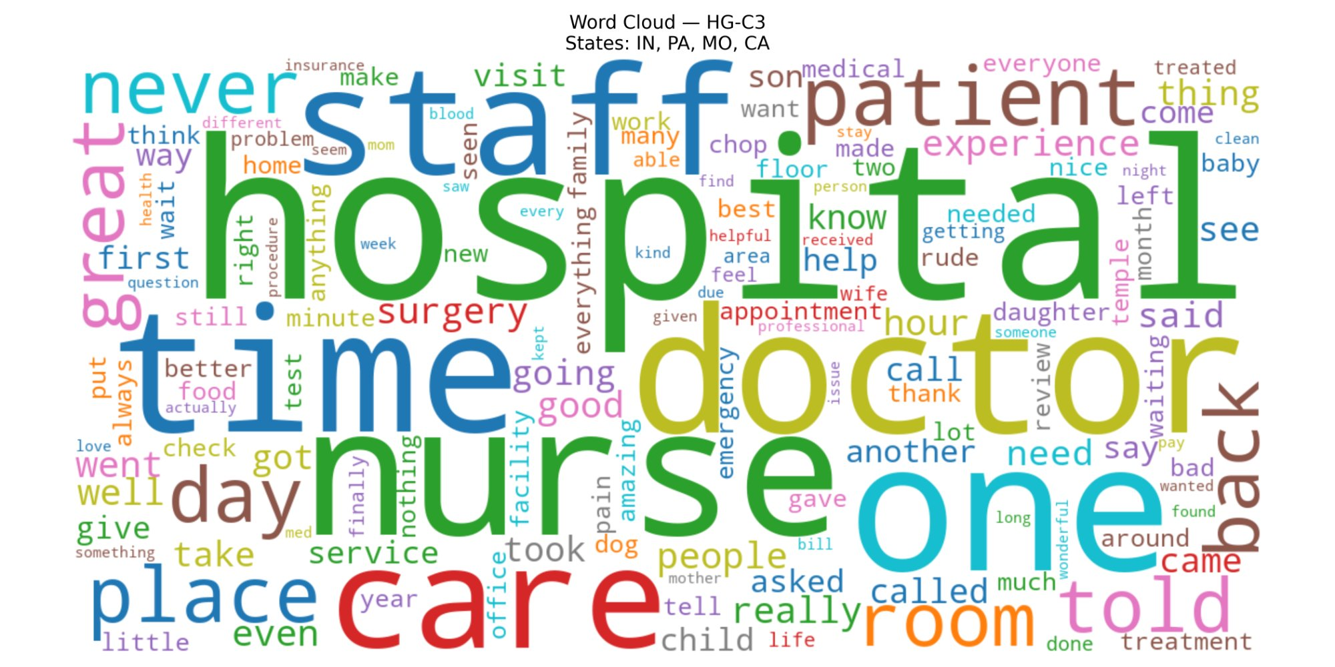
Figure 61: Word Cloud — S-C1 (ID, IL, LA, PA, TN)
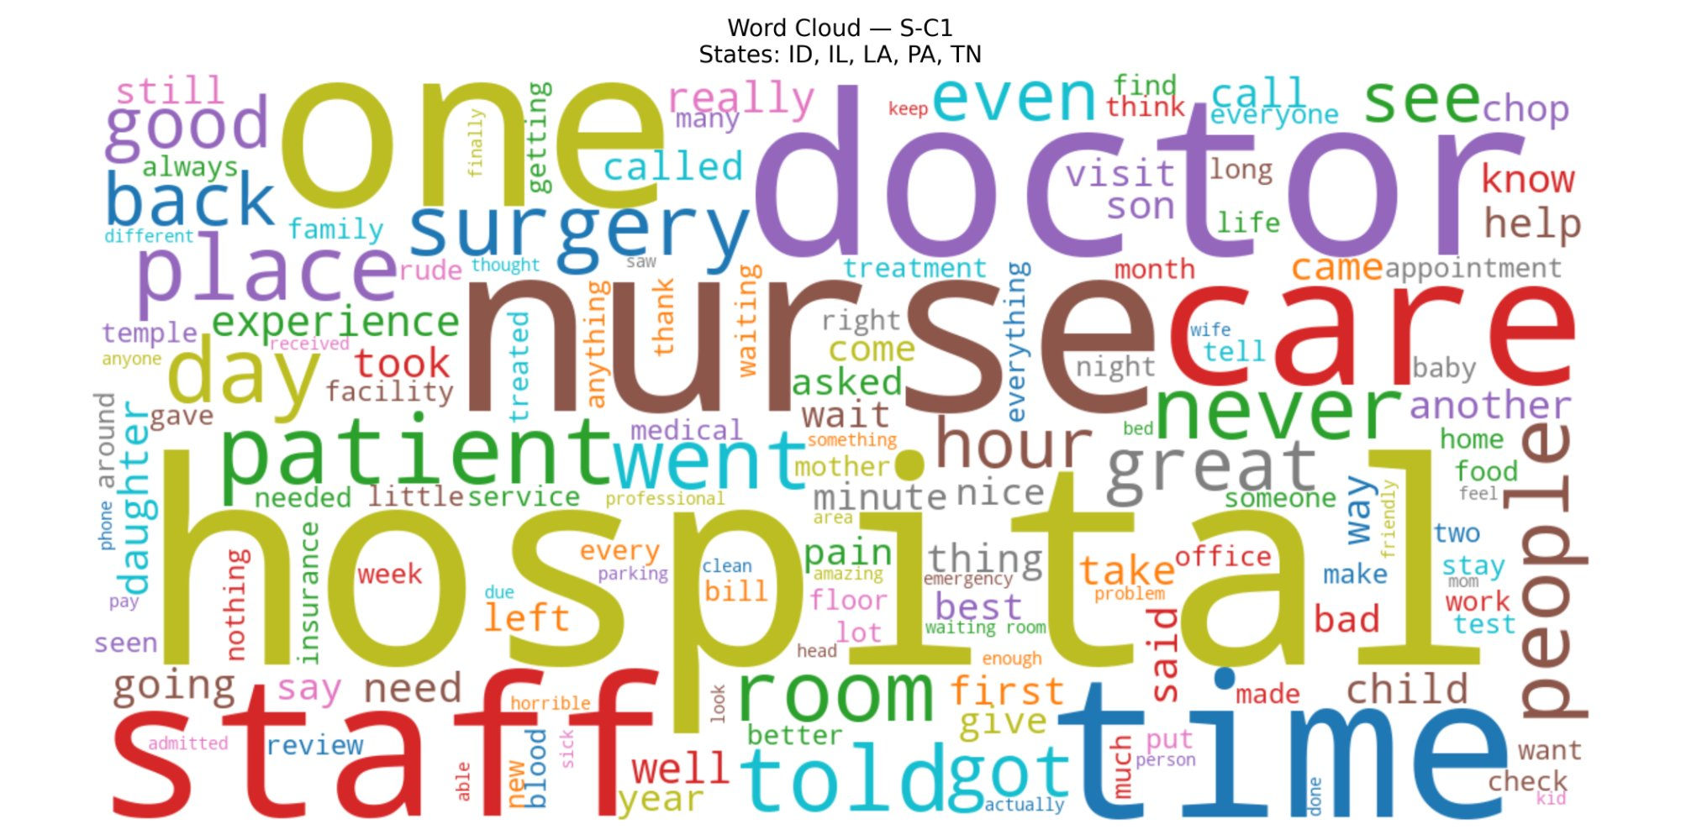
Figure 62: Word Cloud — S-C2 (AZ, IN, NJ)
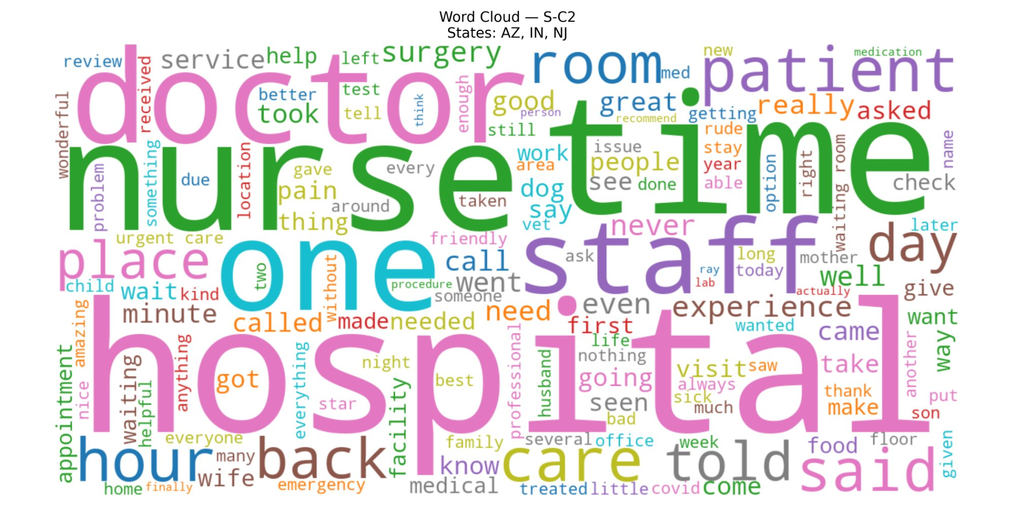
Figure 63: Word Cloud — S-C3 (FL, MO)
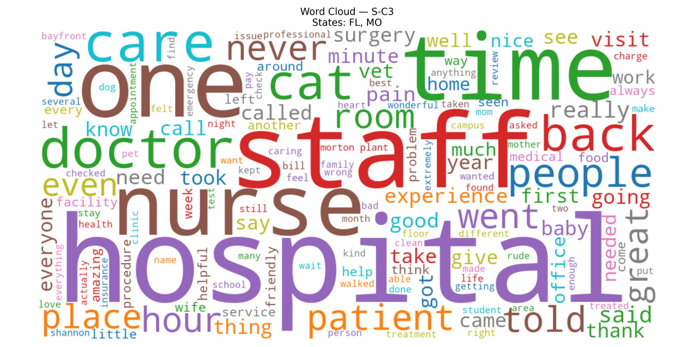
The word clouds confirm and extend the thematic patterns identified in the word association networks. Across all six clusters, hospital, staff, nurse, doctor, time, care, room, and patient are among the largest and most visually dominant terms, reinforcing the universality of these themes in patient-generated hospital reviews. The word never appears prominently across multiple clusters, indicative of the frequency with which patients use negation in their reviews — either to describe experiences that fell short of expectations or to express strong endorsement through phrases such as have never had a better experience.
S-C3 (Florida and Missouri) shows relatively prominent occurrences of great, amazing, and helpful alongside the clinical core vocabulary, consistent with its characterisation as the most positively expressive cluster across all text mining dimensions. HG-C1 (Arizona, Florida, New Jersey, and Illinois) features surgery and urgent care as notable mid-sized terms, suggesting a higher proportion of reviews relating to procedural or emergency care contexts in these states. HG-C2 (Idaho and Tennessee) displays place as a distinctively visible term not prominent in other clusters, while also featuring words such as horrible and worst among its smaller terms, consistent with its HATE quadrant positioning and the highest negative sentiment proportion among all clusters at 39.4%. S-C1 (Idaho, Illinois, Louisiana, Pennsylvania, and Tennessee) shows a broad and evenly distributed vocabulary without strong evaluative differentiators, reflecting the more moderate and mixed sentiment profile of this cluster.

