5.3 Hierarchical Clustering and K-Means Analysis
The third analytical step involved the application of hierarchical clustering and K-means clustering to the state-level median datasets for both the Hospital General Information and OAS CAHPS Survey datasets. Two distance metrics were employed — Euclidean distance and Cosine distance — and for each metric, multiple hierarchical linkage methods were applied. The clustering analysis was implemented in Python using the SciPy, Scikit-learn, and Matplotlib libraries.
SciPy's scipy.cluster.hierarchy module provides the core hierarchical clustering functionality used in this analysis. The linkage function constructs the hierarchical cluster tree by iteratively merging the closest pairs of states based on the specified distance metric and linkage method. The dendrogram function renders this tree as a visual diagram in which the vertical axis represents the distance at which merges occur and the horizontal axis lists the individual states. The fcluster function cuts the dendrogram at a specified threshold to assign each state to a flat cluster. The pdist function from scipy.spatial.distance was used to compute the pairwise distance matrix between all states prior to linkage computation.
Scikit-learn's StandardScaler was applied to the data prior to all Euclidean-based clustering operations. StandardScaler transforms each variable to have zero mean and unit variance, ensuring that variables measured in different scales or ranges do not disproportionately dominate the distance computation. For Cosine-based clustering, the scaled data was further processed using Scikit-learn's normalize function, which scales each state's feature vector to unit length. This ensures that the Cosine distance — which measures the angle between two vectors — reflects genuine directional similarity in the pattern of variable values rather than differences in overall magnitude.
Four hierarchical linkage methods were applied to the Euclidean distance metric: Single linkage, which defines the distance between two clusters as the minimum distance between any pair of points across the two clusters; Complete linkage, which uses the maximum pairwise distance; Average linkage, which uses the mean of all pairwise distances; and Ward linkage, which minimises the total within-cluster variance at each merge step. For the Cosine distance metric, only Single, Complete, and Average linkage were applied. Ward linkage was excluded for Cosine distance because Ward's method requires the computation of centroid positions in Euclidean space and is mathematically incompatible with non-Euclidean distance metrics such as Cosine distance.
The number of clusters for each hierarchical run was determined automatically by the program using a data-driven threshold equal to 70% of the maximum merge distance observed in the linkage matrix. This threshold was applied uniformly across all combinations of linkage method and distance metric, ensuring a consistent and objective basis for cluster assignment without manual intervention. The resulting K value and cluster membership for each combination are reported in the summary tables in the subsections below.
Euclidean distance was selected as the primary metric because it directly measures the absolute difference between state-level values across all quality and survey dimensions, providing a straightforward and widely established basis for similarity in multivariate numerical data. Cosine distance was selected as the complementary metric because it captures the directional alignment of each state's variable profile — that is, whether two states exhibit the same relative pattern of high and low values across dimensions, regardless of their absolute magnitudes. Given that the variables in both datasets are bounded measures (quality counts and survey percentages), Cosine distance provides a meaningful secondary lens that can identify states with similar structural profiles even when their absolute values differ, offering a more complete characterisation of inter-state similarity than Euclidean distance alone.
Following the hierarchical clustering analysis, K-means clustering was applied for each unique K value identified across all hierarchical combinations for a given dataset. Duplicate K values identified by different combinations were consolidated, and K-means was run once per unique K value. K-means is a partitional clustering algorithm that assigns each state to the cluster whose centroid — the mean of all member states' feature vectors — is nearest in Euclidean space. The algorithm iterates between reassigning states to the nearest centroid and recomputing centroids until convergence. Scikit-learn's KMeans implementation was used with ten random initialisations and a fixed random seed to ensure reproducibility. The results of each K-means run are visualised as centroid profile plots, in which each cluster's centroid values across all variables are plotted as a connected line, allowing for direct visual comparison of the characteristic variable profiles of each cluster.
For each dataset, centroid profile plots were also generated for selected hierarchical clustering combinations using the same approach, specifically for the Complete linkage method under both Euclidean and Cosine distance. These hierarchical centroid plots use the standardised or normalised feature space rather than the original variable scale, reflecting the distances that the hierarchical algorithm actually computed. The K-means centroid plots, by contrast, are inverse-transformed back to the original variable scale for interpretability.

5.3.1 Hospital General Information Dataset
Hierarchical clustering was applied to the state-level median values of the Hospital General Information dataset across seven combinations of linkage method and distance metric. The automatic threshold-based cluster assignment produced K values ranging from 2 to 4 across the seven combinations. The full results are summarised in Table 5 below.
Table 5: Hierarchical Clustering Results — Hospital General Information Dataset
Linkage Method | Distance Metric | Auto K | Cluster Composition
Single | Euclidean | 2 | C1: AZ, IN, FL, TN, PA, NJ, MO, LA, IL | C2: ID
Complete | Euclidean | 3 | C1: AZ, FL, NJ | C2: IN, TN, PA, MO, LA, IL | C3: ID
Average | Euclidean | 2 | C1: AZ, IN, FL, TN, PA, NJ, MO, LA, IL | C2: ID
Ward | Euclidean | 3 | C1: AZ, FL, NJ | C2: IN, TN, PA, MO, LA, IL | C3: ID
Single | Cosine | 4 | C1: AZ, FL, NJ | C2: IN, TN, PA, MO, LA | C3: ID | C4: IL
Complete | Cosine | 3 | C1: AZ, FL, NJ, IL | C2: IN, PA, MO, LA | C3: ID, TN
Average | Cosine | 3 | C1: AZ, FL, NJ, IL | C2: IN, PA, MO, LA | C3: ID, TN

The dendrograms for each of the seven combinations are presented in Figures 3 through 9 below. Each dendrogram displays the hierarchical merge structure of the ten states, with the legend identifying which states belong to each automatically determined cluster.
Figure 3: Dendrogram — Single Linkage, Euclidean Distance (Hospital General Information Dataset)
[INSERT FIGURE: single_euclidean — Hospital General (K=2)]
Figure 4: Dendrogram — Complete Linkage, Euclidean Distance (Hospital General Information Dataset)
[INSERT FIGURE: complete_euclidean — Hospital General (K=3)]
Figure 5: Dendrogram — Average Linkage, Euclidean Distance (Hospital General Information Dataset)
[INSERT FIGURE: average_euclidean — Hospital General (K=2)]
Figure 6: Dendrogram — Ward Linkage, Euclidean Distance (Hospital General Information Dataset)
[INSERT FIGURE: ward_euclidean — Hospital General (K=3)]
Figure 7: Dendrogram — Single Linkage, Cosine Distance (Hospital General Information Dataset)
[INSERT FIGURE: single_cosine — Hospital General (K=4)]
Figure 8: Dendrogram — Complete Linkage, Cosine Distance (Hospital General Information Dataset)
[INSERT FIGURE: complete_cosine — Hospital General (K=3)]
Figure 9: Dendrogram — Average Linkage, Cosine Distance (Hospital General Information Dataset)
[INSERT FIGURE: average_cosine — Hospital General (K=3)]
Across the seven combinations, the state of Idaho (ID) consistently emerged as a distinct outlier cluster in all Euclidean-based runs, separated from the remaining nine states at a notably higher distance threshold. This pattern is consistent with the findings of the correlation analysis, where Idaho was identified as one of only two states with an Overall Star Rating of 4, while the majority of states held a rating of 3. The Cosine-based runs produced a more nuanced three-cluster structure, grouping states by the directional profile of their quality measure distributions rather than their absolute values. The states of Arizona, Florida, and New Jersey consistently formed one cluster across multiple combinations, while Indiana, Pennsylvania, Missouri, and Louisiana formed a second, and Idaho and Tennessee a third under Complete and Average Cosine linkage.
The unique K values identified across all seven combinations were 2, 3, and 4. K-means clustering was therefore run for K=2, K=3, and K=4. The hierarchical centroid plots for the Complete linkage under both Euclidean and Cosine distance are presented in Figures 10 and 11, followed by the K-means centroid profile plots in Figures 12, 13, and 14.
Figure 10: Hierarchical Centroid Plot — Complete Linkage, Euclidean Distance (Hospital General Information Dataset)
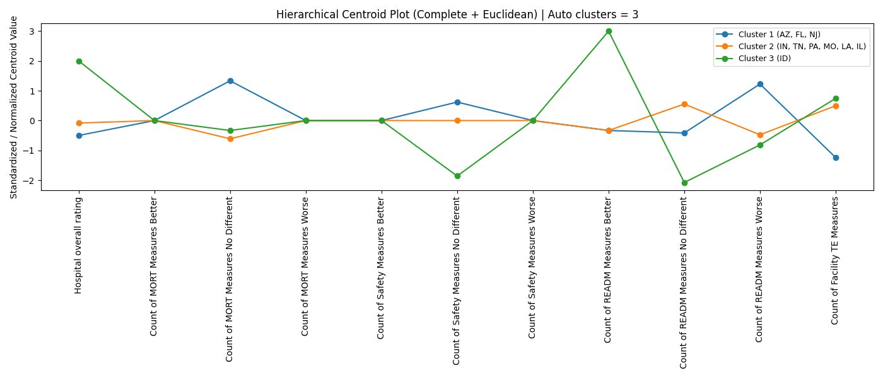
Figure 11: Hierarchical Centroid Plot — Complete Linkage, Cosine Distance (Hospital General Information Dataset)
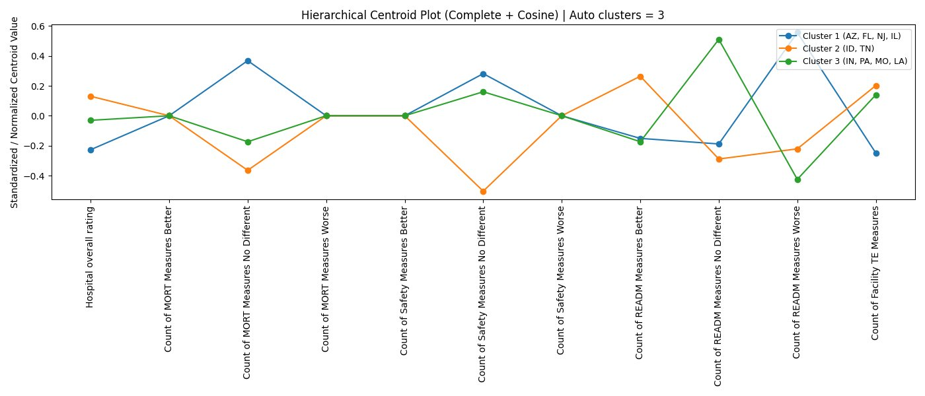
Figure 12: K-Means Centroid Profile Plot — K=2 (Hospital General Information Dataset)
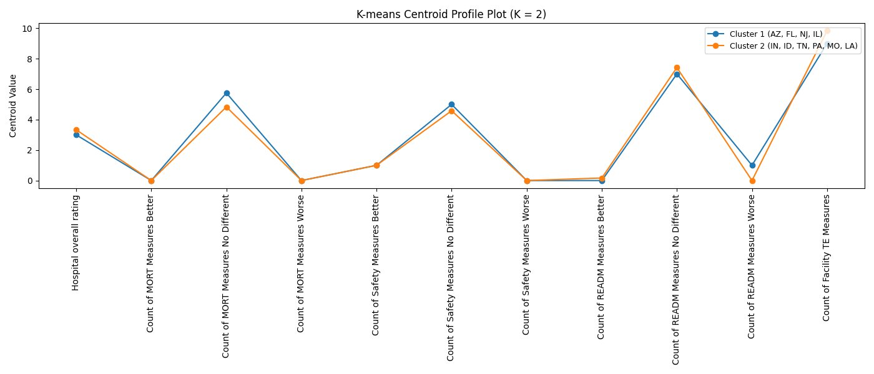
Figure 13: K-Means Centroid Profile Plot — K=3 (Hospital General Information Dataset)
[INSERT FIGURE: kmeans_centroids_k3 — Hospital General]
Figure 14: K-Means Centroid Profile Plot — K=4 (Hospital General Information Dataset)
[INSERT FIGURE: kmeans_centroids_k4 — Hospital General]
The K-means centroid profile plots reveal that for K=2, the two clusters are broadly separated by their Count of MORT Measures No Different and Count of READM Measures No Different values, with Idaho's single-state cluster exhibiting a distinctly higher READM Better count and lower READM No Different count relative to the nine-state cluster. As K increases to 3, the state groupings stabilise around the pattern identified by the Euclidean Complete and Ward dendrograms — Arizona, Florida, and New Jersey forming one cluster characterised by relatively higher MORT No Different and lower TE Measures counts; Indiana, Tennessee, Pennsylvania, Missouri, Louisiana, and Illinois forming a second cluster; and Idaho remaining isolated as a third. At K=4, Tennessee separates into its own cluster, reflecting its marginally distinct position on several quality measure dimensions.

5.3.2 OAS CAHPS Survey Dataset
The same hierarchical clustering and K-means methodology was applied to the state-level median values of the OAS CAHPS Survey dataset. The seven hierarchical combinations produced K values ranging from 3 to 5, reflecting greater variability in the survey data's cluster structure relative to the Hospital General dataset. The full results are summarised in Table 6 below.
Table 6: Hierarchical Clustering Results — OAS CAHPS Survey Dataset
Linkage Method | Distance Metric | Auto K | Cluster Composition
Single | Euclidean | 4 | C1: AZ, ID, IL, IN, LA, NJ, TN | C2: FL | C3: MO | C4: PA
Complete | Euclidean | 3 | C1: AZ, ID, IL, IN, LA, MO, NJ, TN | C2: FL | C3: PA
Average | Euclidean | 4 | C1: AZ, IL, IN, LA, NJ, TN | C2: FL | C3: ID, MO | C4: PA
Ward | Euclidean | 4 | C1: AZ, IN, NJ | C2: FL | C3: ID, IL, LA, MO, TN | C4: PA
Single | Cosine | 5 | C1: AZ, IN, NJ | C2: FL | C3: ID, IL, PA, TN | C4: LA | C5: MO
Complete | Cosine | 3 | C1: AZ, IN, NJ | C2: FL, MO | C3: ID, IL, LA, PA, TN
Average | Cosine | 4 | C1: AZ, IN, NJ | C2: FL, MO | C3: ID, IL, PA, TN | C4: LA

The dendrograms for all seven combinations are presented in Figures 15 through 21 below.
Figure 15: Dendrogram — Single Linkage, Euclidean Distance (OAS CAHPS Survey Dataset)
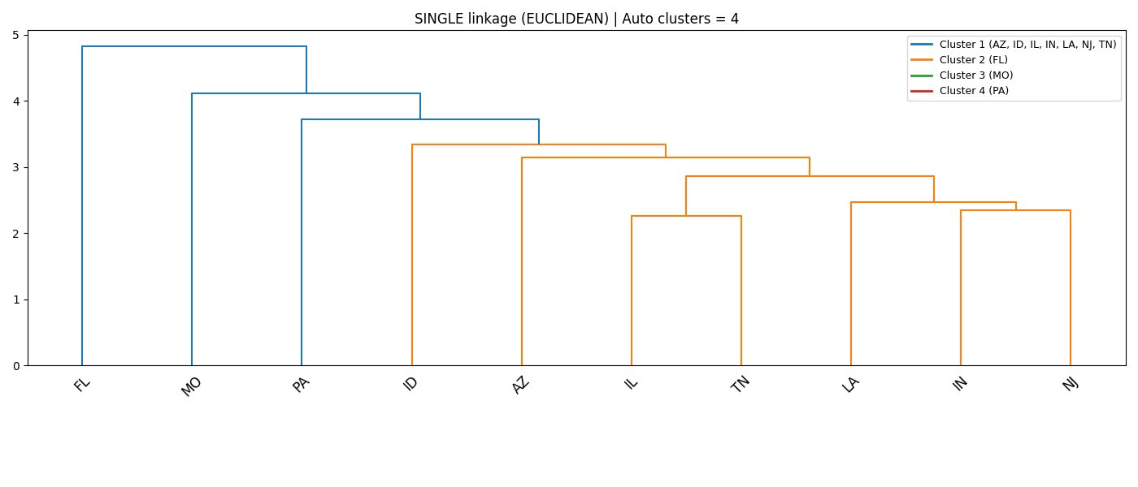
Figure 16: Dendrogram — Complete Linkage, Euclidean Distance (OAS CAHPS Survey Dataset)
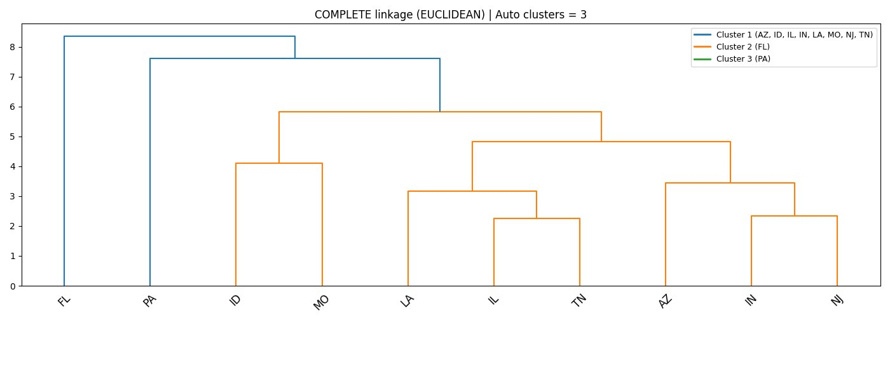
Figure 17: Dendrogram — Average Linkage, Euclidean Distance (OAS CAHPS Survey Dataset)
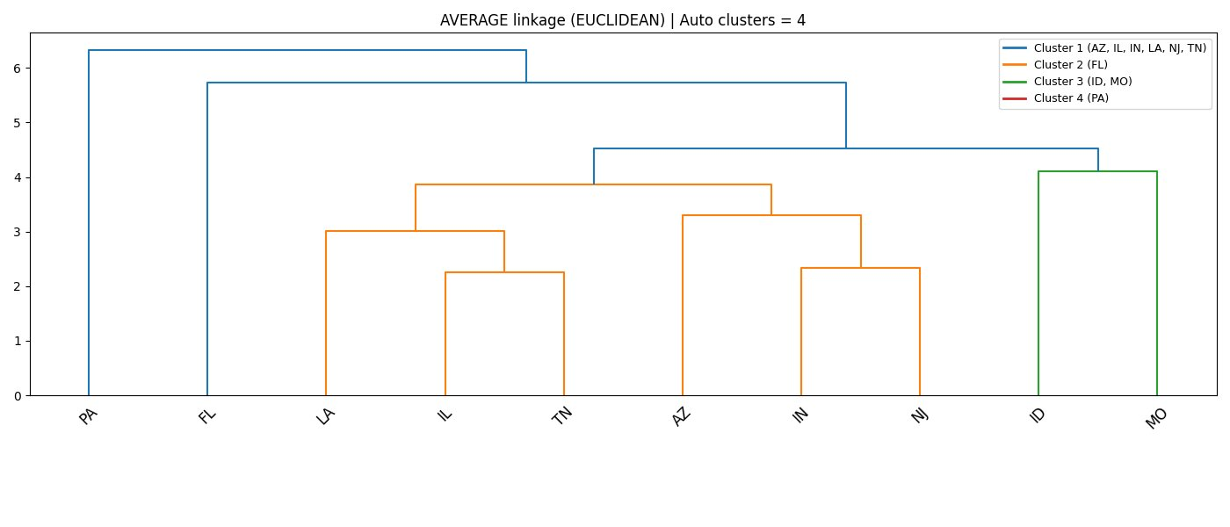
Figure 18: Dendrogram — Ward Linkage, Euclidean Distance (OAS CAHPS Survey Dataset)
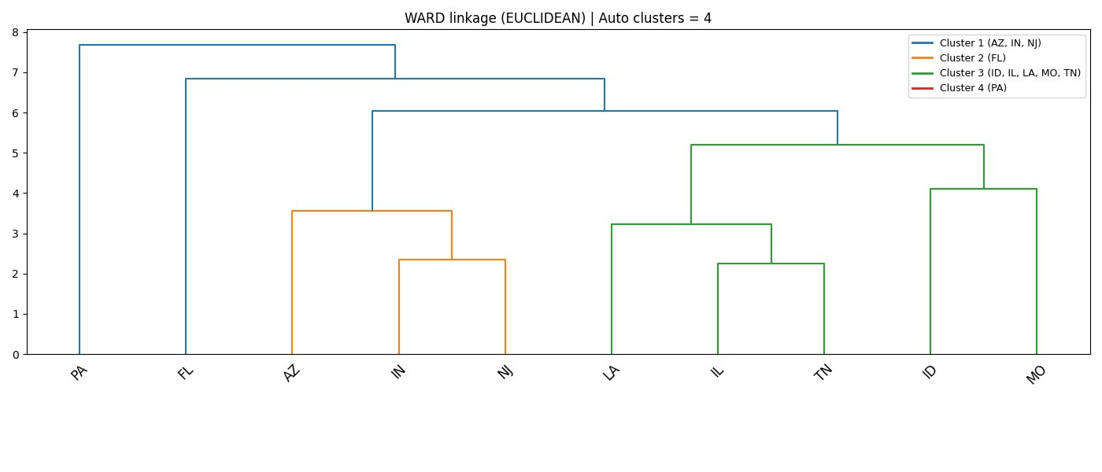
Figure 19: Dendrogram — Single Linkage, Cosine Distance (OAS CAHPS Survey Dataset)
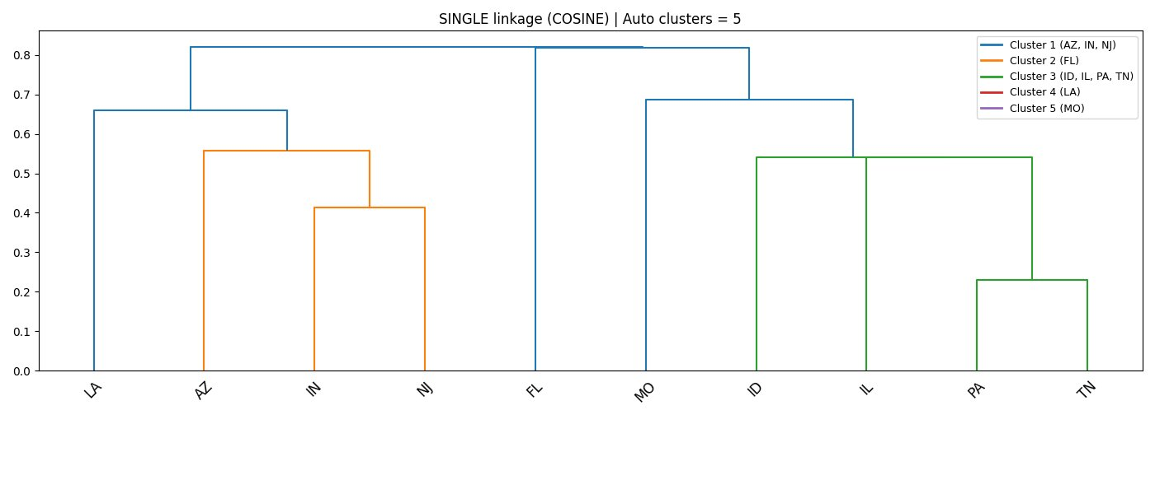
Figure 20: Dendrogram — Complete Linkage, Cosine Distance (OAS CAHPS Survey Dataset)
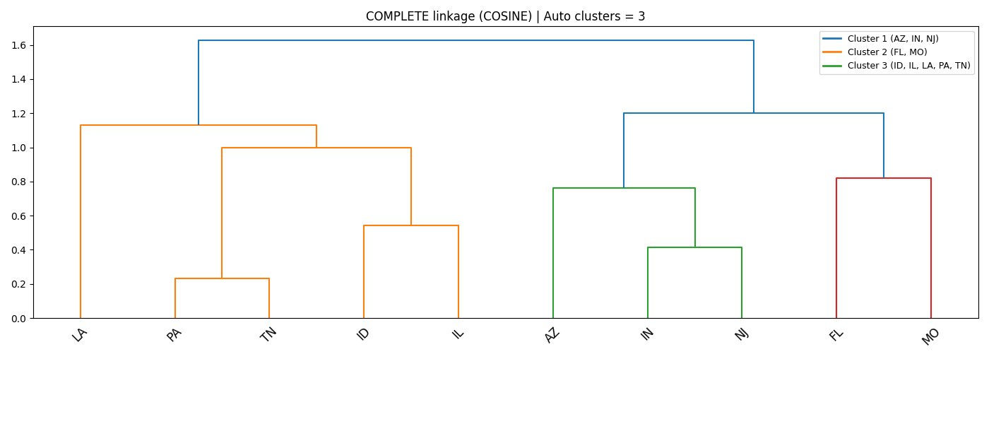
Figure 21: Dendrogram — Average Linkage, Cosine Distance (OAS CAHPS Survey Dataset)
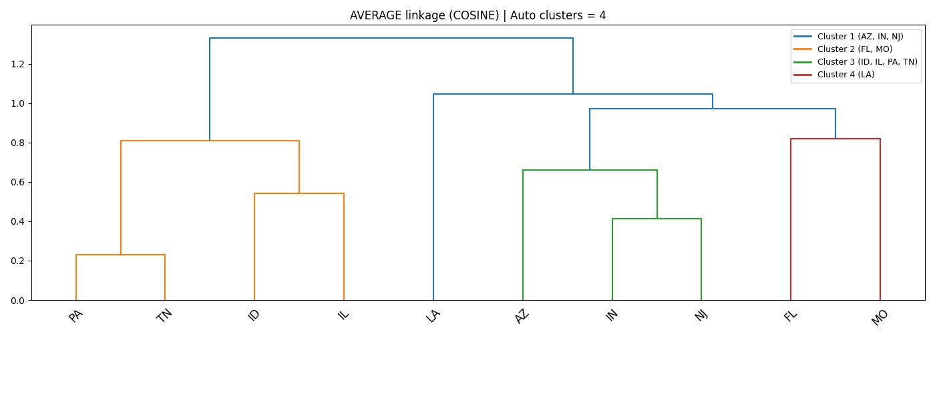
The survey dataset dendrograms reveal a more varied clustering structure than the Hospital General dataset, which is consistent with the greater variance and wider value ranges observed in the survey data during the correlation analysis. Florida and Pennsylvania emerged as frequent outlier states across multiple combinations. Florida consistently separated as a single-state cluster in the Euclidean-based runs, while Pennsylvania appeared as a singleton in several combinations including Complete Euclidean and Ward Euclidean. The state of Missouri also separated individually under Single Euclidean linkage.
The Cosine-based dendrograms produced more interpretable cluster structures. Under Complete Cosine linkage, three clusters emerged consistently: Arizona, Indiana, and New Jersey forming one cluster; Florida and Missouri forming a second; and Idaho, Illinois, Louisiana, Pennsylvania, and Tennessee forming a third. This grouping by directional survey profile suggests that the first cluster represents states with a characteristic pattern of strong patient endorsement and high communication scores, while the third cluster captures a broader group of states with a more moderate and varied survey response profile.
The unique K values across all seven combinations were 3, 4, and 5. K-means clustering was therefore run for K=3, K=4, and K=5. The hierarchical centroid plots for the Cosine distance under Complete and Average linkage are presented in Figures 22 and 23, followed by the K-means centroid profile plots for K=3, K=4, and K=5 in Figures 24, 25, and 26.
Figure 22: Hierarchical Centroid Plot — Complete Linkage, Cosine Distance (OAS CAHPS Survey Dataset)
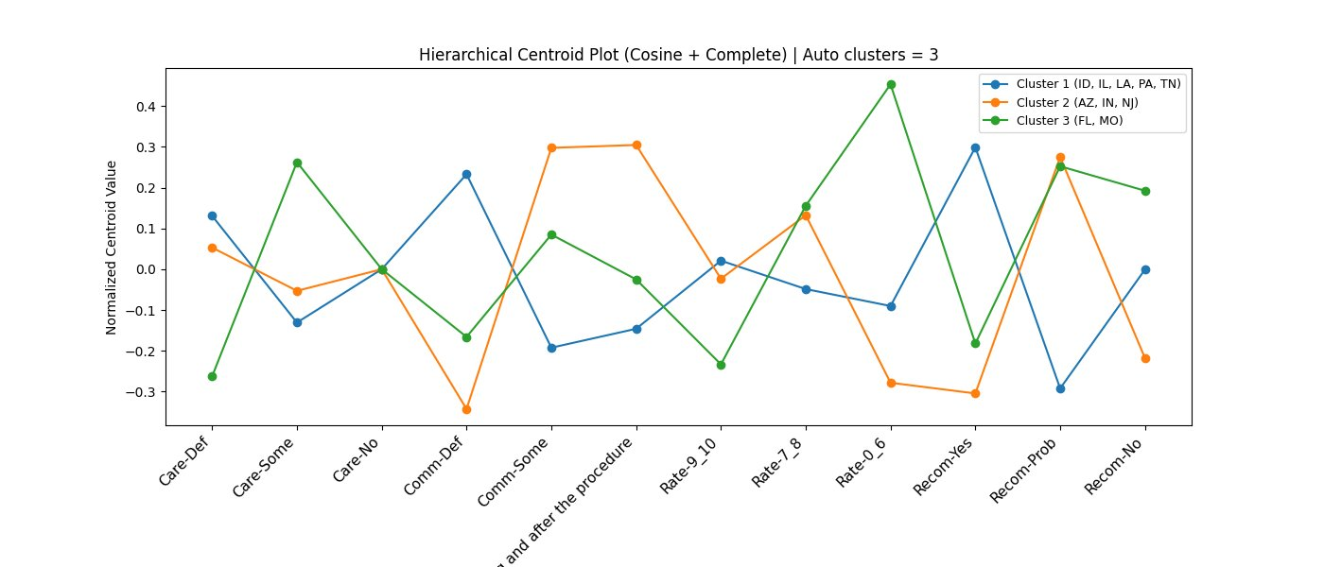
Figure 23: Hierarchical Centroid Plot — Average Linkage, Cosine Distance (OAS CAHPS Survey Dataset)
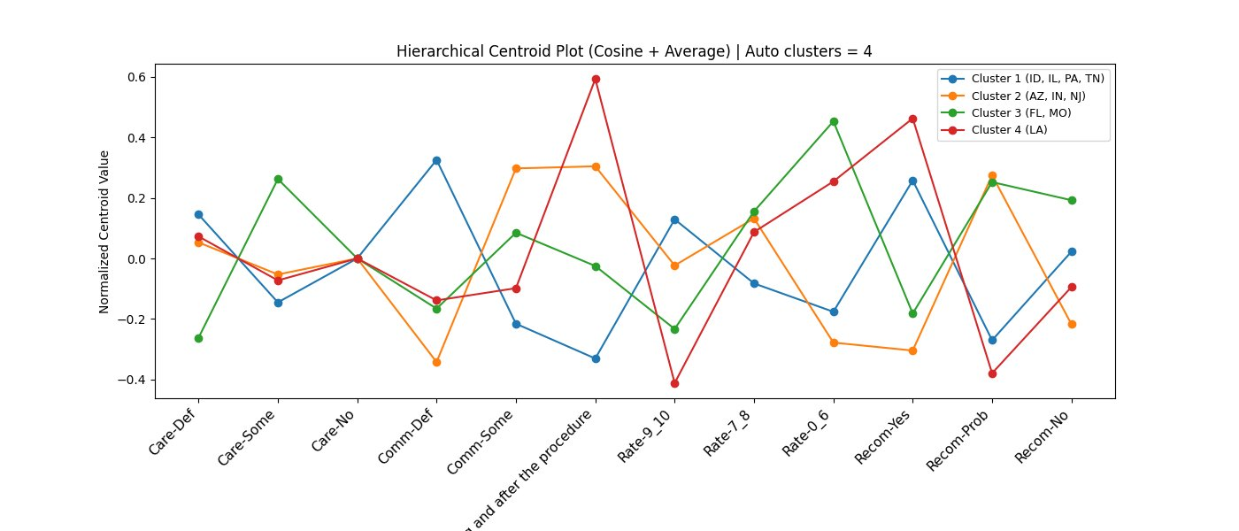
Figure 24: K-Means Centroid Profile Plot — K=3 (OAS CAHPS Survey Dataset)
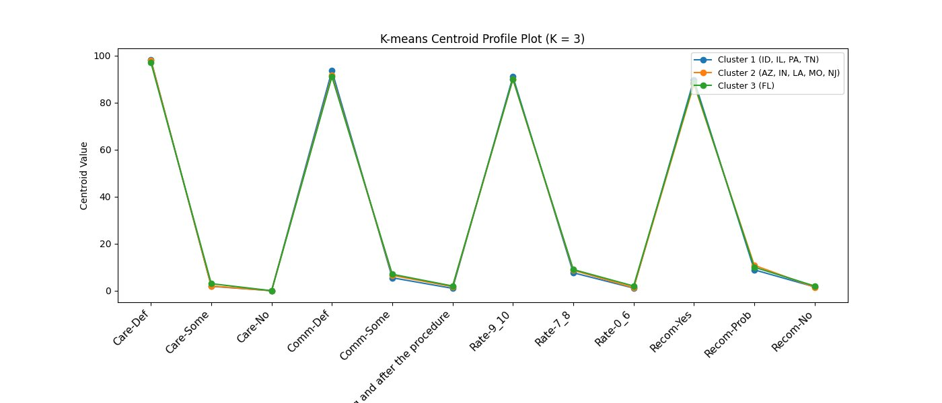
Figure 25: K-Means Centroid Profile Plot — K=4 (OAS CAHPS Survey Dataset)
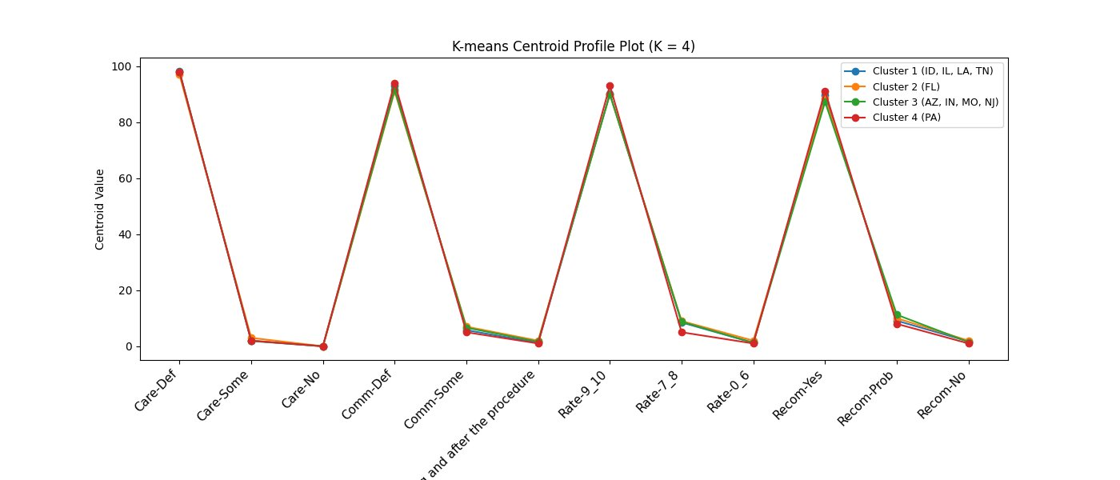
Figure 26: K-Means Centroid Profile Plot — K=5 (OAS CAHPS Survey Dataset)
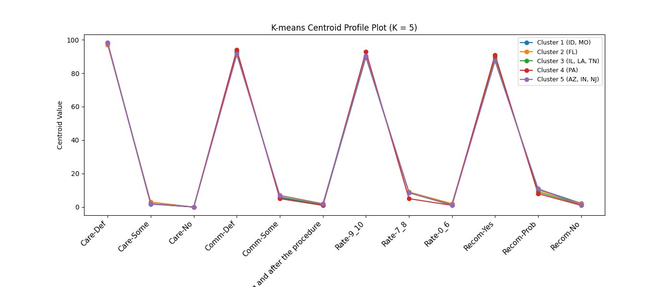
The K-means centroid profile plots for the survey dataset reveal that the centroid lines are visually very close across all clusters for all values of K. This is a direct consequence of the extremely narrow variance in the survey data — all ten states score very highly on the key satisfaction dimensions (Care-Def and Comm-Def both above 97%, Rate-9-10 above 89%, and Recom-Yes above 86% for all states), leaving only marginal absolute differences between clusters. The clusters are therefore differentiated by subtle but consistent directional differences rather than large absolute gaps, which is precisely why Cosine distance was a valuable complementary metric for this dataset — it was able to identify the directional pattern differences that Euclidean distance, sensitive to absolute values, would treat as negligible.
For K=3, the K-means solution groups Idaho, Illinois, Pennsylvania, and Tennessee as one cluster; Arizona, Indiana, Louisiana, Missouri, and New Jersey as a second; and Florida as a third. This structure is broadly consistent with the Complete Cosine hierarchical result, validating the cluster assignments across two independent clustering methods. As K increases to 4 and 5, the clusters fragment further, primarily separating Florida and Pennsylvania into individual clusters, reflecting their consistently distinct survey profiles relative to the other eight states. The stability of the three-cluster solution across both hierarchical and K-means approaches, and across both distance metrics, provides confidence that the three-cluster structure represents a meaningful and robust grouping of the ten states based on their ambulatory surgical centre patient experience profiles.

