4.3 Sentiment Analysis
The sentiment analysis was applied to the Yelp review corpus for each of the six finalised clusters — three from the Hospital General clustering (HG-C1, HG-C2, HG-C3) and three from the Survey clustering (S-C1, S-C2, S-C3). Five analytical dimensions are presented: overall sentiment, attribute net scores, emotion distribution, the Passion Index, and word clouds.

4.3.1 Overall Sentiment
Table 4.11 summarises the positive and negative sentiment percentages across all six clusters. Figures 4.30 through 4.35 show the individual cluster charts.
Table 4.11: Overall Sentiment Summary — All Six Clusters
Cluster | States | Positive | Negative
HG-C1 | AZ, FL, NJ, IL | 66.2% (247) | 33.8% (126)
HG-C2 | ID, TN | 60.6% (77) | 39.4% (50)
HG-C3 | IN, PA, MO, LA | 62.3% (425) | 37.7% (257)
S-C1 | ID, IL, LA, PA, TN | 60.1% (369) | 39.9% (245)
S-C2 | AZ, IN, NJ | 65.6% (250) | 34.4% (131)
S-C3 | FL, MO | 70.2% (165) | 29.8% (70)

Figure 4.30: Overall Sentiment — HG-C1 (AZ, FL, NJ, IL)
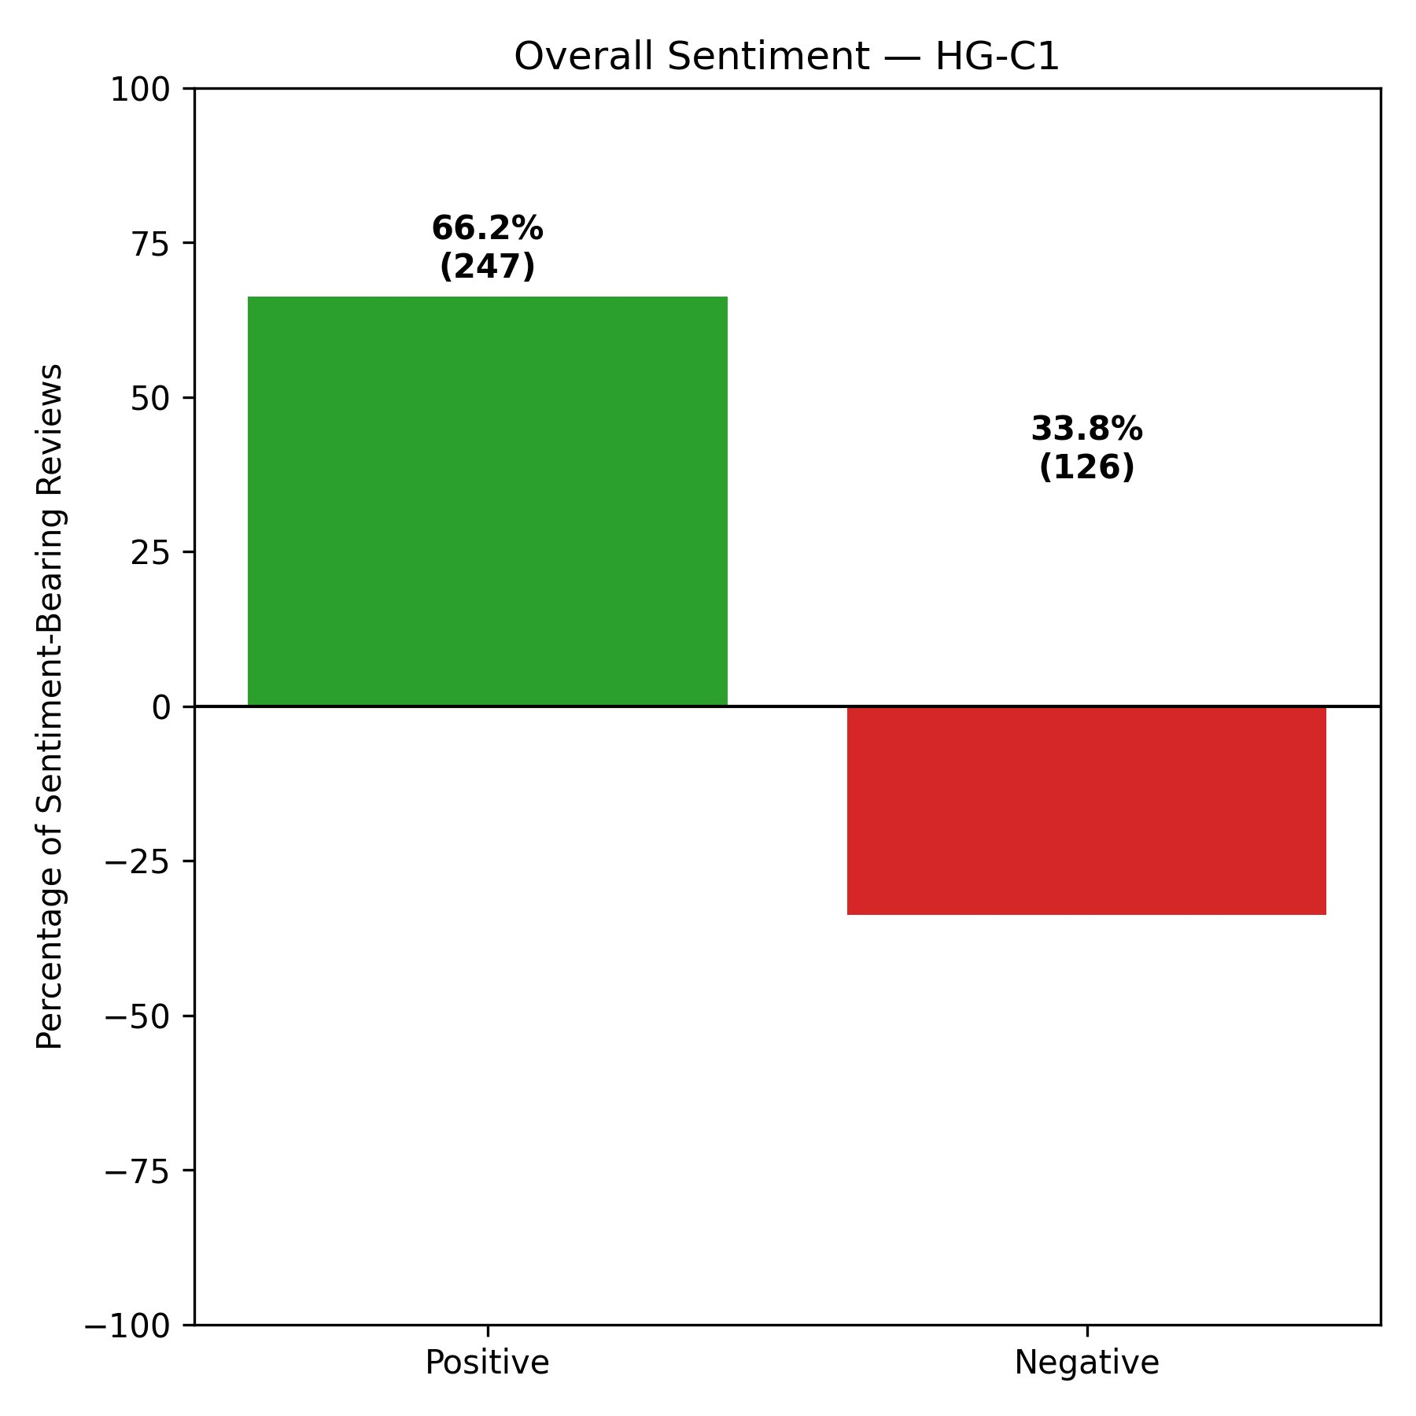
Figure 4.31: Overall Sentiment — HG-C2 (ID, TN)
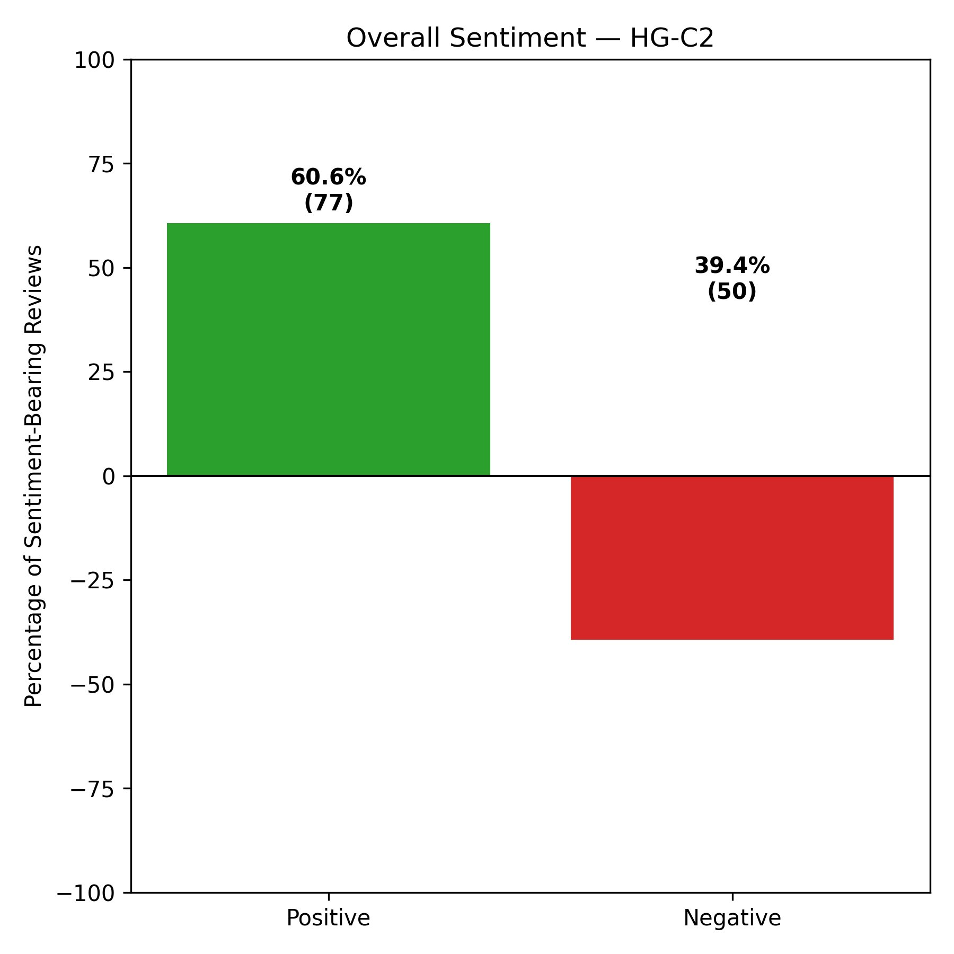
Figure 4.32: Overall Sentiment — HG-C3 (IN, PA, MO, LA)
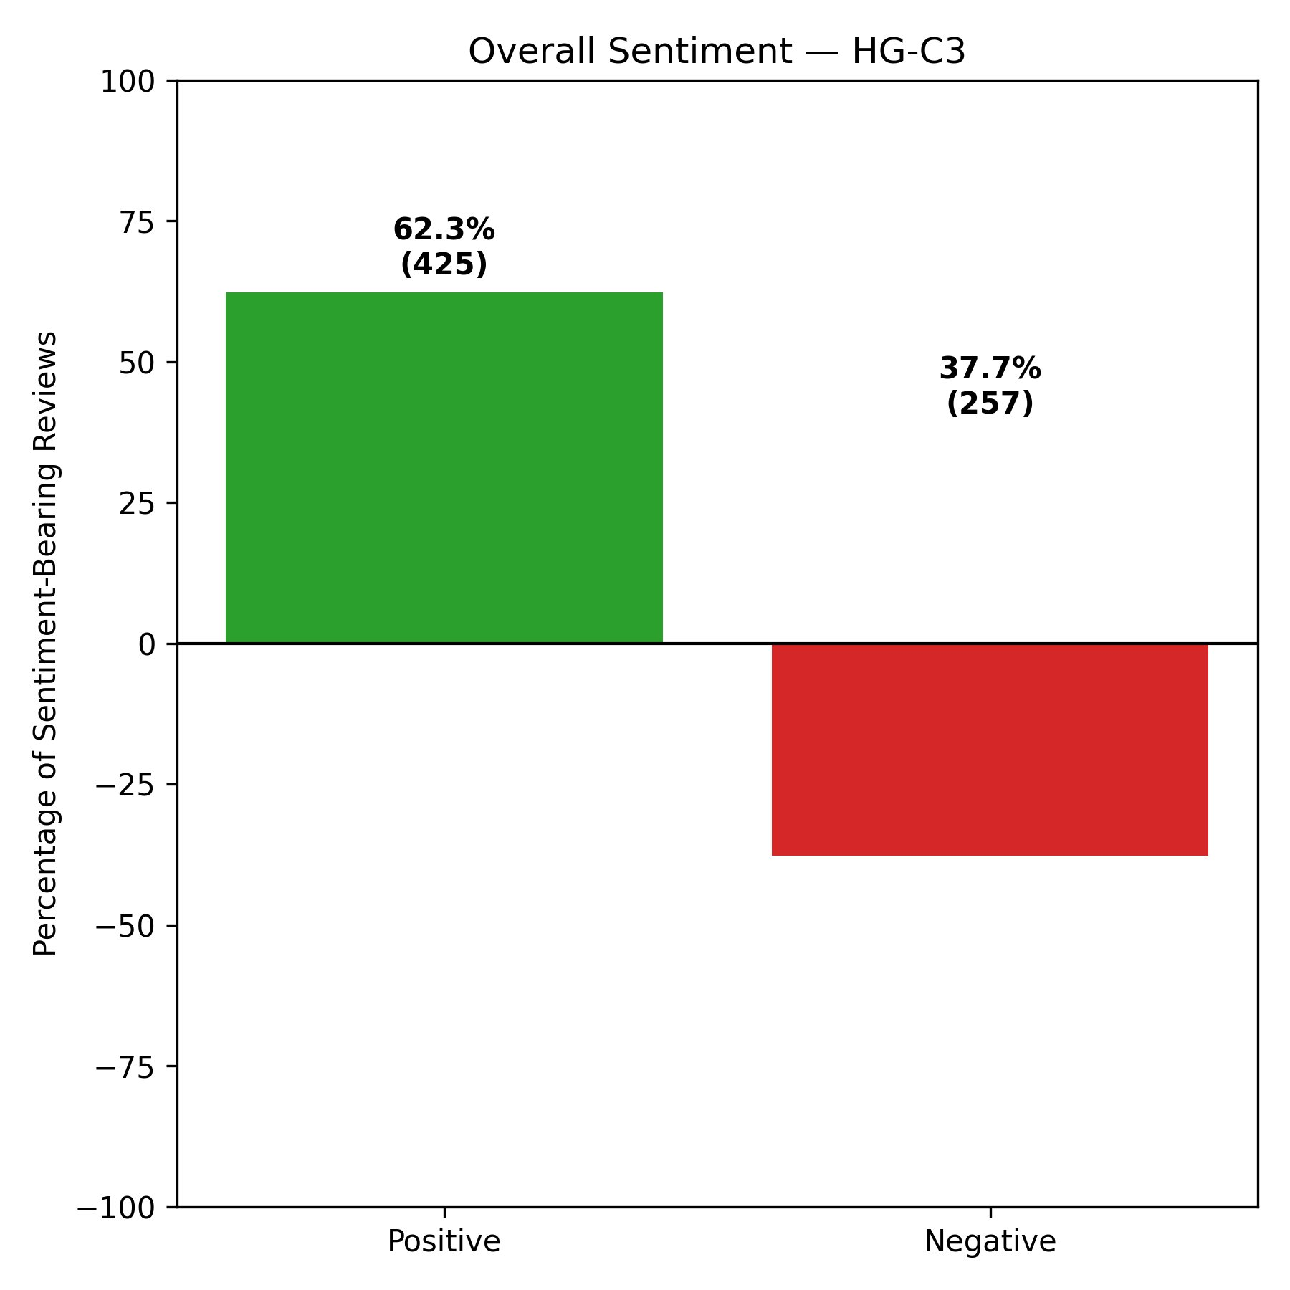
Figure 4.33: Overall Sentiment — S-C1 (ID, IL, LA, PA, TN)
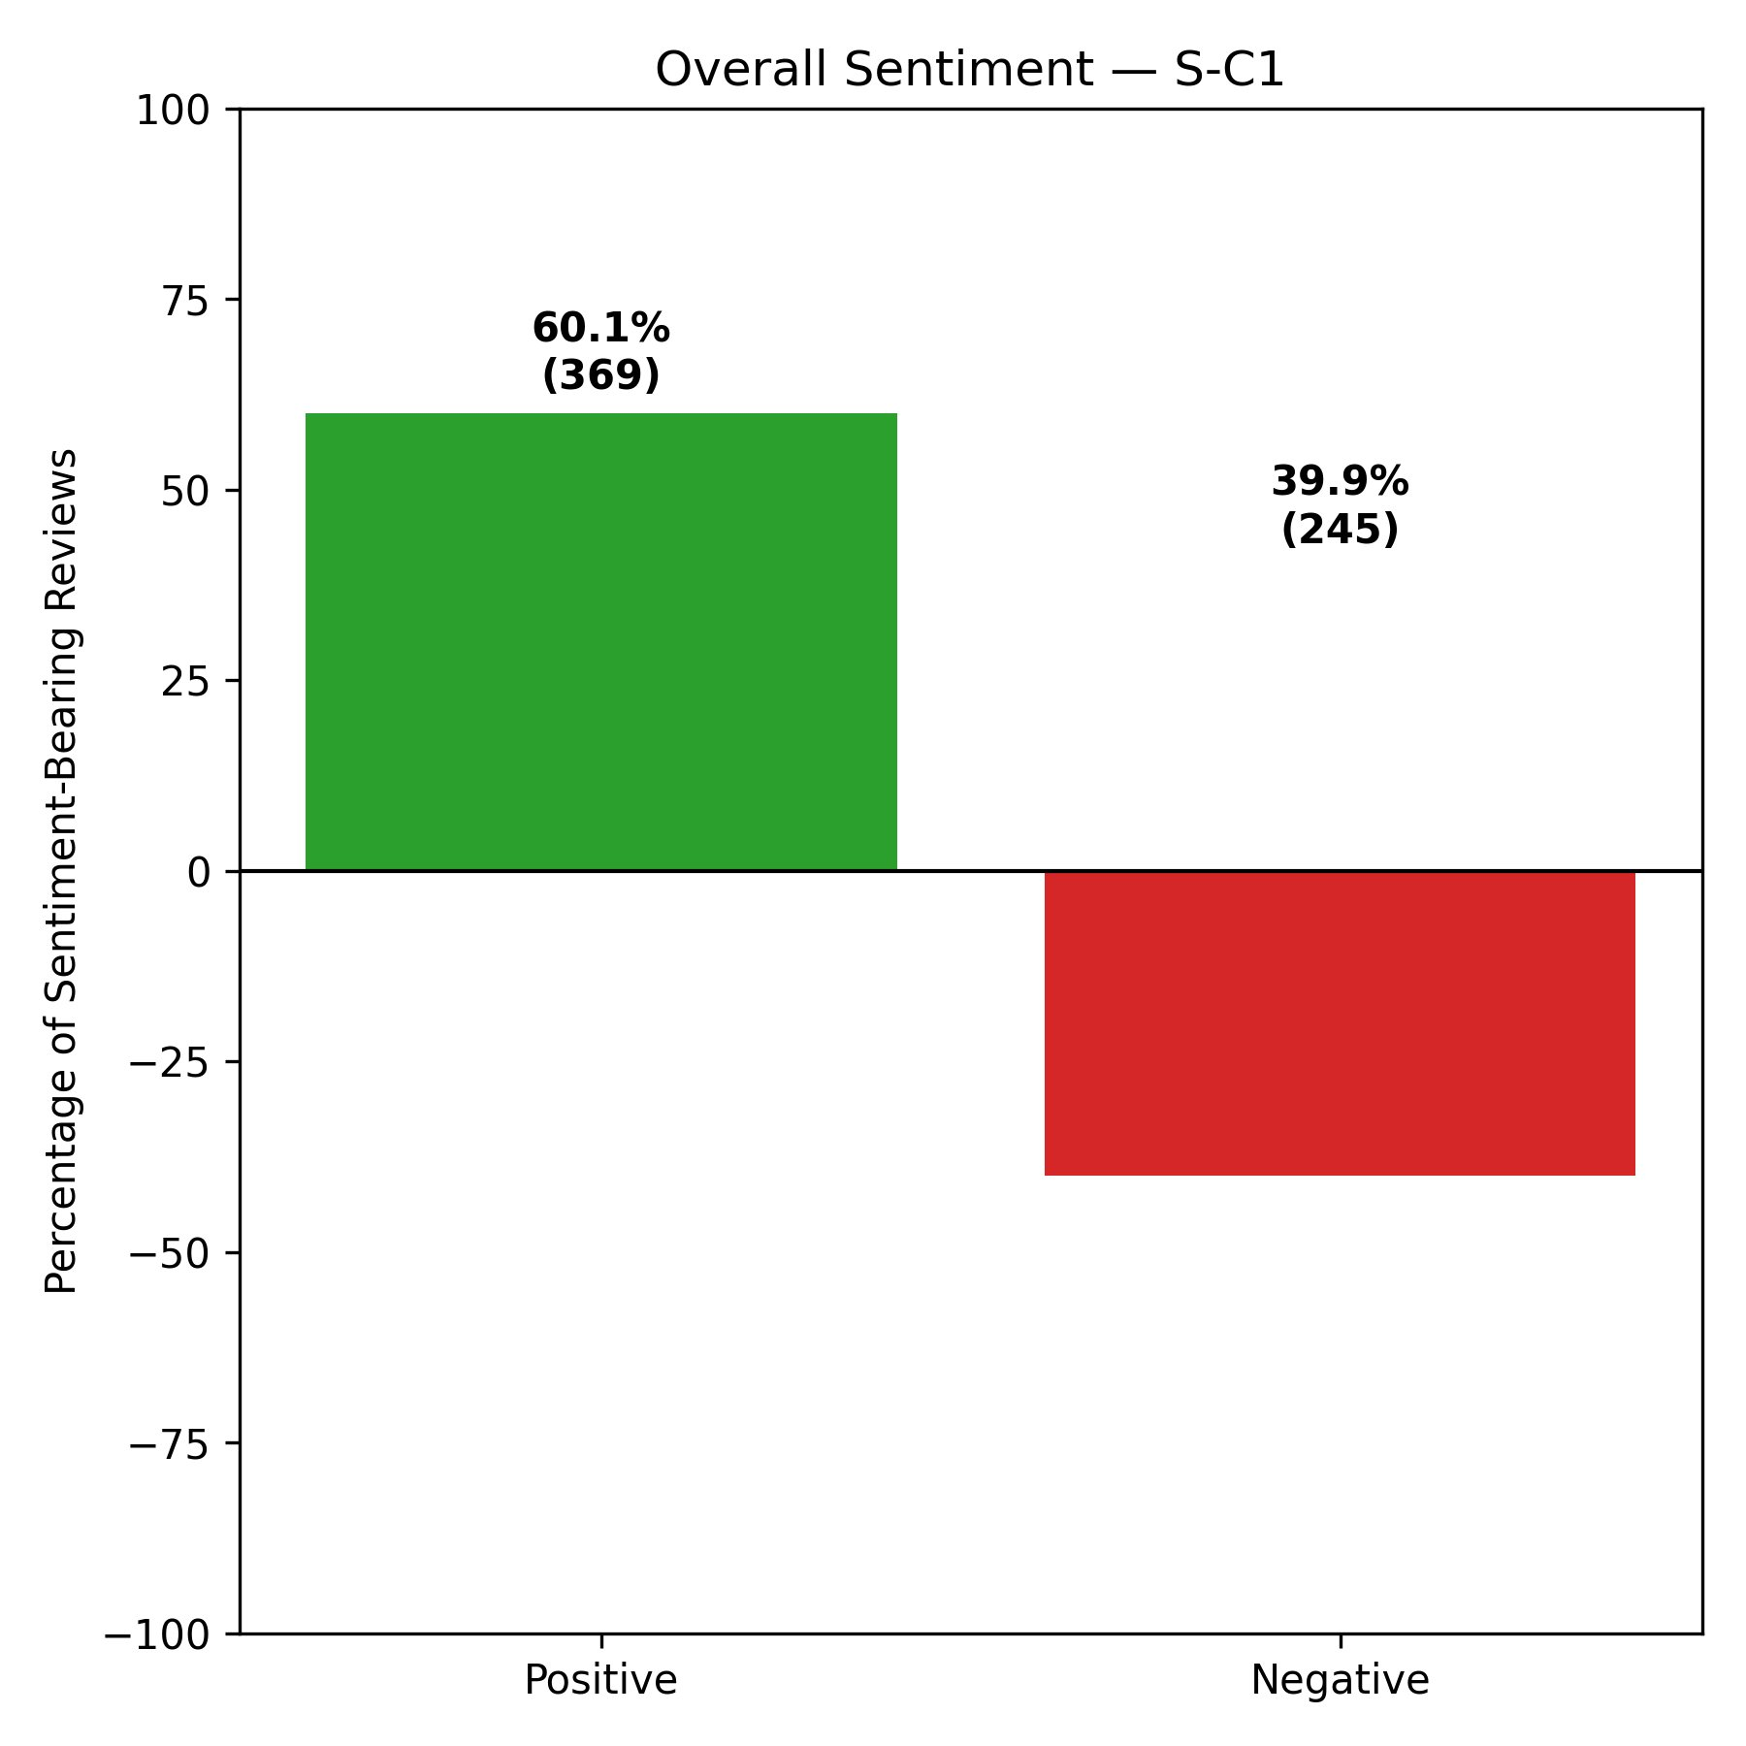
Figure 4.34: Overall Sentiment — S-C2 (AZ, IN, NJ)
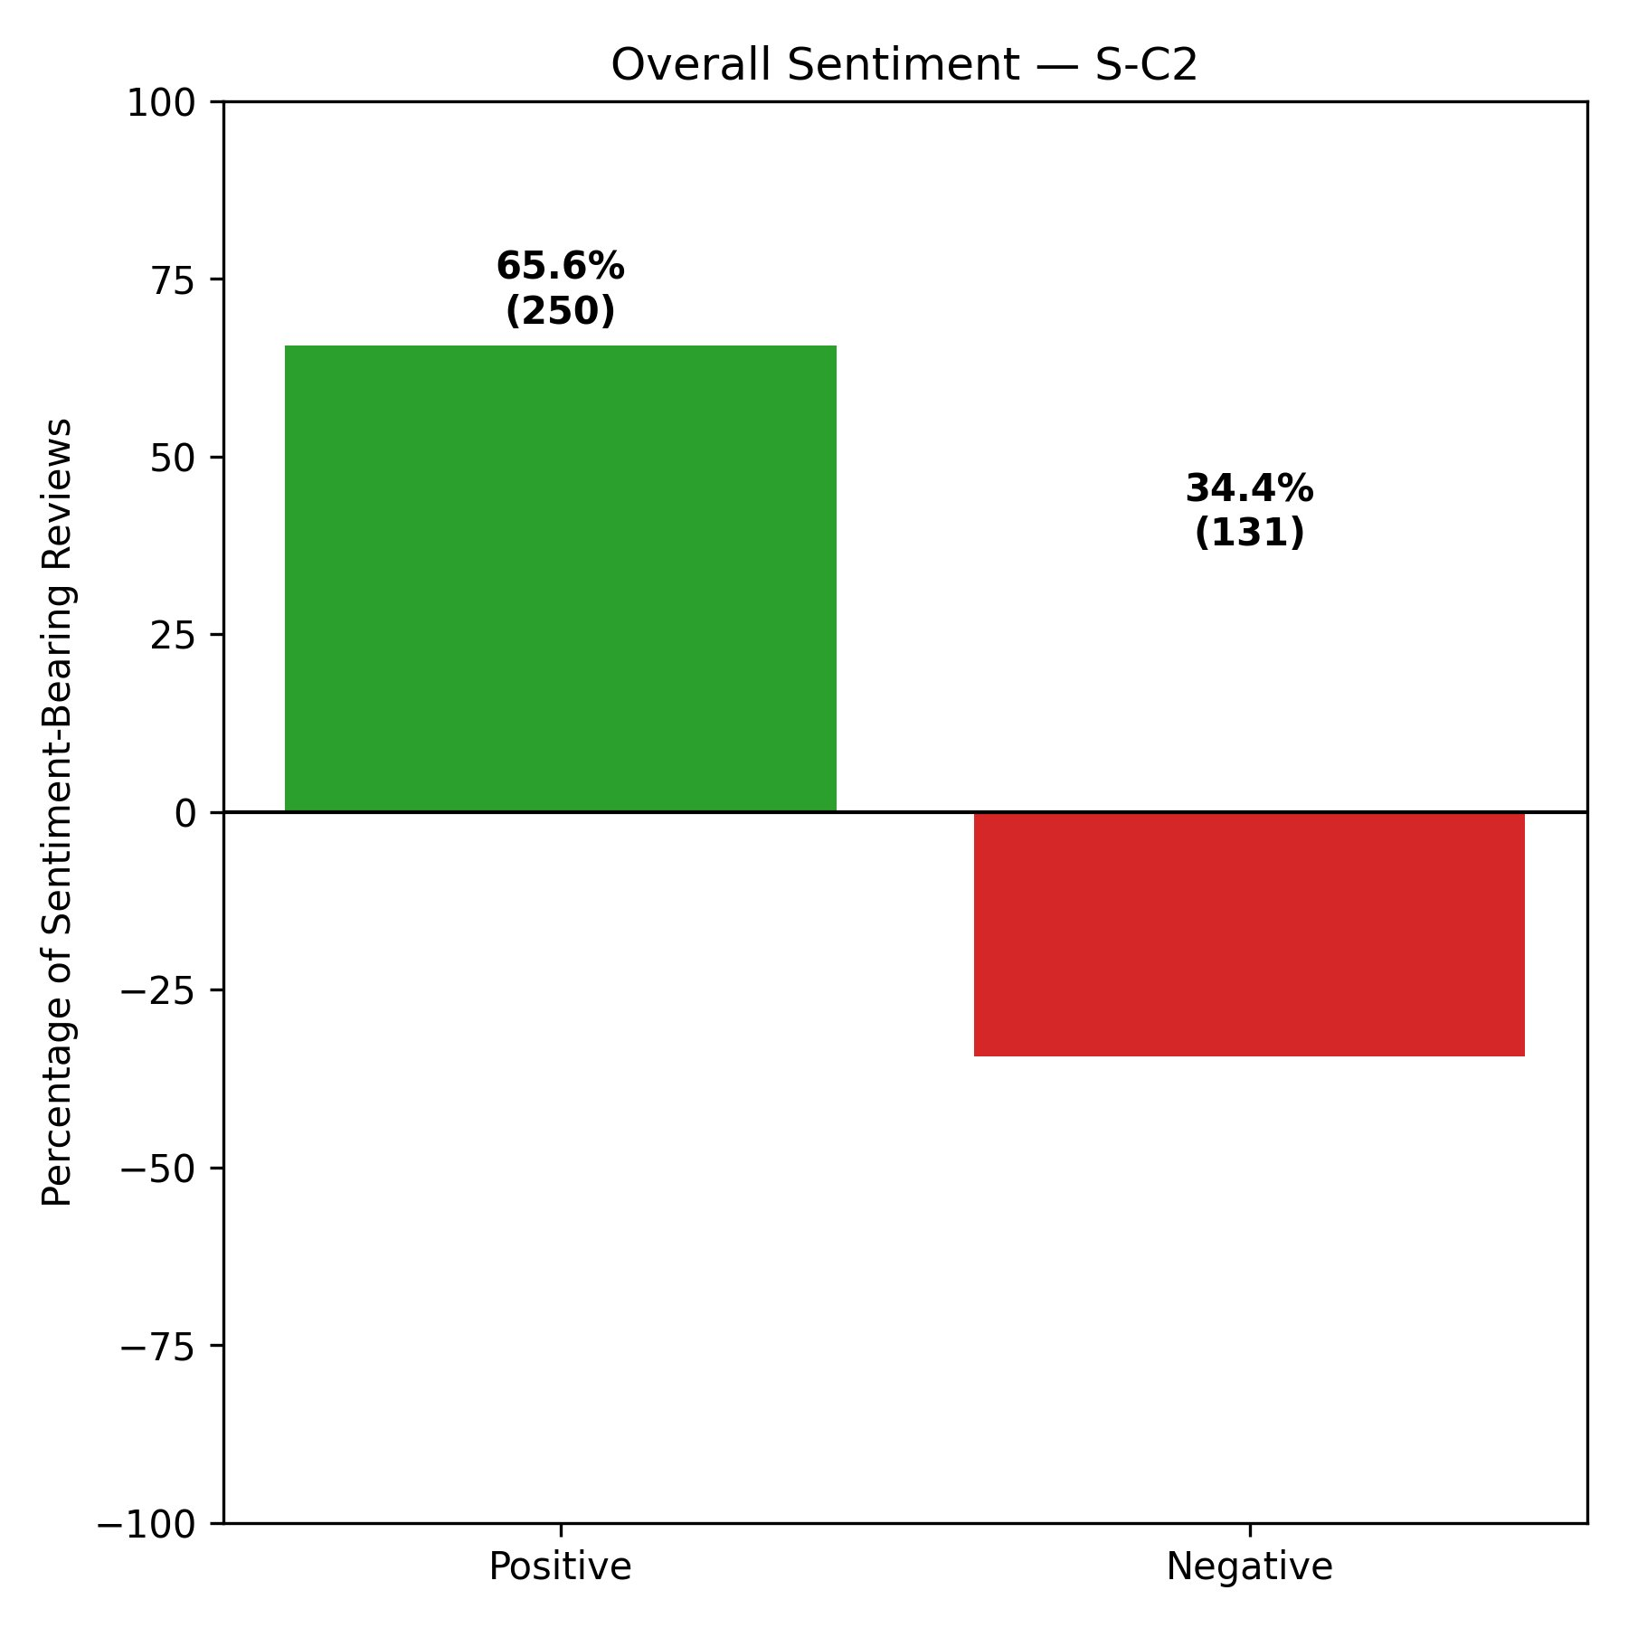
Figure 4.35: Overall Sentiment — S-C3 (FL, MO)
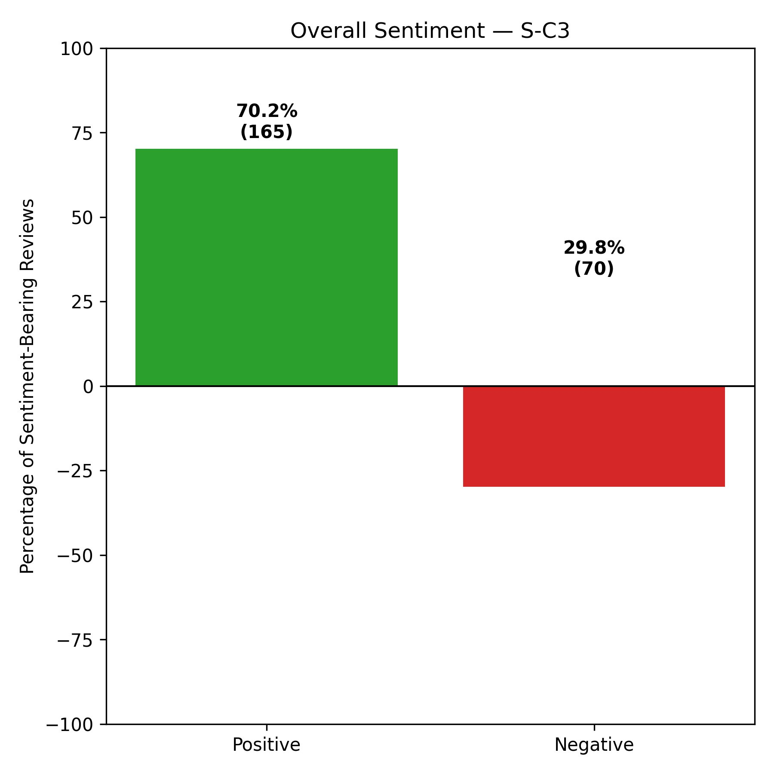
Positive sentiment exceeds negative sentiment in all six clusters. S-C3 records the highest positive rate at 70.2%, followed by HG-C1 at 66.2% and S-C2 at 65.6%. S-C1 and HG-C2 return the lowest positive rates at 60.1% and 60.6% respectively, with correspondingly higher negative proportions. The overall picture is one of net positive patient expression across all clusters, though the degree of positivity varies meaningfully between them.

4.3.2 Attribute Net Scores
Table 4.12 presents the net scores across six healthcare attributes for all clusters, with individual cluster charts in Figures 4.36 through 4.41.
Table 4.12: Attribute Net Scores (%) — All Six Clusters
Cluster | Effectiveness | Wait Time | Staff | Cleanliness | Cost | Communication
HG-C1 | 42.5% | 19.1% | 33.8% | 56.8% | -6.7% | 25.0%
HG-C2 | 25.9% | 5.9% | 29.9% | 28.6% | -29.4% | 23.1%
HG-C3 | 30.2% | 7.5% | 23.2% | 50.0% | -3.4% | 16.3%
S-C1 | 27.5% | 3.6% | 24.8% | 38.5% | -16.2% | 7.5%
S-C2 | 39.8% | 23.1% | 30.4% | 55.6% | 13.7% | 21.4%
S-C3 | 43.1% | 19.3% | 34.6% | 72.4% | -6.7% | 37.9%

Figure 4.36: Attribute Net Scores — HG-C1 (AZ, FL, NJ, IL)
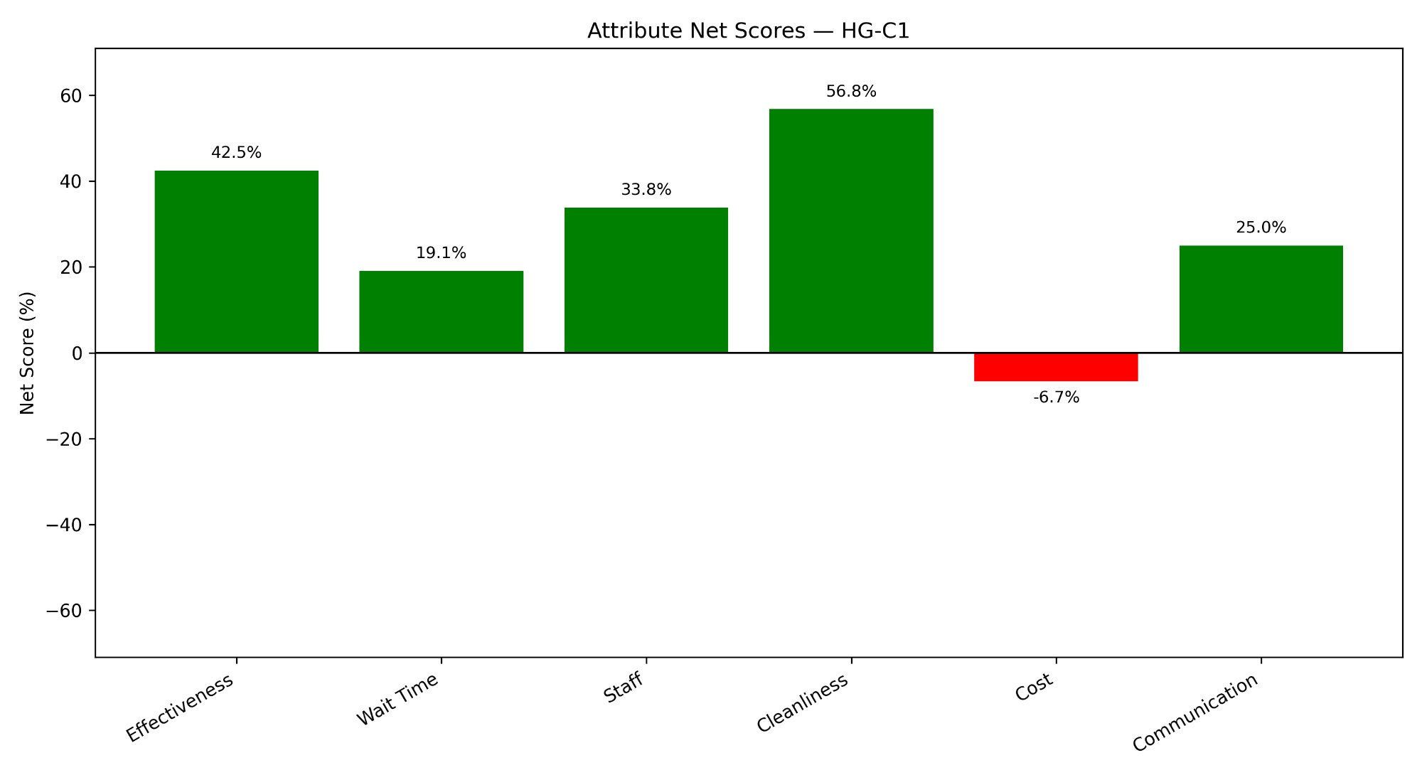
Figure 4.37: Attribute Net Scores — HG-C2 (ID, TN)
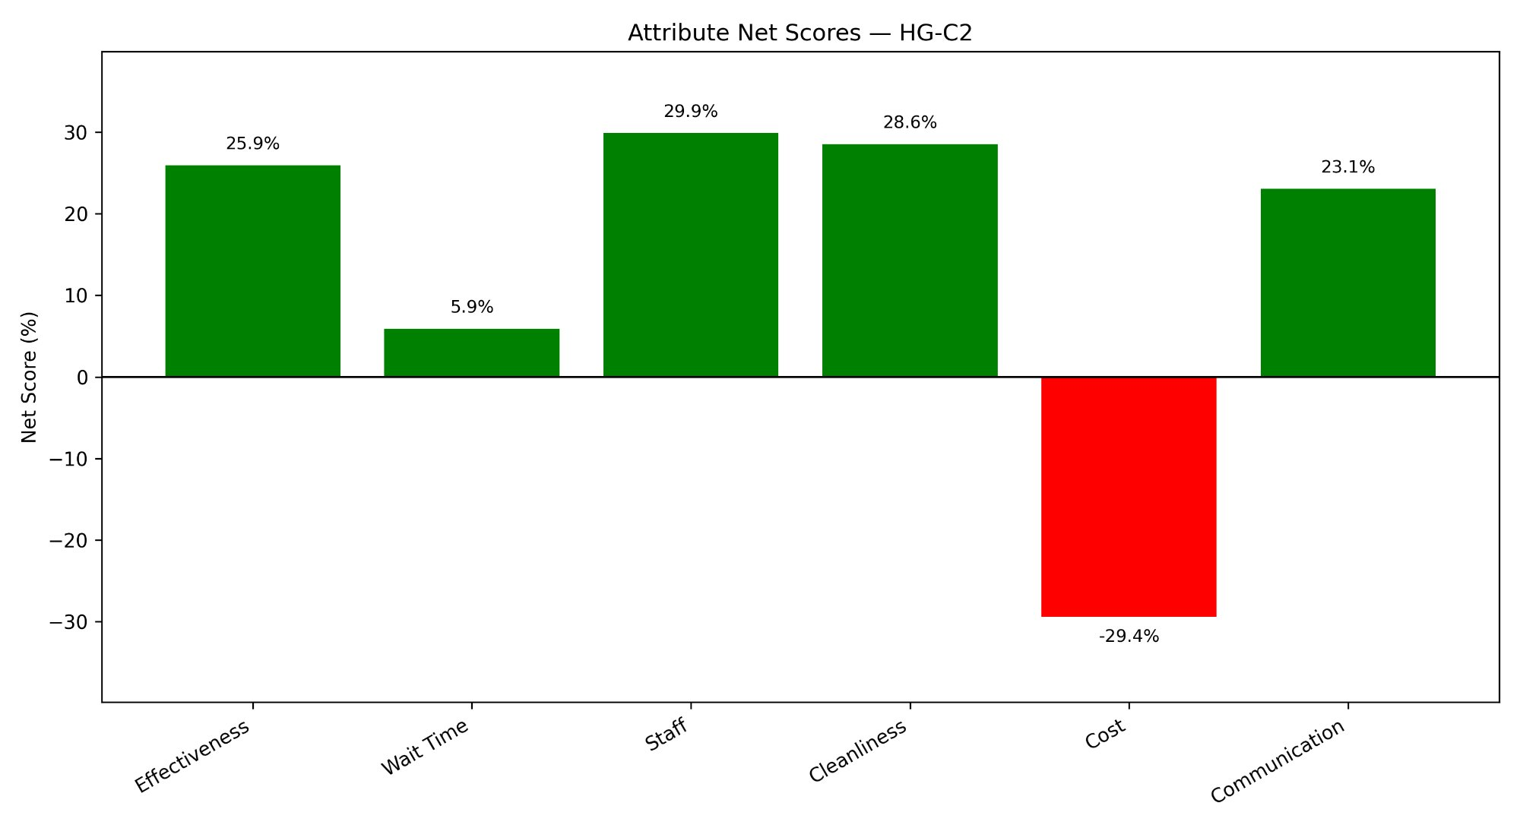
Figure 4.38: Attribute Net Scores — HG-C3 (IN, PA, MO, LA)
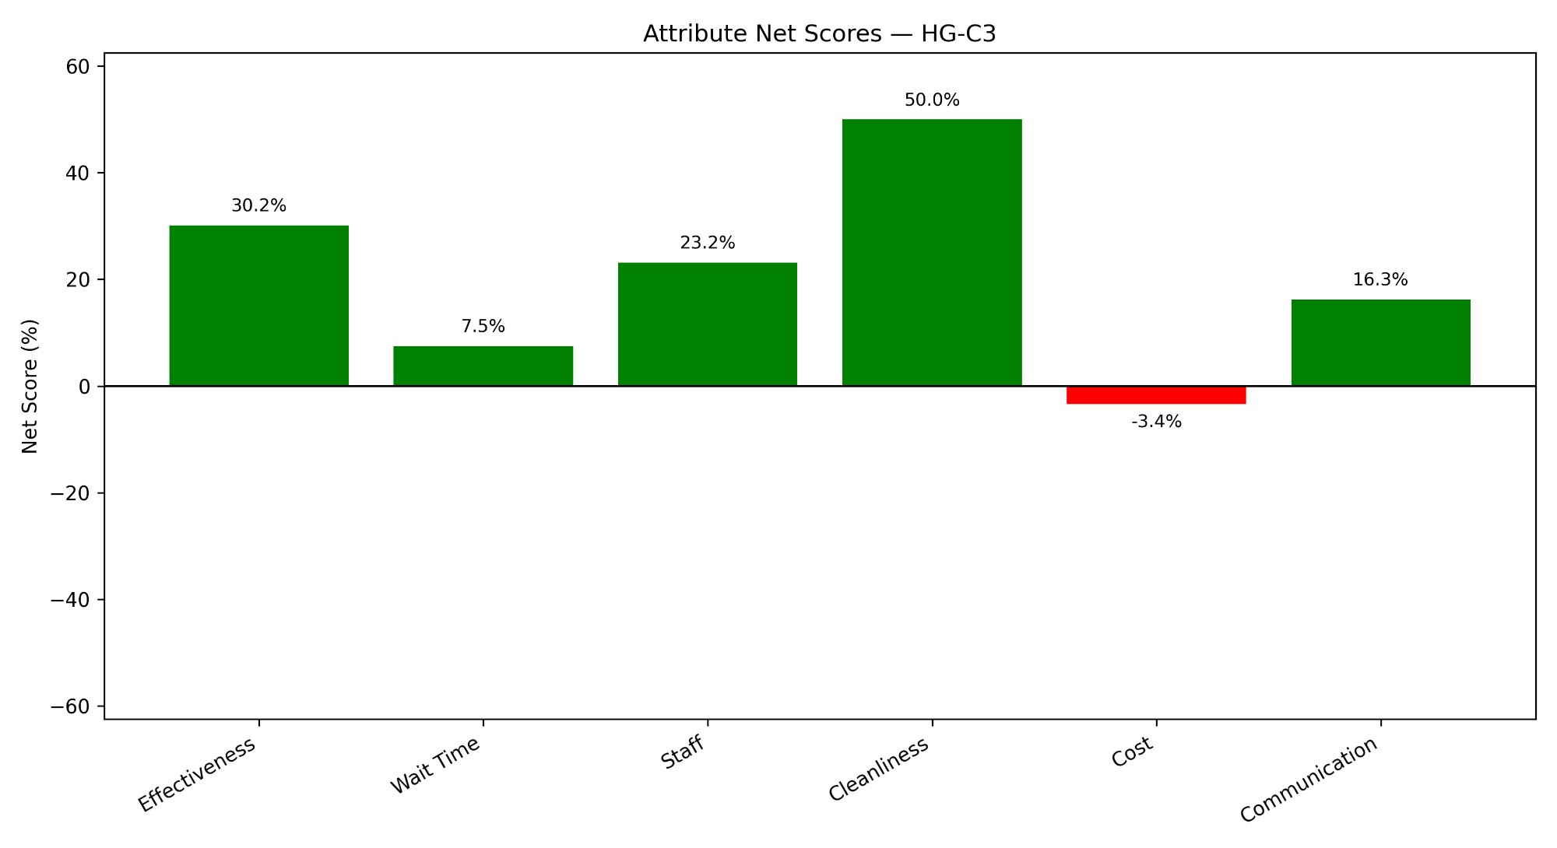
Figure 4.39: Attribute Net Scores — S-C1 (ID, IL, LA, PA, TN)
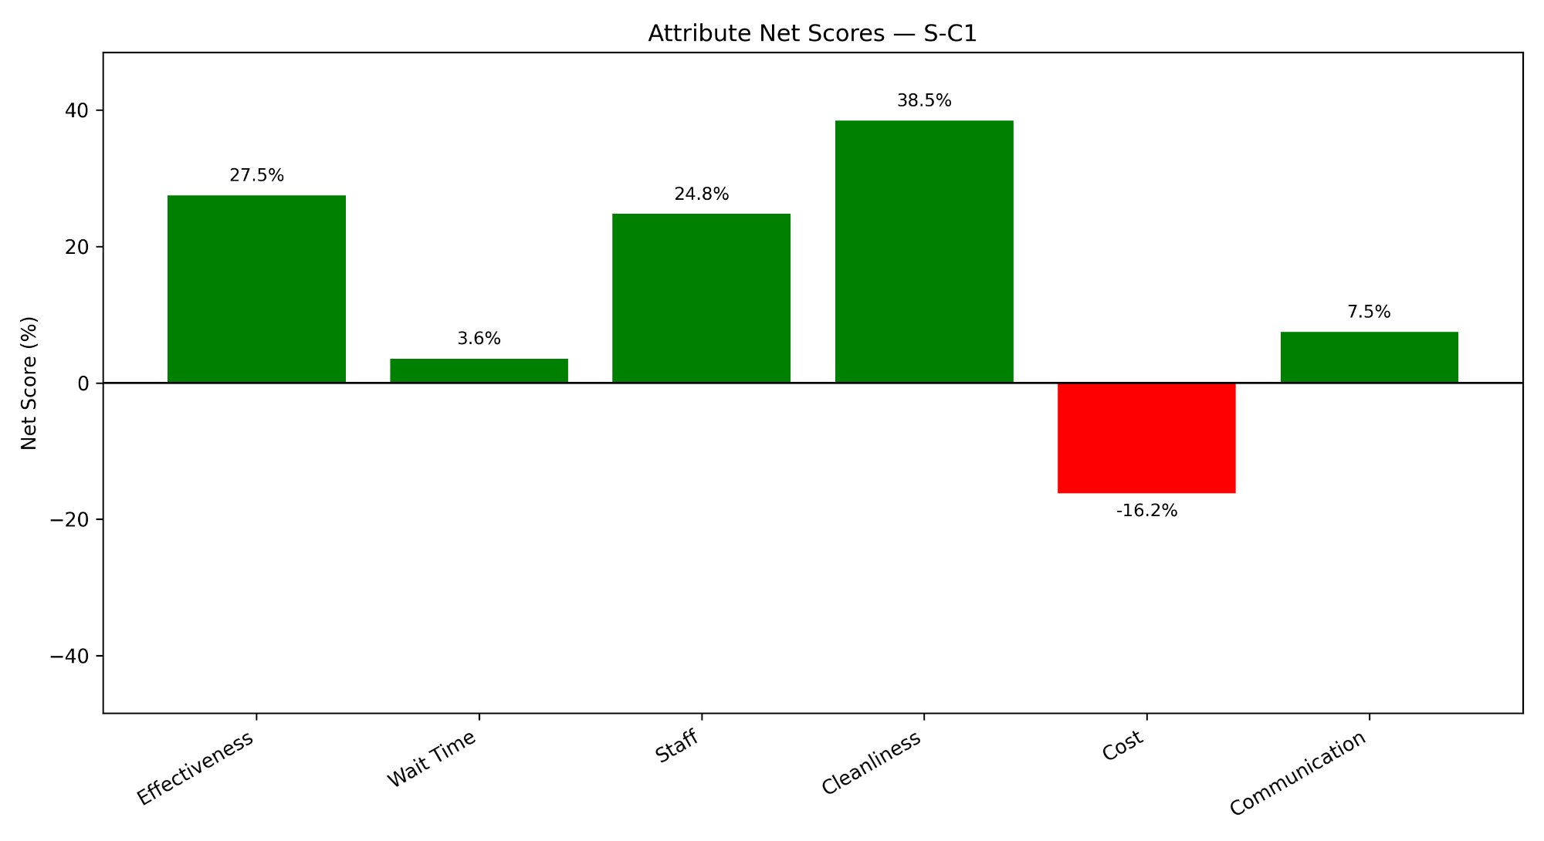
Figure 4.40: Attribute Net Scores — S-C2 (AZ, IN, NJ)
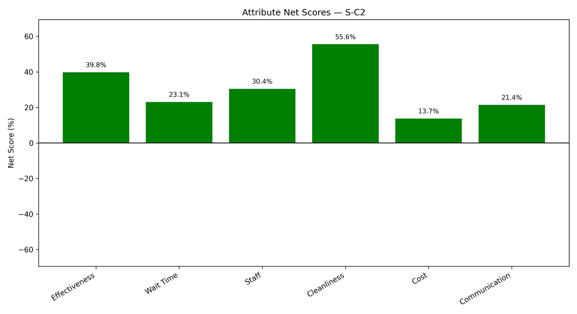
Figure 4.41: Attribute Net Scores — S-C3 (FL, MO)
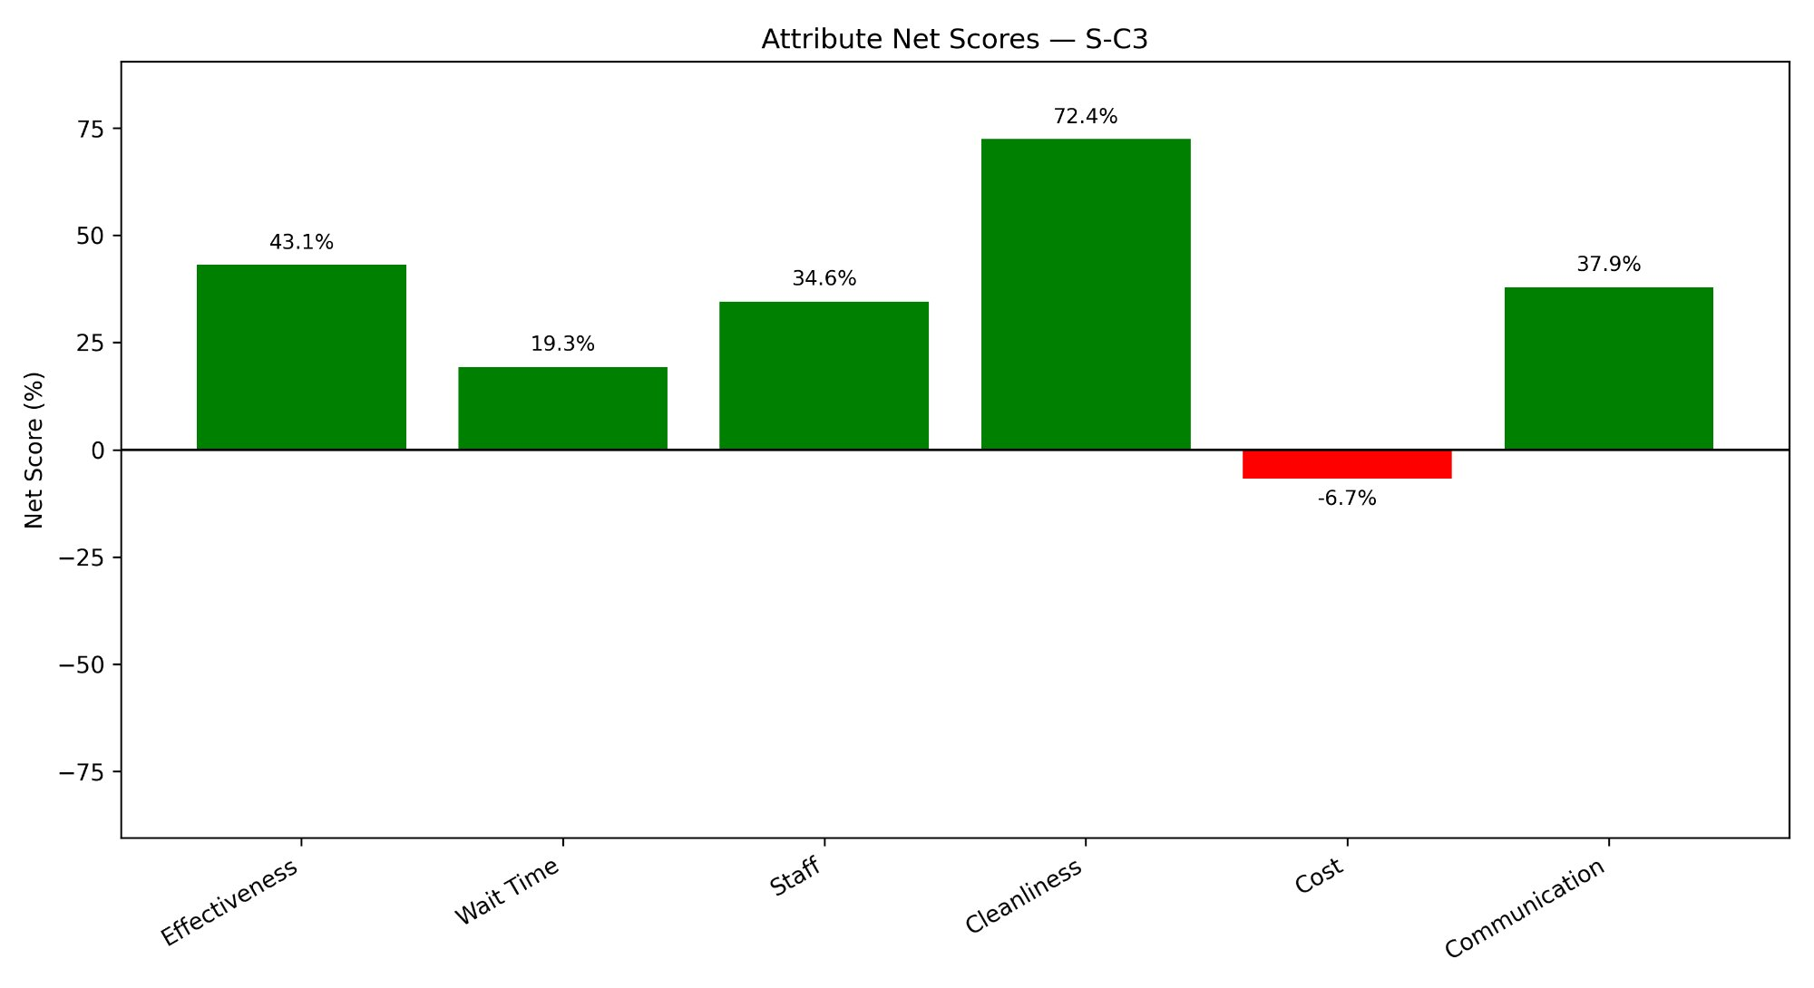
Cleanliness consistently returns the highest positive net score in every cluster, peaking at 72.4% in S-C3. Cost is the only attribute with a negative net score in five of the six clusters, indicating that financial mentions in patient reviews are more often unfavourable than favourable. HG-C2 shows the most pronounced negative Cost score at -29.4%, nearly double the next most negative cluster. S-C2 is the sole exception, returning a positive Cost net score of 13.7%, the only cluster where patients viewed cost-related aspects favourably on balance. S-C3 achieves the highest scores across almost every attribute, reinforcing its position as the strongest-performing cluster across all sentiment dimensions.

4.3.3 Emotion Analysis
Figures 4.42 through 4.47 show emotion counts and Figures 4.48 through 4.53 show emotion distribution percentages for each cluster.
Figure 4.42: Emotion Counts — HG-C1
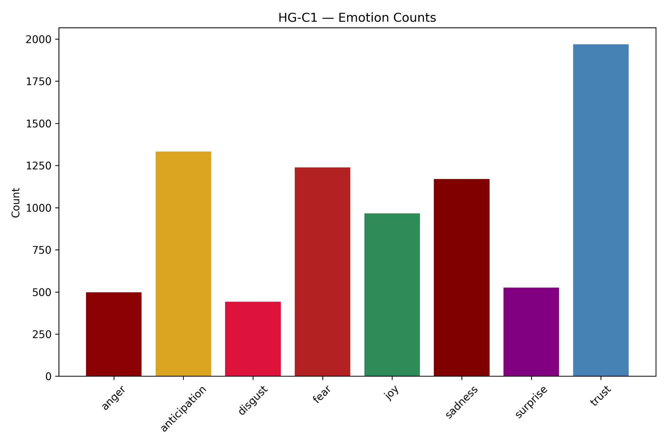
Figure 4.43: Emotion Counts — HG-C2
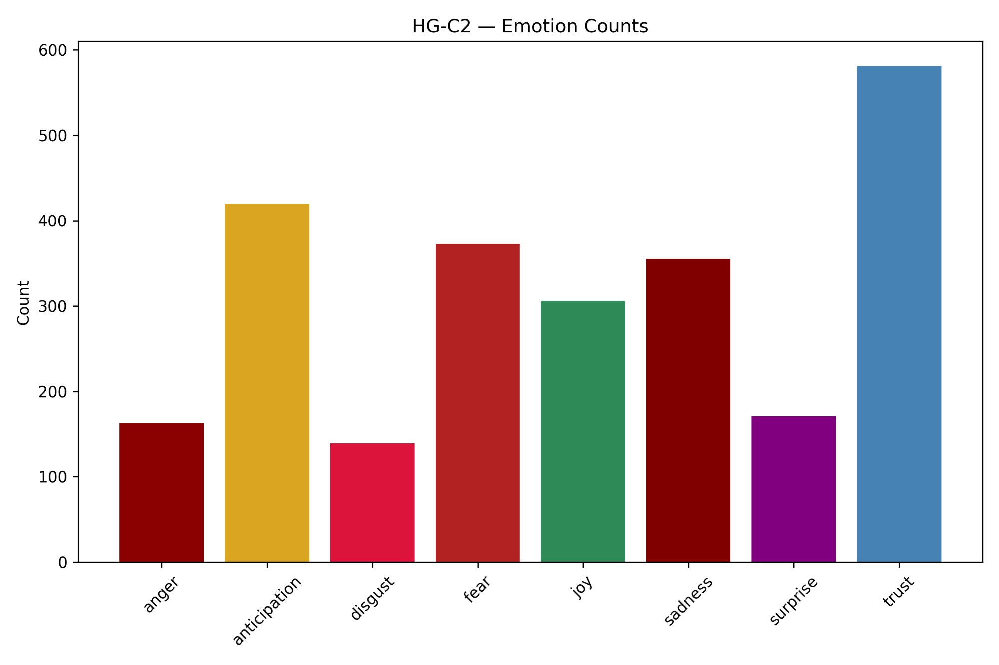
Figure 4.44: Emotion Counts — HG-C3
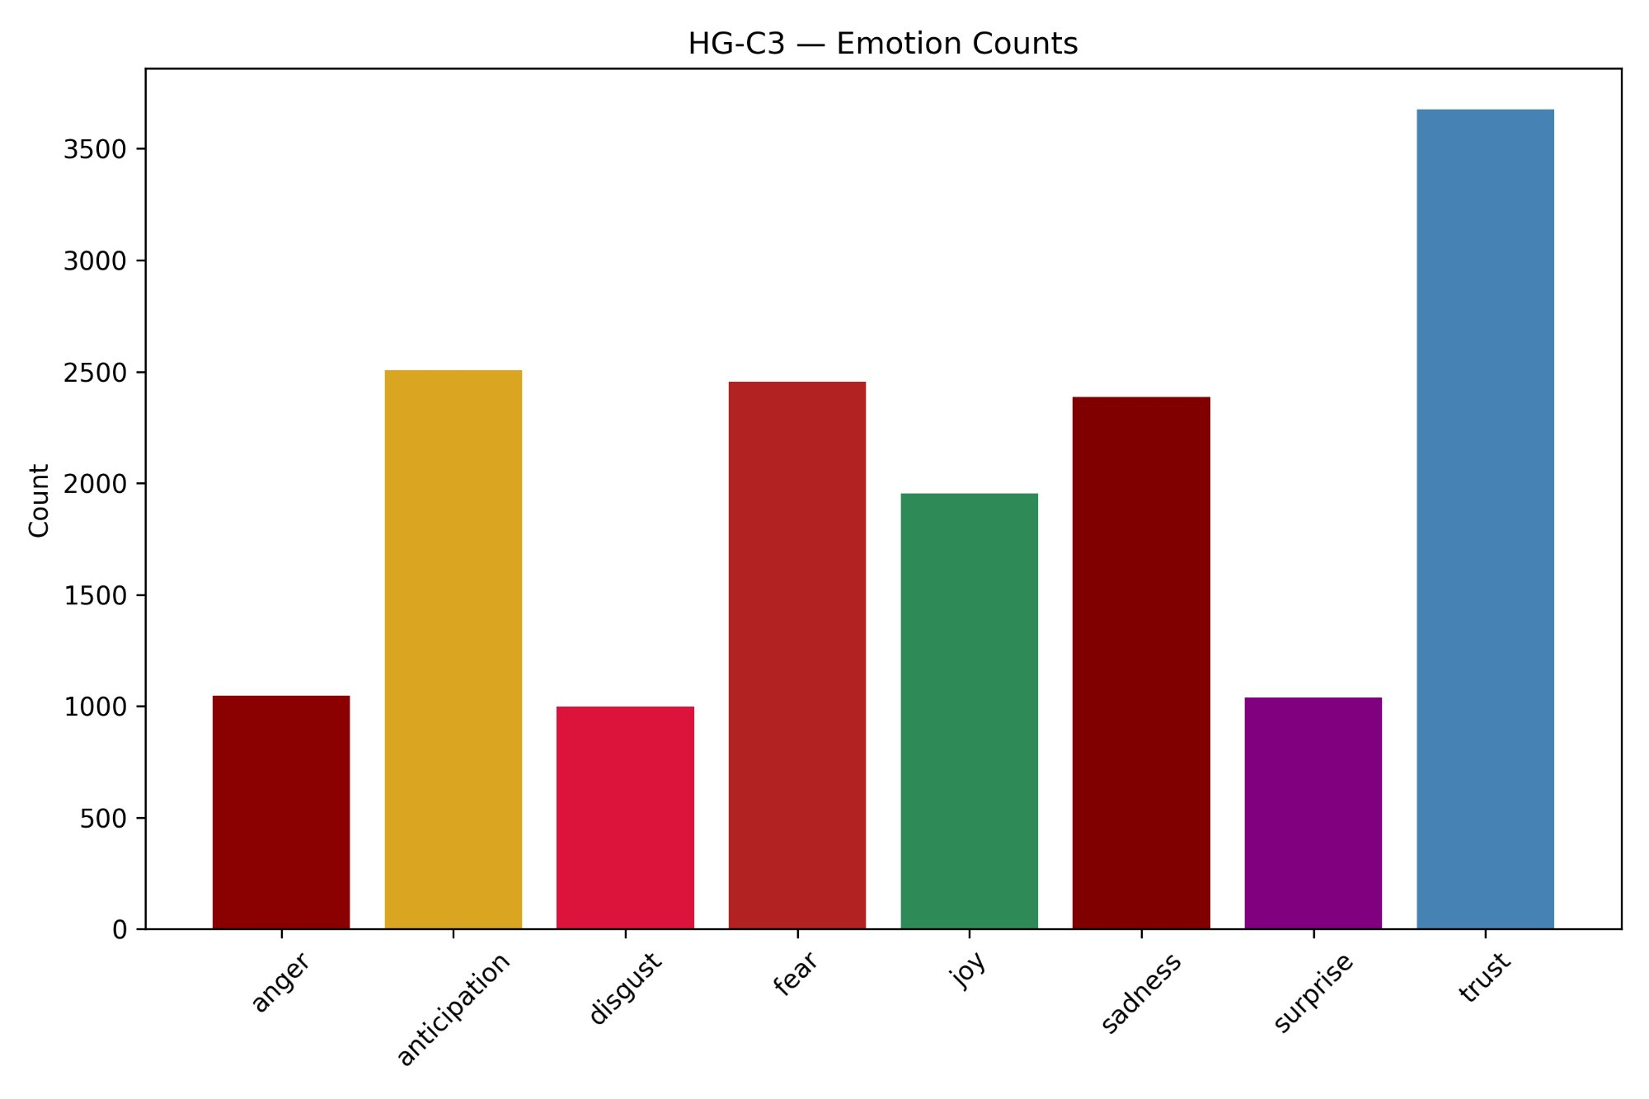
Figure 4.45: Emotion Counts — S-C1
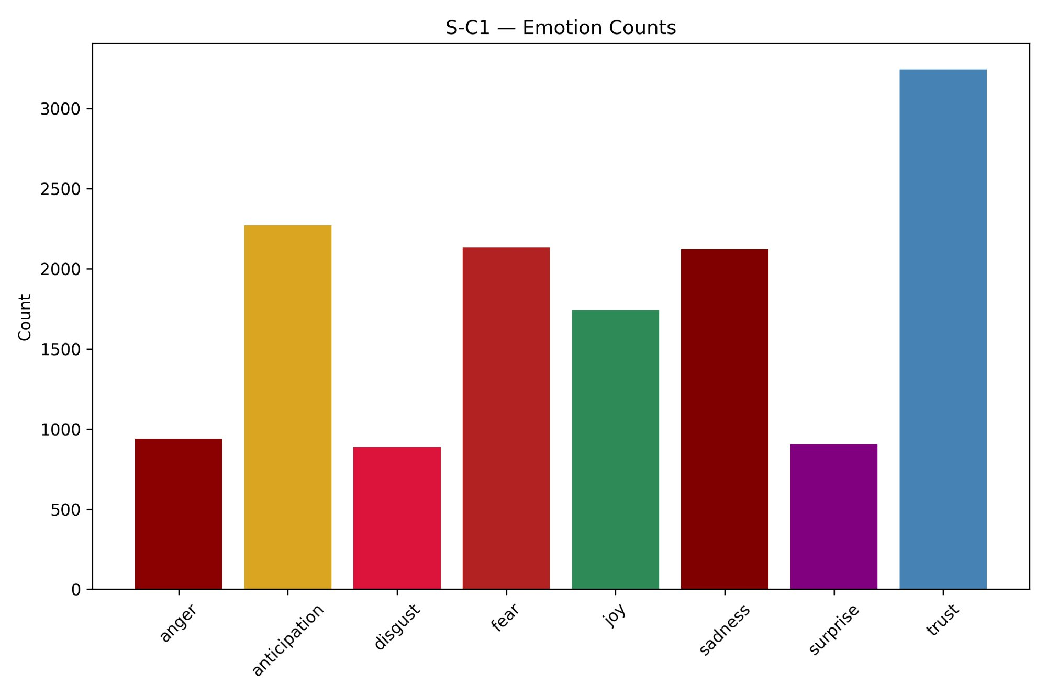
Figure 4.46: Emotion Counts — S-C2
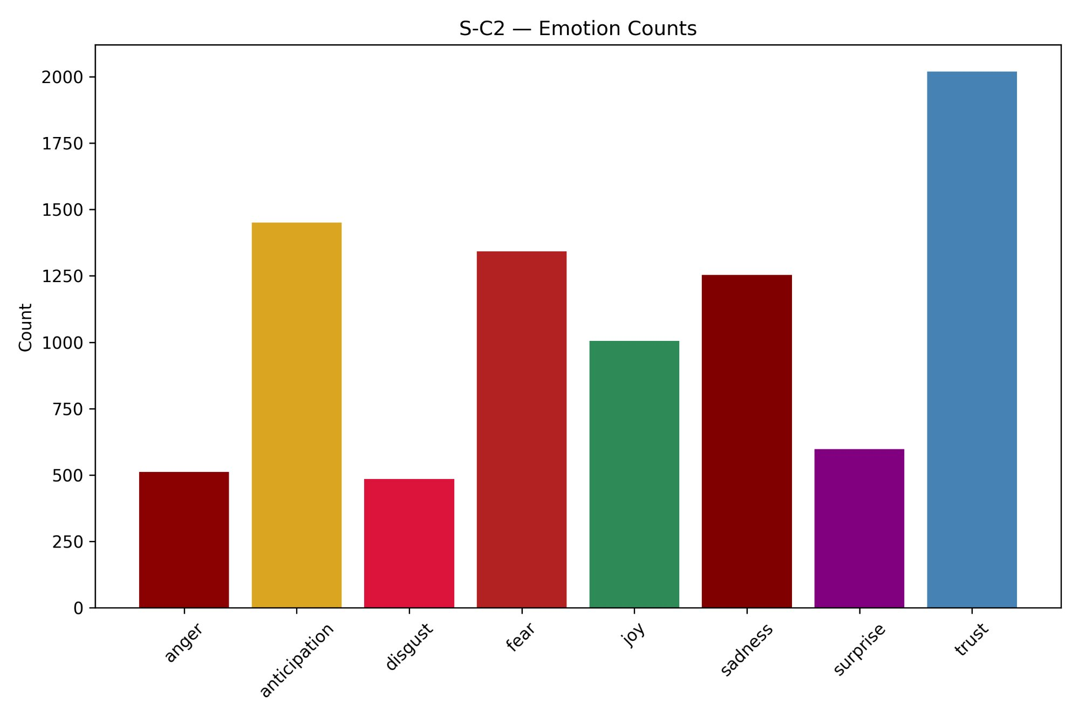
Figure 4.47: Emotion Counts — S-C3
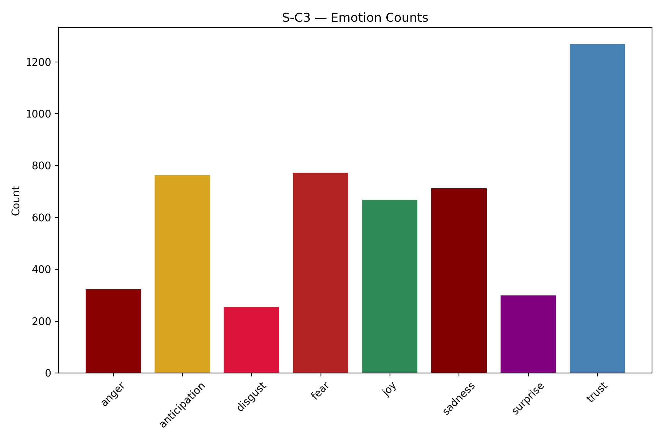
Figure 4.48: Emotion Distribution — HG-C1
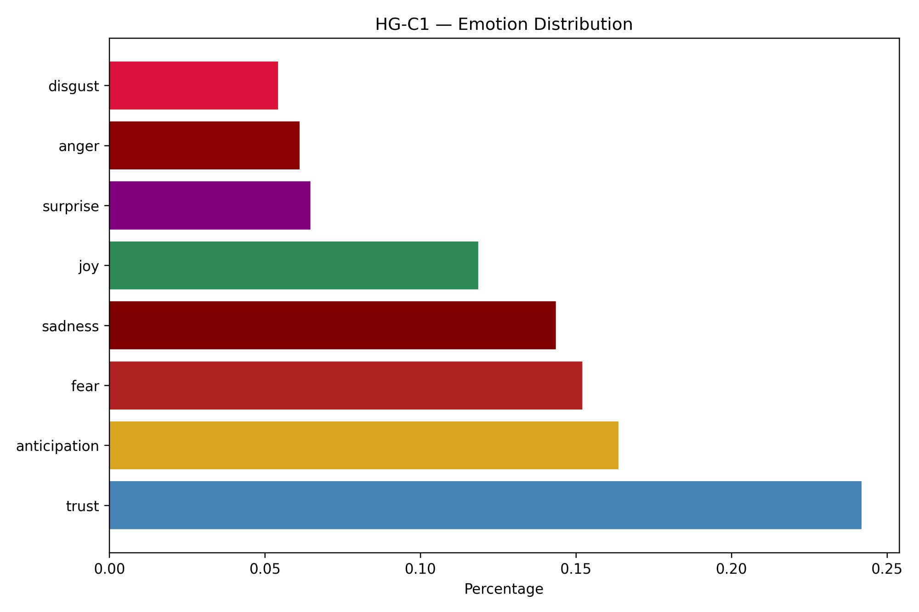
Figure 4.49: Emotion Distribution — HG-C2
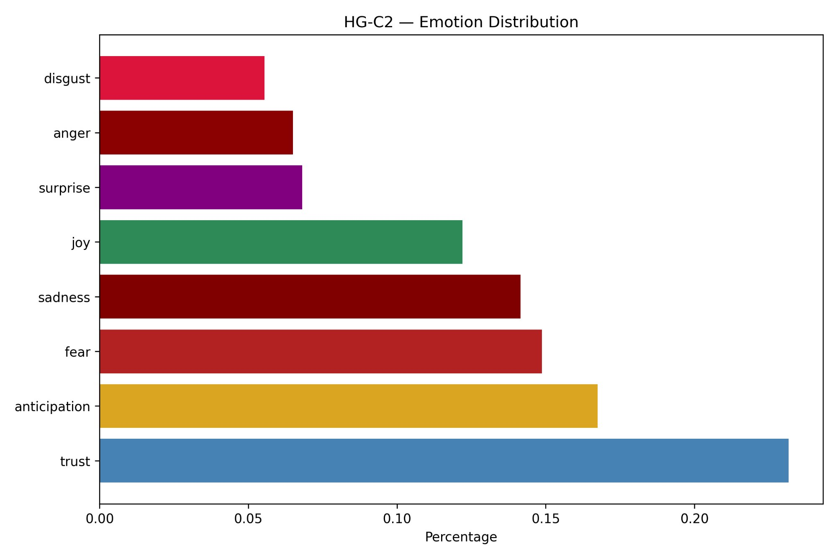
Figure 4.50: Emotion Distribution — HG-C3
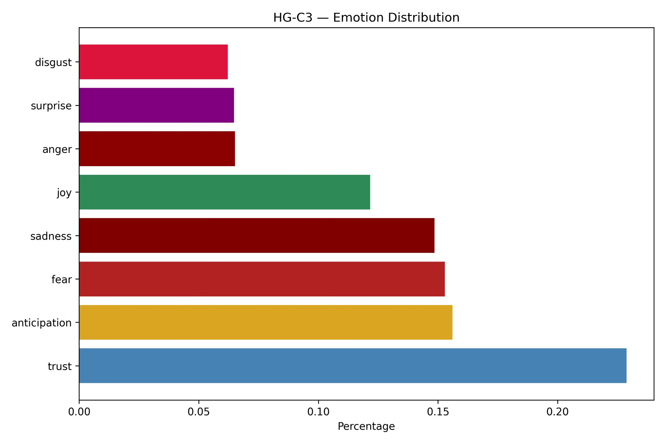
Figure 4.51: Emotion Distribution — S-C1
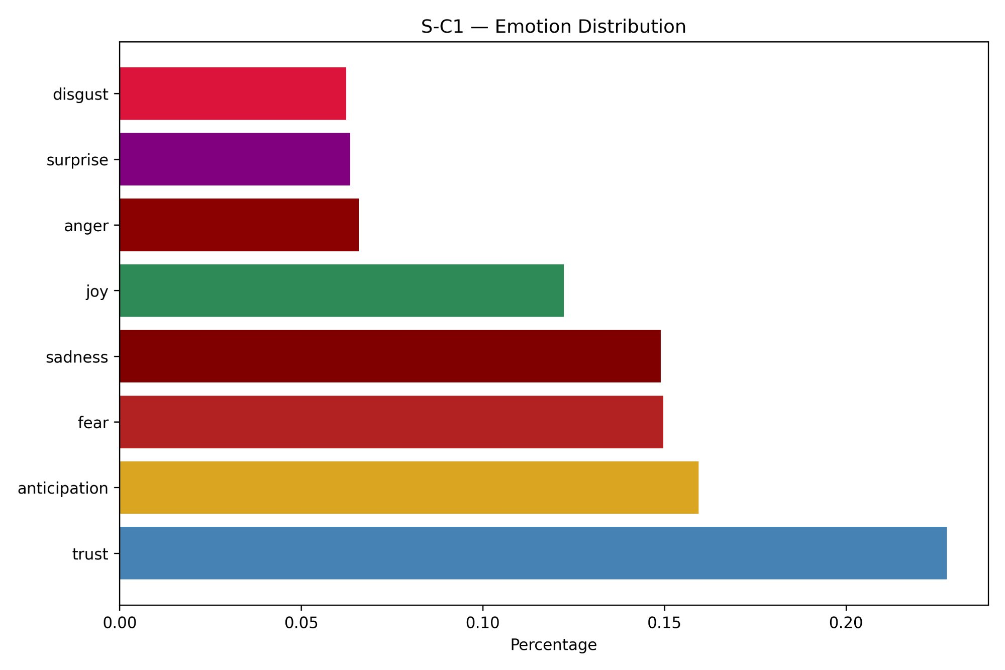
Figure 4.52: Emotion Distribution — S-C2
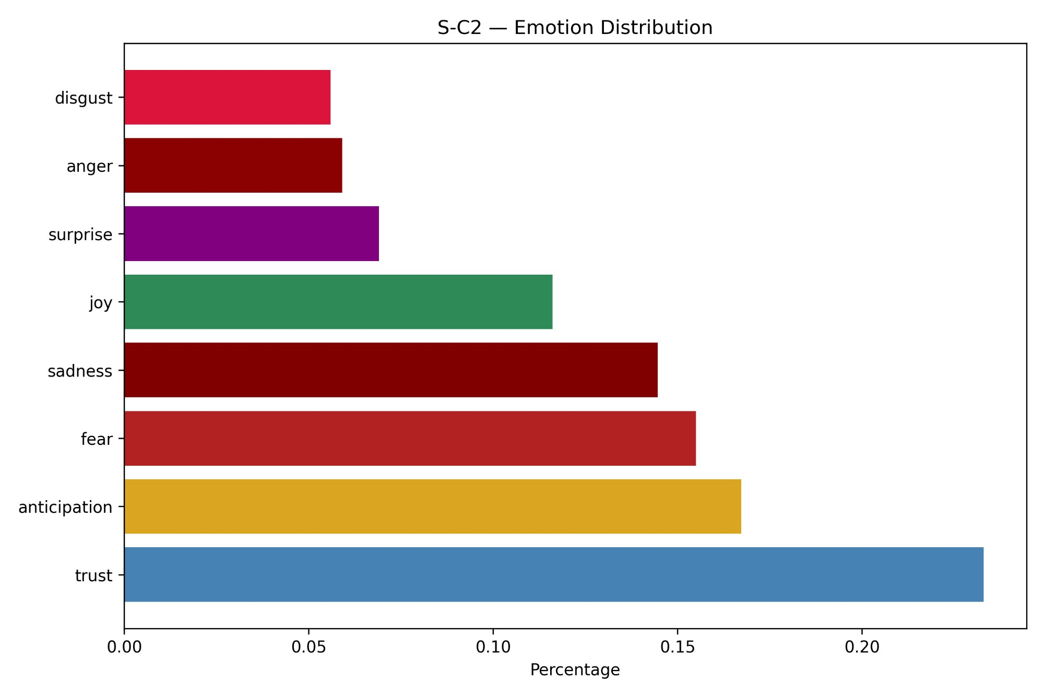
Figure 4.53: Emotion Distribution — S-C3
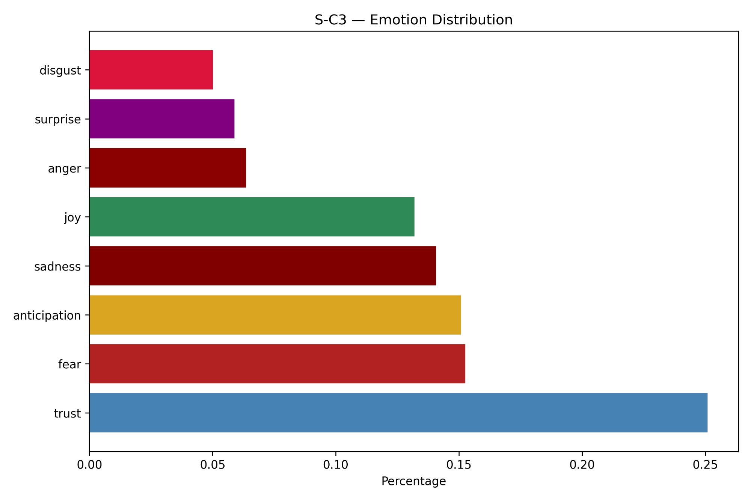
Trust is the dominant emotion in every cluster, accounting for approximately 23% to 25% of all emotion-bearing words, followed by anticipation at around 16% to 17%. Fear and sadness each contribute approximately 14% to 15%, reflecting the inherent emotional weight of healthcare experiences even in predominantly positive reviews. Joy sits at around 12% and anger, surprise, and disgust each contribute 5% to 7%. The emotion ordering is virtually identical across all six clusters. S-C3 shows the highest trust proportion at approximately 25% and the lowest disgust at approximately 5%, making it the most emotionally positive cluster in relative terms. The persistent presence of fear and sadness across all clusters — collectively accounting for about 29% of all emotion words — is consistent with the anxiety and vulnerability that patients commonly associate with hospital visits regardless of the overall sentiment of their review.

4.3.4 Passion Index
Figure 4.54 presents the Passion Index bubble chart. The crosshairs are positioned at the mean values of polarity and intensity across all six clusters, dividing the chart into four quadrants: LIKE (high polarity, low intensity), LOVE (high polarity, high intensity), DISLIKE (low polarity, low intensity), and HATE (low polarity, high intensity).
Figure 4.54: Passion Index — Cluster-wise Sentiment Positioning
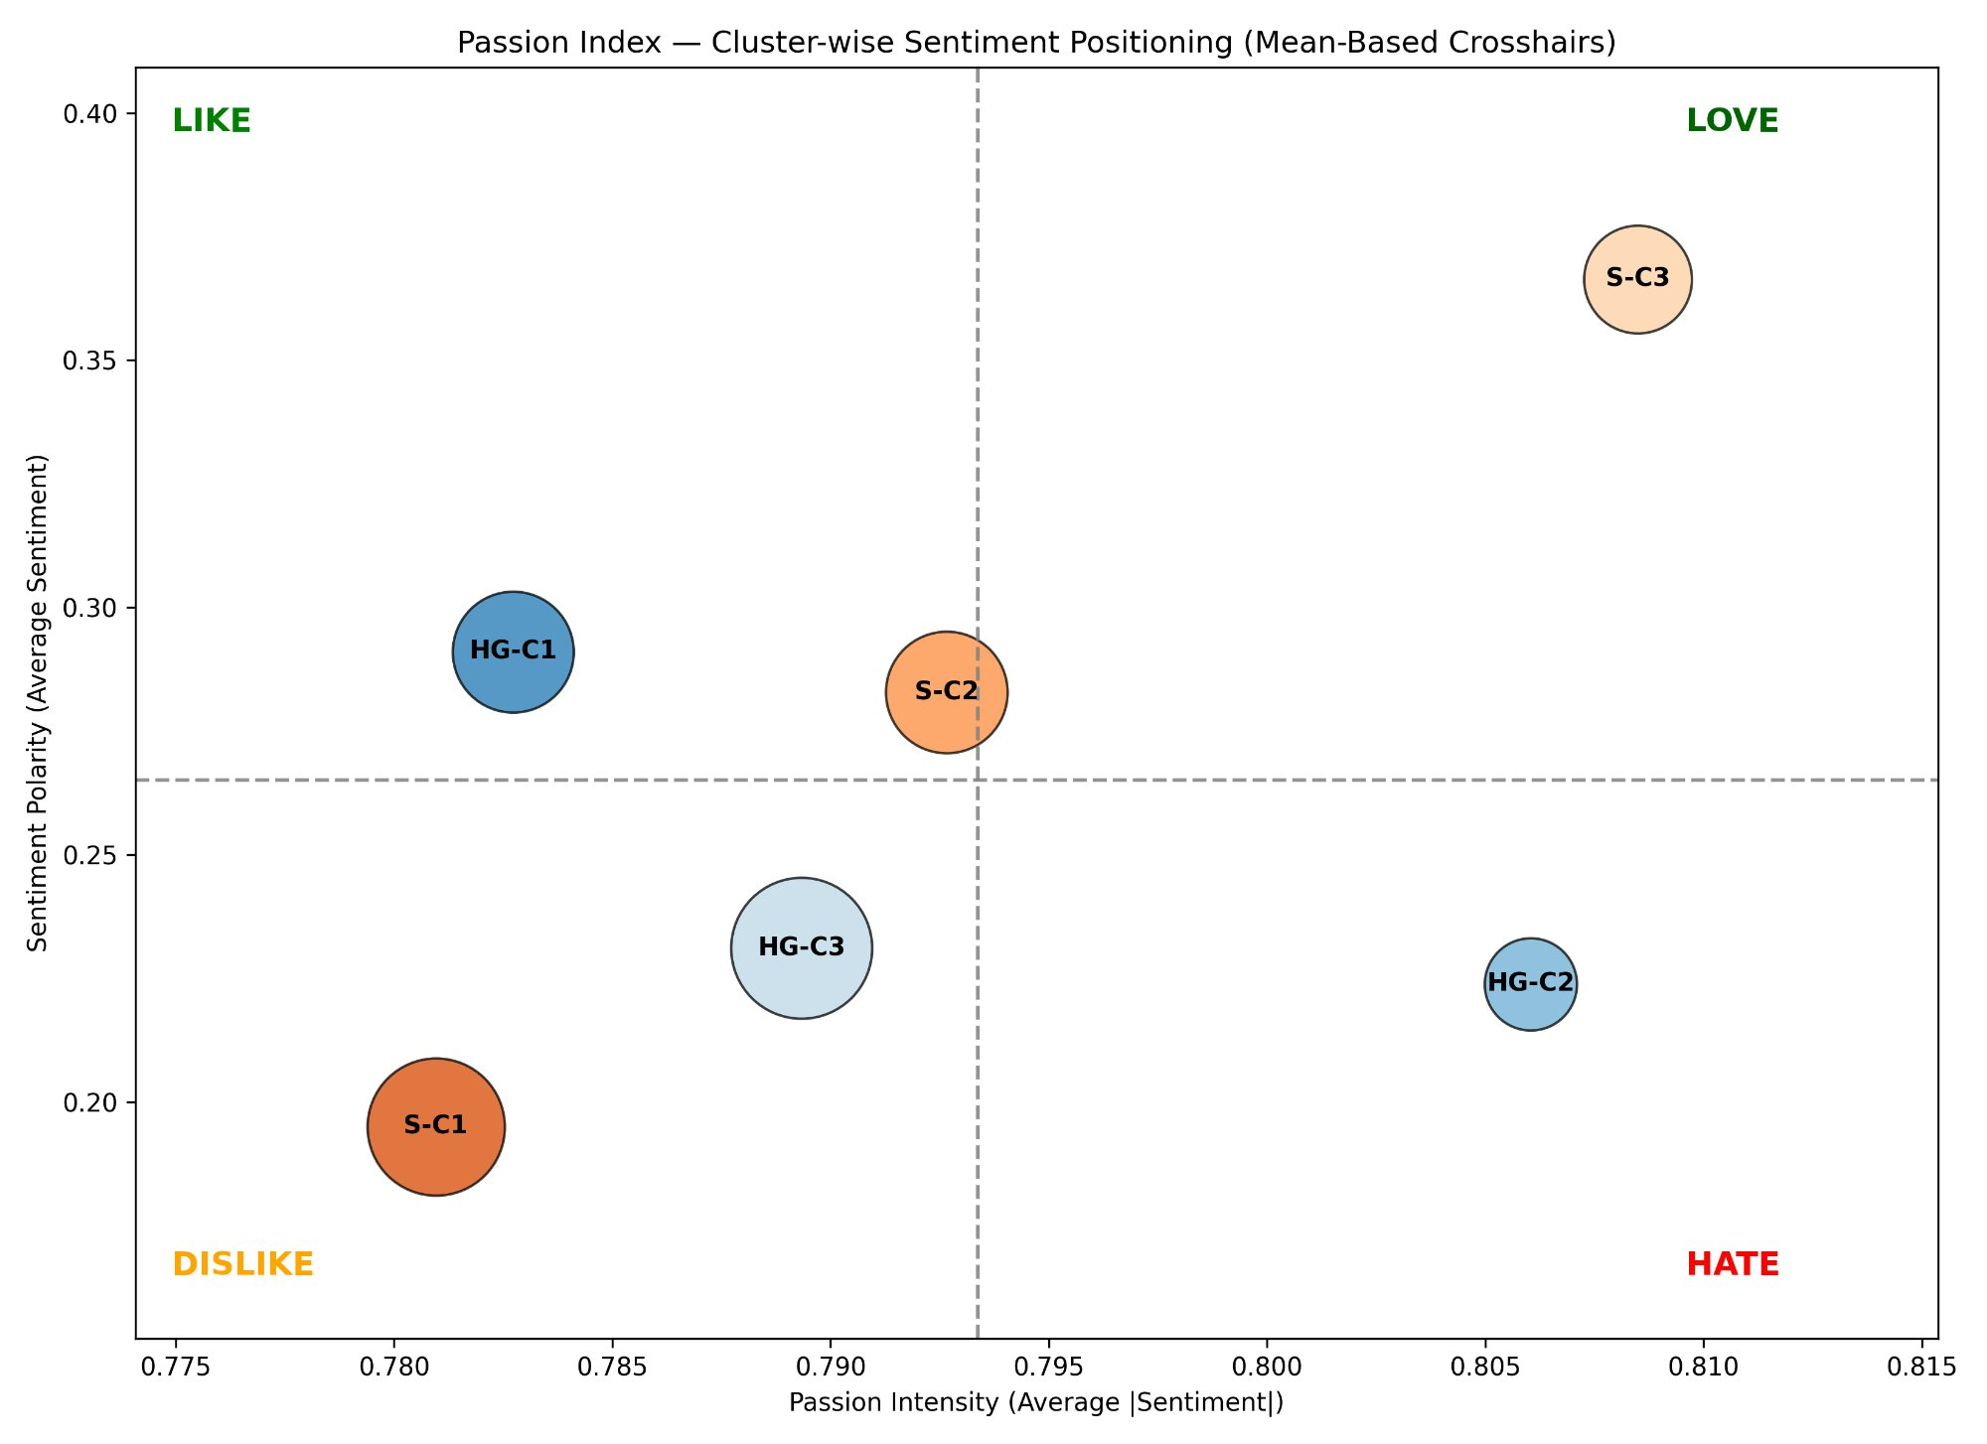
S-C3 occupies the LOVE quadrant with the highest polarity at approximately 0.37 and above-average intensity, reflecting both the strongest positive sentiment and the greatest emotional force across all clusters. HG-C1 and S-C2 both fall in the LIKE quadrant, indicating positive but less intensely expressed sentiment. S-C2 sits almost exactly on the mean crosshair, representing the central tendency across all six clusters. HG-C3 and S-C1 both fall in the DISLIKE quadrant, with below-average polarity and below-average intensity — reviews in these clusters are more mixed and more measured in their expression. HG-C2 occupies the HATE quadrant, the only cluster with both below-average polarity and above-average intensity, meaning its reviews are more often negative and expressed with relative force. This is consistent with HG-C2's pronounced negative Cost net score and its higher negative sentiment proportion.

4.3.5 Word Clouds
Figures 4.55 through 4.60 present word clouds for each cluster. Word size is proportional to term frequency across the cluster's review corpus.
Figure 4.55: Word Cloud — HG-C1 (AZ, FL, NJ, IL)
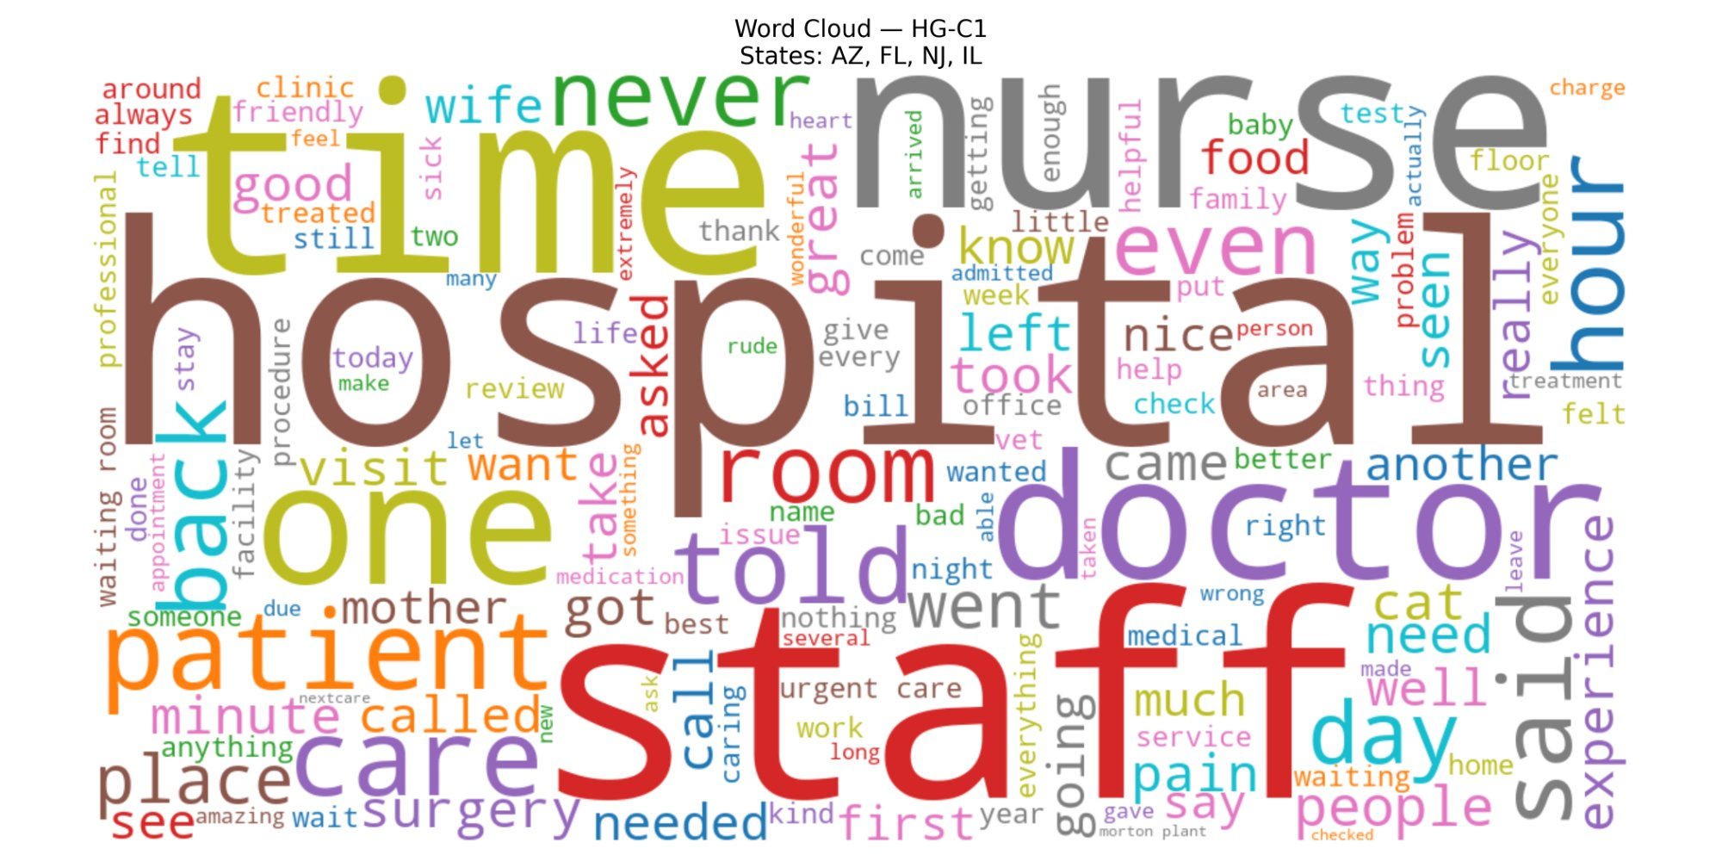
Figure 4.56: Word Cloud — HG-C2 (ID, TN)
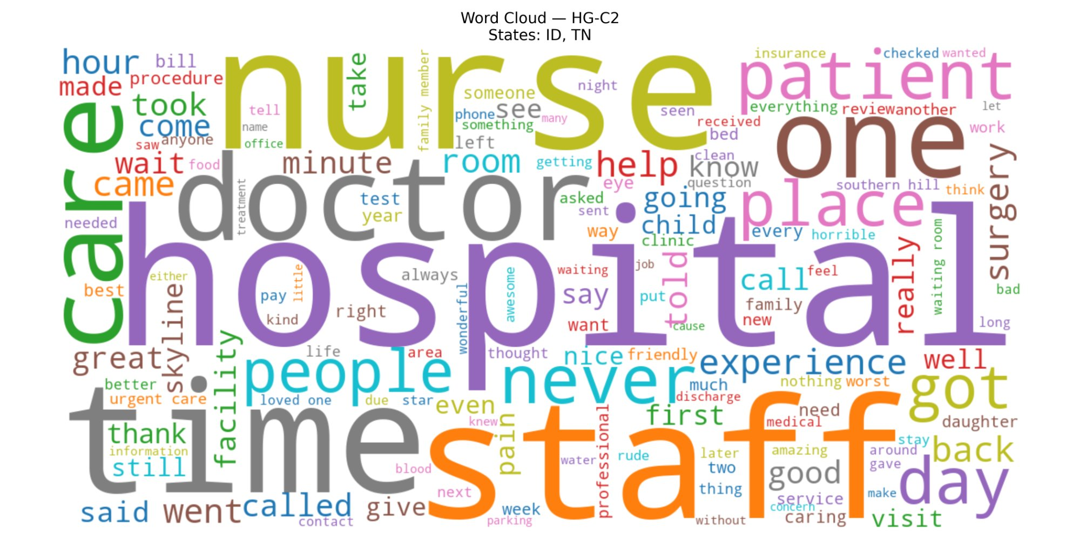
Figure 4.57: Word Cloud — HG-C3 (IN, PA, MO, LA)
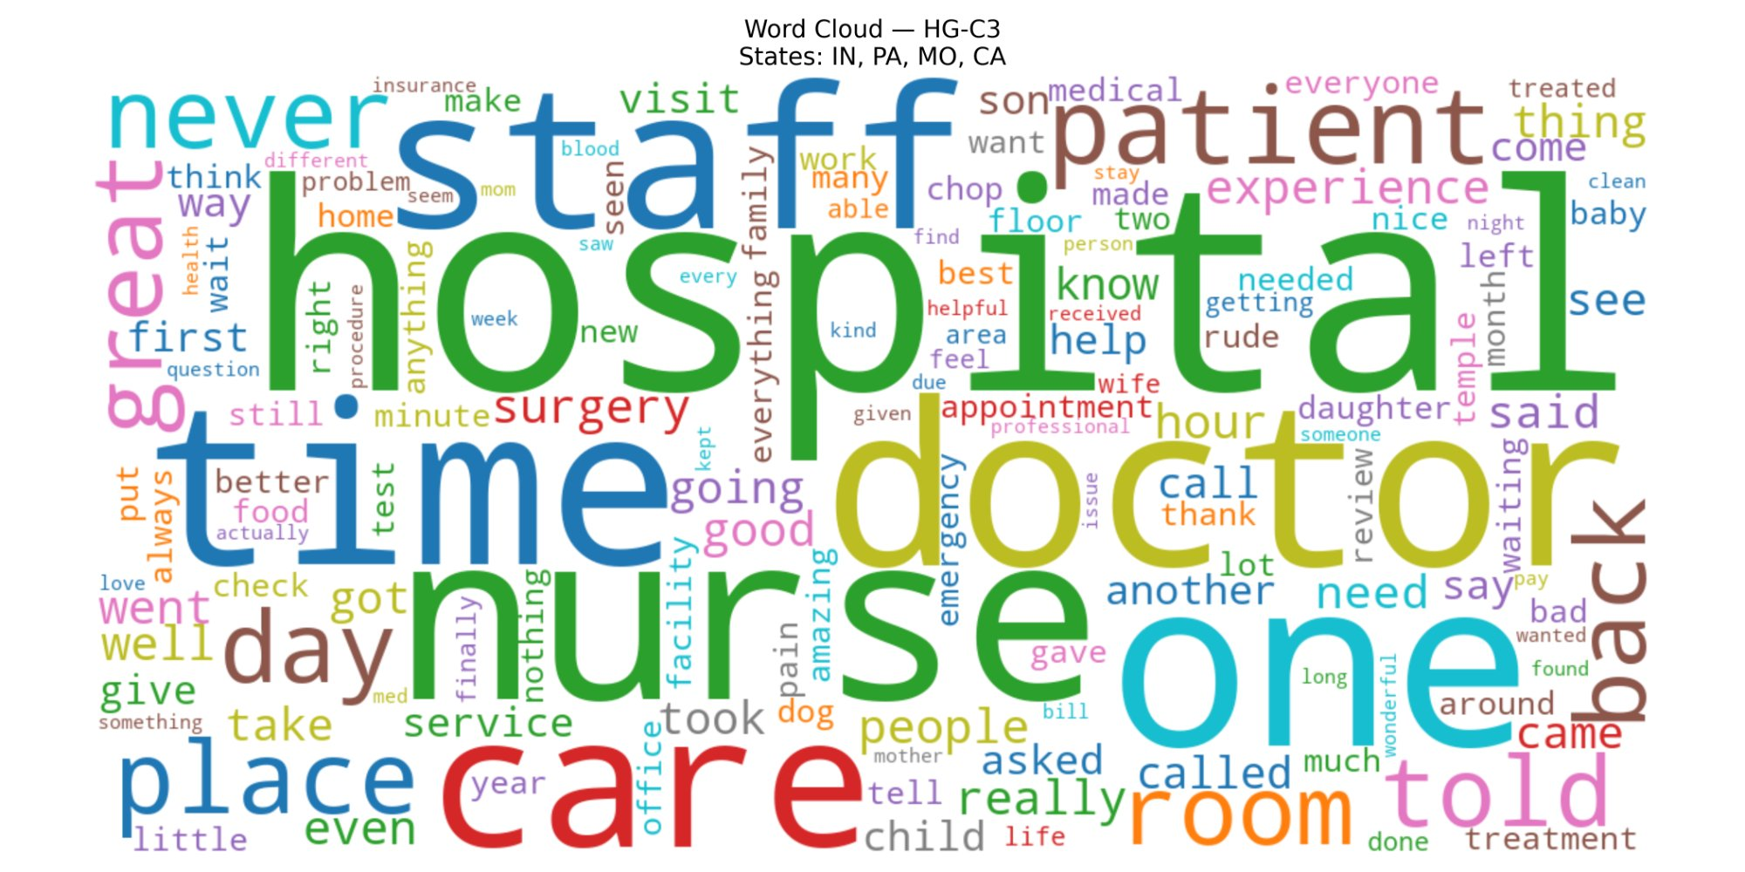
Figure 4.58: Word Cloud — S-C1 (ID, IL, LA, PA, TN)
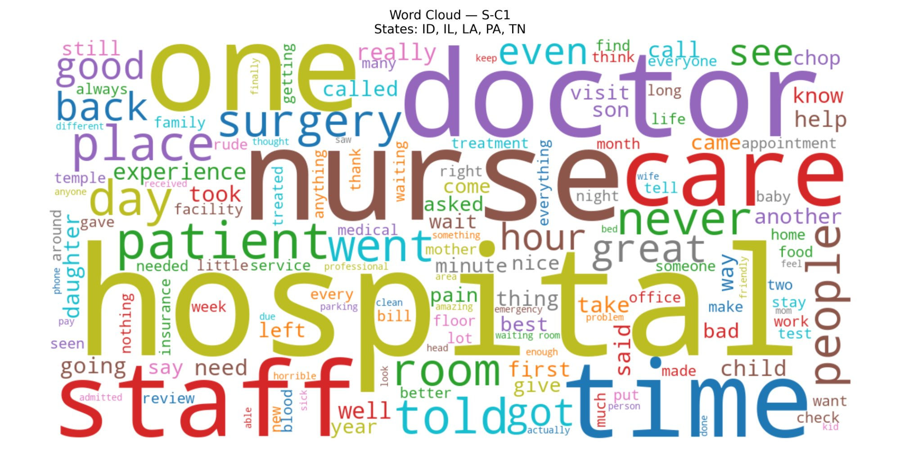
Figure 4.59: Word Cloud — S-C2 (AZ, IN, NJ)
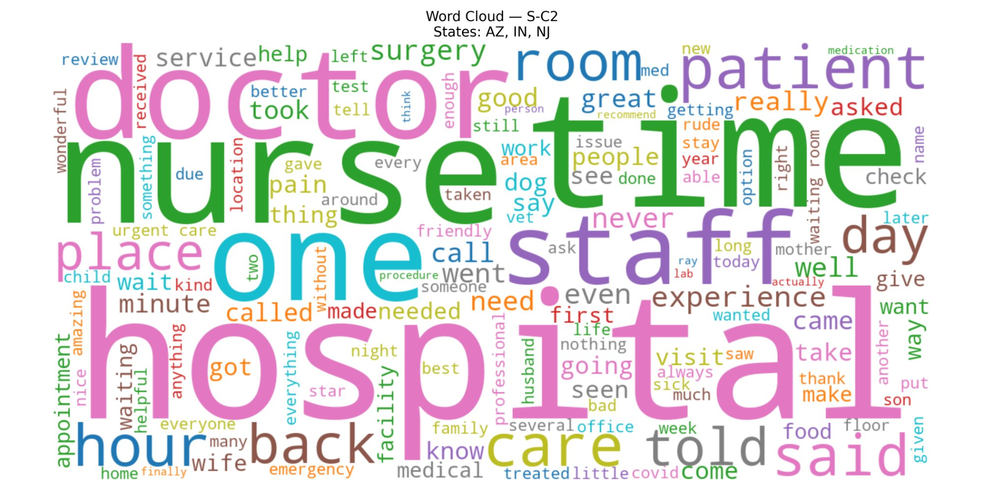
Figure 4.60: Word Cloud — S-C3 (FL, MO)
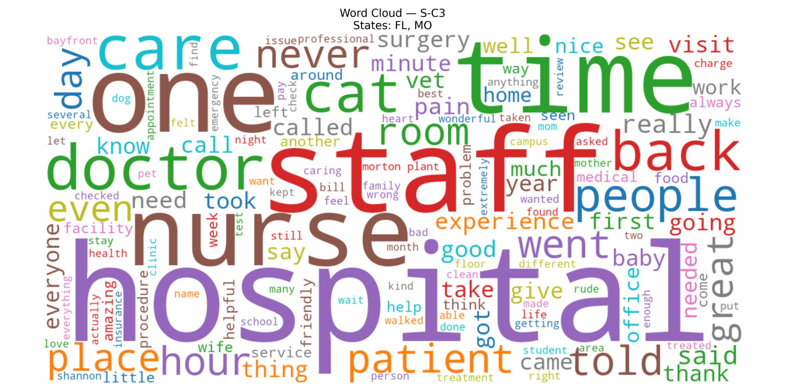
Hospital, staff, nurse, doctor, time, care, room, and patient are the dominant terms across all six clusters, reflecting the universal vocabulary of hospital reviews. The word never is prominent in several clusters, consistent with its frequent use in both negative complaints and strong positive endorsements. S-C3 distinctively features great, amazing, and helpful among its more visible terms, aligned with its position as the highest-performing cluster across all other sentiment dimensions. HG-C2 shows words such as horrible and worst among its smaller terms, consistent with its HATE quadrant positioning. The overall similarity of vocabulary across clusters underscores that differentiation in this study lies not in what patients write about, but in the sentiment and intensity with which they write about the same topics.

