I have a database an Exam,Database Exam have two collections one is Students, another one is Grades
first i created a databse and collection then i inserted collection datas,here i have attached my code screenshot
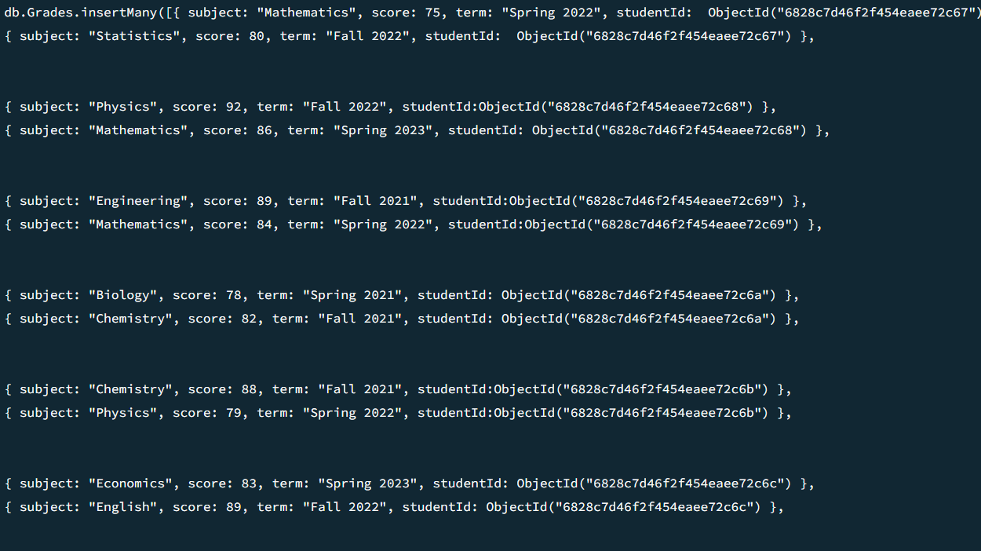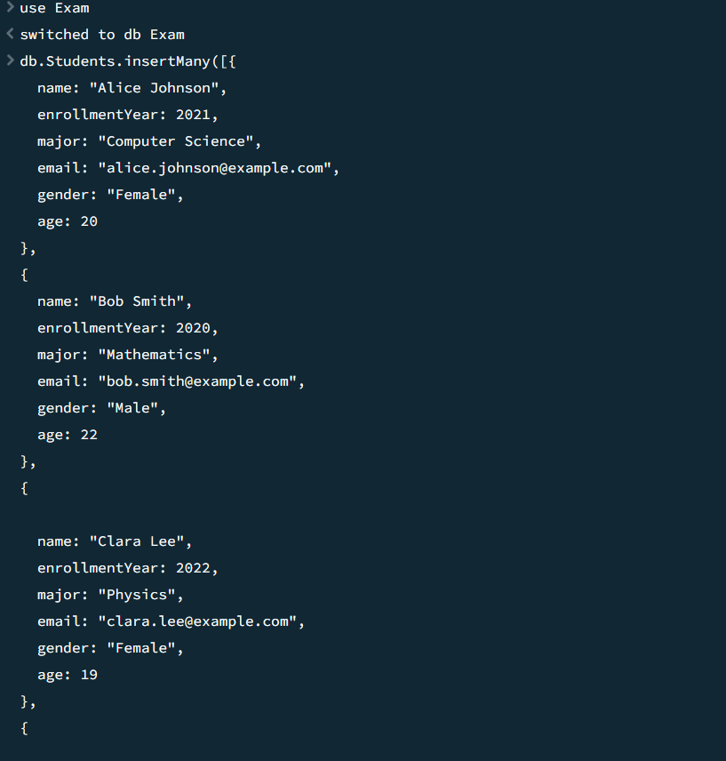
Collection Table view
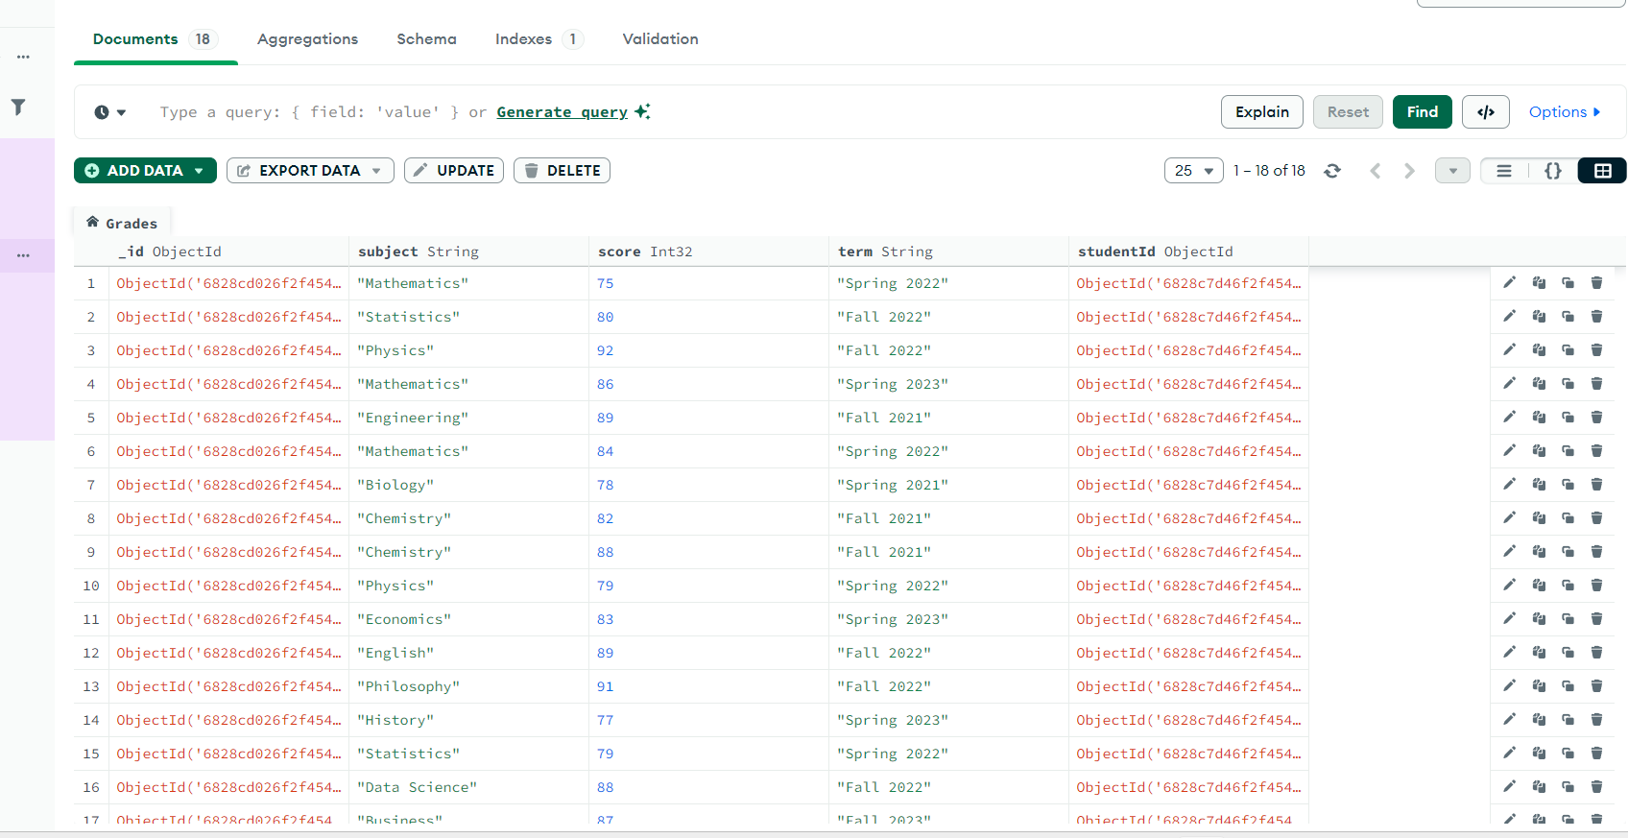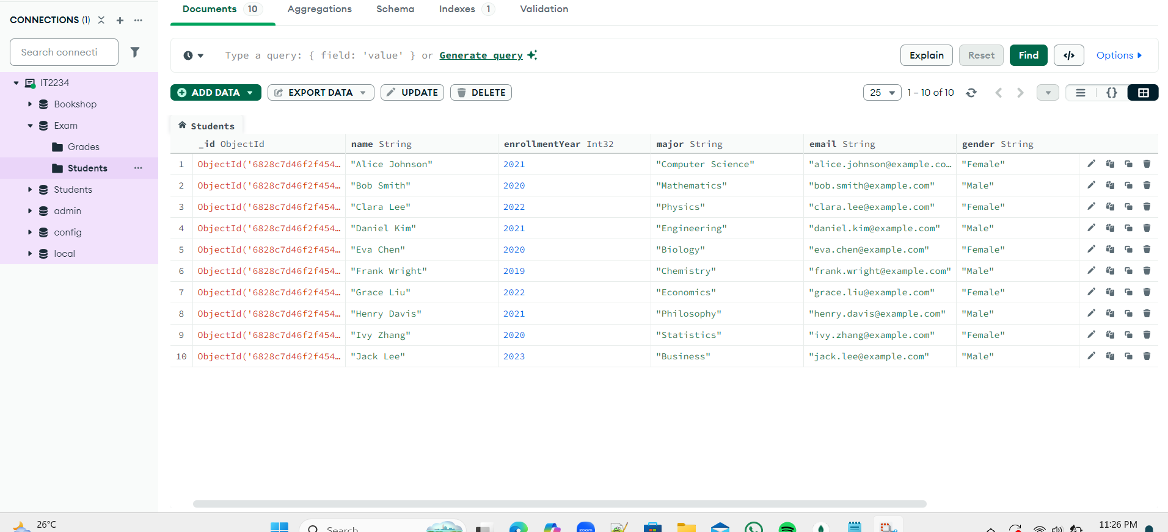
Find the female students and only display their name, age and gender.
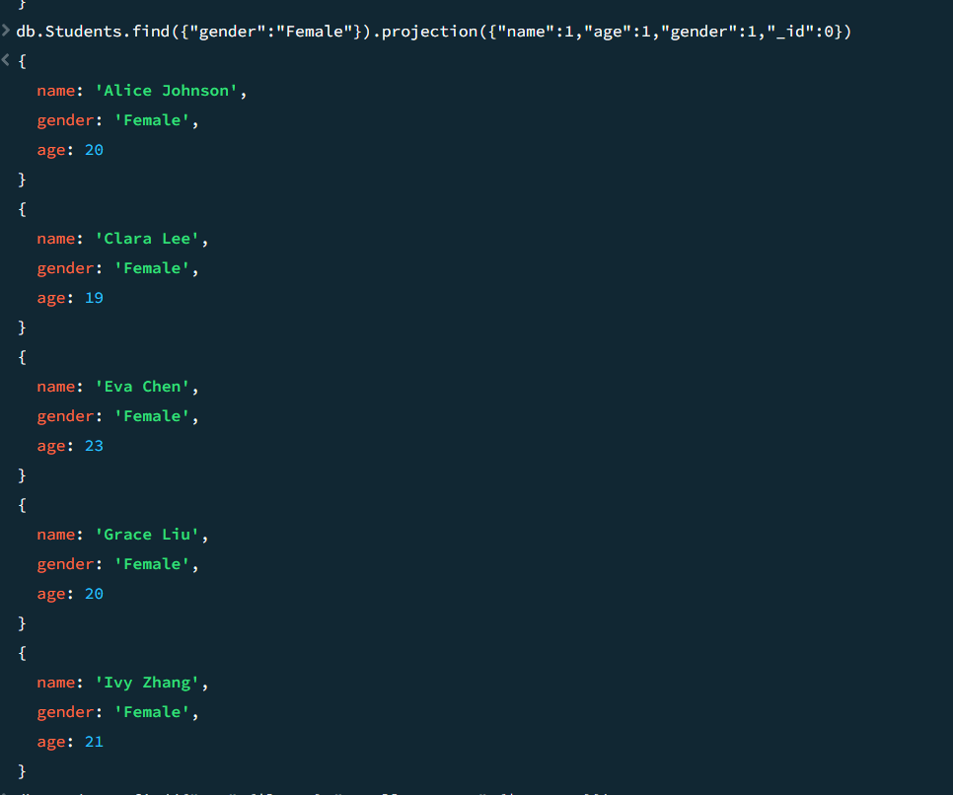
Find the students who are younger than 22 and enrolled after 2020.
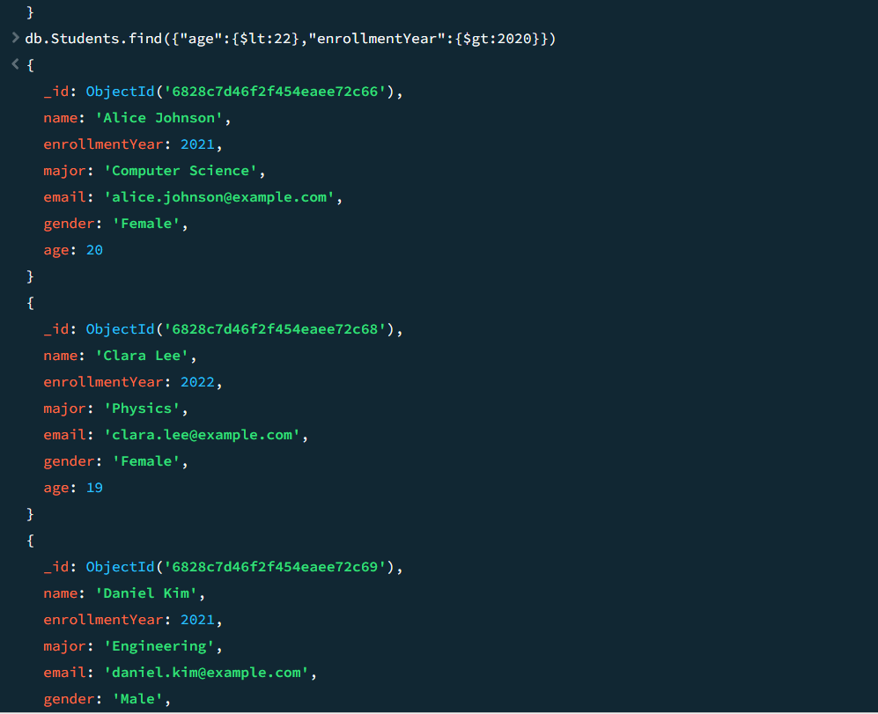
Find how many students followed the subject “Mathematics”.
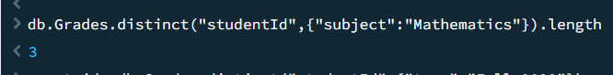
Find all students with grades in the term "Fall 2022".
