# **Geyser Application**

##### **24 Fix**

##### **Sodalicium Members:**

#### **Baven Pavaday**

#### **Oluwatosin Botti**

#### **Ryan Hartley**

#### **Tlou Lebelo**

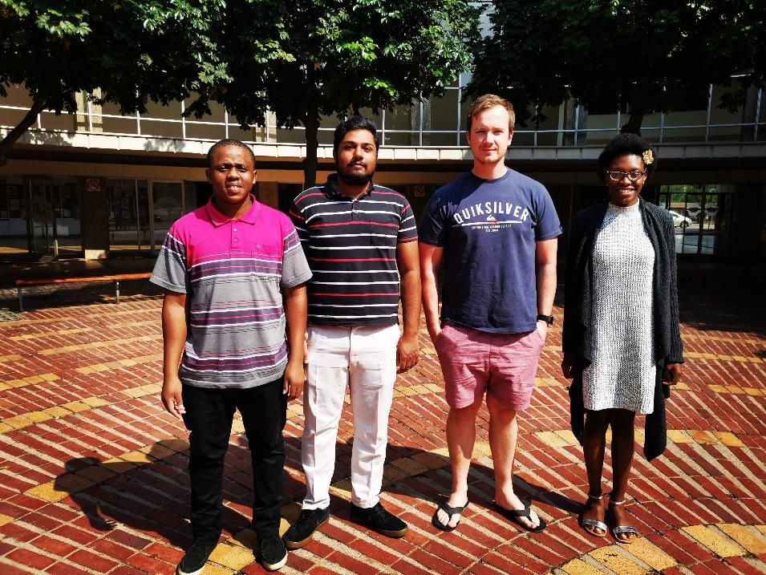

# **Domain Model**

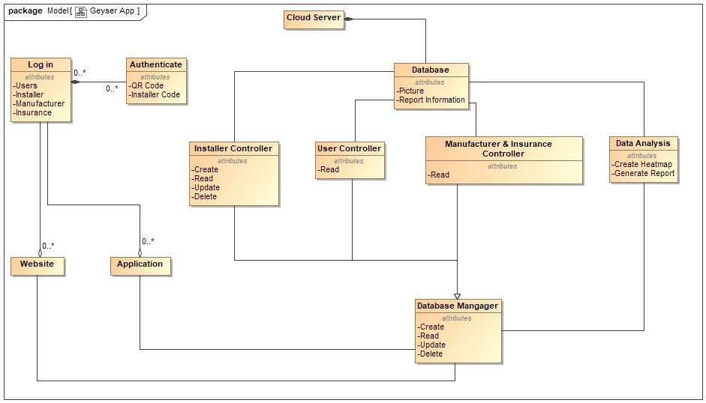

### **Description:**

We view the geyser system as having two separate front end interfaces, the geyser application as well as the geyser website. The geyser application will be used by geyser installers as well as resident users, the operations that can be performed by these users will differ and will be verified using an Installer code given to the specific installer companies. The application users will make use of the QR functionality to register/view/update their geyser. The manufacturers as well as the insurance companies will make use of the website interface where higher level authentication will take place as well as more detailed information can be retrieved. Both of the front end interfaces (application, website) will make use of a database manager to perform specific operations on the stored data. The operations that can be performed on the data is again determined by the type of user in the system. The data will be stored in a database consisting of relevant tables of information using a secure cloud service, the information stored will be streamlined and compact.

The tables in the database will store pictures as well as relevant report data relating to the geysers. We also have a data analysis module that will be able to draft reports for both manufacturers as well as insurance companies in addition to this the module will provide the functionality to generate a heat map of the geysers currently stored in the system.

# **Technologies to be used:**

### **Front end:**

* Application - Android Studio
* Website – HTML, CSS, Bootstrap, Node JS, Angular
* Authentication – Back-end List service using Java

### **Database Operations:**

* Manager - Node JS
* Controllers - Node JS

### **Database:**

* Database: MongoDB
* Cloud Service: MongoDB Atlas/Stitch

# **Development Methodology:**

We are willing to put in as many work hours in as possible, we hope to develop multiple versions that will be available for client testing as soon as possible. We hope to involve our client using this iterative development process to not only develop an adequate product but also reaches the expectations of the client. We want to spend a large portion of the development time immersing ourselves in the problem to better understand and solve the project. We plan on creating solid communication channels between our group members using not only weekly face to face meetings but also a host of mediums that will allow us to collaborate and share ideas. We want to set strict deadlines for ourselves in order to deliver a well-constructed and timely product.

We expect our client to be actively involved in the project, they should open to regular communication and occasional consultation. The client must provide regular feedback based on the work that will be presented to them at certain developmental intervals.

# **Skills and Knowledge:**

### **Baven Pavaday:**

* Web Development Skills - HTML, CSS, Bootstrap, Javascript, Node JS
* Database Skills – MySQL, SQLite, MongoDB
* Application – Java, C++, C

### **Ryan Hartley:**

* Web Development Skills – HTML, CSS, Bootstrap, Javascript, PHP
* Database Skills – MySQL, SQLite, Postgresql, MongoDB
* Application – Java, C++, Python