ASSIGNMENT-2
EXERCISE 1

DATA VALUE | FREQUENCY | RELATIVE  FREQUENCY | CUMULATIVE RELATIVE  FREQUENCY
1 | 95 | 0.1 | 0.1
1 | 90 | 0.1 | 0.2
2 | 85 | 0.2 | 0.4
1 | 80 | 0.1 | 0.5
2 | 70 | 0.2 | 0.7
1 | 65 | 0.1 | 0.8
1 | 60 | 0.1 | 0.9
1 | 55 | 0.1 | 1

EXERCISE 2

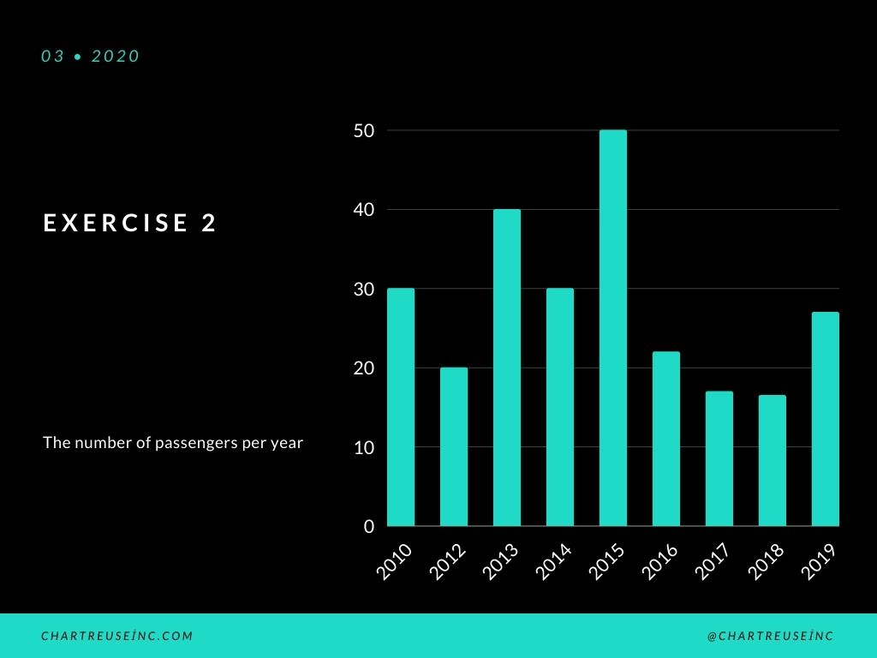

EXERCISE 3

