### 《数据库系统原理》实验报告

**实验题目：数据查询**

**姓名：温长锟** **实验日期：2021年 10月26日**

**实验内容及完成情况：**（可续页）

1.查询country表中所有亚洲国家的名称、地区，要求查询结果按人口的升序排列。

USE world;

SELECT Name,Region

FROM country

WHERE Continent = 'Asia'

ORDER BY Population;

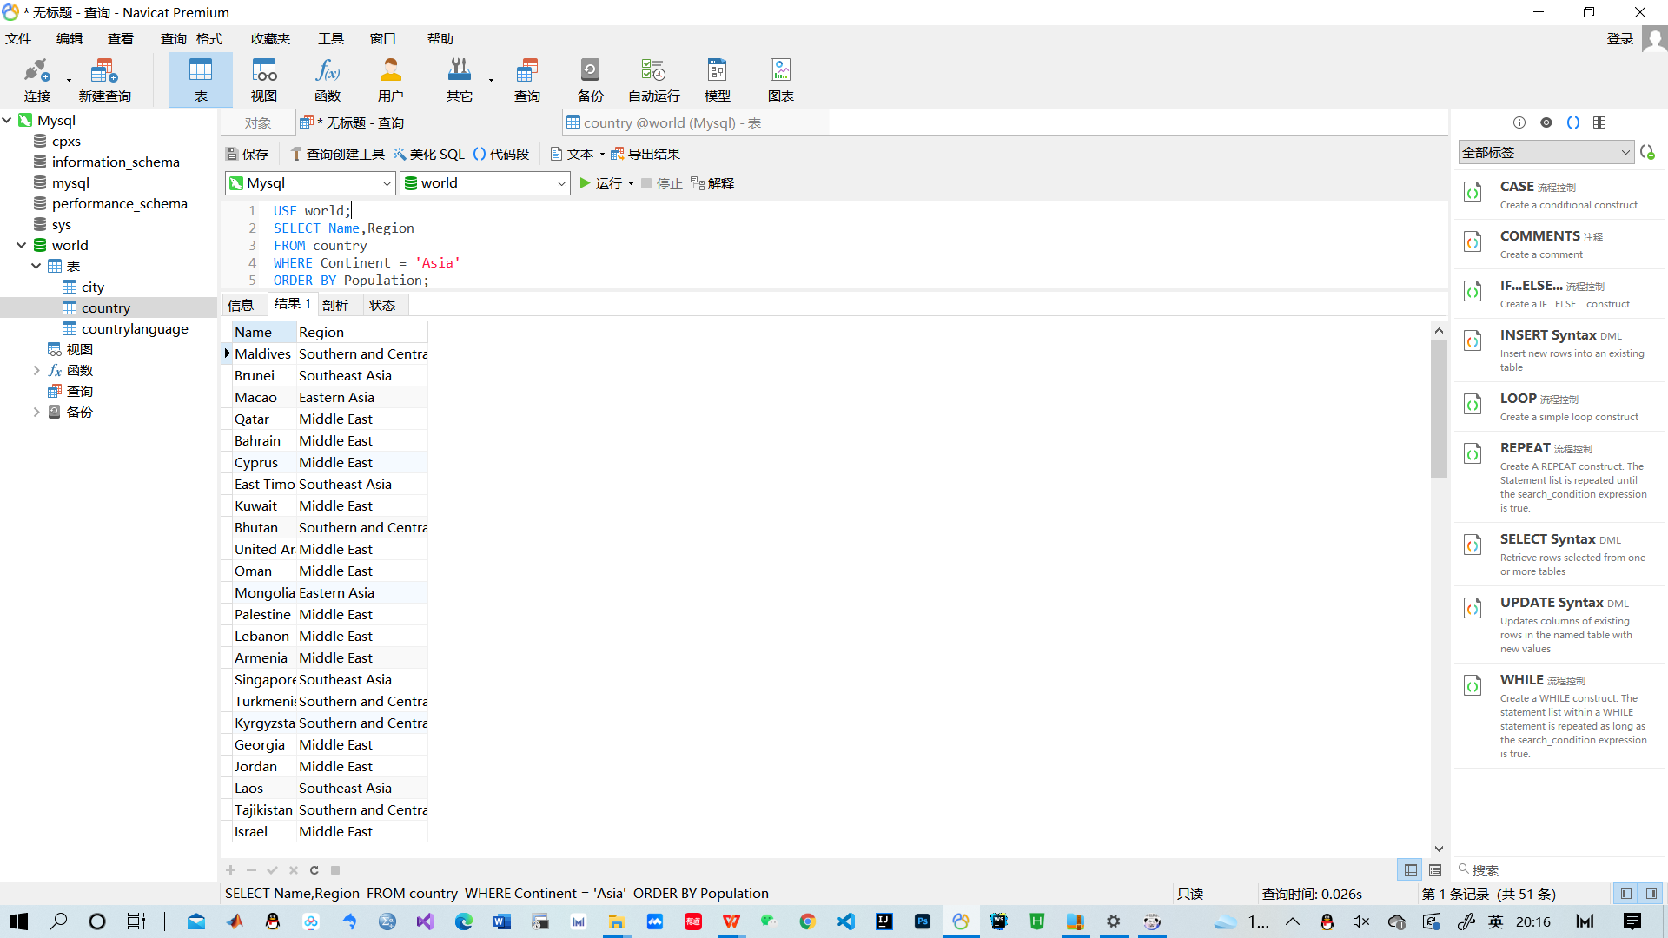

2.查询city表中智利（CHL）或保加利亚（BGR）的城市名称。

USE world;

SELECT Name

FROM city

WHERE CountryCode IN ('CHL','BGR');

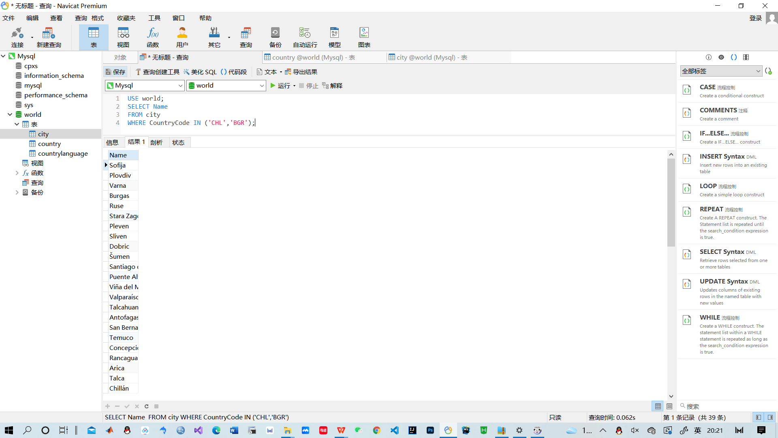

3.查询country表中Region字段包含“Europe”的国家的全部信息

USE world;

SELECT *

FROM country

WHERE Region LIKE '%Europe%';

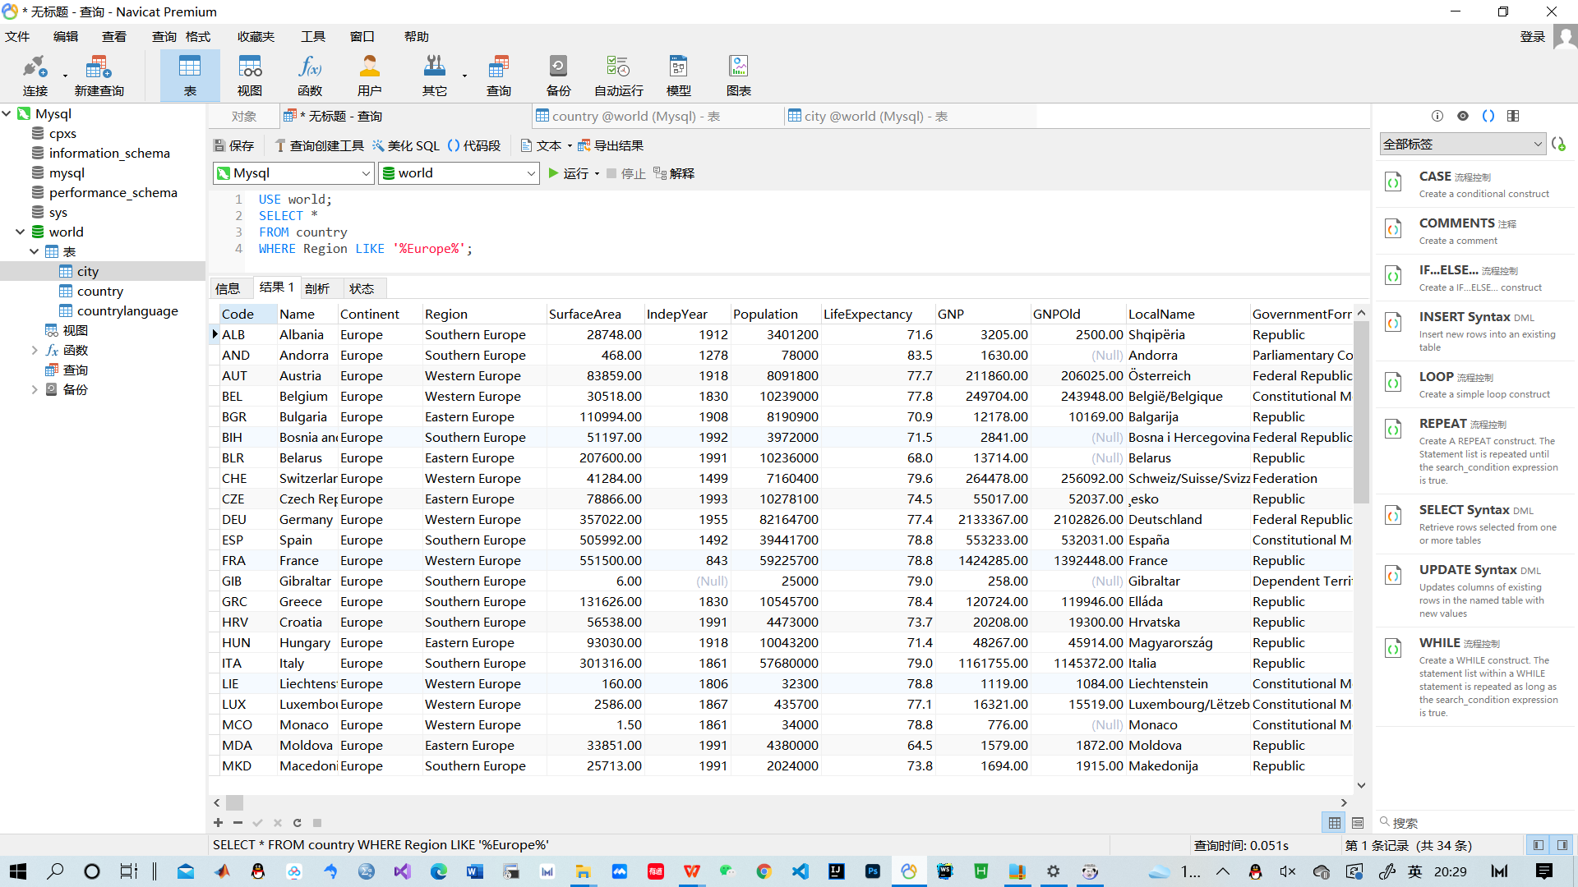

4.

USE world;

SELECT Name,Population

FROM country

WHERE GovernmentForm = 'Constitutional Monarchy'

ORDER BY Population DESC

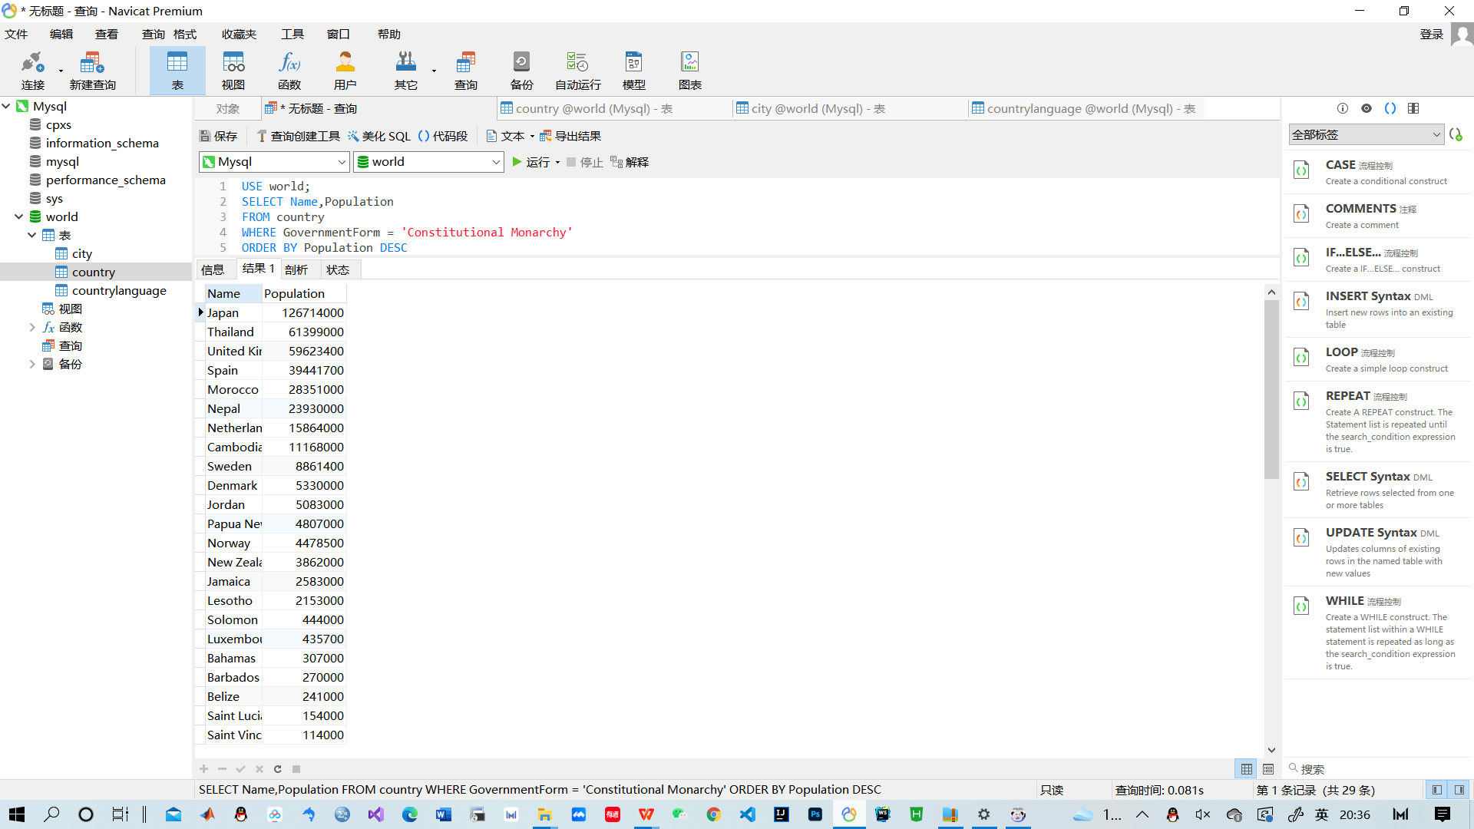

5.查询country表中各种政体的国家数量。

USE world;

SELECT GovernmentForm,COUNT(*)

FROM country

GROUP BY GovernmentForm;

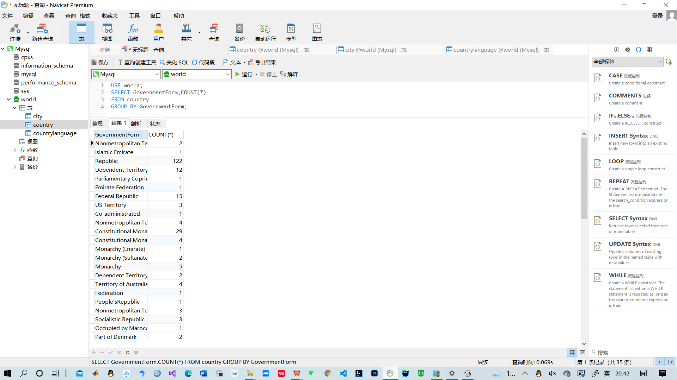

6.建立共和国政体的国家的视图。

USE world;

CREATE VIEW a

as

SELECT *

FROM country

WHERE GovernmentForm='Republic';

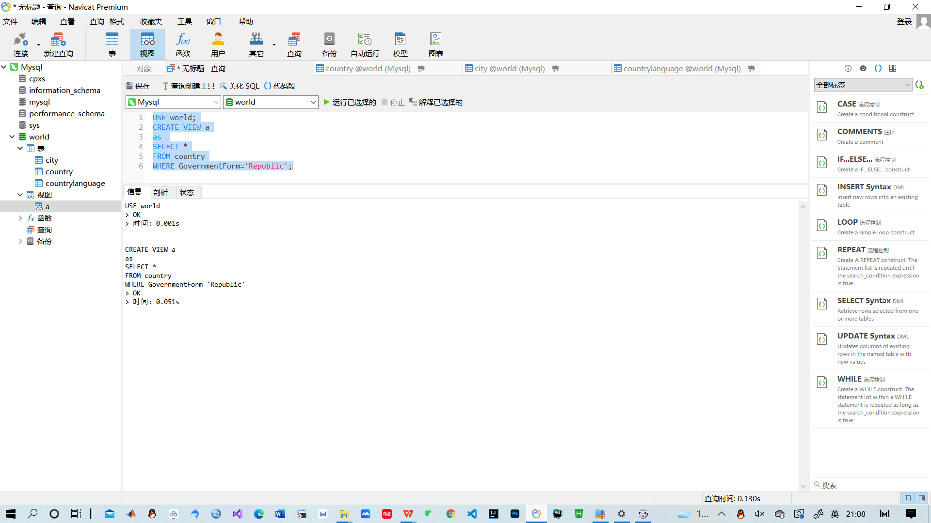

7.建立君主立宪制（Constitutional Monarchy）国家的视图，并要求进行修改和插入操作时仍须保证该视图只有君主立宪制国家。

USE world;

CREATE VIEW b

as

SELECT *

FROM country

WHERE GovernmentForm='Constitutional Monarchy'

WITH CHECK OPTION;

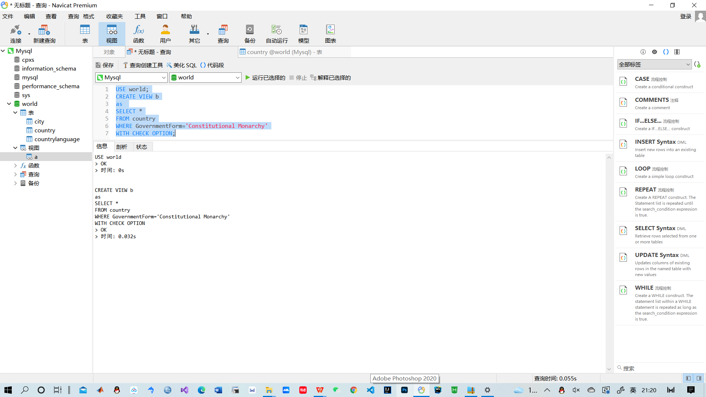

8.建立共和国政体且国名生产总值在10000以上的国家视图

USE world;

CREATE VIEW c

as

SELECT *

FROM country

WHERE GovernmentForm='Republic' AND GNP>=10000;

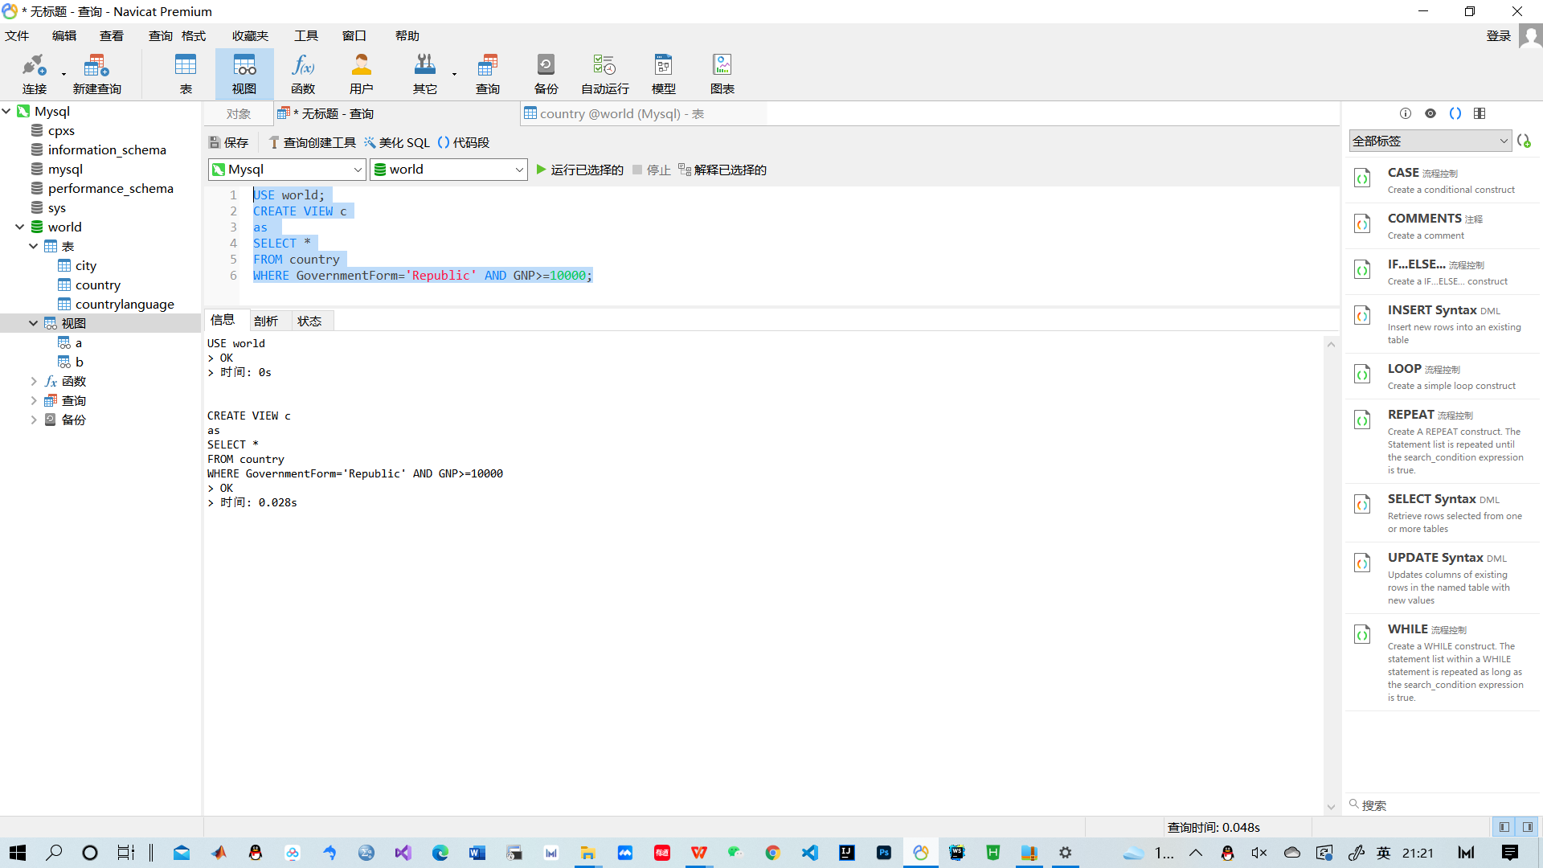

9,10建立上述数据库，创建上述基本表，并按标定（加粗及下划线）要求创建各个基本表的主码和外码约束，并依据问题分析建立其他必要的完整性约束

CREATE DATABASE SPJ;

USE SPJ;

CREATE TABLE S(SNO CHAR(10) PRIMARY KEY,SNAME char(10),STATUS INT,CITY CHAR(10));

CREATE TABLE P(PNO CHAR(10) PRIMARY KEY,PNAME CHAR(10),COLOR CHAR(10),WEIGHT INT);

CREATE TABLE J(JNO CHAR(10) PRIMARY KEY,JNAME CHAR(10),CITY CHAR(10));

CREATE TABLE SPJ(SNO CHAR(10), PNO CHAR(10),JNO CHAR(10),FOREIGN KEY(SNO) REFERENCES S(SNO),FOREIGN KEY(PNO) REFERENCES P(PNO),FOREIGN KEY(JNO) REFERENCES J(JNO));

INSERT INTO S VALUES('S1','精益',20,'天津');

INSERT INTO S VALUES('S2','盛锡',10,'北京');

INSERT INTO S VALUES('S3','东方红',30,'北京');

INSERT INTO S VALUES('S4','丰秦盛',20,'天津');

INSERT INTO S VALUES('S5','为民',30,'上海');

INSERT INTO P VALUES('P1','螺母','红',12);

INSERT INTO P VALUES('P2','螺栓','绿',17);

INSERT INTO P VALUES('P3','螺丝刀','蓝',14);

INSERT INTO P VALUES('P4','螺丝刀','红',14);

INSERT INTO P VALUES('P5','凸轮','蓝',40);

INSERT INTO P VALUES('P6','齿轮','红',30);

INSERT INTO J VALUES('J1','三建','北京');

INSERT INTO J VALUES('J2','一汽','长春');

INSERT INTO J VALUES('J3','弹簧厂','天津');

INSERT INTO J VALUES('J4','造船厂','天津');

INSERT INTO J VALUES('J5','机车厂','唐山');

INSERT INTO J VALUES('J6','无线电厂','常州');

INSERT INTO J VALUES('J7','半导体厂','南京');

INSERT INTO SPJ VALUES('S1','P1','J1',200);

INSERT INTO SPJ VALUES('S1','P1','J3',100);

INSERT INTO SPJ VALUES('S1','P1','J4',700);

INSERT INTO SPJ VALUES('S1','P2','J2',100);

INSERT INTO SPJ VALUES('S2','P3','J1',400);

INSERT INTO SPJ VALUES('S2','P3','J2',200);

INSERT INTO SPJ VALUES('S2','P3','J4',200);

INSERT INTO SPJ VALUES('S2','P3','J5',200);

INSERT INTO SPJ VALUES('S2','P5','J1',400);

INSERT INTO SPJ VALUES('S2','P5','J2',100);

INSERT INTO SPJ VALUES('S3','P1','J1',200);

INSERT INTO SPJ VALUES('S3','P3','J1',200);

INSERT INTO SPJ VALUES('S4','P5','J1',200);

INSERT INTO SPJ VALUES('S4','P6','J3',200);

INSERT INTO SPJ VALUES('S4','P6','J4',200);

INSERT INTO SPJ VALUES('S5','P2','J4',200);

INSERT INTO SPJ VALUES('S5','P3','J1',200);

INSERT INTO SPJ VALUES('S5','P6','J2',200);

INSERT INTO SPJ VALUES('S5','P6','J4',200);

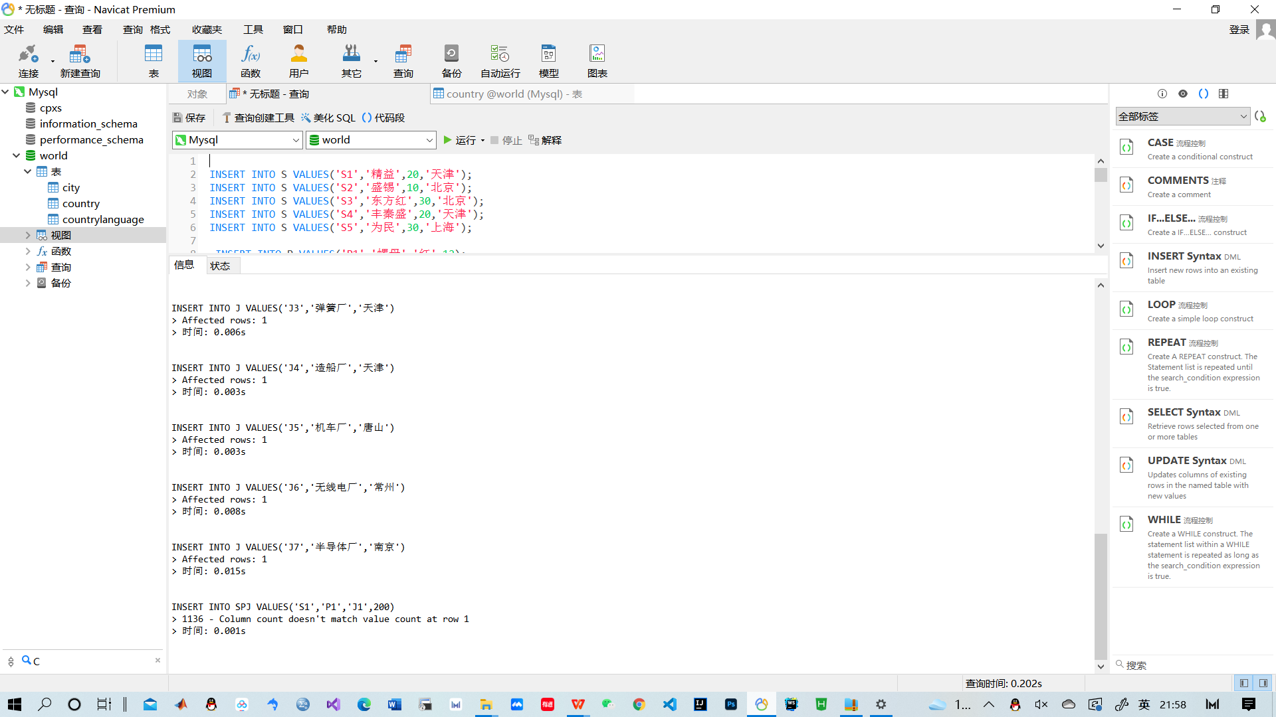

11.查询重量最轻的零件的零件代码

USE spj;

SELECT PNO,MIN(WEIGHT)

FROM p;

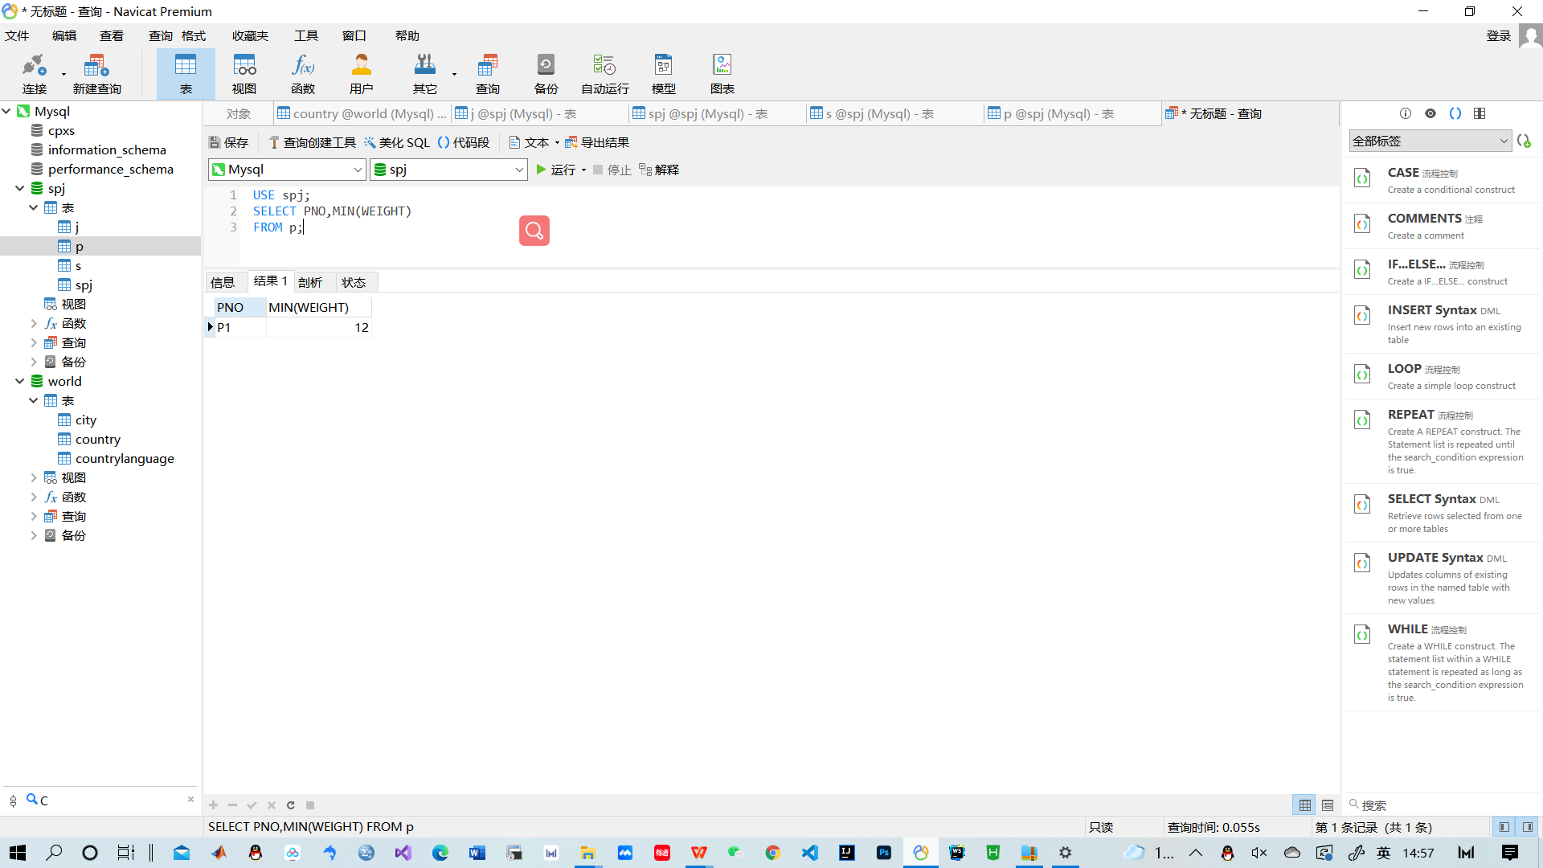

12.查询由供应商S1提供零件的工程项目名

USE spj;

SELECT JNAME

FROM j,spj

WHERE sno='S1' AND j.JNO=spj.JNO;

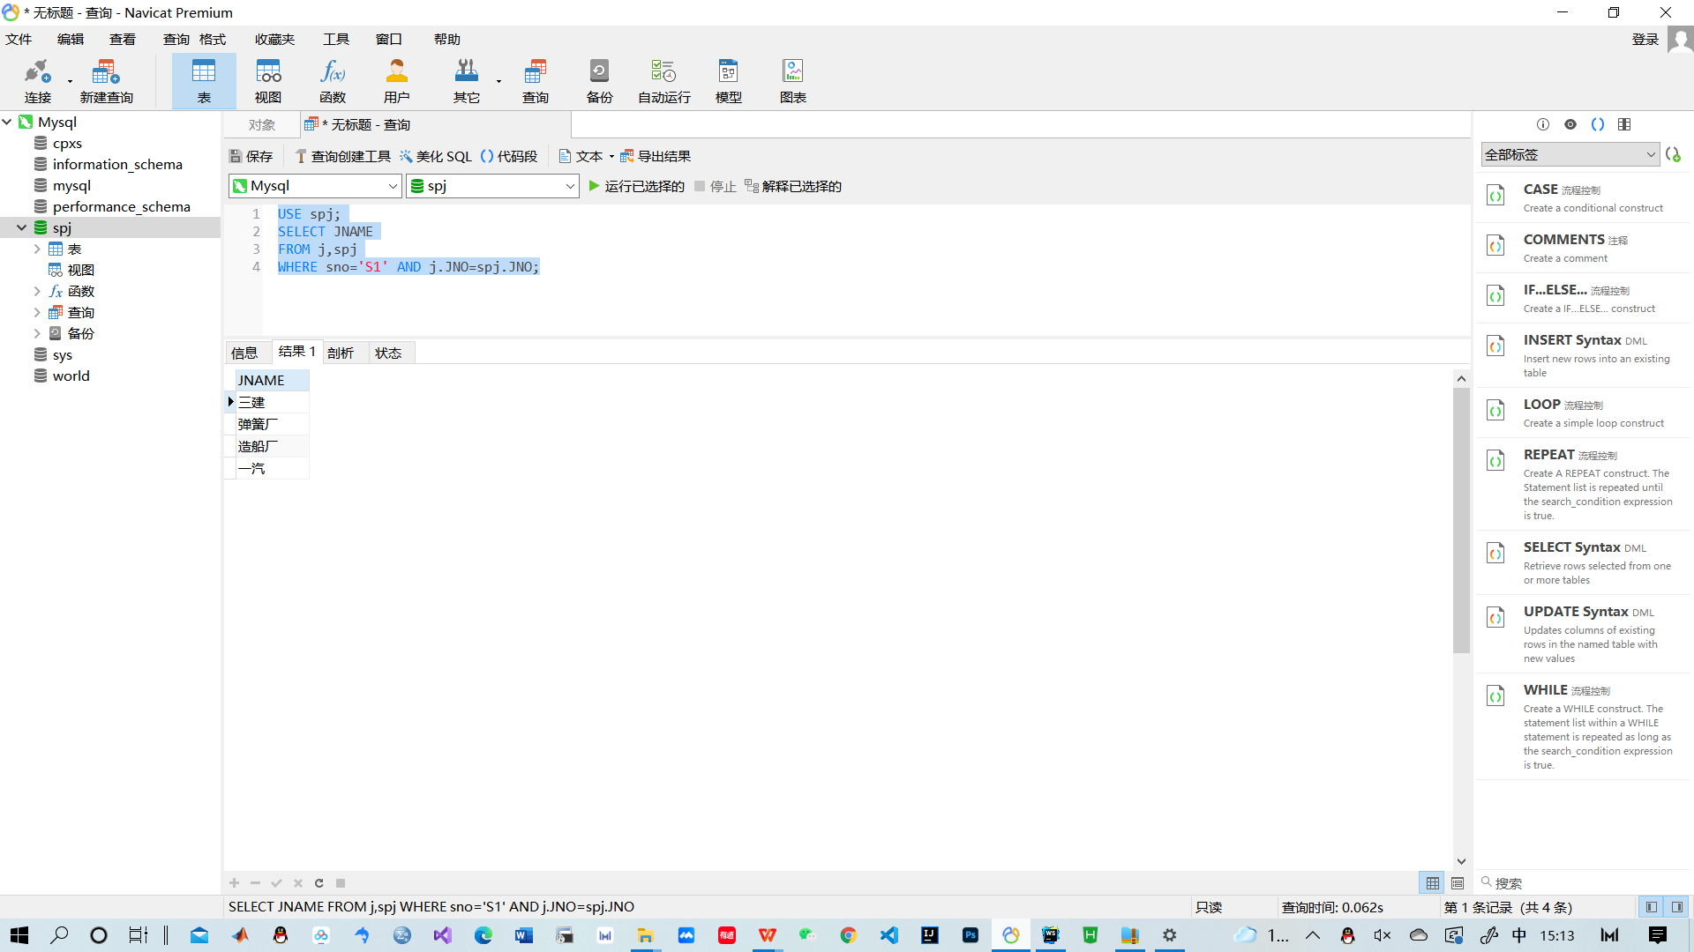

13.查询同时为工程J1和J2提供零件的供应商代码

USE spj;

SELECT DISTINCT s1.sno

FROM spj s1,spj s2

WHERE s1.JNO='J1' AND s2.JNO='J2' AND s1.SNO=s2.SNO;

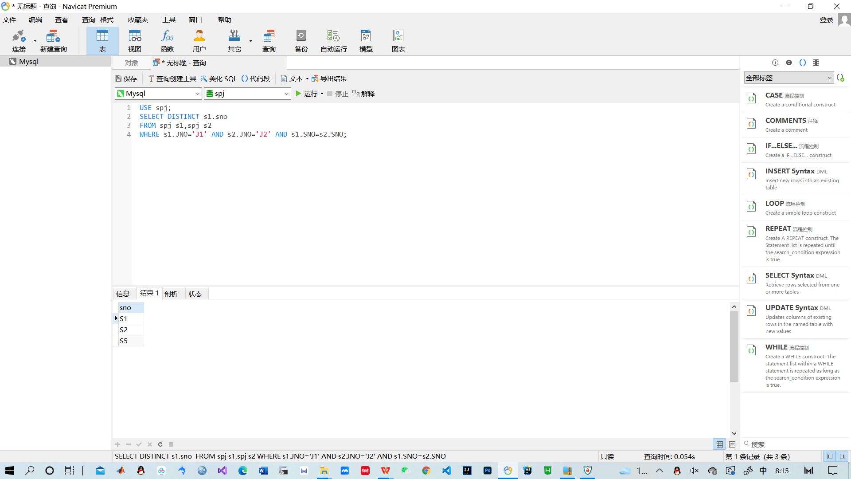

14.查询为位于上海的工程提供零件的供应商代码。

USE spj;

SELECT DISTINCT SNO

FROM j,spj

WHERE j.CITY = '上海' AND spj.JNO = j.JNO;

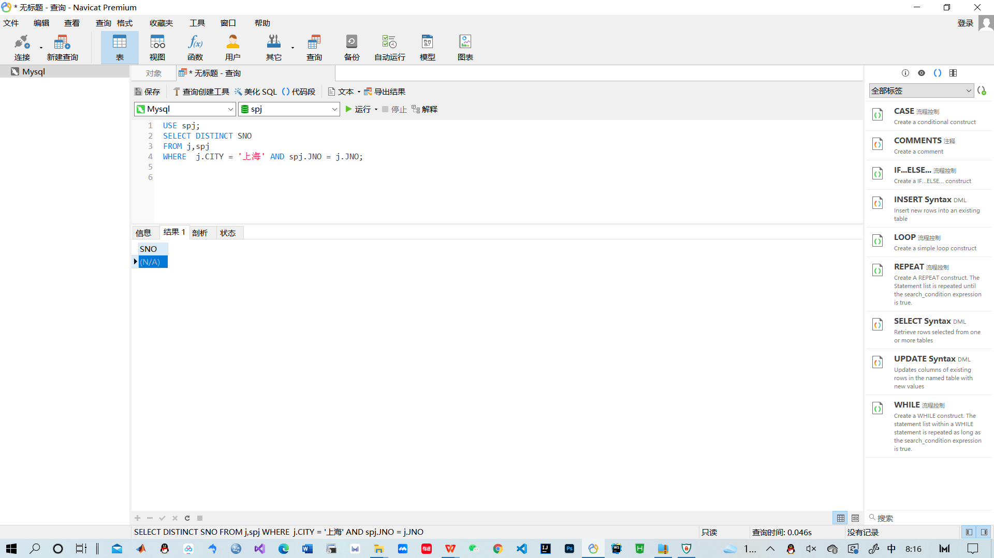

15.查询同时为位于上海或北京的工程提供红色零件的供应商代码

SELECT SNO

FROM SPJ

WHERE JNO IN

(SELECT JNO

FROM J

WHERE CITY='上海'OR CITY='北京')

AND PNO IN

(SELECT PNO FROM P WHERE COLOR='红') ;

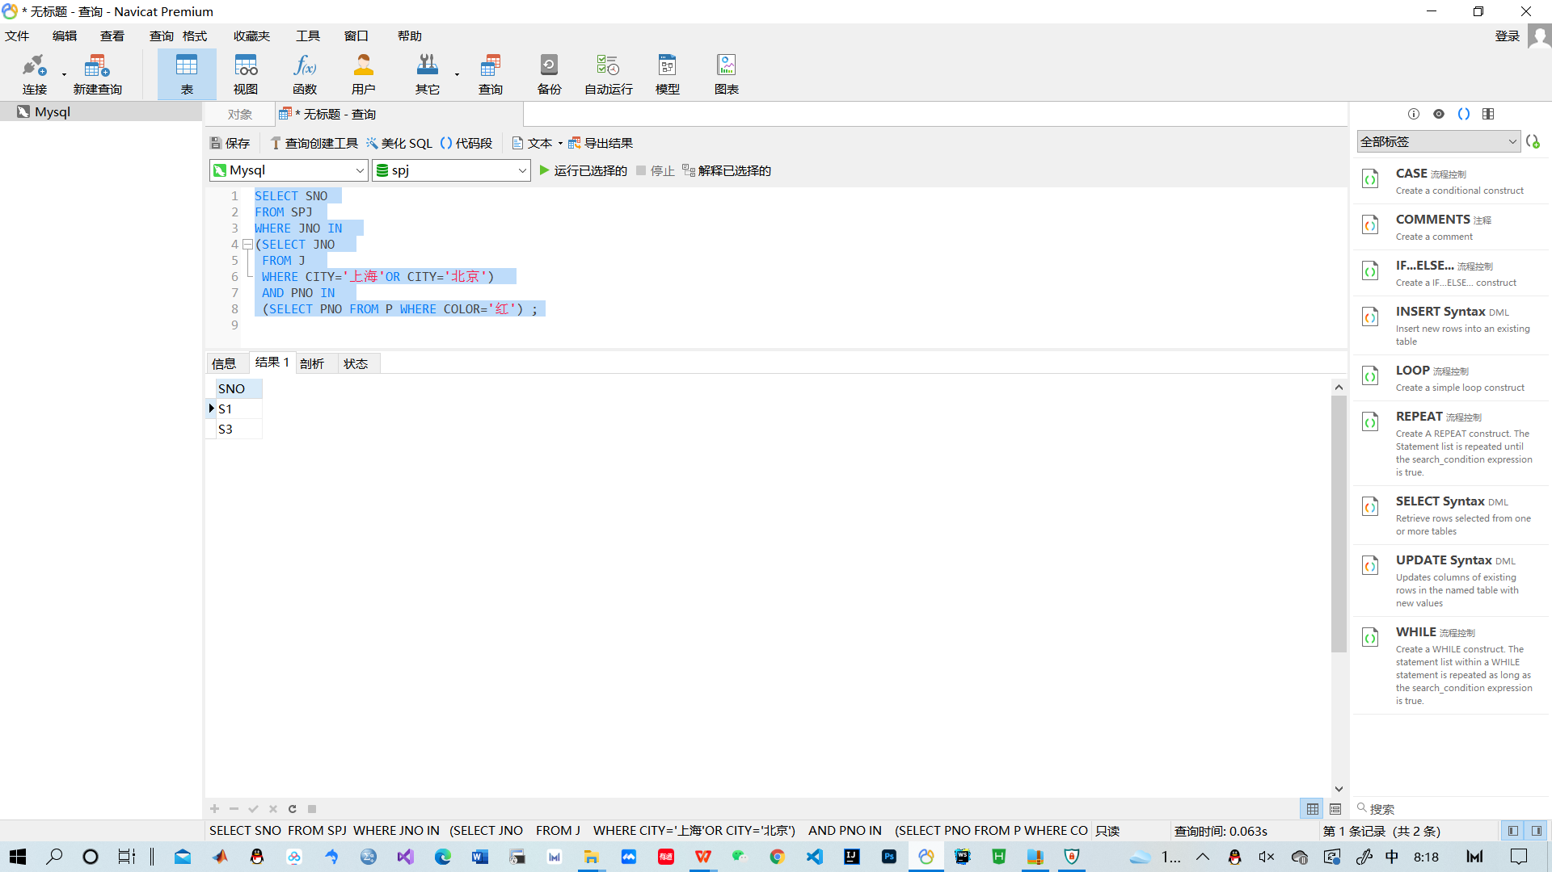

16、查询供应商和工程所在城市相同的供应商能提供的零件代码。

SELECT DISTINCT p.pno

FROM p,s,spj,j

WHERE s.sno=spj.sno AND j.JNO=spj.JNO AND s.city=j.CITY and spj.pno=p.pno ;

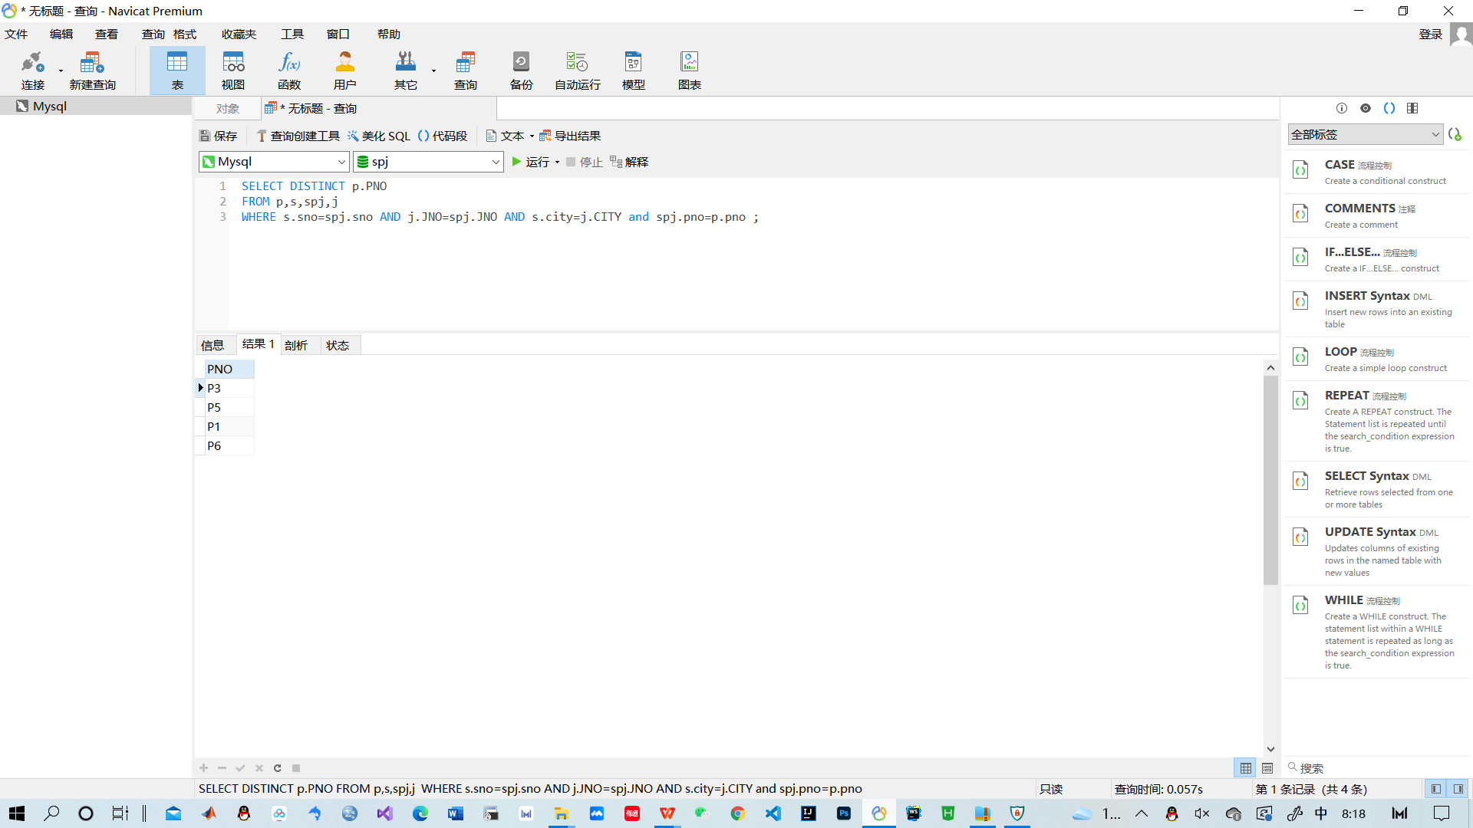

17、查询上海供应商不提供任何零件的工程代码。

SELECT JNO

FROM J

WHERE JNO NOT IN

(SELECT DISTINCT JNO

FROM SPJ

WHERE SNO IN

(SELECT SNO

FROM S

WHERE CITY='上海')) ;

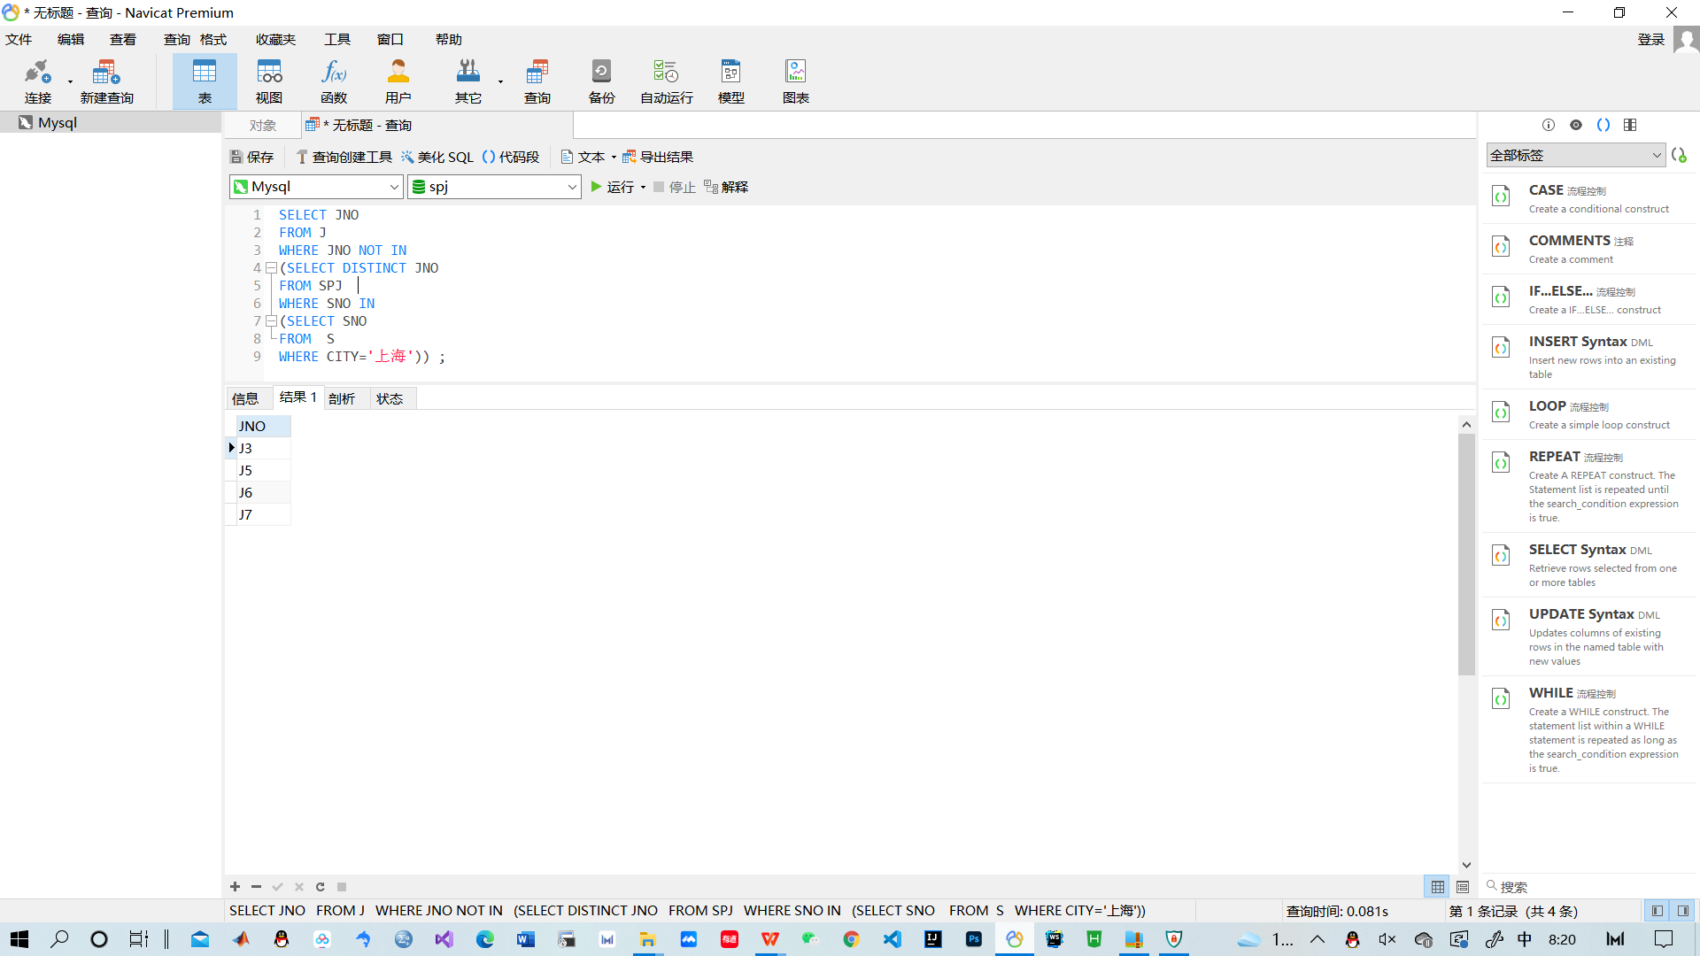

18、查询供应零件数量最多的工程项目，供应零件的数量。

SELECT JNAME,MAX(QTY)

FROM spj,j

WHERE spj.JNO=j.JNO;

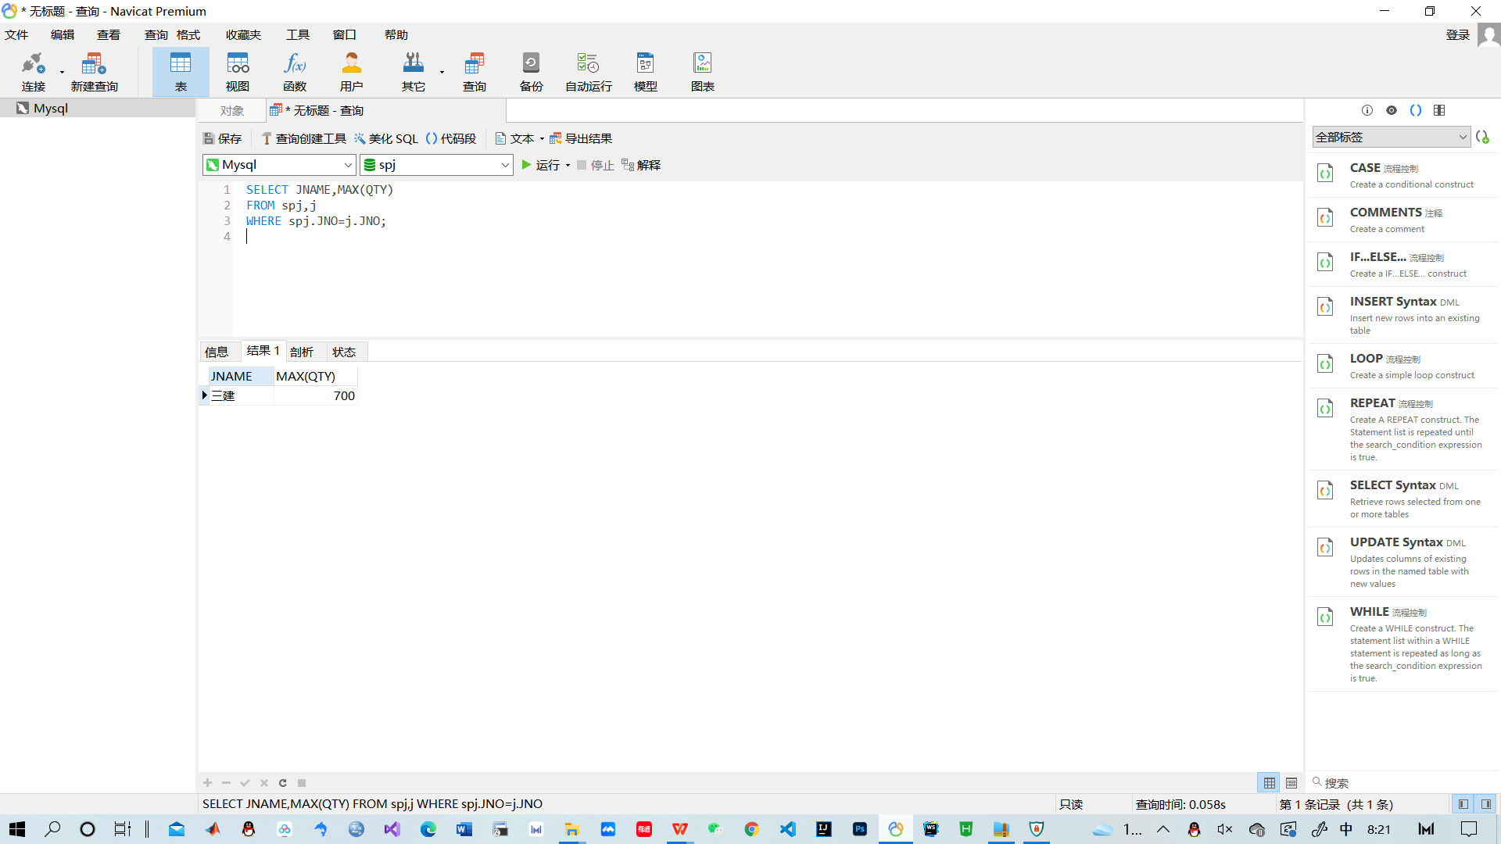

19、查询供应商数量最多的工程项目，供应商的数量。

SELECT JNAME,COUNT(spj.SNO)

FROM spj,j

WHERE spj.JNO=j.JNO

GROUP BY JNAME

ORDER BY COUNT(spj.SNO) DESC

LIMIT 0,1;

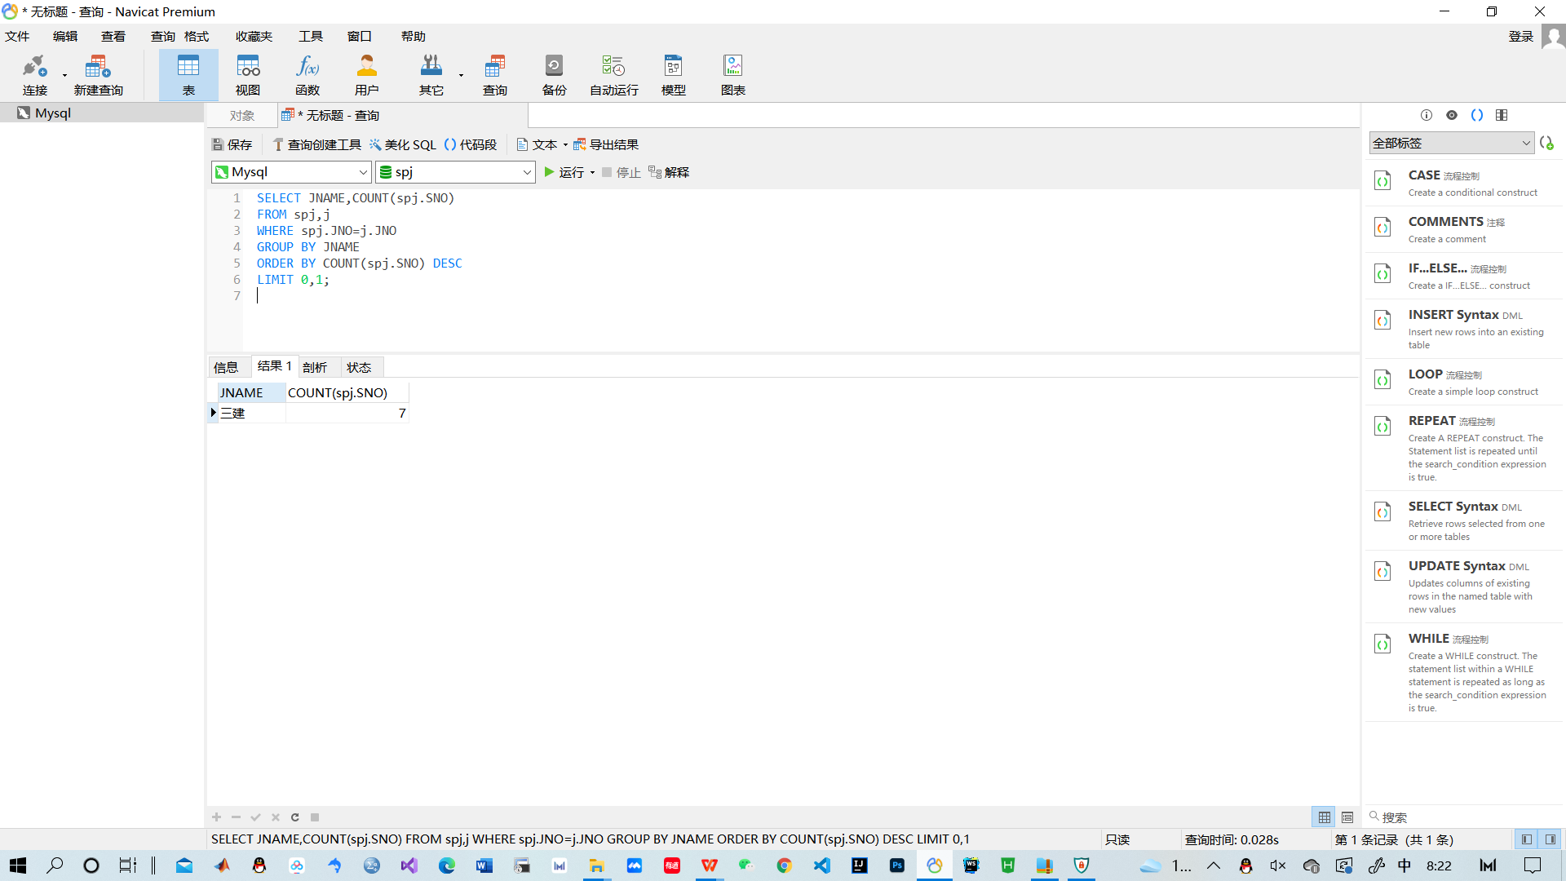

20、查询每个工程项目所使用零件的数量总和。

SELECT JNAME,sum(QTY)

FROM spj,p,j

WHERE spj.JNO=j.JNO and spj.PNO=p.PNO

GROUP BY JNAME;

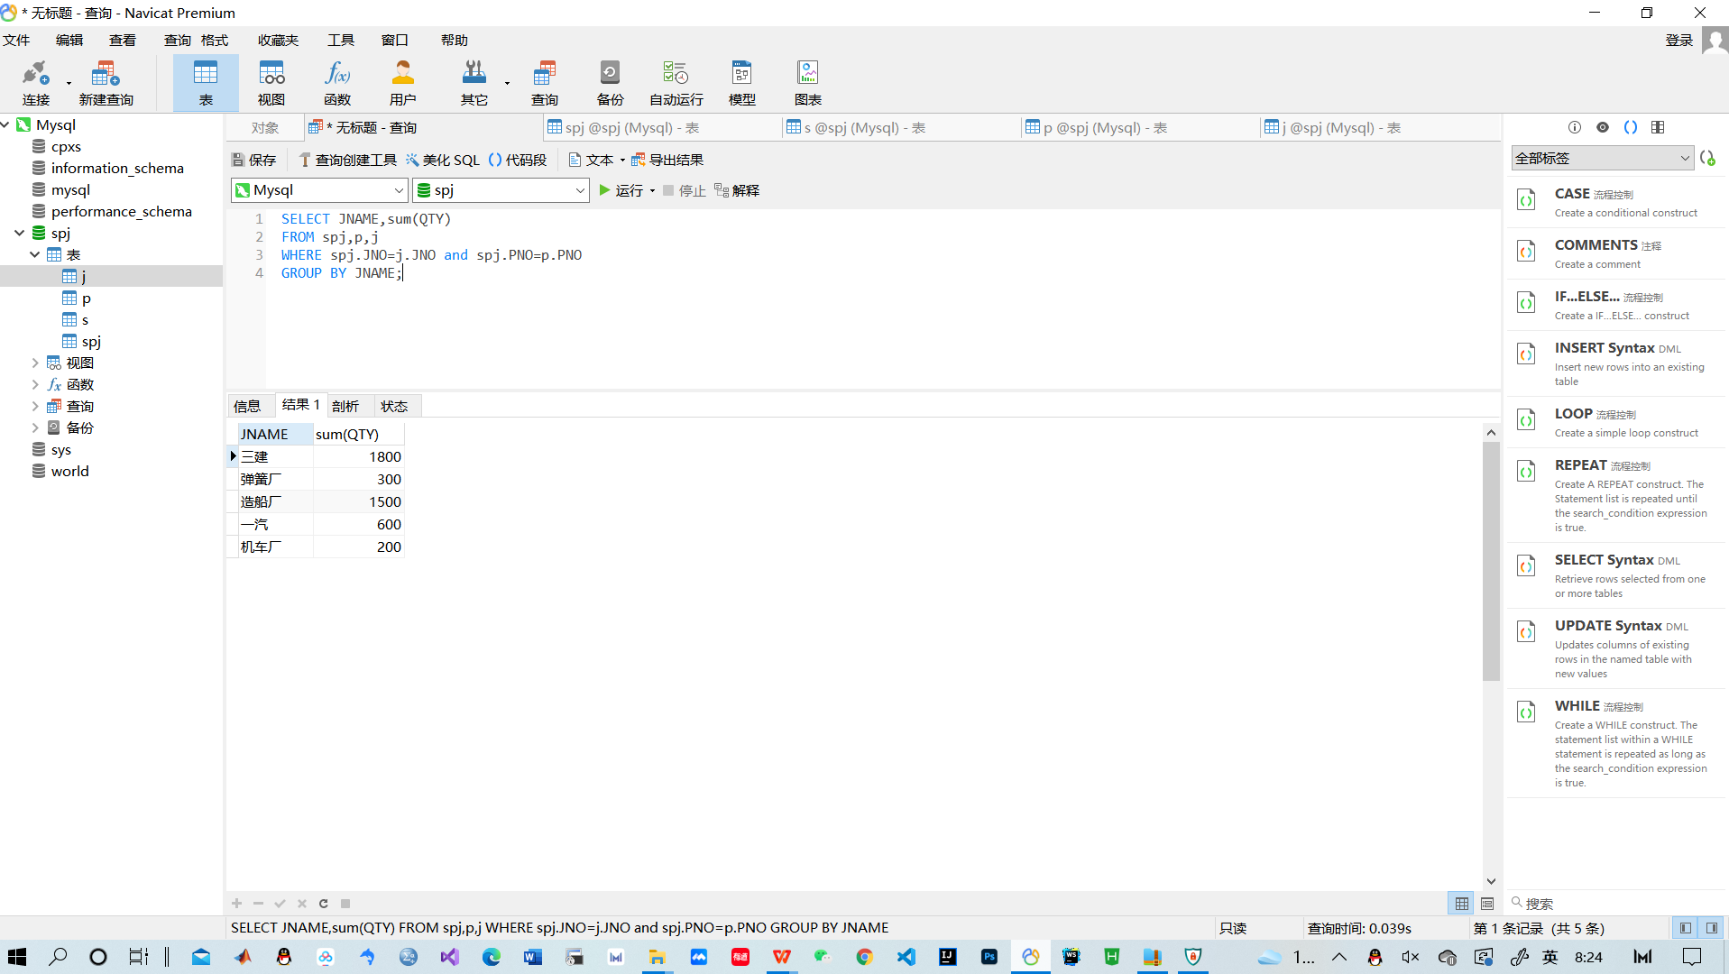

**出现的问题及解决方案：**

1. 升序降序无法查询

解决：查找教材，升序直接使用ORDER BY，降序在后面再加上一个DESC

例：USE world;

SELECT Name,Region

FROM country

WHERE Continent = 'Asia'

ORDER BY Population;

1. 在自身连接时报错

解决：对表进行重命名，例如 FROM S1 ,S2 不能FROM SPJ,SPJ

例如：查询同时为工程J1和J2提供零件的供应商代码

USE spj;

SELECT DISTINCT s1.sno

FROM spj s1,spj s2

WHERE s1.JNO='J1' AND s2.JNO='J2' AND s1.SNO=s2.SNO;

1. 无法查询最高，不知道怎么样把它单度分离出来

解决: 对其进行降序排列后，使用LIMIT

例如：查询供应商数量最多的工程项目，供应商的数量。

SELECT JNAME,COUNT(spj.SNO)

FROM spj,j

WHERE spj.JNO=j.JNO

GROUP BY JNAME

ORDER BY COUNT(spj.SNO) DESC

LIMIT 0,1;

**教师评语及成绩**：