Develop vector auto regression model for multivariate time series data forecasting
EX:No.10
DATE:14/04/25

AIM:
To implement a Vector AutoRegression (VAR) model for forecasting multivariate time series data using AAPL stock data.
ALGORITHM:
- Import necessary libraries and load the multivariate time series dataset (e.g., AAPL.csv).
- Convert the 'Date' column to datetime format, set it as index, and select relevant features (e.g., Close, Volume).
- Handle missing values and check for stationarity; apply differencing if necessary.
- Split the dataset into training and testing sets.
- Fit the VAR model on the training data and determine the optimal lag order.
- Generate forecasts using the trained VAR model on the test data.
- Reverse differencing (if applied), visualize the results, and evaluate the model using metrics like MAE and RMSE.
CODE:
import pandas as pd
import numpy as np
import matplotlib.pyplot as plt
from statsmodels.tsa.api import VAR
from statsmodels.tools.eval_measures import rmse, meanabs

# 1. Load dataset
data = pd.read_csv('/content/AAPL.csv')
data['Date'] = pd.to_datetime(data['Date'])
data.set_index('Date', inplace=True)

# 2. Select relevant features (multivariate)
df = data[['Close', 'Volume']].copy()

# 3. Handle missing values
df = df.fillna(method='ffill')

# 4. Split into train and test
n_obs = 30 # number of observations for testing
train, test = df[:-n_obs], df[-n_obs:]

# 5. Check for stationarity - Difference the series
train_diff = train.diff().dropna()

# 6. Fit VAR model
model = VAR(train_diff)
lag_order = model.select_order(maxlags=15)
print("Selected Lag Order:\n", lag_order.summary())

selected_lag = lag_order.aic # choose based on AIC
var_model = model.fit(selected_lag)

# 7. Forecast
forecast_input = train_diff.values[-selected_lag:]
forecast = var_model.forecast(y=forecast_input, steps=n_obs)

# 8. Convert forecast to DataFrame and reverse differencing
forecast_df = pd.DataFrame(forecast, index=test.index, columns=['Close', 'Volume'])
forecast_cumsum = forecast_df.cumsum()
last_known = train.iloc[-1]
forecast_values = forecast_cumsum + last_known

# 9. Evaluation
print("\n Evaluation Metrics (Close Price):")
print("MAE:", meanabs(test['Close'], forecast_values['Close']))
print("RMSE:", rmse(test['Close'], forecast_values['Close']))

# 10. Plotting
plt.figure(figsize=(12, 6))
plt.plot(train['Close'], label='Train Close')
plt.plot(test['Close'], label='Actual Close', color='green')
plt.plot(forecast_values['Close'], label='Forecast Close', color='red')
plt.title('AAPL Close Price Forecast using VAR')
plt.xlabel('Date')
plt.ylabel('Price')
plt.legend()
plt.show()

OUTPUT:

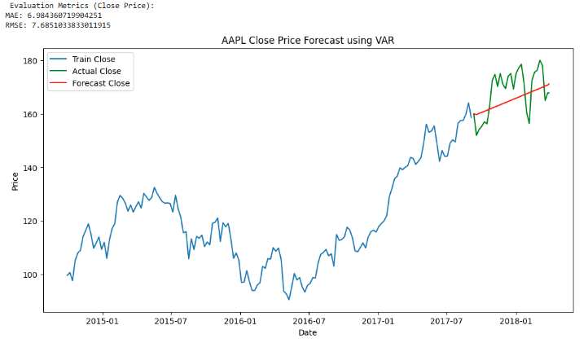

RESULT:
Thus the program has been completed and verified successfully.

