Stored Procedure
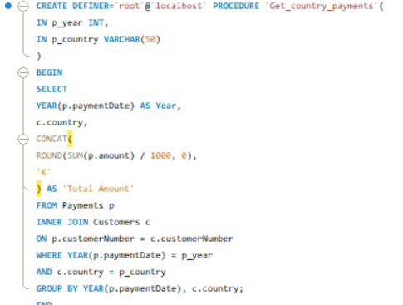

Sales Category view

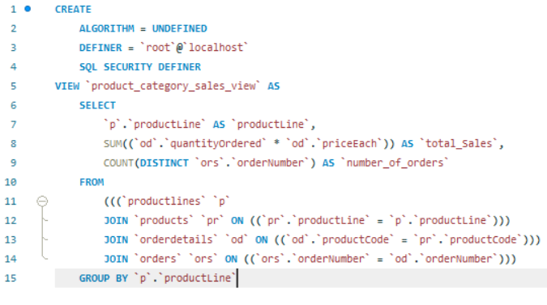

Error handling
CREATE DEFINER=`root`@`localhost` PROCEDURE `Validate_And_Insert_Emp`(
IN p_EmpID VARCHAR(20),
IN p_EmpName VARCHAR(50),
IN p_EmailAddress VARCHAR(100)
)
BEGIN
DECLARE v_sqlstate CHAR(5);
DECLARE v_msg TEXT;

DECLARE EXIT HANDLER FOR SQLEXCEPTION
BEGIN
GET DIAGNOSTICS CONDITION 1
v_sqlstate = RETURNED_SQLSTATE,
v_msg = MESSAGE_TEXT;

IF v_sqlstate = '45000' THEN
SELECT v_msg AS Message;
ELSE
SELECT 'Error occurred' AS Message;
END IF;
END;

IF p_EmpID NOT REGEXP '^[0-9]+$' THEN
SIGNAL SQLSTATE '45000'
SET MESSAGE_TEXT = 'Employee ID must be numeric';
END IF;

INSERT INTO Emp_EH(EmpID, EmpName, EmailAddress)
VALUES (
CAST(p_EmpID AS UNSIGNED),
p_EmpName,
p_EmailAddress
);
SELECT 'Record Inserted Successfully' AS Message;
END

Triggers
