**OUTPUT:**

**serverRCE:**

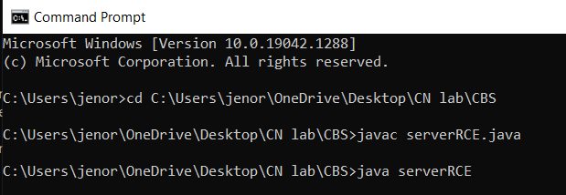

**clientRCE:**

c