ER DIAGRAM DESIGN AND
RELATIONAL SCHEMA
Library Management System

Assignment
Name:Bavya.G
Roll no:2511021240041

OBJECTIVE
To design a complete Entity Relationship (ER) Diagram for the Library Management System and convert it into a Relational Schema by identifying entities, attributes, primary keys, foreign keys, relationships, and cardinalities.

ENTITIES AND ATTRIBUTES
Entity 1: MEMBER
Column | Key
Member_ID | Primary Key
Member_Name | -
Phone | -
Email | -
Address | -
Column | Key
Loan_Item_ID | Primary Key
Loan_ID | Foreign Key
Book_ID | Foreign Key
Quantity | -
Entity 2: LIBRARY_BRANCH
Column | Key
Branch_ID | Primary Key
Branch_Name | -
Phone | -
Address | -
Entity 3: BOOK
Column | Key
Book_ID | Primary Key
Branch_ID | Foreign Key
Title | -
Author | -
Genre | -
Availability | -
Entity 4: LOAN
Column | Key
Loan_ID | Primary Key
Member_ID | Foreign Key
Branch_ID | Foreign Key
Loan_Date | -
Due_Date | -
Loan_Status | -
Entity 5: LOAN_ITEM
Column | Key
Return_Date | -
Entity 6: FINE_PAYMENT
Column | Key
Payment_ID | Primary Key
Loan_ID | Foreign Key
Payment_Date | -
Payment_Method | -
Amount | -
Payment_Status | -
Entity 7: LIBRARIAN
Column | Key
Librarian_ID | Primary Key
Loan_ID | Foreign Key
Librarian_Name | -
Phone | -
Assigned_Status | -

Relationships and Cardinalities
Entity 1 | Relationship | Entity 2 | Cardinality
MEMBER | Places | LOAN | 1:M
LIBRARY_BRANCH | Has | BOOK | 1:M
LIBRARY_BRANCH | Processes | LOAN | 1:M
LOAN | Contains | LOAN_ITEM | 1:M
BOOK | Appears in | LOAN_ITEM | 1:M
LOAN | Has | FINE_PAYMENT | 1:1
LOAN | Assigned to | LIBRARIAN | 1:1

ER DIAGRAM
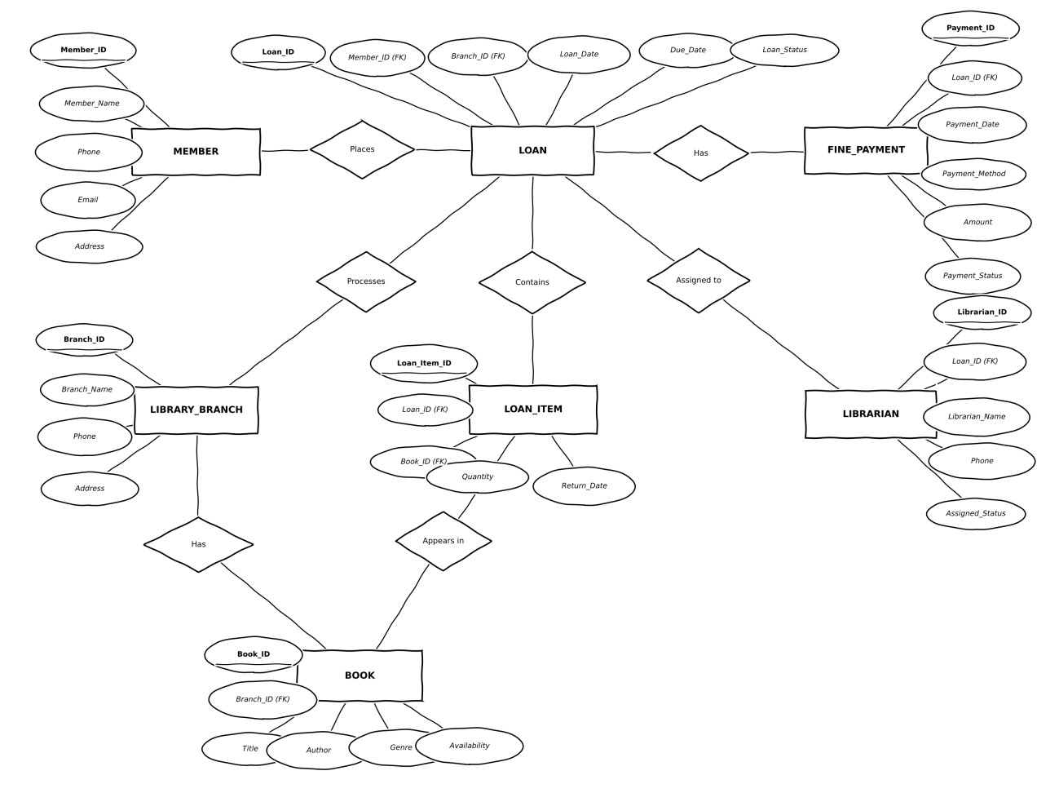

RELATIONAL SCHEMA
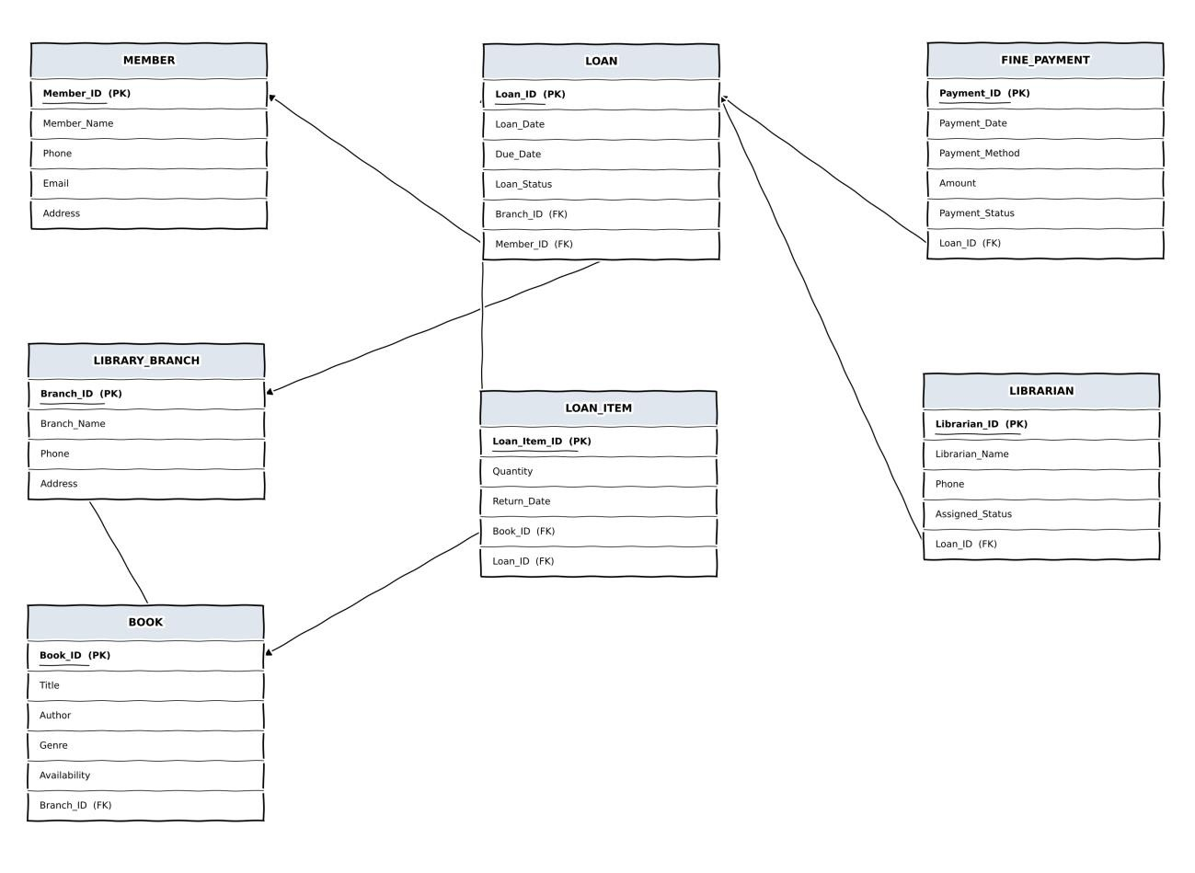

RELATIONAL SCHEMA — PRIMARY / FOREIGN KEYS
Table | Primary Key | Foreign Key
MEMBER | Member_ID | -
LIBRARY_BRANCH | Branch_ID | -
BOOK | Book_ID | Branch_ID
LOAN | Loan_ID | Member_ID, Branch_ID
LOAN_ITEM | Loan_Item_ID | Loan_ID, Book_ID
FINE_PAYMENT | Payment_ID | Loan_ID
LIBRARIAN | Librarian_ID | Loan_ID

RELATIONSHIP EXPLANATION
Member – Loan:
One member can place many loans. Therefore, the relationship is 1:M.
Library Branch – Book:
One library branch can hold many books. Therefore, the relationship is 1:M.
Library Branch – Loan:
One library branch can process many loans. Therefore, the relationship is 1:M.
Loan – Loan Item:
One loan can contain many loan items (books). Therefore, the relationship is 1:M.
Book – Loan Item:
One book can appear in many loan items over time. Therefore, the relationship is 1:M.
Loan – Fine Payment:
Each loan has at most one fine payment record. Therefore, the relationship is 1:1.
Loan – Librarian:
Each loan is assigned to one librarian record. Therefore, the relationship is 1:1.

