WEB CRAWLER
Bavya Balakrishnan
Mtech sem 2
192402IT003
Web crawler is an internet bot which is used to discover web resources (web pages) from world wide web (WWW). Web search engines such as Google, Bing use this in order to build and update search indices. Usually crawler starts crawling with known seed URLs and then use fetched pages to find URLs for subsequent crawling.

Crawler4j
crawler4j is an open source web crawler for Java which provides a simple interface for crawling the Web. Using it, you can setup a multi-threaded web crawler in few minutes.

BASIC CRAWLER
Steps:
1. Download crawler4j-4.1-jar-with-dependencies.jar
2.In Eclipse add the JAR(s) file to the class path.
3.You should implement a controller class which specifies the seeds (starting URLs) of the crawl, the folder in which intermediate crawl data should be stored and the number of concurrent threads, and other configurations dealing with politeness.
4.You need to create a crawler class that extends WebCrawler. This class decides which URLs should be crawled and handles the downloaded page.Two methods, “shouldVisit” and “visit” methods should be overridden to provide expected behavior for the crawler
seed URL:https://nitk.ac.in
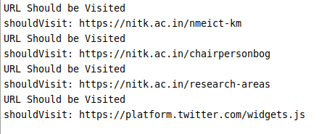

Sequential crawling vs. Multithreaded crawling
We can specify number of threads in controller.start(MyCrawler.class, numberOfCrawlers)

Sequential crawling
Number of threads=1

Multithreaded crawling
Tried with number of threads 2,3 and 4.

NUMBER_OF_CRAWELRS | Start | End | Time taken(s)
1 | 23.07:12.19 | 23:08:33.79 | 81
2 | 23.09:23:21 | 23:09:54.56 | 31
3 | 23.19:48:01 | 23:20:55.53 | 72
4 | 23.21:53.00 | 23:22:55.05 | 62

Crawler will run faster with increased number of threads.

Type of crawling strategy used (BFS v/s DFS)

Breadth First Search
- Implemented with QUEUE (FIFO)
- Finds pages along shortest paths
- If we start with “good” pages, this keeps us close; maybe other good stuff…

Depth First Search
- Implemented with STACK (LIFO)
- Wander away (“lost in cyberspace”)

In older versions of Crawler4j,we can specify the method of traversal in
new CrawlController(config1, pageFetcher1, robotstxtServer, chosen, bestN);

BFS --> chosen = -1
DFS --> chosen = 0
B-FS --> chosen 1

but this parameter is deprecated in newer version.
So BFS and DFS crawling strategy are implemented from scratch.
BFS
Seed:https://snap.stanford.edu/
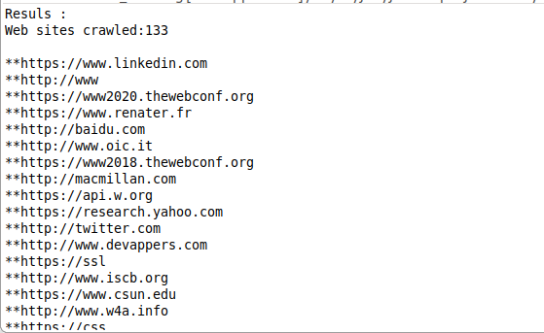

DFS
Seed URL:https://snap.stanford.edu/
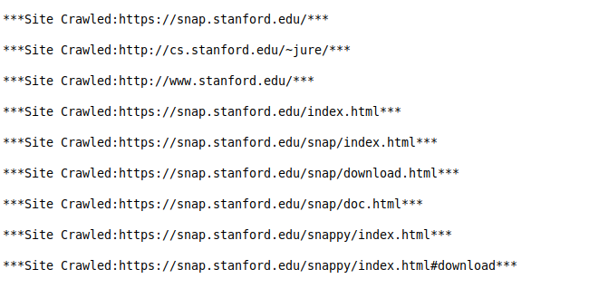

Crawl only from pages whose URL includes one of the words in the list
We can use regex for this.

private final static Pattern pattern1=Pattern.compile("^.*?(maps|landing|statistics|github).*$");

Page is visited only if,

pattern1.matcher(href).matches();

Seed URL:https://www.irctc.co.in/nget/train-search

Crawl only from pages whose title includes one of the words in the list
Example,Extract all articles for ‘Java 8’ on mkyong.com

we notice is that the titles of the articles -which is what we want- are wrapped in <h2></h2> and
<a href=""></a> tags.

So to extract the article titles we will access that specific information using a css selector that restricts our select method to that exact information:
document.select("h2 a[href^=\"http://www.mkyong.com/\"]");
Finally, we will only keep the links in which the title contains ‘Java 8’ and save them to a file.

Crawl only from pages whose content includes one of the words in the list
Entered the words to crawl from pages whose content include those words
