Experiment 17

Aim: To Write a Pandas program to split the following dataframe by school code and get mean, min, and max value of age for each school.

Code

import pandas as pd

df = pd.read_csv('school.csv')

grouped = df.groupby('school_code')['age'].agg(['mean', 'min', 'max'])

print(grouped)

Output

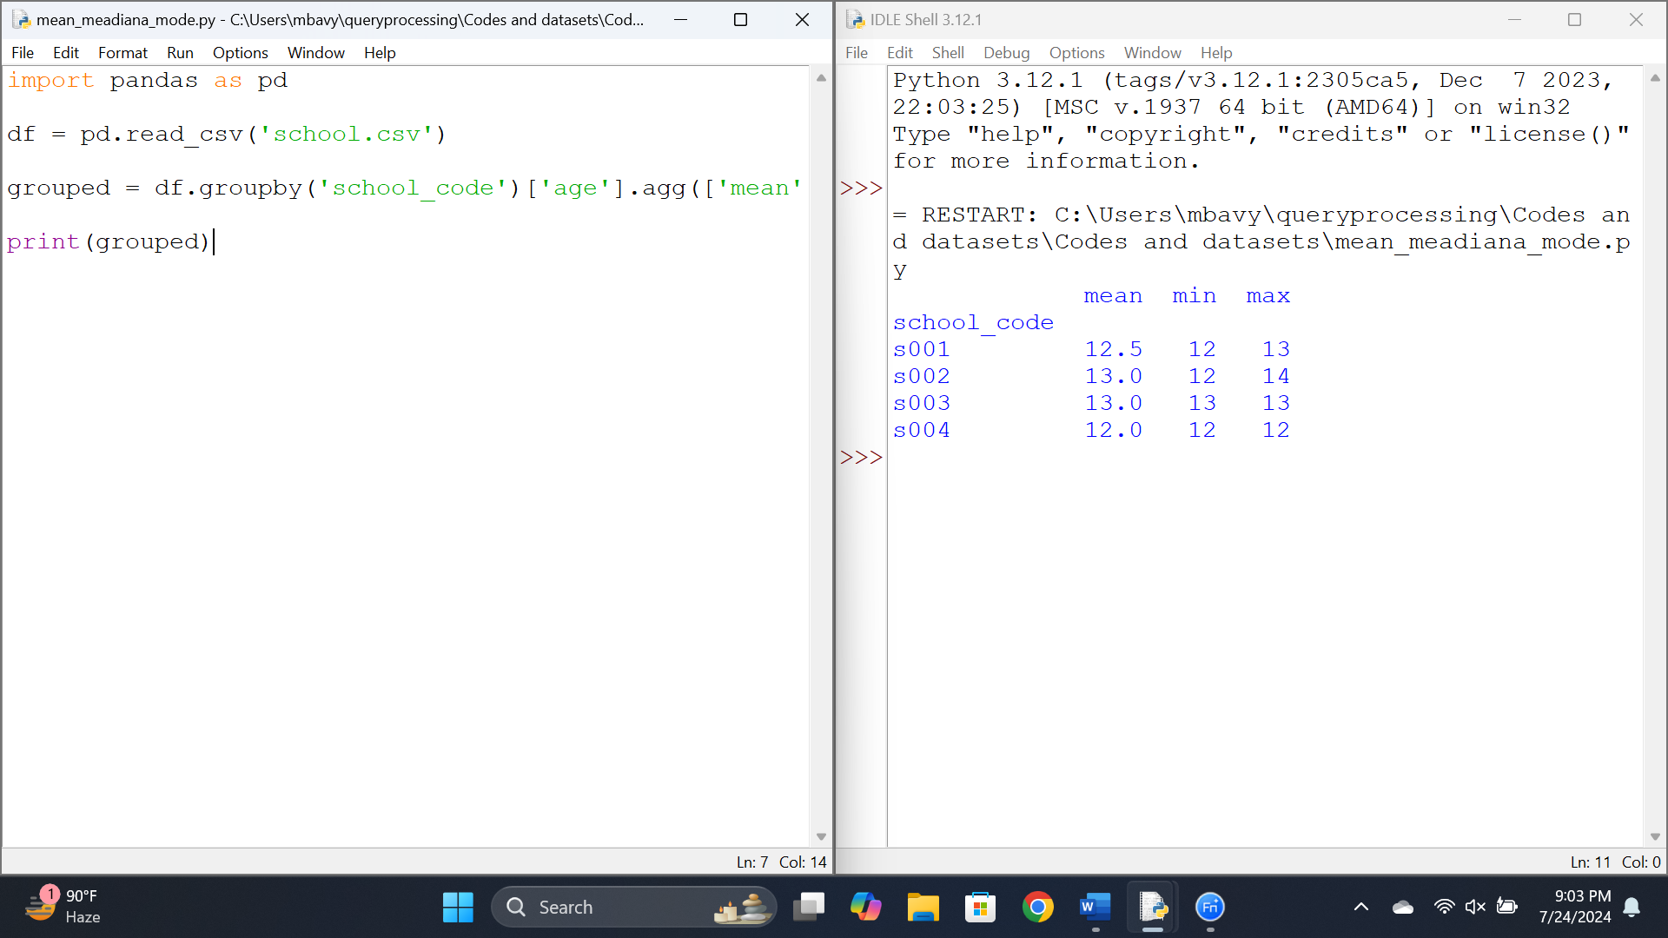

Results:

Thus a Pandas program to split the following dataframe by school code and get mean, min, and max value of age for each school.

Experiment 18

Aim: To Write a Pandas program to split the following given dataframe into groups based on school code and class.

Code

import pandas as pd

df = pd.read_csv('school.csv')

grouped = df.groupby(['school_code', 'class'])

for (school_code, class_number), group in grouped:

print(f"Group (school_code: {school_code}, class: {class_number}):")

print(group)

print()

Output:

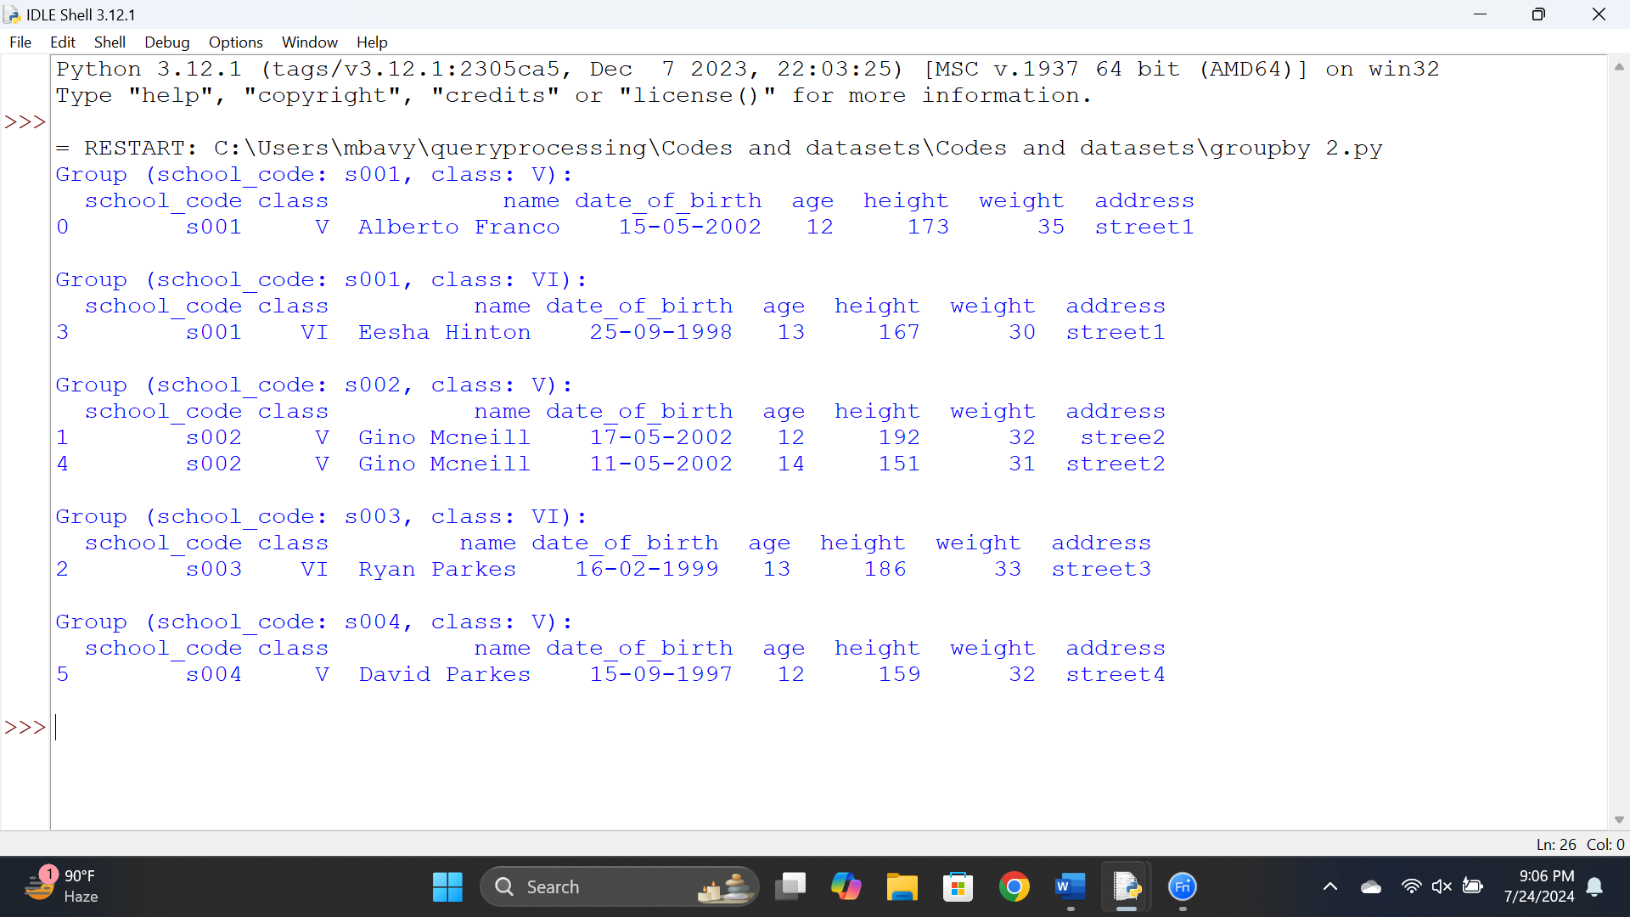

Results:

Thus a Pandas program to split the following given dataframe into groups based on school code and class.

Experiment 19

Aim: To Write a Pandas program to display the dimensions or shape of the World alcohol consumption dataset.

Code:

import pandas as pd

df = pd.read_csv('wine_consumption.csv')

print("Dimensions of the dataset:", df.shape)

print("Column names in the dataset:")

print(df.columns.tolist())

Output

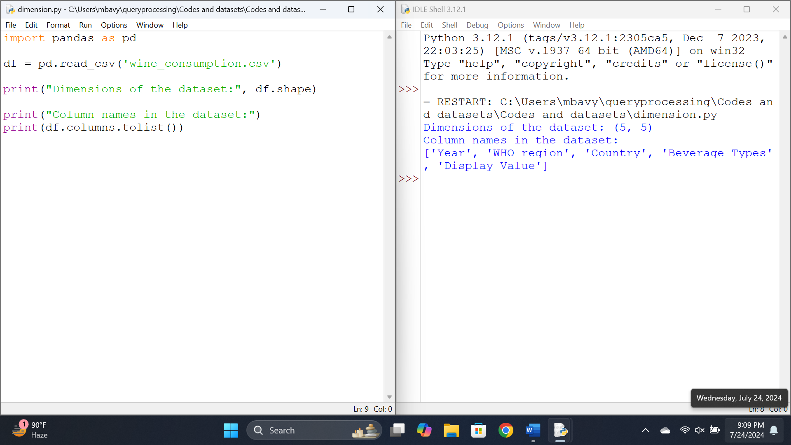

Results:

Thus Write a Pandas program to display the dimensions or shape of the World alcohol consumption dataset.

Experiment 20

Aim: To Write a Pandas program to find the index of a given substring of a DataFrame column.

Code

import pandas as pd

data = {

'Name': ['Alice', 'Bob', 'Charlie', 'David', 'Eve'],

'City': ['New York', 'Los Angeles', 'New Orleans', 'Chicago', 'New Haven']

}

df = pd.DataFrame(data)

substring = 'New'

indices = df.index[df['City'].str.contains(substring, case=False, na=False)].tolist()

print("Indices where the substring '{}' is found: {}".format(substring, indices))

Output

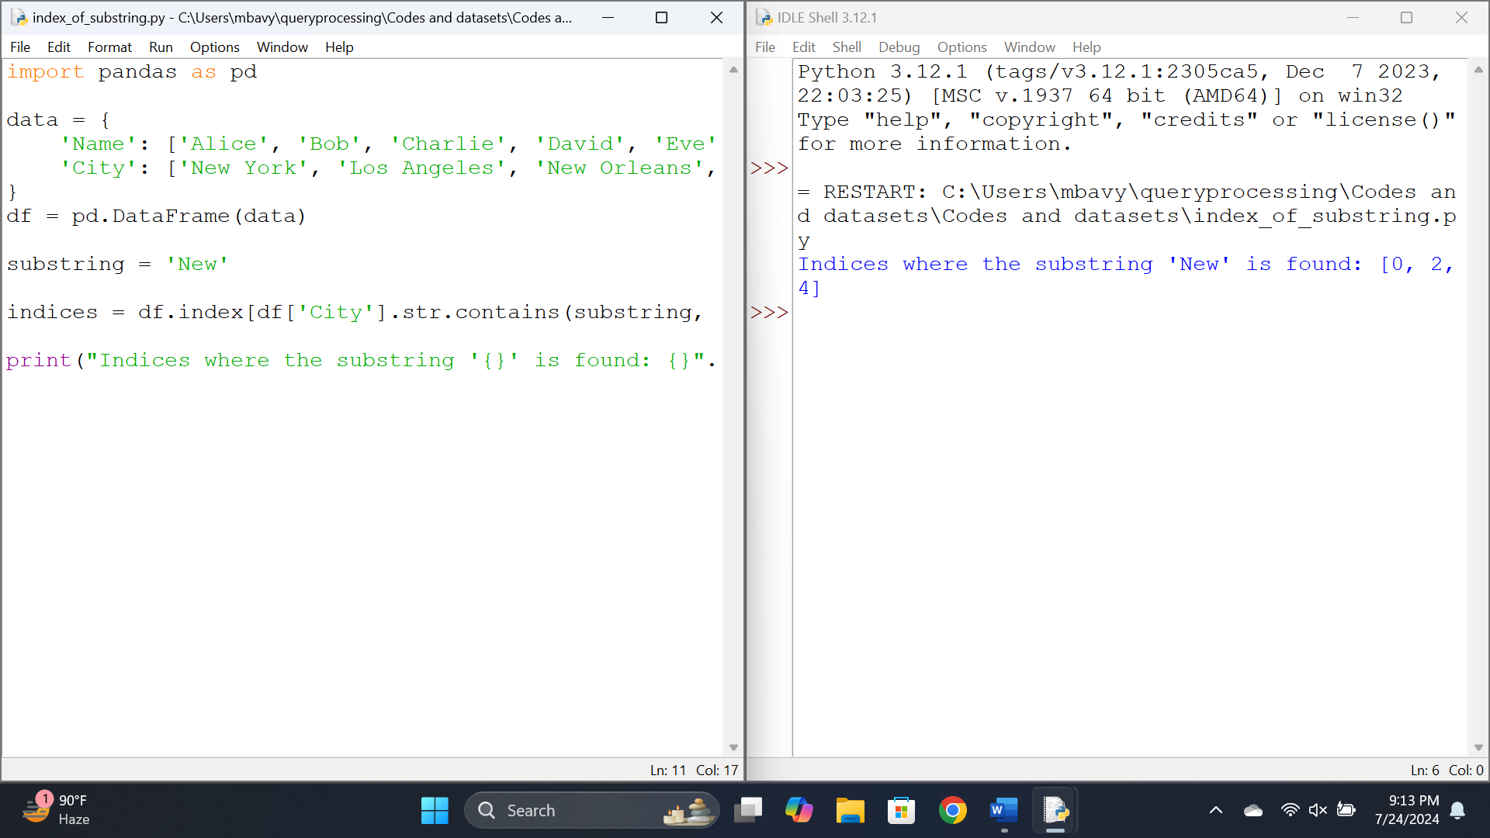

Results:

Thus a Pandas program to find the index of a given substring of a DataFrame column.

Experiment 21

Aim: Write a Pandas program to swap the cases of a specified character column in a given DataFrame.

Code:

import pandas as pd

data = {'Name': ['Alice', 'Bob', 'Charlie'], 'Age': [25, 30, 35]}

df = pd.DataFrame(data)

df['Name'] = df['Name'].str.swapcase()

print(df)

Output:

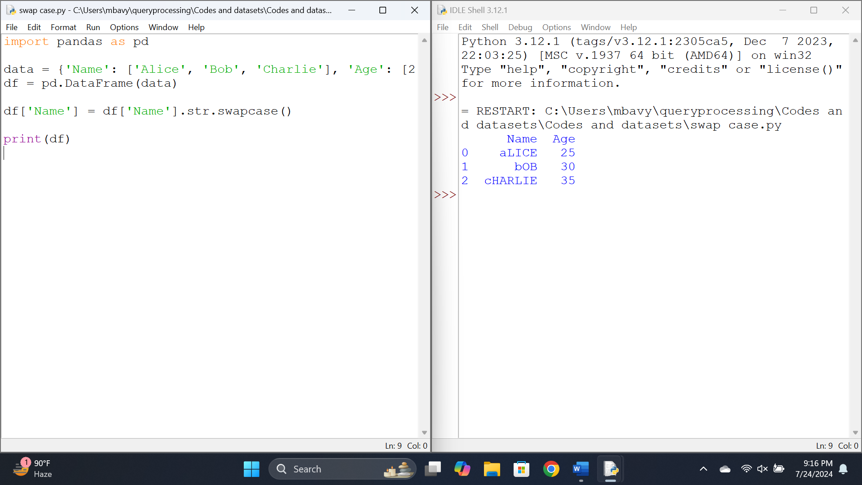

Results:

Thus a Pandas program to swap the cases of a specified character column in a given DataFrame.

Experiment 22

Aim:To Write a Python program to draw a line with suitable label in the x axis, y axis and a title.

Code:

import matplotlib.pyplot as plt

x = [1, 2, 3, 4, 5]

y = [2, 4, 6, 8, 10]

plt.plot(x, y)

# Add labels and title

plt.xlabel('X Axis Label')

plt.ylabel('Y Axis Label')

plt.title('Line Plot Example')

plt.show()

Output:

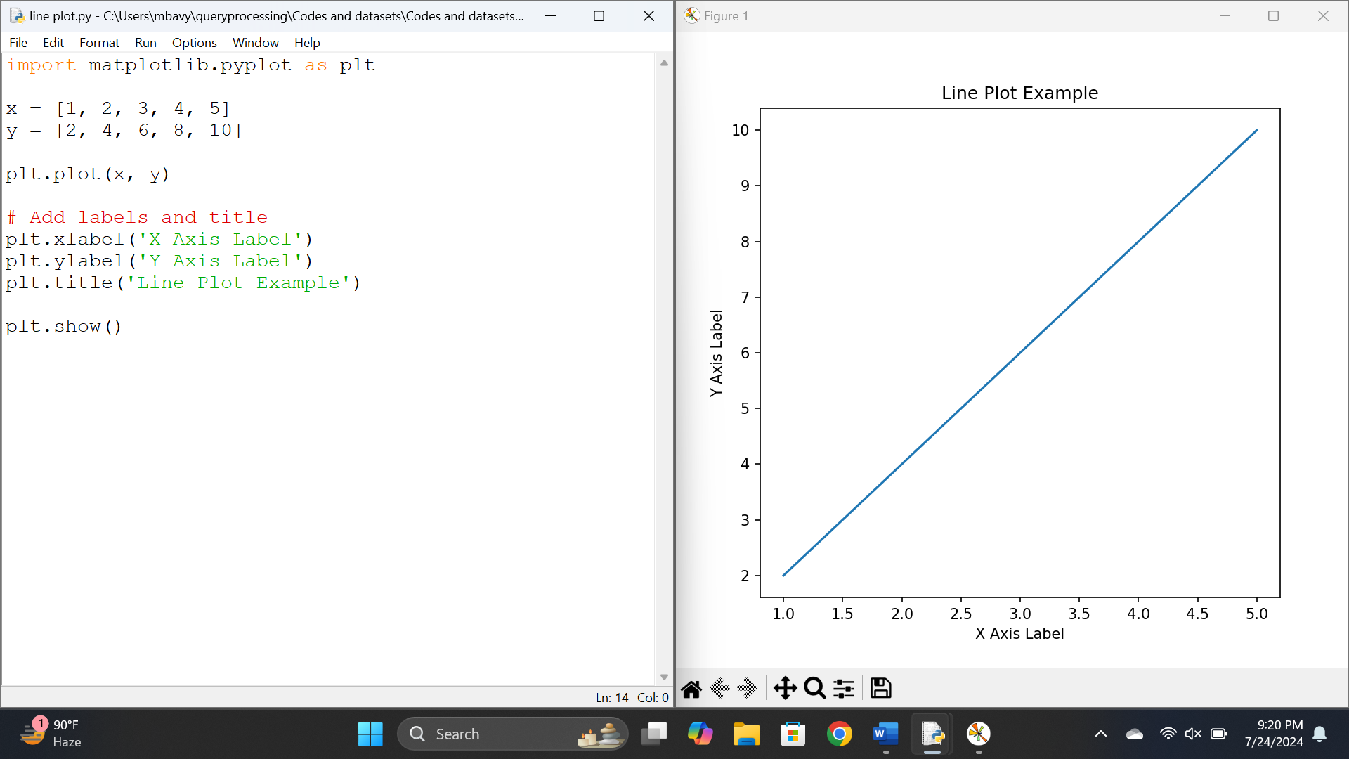

Results:

Thus a Python program to draw a line with suitable label in the x axis, y axis and a title.

Experiment 23

Aim:

To Write a Python program to draw a line using given axis values taken from a text file, with suitable label in the x axis, y axis and a title.

Code:

import matplotlib.pyplot as plt

with open('axis_values.txt', 'r') as f:

x = [float(value) for value in f.readline().split()]

y = [float(value) for value in f.readline().split()]

plt.plot(x, y)

# Add labels and title

plt.xlabel('X Axis Label')

plt.ylabel('Y Axis Label')

plt.title('Line Plot Example')

plt.show()

Output:

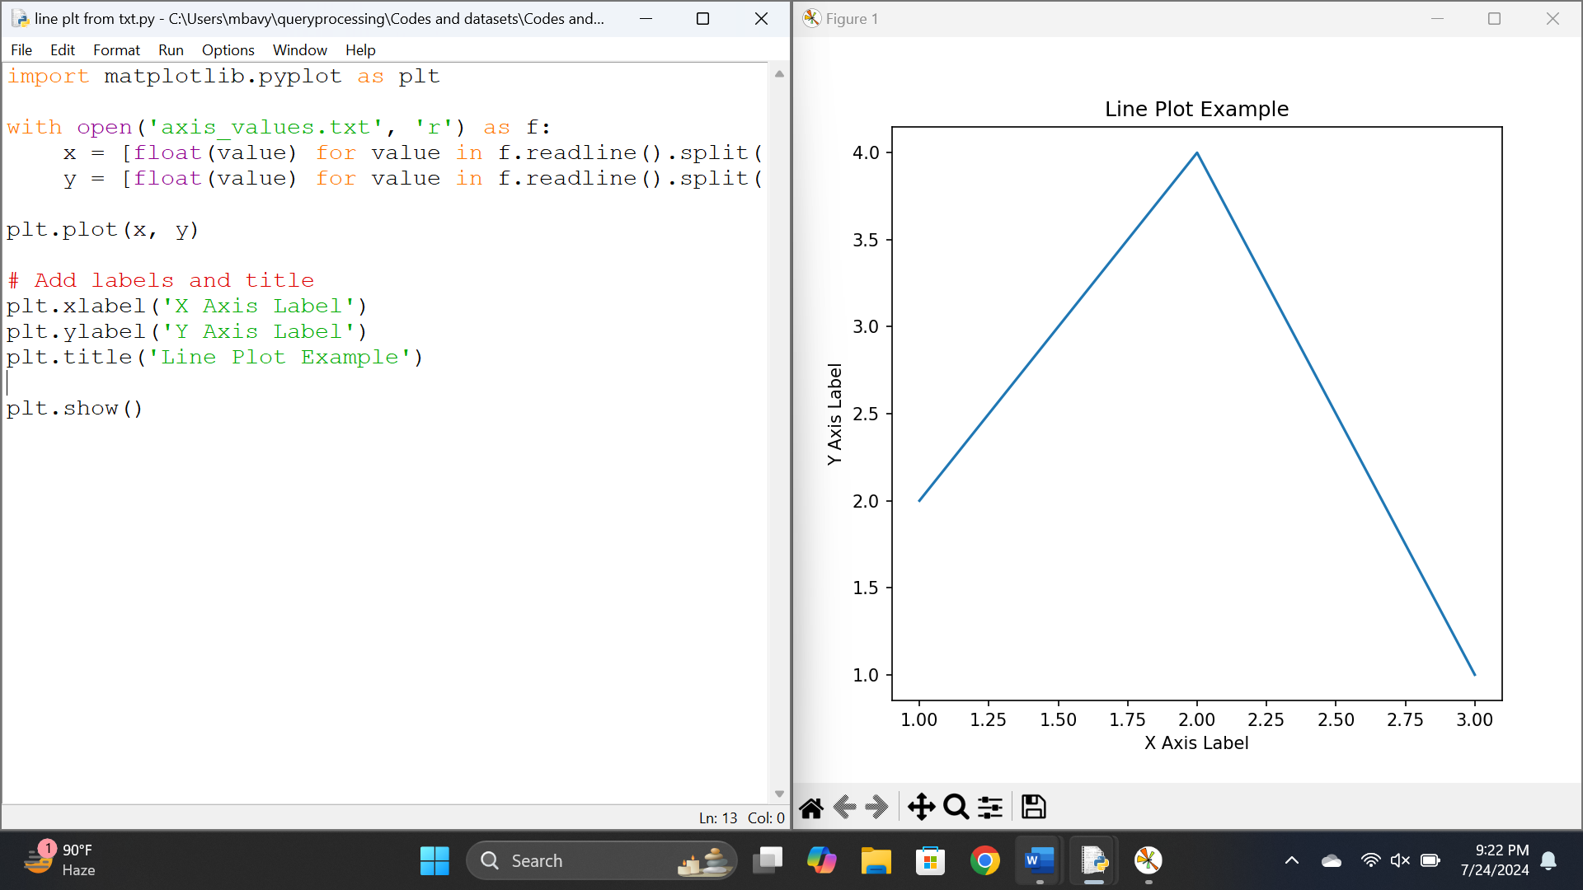

Results:

Thus a Python program to draw a line using given axis values taken from a text file, with suitable label in the x axis, y axis and a title.

Experiment 24

Aim: To Write a Python program to draw line charts of the financial data of Alphabet Inc. between October 3, 2016 to October 7, 2016.

Code:

import pandas as pd

import matplotlib.pyplot as plt

df = pd.read_csv('GOOGL.csv')

plt.figure(figsize=(14, 7))

plt.plot(df['Date'], df['Open'], label='Open', color='blue')

plt.plot(df['Date'], df['High'], label='High', color='green')

plt.plot(df['Date'], df['Low'], label='Low', color='red')

plt.plot(df['Date'], df['Close'], label='Close', color='purple')

plt.title('GOOGL Financial Data')

plt.xlabel('Date')

plt.ylabel('Price')

plt.legend()

plt.show()

Output:

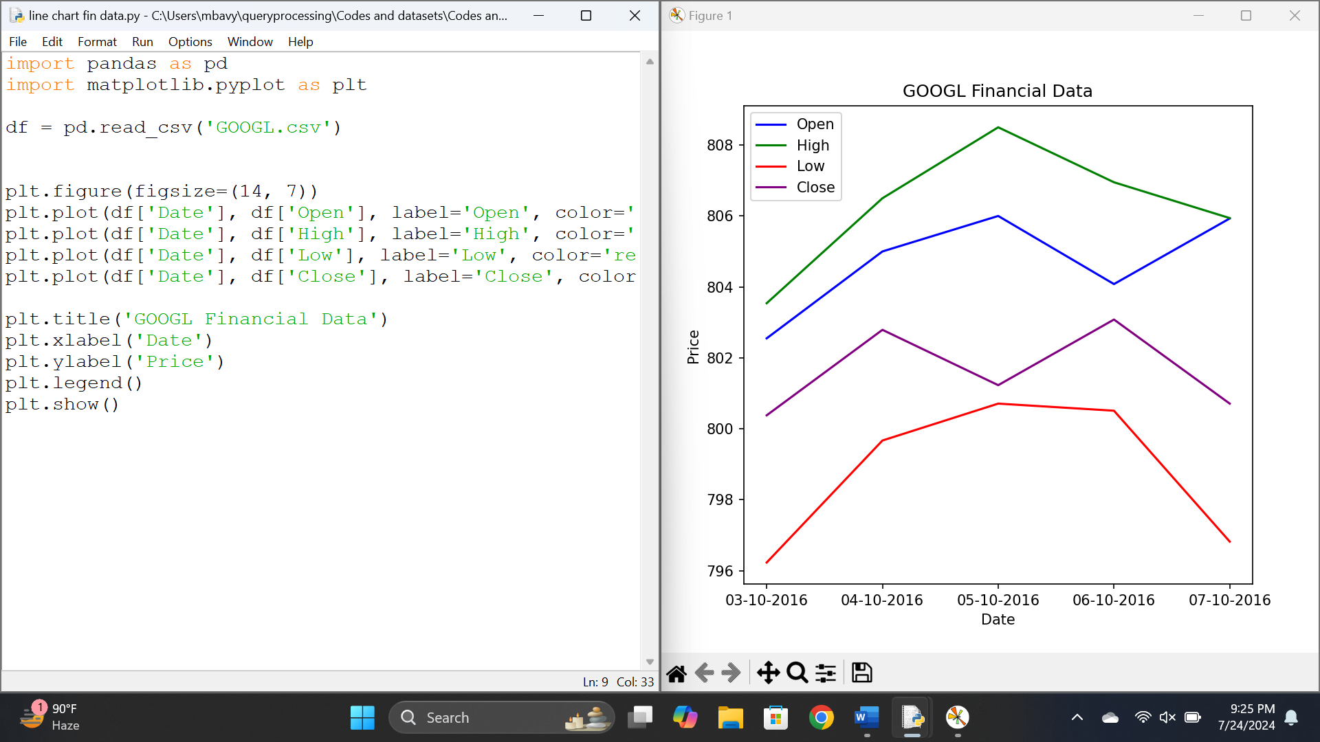

Results:

Thus a Python program to draw line charts of the financial data of Alphabet Inc. between October 3, 2016 to October 7, 2016.