**DEVOPS**

DAY – 2

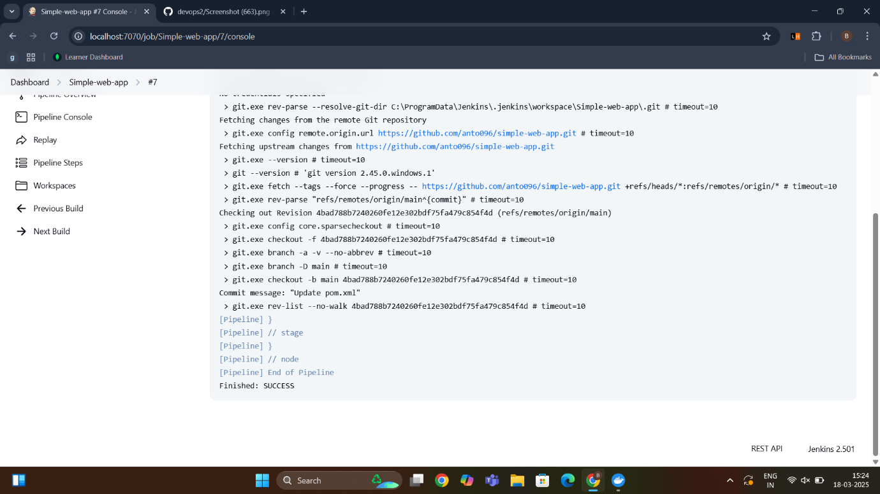

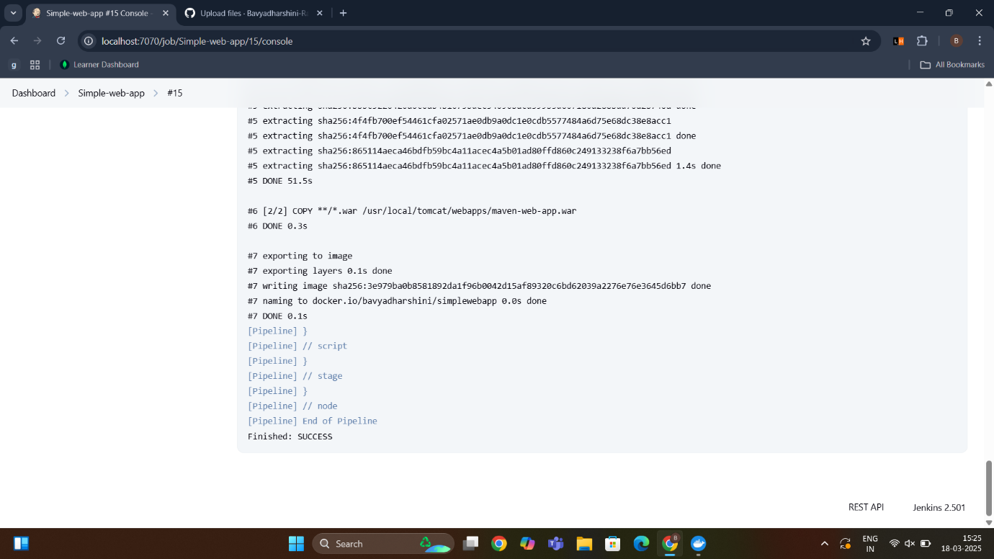Simplewebapp1 Jenkins Output

Simplewebapp2 Jenkins Output

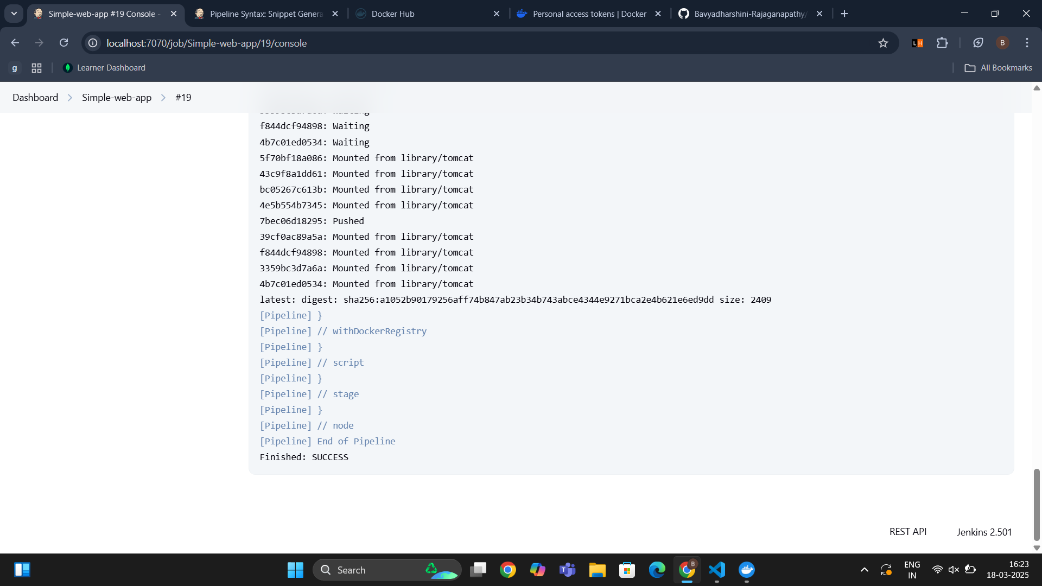

Pushing Image to Hub Jenkins Output