**DEVOPS**

DAY – 3

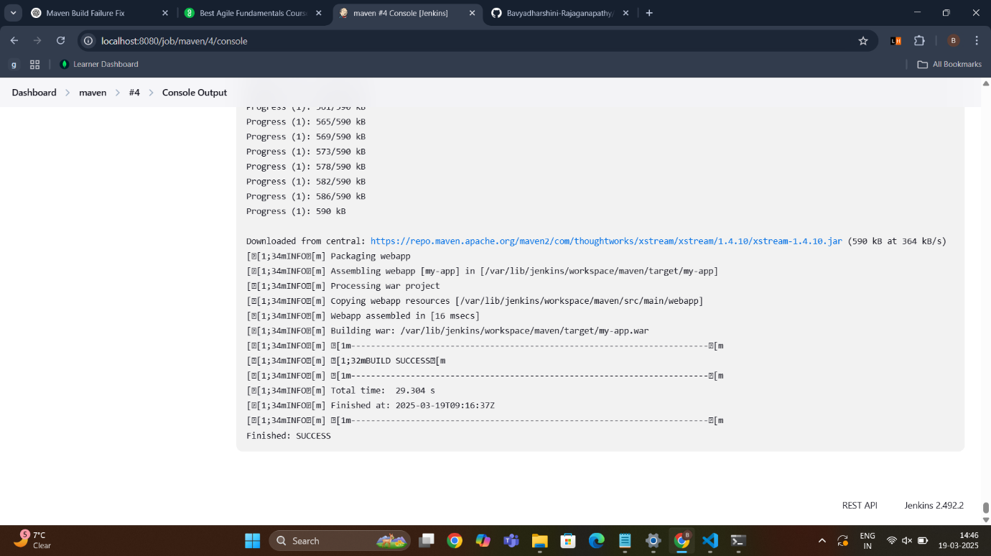 Mavenwebapp Jenkins Output

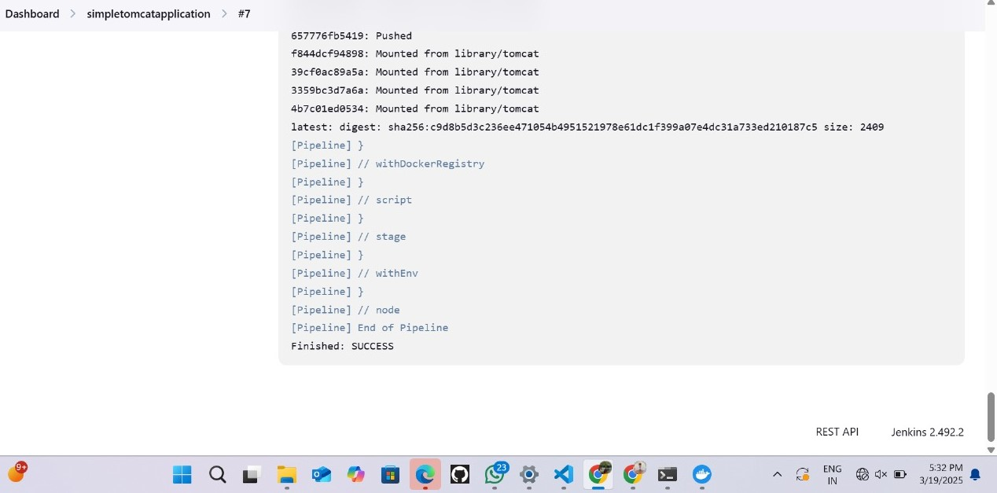 Simpletomcatapplication Jenkins Output

**Installation Commands in WSL:**

1. **Git installation:**
2. sudo apt update
3. sudo apt install git
4. git --version
5. git config --global user.name "Your Name"
6. git config --global user.email [your.email@example.com](mailto:your.email@example.com)
7. **JDK installation:**
8. sudo apt update
9. sudo apt upgrade -y
10. sudo apt install default-jdk -y
11. java –version
12. **Maven installation:**
13. sudo apt install maven -y
14. mvn -version
15. **Jenkins installation:**
16. sudo wget -O /usr/share/keyrings/jenkins-keyring.asc \

https://pkg.jenkins.io/debian-stable/jenkins.io-2023.key

echo "deb [signed-by=/usr/share/keyrings/jenkins-keyring.asc]" \

https://pkg.jenkins.io/debian-stable binary/ | sudo tee \

/etc/apt/sources.list.d/jenkins.list > /dev/null

sudo apt-get update

sudo apt-get install Jenkins

1. sudo service Jenkins restart
2. sudo service Jenkins status
3. 4. sudo cat /var/lib/jenkins/secrets/initialAdminPassword
4. **Docker installation:**
5. sudo apt install docker-compose -y
6. sudo service docker restart
7. sudo service docker status
8. sudo usermod -aG docker $USER
9. docker images
10. docker ps
11. sudo chmod 666 /var/run/docker.sock
12. **Kubernetes installation:**
13. Go to https://kubernetes.io/docs/tasks/tools/install-kubectl-linux/
14. curl -LO https://dl.k8s.io/release/v1.32.0/bin/linux/amd64/kubectl
15. sudo install -o root -g root -m 0755 kubectl /usr/local/bin/kubectl
16. chmod +x kubectl
17. mkdir -p ~/.local/bin
18. mv ./kubectl ~/.local/bin/kubectl
19. kubectl version –client
20. **Minikube installation:**
21. Go to https://minikube.sigs.k8s.io/docs/start/?arch=%2Fwindows%2Fx86-64%2Fstable%2F.exe+download
22. curl -LO https://github.com/kubernetes/minikube/releases/latest/download/minikube-linux-amd64
23. sudo install minikube-linux-amd64 /usr/local/bin/minikube && rm minikube-linux-amd64
24. minikube start
25. minikube status
26. kubectl get pod
27. kubeclt get deploy
28. kubectl get replica or rs or replicaaset
29. kubectl get pod -o wide

**Docker Compose:**

1. sudo apt install docker-compose -y

2. sudo nano docker-compose.yml

{

version: '3'

services:

web:

image: nginx:latest

ports:

- "80:80"

db:

image: mysql:latest

environment:

MYSQL_ROOT_PASSWORD: "1234"

}

3. docker-compose up -d

4. docker-compose images

5. docker-compose ps

6. sudo docker exec -it bavya_db_1 bash

7. mysql -u root -p

**Maven Jenkins:**

1. git clone https://github.com/Bavyadharshini-Rajaganapathy/devops1.git

2. cd devops1

3. Go to localhost:8080

4. Create an Item named Maven freestyle

5. Choose git

6. Select Execute shell

Shell:

mvn clean package

**Simpletomcatapplication:**

1. sudo nano JenkinsFile

{

pipeline {

agent any

stages {

stage('scm') {

steps {

git branch: 'main', url: 'https://github.com/Bavyadharshini-Rajaganapathy/devops1.git'

}

}

stage('build') {

steps {

sh "mvn clean"

sh "mvn install"

}

}

stage('build to images') {

steps {

script{

sh 'docker build -t bavyadharshini/simplewebapp .'

}

}

}

stage('push to hub') {

steps {

script{

withDockerRegistry(credentialsId: 'Docker_cred', url: 'https://index.docker.io/v1/') {

sh 'docker push bavyadharshini/simplewebapp'

}

}

}

}

}

}

}

2. ls

3. cd devops1

4. git add .

5. git push origin main

6. sudo chmod 666 /var/run/docker.sock

7. ls -lrt /var/run/docker.sock